**Name: Sakshi Shinde**

**Roll No: A064 SAP ID: 86062300041**

**Practical 1**: Infrastructure as a service using AWS.

1. Implementing the Ubuntu machine using AWS ec2 and execute LINUX commands.

**Steps involved:**

Click on launch instance after searching for ec2 dashboard.

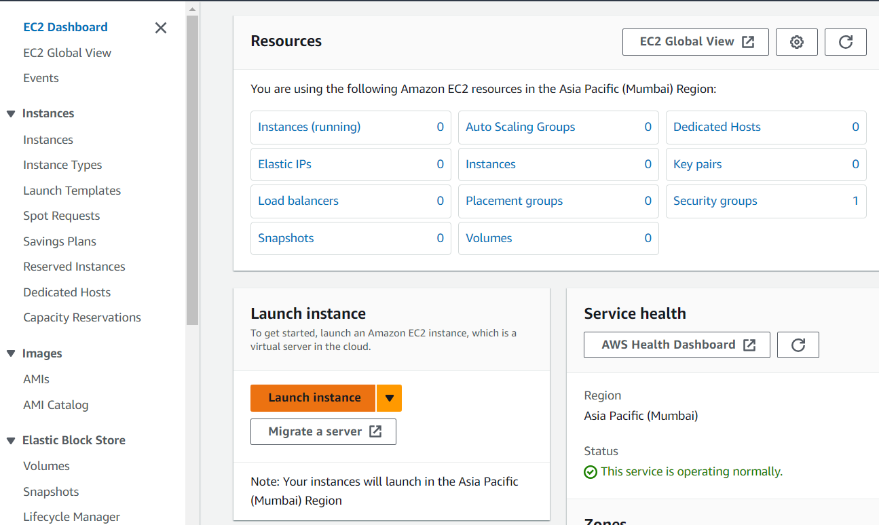

Name the instance and from the quick start menu select Ubuntu server.

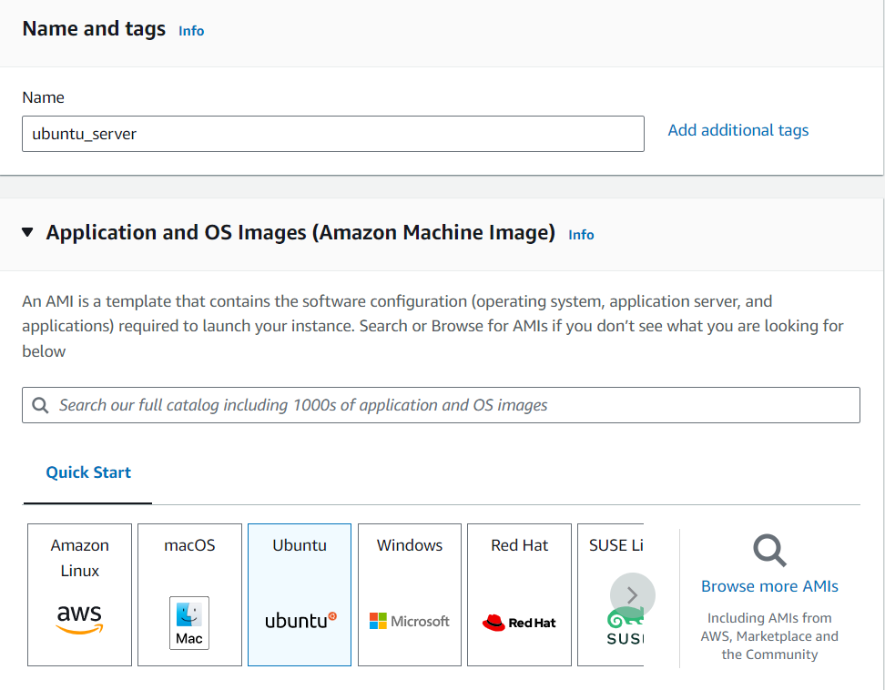

Select appropriate Ubuntu server from Amazon Machine Image and the instance type.

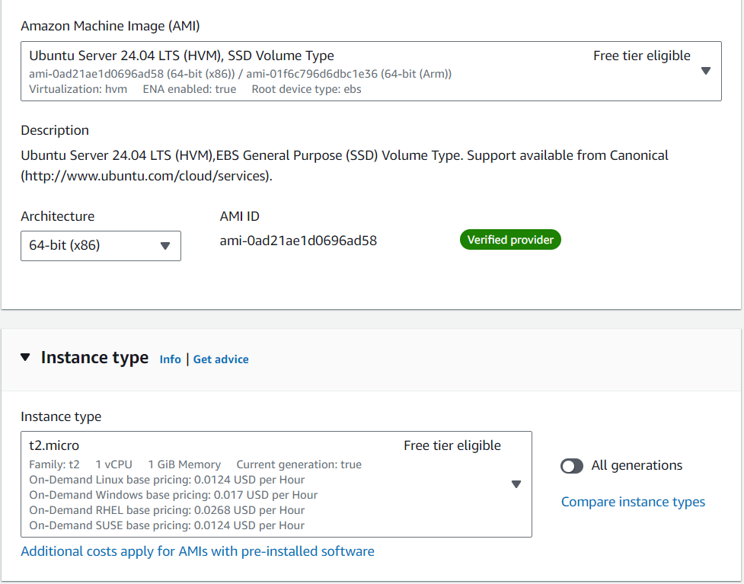

Key-pair: It is used to ensure safe login and connection to your EC2 instance.

Create new key-pair by naming it and keeping the following settings same.

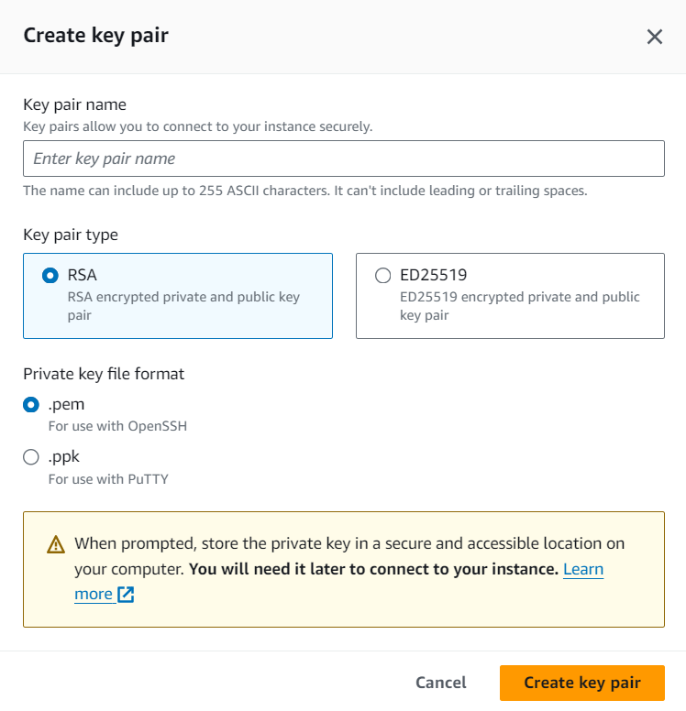

Allow all the following rules and then select launch instance.

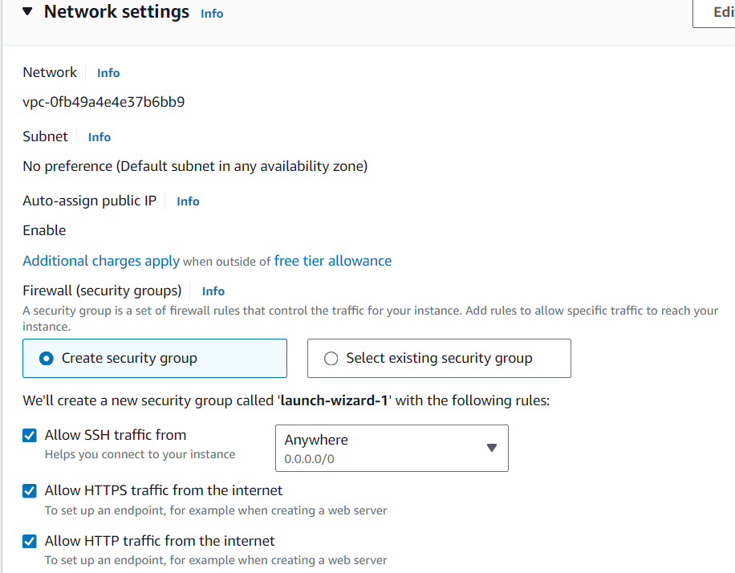

Write linux commands on the server.

