Customer Churn Prediction - Project Report
Full-stack ML project: Flask backend + Streamlit frontend, built on the Telco Customer Churn dataset

1. Business Problem
Telecom operators lose revenue every time a subscriber cancels, and winning a new customer costs far more than keeping an existing one. This project builds a churn-prediction system that flags customers who are likely to leave, estimates the revenue at risk, and suggests a targeted retention action so the retention team can spend its budget where it matters most.
Business questions answered:
- Which customers are most likely to churn in the near future?
- Which contract, payment and service factors drive churn?
- How much annual revenue is at risk for a given customer?
- What retention action should be offered to each at-risk customer?

2. Project Structure
File / Folder | Description
churn_project/ | Project root
data/telco_churn.csv | 7,043 customers, 20 features + churn label
common.py | Shared feature lists and data-cleaning logic
train_model.py | Training script - preprocessing, model comparison, evaluation
model/model.pkl | Trained scikit-learn Pipeline (preprocessing + classifier)
model/metrics.json | Metrics, top drivers and input schema
model/diagnostics.png | ROC curve, confusion matrix, feature importance
backend/app.py | Flask REST API (port 5000)
frontend/ui.py | Streamlit frontend (port 8501)
generate_report.py | Builds this Word report
requirements.txt | Python dependencies
README.md | Run instructions

3. Dataset
The Telco Customer Churn dataset (IBM sample data, published on Kaggle) contains 7,043 customers. Overall churn rate is 26.5%, so the classes are imbalanced and recall is monitored alongside accuracy.
Feature group | Columns
Account | tenure, Contract, PaperlessBilling, PaymentMethod, MonthlyCharges, TotalCharges
Services | PhoneService, MultipleLines, InternetService, OnlineSecurity, OnlineBackup, DeviceProtection, TechSupport, StreamingTV, StreamingMovies
Demographics | gender, SeniorCitizen, Partner, Dependents
Target | Churn (Yes / No)

Data cleaning: customerID removed; blank TotalCharges (tenure = 0) set to 0; SeniorCitizen converted to Yes/No; Churn encoded as 1/0.
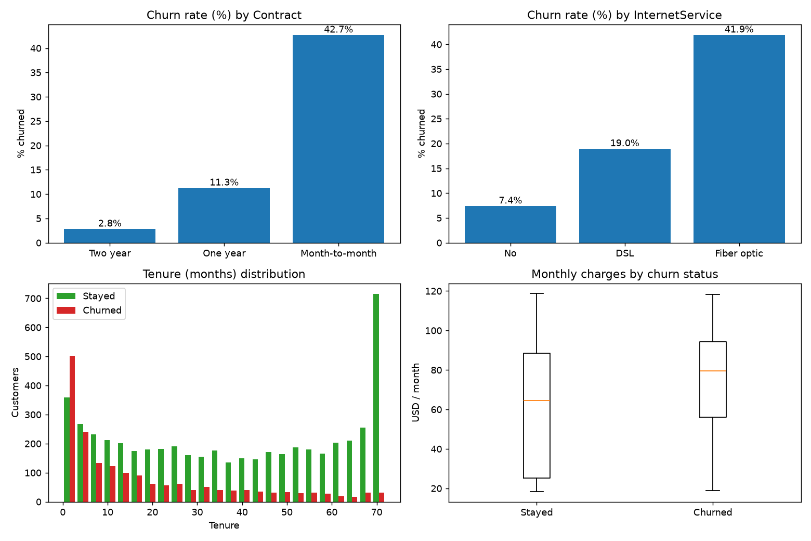
Figure 1 - Exploratory data analysis

4. Machine Learning Model
Two classifiers were trained inside a scikit-learn Pipeline and compared on ROC-AUC. An 80/20 stratified train-test split (random_state=42) was used; the best model was Random Forest.

4.1 Model Pipeline
- Load CSV and clean with common.clean_data()
- Numeric features: median imputation + StandardScaler
- Categorical features: most-frequent imputation + OneHotEncoder
- Classifiers: Logistic Regression and Random Forest (class_weight='balanced')
- Model selection by test ROC-AUC, 5-fold cross-validated ROC-AUC as a stability check
- Persistence: joblib.dump(pipeline, 'model/model.pkl')

4.2 Model Comparison
Model | ROC-AUC | CV ROC-AUC | Recall | Precision | F1 | Accuracy
Logistic Regression | 0.8415 | 0.8454 | 0.7834 | 0.5043 | 0.6136 | 0.7381
Random Forest | 0.8417 | 0.8465 | 0.7727 | 0.5362 | 0.6331 | 0.7622

4.3 Evaluation Metrics (best model)
Metric | Value | Interpretation
ROC-AUC | 0.8417 | Ability to rank churners above non-churners (1 = perfect)
Recall | 0.7727 | Share of real churners the model catches - key business metric
Precision | 0.5362 | Share of flagged customers who really churn
F1 score | 0.6331 | Balance of precision and recall
Accuracy | 0.7622 | Overall share of correct predictions

On the 1,409 test customers the model correctly identified 289 churners and missed 85; it also raised 250 false alarms. False alarms cost a small retention offer, while a missed churner costs the customer's full lifetime revenue, so favouring recall is a deliberate choice.

4.4 Top Drivers of Churn
Feature | Weight
tenure | 0.1265
Contract_Month-to-month | 0.1205
TotalCharges | 0.1037
MonthlyCharges | 0.0758
OnlineSecurity_No | 0.0611
Contract_Two year | 0.058
TechSupport_No | 0.0522
InternetService_Fiber optic | 0.0424
PaymentMethod_Electronic check | 0.0372
Contract_One year | 0.0202
OnlineBackup_No | 0.018
InternetService_DSL | 0.018

Weight type: feature importance.
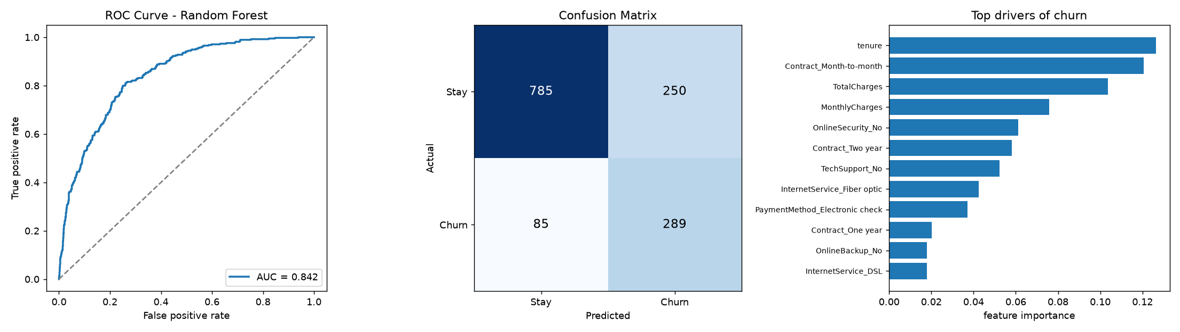
Figure 2 - Model diagnostics

5. Backend API (Flask)
The Flask backend loads the trained pipeline once at start-up and exposes JSON endpoints on port 5000. Inputs are validated and clear error messages are returned for bad requests.
Method | Endpoint | Description
GET | /health | Health check
POST | /predict | Churn probability, risk tier, revenue at risk, recommended actions
GET | /dataset | Dataset records as JSON (?limit=N)
GET | /insights | KPIs and churn rates by segment
GET | /model_info | Metrics, top drivers and input schema

6. Frontend UI (Streamlit)
The Streamlit frontend runs on port 8501, has three pages and talks to the Flask API in real time.

6.1 Predict Churn
Form for account, service and demographic inputs; shows a probability gauge, risk tier, annual revenue at risk and retention actions.

6.2 Customer Insights
KPI cards and churn-rate charts by contract, internet service, payment method, tech support, seniority and tenure band; dataset browser.

6.3 Model Performance
Metrics, model comparison, confusion matrix and top churn drivers.

7. Sample Prediction Results
Predictions from the trained model for five typical customer profiles:
Profile | Tenure | Contract | Monthly | Churn probability | Risk
New fibre customer, month-to-month, e-check | 12 | Month-to-month | $70 | 76.2% | High
Loyal 2-year DSL customer with support | 60 | Two year | $55 | 9.1% | Low
Phone-only customer, 1-year contract | 36 | One year | $22 | 5.4% | Low
Premium fibre, streaming bundle, month-to-month | 8 | Month-to-month | $105 | 89.4% | High
Mid-tenure DSL, one-year, bank transfer | 24 | One year | $60 | 20.1% | Low

8. Business Insights & Recommendations
Churn by contract type: Month-to-month 42.7%, One year 11.3%, Two year 2.8%. Customers who already left represent about $139,131 of monthly recurring revenue.
- Move month-to-month customers to 1- or 2-year plans with a loyalty discount.
- Bundle tech support and online security for fibre customers - it is a top-risk segment.
- Encourage automatic payment methods with a small bill credit.
- Run onboarding check-ins during the first 12 months, when churn is highest.
- Score the whole customer base monthly and hand the High-risk list to the retention team.

9. How to Run the Project
Step 1: Install dependencies
pip install -r requirements.txt
Step 2: Train the model
python train_model.py
Step 3: Start Flask backend (Terminal 1)
python backend/app.py
Step 4: Launch Streamlit frontend (Terminal 2)
streamlit run frontend/ui.py

