Table of Contents

Chapter 1: Introduction
  - Motivation/Relevance of Project
  - Present status/Current trends related to project topic

Chapter 2: Literature Review

Chapter 3: Hardware Implementation
3.1 System block diagram
3.2 Hardware design details

Chapter 4: Software Implementation
4.1 Algorithm details
4.2 Flowchart
4.3 Project coding details

Chapter 5: Results and Discussion
5.1 Results
5.2 Merits
5.3 Limitations of project

Chapter 6: Summary and Conclusion
6.1 Summary of project work
6.2 Conclusion
6.3 Future development in the project

- References
- Appendices

Chapter 1: Introduction

  - Motivation/Relevance of project:

The investigation and utilization of bioelectrical signals originating from the human body constitute a cutting-edge area of study with significant ramifications for multiple disciplines. Myoelectric signals, more especially electromyogram (EMG) signals, have attracted a lot of interest among these signals. Like motor action potentials, these signals record the electrical activity of muscle bundles and provide information about the contraction of muscles.

Surface electromyography (sEMG), a non-invasive technique that uses sensors applied to the skin's surface above specific muscles, is the particular focus of this project. The appeal of sEMG is its adaptability and suitability for a wide range of fields. Its applications include injury identification, gesture recognition, rehabilitation, and the development of prosthetics as well as the classification of neuromuscular diseases.
The main goal of this project is to progress the field of prosthetics, specifically by improving the myoelectric prosthetic hands and arms' usability and functionality. This project aims to improve the classification of EMG signals by differentiating between three types of movements: rest, wrist, and fist. This will pave the way for more accurate control mechanisms in prosthetic devices.

This research has a huge impact on society. For those with limb differences, improved prosthetic technology promises increased mobility and independence, enabling them to participate more fully in everyday activities. Furthermore, there is a significant commercial potential due to the growing demand for cutting-edge prosthetic solutions. This project is in line with the imperative to use technology to improve the lives of people by helping to develop better prosthetic arms.

Essentially, this project is motivated by twofold commitments: first, to advance prosthetic technology to meet urgent societal needs, and second, to utilize state-of-the-art research in bioelectrical signals for useful applications. This project aims to bring in a new era of innovation and accessibility in the field of assistive technology by carefully examining and classifying EMG signals.

  - Present status/Current trends related to project topic:

Surgical techniques for improved prosthetic experience:
Surgical techniques are crucial in improving the prosthetic limb's overall experience and functionality. In particular, they optimize the prosthetic device's fit, control, and acceptance. Prosthetic care has long been known to include stump management, which has a big impact on these variables. A range of surgical techniques have been utilized to preserve or re-establish hand and arm functionality, leading to the development of more efficient prosthetic systems.

These procedures cover a variety of methods, such as skin grafting, digit and toe transfers, various flap procedures, and surgical tendon transfers. Targeted muscle reinnervation (TMR) is a result of surgical knowledge gained over the last ten years, especially with regard to nerve transfers. Rerouting residual nerves to new muscle sites after they have lost their original muscle targets is known as TMR. Using the idea that muscles are biological signal amplifiers, TMR makes it possible to create unique and understandable EMG signal sources, which are essential for prosthetic control. Notably, a prosthetic solution specifically designed for TMR is now available for purchase in the form of the Ottobock DynamicArm Plus, which works in conjunction with the MyoHand Vari PlusSpeed terminal device, Wrist Rotator, and a specially made TMR socket.

Moreover, the notion of bionic reconstruction has surfaced as a revolutionary strategy in situations involving severe trauma to the hand or arm, where conventional biological restoration techniques prove inadequate. Patients suffering from severe brachial plexus injuries that result in permanent hand dysfunction may find a viable solution with bionic reconstruction, which broadens the range of reconstructive options beyond biological limitations. Previously unattainable, even simple terminal devices can now greatly enhance these people's quality of life. Several factors, including extensive neurorehabilitation programs provided throughout the procedure, are critical to the success of bionic reconstruction.

To sum up, advancements in surgery like total joint replacement (TMR) and bionic reconstruction present opportunities to improve prosthetic results and enable people with limb differences to reclaim their independence and functionality. These developments improve the lives of those who are in need by contributing to the ongoing evolution of prosthetic technology through precise surgical techniques and interdisciplinary collaboration.

Control strategies:
Over the past few decades, control strategies for myoelectric prosthetic upper limbs have gradually improved, but up until recently, commercially available systems have stayed mostly unchanged. Using a state machine technique, the first two-channel control systems that allowed for proportional steering of a single DoF have developed to support multiple DoFs that can be driven sequentially. With this method, users can control different DoFs by cycling through states using co-contractions or particular patterns of muscle activation. But even though these techniques are strong, they are often considered confusing and laborious, especially for those who have high-level amputations that necessitate the articulation of multiple DoFs.

Some manufacturers of prosthetic hands have responded to these obstacles by introducing supportive technologies that lessen direct user control. Systems such as BeBionic v3 have switches to switch between preset grip types, and Touch Bionics has i-moTM technology, which uses gyroscopes to detect direction changes elicited by the user to select preset gestures. Furthermore, users can now fine-tune and customize gestures using external applications. Touch Bionics has even introduced grip chips that automatically change hand shape in response to specific devices in the user's environment. It is still unclear how effective these features will be in the clinic, though.

Scholarly investigations have delved into machine learning strategies for prosthetic management, presuming discernible and consistent signal patterns are present across various motor tasks. Although many classification schemes have been put forth, it has proven difficult to translate laboratory test results into clinical practice. The pattern recognition-based COAPT system was just introduced to the market, but its efficacy and acceptability have not yet been thoroughly assessed.
Relying on consistent matching of EMG patterns generated during prosthetic manipulation—which can be impacted by a variety of environmental factors and user-related changes—is a major drawback of pattern recognition-based systems. Furthermore, these systems can be cognitively taxing for users and have trouble handling multiple motions at once.

Research has moved toward biologically inspired algorithms that combine mathematical regression with physiologically grounded models in order to overcome these difficulties. The goal of these algorithms is to provide proportionate and simultaneous intuitive control of multiple DoFs. However, there are still restrictions on the number of controllable DoFs that can be achieved without the use of nonintuitive motions or high-density EMG recordings. Though thorough clinical testing is still lacking, recent proposals have investigated systems combining signal classification and regression for wrist and hand control.

Chapter 2: Literature Review

Electromyography (EMG) signals have attracted a lot of attention in research lately for the purpose of classifying hand gestures, especially in light of the development of intelligent prosthetic systems. In order to accurately and efficiently classify EMG signals, various approaches have been investigated in a number of studies, which has advanced prosthetic technology.

Neural networks are one method used for EMG signal classification. With an accuracy of 80%, "Classification of EMG signal for multiple hand gestures based on neural network" classified EMG signals from forearm muscles into different hand gestures. The paper "EMG Signal Classification Using Radial Basis Function Neural Network" similarly illustrated how RBFNNs can be used to reliably classify EMG signals in order to control myoelectric prostheses [1,2].

Additionally, the use of fuzzy logic systems for the classification of EMG signals has been studied. In order to create classifiers for EMG signal classification, "Classification of EMG Signals Using Wavelet Features and Fuzzy Logic Classifiers" investigated type-1 and type-2 fuzzy logic systems, highlighting the difficulties and developments in this field [3].

A potent method for raising the precision of hand gesture recognition based on EMG signals is deep learning. The paper "EMG based Hand Gesture Recognition using Deep Learning" introduced a brand-new method for high-accuracy hand movement prediction using convolutional neural networks (CNNs). In a similar vein, "Recognition of Hand Gestures Based on EMG Signals with Deep and Double-Deep Q-Networks" illustrated how well Deep Q-networks (DQN), in particular, work as reinforcement learning algorithms to create precise hand gesture recognition systems [4,5].

Additionally, studies have looked into ways to improve EMG signal classification in real time for prosthetic hand control. In order to increase classification accuracy, "EMG-Based Feature Extraction and Classification for Prosthetic Hand Control" suggested new feature extraction functions and post-processing techniques. Furthermore, "Real-Time EMG Signal Classification via Recurrent Neural Networks" examined the application of recurrent neural network architectures for EMG signal classification in real time, demonstrating enhanced precision and decreased latency in contrast to previous techniques [6,7].

All in all, these investigations add to the expanding corpus of literature that aims to improve prosthetic technology by precisely and effectively classifying EMG signals. It is possible that more research in this field will improve prosthetic device usability and functionality, which will benefit people with limb differences in the long run.

Chapter 3: Hardware Implementation

  - System block diagram:

To commence, we collect signals from the ulnar nerve and Flexor carpi ulnaris muscle by means of electrodes and a wearable muscle sensor that is fitted with integrated EMG signal filters [1]. The wearable sensor and electrodes are then connected to an Arduino, which reads the signals using an EMG envelope and records them for six seconds for each movement. The next step is feature extraction, where we take common features such as Mean Absolute Value, Root Mean Square, Median, Waveform Length, Variance, and Standard Deviation and extract them from the recorded signals. These features serve as input for machine learning models, specifically K-Nearest Neighbours (KNN) and Support Vector Machine (SVM) Kernel, which are trained for motion classification. Finally, the outputs predicted by the machine learning models are utilized to control the prosthetic hand, thereby enabling intuitive and accurate prosthetic control based on the analyzed EMG signals.

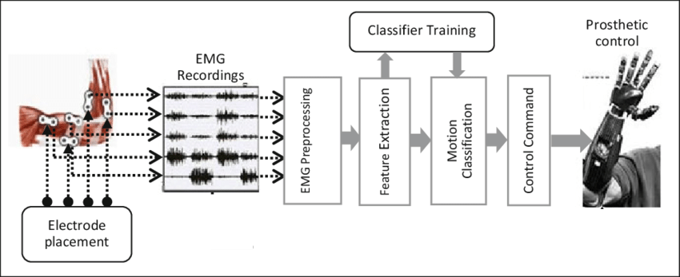
Figure (1)

Electrode Placement & Signal Recording:
The signal strength is greatly influenced by the location and orientation of the muscle sensor electrodes. The electrodes ought to be positioned midway within the muscle mass and in line with the direction of the muscle fiber orientation. By reducing the number of motor units measured and the interference caused by crosstalk, moving the sensor to different locations will weaken and degrade the signal quality of the sensor [8].

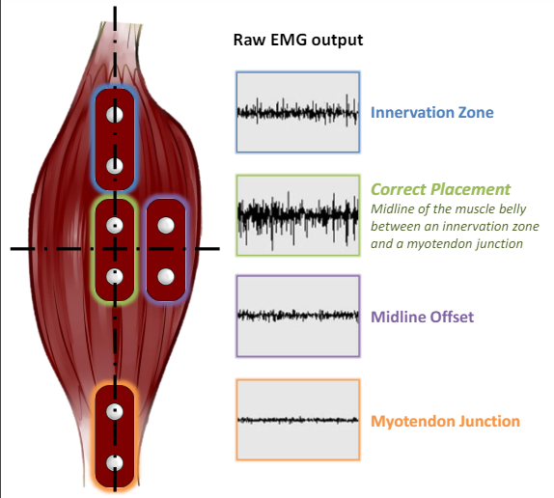
Figure (2)
Muscle Selection: Gripping, lifting, tugging, and throwing are just a few of the wrist and hand motions that depend on the flexor carpi ulnaris muscle. It plays a crucial part in giving precise control and strength during wrist flexion and adduction. On this muscle, electrodes were placed in order to measure [9].

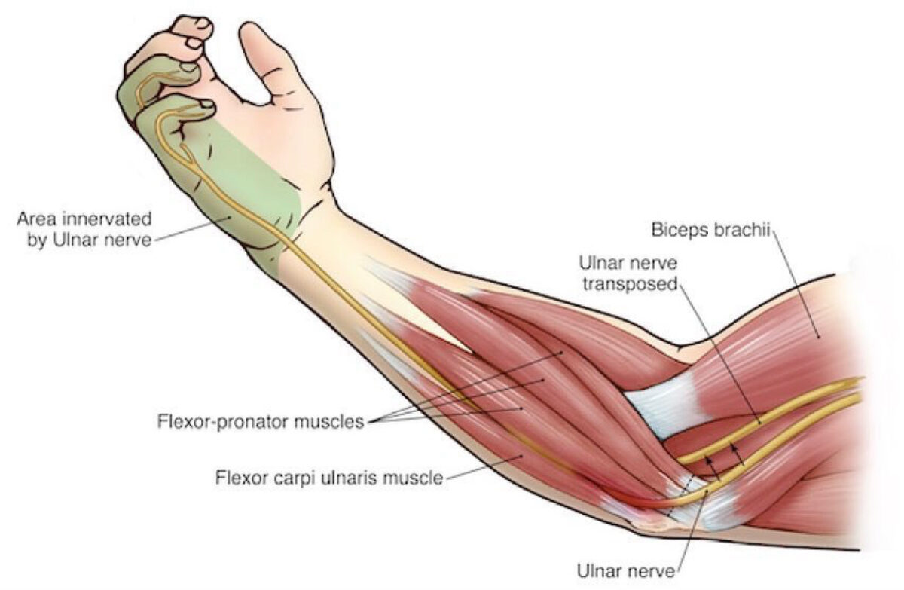
Figure (3)

EMG Preprocessing:
Our muscle sensors are intended to be utilized in conjunction with microcontrollers directly. Consequently, the primary output of our sensors is not a raw EMG signal but rather an amplified, rectified, and integrated signal (also known as the EMG's envelope), which is compatible with the analog-to-digital converter (ADC) of a microcontroller. Below is an example of this difference using a representative EMG signal [8].

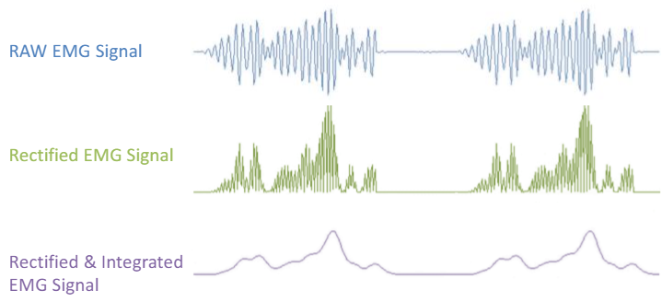
Figure (4)

Feature Extraction:
Following the extraction of pertinent features from EMG signals, these features are encapsulated within a designated class structure, thereby facilitating enhanced pattern recognition and interpretation. An imperative focus lies in the selection of a classifier possessing optimal speed, efficacy, and robustness to accommodate variances in feature extraction values attributed to external influences. These attributes are pivotal in ensuring the efficacy and reliability of the pattern recognition process within the research framework.
The database signals in Microsoft Excel that have been arranged and processed into feature matrix are delivered to Classification Lerner toolbox in MATLAB [1].
For further classification, the recorded EMG signals were extracted with time and frequency domain which are mean absolute value (MAV), root mean square (RMS), median, waveform length (WL), variance (var), and standard deviation (stddev). MAV is produced by calculating the absolute value of the signal’s average as shown in (1). RMS is represented as a random amplitude modulated procedure in which Gaussian RMS is linked to the continuous and non-fatiguing contraction force shown in (2). Median is acquired by separating the value of samples into two equal halves as shown in (3). WL is obtained by calculating the cumulative changes in amplitude from one-time sample to another over the entire time period shown in (4). Variance is a statistical measure capturing the degree of dispersion of a dataset around its mean. It quantifies the average squared deviation of each data point from the mean, providing insight into the spread of values within the dataset. Symbolically, it is represented as the average of the squared differences between each data point and the mean, as illustrated in equation (5). Standard deviation, a closely related metric, is calculated as the square root of the variance. It serves as a measure of the extent to which data points deviate from the mean, providing a more intuitive understanding of the dispersion. Symbolically, it is denoted as the square root of the variance, as depicted in equation (6) [2].

Mean Absolute Value, (MAV) = $\frac{1}{n}\sum_{n=1}^{N}{\left|Xn\right|}$ (1)

Root Mean Square, (𝑅𝑀𝑆) =$\sqrt{\frac{1}{n}}\sum_{n=1}^{N}{x^{2}(n)}$ (2)

Median, (𝑥̃ ) = $\frac{n}{2}$ (3)

Waveform Length, (𝑊𝐿) = $\sum_{n=1}^{N}{|x(n+1)-x(n)| n=1}$ (4)

Variance$, \left( S^{2}\right)$ = $\frac{\sum{(X_{i }}-\overline{X})^2}{n - 1}$ (5)

Standard Deviation $,\left(σ\right) =\sqrt{\frac{\sum{{(X_{i }-μ)}^{2}}}{N}}$ (6)

In this study, the network for training purpose is fed with input vectors and target vectors.
Classifier Training and Motion Classification:
The collected data and its features are methodically saved in a spreadsheet format following feature extraction. The main goal of this step is then to use MATLAB software to train machine learning models like KNN and SVM Kernel.
Control Command and Prosthetic Control:
Establishes the connections to the servo motors that are fastened to the Arduino board via particular pins. Uses the servo motors to execute the appropriate actions based on the machine learning model's prediction. Certain servos are moved to particular locations if the anticipated class is "Fist" or "Wrist." When "Rest" is the anticipated class, every servo goes back to its neutral position. A message is shown informing the user that no action is specified for the predicted class.

  - Hardware design details:

For the robotic hand to accurately and flexibly mimic human hand movements, its hardware components are essential. This is a thorough analysis of the project's hardware:

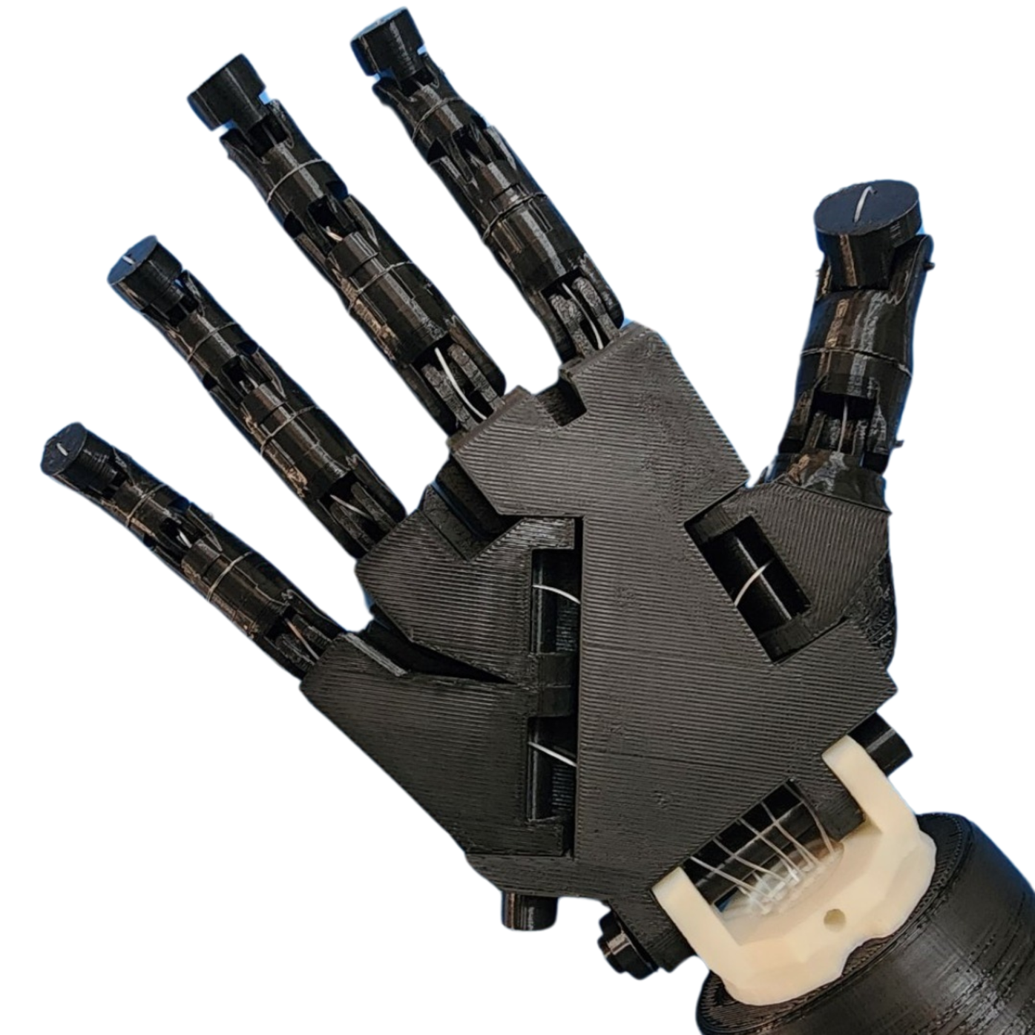
Figure (5)

3D Printed Hand Components:
3D printing technology is used to fabricate the robotic hand, enabling the production of complex and programmable mechanical parts. The palm, fingers, joints, and knuckles are among the various parts that make up the hand; each is painstakingly crafted to imitate the shape and articulation of the human hand. With the help of 3D printing, strong and lightweight parts can be created, guaranteeing the robotic hand's long-term durability and optimal performance.

Hand Pulley System:
The hand pulley system is made to convert the robotic fingers' linear motion from the servo motors' rotational motion. Pulleys, cables, and tensioning devices make up this system, which effectively transfers the torque produced by the servo motors to each individual finger joint. The robotic hand can mimic a variety of gestures and grasping actions thanks to the pulley system, which guarantees smooth and accurate finger movements.

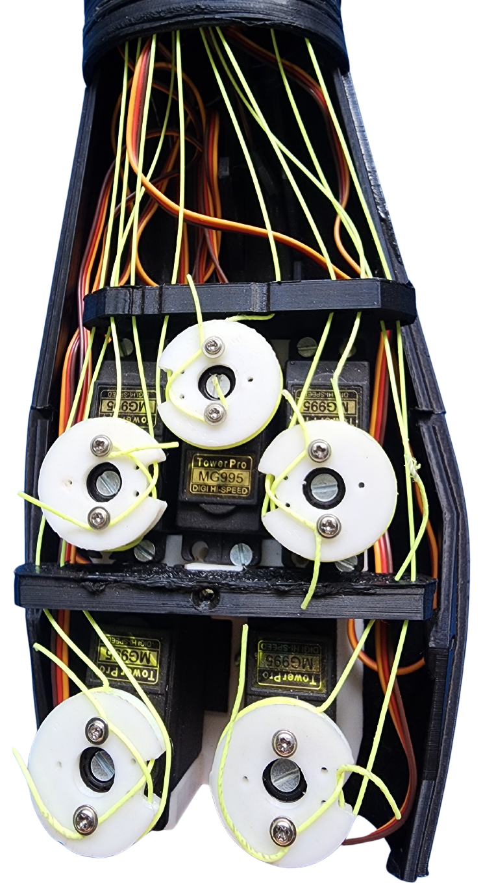
Figure (6)

MG 995 Servo Motors:
The robotic hand's main actuators are these servo motors. The high torque output of the MG995 servo motors is well-known, and it is crucial for simulating the strength and dexterity of human hand movements. A distinct MG995 servo motor controls each finger of the robotic hand, enabling independent movement and coordination.

Below figure shows the single MG995 servo Motor:

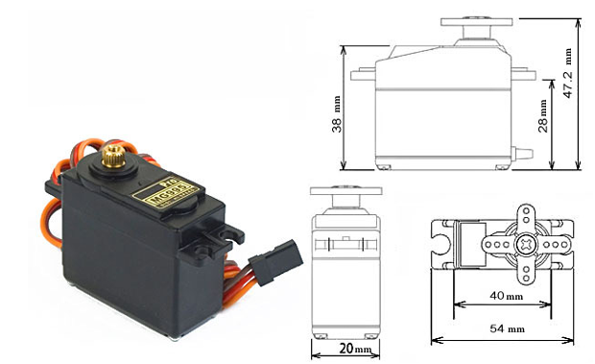
Figure (7)

Specification of the MG995 Motor is as follows:

Feature and Specifications:
- Weight: 55 g
- Dimension: 40.7 x 19.7 x 42.9 mm approx.
- Stall torque: 8.5 kgf·cm (4.8 V ), 10 kgf·cm (6 V)
- Rotation Angle: 120deg. (+- 60 from center)
- Operating speed: 0.2 s/60º (4.8 V), 0.16 s/60º (6 V)
- Operating voltage: 4.8 V to 7.2 V
- Dead band width: 5 µs
- Stable and shock proof double ball bearing design
- Metal Gears for longer life
- Temperature range: 0 ºC – 55 ºC
This high-speed servo actuator is not code dependant.

Muscle BioAmp Patchy:
Muscle BioAmp Patchy is a wearable ElectroMyoGraphy (EMG) sensor that attaches itself like a patch to gel electrodes. It has onboard snap connectors, reverse polarity projection, power indication, and robust BioAmp sensing technology for accurate recording of muscle signals. This makes it simple for you to incorporate this sensor into your Human-Computer Interface (HCI) that uses EMG.

Below figure shows the Muscle BioAmp Patchy:

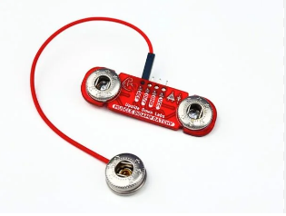
Figure (8)

Specification of the Muscle BioAmp Patchy is as follows:

Features and Specifications:
Minimum Input Voltage: 4.5 V
Input Impedance: 10^12 Ω
Fixed Gain: x2420
Bandpass filter: 72 – 720 Hz
Wearable: Yes
Compatible Hardware: Any development board with an ADC (Arduino UNO & Nano, Espressif ESP32, Adafruit QtPy, STM32 Blue Pill, BeagleBone Black, Raspberry Pi Pico, to name just a few)
BioPotentials: EMG (Electromyography)
No. of channels: 1
Electrodes: 3 (Positive, Negative, and Reference)
Dimensions: 47 x 14 mm
Open Source: Hardware + Software

Chapter 4: Software Implementation

  - Algorithm details:

EMG-Envelope Code (used for signal acquisition):
In order to interface with the Muscle BioAmp Patchy, record electromyography (EMG) signals, process them, and then send the processed data over the serial port, this Arduino sketch was created. First, a number of constants are defined, including the input pin, buffer size, baud rate, and sample rate. The serial connection is initialized with the given baud rate by the setup function. The loop function keeps track of time elapsed and controls a timer to regulate the sampling rate. Using the EMG Filter function, it applies a band-pass Butterworth IIR digital filter to the EMG signal after reading the analog input from the sensor linked to the designated input pin. It also uses the getEnvelop function to compute the filtered signal's envelope. The getEnvelop function's envelope detection algorithm keeps track of the amplitudes of EMG signals in a circular buffer, averages them, and then scales the result to find the envelope amplitude. The serial port receives this processed envelope value after which it can be viewed or processed further. All in all, this code preprocesses the raw EMG signal by removing unwanted frequencies and extracting the envelope, which allows the signal to be transmitted for visualization or additional analysis and allows for a more precise analysis of muscle activity.

MATLAB Code (used for prediction and servo movements):
The next stage of the project is represented by this MATLAB code, which communicates with an Arduino board to obtain data from a sensor via a serial port, computes features from the data, uses a trained machine learning model to make predictions, and then moves servos in accordance with the predictions. This is an overview of its features:

Serial Port Communication Setup:
Connects to the Arduino board via the specified COM port and baud rate. Reads incoming data from the serial port in real-time and stores it for further processing.
Data Processing:
Calculates various features from the received data, such as the mean absolute value (MAV), root mean square (RMS), median, waveform length (WL), variance, and standard deviation.
Machine Learning Prediction:
Loads a pre-trained machine learning model (in this case, a k-nearest neighbors classifier) from a file. Uses the calculated features as input to the model to make predictions about the observed gesture or movement.
Servo Control:
Initializes connections to servo motors attached to the Arduino board on specific pins. Based on the prediction made by the machine learning model, performs corresponding actions with the servo motors. If the predicted class is "Fist" or "Wrist," certain servos are adjusted to specific positions. If the predicted class is "Rest," all servos return to a neutral position. If no action is specified for the predicted class, a message is displayed indicating this.

Clean-up and Closure:
Clears Arduino connections and displays a message indicating the closure of the Arduino connection. Overall, this code demonstrates a closed-loop system where data from a sensor is processed, analyzed, and used to control servo motors based on machine learning predictions, enabling gesture recognition and corresponding physical responses.

  - Flowchart:

This diagram illustrates the flowchart/sequence diagram depicting the MATLAB code's execution process. It encompasses data acquisition, preprocessing, feature extraction, and classification to identify hand movements. Additionally, it involves communication with a second Arduino for controlling the servo motor.

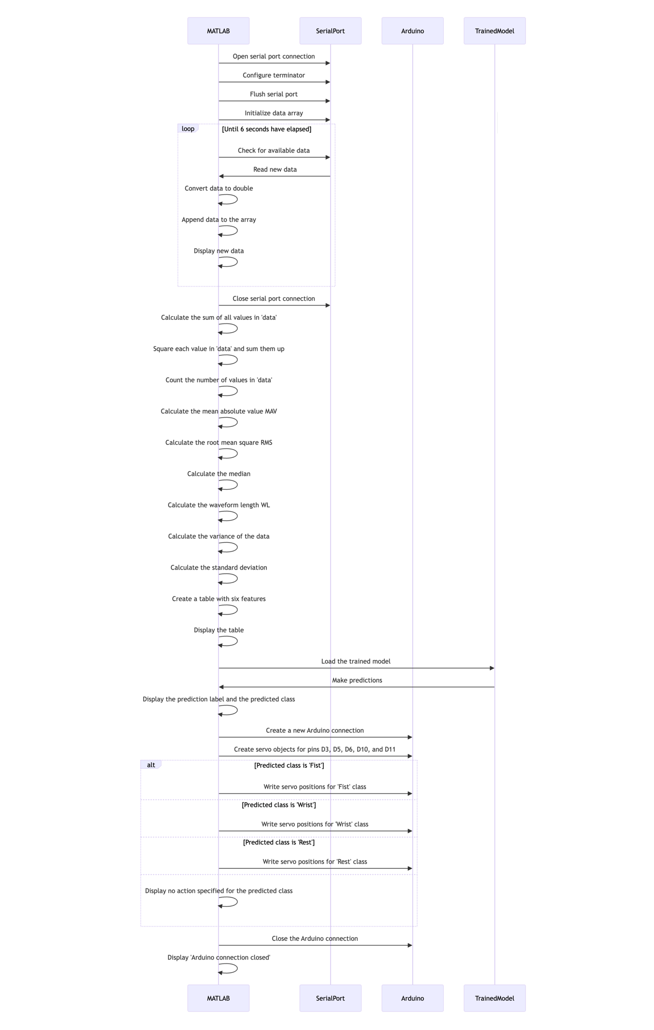
  - Project coding details:

EMG Signal Visualization (Arduino Code):
This code is designed to visualize electromyography (EMG) signals captured by the Muscle BioAmp Patchy sensor. It samples the EMG signal at a specified sample rate, filters it, and sends the envelope-detected signal to the serial port.
Key components include:
- Sampling and buffering of EMG data.
- Envelope detection algorithm.
- Band-pass Butterworth IIR digital filter for signal processing.
- The Arduino board is responsible for real-time signal processing and visualization.

Feature Extraction and Gesture Recognition (MATLAB Code):
This MATLAB code is used for feature extraction and gesture recognition based on the EMG signal data received from the Arduino. It receives data from the sensor through the serial port, calculates various features from the data (such as MAV, RMS, etc.), and makes predictions using a pre-trained machine learning model. After prediction, it controls servo motors based on the recognized gesture.
Key components include:
- Serial communication for data reception.
- Feature extraction algorithms.
- Machine learning prediction model.
- Servo motor control based on predictions.
- MATLAB is responsible for high-level signal processing, feature extraction, and machine learning inference.

EMG Signal Processing and Servo Control (Arduino Code):
This Arduino code complements the MATLAB code by processing the EMG signal and controlling servo motors based on predictions. It samples the EMG signal, filters it, and calculates the envelope in real-time. It receives commands from the MATLAB code through the serial port and adjusts servo positions accordingly.
Key components include:
- EMG signal sampling and processing.
- Envelope calculation.
- Serial communication for receiving commands.
- Servo motor control based on received commands.
- Arduino is responsible for real-time signal processing and servo motor control based on external commands.
Overall, the project involves a combination of Arduino and MATLAB code to capture, process, analyze, and respond to EMG signals for gesture recognition and servo motor control. Arduino handles real-time signal processing and motor control, while MATLAB performs higher-level analysis, feature extraction, and machine learning-based gesture recognition.

Chapter 5: Results and Discussion

  - Results:

Classification Learner Results:
Following the classification of EMG signal data utilizing the KNN (K-Nearest Neighbours) model, the utilization of a confusion matrix and scatter plot becomes pivotal for thorough evaluation and visualization of the classification performance.

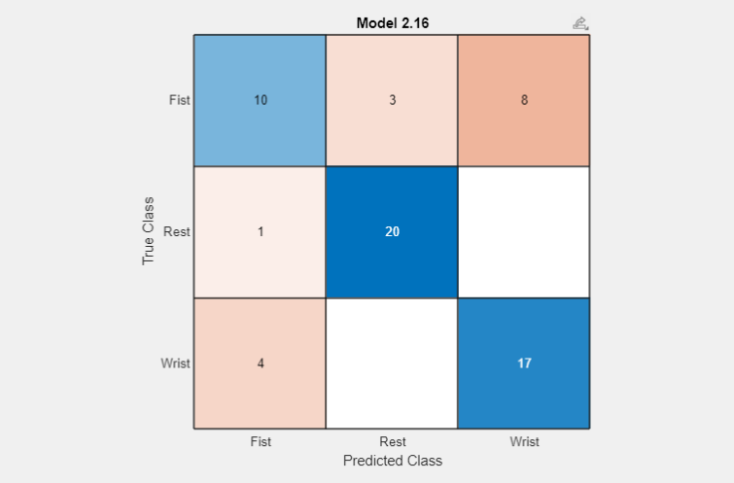
Figure (9)

The confusion matrix, a fundamental tool in classification analysis, serves to provide a granular breakdown of the model's efficacy by meticulously comparing predicted class labels against the ground truth. Structured as a grid, where each row corresponds to the actual class and each column represents the predicted class, the confusion matrix offers a comprehensive overview of classification outcomes. Within this matrix, the diagonal elements signify correct predictions, while off-diagonal elements indicate misclassifications. By examining the distribution of values across the matrix, one can discern patterns of misclassification, gauge the model's accuracy, and compute performance metrics such as precision, recall, and the F1 score, thereby offering insights into the model's overall effectiveness.

On the other hand, the scatter plot, a visual representation of data points in a multi-dimensional space, offers a more intuitive understanding of the classification process. Each data point is depicted as a marker on the plot, with its position determined by the values of its features. In the context of the KNN model, the scatter plot can elucidate how data points are distributed across different classes and reveal potential overlaps or clusters within the feature space. By employing distinct colours or markers to represent different classes, the scatter plot facilitates the visualization of class boundaries and the decision-making process of the KNN algorithm. This visual exploration provides valuable insights into the separability of classes and the model's ability to correctly classify data points based on their proximity to neighbouring points.
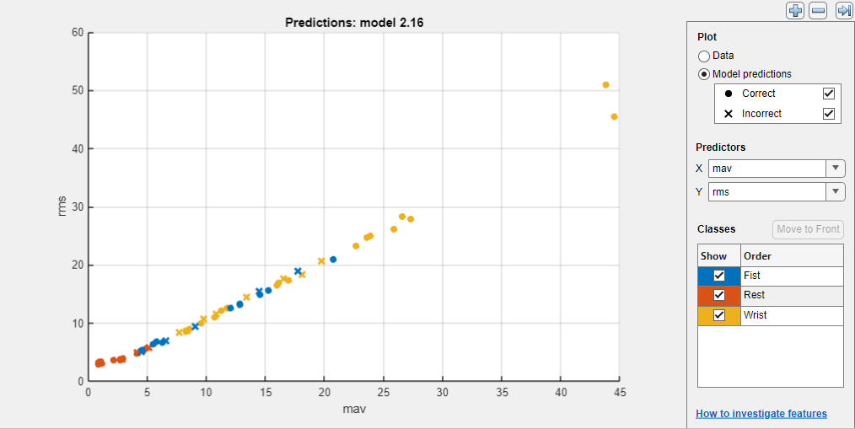
In summary, the combined use of a confusion matrix and scatter plot offers a multifaceted approach to assessing the performance and behaviour of the KNN classifier in the classification of EMG signal data. While the confusion matrix provides quantitative metrics for evaluation, the scatter plot offers qualitative insights into the data distribution and classification boundaries, thereby enabling a comprehensive analysis of the model's effectiveness.
Figure (10)

MATLAB Results:
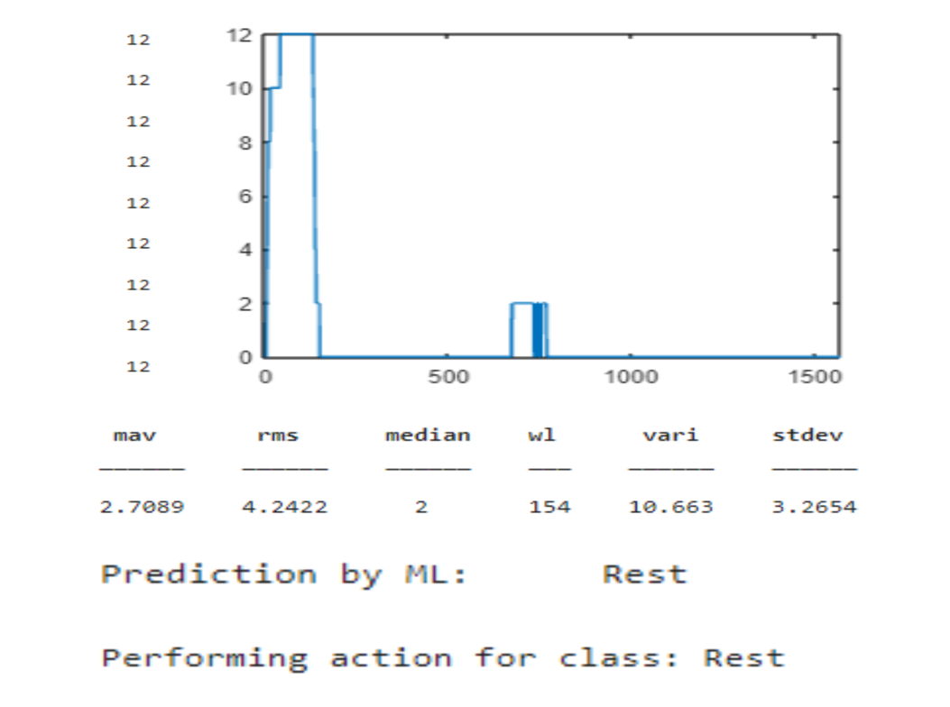
Figure (11)
The results are taken from the MATLAB command window. Where we can see the analog values of the sensor data done for the Specific movement "Rest". The Table for the Extracted Features gets displayed in the result window which will further helps in the prediction making by classifier learner. Based upon the results/predictions of classifier learner the actions are performed which relicts in the hardware.
Hardware Results:

The results of the "rest" action are shown in the image below. Both the action and digital position signals are sent to the second Arduino after the learner has classified them. These digital signals are customized for particular motors, allowing for accurate movement replication following action prediction.

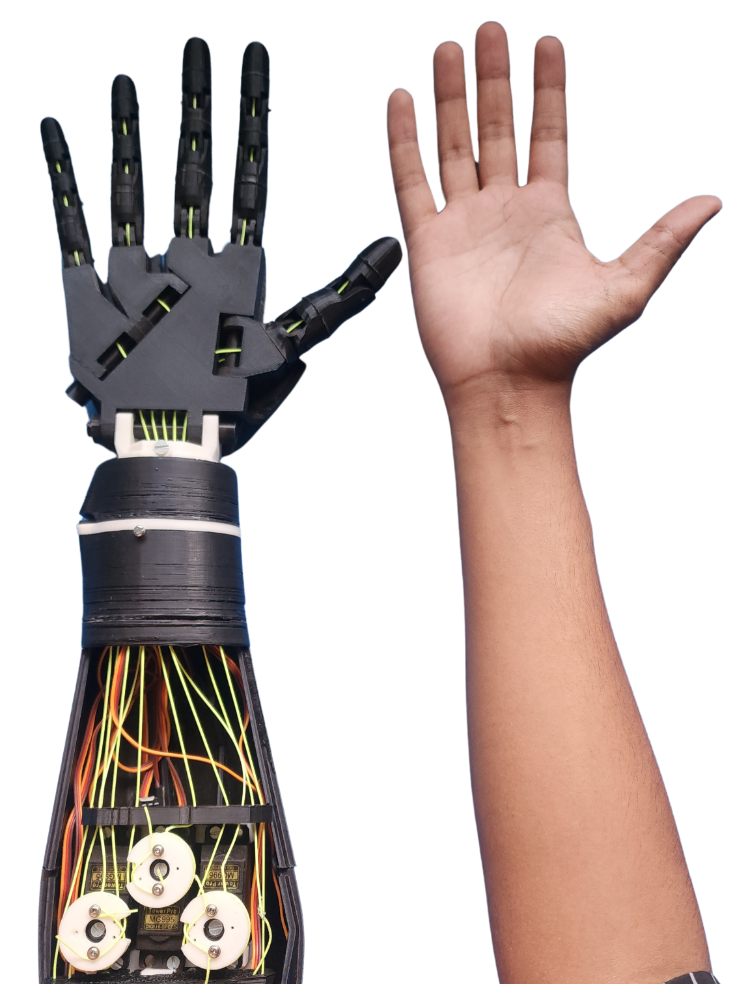
Figure (12)

The "Fist" action is duplicated using the same action sequence. The actuation signals are sent to the second Arduino once the "Fist" class prediction is accurate. These signals are made up of digital position instructions made specifically for particular motors. Based on these signals, the motors then function to accurately replicate the movements made by the human hand.

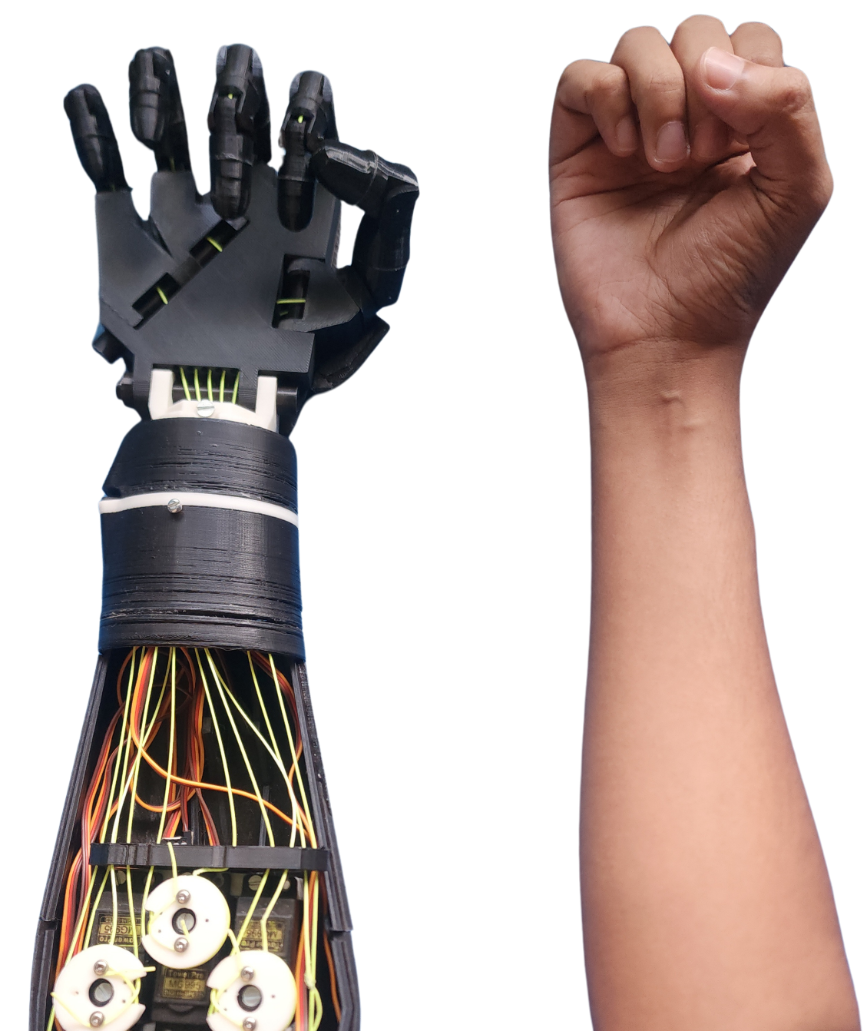
Figure (13)

  - Merits:

1. Real-time Movement Replication:
- The project makes it possible to replicate hand movements in real time. This means that when a person makes a particular hand gesture, the system can instantly imitate it by coordinating the activation of motors or actuators.
- This capability has important ramifications for applications like prosthetics, where real-time replication of natural hand movements can significantly improve functionality and user experience.

2. Precise Classification:
- Based on features that are extracted from the recorded data, machine learning algorithms such as KNN (K-Nearest Neighbours) and SVM (Support Vector Machine) Kernel are used to precisely predict hand movements.
- Because these algorithms are trained on labelled datasets, they can accurately classify incoming data into predefined categories.

3. Flexibility in Movement Replication:
- The system's capacity to imitate a broad variety of gestures and actions is demonstrated by its ability to replicate different hand movements, such as "Rest" and "Fist."
- Because of its adaptability, the system can be used for a wide range of situations and applications, including virtual reality and rehabilitation therapy.

4. Potential for Real-World Applications:
- Precisely simulating hand motions has useful applications in domains like rehabilitation, where patients can utilize the system to hone particular movements and enhance their motor abilities.
- Furthermore, the system can be applied to virtual reality environments to improve user interaction and immersion, or to robotics to develop more dexterous robotic hands.

5. Low-cost Implementation:
- The project provides an affordable way to replicate hand movements by utilizing widely available parts like Arduino boards and MATLAB software.
- This low-cost implementation maintains functionality and performance while opening up the system to a wider audience, including resource-constrained researchers and hobbyists.

  - Limitations of project:

1. Low-End Hardware Restrictions Cause Data Acquisition & Prediction Delays:
The project's low-end hardware components impose limitations that cause delays in both the data acquisition and prediction processes. Low-end hardware, like microcontrollers with little memory and processing power, might find it difficult to meet the computational demands of machine learning and real-time data processing. This means that there may be discernible lags between sensor data collection, pre-processing, and prediction, which affects the usability and responsiveness of the system.

2. Precise Classification:
The project's dependence on inexpensive sensors results in restrictions on the accuracy and dependability of the sensors. Comparing low-cost sensors to their higher-quality counterparts, it is common to observe higher noise levels, lower resolution, and reduced sensitivity. These restrictions may have an impact on the accuracy and consistency of the data that is collected, which may result in mistakes during the feature extraction and classification processes and ultimately affect the system's overall performance.

3. Sensor Not Wearable for Long Time:
Due to discomfort or design constraints, the project's sensors might not be appropriate for extended wear or continuous monitoring. When worn for extended periods, factors like the sensors' size, weight, material, and ergonomics may irritate or cause discomfort. This restriction limits the system's application in situations where continuous activity tracking or rehabilitation necessitate long-term hand movement monitoring.

4. Computer Required for Project Execution:
The project must be completed using a computer, which can be problematic in some circumstances. Depending on how the project is set up, the requirement for a computer may limit its autonomy and portability, necessitating additional equipment and a reliable power source. This reliance on a computer increases the system's complexity, raising the need for setup and maintenance as well as possible weak points.

5. Low-End Processing Board:
The computational capacity and performance of the system are restricted when low-end processing boards are used. In comparison to their higher-end counterparts, low-end processing boards usually have fewer processing cores, slower clock speeds, and smaller amounts of memory. These restrictions limit the system's capacity to manage intricate calculations, handle sizable datasets, or effectively execute computationally demanding algorithms, which lowers responsiveness and overall performance.

Chapter 6: Summary and Conclusion

  - Summary of project work:

In order to precisely predict hand movements, the current project is focused on classifying electromyography (EMG) signal data, with a particular emphasis on actions such as "Rest" and "Fist." The system uses patterns identified from the EMG signals to effectively distinguish between different hand gestures by utilizing the K-Nearest Neighbours (KNN) model.

The confusion matrix and scatter plot are two essential tools used by the system for evaluation and visualization after the classification process. A key component of classification analysis is the confusion matrix, which provides an extensive analysis of the model's performance. It is organized as a grid and contrasts the actual ground truth with the predicted class labels. In the matrix, the predicted class is represented by each column, and the actual class is represented by each row. With diagonal elements denoting accurate predictions and off-diagonal elements emphasizing incorrect classifications, this arrangement facilitates a thorough analysis of classification results. By examining the confusion matrix, misclassification patterns can be found and metrics like precision, recall, and the F1 score can be calculated to gain understanding of the model's efficacy and accuracy.

The scatter plot offers a multi-dimensional visual representation of the data points in conjunction with the confusion matrix. The values of the features that are extracted from the EMG signals are used to determine the position of each data point, which is represented as a marker on the plot. Understanding the distribution of data points among various classes and spotting possible overlaps or clusters within the feature space are made easier with the aid of this visualization. The scatter plot makes it easier to see class boundaries and the KNN algorithm's decision-making process by using different colours or markers to represent different classes. This visual exploration provides insightful information about the model's accuracy in classifying data points according to their proximity to neighbouring points and the separability of classes.

In addition, the project entails recording analog sensor data values for particular hand movements, which are subsequently utilized to extract pertinent features for the classifier learner to predict. These sensor data values and the matching extracted features are included in the MATLAB results, which serve as crucial inputs for the classification procedure. Certain actions are carried out in response to the classifier learner's predictions, which replicate hand movements using hardware like motors.

Essentially, the project demonstrates how hardware components and machine learning techniques can be combined to achieve real-time movement replication. The system seeks to improve comprehension and hand movement prediction accuracy by emphasizing comprehensive evaluation and visualization of classification results. It has potential applications in prosthetics, rehabilitation, and human-machine interaction.

  - Conclusion:

The EMG-based bionic arm project's conclusion sums up the tremendous advancements made in the creation of more adaptable, inclusive, and responsive assistive technology. The project intends to give users more functionality and control by using electromyography (EMG) signals to predict hand movements, ultimately enhancing their quality of life.

The adaptation of the project's code for deployment on portable hardware is one significant advancement that is highlighted in the conclusion. With this advancement, accessibility is improved and users can now easily incorporate the bionic arm into a variety of settings and activities. Because the hardware is portable, users can take advantage of assistive technology wherever they go, which encourages independence and mobility.

Moreover, the conclusion highlights the need to optimize the project's code in order to decrease response times. Users can interact with the bionic arm more naturally and effectively as a result of this optimization, since it can react to their commands with speed and accuracy. The improved responsiveness makes the assistive technology more intuitive and user-friendly while also improving its overall usability and effectiveness.

The conclusion highlights another important factor, which is the extensive machine learning model training that was done for the project. In order to guarantee that the bionic arm can correctly interpret and react to user gestures, this training procedure shows a dedication to accuracy and dependability in movement prediction. Through the application of cutting-edge machine learning techniques, the project seeks to provide an intelligent and user-focused assistive technology solution.
The conclusion offers hope for the future regarding the trained model's potential influence on users' lives. The project's overall goal of increasing the autonomy and independence of people with mobility impairments is emphasized in the conclusion, which places a strong emphasis on empowerment through improved control and functionality. With its integration of state-of-the-art technology and user-centred design principles, the project is a major step toward the realization of an accessible and inclusive assistive technology future.

  - Future development in the project:

When considering the project's future scope, a number of developments have the potential to greatly improve its capabilities and performance. First off, using the MyoWare 2.0 Muscle Sensor is a critical first step in the direction of more precise data collection. When compared to conventional EMG sensors, the MyoWare 2.0 provides superior signal quality and sensitivity, guaranteeing accurate muscle activity capture. This improvement has the potential to improve the accuracy of hand movement classification and detection, providing a strong basis for more accurate and consistent predictions.

Furthermore, the system's data processing could be completely transformed by the incorporation of state-of-the-art computing platforms like the NVIDIA Jetson Nano. The Jetson Nano's powerful GPU and multicore CPU allow for quick and effective computation, making it the perfect tool for processing intricate machine learning algorithms. The project can process EMG signal data more quickly and accurately by utilizing the Jetson Nano's computational power, which will improve classification performance and responsiveness.

The project's future trajectory includes a transformative shift from conventional machine learning models, such as KNN and SVM Kernel, to more sophisticated neural network architectures, specifically Recursive Neural Networks (RNNs). RNNs are perfect for processing time-series data, like EMG signals, because they are good at identifying sequential patterns and temporal dependencies in the data. The project can achieve new levels of accuracy and precision in hand movement classification, especially for dynamic and nuanced gestures, by utilizing the capabilities of RNNs.

Reducing response time from the current 10 seconds to real-time performance is a crucial objective of the project's future efforts. Real-time responsiveness must be attained to guarantee smooth user-bionic arm interaction and feedback. Through the utilization of data processing methods, machine learning models, and hardware innovations, the project seeks to maximize efficiency and provide prompt user responses. This metamorphosis will improve the bionic arm's usability while expanding its practical applications, ranging from assistive technology to rehabilitation.

In conclusion, the project's future scope will be defined by the convergence of cutting-edge machine learning techniques, robust computing platforms, and sophisticated sensor technology. These developments could push the project to new limits in terms of precision, speed, and clarity, ultimately expanding the field of assistive technology and giving users more functionality and control.

References

[1] Mohd Azlan Abu, Mohd Zubir Suboh, Nurul Fauzani Jamaluddin (January 2020). "Classification of EMG signal for multiple hand gestures based on neural network". Article in Indonesian Journal of Electrical Engineering and Computer Science.

[2] Ahmed Mohammed AlKhazzar, Mithaq Nama Raheema. "EMG Signal Classification Using Radial Basis Function Neural Network". In 2018 Third Scientific Conference of Electrical Engineering (SCEE), University of Technology – Iraq.

[3] Nithya Gnanassegarane. "Classification Of Emg Signals Using Wavelet Features and Fuzzy Logic Classifiers". A Thesis Submitted for The Degree Of Master Of Engineering Department Of Mechanical Engineering National University Of Singapore 2009.

[4] Mehmet Akif OZDEMIR, Deniz Hande, Aytug ONAN, Aydin AKAN. "EMG based Hand Gesture Recognition using Deep Learning". Supported by the Scientific and Technical Research Council of Turkey (TUBITAK).

[5] Ángel Leonardo Valdivieso Caraguay, Juan Pablo Vásconez, Lorena Isabel Barona López, Marco E. Benalcázar." Recognition of Hand Gestures Based on EMG Signals with Deep andDouble-Deep Q-Networks". In Article Sensors 2023, 23, 3905.

[6] Reza Bagherian Azhiri, Mohammad Esmaeili, Mehrdad Nourani. " EMG-Based Feature Extraction and Classification for Prosthetic Hand Control". In EPiC Series in Computing Volume 83, 2022, Pages 136–145 Proceedings of 14th International Conference on Bioinformatics and Computational Biology.

[7] Reza Bagherian Azhiri, Mohammad Esmaeili, Mehrdad Nourani. "Real-Time EMG Signal Classification via Recurrent Neural Networks". In IEEE Transactions on biomedical engineering, vol. 53, no. 11, pp. 2232–2239, 2006.

[8] Advancer Technologies. "3-lead Muscle / Electromyography Sensor for Microcontroller Applications" Internet: https://www.digikey.com/htmldatasheets/production/1897318/0/0/1/MyoWare-Muscle-Sensor-AT-04-001-.pdf [Nov. 20, 2023]

[9] Physiopedia. "Flexor Carpi Ulnaris Muscle". Internet: https://www.physio-pedia.com/Flexor_Carpi_Ulnaris_Muscle [Dec. 15, 2023]

Appendices

Captured Signals of Fist Hand Position:
Below are the recorded signals representing the Fist position of the hand. Each signal was captured for a duration of 6 seconds, comprising approximately 1200-1500 samples. The screenshot below displays the first 50 samples of the recorded signal. These hand movements are recorded from 21 individuals aged between 20 and 23 years.

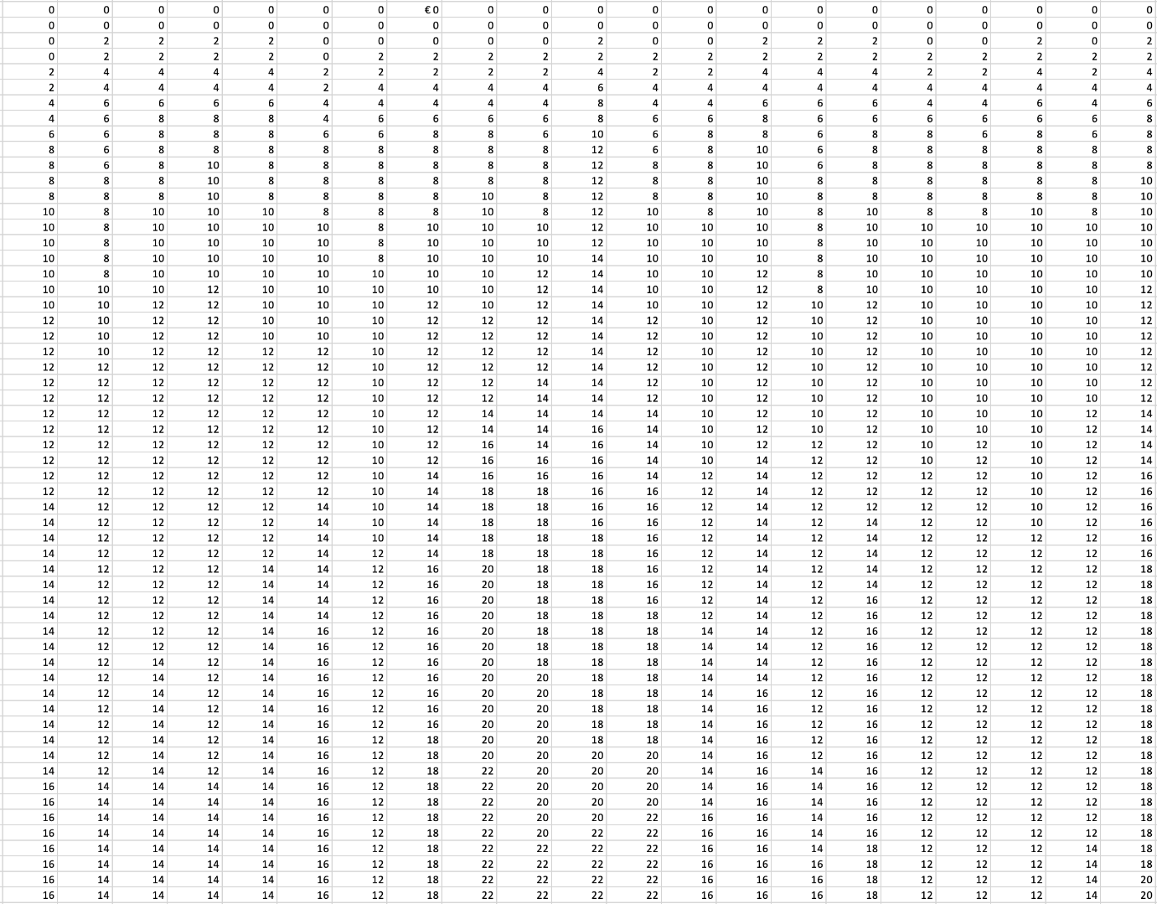

Captured Signals of Wrist Hand Position:
Below are the recorded signals representing the Wrist position of the hand. Each signal was captured for a duration of 6 seconds, comprising approximately 1200-1500 samples. The screenshot below displays the first 50 samples of the recorded signal. These hand movements are recorded from 21 individuals aged between 20 and 23 years.

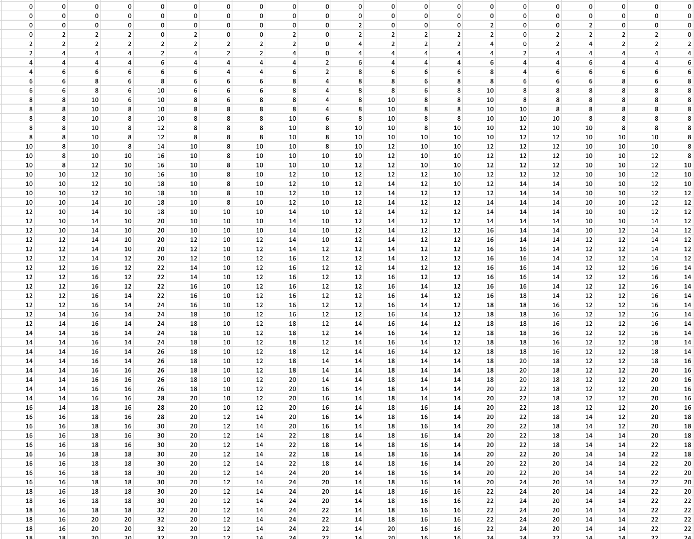

Captured Signals of Rest Hand Position:
Below are the recorded signals representing the Rest position of the hand. Each signal was captured for a duration of 6 seconds, comprising approximately 1200-1500 samples. The screenshot below displays the first 50 samples of the recorded signal. These hand movements are recorded from 21 individuals aged between 20 and 23 years.



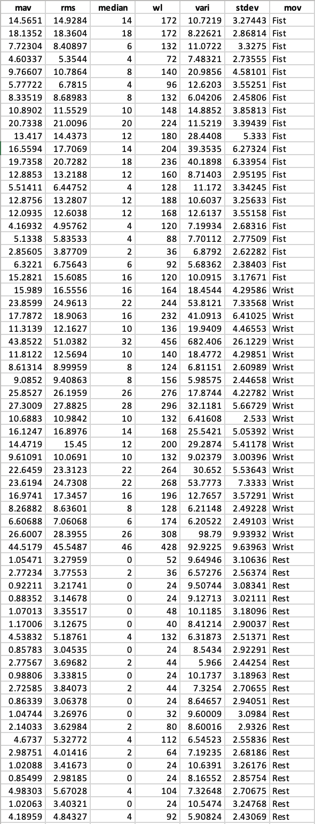
Features of the Captured Signals:

After capturing signals for three hand positions, we extracted six mathematical features such as Mean Absolute Value (MAV), Root Mean Square (RMS), Median, Waveform Length (WL), Variance, and Standard Deviation (STDEV). This feature extraction process is essential as it prepares the input data for training a machine learning model. The extracted features are listed on the left-hand side for each hand movement. We calculated these features for hand movements recorded from 21 individuals aged between 20 and 23 years.

