AEIOU FRAMEWORK – ASSIGNMENT 1
Group Name:
Group ID:
Batch: | C2
Group Members: | 1. Varsharani Shivaji Patil -202501100152  2.Sakshi Vasudev Pathare-202501100147
Submitted To:

AI-POWERED CREW ASSEMBLY FOR EVENT STAFFING



AEIOU FRAMEWORK | Group ID: | Sheet No: 1
ACTIVITY SHEET | Group Name: | Project Title: AI-POWERED CREW ASSEMBLY

THINGS HAPPENING AROUND:  Event organizers identify staffing needs based on event type, date, location, budget, and guest count.  Organizers search for freelance photographers, sound engineers, decorators, anchors, security staff, and other crew.  Freelancers share their skills, experience, availability, location, and expected payment.  Organizers compare candidates manually and assign people to event roles.  Crew members confirm availability and accept or reject assignments.  Organizers coordinate schedules, payments, transport, and responsibilities.  When a selected crew member cancels, organizers contact other freelancers for replacements.  EFFECTS OF AI-POWERED CREW ASSEMBLY:  Reduces manual recruitment time and effort.  Improves skill-to-role matching and budget utilization.  Helps reduce staffing gaps caused by cancellations.  Provides ranked backup candidates to lower no-show risk.  HOW IT IS GOING ON:  Organizer enters event details and required roles.  System checks crew skills, availability, location, budget, and reliability.  AI assembles a suitable team and provides ranked backups.  Organizer reviews recommendations and confirms assignments. | Sketch/Photo:  Event organizer coordinating crew or AI crew-assembly workflow  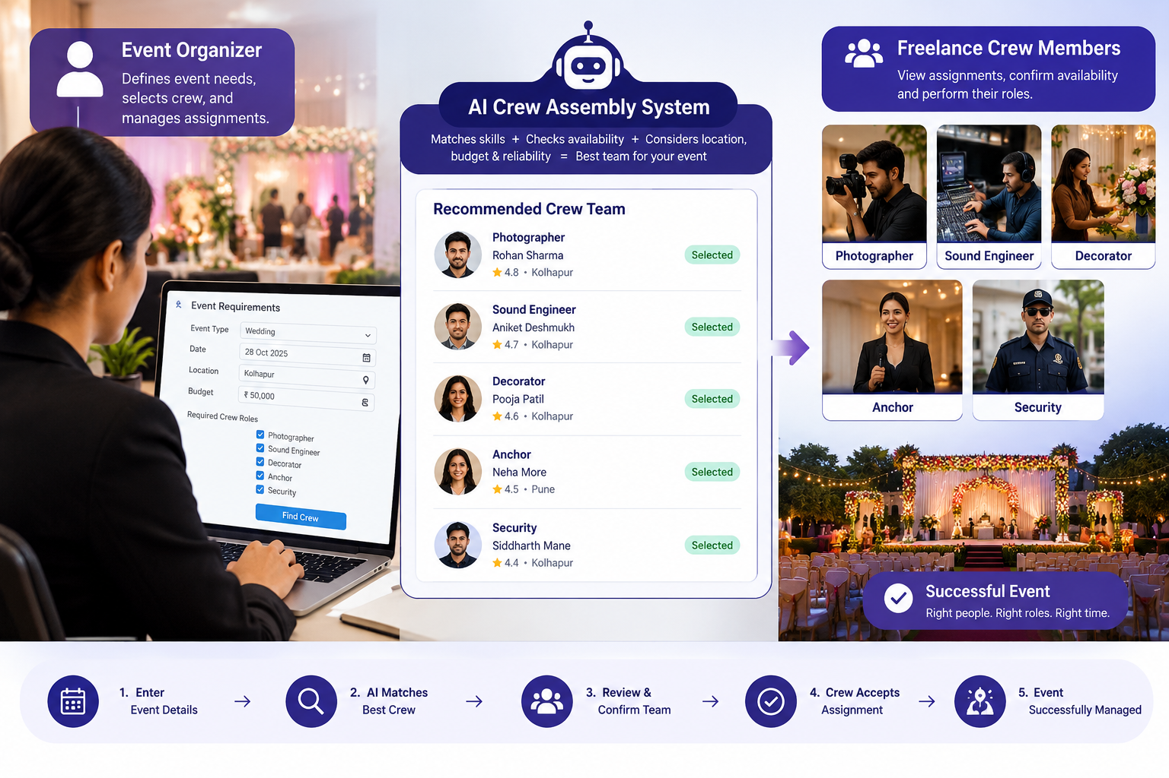

AEIOU FRAMEWORK | Group ID: | Sheet No: 2
ENVIRONMENT SHEET | Group Name: | Project Title: AI-POWERED CREW ASSEMBLY

ENVIRONMENT 1: EVENT VENUE  - Weddings, corporate functions, concerts, and other events take place here.  - Photographers, decorators, sound engineers, anchors, and security staff work together.  - Crew members must arrive on time and complete assigned responsibilities.  - Unexpected staff shortages can affect event quality and timing.  Effect:  Proper crew allocation supports smooth event execution; mismatches or no-shows may cause delays.  Precautions:  Confirm assignments in advance, share clear schedules, and maintain backup crew.  ENVIRONMENT 2: EVENT MANAGEMENT OFFICE  - Organizers plan events and identify staffing requirements.  - Skills, availability, location, and budget are reviewed before hiring.  - Communication occurs through calls, messages, spreadsheets, and online platforms.  - Manual recruitment and coordination may consume considerable time.  Effect & Precautions:  Centralized crew records and automated matching can improve planning; verify details and track confirmations.  ENVIRONMENT 3: ONLINE CREW RECRUITMENT PLATFORM  - Freelancers create profiles with skills, experience, location, rates, and availability.  - Organizers post event details and required roles.  - AI evaluates profiles, forms team combinations, and suggests ranked backups.  Effect & Precautions:  Digital matching can reduce staffing risks. Verify profiles, protect personal data, and update availability. | Scenes / Photos:  Event venue, event-planning office, or recruitment platform  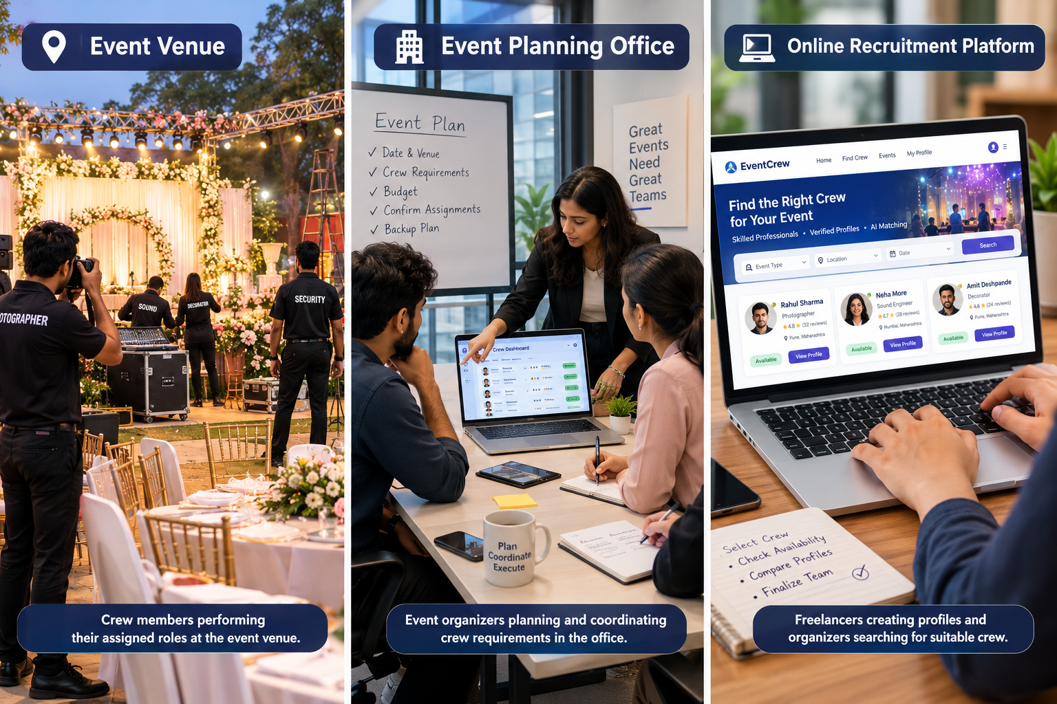
PEOPLE WHO ARE INVOLVED:  Event organizers – define staffing needs and approve assignments.  Freelance crew – photographers, decorators, sound engineers, anchors, security, etc.  Event managers – supervise preparation and execution.  Crew coordinators – manage communication, schedules, and confirmations.  AI platform – analyzes requirements and recommends team combinations.  HOW THE CONTACTS ARE IN ACTION:  Organizers enter event type, date, location, budget, and required roles.  Freelancers update profiles, skills, rates, and availability.  AI matches crew to roles and forms a team across multiple constraints.  Organizers review recommendations and confirm selected candidates.  If someone cancels, ranked backup candidates are presented.  Post-event feedback may update performance records.  AI CREW ASSEMBLY – ACTION VS. REACTION:  Enter event requirements → System identifies suitable candidates.  Update availability → Matching results refresh.  Crew member cancels → System suggests ranked backups.  Confirm assignments → Crew receives event details and schedules. | Sketch/Photo:  Organizer → AI Crew Assembly System → Freelance Crew → Event Venue  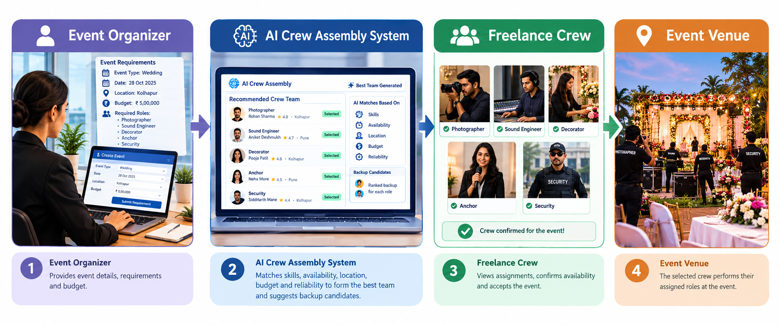
AEIOU FRAMEWORK | Group ID: | Sheet No: 3
INTERACTION SHEETS | Group Name: | Project Title: AI-POWERED CREW ASSEMBLY

AEIOU FRAMEWORK | Group ID: __________ | Sheet No: 4
OBJECT SHEET | Group Name: __________ | Project Title: AI-POWERED CREW ASSEMBLY

LIST OF COMPONENTS / OBJECTS:  Laptop or computer – access to the crew assembly platform.  Smartphone – communication, notifications, and confirmations.  Crew profile database – skills, experience, rates, availability, and reliability.  Event requirement form – event type, date, location, budget, and roles.  AI matching algorithm – evaluates candidates and assembles teams.  Calendar/scheduling tool – checks availability and conflicts.  Notification system – assignment, reminder, and cancellation alerts.  Backup crew list – alternative candidates for each role.  HOW OBJECTS RELATE TO ACTIVITIES:  Requirement form collects event details.  Crew database organizes freelancer profiles.  AI algorithm considers skill fit, proximity, availability, budget, and reliability.  Calendar helps avoid schedule conflicts.  Notifications support confirmations and updates.  Backup list supports replacement; performance records inform future matching. | Existing User Photographs / Related Images:  Laptop, smartphone, calendar, crew profile, or staffing dashboard  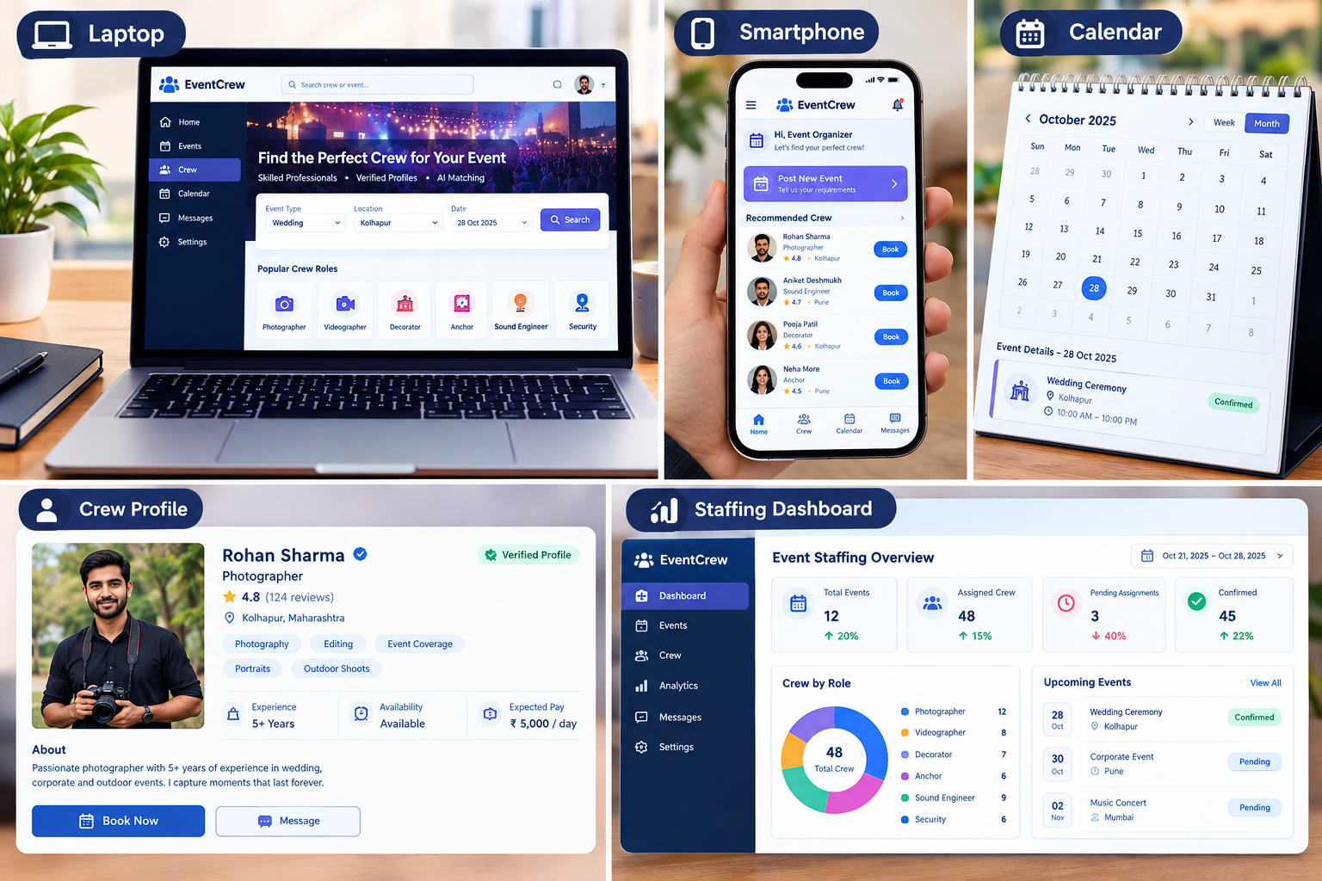

AEIOU FRAMEWORK | Group ID: | Sheet No: 5
USER SHEET | Group Name: | Project Title: AI-POWERED CREW ASSEMBLY

USERS, ROLES, RELATIONSHIPS:  Event organizers – define requirements, review recommendations, and finalize teams; coordinate with managers and freelancers.  Freelance crew members – provide skills, rates, and availability; accept assignments and perform tasks.  Event managers – supervise execution, monitor attendance, and coordinate staff.  Crew coordinators – manage schedules, communication, and confirmations.  System administrators – maintain the platform, access, and data security.  VALUES AND PREJUDICES:  Values: Reliability, fairness, efficiency, transparency, privacy, collaboration, and accountability.  New freelancers may have fewer ratings despite suitable skills.  Overemphasis on proximity may exclude qualified candidates from nearby regions.  Outdated availability or biased ratings may affect recommendations.  Precaution: Use transparent criteria, updated profiles, and human review of AI recommendations. | Existing User Photographs:  Event organizers, freelancers, event managers, or crew coordinators  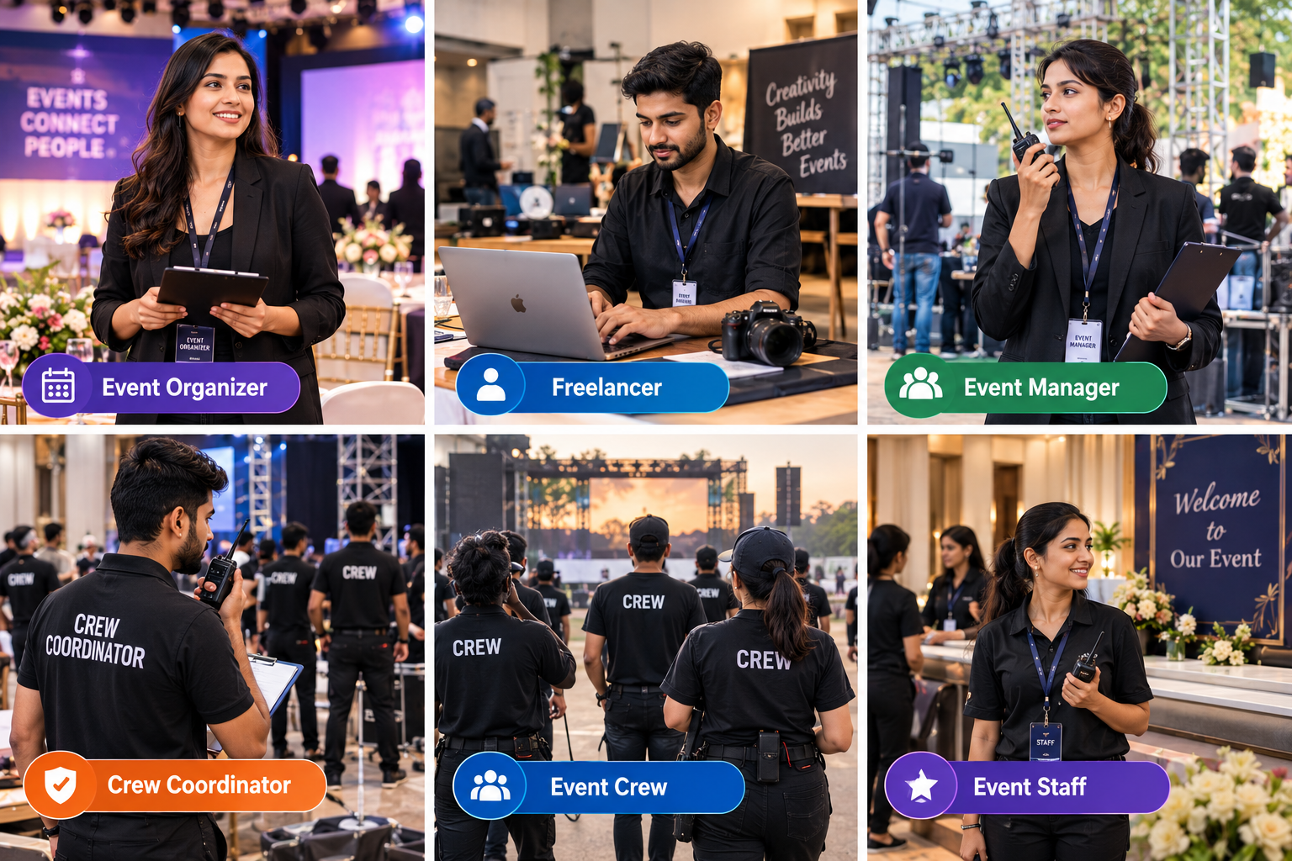

AEIOU FRAMEWORK | Group ID: | Sheet No: 6
SDLC & CONCEPTS | Group Name: | Project Title: AI-POWERED CREW ASSEMBLY

APPLICATION OF SDLC:  Requirement Analysis – identify roles, event details, budget, availability, location, and reliability needs.  System Design – plan the interface, crew database, matching workflow, and backup feature.  Implementation – develop the platform and AI-based matching/optimization logic.  Testing – test role matching, availability, budget limits, team formation, and backup suggestions.  Deployment – make the platform accessible to organizers and freelancers.  Maintenance – update profiles, improve matching, protect data, and fix issues.  CONCEPTS APPLIED:  Artificial Intelligence – analyzes event requirements and crew profiles.  Constraint Optimization – considers multiple requirements jointly, not just filter-and-sort.  Database Management – stores crew profiles, events, availability, and feedback.  Risk Management – ranked backups reduce no-show and cancellation risks.  User-Centred Design – supports organizer and freelancer needs. | Sketch/Photo:  SDLC flowchart or AI crew matching process  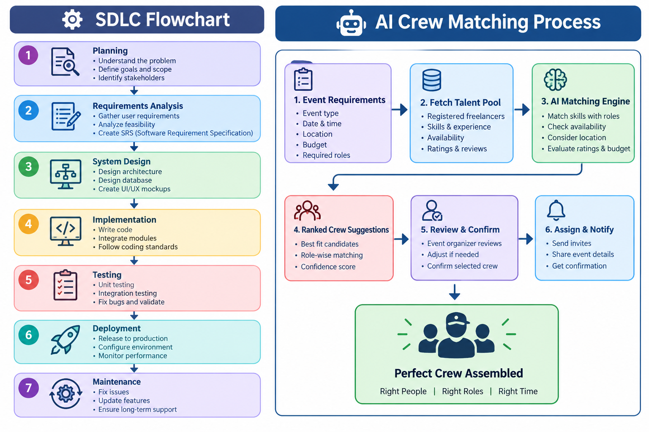

AEIOU FRAMEWORK | Group ID: | Sheet No: 7
PROBLEM STATEMENT & PARTICIPATION | Group Name: | Project Title: AI-POWERED CREW ASSEMBLY

PROBLEM STATEMENT:  Event organizers spend significant manual effort sourcing, coordinating, and retaining reliable freelance crew for weddings, corporate functions, and other events. Finding the right combination of photographers, sound engineers, decorators, anchors, security personnel, and other professionals is challenging because of differences in skills, availability, location, budget, and reliability.  Manual recruitment can lead to mismatched hires, last-minute cancellations, staffing shortages, and increased coordination costs. There is a need for an AI-powered crew assembly system that forms an optimized team based on event type, date, location, budget, and required roles. It should jointly consider skill fit, proximity, availability, budget, and reliability, and provide ranked backups for each role.  TEAM PARTICIPATION:  Member 1: Varsharani Patil – Problem identification, activity observations, SDLC concepts, and preparation of the problem statement.  Member 2: Sakshi – Environment observations, interaction/object/user analysis, documentation, and AEIOU framework preparation.  CONCLUSION:  The AEIOU Framework identified the activities, environments, interactions, objects, and users involved in event crew recruitment. It highlights the challenges of manual staffing and supports an AI-powered solution for optimized teams, improved coordination, and backup staffing. | Sketch/Photo:  Team discussion, brainstorming, or project concept sketch  

