Question 1

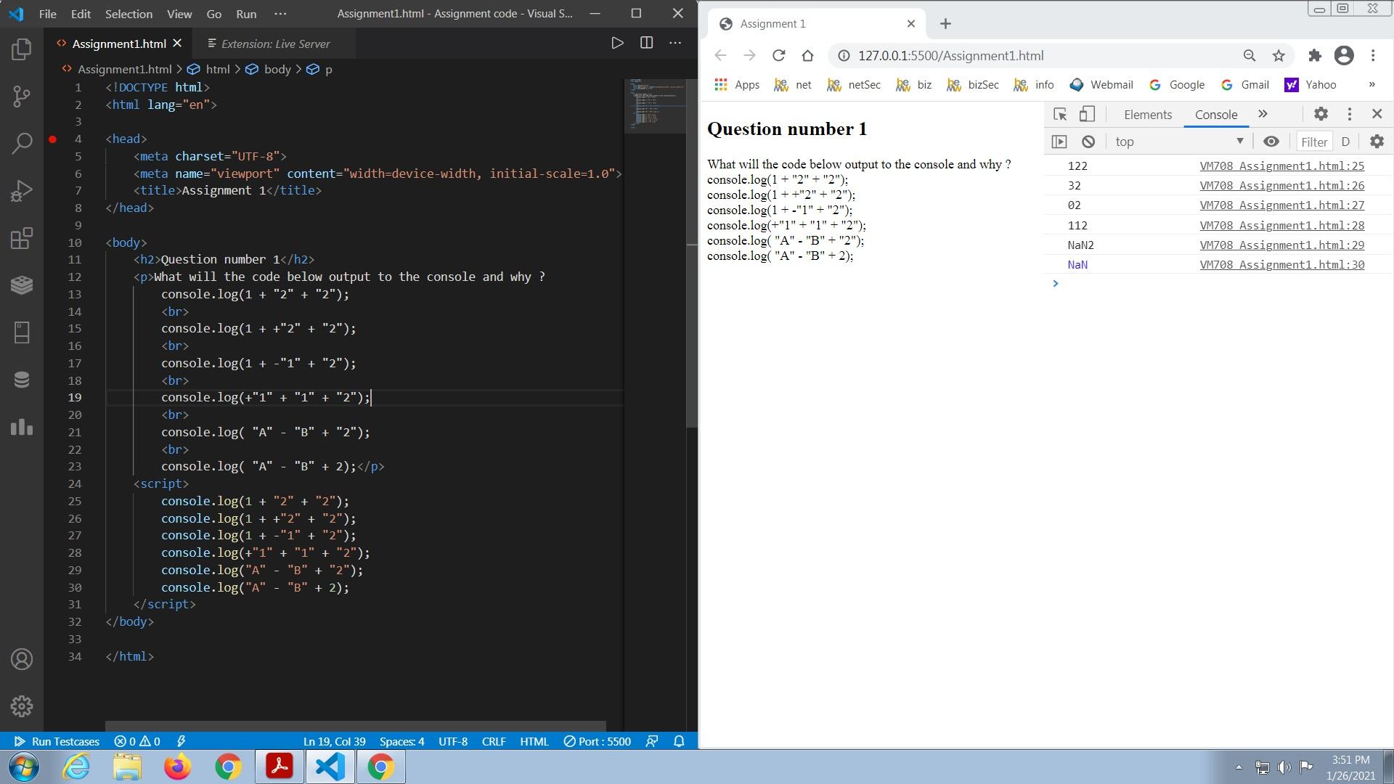

The plus(+) operator in console.log is used to combine two strings. It is called string concatenation in JavaScript.
In the first statement it combines the string 1 , 2 and 2 as + operator is used between them.So the output is 122.
In the second statement there are two + operators between them so first it adds 1 and 2 which gives 3 and them combines with the third string “2”. So the output is 32.
In the third statement there is + and - operator betwwen 1 and 1 so it first subtracts 1 and 1 which gives 0 and combines that string to the string “2” . So the output is 02.
Similarly in the fourth statement it combines the string 1 1 and 2 . So the output is 112.
In the 5th and 6th statement string A and B when subtracted gives a non numerical value which is denoted by Nan which combines with the last string . So the output is Nan2 and Nan respectively

Question 2

