Question 1:
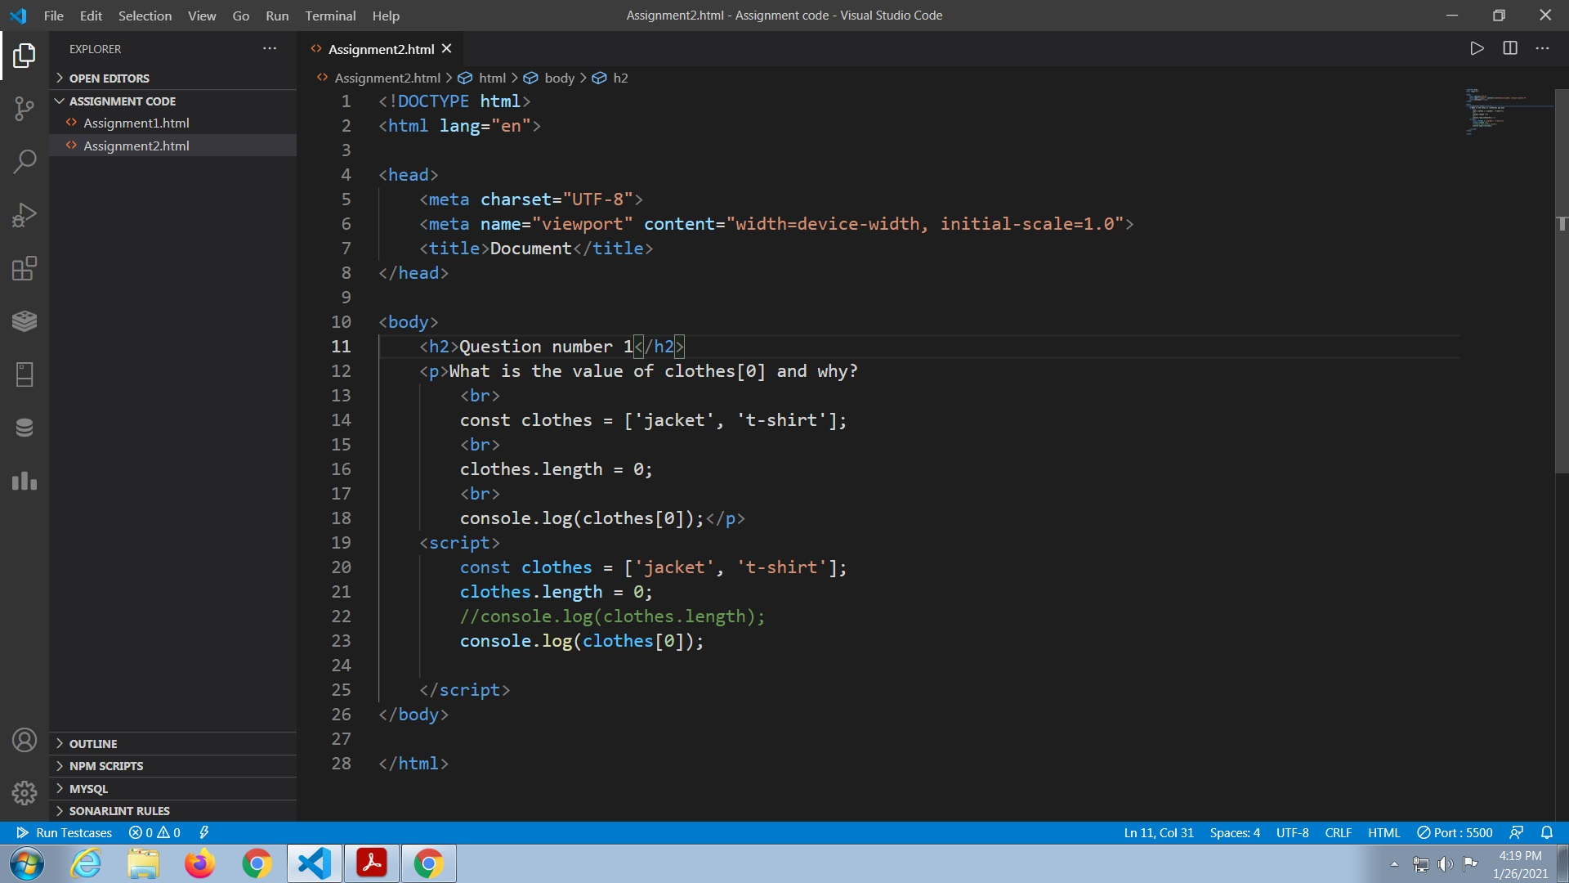
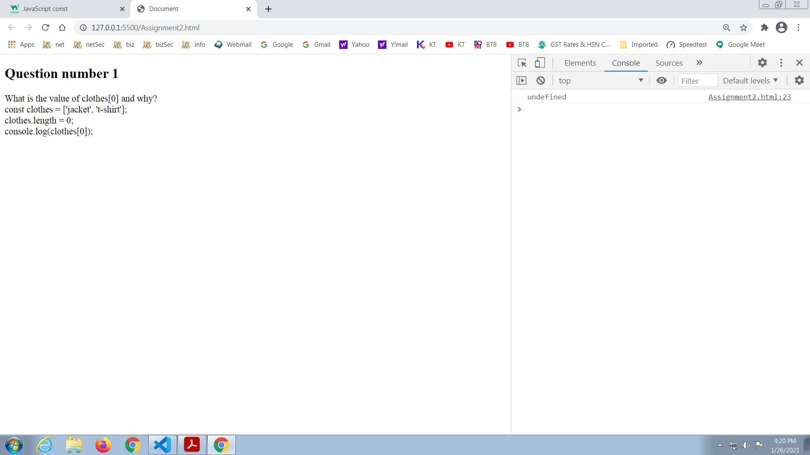
Intitially the length of the array is 2.
In the second statement the length of the array is changed to 0
Therefore in the third statement when we print the value of clothes[0] using concole.log , the output displays undefined because the now the array is of the length 0 so it does not contain any value in it.

Question 2
