**FACEBOOK DATASET OUTPUT**

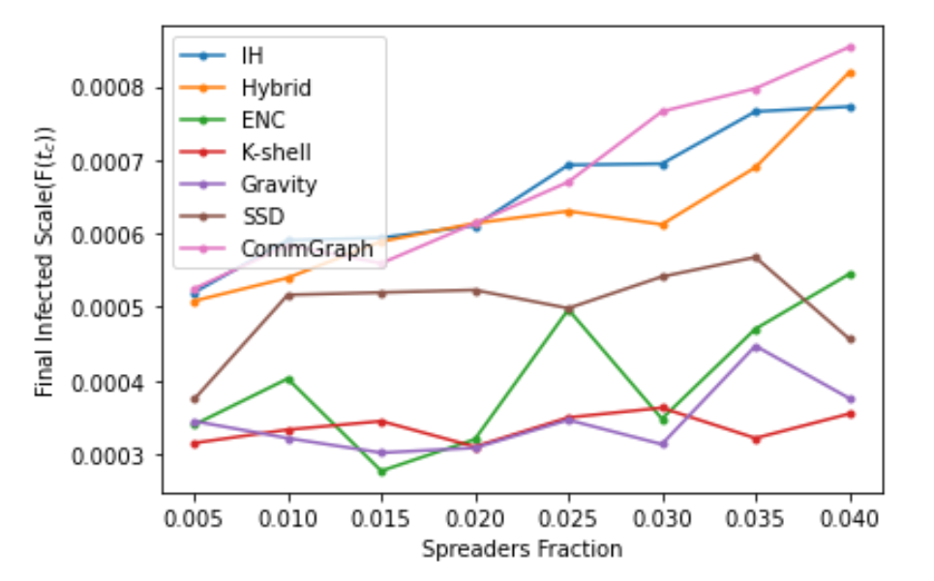

**JAZZ DATASET OUTPUT**

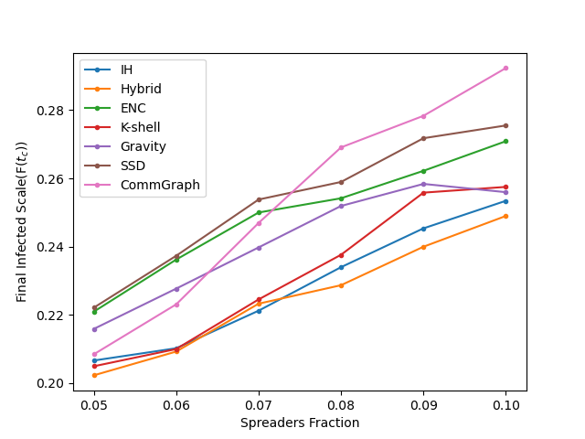

**BITCOIN DATASET OUTPUT**

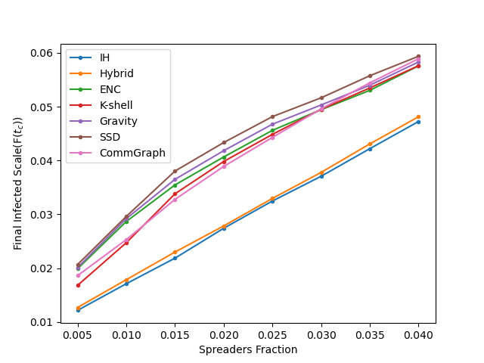

**CONDA DATASET OUTPUT**

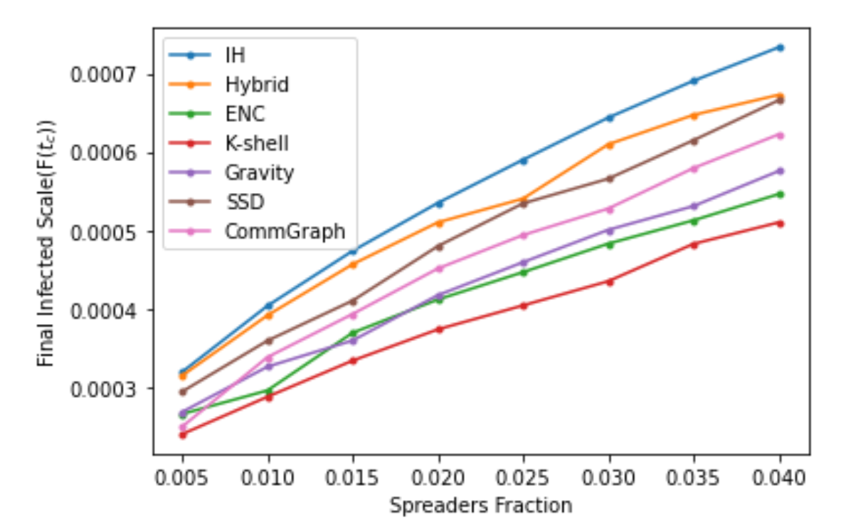

**PGP DATASET OUTPUT**

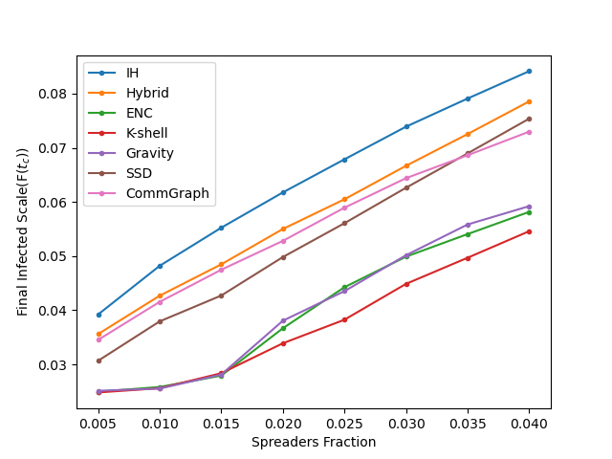

**EMAIL DATASET OUTPUT**

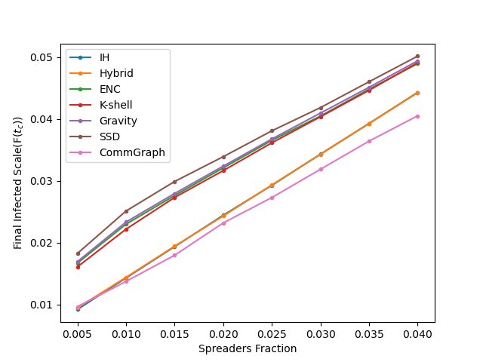

**DOLPHINS DATASET OUTPUT**

