**Q.1 What is software? What is software engineering?**

**A.1** Software is a set of instruction, data or programs used to operate computers and execute specific tasks. For example, MS-Word , MS-Excel, Power point, etc.

Software engineering is the branch of computer science that deals with the design, development, testing, and maintenance of software applications.

**Q.2 Explain types of software.**

**A.2** There are total five types of software :

1. Application software

2. System software

3. Driver software

4. Middleware

5. Programming software

**Q.3 What is SDLC? Explain each phase of SDLC**

**A.3** SDLC is software development life cycle. It is a process used by [software development](https://www.geeksforgeeks.org/software-development/?ref=lbp) organizations to plan, design, develop, test, deploy, and maintain software applications. It is used to create high-quality software.

There are five phases of SDLC :

1. Analysis and design environment

It is aligned to the planning and analysis phases of SDLC.

1. The development environment

It is (IDE) Integrated Development Environment.

1. The common build environment

It is closely aligned to the development phase of SDLC.

It gather all the details to make final application.

1. Testing environment

It evaluates application quality.

1. Production environment

In this phase, end user use a web mobile application.

**Q.4 What is DFD? Create a DFD diagram on Flipkart**

**A.4** Data Flow Diagrams (DFD) provide a graphical representation of the data flow of a system that can be understood by both technical and non-technical users.

There are three levels to complete DFD :

1. Level 0 data flow diagram

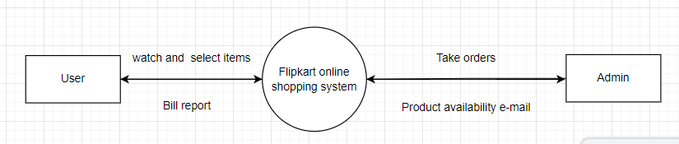

1. Level 1 data flow diagram

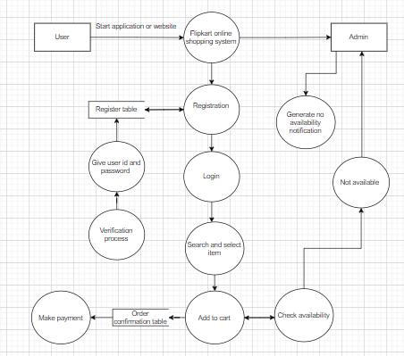

1. Level 2 data flow diagram

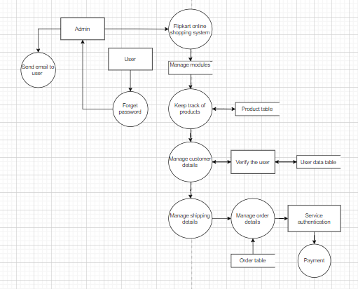

**Q.5 What is Flow chart? Create a flowchart to make addition of two numbers**

**A.5** A flowchart is a type of diagram that represents a workflow or process. A flowchart can also be defined as a diagrammatic representation of an algorithm, a step-by-step approach to solving a task. The flowchart shows the steps as boxes of various kinds, and their order by connecting the boxes with arrows.

Flowchart to make addition of two numbers

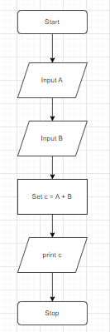

**Q.6 What is Use case Diagram? Create a use-case on bill payment on paytm.**

**A.6** A use case diagram is a graphical depiction of a user's possible interactions with a system. A use case diagram shows various use cases and different types of users the system has and will often be accompanied by other types of diagrams as well.

Use-case on bill payment on paytm:

Actors : 3

1. Visitor
2. Registered user
3. Admin
4. Service authentication

