|  |  |  |
| --- | --- | --- |
| WordPress- User Guide | December 19  2020 | |
| WordPress is an open source Content Management System (CMS), which allows the users to build dynamic websites and blog. WordPress is the most popular blogging system on the web and allows updating, customizing and managing the website from its back-end CMS and components. | | User Guide |

Contents

Table of Figures 3

Preface 4

About this Manual 4

Document Purpose 4

Audience 4

Revision History 4

Introduction to WordPress 7

Benefits 7

Login 7

The Dashboard 11

Dashboard Menu Options 11

Toolbar 13

Posts versus Pages 16

Pages 16

Edit 17

To edit the page 17

View Page 17

To preview the page on different devices and platforms 17

Copy Link 17

To copy the block link and share on various platforms 17

Set as Homepage 17

To set Blog/Page as homepage. Displayed on main dashboard 17

Trash 17

To send page to Trash. Once the trash is empty, the page is deleted 17

Posts 17

Adding your Site Content 18

Block Editor 18

Adding a New Page 18

Adding a new Post 19

Block Editor Tools 21

Block Editor Options 22

Adding Content with Blocks 23

Categories 24

Adding Categories within your post 24

Tags 25

Adding Tags within your Post 26

Appearance 26

Selecting your Theme 26

# Table of Figures

Figure 1: Login Page 8

Figure 2: Dashboard 11

Figure 3: Dashboard Menu Options 12

Figure 4: Toolbar 14

Figure 5: Pages 16

Figure 6: Posts 17

Figure 7: New Page 19

Figure 8: New Post 20

Figure 9: Block Editor Options 22

Figure 10: Adding Blocks 1st Method 23

Figure 11: Adding Blocks 2nd method 24

Figure 12: Adding Category 25

Figure 13: Adding Tags 26

Figure 14: Selection of Theme 27

# Preface

## About this Manual

This manual describes the Word Press tool and explains how to work and use its major features. It serves as a means to describe the User interface, functionalities and how to use it to accomplish the tasks.

## Document Purpose

The purpose of this document is to explain the activities involved in building the posts or websites and managing the same, to enable the users to understand and perform the tasks in an easy way.

## Audience

All the common users who develop the sites or blogs and manage the same are the intended audience.

# Revision History

|  |  |  |
| --- | --- | --- |
| Date | Author | Comments |
| December 19, 2020 | Sakshi/Shravan | Need to undergo Technical Review |
| January 19, 2021 | Sakshi/Shravan | Finalized |

**Chapter- 1**

**Introduction to Word Press**

This chapter will introduce you the purpose of this

Application…

# Introduction to WordPress

WordPress is an Open Source software system used by millions of people around the world to create beautiful websites and blogs. It is completely customizable by the use of themes and plugins.

Themes can be easily downloaded from the official WordPress site or from hundreds of other places around the web. The same goes with plugins, which are used to extend the functionality of your WordPress site.

**Objective:** The main objective of Word Press CMS tool is to build a semantically structured website or blog and manage the same efficiently.

## Benefits

* Just about anybody can learn how to use it.
* It's stable and relatively bug free.
* It has a huge range of free and premium themes which can add functionality and

style to your site.

* It has a huge selection of plugins that can add new features and tricks to your site.
* It’s no longer only for blogs.
* it’s FREE!.

# Login

Before you can make any changes to your site, you will need to log in. The login for your site is typically found at the following URL – http://your-wordpress-site.com/wp-admin. Replace “your-wordpress-site.com” with your actual domain name.

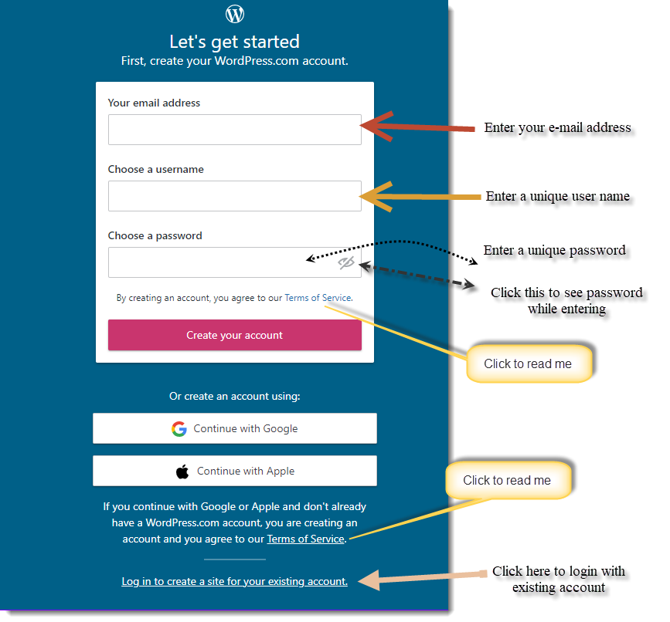

Figure : Login Page

You can create your account by using your Username, email address and a unique password. Click on the ‘eye’ icon in the Password field to reveal the password that you entered, if you’d like to make sure you typed it correctly.

Login to your Dashboard using either your Username or email address associated with your account.

First connect to your website – during installation you will have set up a username and been emailed a password which will have been auto-generated.

If you lose your credentials, click on “Lost your password?” and a new password will be generated and emailed to you with instructions on how to reset the password. You can change newly set password to something more memorable.

**Chapter- 2**

**The Dashboard**

This chapter talks about the main Dashboard with other menu options along with toolbar and managing the same…

# The Dashboard

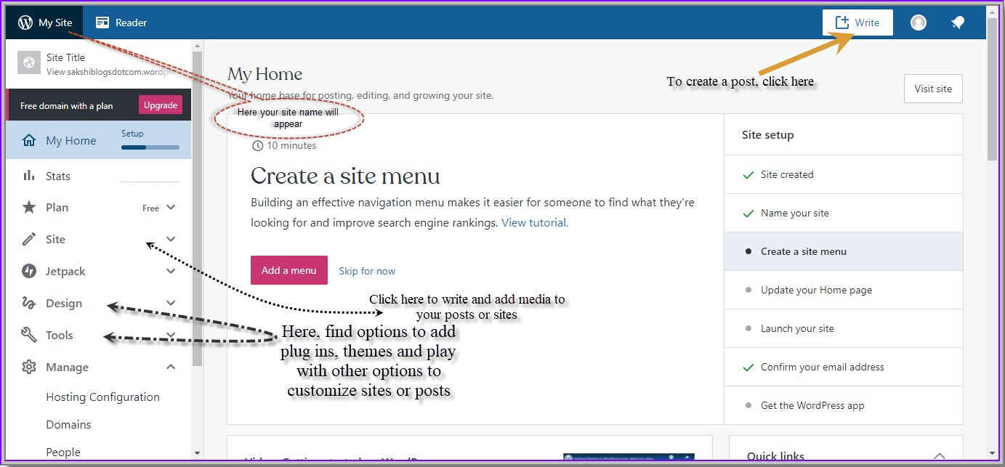

Figure : Dashboard

After you’ve logged in, you will see the Dashboard which is your administration section. In the example screenshot below (and throughout this documentation) the site name is **My Site.**

On top of the Dashboard, there is an option “Write”. On clicking this tab, you will be redirected to the blank post page, where you can write posts and share with the world.

Beside “Write” tab, there is a human icon and bell icon. Once you click this “Human icon”, a page will appear where you will see the options to update your profile, manage your account and security settings.

## Dashboard Menu Options

On the left hand side of the Dashboard and on every page you will see the main admin navigation menu. Here you’ll find all the options to update and configure the site.

Clicking the cursor on each of the main menu options will display a downward submenu with the various choices for that particular menu option.

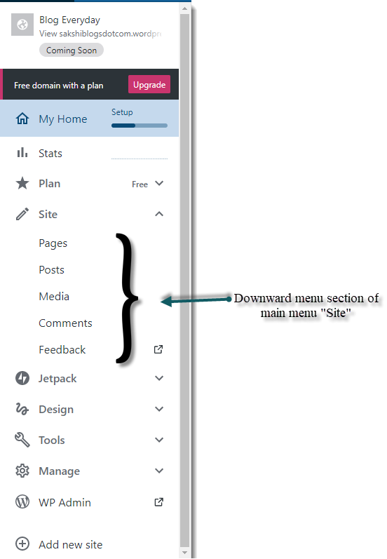

Figure : Dashboard Menu Options

The main menu options and their usage are:

**My Home**

My home is your home base for posting, editing, and growing your site. It is the administrative center of the Word Press website where you can manage the content, change the website look, add new functionality, integrate with social networks, and many more.

**Stats**

This is the page where you will see the variable numbers on views, visitors, likes and comments, followers and the activity for a day, week, months and years.

**Site**

This is where you can create pages and posts, and customize your posts through implementation of media such as, images, audios, videos and many more. Also, the number of comments and feedback from visitors can be seen here.

**Jetpack**

This is where you will see your activity history over a period of time. You can export your data and restore it to any previous state.

**Design**

This is where you will find options to customize your posts and sites using various beautiful themes.

**Tools**

Here you will find options to customize the site. Moreover, you are able to import, export and even promote your site using handpicked services and new tools.

**Manage**

This is where you can configure your site and get backup of the site. You can access database of site. You will get options to change your primary domain. Apart from this you can invite and even see your followers and visitors’ list. You will get option to customize your site address along with the option to Launch your site and share with the world.

## Toolbar

The WordPress Toolbar is a way of easily accessing some of the most common WordPress features. When you are logged into your WordPress dashboard and visit website, you will see the Toolbar running across the top of the site. This bar only appears if you are currently logged into your WordPress site, which means that it won’t be visible to your everyday site visitors. If not logged in, the Toolbar won’t be displayed.

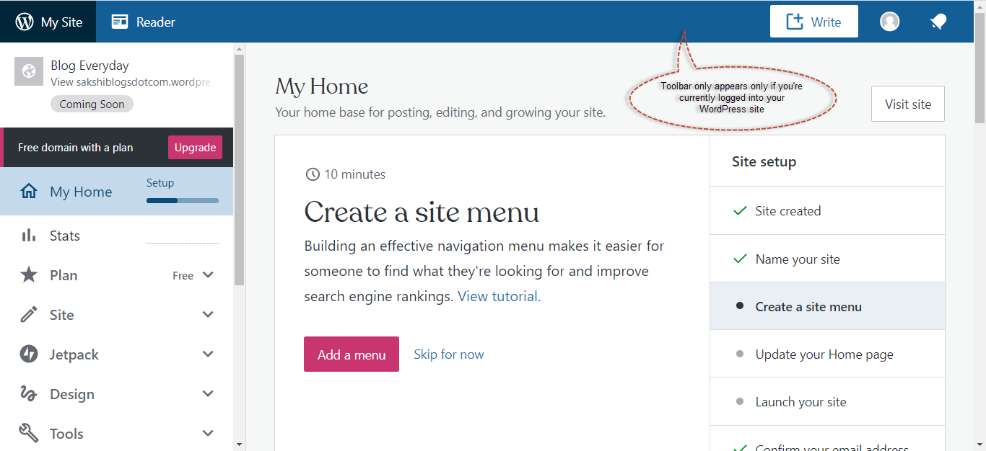

Figure : Toolbar

The Toolbar allows you to quickly access the following commonly used features

* Display site Dashboard and other commonly used menu options that allow you to update the site Themes, Widgets and Menus
* Perform a site Search
* Follow your favorite posts, sites. Like and comment on posts.
* Add tags to your sites and posts.
* Write and launch the posts or sites to share with world.
* Get notification for your posts and sites
* View or Edit your Profile and logout from the WordPress Dashboard

**Chapter- 3**

**Structuring your Website**

This chapter defines and describes the important contents of the site….

# Posts versus Pages

WordPress is built around two basic concepts. **Posts** and **Pages**. **Posts** are typically blog entries or in other words, a series of articles, **Pages** are used for more static content (i.e. content that doesn’t change or changes infrequently).

You can also use the blog concept if you have a site where you need to display your ‘latest news’ or update even just about anything. Basically, any information that gets updated on a semi-regular basis can benefit from the ‘blog’ functionality. Whether that’s a traditional blog, your company’s ‘latest news’ or even just your own personal updates.

## Pages

After clicking the Site menu, and submenu Pages you'll be shown a list of Pages that your site contains. Among the information displayed is the Page title, either the date published or the date the page was last modified. The Pages screen will look similar to screen below.

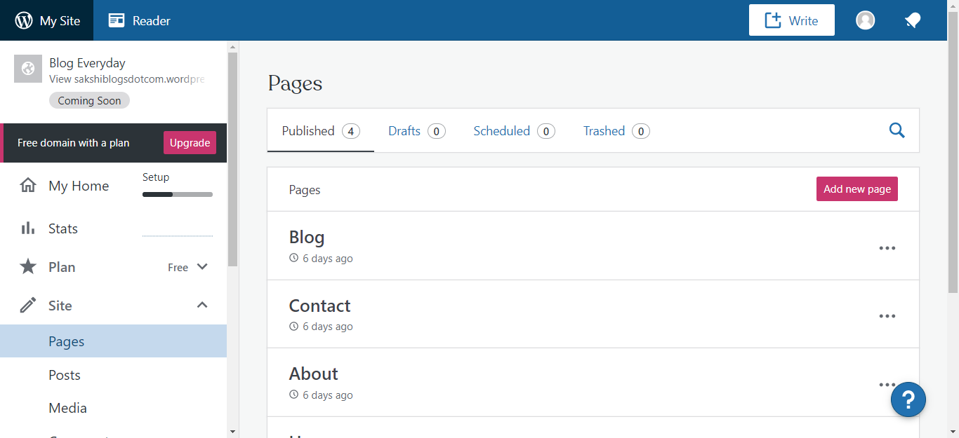

Clicking these 3 dots will show various options you can perform

Figure : Pages

At the top of the page you can view how many Pages in total you have in your site, how many have been published , in drafts, scheduled to publish or Trashed.

When clicking the 3[…] dots corresponding to each blog, below links appear:-

|  |  |
| --- | --- |
| Edit | To edit the page |
| View Page | To preview the page on different devices and platforms |
| Copy Link | To copy the block link and share on various platforms |
| Set as Homepage | To set Blog/Page as homepage. Displayed on main dashboard |
| Trash | To send page to Trash. Once the trash is empty, the page is deleted |

## Posts

After clicking on the Posts menu option you'll be shown a list of Posts that your site contains. Among the information displayed is the Post title, either the Date Published, Date Scheduled or the Date the Post was Last Modified. The Posts screen will look similar to the screen below.

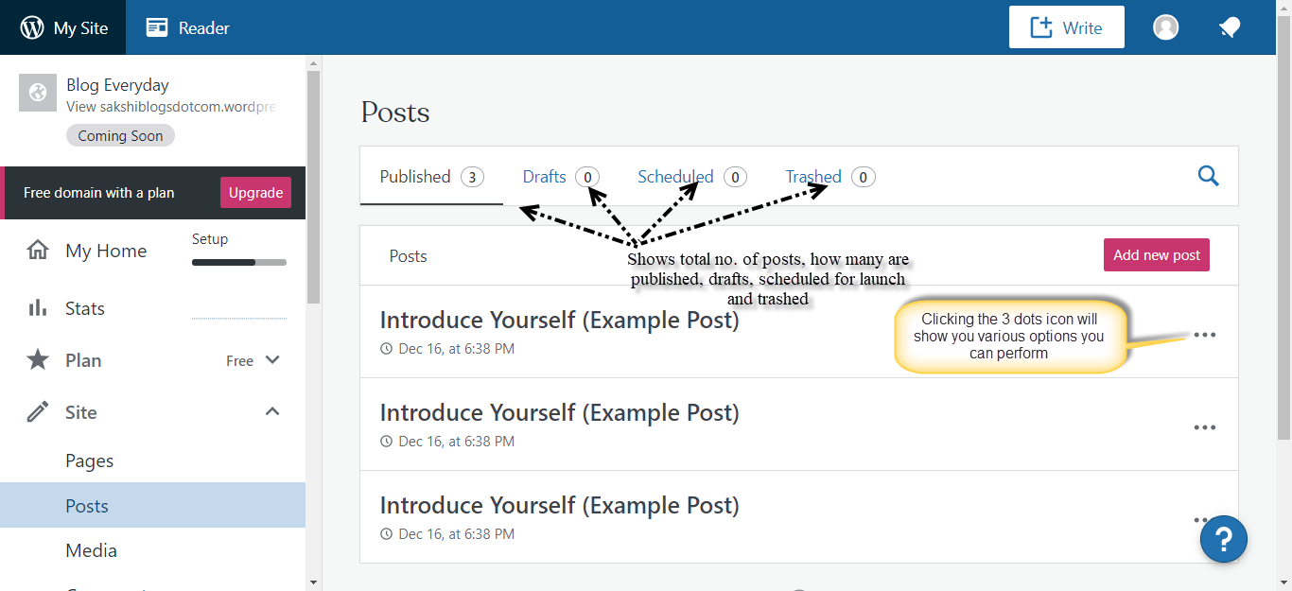

Figure : Posts

At the top of the page you can view how many Posts in total you have in your site, how many have been published, Scheduled, Pending, in Draft or in the Trash.

When clicking the 3[…] dots corresponding to each post, below links appear.

|  |  |
| --- | --- |
| Edit | To edit the Post. Same as clicking the Post Title |
| View | To preview the Post on different devices and social platforms |
| Comments | To view number of comments and perform actions viz., approve, reject, mark spam or delete the comments |
| Share | To share your Posts through connected Social media accounts using “Publicize” link |
| Trash | To send posts to Trash. Once the trash is empty, the page is deleted |

# Adding your Site Content

Adding content to your site is an easy process no matter whether you’re creating a Post or a Page. The procedure for both is almost identical. Apart from how they display on your site, which was described earlier, the other main difference is that Posts allow you to associate [Categories](https://wordpress.org/support/article/posts-categories-screen/) and [Tags](https://wordpress.org/support/article/posts-tags-screen/) whereas Pages don’t. What’s the difference between categories and tags? Normally, Tags are ad-hoc keywords that identify important information in your Post (names, subjects, etc) that may or may not recur in other Posts, while Categories are pre-determined sections. If you think of your site like a book, the Categories are like the Table of Contents and the Tags are like the terms in the index.

# Block Editor

As the name suggests, the Block Editor treats all your content as individual blocks. Each block can be inserted, rearranged and styled individually.

The Block Editor provides individual blocks for all your common content such as paragraphs, headings, ordered and unordered Lists (i.e. bullet points), quote, images, galleries and any other content. On top of that, the Block Editor also provides additional blocks for easily adding content such as buttons, tables and columns.

Rearranging your content is even easier than before. The Block Editor allows you to drag-and-drop or use the block mover icons, to rearrange the order of individual blocks. Each block can also be styled individually using the toolbar at the top of block. The types of styles that you can add to a block are dependent on the individual block.

## Adding a New Page

To add a new page, click on the submenu option “Pages” on left hand navigation menu and right hand region, click on ***Add new page*** button. You will see the page similar to the image below.

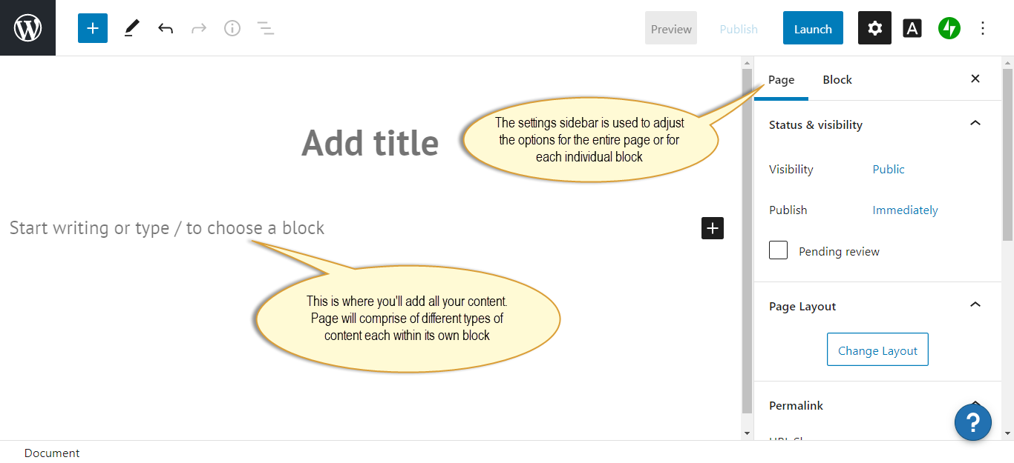

Figure : New Page

## Adding a new Post

To add a new post, click on the submenu option “Posts” on left hand navigation menu and right hand region, click on ***Add new post*** button. You will see the page similar to the image below.

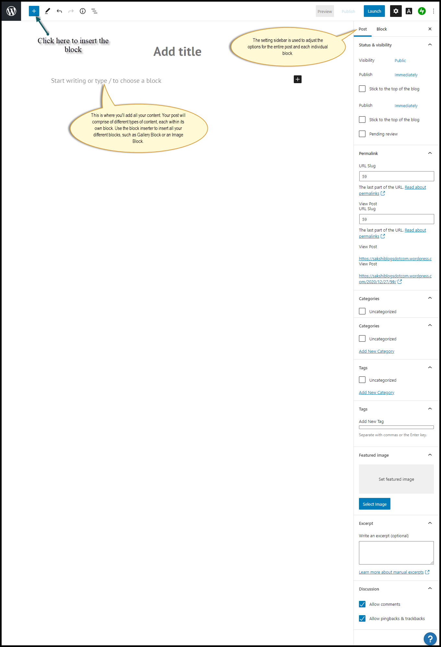

Figure : New Post

## Block Editor Tools

The Block Editor provides a completely redesigned editing experience, and along with it, a set of tools with which to edit your page. At the top of the page is the main *Block Editor Toolbar*.

 The Add Block icon is used to insert new blocks into your content. Clicking this icon will pop open a small panel that gives you access to all the different types of blocks that you can insert.

 The **Tools** button offers different interactions for block selection and editing. Use the **Select** tool to help select Blocks. Once a Block is selected, press your Enter key to return to the **Edit** tool.

 The **Undo** icon allows you to Undo your most recent change(s).

 The Redo button allows you to Redo your most recent change(s).

 The **Content Structure** button provides information about your page content. It will show you how many Words, characters, Headings, Paragraphs and Blocks your content contains along with showing the document structure and providing links to each of the headings in your content.

 The **Block Navigation** button shows a list of all the blocks in your content and provides a quick link to each of them.

 The **Switch to Draft** button only appears after your Page/Post is published. Clicking this button will unpublish your Page/Post and put it back in Draft mode.

 The **Preview** button will allow you to preview your page. The preview page will open a new browser tab/window.

 On clicking this, you can publish your Page/Post. Now, you can publish your Page/Post in two steps. After clicking the Publish button, new panel will be displayed with confirmation message and another Publish button. This panel allows to set visibility of the content and publish on specific date and time.

 This setting sidebar shows all the settings for your Page/Post including elements like adding Featured Images, specifying your Categories and Tags on Posts, or selecting Page/Post templates. Clicking the Settings icon will show and hide the settings sidebar.

## Block Editor Options

To customize the Block Editor there are several options available. These options will be displayed under the Options icon in the top-right corner of the page ( ) when editing a Page or Post.

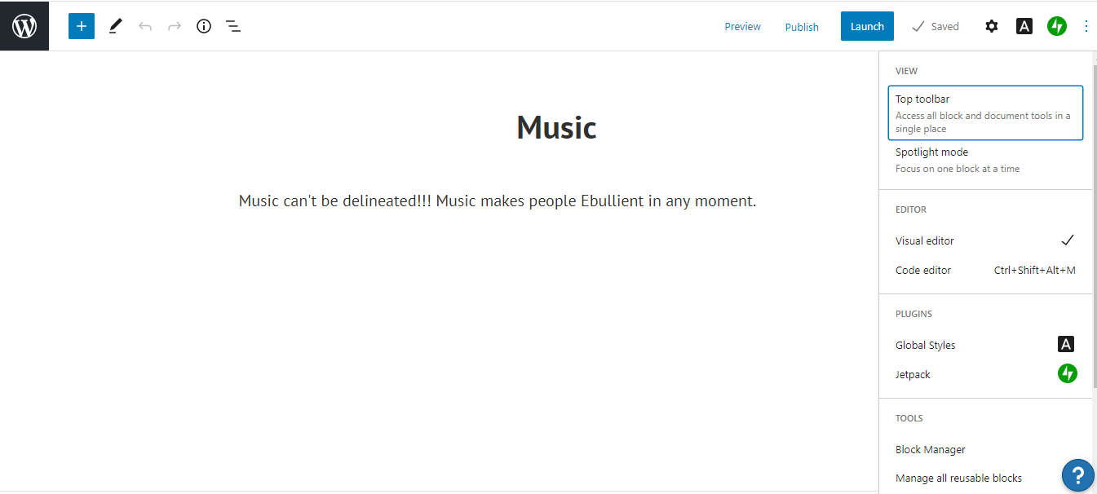

Clicking on Options icon on top right corner of the screen will display a menu with more editor options

Figure : Block Editor Options

The *Options* menu has the following options:

* **Top Toolbar-** Enabling this option will display the Block Toolbar at the top of

the page, rather than just above each individual block.

* **Spotlight Mode-** Enabling this option will dim all the blocks on the page except for the currently selected block, making it easier to focus on just that block.
* **Visual Editor-** This option is enabled by default and will show your content as individual blocks.
* **Code Editor-** - Enabling this option will turn off the Visual Editor and instead, display the html that makes up your content.
* **Block Manager-** This option allows you to disable individual blocks or entire block panels. This stops them from being displayed within the Block Inserter.
* **Manage All Reusable Blocks-** Clicking this option will exit you from the editor and present you with a list of all your Reusable blocks, which you can then Edit, Delete or Export to a file (which can then be imported to another site is so desired).
* **Keyboard Shortcuts-** Clicking this displays a list of the keyboard shortcuts that are available within the Block Editor.
* **Welcome Guide-** Displays a very short slideshow explaining about Block Editor.
* **Copy all Content-** This option allows you to copy all the content within the current Page or Post, to your clipboard.
* **Help-** The Help option provides a link to some external pages that give a detailed explanation of how to use the Block Editor.

## Adding Content with Blocks

Using the new Block Editor, your page content is made up of blocks of various types. The Block Editor provides blocks for all common content such as paragraphs, headings, ordered and unordered Lists (i.e. bullet points), quotes, images, galleries and any other content.

There are several ways to insert blocks into your content. The easiest way is to click the Add block icon () in the Block Toolbar at the top of screen. Clicking this icon will show the Block Inserter panel that gives access to all the different types of blocks that you can insert. Simply scroll through the list and click on the type of block that you'd like to insert.

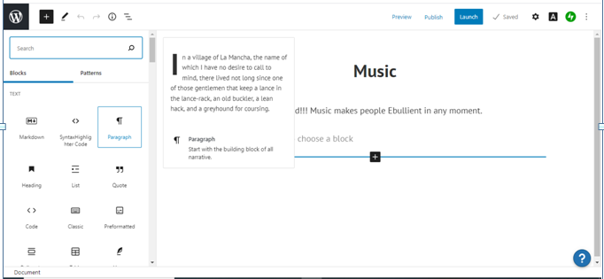

Click here to find all the different blocks to add to your content

Figure : Adding Blocks 1st Method

There is one more option to add different blocks whereby clicking the Add block icon ( ) that appears at the top of each individual block. This Add Block icon appears at the top of each block when you move cursor over the top border of each block. Clicking this icon will show a Block Inserter popup, which is a small panel that gives access to all the different types of blocks that you can insert. By default, it only shows six recent blocks. To view all the available blocks, click the Browse all button in the popup to show the Block Inserter panel.

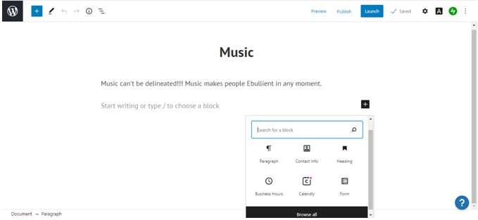

Click here to find all the different blocks to add to your content

Figure : Adding Blocks 2nd method

# Categories

Categories are used to define sections of the site and group related posts. The default category is Uncategorized but this can be easily changed in your Settings. Posts allow you to associate categories whereas pages don’t. To know more about categories, click **Categories** under “Adding your site content”.

## Adding Categories within your post

If you would like to create a new Category and assign it to the Post at the same time, follow the steps

1. Click  then click the **Add New Category** link.
2. Two fields appear, type the name in *New Category Name* text fields.
3. Add the *Parent category* by selecting one (Optional)
4. Click *Add New category* button.

New Category name will automatically be assigned to the post.

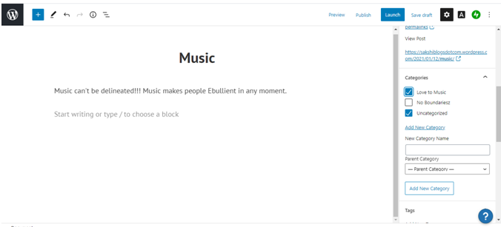

To add a new Category, click Add New Category link and type in the category name. Select Parent Category from the list, if appropriate. Click the Add New Category button to assign it to the post.

To add an existing category, tick the checkbox(es) next to the appropriate ones to assign them to the Post.

Figure : Adding Category

# Tags

Tags are ad-hoc keywords that identify important information in the post (names, subjects, etc) that may or may not recur in other posts. Unlike Categories, Tags have no hierarchy so there is no Parent->Child relationship like that of Categories. But like Categories, Tag names must be unique.

In two ways, Tags can be added:

* Whilst adding or editing the Post
* added via the Tags menu option.

Adding Tags whilst editing your Post, will automatically assign those Tags to the Post. Adding Tags using the Tags menu option will simply add them to the list of available Tags. For more information on Tags, Click **Tags** linkunder “Adding your Site Content”.

## Adding Tags within your Post

If you would like to add Tags to the post, follow the following steps

1. click  then click Tags.
2. write the Tag or Tags (separated with commas) into the Add New Tag field.
3. click the small ‘x’ next to the individual tag to remove it, if made mistake while entering the tag

Tags will automatically be assigned to the post.

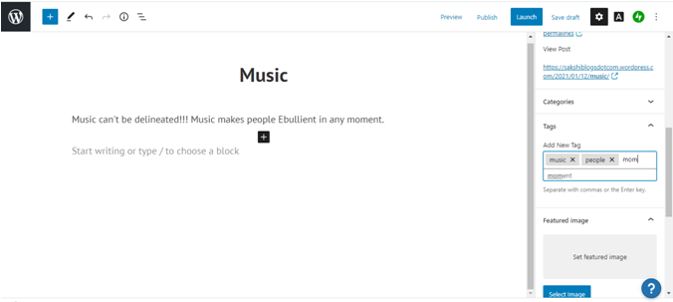

When you start typing the tags, existing or used tags will be displayed. Click anyone of the Tags to select them.

To add a new Tag, type Tag name into edit field. Hit the comma key to enter multiple tags. To remove a tag, click the ‘x’ next to the tag.

Figure : Adding Tags

# Appearance

The various Appearance menus allow you to change how your site looks and behaves.

## Selecting your Theme

The overall appearance of a WordPress site is controlled by the Theme. Clicking on the *Themes* menu option will land you at the Themes screen. The theme that is currently active is shown at the top bar of the screen above all themes. The other themes shown are ones that are installed, but not currently in use.

To see Preview of your site in another theme (that isn’t currently active), follow the steps:

1. Click () button associated with each theme.
2. Click on *Live Demo* button to view the Preview of the site
3. In Preview window, click on *Activate* button on top right corner of the window to activate the theme

To view more details about a particular theme, hover the cursor over a theme thumbnail image and click on *Info*. A pop-up window will appear that displays a larger image along with the theme description and other details.

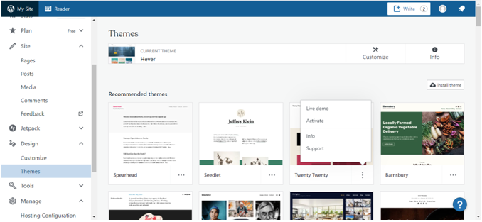

You can select options to Preview, activate or see the details of the theme

Currently active theme

Figure : Selection of Theme

.