Internship Report
On
Data Analytics Internship at Link In Blink

Submitted To
School of Computer Science and Engineering
IILM University, Greater Noida, U.P.
In partial fulfilment of the requirement of degree of
B.Tech CSE

By
Roll Number of Student: CS-23411589
Name of Student: SAKSHI KUMARI
Batch: 2026-27

CANDIDATE'S DECLARATION
I, Sakshi Kumari, do hereby declare that the internship report titled “Data Analytics Internship at Link In Blink” has been completed by me to fulfil the requirement for the award of the degree of Bachelor of Technology in Computer Science and Engineering. All the references have been quoted and I have not taken as such any material from any other source. I affirm that this report is my own work and has not been submitted to any other institute for any degree/diploma requirement, and I shall be solely responsible for any kind of copyright violation in this regard.
Signature
Student Name: Sakshi Kumari
Roll No.: CS-23411589

ACKNOWLEDGEMENT
I am using this opportunity to express my gratitude to everyone who supported me throughout my internship at Link In Blink (HM ESCAN Pvt. Ltd.). I am thankful for their aspiring guidance, invaluably constructive criticism and friendly advice during this work. I am sincerely grateful to Ms. Harshala Mali, HR Manager, and the entire team at Link In Blink for sharing their truthful and illuminating views on a number of issues related to this internship, and for the opportunity to work as a Data Analyst Intern.
I express my gratitude to my parents for their blessings, and to the faculty of the School of Computer Science and Engineering, IILM University, for their continuous support and encouragement.
Signature
Student Name: Sakshi Kumari
Roll No.: CS-23411589

INTERNSHIP COMPLETION CERTIFICATE
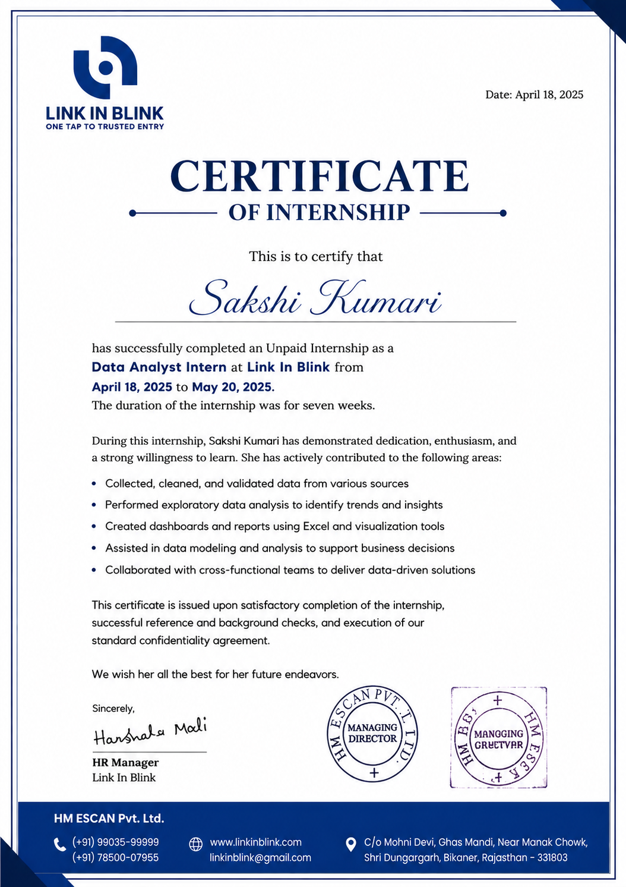

PROJECT DESCRIPTION

4.1 Introduction
This report presents an account of the internship undertaken at Link In Blink, a security-technology and visitor-management platform operated by HM ESCAN Pvt. Ltd., under the brand tagline “One Tap to Trusted Entry.” The internship was completed as part of the Data Analyst Intern role, and it provided an opportunity to apply classroom knowledge of data collection, data cleaning, exploratory data analysis and dashboarding to real business problems.
The internship was carried out over a period of seven weeks, from April 18, 2025 to May 20, 2025, on an unpaid basis, and involved close collaboration with cross-functional teams to deliver data-driven solutions in support of the organization's operational and business goals.

4.2 Organization Profile
Link In Blink, operated by HM ESCAN Pvt. Ltd., is a technology company focused on secure and seamless visitor and entry management solutions, enabling trusted, tap-based access control for organizations. The company is headquartered in Bikaner, Rajasthan, and can be reached through its official website, www.linkinblink.com.

4.3 Problem Statement
Organizations that rely on manual or fragmented processes for tracking visitor entry, business data and operational records face challenges in maintaining accuracy, consistency and timely insight. There was a need to collect, clean and analyze data from multiple sources, and to translate that data into clear dashboards and reports that could support faster, better-informed business decisions.

4.4 Project Objectives
- To collect, clean and validate data from various sources.
- To perform exploratory data analysis (EDA) in order to identify trends and insights.
- To create dashboards and reports using Excel and visualization tools.
- To assist in data modeling and analysis to support business decisions.
- To collaborate with cross-functional teams to deliver data-driven solutions.

4.5 Scope of the Project
The scope of the internship covered end-to-end handling of business data, including sourcing and validating raw data, performing exploratory analysis, and presenting findings through dashboards and summary reports for use by internal stakeholders. The work supported operational decision-making within the organization's data analytics function.

4.6 Technologies and Tools Used
- Microsoft Excel – for data cleaning, analysis and dashboard creation.
- Data visualization tools – for presenting trends and insights.
- Standard data collection and validation techniques for ensuring data quality.

4.7 System Architecture
At a high level, the data workflow followed a structured pipeline: data was first collected from relevant sources, then cleaned and validated to remove inconsistencies, followed by exploratory analysis to surface patterns and trends. The processed data was then organized into dashboards and reports, which were shared with cross-functional teams to support downstream decision-making.

4.8 Methodology
The internship followed an iterative approach: data collection and validation, exploratory data analysis, dashboard and report creation, and review with the team. Regular feedback from the HR Manager and other team members was incorporated to refine the analysis and ensure the outputs remained aligned with business needs.

4.9 Expected Outcomes
By the end of the internship, the intern was expected to have gained practical experience in data collection, cleaning, exploratory analysis, dashboard creation and cross-functional collaboration, along with a working understanding of how data analytics supports real business decisions in an organizational setting.

4.10 Certificate of Completion
A copy of the Internship Completion Certificate issued by Link In Blink (HM ESCAN Pvt. Ltd.), confirming successful completion of the internship, is attached in the preceding section of this report (Internship Completion Certificate).

BIBLIOGRAPHY / REFERENCES
1. Link In Blink – Official Website. Available at: www.linkinblink.com
2. Internship Completion Certificate, issued by HM ESCAN Pvt. Ltd. (Link In Blink), dated April 18, 2025.

