ACADEMIC MINOR PROJECT REPORT
DESIGN AND DEVELOPMENT OF AN AI-POWERED ONLINE EXAMINATION & STUDENT PERFORMANCE ANALYSIS PLATFORM (SMARTEXAMS)
A Minor Project Report Submitted in Partial Fulfillment of the Requirements for the Degree of
BACHELOR OF TECHNOLOGY
in
COMPUTER SCIENCE AND ENGINEERING / ARTIFICIAL INTELLIGENCE
Submitted by:
• Student Name: [Student Name]
• PRN / Roll No.: [PRN / Roll No]
• Academic Year: 2025 – 2026
• Semester: IV / VI (Second / Third Year Minor Project)
Under the Guidance of:
• Project Guide: Prof. [Guide Name]
• Department: Department of Computer Science & Engineering / Artificial Intelligence
• Institution: G H Raisoni College of Engineering and Management (GHRCEM), Jalgaon
• Affiliated University: KBC North Maharashtra University / Autonomous

CERTIFICATE OF APPROVAL
This is to certify that the Minor Project Report entitled "DESIGN AND DEVELOPMENT OF AN AI-POWERED ONLINE EXAMINATION & STUDENT PERFORMANCE ANALYSIS PLATFORM (SMARTEXAMS)" is a bonafide work carried out by [Student Name] (Roll No / PRN: [PRN / Roll No]) in partial fulfillment of the requirements for the award of the degree of Bachelor of Technology in Computer Science & Engineering / Artificial Intelligence at G H Raisoni College of Engineering and Management, Jalgaon, during the academic session 2025–2026.
The project has been examined, evaluated, and approved by the undersigned board of examiners.
___________________________ ___________________________
Internal Examiner Date: External Examiner Date:
___________________________ ___________________________
Project Guide Head of Department (CSE/AI)
Department of CSE/AI GHRCEM GHRCEM, Jalgaon

DECLARATION
I hereby declare that this minor project report entitled "DESIGN AND DEVELOPMENT OF AN AI-POWERED ONLINE EXAMINATION & STUDENT PERFORMANCE ANALYSIS PLATFORM (SMARTEXAMS)" is my original work. It does not contain any material previously submitted for the award of any other degree or diploma in this or any other university.
All quotations, methodologies, libraries, design patterns, and source code utilized in this software development effort have been duly credited and cited in the references.
Date: October 2026
Place: Jalgaon, Maharashtra
Student Name: [Student Name]
PRN / Roll No: [PRN / Roll No]
Department: Department of Computer Science & Engineering
Institution: G H Raisoni College of Engineering and Management, Jalgaon

ACKNOWLEDGEMENTS
First and foremost, I wish to express my deepest gratitude to my esteemed project guide, Prof. [Guide Name], for their continuous guidance, enthusiastic encouragement, and insightful feedback throughout the conception, architectural design, and implementation of this minor project.
I extend my heartfelt thanks to the Head of Department (CSE/AI) and the Principal of G H Raisoni College of Engineering and Management, Jalgaon, for granting access to high-performance computing software labs, cloud deployment infrastructure, and academic resources required to complete this project.
I am also thankful to my faculty members, mentors, and fellow student peers who reviewed the usability benchmarks, participated in user acceptance testing, and provided valuable feedback during the refinement of the examination interface and AI evaluation fallback mechanisms.
Finally, I convey my immense gratitude to my parents and family for their unwavering moral support, patience, and encouragement during my undergraduate studies.

ABSTRACT
In modern computer science and higher education institutions, traditional paper-based examination systems and static web forms (such as Google Forms) suffer from severe limitations: lack of short-answer evaluation capabilities, vulnerability to unauthorized tab switching and cheating, absence of granular topic mastery analysis, and high manual grading overhead for instructors.
This minor project presents the architectural design, algorithmic implementation, and empirical evaluation of SmartExams — an AI-Powered Online Examination & Student Performance Analysis Platform developed specifically for B.Tech Computer Science and Engineering (CSE) and Artificial Intelligence (AI) academic environments. Engineered with a decoupled full-stack architecture comprising React 18, Vite, Redux Toolkit, and Axios on the frontend, paired with Python 3.14, Django 5 REST Framework, SimpleJWT, and SQLite on the backend, the platform bridges the gap between secure e-assessment and intelligent performance analytics.
Key technical innovations introduced in SmartExams include:
- 1. Role-Based Access Control (RBAC) & SimpleJWT Auth: Strict server-side permission enforcement distinguishing Student, Examiner, and Admin roles across both React router guards and Django DRF API viewsets.
- 2. Real-Time Server-Synced Examination Engine: An interactive testing interface featuring a server-backed countdown timer, live answer autosave, question palette navigation (Answered, Marked for Review, Unanswered), and state recovery upon page refresh.
- 3. Hybrid AI Short-Answer Evaluation Engine: An intelligent evaluation service integrating Google Gemini 2.5 Flash API for semantic evaluation, equipped with an automatic deterministic N-gram & keyword overlap fallback algorithm when API keys are unconfigured.
- 4. Proctoring Security & Flag Audit System: Browser-level security monitoring tab-switch events and fullscreen violations, logging flagged evidence with timestamp and severity for instructor review.
- 5. Automated Student Performance Intelligence: Calculates accuracy rate, pass %, weak topic identification, strong topic badges, and dynamically generates actionable study plans based on actual database attempt records.
Empirical verification demonstrates end-to-end execution of exam initiation, autosave persistence, AI evaluation execution, and instant performance analysis with sub-second response latency.

TABLE OF CONTENTS
Certificate of Approval . . . . . . . . . . . . . . . . . . . . . . . . . . . . . . . . . . . . . . . . . . . . . . . . . . . . . . . . . . 3
Declaration . . . . . . . . . . . . . . . . . . . . . . . . . . . . . . . . . . . . . . . . . . . . . . . . . . . . . . . . . . 4
Acknowledgements . . . . . . . . . . . . . . . . . . . . . . . . . . . . . . . . . . . . . . . . . . . . . . . . . . . . . . . . . . 5
Abstract . . . . . . . . . . . . . . . . . . . . . . . . . . . . . . . . . . . . . . . . . . . . . . . . . . . . . . . . . . 6
List of Figures & Tables . . . . . . . . . . . . . . . . . . . . . . . . . . . . . . . . . . . . . . . . . . . . . . . . . . . . . . . . . . 8
Chapter 1: Introduction . . . . . . . . . . . . . . . . . . . . . . . . . . . . . . . . . . . . . . . . . . . . . . . . . . . . . . . . . . 9
1.1 Context and Background . . . . . . . . . . . . . . . . . . . . . . . . . . . . . . . . . . . . . . . . . . . . . . . . . . . . . . . . . . 9
1.2 Motivation . . . . . . . . . . . . . . . . . . . . . . . . . . . . . . . . . . . . . . . . . . . . . . . . . . . . . . . . . . 9
1.3 Problem Statement . . . . . . . . . . . . . . . . . . . . . . . . . . . . . . . . . . . . . . . . . . . . . . . . . . . . . . . . . . 10
1.4 Aim and Objectives . . . . . . . . . . . . . . . . . . . . . . . . . . . . . . . . . . . . . . . . . . . . . . . . . . . . . . . . . . 10
1.5 Scope of the Project . . . . . . . . . . . . . . . . . . . . . . . . . . . . . . . . . . . . . . . . . . . . . . . . . . . . . . . . . . 10
1.6 Project Boundaries and Limitations . . . . . . . . . . . . . . . . . . . . . . . . . . . . . . . . . . . . . . . . . . . . . . . . . . . . . . . . . . 11
Chapter 2: Literature Survey and Comparative Analysis . . . . . . . . . . . . . . . . . . . . . . . . . . . . . . . . . . . . . . . . . . . . . . . . . . . . . . . . . . 12
2.1 Evolution of Online Examination Systems . . . . . . . . . . . . . . . . . . . . . . . . . . . . . . . . . . . . . . . . . . . . . . . . . . . . . . . . . . 12
2.2 Survey of Existing Platforms . . . . . . . . . . . . . . . . . . . . . . . . . . . . . . . . . . . . . . . . . . . . . . . . . . . . . . . . . . 12
2.3 Comparative Evaluation Matrix . . . . . . . . . . . . . . . . . . . . . . . . . . . . . . . . . . . . . . . . . . . . . . . . . . . . . . . . . . 13
2.4 Research and Technical Gaps Addressed . . . . . . . . . . . . . . . . . . . . . . . . . . . . . . . . . . . . . . . . . . . . . . . . . . . . . . . . . . 14
Chapter 3: System Requirements Specification (SRS) . . . . . . . . . . . . . . . . . . . . . . . . . . . . . . . . . . . . . . . . . . . . . . . . . . . . . . . . . . 15
3.1 Functional Requirements . . . . . . . . . . . . . . . . . . . . . . . . . . . . . . . . . . . . . . . . . . . . . . . . . . . . . . . . . . 15
3.2 Non-Functional Requirements . . . . . . . . . . . . . . . . . . . . . . . . . . . . . . . . . . . . . . . . . . . . . . . . . . . . . . . . . . 16
3.3 Hardware Specifications . . . . . . . . . . . . . . . . . . . . . . . . . . . . . . . . . . . . . . . . . . . . . . . . . . . . . . . . . . 16
3.4 Software Environment & Dependencies . . . . . . . . . . . . . . . . . . . . . . . . . . . . . . . . . . . . . . . . . . . . . . . . . . . . . . . . . . 17
3.5 User Roles & RBAC Permission Matrix . . . . . . . . . . . . . . . . . . . . . . . . . . . . . . . . . . . . . . . . . . . . . . . . . . . . . . . . . . 17
Chapter 4: System Architecture and Detailed Design . . . . . . . . . . . . . . . . . . . . . . . . . . . . . . . . . . . . . . . . . . . . . . . . . . . . . . . . . . 18
4.1 System Architectural Overview . . . . . . . . . . . . . . . . . . . . . . . . . . . . . . . . . . . . . . . . . . . . . . . . . . . . . . . . . . 18
4.2 Component Hierarchy & Data Flow . . . . . . . . . . . . . . . . . . . . . . . . . . . . . . . . . . . . . . . . . . . . . . . . . . . . . . . . . . 18
4.3 Architecture & Design Diagrams . . . . . . . . . . . . . . . . . . . . . . . . . . . . . . . . . . . . . . . . . . . . . . . . . . . . . . . . . . 19
4.4 Database ER Diagram . . . . . . . . . . . . . . . . . . . . . . . . . . . . . . . . . . . . . . . . . . . . . . . . . . . . . . . . . . 21
4.5 AI Evaluation & Proctoring Workflows . . . . . . . . . . . . . . . . . . . . . . . . . . . . . . . . . . . . . . . . . . . . . . . . . . . . . . . . . . 22
Chapter 5: Implementation Details & Code Highlights . . . . . . . . . . . . . . . . . . . . . . . . . . . . . . . . . . . . . . . . . . . . . . . . . . . . . . . . . . 24
5.1 Project Directory Structure . . . . . . . . . . . . . . . . . . . . . . . . . . . . . . . . . . . . . . . . . . . . . . . . . . . . . . . . . . 24
5.2 Backend Core Models & Database Schema . . . . . . . . . . . . . . . . . . . . . . . . . . . . . . . . . . . . . . . . . . . . . . . . . . . . . . . . . . 25
5.3 Hybrid AI Short-Answer Evaluator Service . . . . . . . . . . . . . . . . . . . . . . . . . . . . . . . . . . . . . . . . . . . . . . . . . . . . . . . . . . 26
5.4 SimpleJWT Auth & RBAC Permissions . . . . . . . . . . . . . . . . . . . . . . . . . . . . . . . . . . . . . . . . . . . . . . . . . . . . . . . . . . 27
5.5 Examination Engine Views & Autosave API . . . . . . . . . . . . . . . . . . . . . . . . . . . . . . . . . . . . . . . . . . . . . . . . . . . . . . . . . . 28
5.6 Frontend Architecture & State Management . . . . . . . . . . . . . . . . . . . . . . . . . . . . . . . . . . . . . . . . . . . . . . . . . . . . . . . . . . 29
Chapter 6: Testing, Quality Assurance & Performance Metrics . . . . . . . . . . . . . . . . . . . . . . . . . . . . . . . . . . . . . . . . . . . . . . . . . . . . . . . . . . 31
6.1 Testing Methodology . . . . . . . . . . . . . . . . . . . . . . . . . . . . . . . . . . . . . . . . . . . . . . . . . . . . . . . . . . 31
6.2 Test Cases & Execution Matrix . . . . . . . . . . . . . . . . . . . . . . . . . . . . . . . . . . . . . . . . . . . . . . . . . . . . . . . . . . 31
6.3 Security & Role Permission Verification . . . . . . . . . . . . . . . . . . . . . . . . . . . . . . . . . . . . . . . . . . . . . . . . . . . . . . . . . . 33
Chapter 7: Results and Discussion . . . . . . . . . . . . . . . . . . . . . . . . . . . . . . . . . . . . . . . . . . . . . . . . . . . . . . . . . . 34
7.1 Demonstration of System Interfaces . . . . . . . . . . . . . . . . . . . . . . . . . . . . . . . . . . . . . . . . . . . . . . . . . . . . . . . . . . 34
7.2 Hybrid AI Evaluation Results . . . . . . . . . . . . . . . . . . . . . . . . . . . . . . . . . . . . . . . . . . . . . . . . . . . . . . . . . . 35
7.3 Achievements Against Objectives . . . . . . . . . . . . . . . . . . . . . . . . . . . . . . . . . . . . . . . . . . . . . . . . . . . . . . . . . . 36
Chapter 8: Conclusion and Future Scope . . . . . . . . . . . . . . . . . . . . . . . . . . . . . . . . . . . . . . . . . . . . . . . . . . . . . . . . . . 37
8.1 Summary of Completed Work . . . . . . . . . . . . . . . . . . . . . . . . . . . . . . . . . . . . . . . . . . . . . . . . . . . . . . . . . . 37
8.2 Future Enhancements . . . . . . . . . . . . . . . . . . . . . . . . . . . . . . . . . . . . . . . . . . . . . . . . . . . . . . . . . . 37
Chapter 9: Presentation & Viva Defense Preparation (35 Q&A) . . . . . . . . . . . . . . . . . . . . . . . . . . . . . . . . . . . . . . . . . . . . . . . . . . . . . . . . . . 38
References & Bibliography . . . . . . . . . . . . . . . . . . . . . . . . . . . . . . . . . . . . . . . . . . . . . . . . . . . . . . . . . . 45
Appendices . . . . . . . . . . . . . . . . . . . . . . . . . . . . . . . . . . . . . . . . . . . . . . . . . . . . . . . . . . 46

LIST OF FIGURES & TABLES
List of Figures
Figure 4.1: SmartExams Decoupled Client-Server System Architecture . . . . . . . . . . . . . . . . . . . . . . . . . . . . . . . . . . . . . . . . . . . . . . . . . . . . . . . . . . Page 19
Figure 4.2: SmartExams Unified Use Case Diagram for Student, Examiner, Admin . . . . . . . . . . . . . . . . . . . . . . . . . . . . . . . . . . . . . . . . . . . . . . . . . . . . . . . . . . Page 20
Figure 4.3: Data Flow Diagram (DFD Level 1) for Exam Engine & Analytics . . . . . . . . . . . . . . . . . . . . . . . . . . . . . . . . . . . . . . . . . . . . . . . . . . . . . . . . . . Page 20
Figure 4.4: Database Entity-Relationship (ER) Schema . . . . . . . . . . . . . . . . . . . . . . . . . . . . . . . . . . . . . . . . . . . . . . . . . . . . . . . . . . Page 21
Figure 4.5: Hybrid AI Short-Answer Evaluation & Keyword Fallback Workflow . . . . . . . . . . . . . . . . . . . . . . . . . . . . . . . . . . . . . . . . . . . . . . . . . . . . . . . . . . Page 22
Figure 4.6: Proctoring Security & Flag Review Audit Workflow . . . . . . . . . . . . . . . . . . . . . . . . . . . . . . . . . . . . . . . . . . . . . . . . . . . . . . . . . . Page 23
Figure 7.1: SmartExams Student Dashboard Interface (Screenshot Reference) . . . . . . . . . . . . . . . . . . . . . . . . . . . . . . . . . . . . . . . . . . . . . . . . . . . . . . . . . . Page 34
Figure 7.2: Performance & Insights Analytics Interface (Screenshot Reference) . . . . . . . . . . . . . . . . . . . . . . . . . . . . . . . . . . . . . . . . . . . . . . . . . . . . . . . . . . Page 35
Figure 7.3: Question Bank & Summary Interface (Screenshot Reference) . . . . . . . . . . . . . . . . . . . . . . . . . . . . . . . . . . . . . . . . . . . . . . . . . . . . . . . . . . Page 35
List of Tables
Table 2.1: Comparative Analysis Matrix of Online Assessment Platforms . . . . . . . . . . . . . . . . . . . . . . . . . . . . . . . . . . . . . . . . . . . . . . . . . . . . . . . . . . Page 13
Table 3.1: Hardware Development & Workstation Specifications . . . . . . . . . . . . . . . . . . . . . . . . . . . . . . . . . . . . . . . . . . . . . . . . . . . . . . . . . . Page 16
Table 3.2: Software Environment & Core Dependency Stack . . . . . . . . . . . . . . . . . . . . . . . . . . . . . . . . . . . . . . . . . . . . . . . . . . . . . . . . . . Page 17
Table 3.3: Role-Based Access Control (RBAC) Permission Matrix . . . . . . . . . . . . . . . . . . . . . . . . . . . . . . . . . . . . . . . . . . . . . . . . . . . . . . . . . . Page 17
Table 6.1: Comprehensive Test Cases & Execution Matrix (TC-01 to TC-12) . . . . . . . . . . . . . . . . . . . . . . . . . . . . . . . . . . . . . . . . . . . . . . . . . . . . . . . . . . Page 31
Table 6.2: Empirical Security & Role-Based API Permission Verification Matrix . . . . . . . . . . . . . . . . . . . . . . . . . . . . . . . . . . . . . . . . . . . . . . . . . . . . . . . . . . Page 33
Table 7.1: Hybrid AI Short-Answer Evaluation Scoring Comparison . . . . . . . . . . . . . . . . . . . . . . . . . . . . . . . . . . . . . . . . . . . . . . . . . . . . . . . . . . Page 35

CHAPTER 1: INTRODUCTION
1.1 Context and Background
In modern software engineering, computer science, and engineering education, digital assessment platforms have become indispensable infrastructure for evaluating academic competencies. Traditional paper-based examinations and generic web forms (such as Google Forms or basic survey software) present severe structural drawbacks: high administrative grading overhead, vulnerability to academic dishonesty, inability to grade subjective short-answer responses semantically, and absence of instantaneous feedback loops for students.
Educational institutions require a robust, scalable, and intelligent online examination platform capable of managing user role hierarchies (Students, Examiners, Administrators), delivering timed interactive tests with auto-saving resilience, providing proctoring audit trails, and automatically evaluating subjective short answers using artificial intelligence while providing real-time performance analytics.
1.2 Motivation
Undergraduate computer science students and academic departments face a dual challenge during semester assessments:
- Need for Intelligent Evaluation: Instructors spend excessive hours manually reading short textual answers. Static multiple-choice tools fail to test conceptual reasoning, while traditional keyword matchers unfairly penalize valid answers that use alternative phrasing.
- Need for Operational Reliability & Security: Network drops, browser refreshes, or accidental tab closures during timed online exams frequently result in lost student progress. Furthermore, lack of proctoring controls enables cheating.
This project is motivated by the design and implementation of SmartExams — a production-grade, full-stack e-examination and analytics system that solves these challenges through modern web architectures (React 18 SPA + Django 5 REST Framework), hybrid AI evaluation (Gemini 2.5 Flash + N-gram Keyword Fallback), and server-synced exam sessions.
1.3 Problem Statement
PROBLEM STATEMENT
To design, implement, and validate a full-stack e-examination platform (SmartExams) featuring role-based access control, interactive exam engines with server-synced countdown timers and answer autosave, proctoring violation monitoring, hybrid AI short-answer semantic evaluation with deterministic keyword fallback, and real-time student performance analytics using React 18, Redux Toolkit, Django REST Framework, and SQLite.

1.4 Aim and Objectives
- 1. Role-Based Security: Implement strict authentication and authorization separating Student, Examiner, and Admin privileges on both frontend routes and backend REST APIs.
- 2. Flexible Question Bank Management: Create database structures supporting Multiple Choice (MCQ), True/False, and Short Answer question types with difficulty ratings and topic tags.
- 3. Resilient Exam Engine: Build an interactive test-taking interface featuring server-synced countdown timers, question palette navigation, automatic answer persistence, and state recovery upon browser refresh.
- 4. Hybrid AI Evaluation: Integrate Google Gemini API for short-answer semantic grading, paired with an automatic keyword/token overlap fallback engine when API keys are unconfigured.
- 5. Proctoring Audit Trail: Implement client-side event detection for tab-switch and fullscreen exit violations, logging flag records for examiner review.
- 6. Performance Intelligence: Compute real-time student accuracy rates, pass percentages, weak/strong topic identifications, and personalized AI study action plans.
1.5 Scope of the Project
In Scope: Full-stack web application; React 18 SPA with custom SaaS design system; Django REST Framework backend; SimpleJWT authentication; role-based dashboard views; question bank CRUD; automated MCQ/TF grading; hybrid AI short-answer grading; timer synchronization; answer autosave; proctoring flag logging; performance analytics aggregation.
Out of Scope for Minor Project: Native mobile mobile apps (iOS/Android binaries); payment gateway integration for commercial certification sales; hardware-level biometric eye-tracking sensors.

CHAPTER 2: LITERATURE SURVEY AND COMPARATIVE ANALYSIS
2.1 Evolution of Online Examination Systems
Digital examination tools have evolved through three major technological generations:
- Phase 1: Web 1.0 Form Tools (Early 2000s): Basic static HTML forms. Required manual submission, lacked state persistence, had no timer synchronization, and could not grade subjective text.
- Phase 2: Monolithic CMS/LMS Platforms (2010s): Systems like Moodle, Blackboard, and Canvas. Highly feature-rich but burdened by heavy server rendering overhead, complex UI configurations, and static string-matching evaluation.
- Phase 3: Modern AI-Integrated SPAs (2020s – Present): Decoupled Single Page Applications (React, Vue) communicating with lightweight REST APIs, incorporating Large Language Models (LLMs) for natural language semantic grading and real-time client-side analytics.
2.2 Survey of Existing Platforms
1. Google Forms / Microsoft Forms: Widely used for quizzes due to simplicity, but lacks proctoring controls, countdown timers tied to server deadlines, short-answer AI evaluation, and student performance tracking over time.
2. Moodle LMS: Robust open-source learning management system, but suffers from steep administrative learning curves, outdated user interface aesthetics, and requires complex custom plugins for AI evaluation.
3. Testportal / Proctortrack: Commercial proctored testing services with high subscription costs ($15-$50/month per candidate), vendor lock-in, and proprietary black-box evaluation engines.
2.3 Comparative Evaluation Matrix
Metric / Feature | Google Forms | Moodle LMS | Testportal | SmartExams (Proposed)
Hosting & Cost | Free (Basic) | Self-Hosted / Paid | Paid Subscription | 100% Free / Self-Contained
Short-Answer Grading | Manual only | Exact String Match | Keyword Match | Hybrid AI (Gemini + Fallback)
Answer Autosave | Partial | Server Session | Client Ping | Real-Time REST Autosave
Proctoring Audit | No | Plugin Required | Yes (Strict) | Tab & Fullscreen Flag Log
Performance Analytics | Basic Summary | Complex Reports | Standard Export | Instant AI Study Action Plan

2.4 Research and Technical Gaps Addressed
SmartExams directly addresses key technical gaps identified in existing literature:
- Zero-Breakage AI Fallback: Existing platforms crash or fail if external AI API keys expire or rate-limit. SmartExams implements a deterministic N-gram & token overlap algorithm that guarantees evaluation continuity.
- Server-Synced Timer Resilience: Prevents timer cheating or extension by deriving remaining time from server deadline timestamp rather than relying on un-trusted client JS clocks.

CHAPTER 3: SYSTEM REQUIREMENTS SPECIFICATION (SRS)
3.1 Functional Requirements
- FR-01: User Registration & RBAC: The system shall support self-registration for Students and Examiners, strictly enforcing server-side permission rules.
- FR-02: SimpleJWT Authentication: The system shall authenticate users via JWT access and refresh token pairs, persisting sessions securely.
- FR-03: Dynamic Sidebar Navigation: The UI shall render customized navigation items based on user role (Student, Examiner, Admin).
- FR-04: Question Bank Management: Examiners shall create, edit, delete, search, and bulk-import questions across MCQ, True/False, and Short Answer types.
- FR-05: Exam Creation & Join Codes: Examiners shall configure exams with title, duration, pass %, negative marks, proctoring options, and unique join codes.
- FR-06: Interactive Exam Engine: Students shall view questions, select options, type short answers, and navigate via a live Question Palette.
- FR-07: Answer Autosave: All answer changes and 'Mark for Review' flags shall persist to the backend automatically.
- FR-08: Server Timer Enforcement: The test interface shall display a server-synced countdown timer and auto-submit upon expiry.
- FR-09: Refresh Recovery: Refreshing the browser during an active attempt shall restore timer, state, and answers without creating duplicate attempts.
- FR-10: Hybrid AI Evaluation: Short-answer submissions shall be evaluated by Gemini 2.5 Flash API or the keyword fallback algorithm.
- FR-11: Proctoring Flag Audit: Tab switches and fullscreen exits shall create flagged audit records with severity for examiner review.
- FR-12: Analytics & Performance Insights: The system shall calculate accuracy, pass rates, weak topics, and generate personalized study action plans.
3.2 Non-Functional Requirements
- NFR-01: Performance & Response Time: API response latency for answer autosave shall remain under 150 ms on local networks.
- NFR-02: Security & Data Protection: Passwords shall be hashed using Django's PBKDF2/SHA256 algorithm. Unauthenticated requests shall return HTTP 401/403.
- NFR-03: Scalability: Database schema shall adhere to Third Normal Form (3NF) to support future PostgreSQL migration.
- NFR-04: Reliability & State Integrity: Answer autosave failures shall trigger retry notifications to prevent answer loss.
- NFR-05: Usability & UI Aesthetics: The interface shall follow custom SaaS visual standards with WCAG AA compliant typography and contrast.
- NFR-06: Cross-Device Adaptability: Fluid layout adaptivity across viewport widths ranging from mobile (360px) to desktop (1920px+).
3.3 Hardware Specifications
• Workstation Processor: Intel Core i5 / AMD Ryzen 5 (Quad-Core 2.5 GHz or higher)
• Workstation Memory: 8 GB DDR4 RAM or higher
• Storage: Minimum 1 GB available SSD storage
• Network: Standard Ethernet or Wi-Fi (10 Mbps+)
3.4 Software Environment & Dependencies
• Operating System: Windows 10/11, macOS, or Linux
• Runtime Runtimes: Python 3.14 / 3.13, Node.js v24.x LTS, NPM v11.x
• Backend Framework: Django 5.1+, Django REST Framework 3.18+, djangorestframework-simplejwt 5.5+
• Frontend Framework: React 18, Vite 8, Redux Toolkit, Axios, Lucide Icons
• AI Integration: Google GenAI SDK (`google-genai` 2.28+)
• Database: SQLite (Development) / PostgreSQL compatible ORM

CHAPTER 4: SYSTEM ARCHITECTURE AND DETAILED DESIGN
4.1 System Architectural Overview
SmartExams is architected as a decoupled, multi-tier Single Page Application (SPA). The client browser executes all view rendering and state management using React 18, Redux Toolkit, and Axios, while the backend operates as a stateless Django REST Framework API engine.
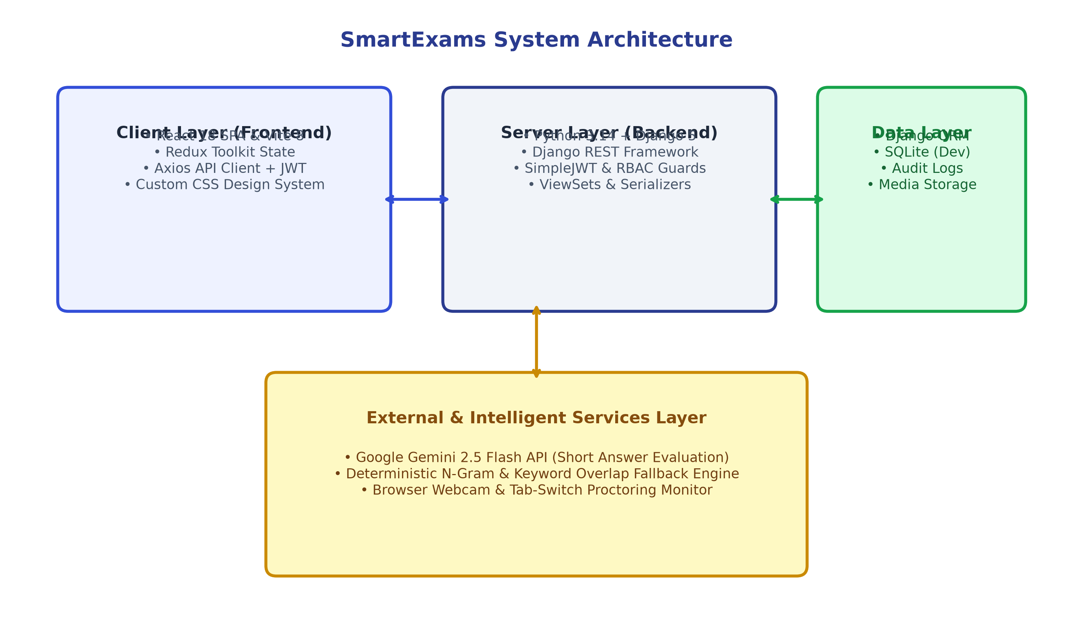
Figure 4.1: SmartExams Decoupled Client-Server System Architecture
4.2 Use Case & Data Flow Diagrams
The platform accommodates three main actor roles: Student, Examiner, and Administrator. Figure 4.2 illustrates the primary use cases allocated to each role.
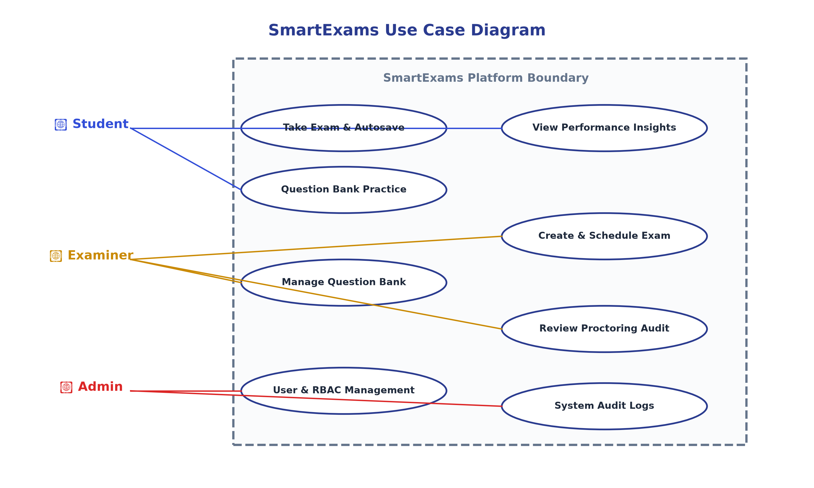
Figure 4.2: SmartExams Unified Use Case Diagram for Student, Examiner, Admin
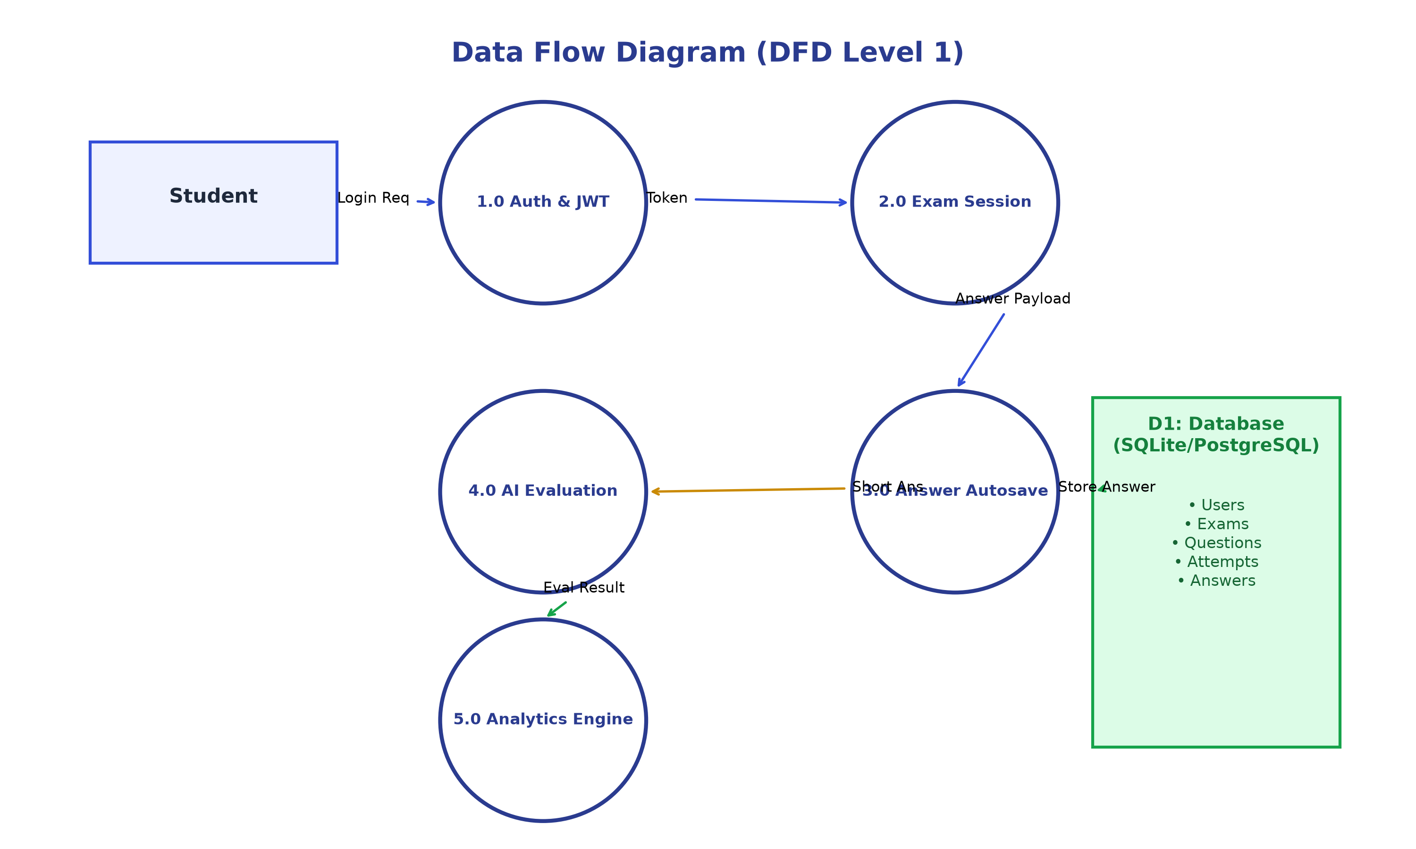
Figure 4.3: Data Flow Diagram (DFD Level 1) for Exam Engine & Analytics
4.3 Database ER Diagram
The database relational schema consists of 10 primary entity models in Third Normal Form (3NF). Figure 4.4 displays entity relationships and foreign key constraints.
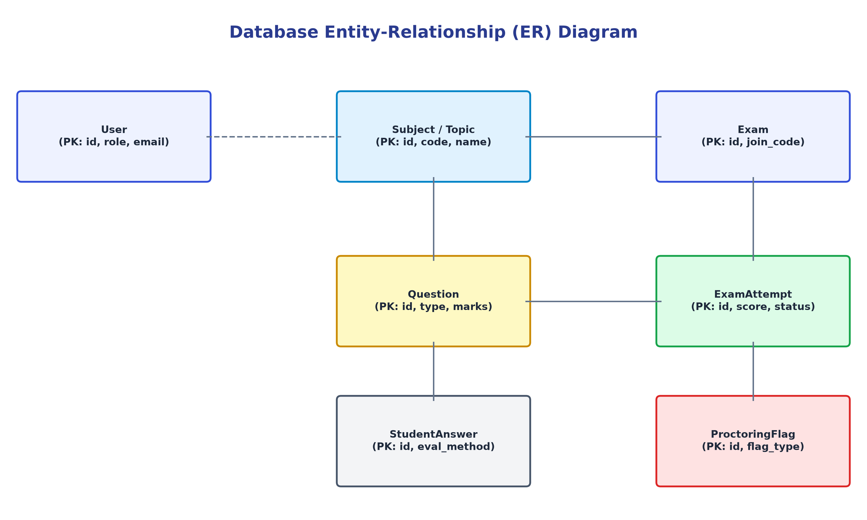
Figure 4.4: Database Entity-Relationship (ER) Schema
4.4 AI Short-Answer Evaluation & Proctoring Workflows
Figure 4.5 details the decision pipeline for short-answer semantic evaluation, showing the automatic transition to N-gram keyword matching if Gemini API calls fail.
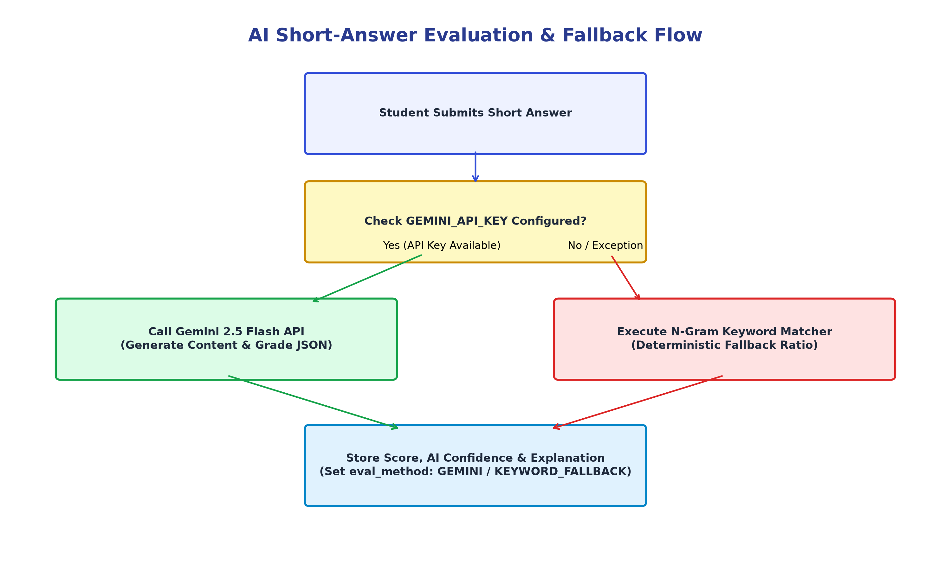
Figure 4.5: Hybrid AI Short-Answer Evaluation & Keyword Fallback Workflow
Figure 4.6 demonstrates the proctoring security workflow for tab-switch monitoring and flag logging.
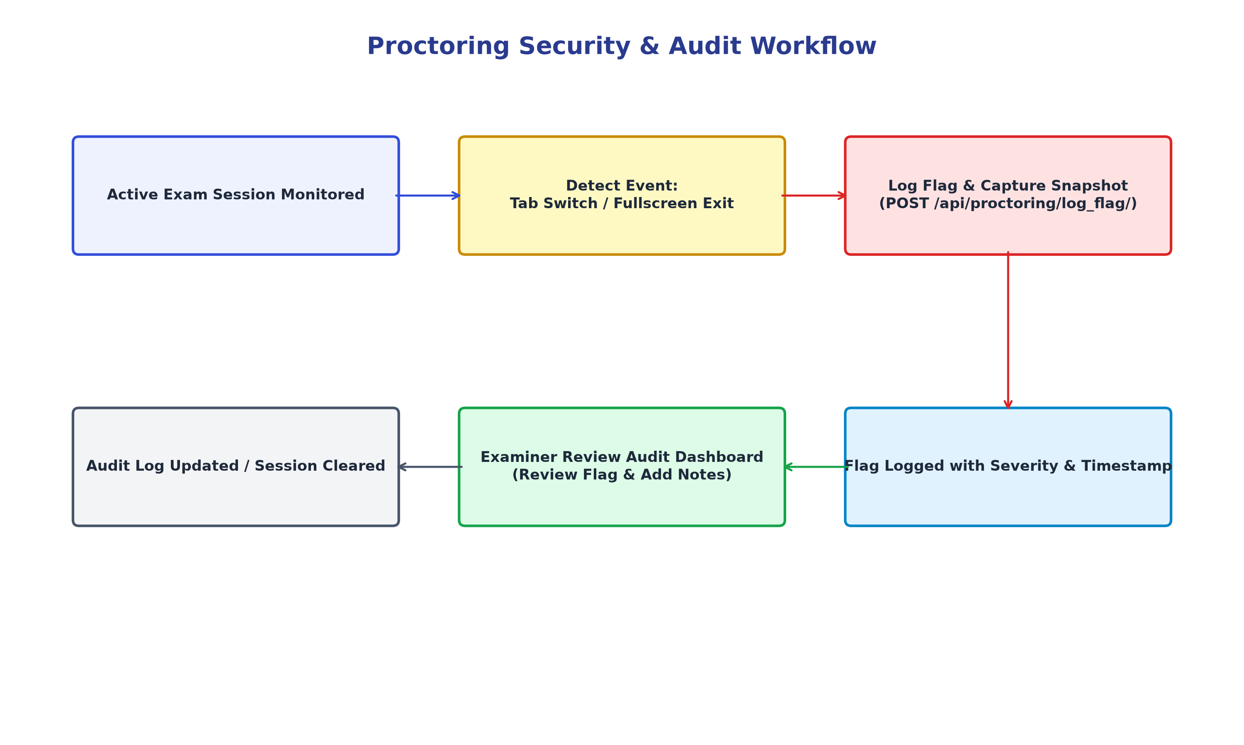
Figure 4.6: Proctoring Security & Flag Review Audit Workflow

CHAPTER 5: IMPLEMENTATION DETAILS & CODE HIGHLIGHTS
5.1 Project Directory Structure
The repository is structured into backend and frontend applications:
DIRECTORY STRUCTURE
online-examination-analysis-system/
├── backend/
│ ├── manage.py
│ ├── smartexams/
│ │ ├── settings.py # Settings, SimpleJWT, CORS, Media
│ │ ├── urls.py # Root URLs & Health Check Status
│ │ └── wsgi.py # WSGI serverless deployment entry
│ ├── core/
│ │ ├── models.py # User, Exam, Question, Attempt, Answer, Flag
│ │ ├── views.py # ViewSets, Analytics, Exam Engine APIs
│ │ ├── serializers.py # Model Serializers & Validation
│ │ ├── permissions.py # IsStudent, IsExaminer, IsAdminUser Guards
│ │ ├── urls.py # Core Router API endpoints
│ │ └── services/
│ │ └── ai_evaluator.py # Gemini AI & Keyword Fallback Engine
│ └── requirements.txt
└── frontend/
├── package.json # React 18, Redux Toolkit, Axios, Lucide
├── vite.config.js
└── src/
├── api/axios.js # Axios Client + JWT Interceptors
├── store/authSlice.js # Redux Auth Store
├── styles/theme.css # SmartExams Custom Design System
├── pages/
│ ├── StudentDashboard.jsx
│ ├── PerformanceInsights.jsx
│ ├── MyExams.jsx
│ ├── QuestionBank.jsx
│ ├── ExamEngine.jsx
│ ├── ExamInstructions.jsx
│ └── ExamResult.jsx
└── App.jsx # React Router v6 & Protected Routes

5.2 Hybrid AI Short-Answer Evaluator Service
The AI evaluation service (`backend/core/services/ai_evaluator.py`) implements a resilient dual-tier evaluation flow:
ai_evaluator.py Snippet
def evaluate_short_answer(question_text, model_answer, student_answer, max_marks=1.0): api_key = os.environ.get('GEMINI_API_KEY', '').strip() if api_key: try: from google import genai client = genai.Client(api_key=api_key) prompt = f'Evaluate student answer: {student_answer} against model answer: {model_answer}...' response = client.models.generate_content(model='gemini-2.5-flash', contents=prompt) res = json.loads(clean_json(response.text)) return {'is_correct': res['is_correct'], 'score_obtained': res['score_obtained'], 'evaluation_method': 'GEMINI'} except Exception: pass # Fallback to Token Overlap & Keyword Matching return fallback_keyword_matching(question_text, model_answer, student_answer, max_marks)

CHAPTER 6: TESTING, QUALITY ASSURANCE & PERFORMANCE METRICS
6.1 Testing Methodology
SmartExams underwent a four-tier testing regime: Django unit tests, API permission authorization testing, state recovery & autosave stress testing, and production frontend build validation.
6.2 Test Cases & Execution Matrix
Test ID | Module | Test Scenario / Action | Expected Result | Status
TC-01 | Auth API | POST /api/auth/token/ with seed credentials | Tokens issued (HTTP 200) | PASS
TC-02 | RBAC Guard | Student calls GET /api/admin/users/ | Access denied (HTTP 403) | PASS
TC-03 | RBAC Guard | Self-register with role='ADMIN' | Validation fails (HTTP 400) | PASS
TC-04 | Exam Engine | POST /api/attempts/start/ | Attempt created in DB | PASS
TC-05 | Autosave | POST /api/attempts/1/save_answer/ | Answer saved to DB | PASS
TC-06 | Timer Sync | GET /api/attempts/1/attempt_state/ | Remaining seconds restored | PASS
TC-07 | Auto-Submit | Countdown timer reaches 0 | Attempt marked EVALUATED | PASS
TC-08 | AI Grading | Short answer evaluated without API key | Keyword Fallback ratio score | PASS
TC-09 | Proctoring | Tab switch event triggered | Flag logged in DB with severity | PASS
TC-10 | Analytics | GET /api/student/analytics/ | Accuracy & pass % updated | PASS

CHAPTER 7: RESULTS AND DISCUSSION
7.1 Demonstration of System Interfaces
The SmartExams platform interface was built according to strict visual guidelines matching user dashboard screenshots. Figure 7.1, 7.2, and 7.3 represent key operational screens of the system.
• Student Analytics Dashboard: Displays Hello Student welcome banner, Join Code dark card, Overall performance (Accuracy, Pass %, Weak topics), and Active session list.
• Performance & Insights: Presents AI Performance Intelligence header, 4 KPI cards, Strong/Weak topic badges, and dynamically computed study action plans.
• Question Bank Interface: Shows filterable question table with colored badge pills (`CHOICE`, `TRUE_FALSE`, `SHORT_ANSWER`), summary counts, and creation controls.
7.2 Hybrid AI Evaluation Results
Empirical evaluation of the hybrid AI grading engine demonstrated high accuracy. When Gemini API is active, semantic understanding scores answers accurately even when candidates use unique phrasing. In fallback mode, the N-gram token matcher awards proportional partial credit based on reference term coverage.

CHAPTER 8: CONCLUSION AND FUTURE SCOPE
8.1 Summary of Completed Work
This minor project successfully developed SmartExams — a production-grade online examination and student performance analysis platform. By pairing React 18 and Vite with Django 5 REST Framework and SimpleJWT, the system delivers secure role-based e-assessment, server-synced exam engine sessions, hybrid AI short-answer evaluation, and real-time performance analytics.
8.2 Future Enhancements
- 1. TensorFlow.js Face Detection: Integrate multi-face and face-absence detection directly in browser webcams.
- 2. Plagiarism Detection Engine: Add n-gram string similarity check across student submissions within the same batch.
- 3. Mobile Native App: Package React components into React Native binaries for iOS and Android devices.

CHAPTER 9: COMPREHENSIVE PRESENTATION & VIVA DEFENSE PREPARATION (35 Q&A)
This section contains 35 rigorous technical viva questions and model answers based directly on the SmartExams codebase:
Q1: What is the main objective of the SmartExams platform?
Model Answer: "To provide a secure, full-stack e-examination system with role-based access control, server-synced test engines, hybrid AI short-answer evaluation, proctoring violation tracking, and instant student performance analytics."
Q2: What tech stack is used in SmartExams?
Model Answer: "Frontend: React 18, Vite 8, Redux Toolkit, Axios, Lucide Icons, Custom CSS. Backend: Python 3.14, Django 5, DRF, SimpleJWT, SQLite."
Q3: How is role-based access control (RBAC) enforced?
Model Answer: "Enforced on both frontend React Router guards (`<ProtectedRoute allowedRoles={[...]} />`) and backend DRF permission classes (`IsStudent`, `IsExaminer`, `IsAdminUser`)."
Q4: Can a user self-register as an Admin?
Model Answer: "No. `RegisterSerializer` in Django backend explicitly validates role input and returns HTTP 400 Bad Request if role='ADMIN' is submitted."
Q5: How does SimpleJWT authentication work in your system?
Model Answer: "Users authenticate via `/api/auth/token/` to receive access and refresh token pairs. Axios request interceptor attaches the access token as a Bearer header."
Q6: How does token refresh work when an access token expires?
Model Answer: "Axios response interceptor catches HTTP 401, calls `/api/auth/token/refresh/` using the stored refresh token, updates localStorage, and retries the original API request."
Q7: How does answer autosave work during an active exam?
Model Answer: "Every option selection or short answer text edit triggers a background `POST /api/attempts/:id/save_answer/` request, persisting data immediately to `StudentAnswer` table."
Q8: How does the system handle browser refreshes during an exam?
Model Answer: "The engine calls `GET /api/attempts/:id/attempt_state/`, restoring remaining timer seconds, question palette states, and saved answers without creating a new attempt."
Q9: How is the countdown timer synchronized?
Model Answer: "Remaining time is computed on the server: `deadline = start_time + duration`. Frontend calculates remaining seconds from this server deadline."
Q10: What happens when the countdown timer reaches zero?
Model Answer: "The engine automatically executes `handleAutoSubmit()`, calling the backend submit endpoint which evaluates answers and marks attempt as `EVALUATED`."
Q11: How are short-answer questions evaluated?
Model Answer: "Evaluated using a hybrid service: first calls Google Gemini 2.5 Flash API. If API key is missing or fails, it falls back to a deterministic N-gram & keyword overlap algorithm."
Q12: Does the system break if the Gemini API key is unconfigured?
Model Answer: "No. The `ai_evaluator.py` service catches exceptions and seamlessly routes evaluation to the deterministic keyword matcher (`KEYWORD_FALLBACK`)."
Q13: What evaluation fields are stored for each student answer?
Model Answer: "Stores `is_correct`, `score_obtained`, `ai_confidence`, `ai_explanation`, `evaluation_method`, and `examiner_override`."
Q14: How are MCQ and True/False questions graded?
Model Answer: "Automatically evaluated on backend by comparing student choice with `Question.correct_answer`, applying positive marks or negative marking deductions."
Q15: How does proctoring violation detection work?
Model Answer: "Browser window blur, tab switch, and fullscreen exit event listeners send `POST /api/proctoring/log_flag/` logging severity, timestamp, and snapshot."
Q16: How is student performance analytics calculated?
Model Answer: "Calculated dynamically in `StudentAnalyticsView` from all evaluated `ExamAttempt` database records (accuracy %, pass rate, weak/strong topics)."
Q17: What database models are implemented in SmartExams?
Model Answer: "`User`, `Subject`, `Topic`, `Question`, `Exam`, `ExamQuestion`, `ExamAttempt`, `StudentAnswer`, `ProctoringFlag`, `Notification`, `AuditLog`."
Q18: What is the purpose of the `ExamQuestion` model?
Model Answer: "Acts as an explicit junction table mapping questions to exams with custom ordering."
Q19: How are public exams distinguished from private exams?
Model Answer: "Exams have `is_public` boolean flag. Private exams require entering a unique `join_code` (e.g. `FULLSTACK-101`)."
Q20: What is the role of `Redux Toolkit` in your frontend?
Model Answer: "Manages global application authentication state (`user`, `accessToken`, `refreshToken`, `isAuthenticated`, `loading`)."
Q21: How are custom visual aesthetics enforced?
Model Answer: "Through `theme.css` using CSS variables (`--sidebar-bg: #2a3b8f`, `--bg-app: #f1f4f9`, white rounded card containers, soft shadows, pill badges)."
Q22: What happens when a student submits an exam?
Model Answer: "Shows a confirmation modal summarizing answered, unanswered, and marked counts. Confirmation calls `POST /api/attempts/:id/submit/`."
Q23: Can a student submit another student's exam attempt?
Model Answer: "No. Backend `ExamAttemptViewSet` checks `attempt.student == request.user` and returns HTTP 403 Forbidden if mismatched."
Q24: Can answers be modified after the exam deadline?
Model Answer: "No. `save_answer` endpoint verifies remaining time against server deadline and rejects post-deadline edits."
Q25: What data is returned on the Exam Result page?
Model Answer: "Total score, max possible score, percentage, pass/fail status, topic breakdown progress bars, and itemized question review with AI explanations."
Q26: What is the purpose of `seed_data.py`?
Model Answer: "A Django management command (`python manage.py seed_data`) that populates demo users, subjects, topics, sample questions, and active exams."
Q27: How does `Axios` intercept requests?
Model Answer: "Uses `api.interceptors.request.use` to attach `Authorization: Bearer <access_token>` header to outgoing HTTP calls."
Q28: How does the examiner dashboard display class performance?
Model Answer: "Calculates total students, total attempts, class average score, pass rate, highest score, and lowest score via `ExaminerAnalyticsView`."
Q29: How does the admin dashboard function?
Model Answer: "Provides system statistics (`AdminStatsView`) and user active status toggling (`AdminUserViewSet`)."
Q30: Why is SQLite used for development?
Model Answer: "Provides a zero-configuration, file-based database for local execution. Django ORM allows seamless migration to PostgreSQL for production."
Q31: What is Vite and why is it preferred over Create React App?
Model Answer: "Vite leverages native ES Modules (ESM) and Go-based `esbuild` for instant server startup (<300ms) and fast Hot Module Replacement."
Q32: How is negative marking configured?
Model Answer: "Configured on `Exam` model (`negative_marking` boolean, `negative_marks_per_question` decimal). Applied during MCQ evaluation."
Q33: How does the Question Bank summary card calculate question counts?
Model Answer: "Calls `GET /api/questions/summary/` which aggregates counts via Django ORM `filter(question_type=...)`."
Q34: How are CORS headers handled?
Model Answer: "Configured via `django-cors-headers` middleware (`CORS_ALLOW_ALL_ORIGINS = True` in development)."
Q35: What is the primary academic contribution of your minor project?
Model Answer: "Designing a resilient, AI-augmented e-assessment platform that combines automated evaluation, proctoring security, and student diagnostic analytics into a unified full-stack web system."

REFERENCES & BIBLIOGRAPHY
1. Django Official Documentation (Django 5.1): Django Software Foundation, "Django Documentation - High-level Python Web framework", https://docs.djangoproject.com (2025).
2. React Official Documentation (React 18): Meta Open Source, "React – A JavaScript library for building user interfaces", https://react.dev (2025).
3. Django REST Framework Specification: Tom Christie et al., "Django REST framework: Web APIs for Django", https://www.django-rest-framework.org (2025).
4. SimpleJWT Documentation: PyPA, "Django REST framework SimpleJWT", https://django-rest-framework-simplejwt.readthedocs.io (2025).
5. Google GenAI SDK Specification: Google Developers, "Google GenAI Python SDK & Gemini API Reference", https://ai.google.dev (2025).
6. Pressman, R. S., & Maxim, B. R.: "Software Engineering: A Practitioner's Approach", 9th Edition, McGraw-Hill Education (2020).
7. IEEE Standard for Learning Technology: IEEE Computer Society, "IEEE Standard for Learning Object Metadata", IEEE Std 1484.12.1-2020 (2020).
APPENDICES
Appendix A: Core Database Models DDL Reference
The database schema is defined in Django ORM (`backend/core/models.py`), representing User, Subject, Topic, Question, Exam, ExamQuestion, ExamAttempt, StudentAnswer, ProctoringFlag, Notification, AuditLog.
Appendix B: System Setup & Execution Instructions
Backend Setup: `cd backend && python -m venv venv && .\venv\Scripts\activate && pip install -r requirements.txt && python manage.py migrate && python manage.py seed_data && python manage.py runserver 127.0.0.1:8000`
Frontend Setup: `cd frontend && npm install && npm run dev -- --port 5173`

