Question-1 Write a simple program in HTML that displays the heading “HTML defines the content and structure of your website” on the web browser?

Output-



Question -2 Explain the purpose of comments in HTML and provide an example of how to use comments in an HTML document.

Answer- Comments in HTML serve as non-rendered text that provides information about the code for human readers.

They are useful for documenting your code, explaining its purpose, making notes, or temporarily disabling parts

of the code without deleting them. Comments are ignored by browsers and do not affect the rendering of the webpage.

Question- 3 Write an HTML program that includes a heading a paragraph of text a horizontal line and a line break. Arrange these elements to create a simple web page layout?

Answer-

<!DOCTYPE html>

<html lang="en">

<head>

  <meta charset="UTF-8">

  <meta http-equiv="X-UA-Compatible" content="IE=edge">

  <meta name="viewport" content="width=device-width, initial-scale=1.0">

  <title>Document</title>

</head>

<body>

<h1>Write a note about Rishikesh.</h1>

<p> Rishikesh, also spelt as Hrishikesh, is a city near Dehradun in Dehradun district of the Indian state Uttarakhand. It is situated on the right bank of the Ganges River and is a pilgrimage town for Hindus, with ancient sages and saints meditating here in search of higher knowledge. There are numerous temples and ashrams built along the banks of the river.

  It is known as the "Gateway to the Garhwal Himalayas" and "Yoga Capital of the World". The city has hosted the annual "International Yoga Festival" on the first week of March since 1999. Rishikesh is a vegetarian-only and alcohol-free city.</p>

<!-- Horizontal rule tag that created thematic break -->

<hr>

<!-- line break tag that breaks the line of text within the paragraph. -->

<p> Rishikesh, also spelt as Hrishikesh, is a city near Dehradun in Dehradun district of the Indian state Uttarakhand.<br>  It is known as the "Gateway to the Garhwal Himalayas" and "Yoga Capital of the World"</p>

</html>

Output-

Question-4 Write a short note on Tag and element with an example.

Answer- An HTML tag is a snippet of code enclosed within angle brackets ("<" and ">") that defines the purpose and structure of a specific element on a webpage. Tags are used to instruct the web browser how to display the content they enclose. Tags usually come in pairs: an opening tag and a closing tag, with the name of the element enclosed within the tags.

Example of a Tag:

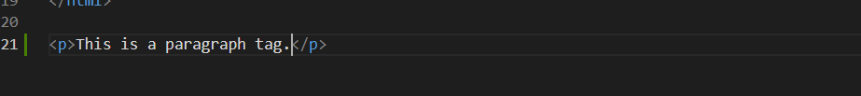

In this example, <p> is the opening tag, and </p> is the closing tag. The content "This is a paragraph tag." is the

text within the paragraph element.

Element:

An HTML element is a complete unit that includes an opening tag, content, and a closing tag. It represents a

distinct part of a webpage's content or structure. Elements are composed of tags and the content enclosed between those tags.

Question-5 What is the DOCTYPE Declaration in HTML?

Answer- The DOCTYPE declaration in HTML is a special instruction placed at the beginning of an HTML document to

specify the version of HTML being used. It ensures proper rendering and parsing by web browsers. The most

common declaration, <!DOCTYPE html>, indicates the use of HTML5, the latest version of HTML.