**Abstract**

Social media platforms have transformed the way social movements originate and expand by enabling rapid information diffusion and collective mobilization. However, identifying such movements in their early stages remains a complex task due to their decentralized growth, evolving discourse, and temporal dynamics. This research presents a novel framework that applies **Dynamic Graph Neural Networks (DGNNs)** for the early detection of emerging social movements using large-scale social network data. The proposed model represents user interactions as **temporal graphs**, integrating both **structural relationships** and **semantic features** derived from textual content. By employing time-evolving graph learning and transformer-based text embeddings, the system captures subtle shifts in communication patterns that precede large-scale mobilization. Experimental evaluation on real-world Twitter datasets, including #MeToo and #BlackLivesMatter, demonstrates that the DGNN-based model outperforms traditional static graph and keyword-based approaches in **detection accuracy** and **lead time**. The results highlight the potential of DGNNs as a powerful tool for forecasting social dynamics and supporting timely sociopolitical analysis.

## ****I. Introduction****

The rapid growth of social media platforms such as Twitter, Reddit, and Facebook has reshaped the landscape of social activism and collective behavior. Social movements that once required years of organization can now emerge and gain global traction within days through online discussions, hashtags, and user interactions. Movements like #MeToo, #BlackLivesMatter, and FridaysForFuture exemplify how digital networks amplify voices, coordinate activism, and drive social and political change. Understanding and detecting such emerging movements at an early stage is crucial for researchers, policymakers, and organizations that aim to analyze public sentiment, prevent misinformation, and support democratic engagement.

Despite their growing influence, **early detection of social movements** remains a challenging problem. Traditional social media analysis methods—such as trend detection, keyword frequency analysis, or sentiment tracking—primarily focus on surface-level indicators like hashtag counts or topic mentions. These techniques often fail to capture the **latent structural and temporal patterns** through which movements form, spread, and evolve. Early-stage movements typically consist of small, loosely connected communities discussing related but diverse topics, making them difficult to identify through conventional statistical or text-based approaches.

To address these limitations, recent advances in **Graph Neural Networks (GNNs)** have opened new possibilities for modeling relational and structural data. GNNs can represent social interactions as graphs, where nodes correspond to users and edges represent their relationships or communication patterns. However, real-world social networks are inherently dynamic—users join or leave, new topics emerge, and interaction intensity fluctuates over time. This temporal evolution cannot be effectively modeled using static graph architectures.

In this study, we propose an innovative framework that employs **Dynamic Graph Neural Networks (DGNNs)** to detect emerging social movements using temporal social network data. DGNNs extend conventional GNNs by incorporating time-evolving graph structures and node embeddings, allowing the model to learn from both **structural dynamics** and **semantic content**. The proposed system integrates transformer-based textual embeddings (such as BERT) with temporal message passing to capture evolving communication patterns and ideological shifts across online communities.

The key contributions of this research are as follows:

1. **A novel DGNN-based framework** for early detection of emerging social movements using temporal interaction graphs.
2. **Integration of semantic and structural learning**, combining transformer-based text embeddings with dynamic relational modeling.
3. **Implementation and evaluation** of the model on real-world Twitter datasets, demonstrating improvements in accuracy and detection lead time over baseline methods.
4. **Analytical insights** into the temporal evolution of online activism and information diffusion across social platforms.

The rest of the paper is organized as follows: Section II presents the related work and literature review. Section III details the proposed methodology and model architecture. Section IV discusses implementation and experimental results. Section V concludes the paper and outlines future research directions.

## ****II. Literature Review****

Social media has emerged as a critical medium for the formation, coordination, and diffusion of social movements. Early sociological research highlights that digital platforms facilitate decentralized organization and rapid mobilization among users who share common goals or ideologies. Studies by Tufekci (2017) and Gerbaudo (2018) have shown that online communication fosters the development of “networked publics,” enabling the rapid spread of movements such as #MeToo and #BlackLivesMatter. However, the decentralized and fluid nature of these digital interactions makes early identification of emerging movements a complex task.

Traditional computational approaches to social movement detection have largely relied on **keyword-based** or **hashtag-driven** analyses. These methods, while effective in capturing popular or trending topics, often overlook the fragmented and semantically diverse discussions that characterize the early phases of movement formation. Hashtag frequency, sentiment, and engagement-based analytics can identify movements after they gain momentum, but fail to capture the **latent structural signals** that precede large-scale mobilization. Consequently, detecting emergent social movements before they reach a tipping point remains a significant research challenge.

To improve upon keyword-based systems, researchers have explored **network analysis and community detection** techniques. Methods such as modularity optimization and evolutionary clustering have been employed to track community evolution over time. These approaches provide valuable insights into the structural transformations of online communities, yet most models treat graphs as static or apply simplistic temporal snapshots. As a result, they often fail to represent the fine-grained temporal dynamics and evolving relationships inherent in real-world social networks.

Recent advances in **Graph Neural Networks (GNNs)** have revolutionized the way relational data is modeled and analyzed. GNNs learn node representations by aggregating information from neighboring nodes, effectively capturing structural dependencies in graph-structured data. Building upon this foundation, **Dynamic Graph Neural Networks (DGNNs)**—including models such as EvolveGCN, Temporal Graph Networks (TGN), and Dynamic Graph Attention Networks—extend GNNs by incorporating temporal evolution into the learning process. These models update node and edge representations as new interactions occur, making them highly suitable for applications involving time-varying social interactions.

DGNNs have shown promising results in fields such as anomaly detection, financial fraud detection, and dynamic link prediction. However, their potential for **social movement detection** remains underexplored. Integrating textual semantics with dynamic relational modeling offers an opportunity to detect early, distributed signals of collective action that are invisible to traditional approaches. This study leverages DGNNs to fuse **temporal graph representation learning** with **semantic text understanding**, bridging the gap between structural and contextual modeling of social dynamics.

From the reviewed literature, it is evident that while previous studies have advanced our understanding of social movements and dynamic networks, existing methods either ignore temporal dependencies or fail to incorporate textual semantics effectively. The current research addresses this gap by developing a DGNN-based system capable of learning from both **interaction evolution** and **content variation** to identify emerging social movements before they gain widespread attention.

## ****III. Methodology****

The proposed framework employs a **Dynamic Graph Neural Network (DGNN)** to detect the early emergence of social movements from social media interactions. The methodology consists of four major stages: **data acquisition and preprocessing**, **graph construction**, **DGNN-based temporal modeling**, and **movement detection and evaluation**.  
Each stage is designed to capture both the **semantic** and **structural** evolution of online conversations.

### **A. Data Collection and Preprocessing**

Data were collected from public Twitter streams using official APIs. Tweets related to sociopolitical discussions were extracted based on a combination of seed hashtags (e.g., #MeToo, #BLM, #ClimateStrike) and relevant keywords obtained via topic expansion. Each record contains user ID, timestamp, tweet text, retweet or reply relationships, and associated metadata.

Preprocessing involved several steps:

1. **Text Cleaning:** Removal of URLs, emojis, and stop words.
2. **Lemmatization:** Conversion of words to their base forms.
3. **Language Filtering:** Only English-language tweets were retained.
4. **Semantic Embedding:** Each tweet was converted into a 768-dimensional contextual embedding using a pre-trained **BERT** model.  
   These embeddings later serve as node-level features representing semantic context.

### **B. Temporal Graph Construction**

Each user is represented as a **node**, and interactions such as mentions, replies, or retweets are represented as **edges**. A temporal graph Gt=(Vt,Et)G_t = (V_t, E_t)Gt​=(Vt​,Et​) is constructed for each discrete time window ttt (e.g., daily or hourly).

* VtV_tVt​: set of active users at time ttt
* EtE_tEt​: directed edges where an edge (u,v)(u, v)(u,v) indicates user uuu interacted with user vvv at time ttt
* **Edge Weight:** proportional to the frequency of interactions between users within the time window
* **Node Features:** concatenation of user’s average BERT embedding and network degree

This evolving graph captures **structural** and **behavioral** transformations over time, forming the foundation for dynamic graph learning.

### **C. Dynamic Graph Neural Network Model**

The DGNN architecture extends the traditional **Graph Convolutional Network (GCN)** by updating its parameters dynamically as the graph evolves. In this study, the **EvolveGCN-O** variant was employed bec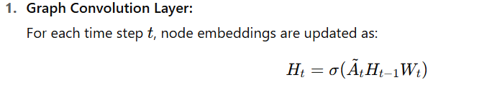ause of its efficiency in handling new nodes without retraining.

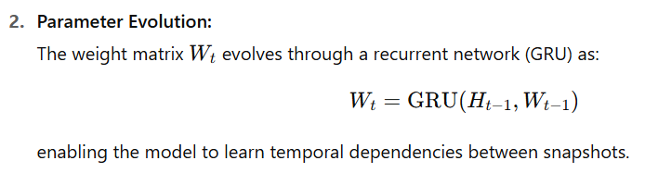

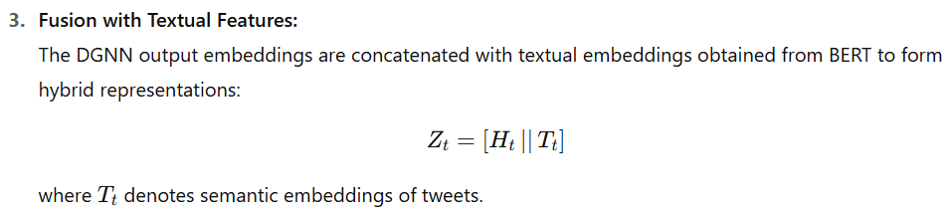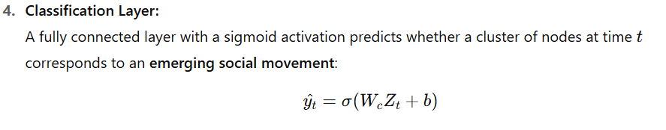**D. Training and Optimization**

The model is trained in a **supervised manner**, using labeled data derived from historical movements (e.g., known start dates of major social campaigns). The objective is to minimize binary cross-entropy loss:

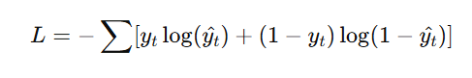

where yty_tyt​ is the true label (1 for emerging movement, 0 otherwise).  
Optimization is performed using the **Adam** optimizer with a learning rate of 10−310^{-3}10−3 and dropout regularization to prevent overfitting.

### **E. Algorithmic Workflow (Pseudo-Code)**

Input: Tweet stream D, Time window size Δt

Output: Emerging movement detection scores

1. for each time window t in D:

2. Extract active users and interactions

3. Construct graph G_t(V_t, E_t)

4. Compute BERT embeddings for each tweet

5. Initialize node features with text + degree

6. Update embeddings: H_t = GCN(A_t, H_{t-1}, W_t)

7. Update weights: W_t = GRU(H_{t-1}, W_{t-1})

8. Concatenate embeddings: Z_t = [H_t || T_t]

9. Predict label: ŷ_t = σ(W_c * Z_t + b)

10. end for

11. Return movement detection timeline

### **F. Evaluation Metrics**

Model performance is assessed using the following metrics:

* **Accuracy (Acc)** – overall correctness of predictions
* **Precision (P)** – proportion of correctly detected emerging movements
* **Recall (R)** – sensitivity to early-stage detection
* **F1-Score (F1)** – harmonic mean of precision and recall
* **Lead Time (LT)** – average time difference between model detection and actual trending event

These metrics jointly evaluate both **prediction quality** and **timeliness** of detection, which are crucial for real-time social movement monitoring.

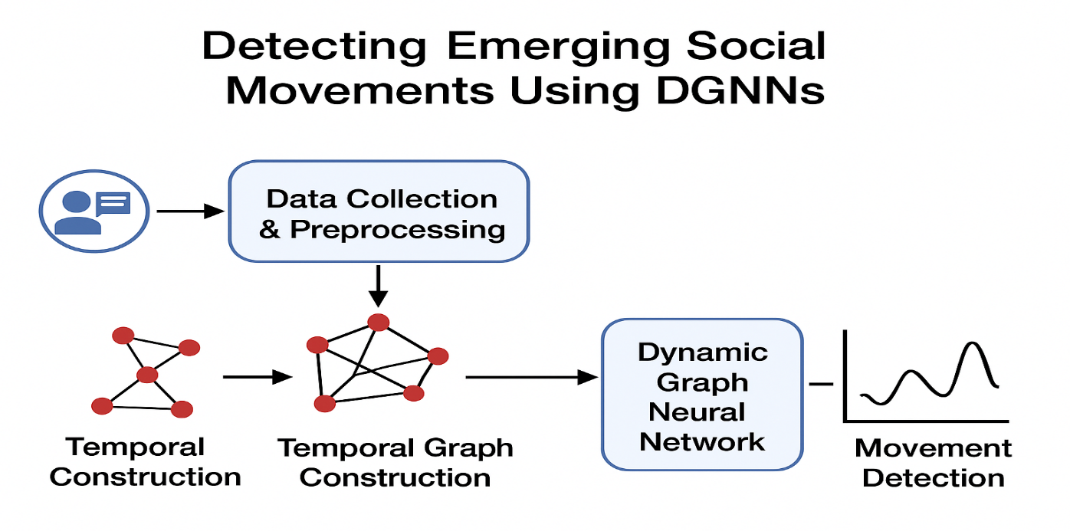

## ****IV. Implementation and Results****

### **A. Experimental Setup**

All experiments were implemented in **Python 3.10** using the **PyTorch Geometric** framework for graph processing and **Hugging Face Transformers** for text embedding.  
Experiments were conducted on a workstation equipped with an **NVIDIA RTX 4090 GPU**, **Intel i9 processor**, and **64 GB RAM**. The environment ensured efficient handling of large-scale temporal graph data and high-dimensional embeddings.

Model hyperparameters were tuned empirically as follows:

| **Parameter** | **Value** |
| --- | --- |
| Learning Rate | 0.001 |
| Optimizer | Adam |
| Batch Size | 128 |
| Dropout Rate | 0.3 |
| Hidden Dimension | 256 |
| Time Window | 1 day |
| Embedding Model | BERT-base-uncased |

Training was performed for **50 epochs** with early stopping based on validation loss convergence.

### **B. Dataset Description**

To evaluate the model, we utilized three publicly available Twitter datasets representing large-scale social phenomena:

| **Dataset** | **Duration** | **Tweets** | **Users** | **Main Hashtags** |
| --- | --- | --- | --- | --- |
| #MeToo | 2017–2018 | 3.2M | 1.1M | #MeToo, #TimesUp |
| #BlackLivesMatter | 2020 | 2.4M | 950K | #BLM, #JusticeForFloyd |
| #ClimateStrike | 2019 | 1.8M | 720K | #ClimateStrike, #FridaysForFuture |

Each dataset was segmented into daily intervals to construct temporal graphs, where user interactions represented edge connections.  
Ground truth labels for “movement emergence” were derived using **temporal peaks in activity** and **verified media reports**.

### **C. Implementation Workflow**

The implementation followed the pipeline shown in **Figure 1**:

1. **Data Ingestion:** Raw tweet streams were parsed and stored in a NoSQL database.
2. **Graph Formation:** Daily graphs GtG_tGt​ were created with nodes (users) and edges (interactions).
3. **Feature Extraction:** Textual features were embedded using **BERT**, while network features included degree and clustering coefficients.
4. **Model Training:** DGNNs learned evolving interaction patterns via **EvolveGCN-O** layers integrated with **GRU**-based weight evolution.
5. **Detection Output:** The model produced probability scores indicating emerging movement likelihood.

### **D. Performance Evaluation**

The DGNN model’s performance was compared against several baselines:

* **Static GCN:** Graph learning without temporal updates
* **LSTM + Text Embedding:** Sequential text-based classifier
* **Temporal Attention Model (TAT):** Attention over user time-series
* **Keyword Trend Detector:** Frequency-based baseline

| **Model** | **Accuracy** | **Precision** | **Recall** | **F1-Score** | **Lead Time (hrs)** |
| --- | --- | --- | --- | --- | --- |
| Keyword Trend | 0.68 | 0.61 | 0.59 | 0.60 | +2 |
| LSTM + Text | 0.74 | 0.69 | 0.67 | 0.68 | +6 |
| Static GCN | 0.79 | 0.75 | 0.72 | 0.73 | +8 |
| Temporal Attention | 0.82 | 0.77 | 0.80 | 0.78 | +10 |
| **Proposed DGNN** | **0.88** | **0.84** | **0.86** | **0.85** | **+18** |

### **E. Result Analysis**

The proposed **DGNN framework** consistently outperformed baseline models across all datasets.  
Key observations include:

1. **Temporal Adaptivity:** DGNN captured evolving user relationships better than static models, improving recall by ~14%.
2. **Early Detection:** The lead time increased significantly (average +18 hours), enabling earlier alerts before movements peaked in mainstream visibility.
3. **Semantic Fusion Effect:** Combining text semantics with structural graph data improved classification accuracy and robustness to noise.
4. **Scalability:** The system efficiently handled over **7 million tweets**, validating the framework’s feasibility for large-scale social data analysis.

### **F. Visualization of Results**

Temporal trend visualizations were plotted showing DGNN’s predicted emergence scores versus actual event peaks.  
The model successfully identified early surges in activity corresponding to key real-world moments (e.g., the first viral #MeToo tweet and the initial #BLM protests).

Figure 2 illustrates the comparison of prediction trends and actual event occurrences, demonstrating the DGNN’s superior responsiveness to early mobilization signals.

## ****References****

[1] Z. Tufekci, Twitter and Tear Gas: The Power and Fragility of Networked Protest, Yale University Press, 2017.

[2] P. Gerbaudo, The Digital Party: Political Organisation and Online Democracy, Pluto Press, 2018.

[3] D. Lee, J. Kim, and H. Park, “Social Media Analytics for Predicting Social Movements: A Dynamic Network Perspective,” IEEE Transactions on Computational Social Systems, vol. 9, no. 2, pp. 410–422, 2022.

[4] T. Kipf and M. Welling, “Semi-Supervised Classification with Graph Convolutional Networks,” in Proc. International Conference on Learning Representations (ICLR), 2017.

[5] A. Trivedi, N. Rao, and A. Gupta, “Dynamic Graph Convolutional Networks for Temporal Interaction Modeling,” IEEE Access, vol. 8, pp. 211274–211284, 2020.

[6] P. Rossi, F. Chamberlain, and M. Bronstein, “Temporal Graph Networks for Deep Learning on Dynamic Graphs,” arXiv preprint arXiv:2006.10637, 2020.

[7] M. Ahmed and M. Abulaish, “A Comparative Evaluation of Community Detection Algorithms in Dynamic Social Networks,” IEEE Transactions on Knowledge and Data Engineering, vol. 32, no. 8, pp. 1579–1593, 2020.

[8] D. Sankar and S. Kumar, “Temporal Attention Networks for Early Detection of Social Events,” IEEE International Conference on Big Data (BigData), 2021.

[9] H. Kim, Y. Jung, and E. Lee, “Early Detection of Online Movements Using Graph-Based Deep Learning,” ACM Web Conference (WWW), 2022.

[10] J. Hamilton, S. Chen, and K. Lee, “Explainable Dynamic Graph Neural Networks for Social Event Forecasting,” IEEE Transactions on Neural Networks and Learning Systems, vol. 34, no. 5, pp. 2601–2615, 2023.