**OUTCOMES**

1. **K=3**

For k=3, the accuracy of the trained model turned out to be 0.76 and was maximum of all the train and test ratios chosen.

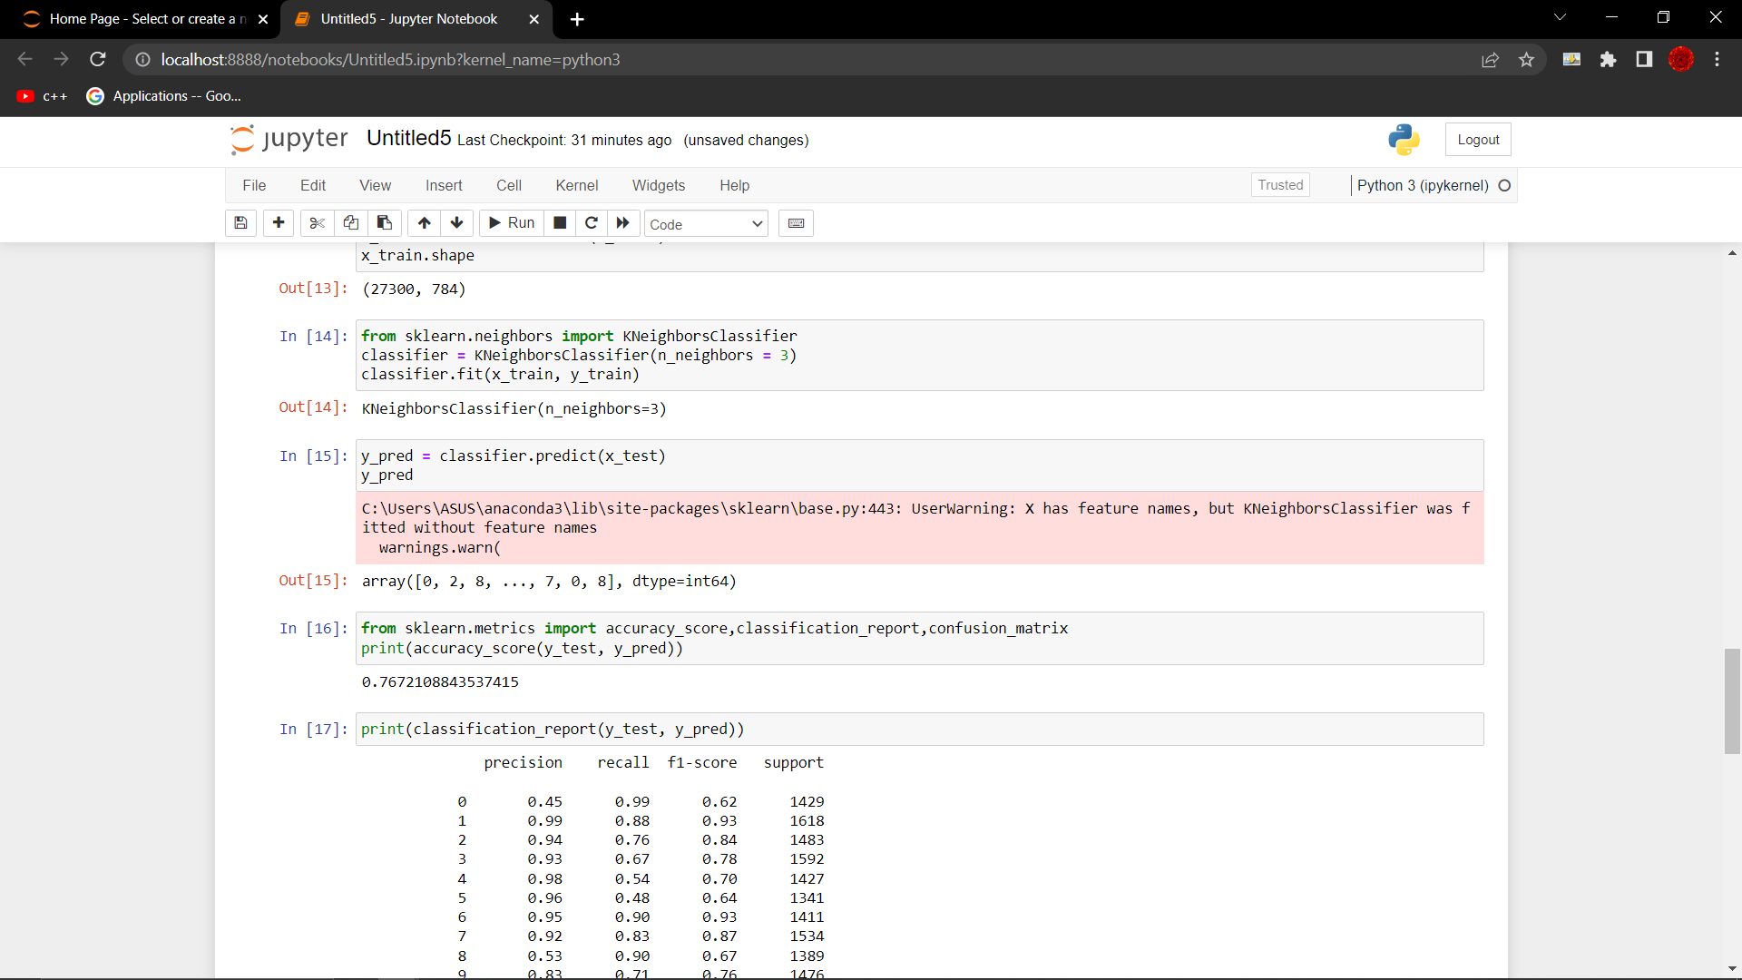

1. **K=5**

For k=5, the accuracy for the model increased to some extent (0.80)

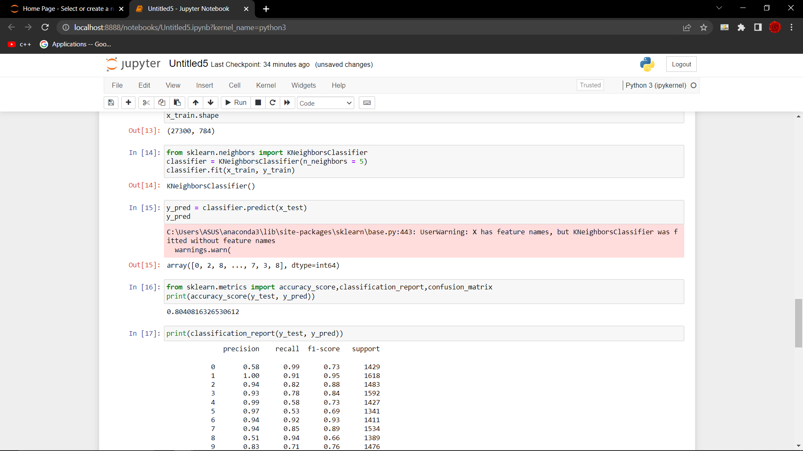

1. **K=6**

With k=6 the accuracy remained almost constant and didn’t deviate much

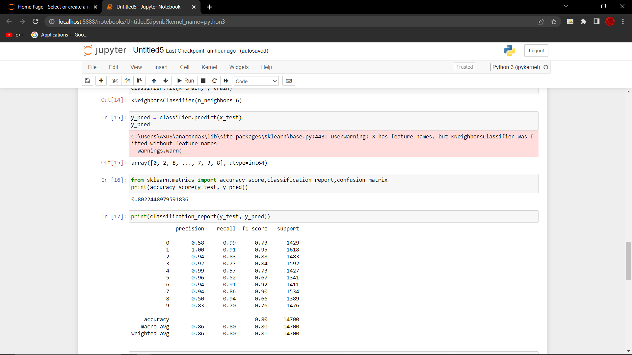

1. **K=7**

For k=7, there was a only minor increase in the accuracy.

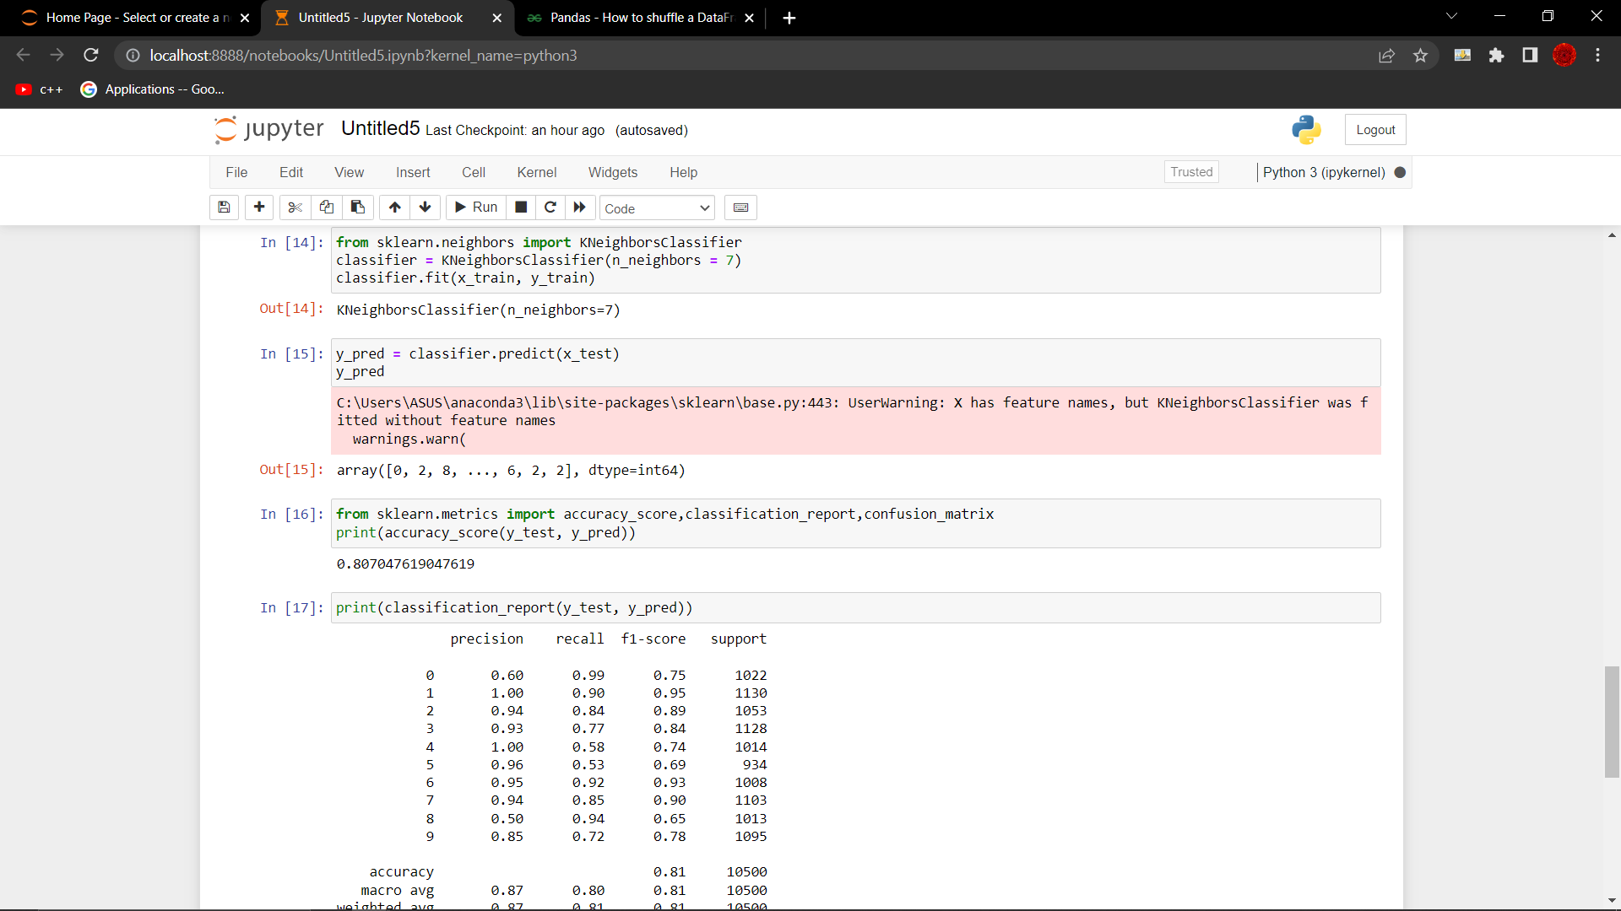

1. **K=11**

The accuracy increased a bit to 0.81.

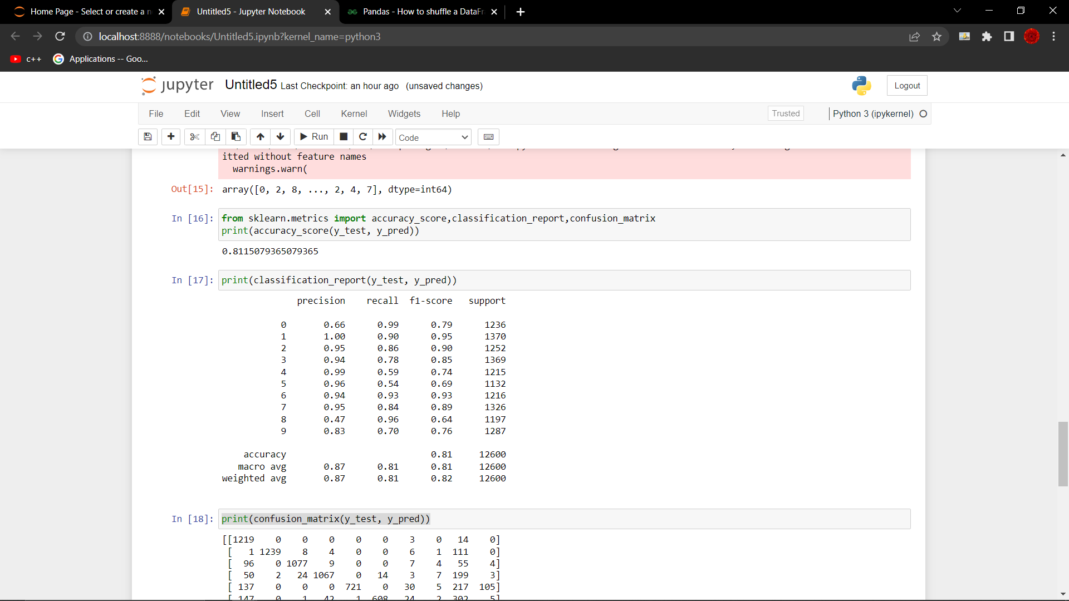

**Although used the same code structure for training the model as instructed by the instructor, the results were considerably different. Trying various train is to test ratios, using the shuffling training data command, did not show any considerable variation.**

**After getting predictions on the test data, a comparison was done between the PREDICTED labels and the images obtained and following results were produced for 5 test cases:**

**1.**

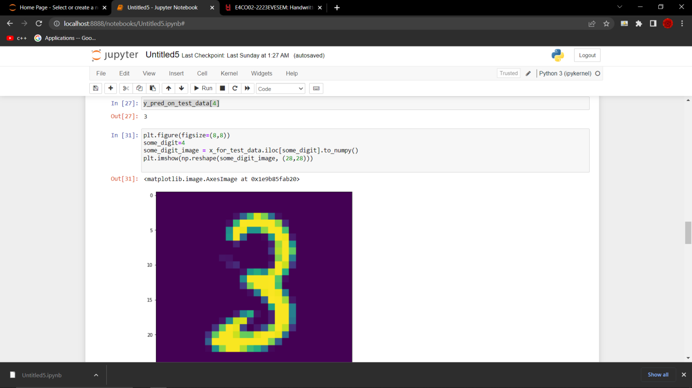

**2.**

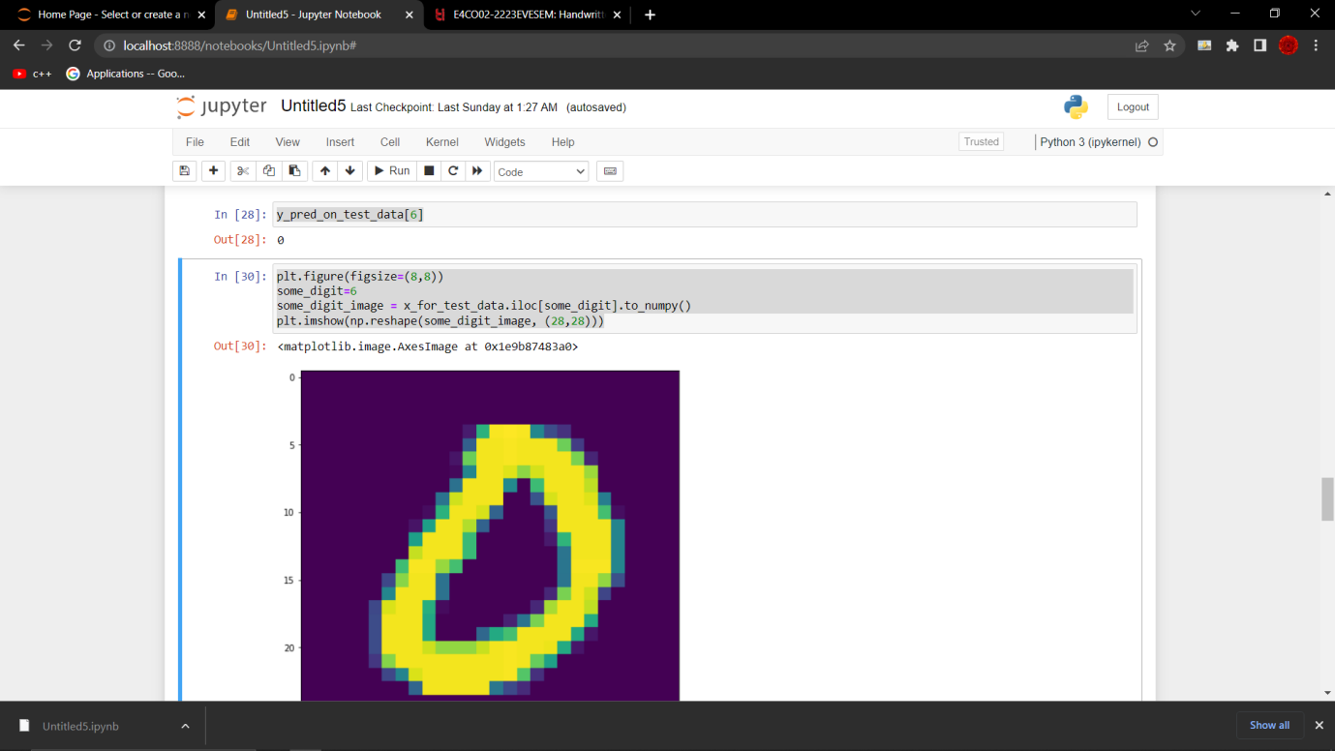

**3.**

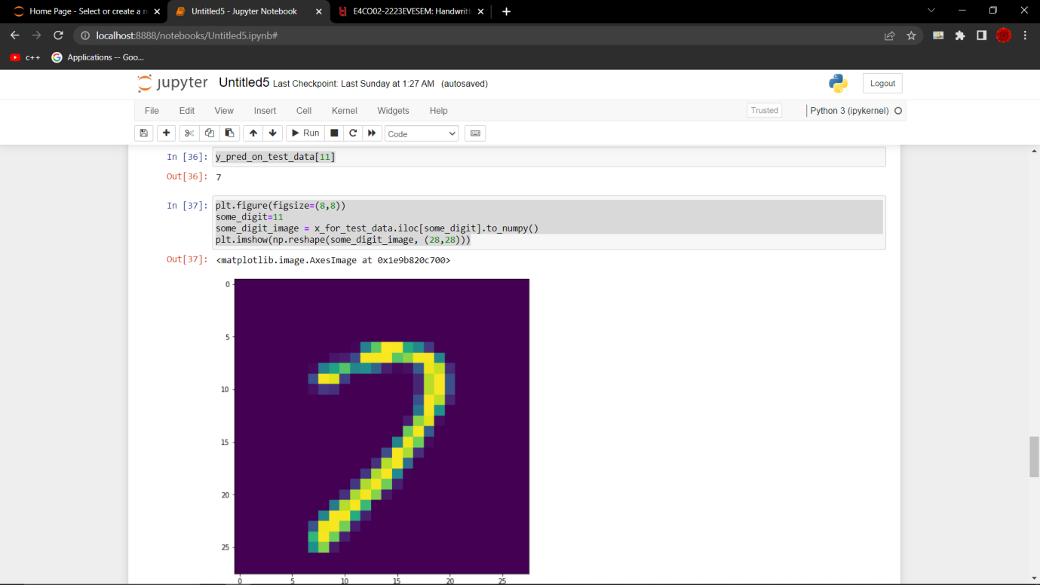

**4.**

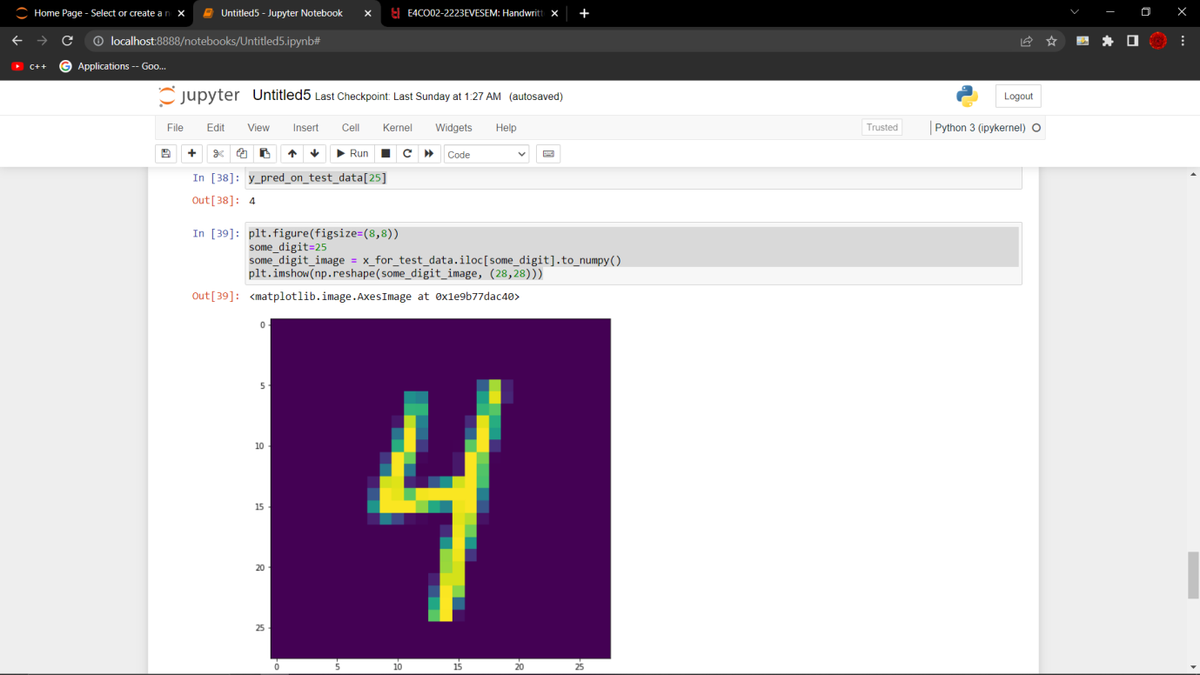

**5.**

