MEDI CAPS UNIVERSITY
INDORE

DEPARTMENT OF COMPUTER SCIENCE & ENGINEERING

COMPILER DESIGN LAB FILE

SUBMITTED TO : SUBMITTED BY:
PROF. SHIVANGI ROY RONAK SHARMA
EN20CS301363,6G-CSE

Practical 1
Write a program to count the number of vowels.
Code:
#include <stdio.h>
int main()
{
int c = 0, count = 0;
char s[1000];

printf("Input a string\n");
gets(s);

while (s[c] != '\0') {
if (s[c] == 'a' || s[c] == 'A' || s[c] == 'e' || s[c] == 'E' || s[c] == 'i' || s[c] == 'I' || s[c] =='o' || s[c]=='O' || s[c] == 'u' || s[c] == 'U')
count++;
c++;
}

printf("Number of vowels in the string: %d", count);

return 0;
}

Output:
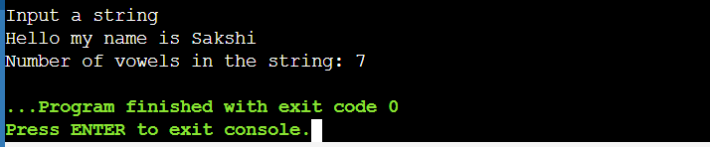
Practical 2
Write a program to test whether a given identifier is valid or not.

Code:
#include <stdio.h>
#include <string.h>
void validIdentifier(char str[]){

if ((str[0] >= 'a' && str[0] <= 'z') || (str[0] >= 'A' && str[0] <= 'Z') || str[0] == '_'){
printf("Valid Identifier");
return;
}
else{
printf("Not a Valid Identifier");
}
}

int main()
{

char str[10];
printf("Enter a string: ");
scanf("%s", str);
validIdentifier(str, keyword);
}

Output:
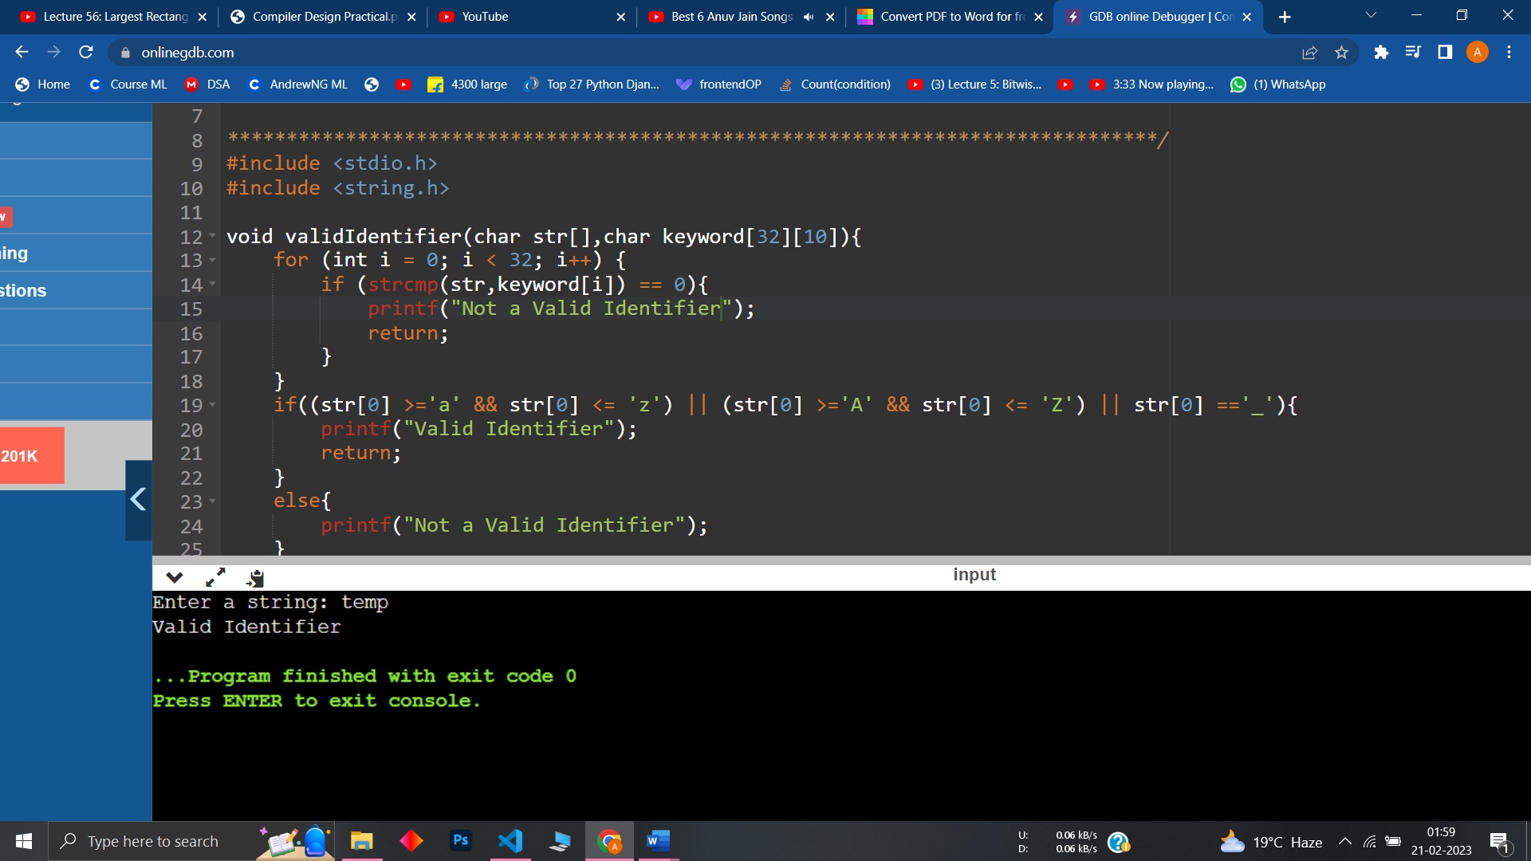

Practical 3
Write a program to simulate lexical analyzer for validating operators.
Code:
#include<stdio.h>
void main()
{
char s[5];
clrscr();
printf("\n Enter any operator:");
gets(s);
switch(s[0])
{
case'>': if(s[1]=='=')
printf("\n Greater than or equal");
else
printf("\n Greater than");
break;
case'<': if(s[1]=='=')
printf("\n Less than or equal");
else
printf("\nLess than");
break;
case'=': if(s[1]=='=')
printf("\nEqual to");
else
printf("\nAssignment");
break;
case'!': if(s[1]=='=')
printf("\nNot Equal");
else
printf("\n Bit Not");
break;
case'&': if(s[1]=='&')
printf("\nLogical AND");
else
printf("\n Bitwise AND");
break;
case'|': if(s[1]=='|')
printf("\nLogical OR");
else
printf("\nBitwise OR");
break;
case'+': printf("\n Addition");
break;
case'-': printf("\nSubstraction");
break;
case'*': printf("\nMultiplication");
break;
case'/': printf("\nDivision");
break;
case'%': printf("Modulus");
break;
default: printf("\n Not a operator");
}
getch();
}

Output:
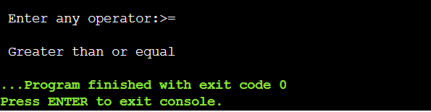

Practical 4
Write a program to identify given line is a comment or not.

Code:
#include <stdio.h>
#include <string.h>
int main()
{
char str[100];
scanf("%s", str);
int length;
length = strlen(str);
if (str[0] == '/' && str[1] == '*' && str[length - 1] == '*' && str[length] == '/'){

printf("Multi line comment.");
}
else if (str[0] == '/' && str[1] == '/'){
printf("Single line comment.");
}
else{
printf("It is not a comment.");
}
return 0;
}

Output:
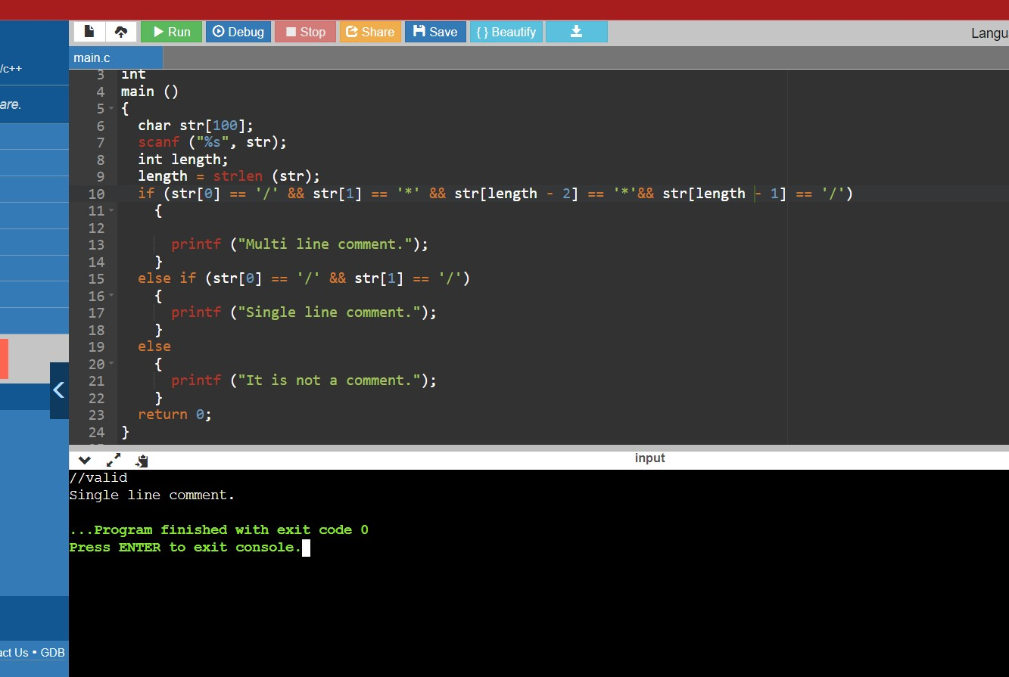

Practical 5
Write a program to count total number of occurrences of each character.

Code:
#include<iostream>
#include<string>
using namespace std;
int main()
{
string s;
cout<<"Enter your string\n";
getline(cin,s);
int a[26]={0};
for(int i=0;i<s.length();i++)
{
if(s[i] >= 'a' && s[i] <= 'z')
a[s[i]-'a']++;

else if(s[i] >= 'A' && s[i] <= 'Z')
a[s[i]-'A'];
}
std::cout << "Character count:" << std::endl;
for(int i=0;i<26;i++)
{
if(a[i]!=0) cout<<char(i+'a')<<"="<<a[i]<<endl;
}
return 0;
}

Output:
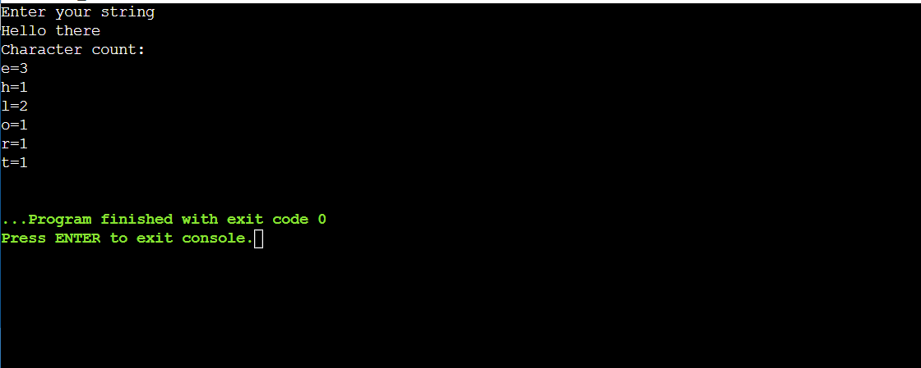

Practical 6
Design a lexical analyzer for given language.
Code:

#include<string.h>
#include<conio.h>
#include<ctype.h>
#include<stdio.h>
void main()
{
FILE *f1;
char c,str[10];
int lineno=1,num=0,i=0;
clrscr();
printf("\nEnter the c program\n");
f1=fopen("input.txt","w");
while((c=getchar())!=EOF)
putc(c,f1);
fclose(f1);
f1=fopen("input.txt","r");
while((c=getc(f1))!=EOF) // TO READ THE GIVEN FILE
{
if(isdigit(c)) // TO RECOGNIZE NUMBERS
{
num=c-48;
c=getc(f1);
while(isdigit(c))
{
num=num*10+(c-48);
c=getc(f1);
}
printf("%d is a number \n",num);
ungetc(c,f1);
}
else if(isalpha(c)) // TO RECOGNIZE KEYWORDS AND IDENTIFIERS
{
str[i++]=c;
c=getc(f1);
while(isdigit(c)||isalpha(c)||c=='_'||c=='$')
{
str[i++]=c;
c=getc(f1);
}
str[i++]='\0';
if(strcmp("for",str)==0||strcmp("while",str)==0||strcmp("do",str)==0||
strcmp("int",str)==0||strcmp("float",str)==0||strcmp("char",str)==0||
strcmp("double",str)==0||strcmp("static",str)==0||
strcmp("switch",str)==0||strcmp("case",str)==0) // TYPE 32 KEYWORDS
printf("%s is a keyword\n",str);
else
printf("%s is a identifier\n",str);
ungetc(c,f1);
i=0;
}
else if(c==' '||c=='\t') // TO IGNORE THE SPACE
printf("\n");
else if(c=='\n') // TO COUNT LINE NUMBER
lineno++;
else // TO FIND SPECIAL SYMBOL
printf("%c is a special symbol\n",c);
}
printf("Total no. of lines are: %d\n",lineno);
fclose(f1);
getch();
}

OUTPUT
Enter the c program
int main()
{
int a=10,20;
charch;
float f;
}^Z
The numbers in the program are: 10 20
The keywords and identifiersare:
int is a keyword
main is an identifier
int is a keyword
a is an identifier
char is a keyword
ch is an identifier
float is a keyword
f is an identifier
Special characters are ( ) { = , ; ; ; }
Total no. of lines are:5

Practical 7
Write a program to recognize strings under a, a*b+, abb.

Code:
#include <iostream>
#include<string>
using namespace std;
int main()
{
string s;
cout<<"Enter the string\n";
cin>>s;
if(s=="a" || s=="abb") std::cout << "Accepted" << std::endl;
else
{
int i=0;
while(s[i]=='a') i++;
if(s[i]!='b') std::cout << "Not Accepted" << std::endl;
else
{
while(s[i]=='b') i++;
if(i==s.length()) std::cout << "Accepted" << std::endl;
else std::cout << "Not Accepted" << std::endl;
}
}
return 0;
}

Output:
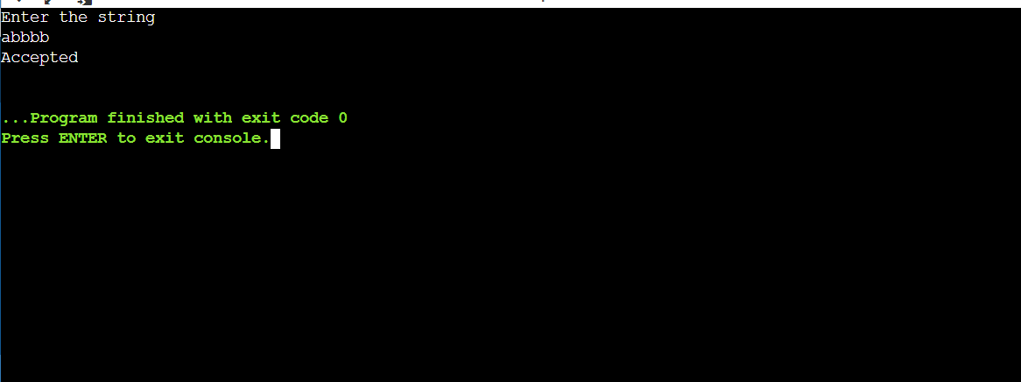

Practical : 8

Write a C program to construct LL(1) parsing.
#include <stdio.h>
#include <conio.h>
#include <string.h>
char s[20],stack[20];
void main(){
char m[5][6][3]={"tb"," "," ","tb"," "," "," ","+tb"," "," ","n","n","fc"," "," ","fc"," "," "," ","n","*fc"," a ","n","n","i"," "," ","(e)"," "," "};
int size[5][6]={2,0,0,2,0,0,0,3,0,0,1,1,2,0,0,2,0,0,0,1,3,0,1,1,1,0,0,3,0,0};
int i,j,k,n,str1,str2;
//clrscr();
printf("\n Enter the input string: ");
scanf("%s",s);
strcat(s,"$");
n=strlen(s);
stack[0]='$';
stack[1]='e';
i=1;
j=0;
printf("\nStack Input\n");
printf("______\n");
while((stack[i]!='$')&&(s[j]!='$')){
if(stack[i]==s[j]){
i--;
j++;}
switch(stack[i]){
case 'e': str1=0;
break;
case 'b': str1=1;
break;
case 't': str1=2;
break;
case 'c': str1=3;
break;
case 'f': str1=4;
break;}
switch(s[j]){
case 'i': str2=0;
break;
case '+': str2=1;
break;
case '*': str2=2;
break;
case '(': str2=3;
break;
case ')': str2=4;
break;
case '$': str2=5;
break;}
if(m[str1][str2][0]=='\0'){
printf("\nERROR");
exit(0);}
else if(m[str1][str2][0]=='n')
i--;
else if(m[str1][str2][0]=='i')
stack[i]='i';
else{
for(k=size[str1][str2]-1;k>=0;k--){
stack[i]=m[str1][str2][k];
i++;}
i--;}
for(k=0;k<=i;k++)
printf(" %c",stack[k]);
printf(" ");
for(k=j;k<=n;k++)
printf("%c",s[k]);
printf(" \n ");}
printf("\n SUCCESS");
getch(); } output ->
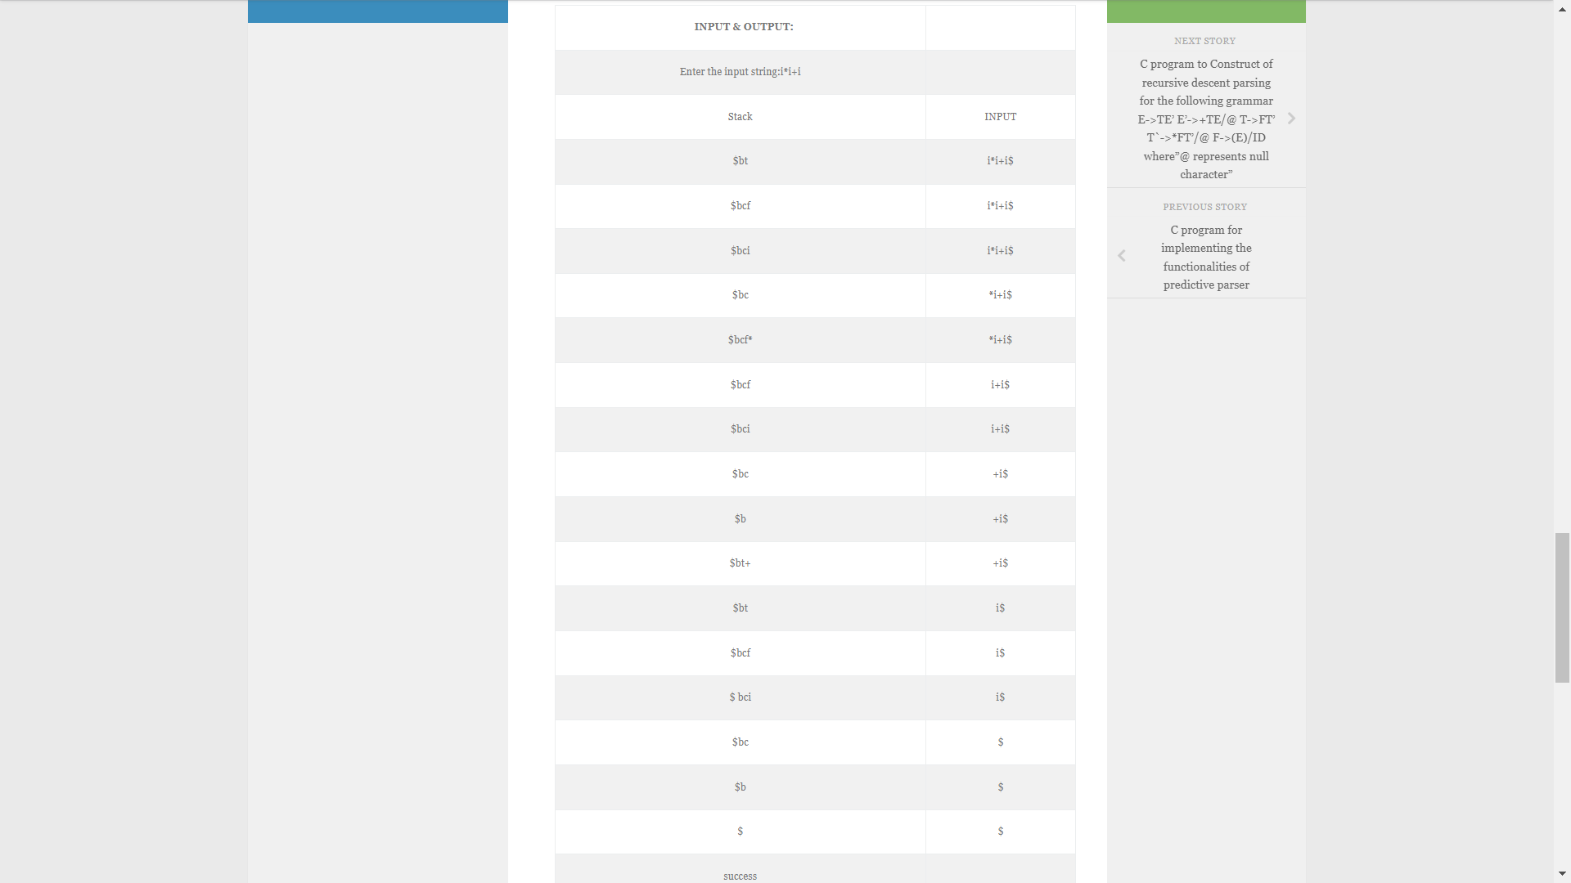

Practical – 9
Write a c program for implementing the functionalities of predictive parser for the mini language specified in Note1.
#include <stdio.h>
#include <string.h>
char prol[7][10] = { "S", "A", "A", "B", "B", "C", "C" };
char pror[7][10] = { "A", "Bb", "Cd", "aB", "@", "Cc", "@" };
char prod[7][10] = { "S->A", "A->Bb", "A->Cd", "B->aB", "B->@", "C->Cc", "C->@" };
char first[7][10] = { "abcd", "ab", "cd", "a@", "@", "c@", "@" };
char follow[7][10] = { "$", "$", "$", "a$", "b$", "c$", "d$" };
char table[5][6][10];
int numr(char c){
switch (c){
case 'S':
return 0;
case 'A':
return 1;
case 'B':
return 2;
case 'C':
return 3;
case 'a':
return 0;
case 'b':
return 1;
case 'c':
return 2;
case 'd':
return 3;
case '$':
return 4;}
return (2);}
int main(){
int i, j, k;
for (i = 0; i < 5; i++)
for (j = 0; j < 6; j++)
strcpy(table[i][j], " ");
printf("The following grammar is used for Parsing Table:\n");
for (i = 0; i < 7; i++)
printf("%s\n", prod[i]);
printf("\nPredictive parsing table:\n");
fflush(stdin);
for (i = 0; i < 7; i++) {
k = strlen(first[i]);
for (j = 0; j < 10; j++)
if (first[i][j] != '@')
strcpy(table[numr(prol[i][0]) + 1][numr(first[i][j]) + 1], prod[i]); }
for (i = 0; i < 7; i++){
if (strlen(pror[i]) == 1){
if (pror[i][0] == '@') {
k = strlen(follow[i]);
for (j = 0; j < k; j++)
strcpy(table[numr(prol[i][0]) + 1][numr(follow[i][j]) + 1], prod[i]); }}}
strcpy(table[0][0], " ");
strcpy(table[0][1], "a");
strcpy(table[0][2], "b");
strcpy(table[0][3], "c");
strcpy(table[0][4], "d");
strcpy(table[0][5], "$");
strcpy(table[1][0], "S");
strcpy(table[2][0], "A");
strcpy(table[3][0], "B");
strcpy(table[4][0], "C");
printf("\n--------------------------------------------------------\n");
for (i = 0; i < 5; i++)
for (j = 0; j < 6; j++){ printf("%-10s", table[i][j]);if (j == 5):printf("\n--------------------------------------------------------\n");}}
Output: Predictive parser in C
1  2  3  4  5  6  7  8  9  10  11  12  13  14  15  16  17  18  19  20  21  22 | The following grammar is used for Parsing Table:  S->A  A->Bb  A->Cd  B->aB  B->@  C->Cc  C->@  Predictive parsing table:  --------------------------------------------------------  a b c d $  --------------------------------------------------------  S S->A S->A S->A S->A  --------------------------------------------------------  A A->Bb A->Bb A->Cd A->Cd  --------------------------------------------------------  B B->aB B->@ B->@ B->@  --------------------------------------------------------  C C->@ C->@ C->@  --------------------------------------------------------

Practical – 10
Construction of recursive descent parser for the following grammar-
E –> T E’
E’ –> + T E’ | e
T –> F T’
T’ –> * F T’ | e
F –> ( E ) | id
#include <stdio.h>
#include <string.h>
#define SUCCESS 1
#define FAILED 0
int E(), Edash(), T(), Tdash(), F();
const char *cursor;
char string[64];
int main(){
puts("Enter the string");
// scanf("%s", string);
sscanf("i+(i+i)*i", "%s", string);
cursor = string;
puts("");
puts("Input Action");
puts("--------------------------------");
if (E() && *cursor == '\0') {puts("--------------------------------");
puts("String is successfully parsed");
return 0;} else {
puts("--------------------------------");
puts("Error in parsing String");
return 1;}}
int E(){printf("%-16s E -> T E'\n", cursor);
if (T()) {if (Edash())
return SUCCESS;
else
return FAILED;} else
return FAILED;}
int Edash(){if (*cursor == '+') {printf("%-16s E' -> + T E'\n", cursor);
cursor++;
if (T()) {if (Edash())return SUCCESS;
else
return FAILED;} else
return FAILED;} else {
printf("%-16s E' -> $\n", cursor);
return SUCCESS;}}
int T(){printf("%-16s T -> F T'\n", cursor);
if (F()) {if (Tdash())return SUCCESS;
else
return FAILED;} else
return FAILED;}
int Tdash(){if (*cursor == '*') {printf("%-16s T' -> * F T'\n", cursor);
cursor++;
if (F()) {if (Tdash())
return SUCCESS;else
return FAILED;} else
return FAILED;} else {printf("%-16s T' -> $\n", cursor);
return SUCCESS;}}
int F(){if (*cursor == '(') {printf("%-16s F -> ( E )\n", cursor);
cursor++;
if (E()) {if (*cursor == ')') {cursor++;
return SUCCESS;} else
return FAILED;} else
return FAILED;} else if (*cursor == 'i') {
cursor++; printf("%-16s F -> i\n", cursor);
return SUCCESS;} else
return FAILED;}
output –
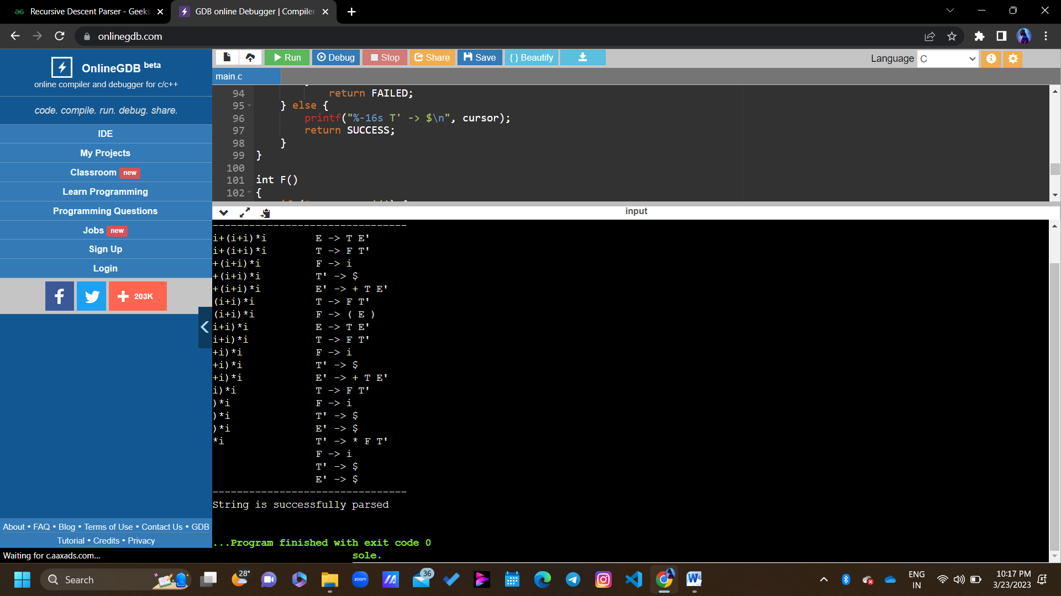

Practical – 11
Program to implement semantic rules to calculate the expression that takes an expression with digits, + and * and computes the value.

#include <stdio.h>
#include <stdlib.h>
#include <ctype.h>
int evaluate_expression(char *expr);
int main() {char expr[100];
printf("Enter an expression with digits, + and *: ");
fgets(expr, sizeof(expr), stdin);
int result = evaluate_expression(expr);
printf("Result = %d\n", result);
return 0;}
int evaluate_expression(char *expr) {
int result = 0;
int num = 0;
int op = '+';
while (*expr != '\0') {
if (isdigit(*expr)) {
num = num * 10 + (*expr - '0');
} else if (*expr == '+' || *expr == '*') {
if (op == '+') {
result += num;
} else if (op == '*') {
result *= num; }
num = 0;
op = *expr;
} else if (*expr == '\n') {
if (op == '+') {
result += num;
} else if (op == '*') {
result *= num;}
} else {
printf("Invalid character: %c\n", *expr);
exit(1);}
expr++; }
return result;}
output:-
Enter an expression with digits, + and *: 3 + 4 * 5 + 2 * 3
Result = 29

Practical – 12 : WAP to Design LALR Bottom up parser.

#include<stdio.h>
void push(char *,int *,char);
char stacktop(char *);
void isproduct(char,char);
int ister(char);
int isnter(char);
int isstate(char);
void error();
void isreduce(char,char);
char pop(char *,int *);
void printt(char *,int *,char [],int);
void rep(char [],int);
struct action{
char row[6][5];};
const struct action A[12]={
{"sf","emp","emp","se","emp","emp"},
{"emp","sg","emp","emp","emp","acc"},
{"emp","rc","sh","emp","rc","rc"},
{"emp","re","re","emp","re","re"},
{"sf","emp","emp","se","emp","emp"},
{"emp","rg","rg","emp","rg","rg"},
{"sf","emp","emp","se","emp","emp"},
{"sf","emp","emp","se","emp","emp"},
{"emp","sg","emp","emp","sl","emp"},
{"emp","rb","sh","emp","rb","rb"},
{"emp","rb","rd","emp","rd","rd"},
{"emp","rf","rf","emp","rf","rf"}};
struct gotol{
char r[3][4];};
const struct gotol G[12]={
{"b","c","d"},
{"emp","emp","emp"},
{"emp","emp","emp"},
{"emp","emp","emp"},
{"i","c","d"},
{"emp","emp","emp"},
{"emp","j","d"},
{"emp","emp","k"},
{"emp","emp","emp"},
{"emp","emp","emp"},};
char ter[6]={'i','+','*',')','(','$'};
char nter[3]={'E','T','F'};
char states[12]={'a','b','c','d','e','f','g','h','m','j','k','l'};
char stack[100];
int top=-1;
char temp[10];
struct grammar{
char left;
char right[5];};
const struct grammar rl[6]={
{'E',"e+T"},
{'E',"T"},
{'T',"T*F"},
{'T',"F"
printf("\n stack \t\t\t input");
printt(stack,&top,inp,i);
do{
x=inp[i];
p=stacktop(stack);
isproduct(x,p);
if(strcmp(temp,"emp")==0)
error();
if(strcmp(temp,"acc")==0)
break;
else{
if(temp[0]=='s'){
push(stack,&top,inp[i]);
push(stack,&top,temp[1]);
i++;}
else{
for(k=0;k<2*n;k++)
for(m=0;dl[m]!='\0';m++)
push(stack,&top,dl[m]);
l=top;
y=stack[l-1];
break;
default :printf("%c",t[r]);
break;}}

Output :- 4,5
23<18<45;

