**Data Visualization in Microsoft Excel**

Data visualization is the graphical representation of information and data. By using visual elements like charts, graphs, and maps, data visualization tools like Excel provide an accessible way to see and understand trends, outliers, and patterns in data.

**1. Column Chart**

A **Column Chart** uses vertical bars to compare values across different categories. It is one of the most common charts and is excellent for showing distinct counts or measurements.

**Fundamental Use:**

* **Comparing data across categories:** Showing sales figures for different product lines (e.g., Electronics vs. Apparel).
* **Showing change over a short period:** Displaying monthly revenue when the number of months is small.

**Example: Quarterly Sales Comparison**

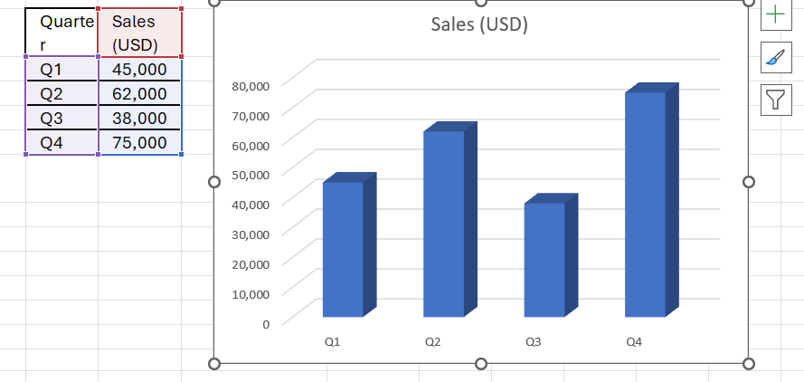

A Column Chart for this data would clearly show that **Q4** had the highest sales and **Q3** had the lowest.

**2. Line Chart**

A **Line Chart** displays data as a series of points connected by straight line segments. Its primary strength is in showing continuous data over time, making it ideal for tracking trends.

**Fundamental Use:**

* **Tracking trends over time:** Monitoring website traffic over a year.
* **Showing rates of change:** Illustrating how the price of a stock changes daily.
* **Comparing multiple series:** Comparing the growth of two different companies side-by-side.

**Example: Website Visitors Over 6 Months**

A Line Chart for this data would immediately visualize a general **upward trend** in visitor numbers, with a slight dip in May before rising again in June.

**3. Pie Chart**

A **Pie Chart** is a circular chart divided into slices to illustrate numerical proportion. Each slice represents a category's percentage contribution to the whole (100%).

**Fundamental Use:**

* **Showing proportions of a total:** Displaying the market share held by competitors.
* **Illustrating budget allocation:** Showing what percentage of the total budget is spent on Rent, Utilities, and Salaries.

**Example: Expense Allocation**

A Pie Chart would highlight the **Salaries** slice as the largest, visually confirming it accounts for half (50%) of the total expenses.

**4. Scatter Chart (X-Y Scatter)**

A **Scatter Chart** uses individual points to plot the values of two variables (x and y). It is crucial for determining the **relationship** or **correlation** between the two variables.

**Fundamental Use:**

* **Showing correlation:** Analyzing if an increase in one variable (like advertising spend) corresponds to an increase or decrease in another (like sales).
* **Scientific and Statistical Data:** Plotting experimental results to find trends or outliers.

**Example: Study Hours vs. Exam Score**

A Scatter Chart for this data would likely show an **positive correlation** (points generally trend upward and to the right), suggesting that more hours studied are associated with higher exam scores.

| Chart Type | Fundamental Use | Key Characteristics |
| --- | --- | --- |
| **Column Chart** | Comparing values across different categories or showing changes over a period of time. | Uses vertical bars. Excellent for showing distinct counts or measurements. |
| **Bar Chart** | Comparing values across different categories, especially when category names are long or there are many categories. | Uses horizontal bars. Essentially a column chart on its side. Good for ranking items. |
| **Line Chart** | Displaying trends or changes in data over a continuous period (like time, years, months, etc.). | Uses points connected by lines. Ideal for spotting patterns, rates of change, and data fluctuations. |
| **Pie Chart** | Showing proportions of a whole; illustrating what percentage each category contributes to the total. | A circular chart divided into slices. Only suitable for one data series. **Avoid** if you have many categories (more than 5-7). |
| **Scatter Chart (or X-Y Scatter)** | Showing the relationship or correlation between two sets of values. | Uses points to plot two variables ( and ). Excellent for scientific data, correlation analysis, and regression. |
| **Area Chart** | Displaying the magnitude of change over time and the contribution of each component to the total. | Similar to a line chart, but the area beneath the lines is filled. Can be **stacked** to show the composition of the total. |
| **Doughnut Chart** | Similar to a pie chart, showing parts of a whole, but it can display multiple data series. | Has a hole in the center. Less common than the pie chart. |
| **Stock Chart** | Visualizing stock price fluctuations, such as high, low, open, and close prices. | Specialized chart type. Requires specific data arrangement. |
| **Surface Chart** | Finding the optimal combinations between two sets of data. Displays data in a 3-D landscape. | Used for analyzing relationships between three variables in a complex dataset. |