CA-3 REPORT

Title: Fruit Freshness Classification using Probabilistic Neural Network
Name | Roll number
SAKSHI ROHILLA | 20231CSD0165
DEEKSHITH P | 20231CSD0129
MOHAMMED YUSUF MAAZ | 20231CSD0166
UDITH SIMHA N | 20231CSD0160

Course Name: DEEP LEARNING FOR DATA SCIENCE
Course Code: CSD2014

Abstract
FruitFresh AI classifies photos of apples, bananas and strawberries as Fresh or Rotten with a Probabilistic Neural Network (PNN) written from scratch in NumPy. After 44 byte-identical duplicates were set aside, 522 unique images were split 70/15/15 into training, validation and test sets. Each image becomes a 468-value feature vector (HSV colour histogram, Lab colour moments, HOG and LBP). The smoothing parameter sigma and the class priors were chosen on validation data only (sigma = 0.2956, uniform priors). On 79 unseen test images the model reached 0.861 accuracy, 0.849 macro-F1 and 0.923 ROC-AUC. Its mean confidence (0.952) is higher than its accuracy, so the scores are over-confident and are not calibrated probabilities. The model is served through a Streamlit web application, and the code and results are in a public GitHub repository.
Repository: Sakshi28r/Fruit_Freshness_Classification

1. Introduction

1.1 Background
Judging whether fruit is fresh or rotten is usually done by eye. Image-based classification can make that check faster and more consistent. A Probabilistic Neural Network, introduced by Specht (1990), is a neural network that classifies with Bayes' rule and Gaussian-kernel density estimates. It has no weights to train by gradient descent, which suits a small dataset and makes every step explainable.

1.2 Problem statement
Given a photo of an apple, banana or strawberry, predict whether it is Fresh or Rotten, report the score behind that decision, and estimate which fruit it is.

1.3 Objectives
- Implement a genuine four-layer PNN (input, pattern, summation, output) with NumPy, without substituting another classifier.
- Extract colour, texture and shape features from the images.
- Handle class imbalance and avoid data leakage between the training, validation and test sets.
- Tune sigma on validation data only and evaluate once on unseen test data.
- Report honest results, including per-fruit performance and the reliability of the confidence score.
- Deliver an interactive Streamlit application.

2. Dataset
The project uses the Kaggle dataset Fruit Freshness Classification (Fresh vs Rotten): 566 images of three fruits.
Fruit | Fresh | Rotten | Total
Apple | 124 | 55 | 179
Banana | 33 | 90 | 123
Strawberry | 220 | 44 | 264
Total | 377 | 189 | 566
Checks run by the code (the original files are only read, never changed):
- All 566 images open correctly; none is corrupted.
- 44 files are byte-identical copies of other images, and no duplicate pair has conflicting labels. Leaving out the copies gives 522 unique images (340 Fresh, 182 Rotten), so a copy of a training image can never appear in the test set.
- Formats are mixed (JPG, PNG, WEBP, JFIF), image sizes vary widely, and some PNGs are transparent. All images are converted to three-channel RGB.
Unique image counts per split (stratified by fruit and class, fixed random seed):
Fruit | Class | Train | Validation | Test | Total
Apple | Fresh | 81 | 17 | 17 | 115
Apple | Rotten | 39 | 8 | 8 | 55
Banana | Fresh | 23 | 5 | 5 | 33
Banana | Rotten | 57 | 13 | 13 | 83
Strawberry | Fresh | 134 | 29 | 29 | 192
Strawberry | Rotten | 30 | 7 | 7 | 44
All | All | 364 | 79 | 79 | 522
Assertions in the code stop the run if any image appears in two splits. The test set has 51 Fresh and 28 Rotten images.
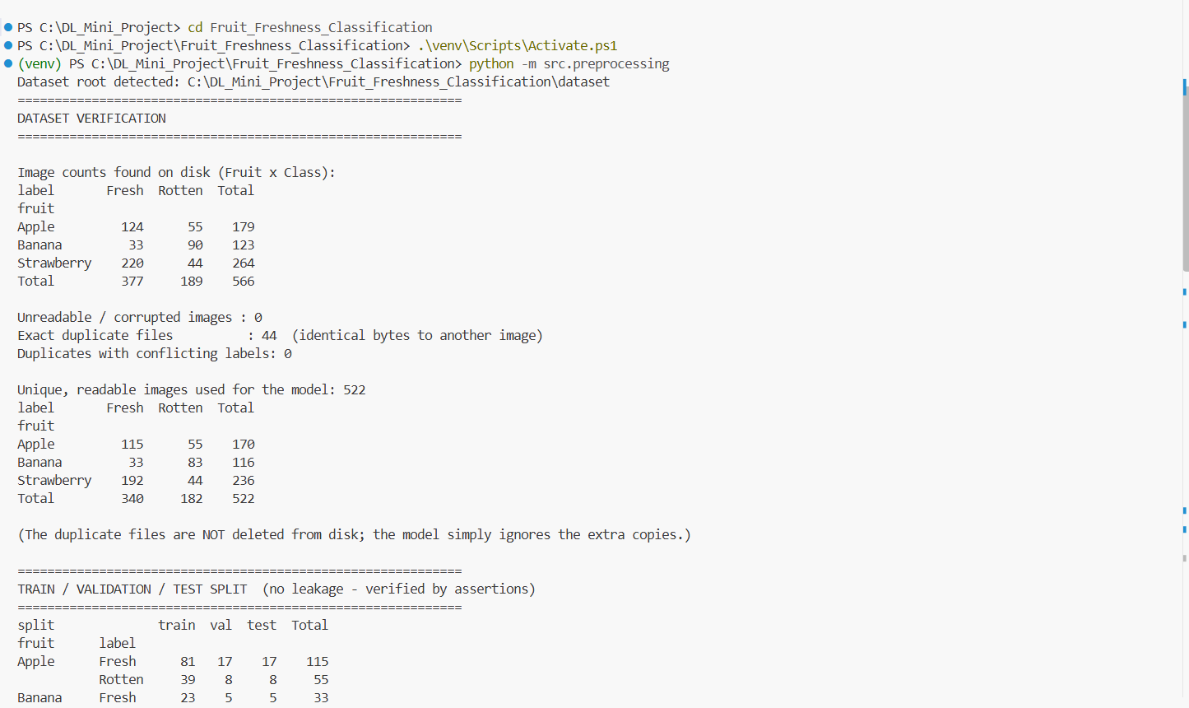
Figure 1: Terminal output of the dataset verification (counts, duplicates and unique images).

3. Methodology

3.1 Pipeline
- Find the dataset folder and build a table with one row per image.
- Verify counts, readability and duplicates.
- Split into training, validation and test sets.
- Load each image, resize it and extract features.
- Standardise the features with training statistics.
- Tune sigma and the class priors on the validation set.
- Evaluate once on the test set and save the model.
- Serve the saved model in a web application.

3.2 Image preprocessing
Pillow opens each image, corrects phone rotation, places transparent pixels on white and converts to RGB. OpenCV then resizes it to 128 x 128 pixels with area interpolation, the method suited to shrinking. A fixed size is needed so that every image gives a feature vector of the same length.

3.3 Feature extraction
Each image is described by 468 numbers from four blocks.
Block | Values | Why it helps
HSV colour histogram (8 x 4 x 4 bins, normalised) | 128 | Hue separates colour from brightness; rotten fruit shifts towards brown and dark.
Lab colour moments (mean and standard deviation of L, a, b) | 6 | Compact brightness and colour cues that follow human perception.
HOG (9 orientations, 16 x 16 cells, 64 x 64 grayscale) | 324 | Edge and shape structure such as wrinkles and bruises.
LBP histogram (uniform, 8 points) | 10 | Fine surface texture such as spots and mould.

3.4 Feature scaling
Every feature is standardised with the training mean and standard deviation, so no feature dominates because of its units. Each block is then divided by the square root of its size, so the 324 HOG values do not outweigh the 6 Lab values in distance calculations. The scaler is fitted on training data only and saved for the application.

4. The Probabilistic Neural Network

4.1 Architecture
A PNN stores the training samples and classifies a new feature vector x with four layers.
Layer | Role
1. Input | Receives the 468 features and passes them to every pattern neuron.
2. Pattern | One neuron per training image; measures similarity to x with a Gaussian kernel.
3. Summation | One neuron per class; averages the kernels of that class to estimate its density.
4. Output | Applies Bayes' rule with the class priors and picks the class with the highest posterior.
Pattern layer, for a stored training vector x_i:
$$k_{i}\left(x\right)=\exp\left(−{\left|\left|x−x_{i}\right|\right|}^{2}/\left(2sigma^{2}\right)\right)$$
Summation layer, for class c with N_c training samples and d = 468 features:
$$p\left(x | c\right)=1/\left({\left(2pi\right)}^{\left(d/2\right)}sigma^{d}N_{c}\right)∗sum_{\left(iinc\right)}k_{i}\left(x\right)$$p(\mathbf{x}\mid c) = \frac{1}{(2\pi)^{d/2}\,\sigma^{d}\,N_c}\sum_{i\in c} k_i(\mathbf{x})
Output layer, with class priors pi_c:
$$P\left(c | x\right)=\left(pi_{c}∗p\left(x | c\right)\right)/\left(sum_{k}pi_{k}∗p\left(x | k\right)\right)$$

$$c_{h}at=\arg{\max_{c}{P\left(c | x\right)}}$$P(c\mid\mathbf{x}) = \frac{\pi_c\,p(\mathbf{x}\mid c)}{\sum_{k}\pi_k\,p(\mathbf{x}\mid k)},\qquad \hat{c}=\arg\max_c P(c\mid\mathbf{x})

4.2 Training
Training a PNN means storing the standardised training vectors of each class. There are no epochs. The only settings to choose are sigma and the prior type.

4.3 Numerical stability
With 468 features the kernel values (for example exp(-300)) underflow to zero in ordinary floating point. All computations are therefore done in log space with the log-sum-exp trick:
$$\log{p\left(x | c\right)}=\log{s}um\exp_{iinc}\left(−{\left|\left|x−x_{i}\right|\right|}^{2}/\left(2σ^{2}\right)\right)−\log{N_{c}}−\left(d/2\right)\log\left(2π\right)−dlogσ$$

The mathematics is unchanged. On small test data the implementation matched a plain textbook version of the formulas to about 1e-16.

4.4 Class priors and imbalance
Each class density is divided by its own sample count N_c, so the larger class is not inflated. The imbalance enters only through the priors. Two options were compared: empirical priors (the training ratio, about 65% Fresh) and uniform priors (equal for both classes). Model selection uses macro-F1, which gives Fresh and Rotten equal weight, because accuracy alone can be dominated by the majority class.

4.5 Choosing sigma
Small sigma lets each training image influence only its close neighbourhood and can over-fit. Large sigma blurs the classes together. Sixty configurations were tried: 30 sigma values (log-spaced from 0.03 to 2.5) with each of the two prior types. The best configuration by validation macro-F1 was chosen, with lower validation log-loss breaking ties. The test set was not used for this choice.

4.6 Confidence score
The application shows the normalised class posteriors P(Fresh | x) and P(Rotten | x); the larger one is the model confidence. These are model scores, not statistically calibrated probabilities: a calibrated 90% would mean about nine in ten such predictions are correct. No calibration method was applied, and Section 6.7 measures the gap.

4.7 Fruit-type estimate
The fruit type shown by the application comes from a second PNN trained on the same features with the labels Apple, Banana and Strawberry. Its sigma (0.401) and priors (uniform) were also tuned on validation data only.

5. Implementation

5.1 Tools
Python with NumPy (the PNN), Pandas, OpenCV and Pillow (image handling), scikit-image (HOG and LBP), scikit-learn (the stratified split and evaluation metrics only, not as a classifier), Matplotlib and Seaborn (plots), Joblib (saving the model) and Streamlit (the interface). The code runs on Windows in VS Code.

5.2 Code structure
File | Purpose
src/preprocessing.py | Dataset discovery, verification, image loading and the leak-free split
src/feature_extraction.py | HSV, Lab, HOG and LBP features
src/pnn.py | The PNN and the block-wise feature scaler
src/train.py | Tuning on validation data, one-time test evaluation, saving the model and results
src/predict.py | Single-image prediction with scores, a borderline note and an unusual-image check
src/make_report.py | Writes the measured results into the README
app.py | Streamlit application FruitFresh AI
main.py | Command-line entry point
Both PNNs (freshness and fruit type) and the scaler are saved to models/pnn_model.joblib, so the application loads them instead of retraining.

5.3 Web application
FruitFresh AI accepts JPG, PNG, WEBP and JFIF images and shows a preview. After the Predict button is pressed it displays the Fresh or Rotten result, the fruit type estimate, the model confidence and both class scores. Unsupported or corrupted files produce a clear error message. A note appears when the winning score is below 70%, and a warning appears when the upload is much farther from every training image than training images are from each other; this warning is a heuristic and does not catch every non-fruit image. An expandable note explains that the scores are not calibrated probabilities.
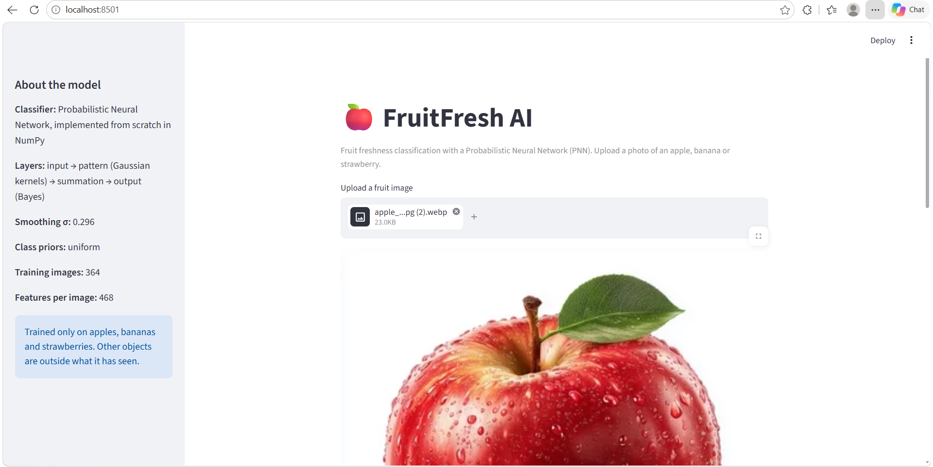
Figure 2: FruitFresh AI after an image has been uploaded.
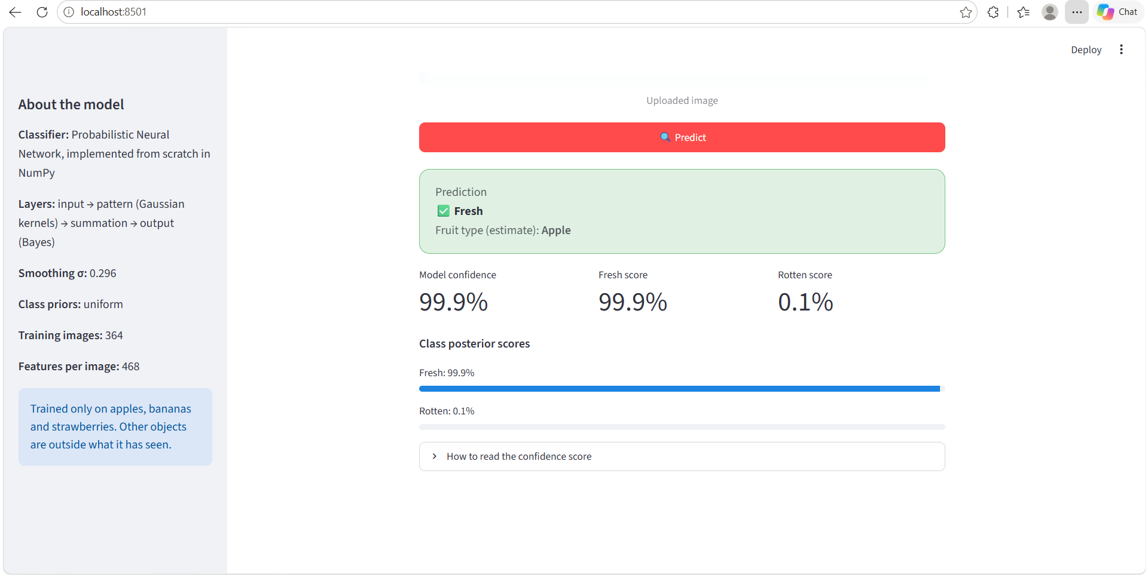
Figure 3: Prediction for an uploaded apple image: Fresh with 99.9% model confidence, fruit type estimated as Apple.
The same page handles rotten fruit. Figures 4 and 5 show a strawberry with visible damage: the application labels it Rotten, shows the Rotten score as the model confidence, and estimates the fruit type as Strawberry. These Fresh and Rotten examples only demonstrate how the interface behaves; the accuracy of the model is measured on the unseen test images in Section 6.
Figure 4: FruitFresh AI after a rotten strawberry image has been uploaded.

Figure 5: Prediction for the uploaded strawberry image: Rotten, model confidence above 99.9%, fruit type estimated as Strawberry.
The application was also tested using a banana image to verify its classification performance for another fruit category. After uploading the banana image, the application displayed a preview and generated the prediction when the Predict button was pressed. The PNN classified the uploaded banana as Fresh and estimated the fruit type as Banana, with model confidence greater than 99.9%. The Fresh score was greater than 99.9%, while the Rotten score was less than 0.1%. This demonstrates that the application can process banana images and display both freshness classification and fruit-type estimation through the same interface.
Figure 6: Banana image uploaded in the FruitFresh AI application.

Figure 7: Prediction result for an uploaded banana image showing Fresh classification, Banana as the estimated fruit type, and model confidence greater than 99.9%.
The full source code, trained model and outputs are available at https://github.com/Sakshi28r/Fruit_Freshness_Classification.

6. Results

6.1 Evaluation protocol
Features and scaler were fitted on the training set, sigma and priors were chosen on the validation set, and the test set was used once after those choices were fixed. All numbers below were computed by the code and saved in the outputs folder; none was typed in by hand.

6.2 Tuning on validation data
Priors | Best validation macro-F1 | Sigma giving the best value | Macro-F1 at sigma = 2.5
Uniform | 0.959 | 0.138 to 0.296 | 0.615
Empirical | 0.945 | 0.03 to 0.218 | 0.430
Uniform priors scored higher, and macro-F1 falls sharply when sigma is large. Several sigma values tie for the best score; the one with the lowest validation log-loss, sigma = 0.2956, was chosen (validation accuracy 0.962). The validation set has only 79 images, so these differences are small.
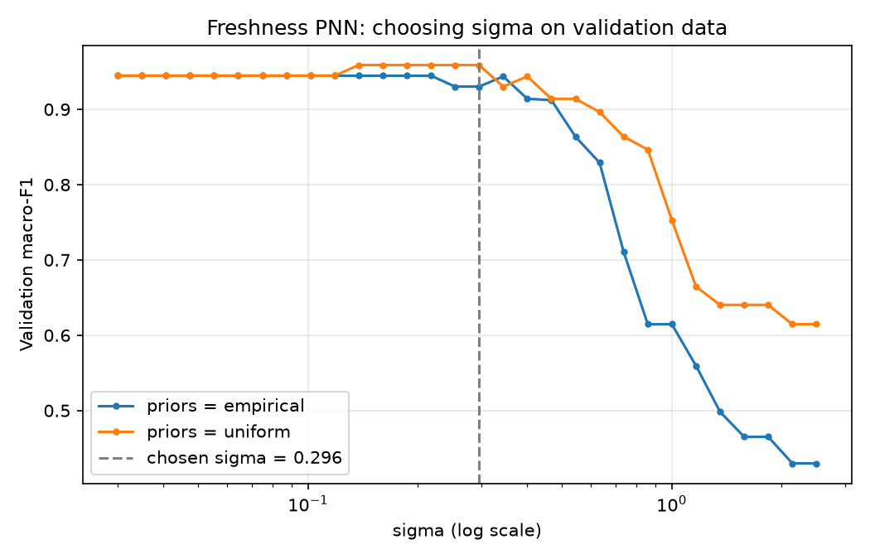
Figure 8: Validation macro-F1 against sigma for both prior types; the dashed line marks the chosen sigma.

6.3 Test-set performance
Metric | Value
Accuracy | 0.861
Precision (macro) | 0.847
Recall (macro) | 0.852
F1-score (macro) | 0.849
Precision / recall / F1 for Rotten | 0.793 / 0.821 / 0.807
ROC-AUC (Rotten = positive) | 0.923
Brier score | 0.112
Test images | 79
Classification report:
Class | Precision | Recall | F1-score | Support
Fresh | 0.900 | 0.882 | 0.891 | 51
Rotten | 0.793 | 0.821 | 0.807 | 28
Accuracy |  |  | 0.861 | 79
Macro average | 0.847 | 0.852 | 0.849 | 79
Weighted average | 0.862 | 0.861 | 0.861 | 79
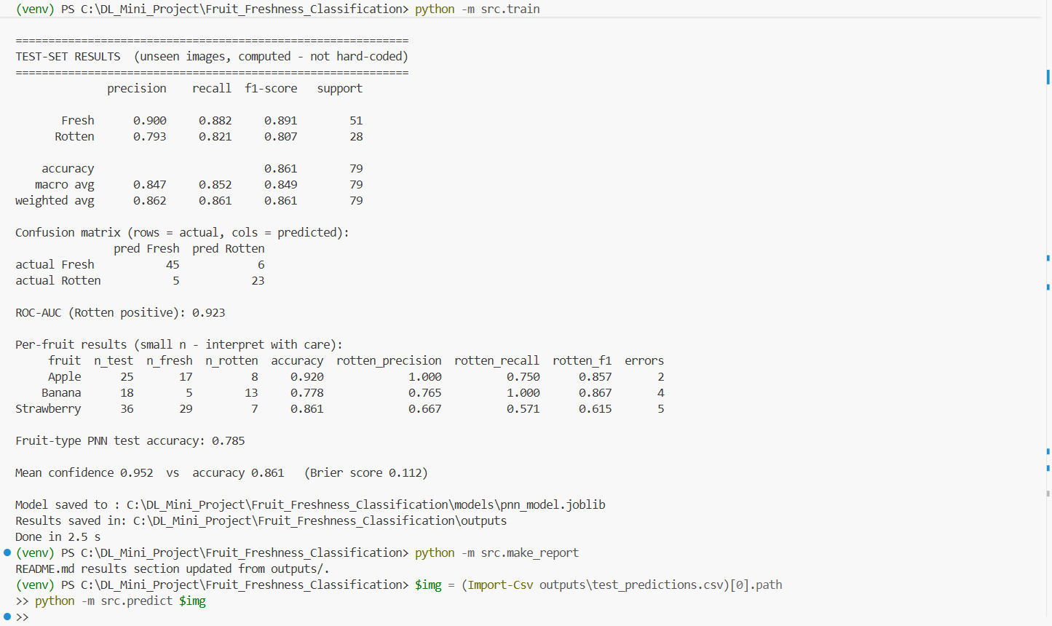
Figure 9: Terminal output of training and evaluation (test-set results, per-fruit table and confidence summary).

6.4 Confusion matrix
Of 79 test images, 68 were classified correctly: 45 Fresh and 23 Rotten. Six Fresh images were predicted Rotten and five Rotten images were predicted Fresh.
 | Predicted Fresh | Predicted Rotten
Actual Fresh | 45 | 6
Actual Rotten | 5 | 23
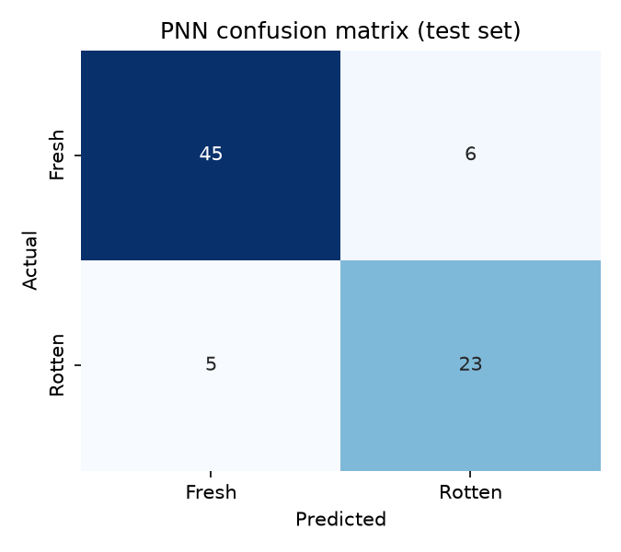
Figure 10: Confusion matrix on the test set.

6.5 ROC curve
The ROC-AUC is 0.923 with Rotten as the positive class, so the Rotten score ranks rotten images above fresh ones well, even though the 0.5 threshold gives some errors.
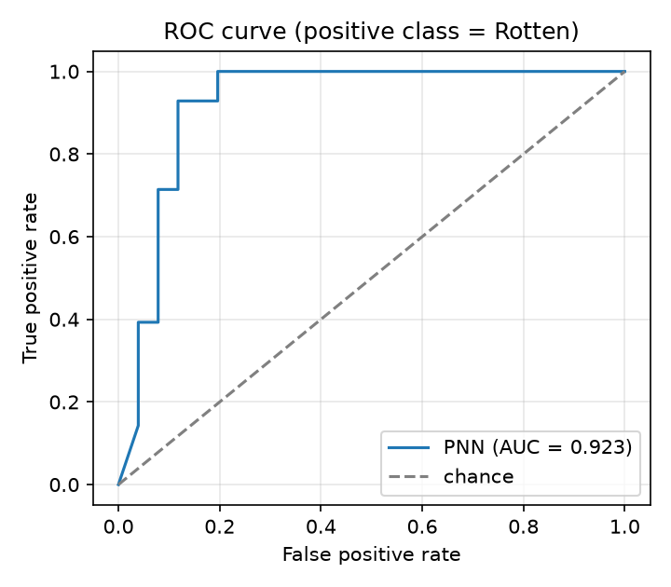
Figure 11: ROC curve on the test set.

6.6 Performance for each fruit
Fruit | Test images | Fresh | Rotten | Accuracy | Rotten precision | Rotten recall | Rotten F1 | Errors
Apple | 25 | 17 | 8 | 0.920 | 1.000 | 0.750 | 0.857 | 2
Banana | 18 | 5 | 13 | 0.778 | 0.765 | 1.000 | 0.867 | 4
Strawberry | 36 | 29 | 7 | 0.861 | 0.667 | 0.571 | 0.615 | 5
Each fruit has few test images, so one image moves these figures by several percentage points. The 11 errors break down as follows.
Fruit | Actual to predicted | Count | Rotten score of the wrong predictions
Apple | Rotten to Fresh | 2 | 0.31 and 0.43
Banana | Fresh to Rotten | 4 | about 1.00 each
Strawberry | Rotten to Fresh | 3 | 0.10 to 0.24
Strawberry | Fresh to Rotten | 2 | 0.86 each
Four of the five Fresh bananas in the test set were called Rotten with a score close to 1.0. Fresh bananas are the smallest group (23 training images), which is a likely reason, but this report did not test that explanation. Strawberry Rotten has the lowest recall (0.571), and only 30 rotten strawberries were available for training.

6.7 Confidence versus calibration
Measure | Value
Mean confidence on the test set | 0.952
Test accuracy | 0.861
Mean confidence when correct | 0.966
Mean confidence when wrong | 0.865
Mean confidence is about 9 percentage points above accuracy, and wrong predictions still carry high scores. The scores are therefore over-confident. They are useful for ranking (ROC-AUC 0.923) but must not be read as calibrated probabilities.

6.8 Fruit-type estimate
The second PNN identified the fruit correctly for 62 of 79 test images (accuracy 0.785). This is adequate for display in the application, which labels the fruit type as an estimate.

7. Discussion and limitations
The PNN reaches 86% test accuracy using only hand-crafted colour, texture and shape features and no gradient training. The gap between validation (accuracy 0.962) and test (0.861) is expected, because sigma was selected as the best of 60 configurations on a small validation set; the test figures are the ones to quote.
- Small dataset: 522 unique images and a 79-image test set. One image changes accuracy by about 1.3 points, and a different split would give somewhat different numbers.
- Class imbalance: Fresh Banana (33 images) and Rotten Strawberry (44 images) are rare. Uniform priors and macro-F1 reduce the bias but cannot add missing information.
- Near-duplicates: only byte-identical files were removed. Visually similar web photos may still sit in different splits and could make results slightly optimistic.
- Hand-crafted features are sensitive to background, lighting and camera, so photos unlike the dataset may be misclassified.
- A PNN keeps every training sample and compares each new image with all of them, which scales poorly to large datasets.
- The model knows only apples, bananas and strawberries and still outputs a score for any other object.
- The scores are not calibrated (Section 6.7).

8. Conclusion and future work
A genuine four-layer PNN was implemented from scratch, tuned without touching the test data, and evaluated on 79 unseen images, giving 0.861 accuracy, 0.849 macro-F1 and 0.923 ROC-AUC. The project also shows where the method struggles: rare classes, small test counts and over-confident scores. The model is available through the FruitFresh AI web application.
Future work: more images per fruit and class, near-duplicate detection, data augmentation, cross-validation for more stable estimates, separate sigma values for each feature block, and a calibration step such as temperature scaling fitted on validation data.

References
- D. F. Specht, “Probabilistic neural networks,” Neural Networks, vol. 3, no. 1, pp. 109-118, 1990.
- E. Parzen, “On estimation of a probability density function and mode,” The Annals of Mathematical Statistics, vol. 33, no. 3, pp. 1065-1076, 1962.
- N. Dalal and B. Triggs, “Histograms of oriented gradients for human detection,” in Proc. IEEE CVPR, 2005.
- T. Ojala, M. Pietikäinen and T. Mäenpää, “Multiresolution gray-scale and rotation invariant texture classification with local binary patterns,” IEEE Trans. Pattern Analysis and Machine Intelligence, vol. 24, no. 7, 2002.
- F. Pedregosa et al., “Scikit-learn: machine learning in Python,” Journal of Machine Learning Research, vol. 12, 2011.
- Kaggle, “Fruit Freshness Classification (Fresh vs Rotten)” dataset.
- Project repository: https://github.com/Sakshi28r/Fruit_Freshness_Classification

Appendix A: Reproducing the results
Run from the project folder with the virtual environment active:
python -m src.preprocessing
python -m src.train
python -m src.make_report
streamlit run app.py

