Customer Shopping Behavior Analysis

Introduction
A leading retail company wants to better understand its customers’ shopping patterns to improve sales, customer satisfaction and long‑term loyalty. The management team has noticed changes in purchasing patterns across demographics, product categories and sales channels and is particularly interested in uncovering which factors (such as discounts, reviews, seasons or payment preferences) drive consumer decisions and repeat purchases. My task was to analyze the company’s customer shopping dataset and answer the overarching question: How can the company leverage consumer shopping data to identify trends, improve customer engagement and optimize marketing and product strategies?

Data
The raw dataset contains 3,900 transactions and 18 columns capturing demographic and transactional information for each customer. Each row represents a unique purchase. The most important variables are listed below:
Column | Description
Customer ID | Unique identifier for each customer
Age | Age of the customer (years)
Gender | Sex of the customer (Male/Female)
Item Purchased | Specific product purchased (e.g., Shirt, Belt, Sandals)
Category | Product category (Clothing, Accessories, Footwear, Outerwear)
Purchase Amount (USD) | Transaction value in US dollars
Location | Customer location (city/state)
Size | Clothing or footwear size ordered
Color | Color of the item
Season | Season when the purchase was made (Spring, Summer, Fall, Winter)
Review Rating | 1–5 rating given by the customer (may have missing values)
Subscription Status | Indicates whether the customer subscribes to the loyalty program (Yes/No)
Shipping Type | Shipping method (Standard or Express)
Discount Applied | Whether a discount was used in the transaction (Yes/No)
Promo Code Used | Duplicate of Discount Applied (dropped during cleaning)
Previous Purchases | Number of previous orders made by the customer
Payment Method | How the transaction was paid (Credit Card, PayPal, Cash, Debit Card, Venmo, Bank Transfer)
Frequency of Purchases | How often the customer generally purchases (Weekly, Fortnightly, Monthly, etc.)

Data Preparation & Modelling (Python)
Data was cleaned and pre‑processed using Python. The key steps were:
- Loading & inspection. The CSV file was loaded with pandas, and summary statistics and missing‐value counts were inspected.
- Handling missing ratings. Missing values in Review Rating were imputed using the median rating within each product category to preserve the distribution of reviews.
- Column standardization. Column names were converted to lowercase with underscores and Purchase Amount (USD) was renamed to purchase_amount_usd for consistency.
- Feature engineering.
- An age_group variable was created by dividing the age distribution into quartiles labelled Young Adult, Adult, Middle‑aged and Senior.
- The textual frequency_of_purchases column was mapped to a numeric purchase_frequency_days variable (e.g., Weekly → 7 days, Monthly → 30 days).
- Removing duplicate information. It was discovered that the promo_code_used column duplicated the discount_applied flag. This column was therefore dropped.
- Loading to SQL. The cleaned DataFrame was exported into a PostgreSQL database table called customer_shopping_behavior so that analytic queries could be run using SQL.
These steps ensured that the data was tidy, consistent and ready for further analysis.

Data Analysis with SQL
Ten SQL queries were written to answer specific business questions. The most important results are summarised below.

Q1 – Revenue by gender
Gender | Total revenue (USD)
Male | 157,890
Female | 75,191
Male customers generated more than double the revenue of female customers, despite being the minority in terms of customer count (see the dashboard section for customer counts). This suggests that male purchasers have a higher average order value and may be a high‑value segment.

Q2 – Customers using discounts but spending above the average order value
The average order value across all transactions is approximately $59.76. Among customers who used a discount, 839 customers still spent above this average. This indicates that discounts are being used by high‑spending customers and may help drive larger basket sizes when applied strategically.

Q3 – Products with the highest average review ratings
Item | Mean rating
Gloves | 3.86
Sandals | 3.84
Boots | 3.82
Hat | 3.80
Skirt | 3.78
These products received the highest customer satisfaction scores. They might be flagship items to feature in marketing campaigns or bundle with lower‑rated products to boost overall perception.

Q4 – Average purchase amounts by shipping type
Shipping type | Avg purchase amount (USD)
Express | 60.48
Standard | 58.46
Orders shipped via Express are slightly more valuable on average. This may reflect that high‑value customers choose faster delivery or that Express shipping encourages larger orders.

Q5 – Does subscription increase spend?
Subscription status | Total customers | Avg spend (USD) | Total revenue (USD)
No | 2,847 | 59.87 | 170,436
Yes | 1,053 | 59.49 | 62,645
Non‑subscribers generated about three times as much revenue simply because there are more of them. Average spend is similar for subscribers and non‑subscribers, implying that the subscription program does not yet drive larger order values; however, subscription may support loyalty (see Q7).

Q6 – Products with the highest discount usage
Item | Discount rate (%)
Hat | 50.00
Sneakers | 49.66
Coat | 49.07
Sweater | 48.17
Pants | 47.37
Half of all Hat purchases are discounted. Discount rates are high across these products, suggesting they are frequently promoted. The company should evaluate whether discounts are necessary for these items or whether margins could be improved.

Q7 – Customer segmentation by prior purchases
Customers were classified into segments based on the number of prior purchases: New (1 previous purchase), Returning (2–10 purchases) and Loyal (>10 purchases).
Segment | Number of customers
Loyal | 3,116
Returning | 701
New | 83
The majority of buyers are Loyal customers, indicating strong repeat business. Strategies should focus on retaining this group and nurturing Returning customers into the Loyal segment.

Q8 – Most purchased products within each category
Category | Rank | Item | Total orders
Accessories | 1 | Jewelry | 171
 | 2 | Belt | 161
 | 3 | Sunglasses | 161
Clothing | 1 | Blouse | 171
 | 2 | Pants | 171
 | 3 | Shirt | 169
Footwear | 1 | Sandals | 160
 | 2 | Shoes | 150
 | 3 | Sneakers | 145
Outerwear | 1 | Jacket | 163
 | 2 | Coat | 161
These rankings show which products are most popular within each category. Blouses and Pants tie as the top clothing items, while Jewelry leads accessories sales. Monitoring these leaders helps optimise inventory and marketing focus.

Q9 – Subscription status of repeat buyers
Only customers with more than five prior purchases were included. Among these repeat buyers, 958 were subscribers and 2,518 were not. In other words, about 27.6 % of repeat buyers subscribed. This suggests an opportunity to convert loyal customers into subscribers by emphasising the benefits of the program.

Q10 – Revenue contribution by age group
Age group | Total revenue (USD)
Young Adult | 62,143
Middle‑aged | 59,197
Adult | 55,978
Senior | 55,763
Revenue is fairly evenly spread across age groups, with Young Adults contributing the most. Marketing efforts can be tailored to each group, but there is no single age demographic dominating sales.

Visualisation & Dashboard (Power BI)
An interactive Power BI dashboard was created to allow stakeholders to explore the data. The dashboard displays high‑level KPIs, geographic maps and a variety of charts. A snapshot of the dashboard is shown below:
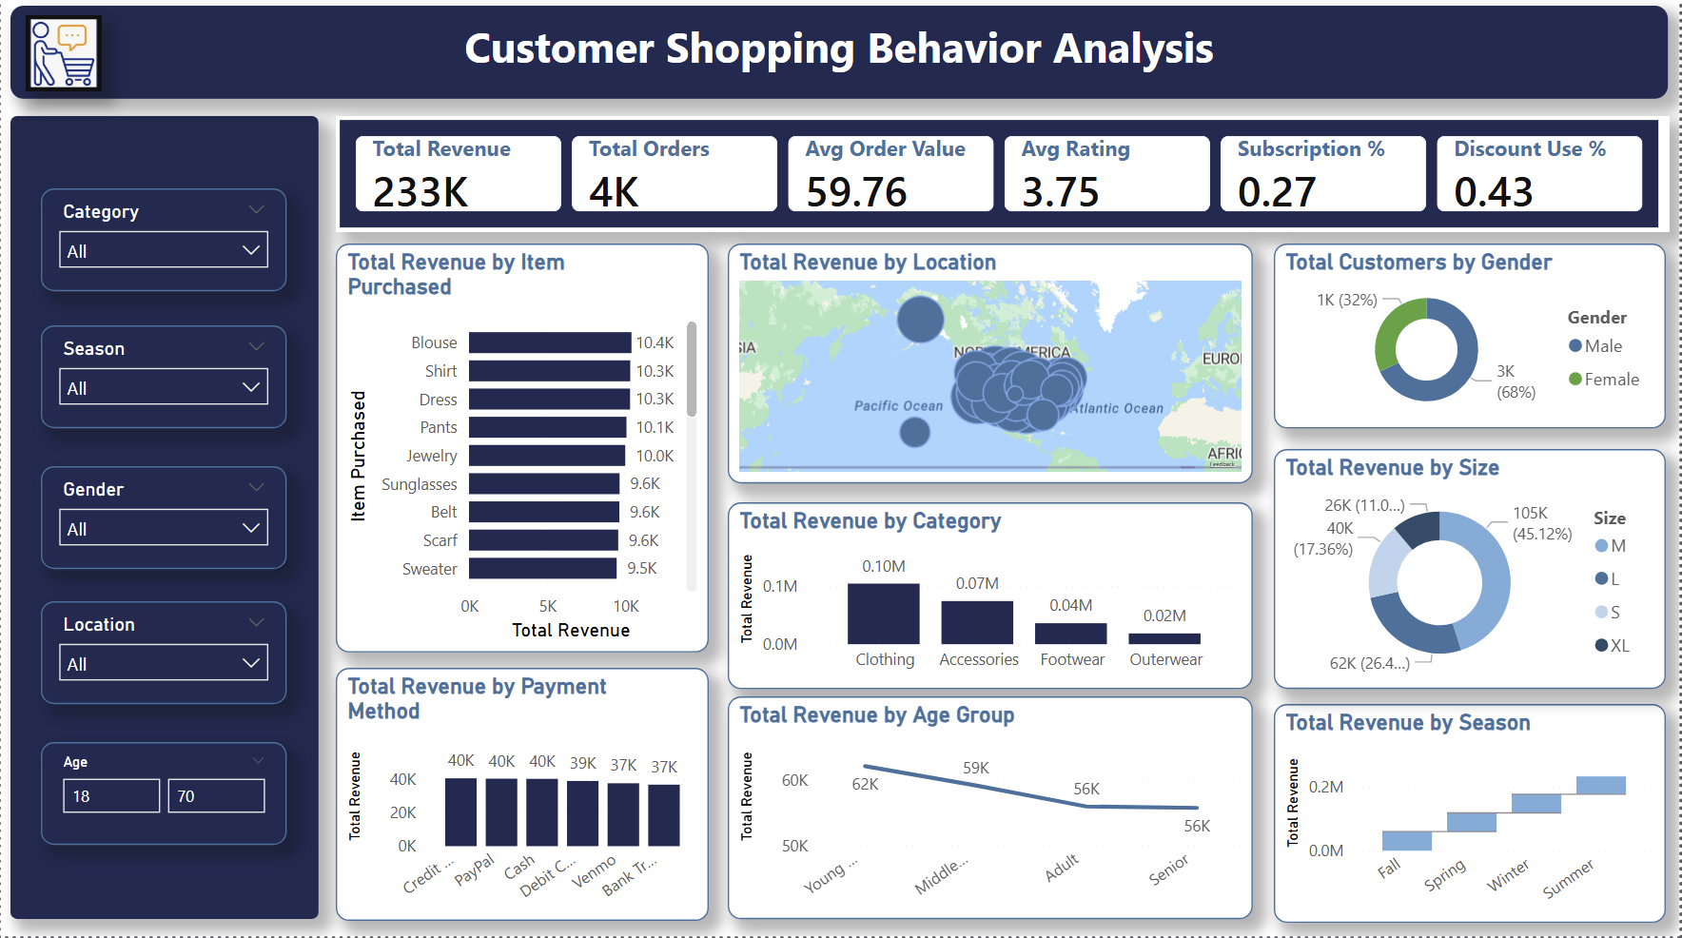
Key highlights from the dashboard include:
- Overall metrics: total revenue of ~233 k USD, ~3.9 k orders, an average order value of ~$59.76, an average review rating of 3.75/5, a subscription rate of 27 % and discount usage on 43 % of orders. These numbers set the context for the analysis.
- Revenue by item: Blouses, Shirts, Dresses, Pants and Jewelry are the top revenue generators, confirming the findings from the SQL queries. Accessories and clothing dominate sales.
- Customer demographics: A donut chart shows that approximately 68 % of customers are female and 32 % are male. Despite this, men spend more per order (see Q1), indicating an opportunity to encourage higher spending among female customers.
- Revenue by size: Medium sizes contribute 45 % of revenue, with Small (26 %), Large (17 %) and Extra‑Large (11 %) following. This information can guide inventory management.
- Category performance: Clothing generates the highest revenue, followed by Accessories, Footwear and Outerwear. Investment should prioritise clothing lines.
- Age and seasonality: A line chart shows that revenue is highest among Young Adults but remains steady across all age segments, while seasonal sales are evenly distributed across Spring, Summer, Fall and Winter, suggesting no strong seasonal effect.
- Payment methods: Revenue is balanced across Credit Card, PayPal, Cash, Debit Card, Venmo and Bank Transfer, indicating that offering multiple payment options remains important.

Key Insights & Recommendations
The analyses reveal several actionable insights:
- Target high‑value male shoppers. Although women represent the majority of customers, men generate more revenue per order. Personalised marketing campaigns and premium products could further increase male spending.
- Optimise discount strategy. High discount rates on Hats, Sneakers and Coats contribute to large sales volumes. The company should evaluate whether such discounts are necessary or whether margins could be improved without reducing demand.
- Nurture subscription adoption among loyal customers. Most repeat buyers are not subscribers. Enhancing the loyalty program with exclusive benefits and communicating its value may encourage subscription, fostering retention and predictable revenue.
- Focus on top‑selling items and categories. Blouses, Pants, Jewelry and Jackets top their categories. Ensuring adequate inventory and featuring these products in promotions can sustain revenue. Conversely, under‑performing categories like Outerwear may require promotional boosts or product line adjustments.
- Maintain diverse payment and shipping options. Customers use a range of payment methods and both Standard and Express shipping. Keeping these options ensures a seamless checkout experience and may encourage higher spending with Express upgrades.
- Tailor marketing by age group. While Young Adults generate slightly more revenue, all age segments contribute meaningfully. Segment‑specific messaging can improve engagement across demographics.

Conclusion
By cleaning and modelling the customer shopping dataset in Python, running targeted SQL queries and building an interactive Power BI dashboard, the project provides a comprehensive view of consumer behaviour. The analyses uncover high‑value customer segments, the impact of discounts and subscriptions, and the products and categories that drive revenue. Acting on these insights can help the company enhance customer engagement, optimise inventory and improve marketing effectiveness.

