Q.1.WAP that accepts marks of five subjects and calculate their sum and percentage.
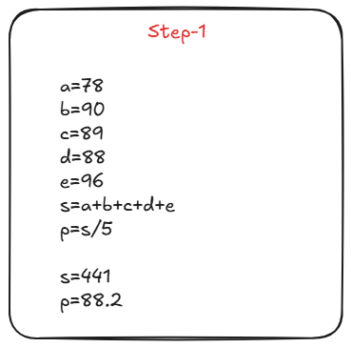
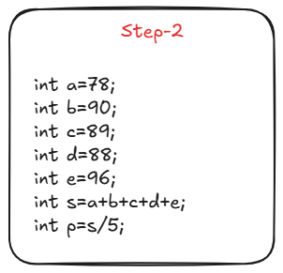
//Step 3
#include <stdio.h>
int main(){
int a=78;
int b=90;
int c=89;
int d=88;
int e=96;
int s=a+b+c+d+e;
float p=s/5;
printf("Sum=%d and percentage=%f",s,p);
return 0;
}

//Step 4
#include <stdio.h>
int main(){
int math=78;
int phy=90;
int chem=89;
int eng=88;
int pps=96;
int sum=math+phy+chem+eng+pps;
float percentage=sum/5;
printf("Sum=%d and percentage=%f ",sum,percentage);
return 0;
}

//Step 5
#include <stdio.h>
int main(){
int math;
printf("Enter maths marrks:");
scanf("%d",&math);
int phy ;
printf("Enter physics marks:");
scanf("%d",&phy);
int chem ;
printf("Enter chemistry marks:");
scanf("%d",&chem);
int eng ;
printf("Enter english marks:");
scanf("%d",&eng);
int pps ;
printf("Enter pps marks:");
scanf("%d",&pps);

int sum=math+phy+chem+eng+pps;
float percentage=sum/5;
printf("Sum=%d and percentage=%f",sum,percentage);
return 0;
}

//Step 6
#include <stdio.h>
int main()
{
int math, phy, chem, eng, pps, sum;
float percentage;

printf("Enter the mark of five subjects: ");
scanf("%d%d%d%d%d",&math, &phy, &chem, &eng, &pps);

sum=math+phy+chem+eng+pps;
percentage=sum/5;
printf("Total mark is %d and percentage obtain is %f",sum,percentage);

return 0;
}

Q.2. WAP to calculate the Simple Interest and CI. The Principal, Amount, Rate of Interest and time are entered through keyboard.
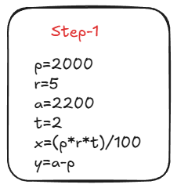

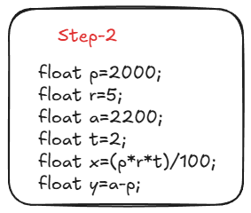
//Step -3
#include <stdio.h>
int main( )
{
float p=2000;
float r=5;
float a=2200;
float t=2;
float x=(p*r*t)/100;
float y=a-p;

printf("x=%f",x);
printf("y=%f",y);
return 0;
}

//Step 4
#include <stdio.h>
int main( )
{
float principal=2000;
float rate=5;
float amount=2200;
float time=2;
float SI=(principal*rate*time)/100;
float CI=amount-principal;

printf("Simple Interest=%f",SI);
printf("Compound Interest=%f",CI);
return 0;
}
//Step 5
#include <stdio.h>
int main( )
{
float principal;
printf("Enter the Principal: ");
scanf("%f",&principal);
float rate;
printf("Enter the Rate: ");
scanf("%f",&rate);
float time;
printf("Enter the time: ");
scanf("%f",&time);

float amount;
printf("Enter the Amount: ");
scanf("%f",&amount);

float SI=(principal*rate*time)/100;
float CI=amount-principal;

printf("Simple Interest=%f",SI);
printf("Compound Interest=%f",CI);

return 0;
}

//Step 6
#include <stdio.h>
int main( )
{
float principal, rate, time, amount, SI, CI;
printf("Enter the principal ,rate, time and amount: ");
scanf("%f%f%f%f",&principal, &rate, &time, &amount);

SI=(principal*rate*time)/100;
CI=amount-principal;

printf("Simple Interest=%f \n",SI);
printf("Compound Interest=%f",CI);

return 0;
}
Q.3.WAP to calculate the area and circumference of a circle.
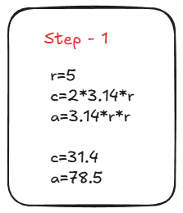
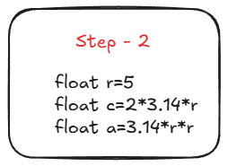
//Step 3
#include <stdio.h>
int main()
{
float r=5;
float c=2*3.14*r;
float a=3.14*r*r;

printf("The area=%f and circumference=%f ",a,c)
return 0;
}

//Step 4
#include <stdio.h>
int main()
{
float radius=5;
float circumference=2*3.14*radius;
float area=3.14*radius*radius;

printf("The area=%f and circumference=%f ",area,circumference);
return 0;
}

