1. Query 1 – total revenue

Query

select sum(total_price) as total_revenue from pizza_sales;

output:-

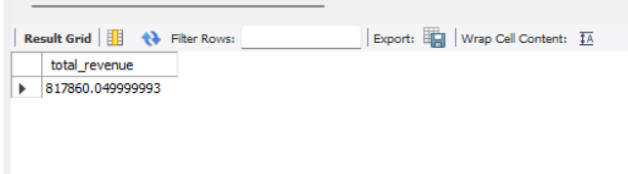

1. Query 2- Average order value

Query:-

select sum(total_price)/count(distinct order_id) as average_order_value from pizza_sales;

output:-

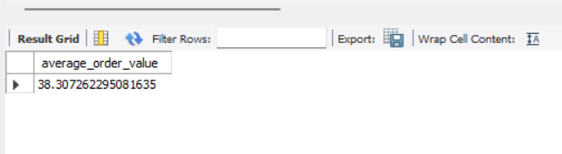

1. Query 3 – Total pizza sold

Query:-

select sum(quantity) as total_pizza_sold from pizza_sales;

output:-

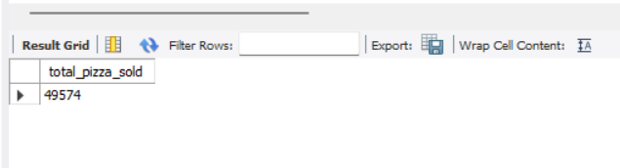

1. Query 4 – Total orders placed

Query:-

select count(distinct order_id) as total_orders_placed from pizza_sales;

Output:-

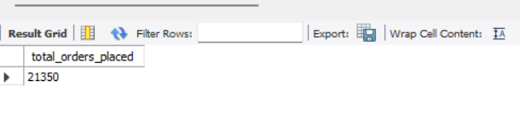

1. Query 5 – average pizza’s per order

Query:-

select round(sum(quantity) / count(distinct order_id),2) as average_pizzas_per_order from pizza_sales;

output:-

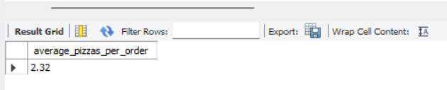

1. Query 6 - Daily trend

Query:-

SELECT

DAYNAME(STR_TO_DATE(order_date, '%d-%m-%Y')) AS order_day,

COUNT(DISTINCT order_id) AS total_orders

FROM

pizza_sales

GROUP BY

order_day

ORDER BY

FIELD(order_day, 'Monday', 'Tuesday', 'Wednesday', 'Thursday', 'Friday', 'Saturday', 'Sunday');

;

## had to query it like this because I did not change the datatype of the fields while importing the data from csv into the new table ##

Output:-

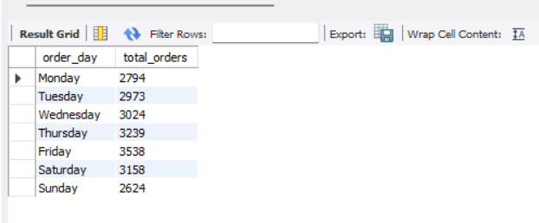

## if the datatype is correct then use this below query

SELECT

DAYNAME(order_date) AS order_day,

COUNT(DISTINCT order_id) AS total_orders

FROM

pizza_sales

GROUP BY

order_day;

1. Query- 7 hourly trend

Query:-

SELECT

HOUR(STR_TO_DATE(order_time, '%H:%i')) AS order_hours,

COUNT(DISTINCT order_id) AS total_orders

FROM

pizza_sales

GROUP BY

order_hours

order by order_hours;

# again had to query it this way because we haven’t changed the data types while creating the table

Output:-

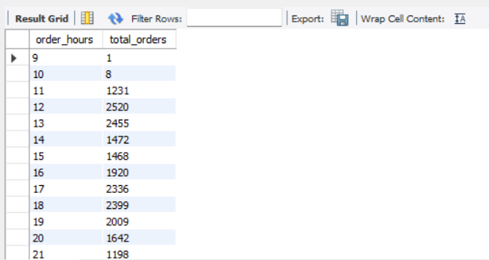



# if the order_time was in correct format then we would have used this below query

SELECT

HOUR(order_time) AS order_hours,

COUNT(DISTINCT order_id) AS total_orders

FROM

pizza_sales

GROUP BY

order_hours;

1. percentage of sales by pizza category:

query:-

SELECT

pizza_category,

SUM(total_price) * 100 / (SELECT SUM(total_price) FROM pizza_sales) AS percentage_of_sales

FROM

pizza_sales

GROUP BY

pizza_category;

output:-

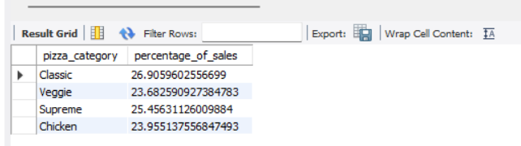

1. percentage of sales by pizza size

query:-

select

pizza_size, sum(total_price) * 100 / (select sum(total_price) from pizza_sales) as percentage_sales

from

pizza_sales

group by

pizza_size

order by percentage_sales desc;

output:-

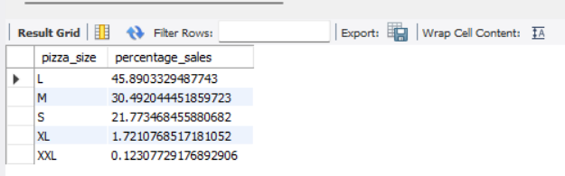

1. Total pizza sold by category

Query:-

select pizza_category, sum(quantity) as total_pizza_sold

from pizza_sales

group by pizza_category;

output:-

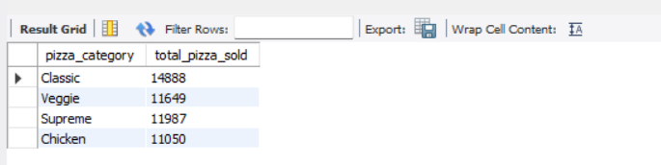

1. Top 5 best sellers by total pizzas sold

Query:-

select pizza_name, sum(quantity) as total_pizza_sold

from pizza_sales

group by pizza_name

order by sum(quantity) desc limit 5;

output:-

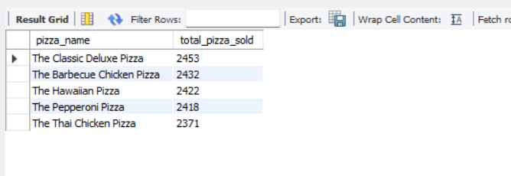

1. Bottom 5 worst sellers by total pizzas sold

Query:-

select pizza_name, sum(quantity) as total_pizza_sold

from pizza_sales

group by pizza_name

order by sum(quantity) limit 5;

output:-

