ACME-ADCS: Implementation Guide
Step-by-step setup of an ACME (RFC 8555) server backed by Active Directory Certificate Services, hosted on IIS, with a non-domain test client. Based on glatzert/ACME-Server-ADCS.

Overview
The ACME server is the only machine that talks to the CA. The client never authenticates to AD, so domain join isn't needed.
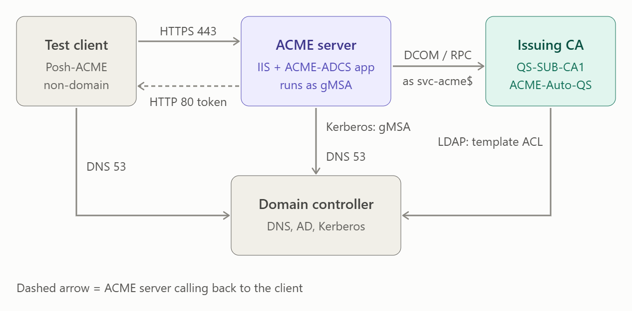
Figure 1. Components and the protocol on each link
The second diagram follows one request in order, from the non-domain test client through to the issued certificate.
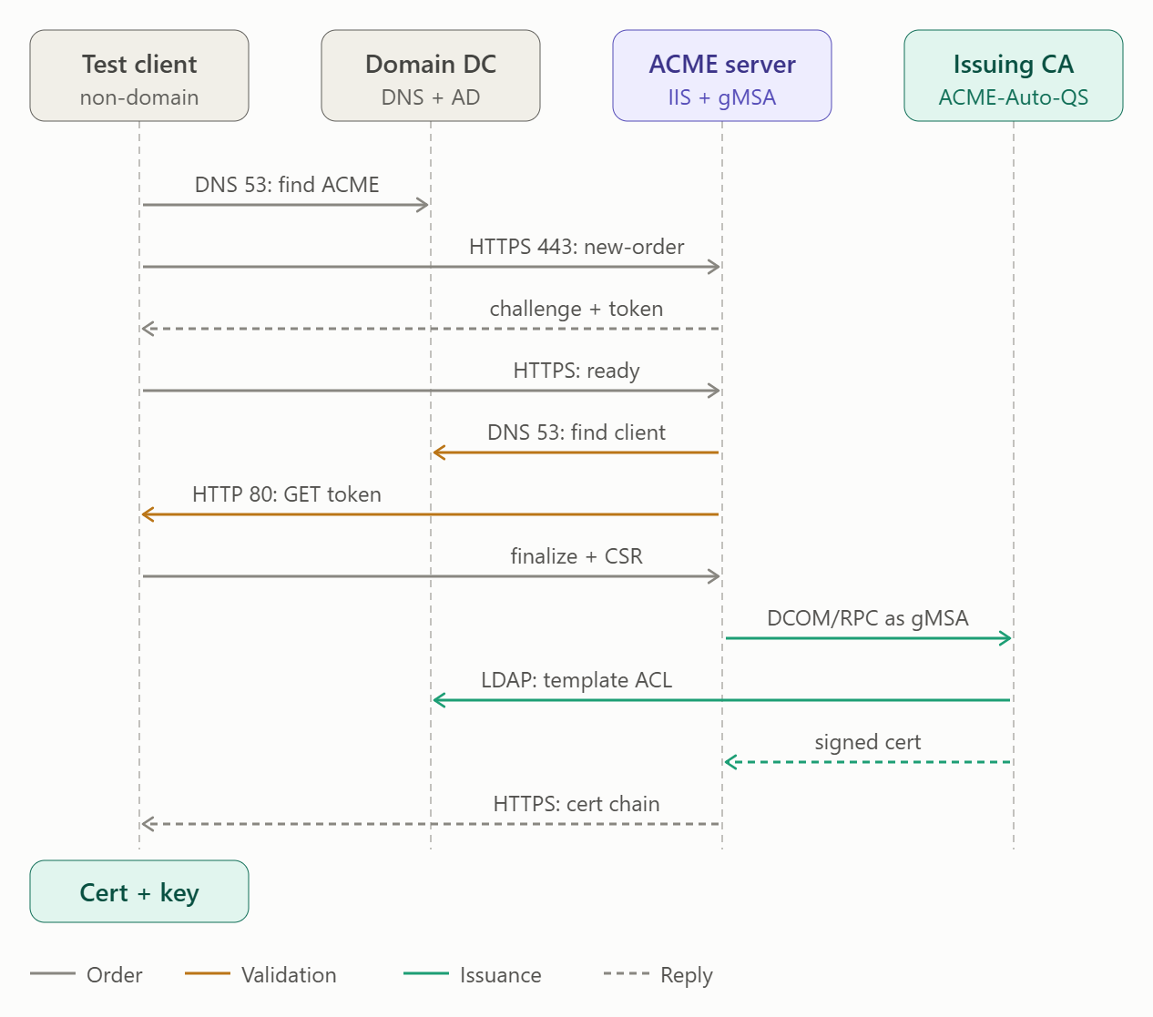
Figure 2. Request flow from the non-domain test client to the issued certificate
Each phase and the process responsible:
Phase | What happens | Protocol and process
Order | The client finds the ACME server by name, trusts its HTTPS certificate (root CA imported), registers an account and creates an order. | DNS 53, HTTPS 443; Posh-ACME signs each request (JWS)
Validation | The ACME server proves the client controls the name. It resolves the client's name, then fetches the token file from the client. | DNS 53, HTTP 80; Posh-ACME WebSelfHost serves the token
Issuance | The client sends a CSR. The ACME server submits it to the CA as svc-acme$. The CA checks the template's permissions in AD, signs the request and returns the certificate. | DCOM/RPC (ICertRequest2), Kerberos for the gMSA, LDAP for the template ACL
Delivery | The ACME server hands the signed certificate chain back to the client. | HTTPS 443

Phase 1: Identity (AD)

1. Create the gMSA
Run on a domain controller or admin workstation.
New-ADServiceAccount -Name svc-acme -DNSHostName qs-ra-acme.quantumspace.com `
-PrincipalsAllowedToRetrieveManagedPassword 'QS-RA-ACME$'

2. Install the gMSA on the ACME server
Install-WindowsFeature RSAT-AD-PowerShell
Install-ADServiceAccount svc-acme
Test-ADServiceAccount svc-acme # must return True
Reboot the ACME server afterwards. If the test returned False, re-run it after the reboot.

Phase 2: CA side (certificate template)

3. Create the template
On the CA, open certtmpl.msc, duplicate Web Server, then set:
- Compatibility: Windows Server 2016 or later (unlocks ECDSA/CNG).
- Cryptography: Key Storage Provider; allow RSA and ECDSA.
- Subject Name: Supply in the request.
- Issuance Requirements: no manager approval.
- Security: svc-acme$ gets Read, Enroll, Autoenroll.
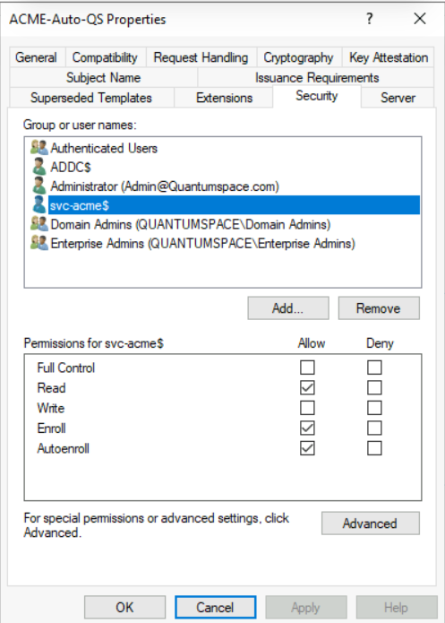
Figure 3. Certificate template properties
Note: The Autoenroll permission on svc-acme$ is required by the project for the process identity. It is not Group Policy autoenrollment, and clients never contact the CA.

4. Publish the template
CA console → Certificate Templates → New → Certificate Template to Issue. An unpublished template can't be requested, even with correct permissions.

5. Check the CA is reachable from the ACME server
certutil -config "QS-SUB-CA1.Quantumspace.com\Quantumspace Issuing CA1" -ping
This is the exact CA name used in the app configuration (step 12). If the ping fails, the config will fail too: check for a name typo, firewall (RPC/DCOM) or CA permissions.

Phase 3: ACME server (IIS + .NET)

6. Add the gMSA to IIS_IUSRS
Add-LocalGroupMember -Group IIS_IUSRS -Member 'QUANTUMSPACE\svc-acme$'
This gives the app pool identity the standard IIS permissions.

7. Install IIS, then the .NET Hosting Bundle (in that order)
Install-WindowsFeature Web-Server,Web-Http-Logging,Web-Request-Monitor,Web-Http-Tracing,Web-Filtering,Web-IP-Security,Web-Mgmt-Console
Then install the .NET 8 (or 10) LTS Hosting Bundle and run iisreset.

8. Get an HTTPS certificate for the ACME server
In certlm.msc, Request New Certificate, with CN/DNS = qs-ra-acme.quantumspace.com. ACME clients only talk HTTPS, and a certificate from your own CA is trusted by every client that trusts your root.
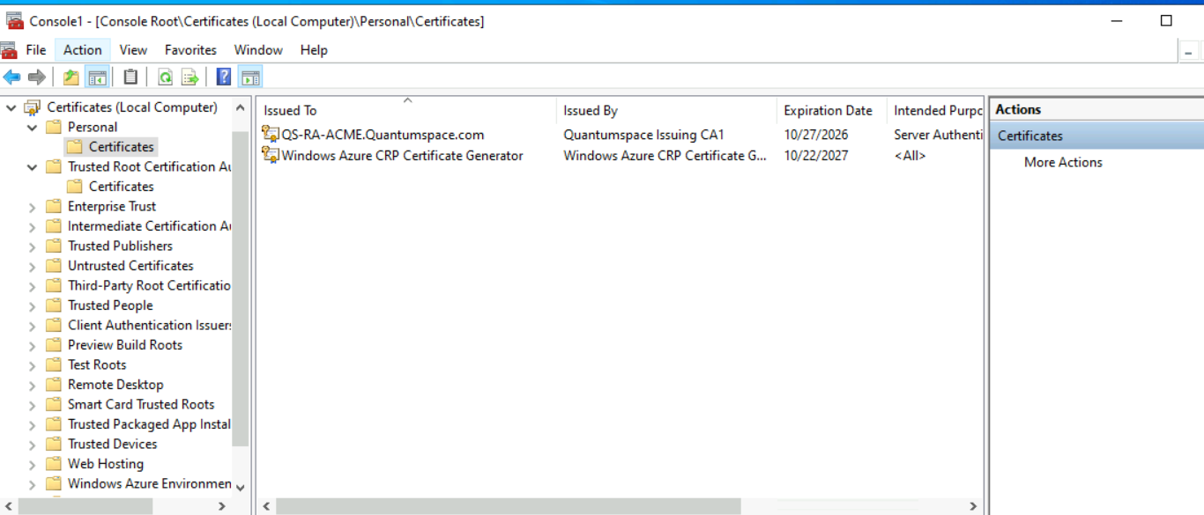
Figure 4. Server certificate in the local computer store

9. Deploy the app files
- Download the release zip (not "Source code") from the project's GitHub Releases: glatzert/ACME-Server-ADCS.
- Extract it directly into C:\inetpub\acme so ACMEServer.ADCS.dll and web.config sit at the top level.
Get-ChildItem C:\inetpub\acme -Recurse | Unblock-File
A downloaded zip carries a block flag, so unblock the extracted files. If the files end up in a sub-folder, web.config won't find them.

10. Create the data folder and set permissions
New-Item -ItemType Directory C:\ACME-ADCS -Force
icacls C:\ACME-ADCS /grant 'QUANTUMSPACE\svc-acme$:(OI)(CI)M'
icacls C:\inetpub\acme /grant 'QUANTUMSPACE\svc-acme$:(OI)(CI)RX'
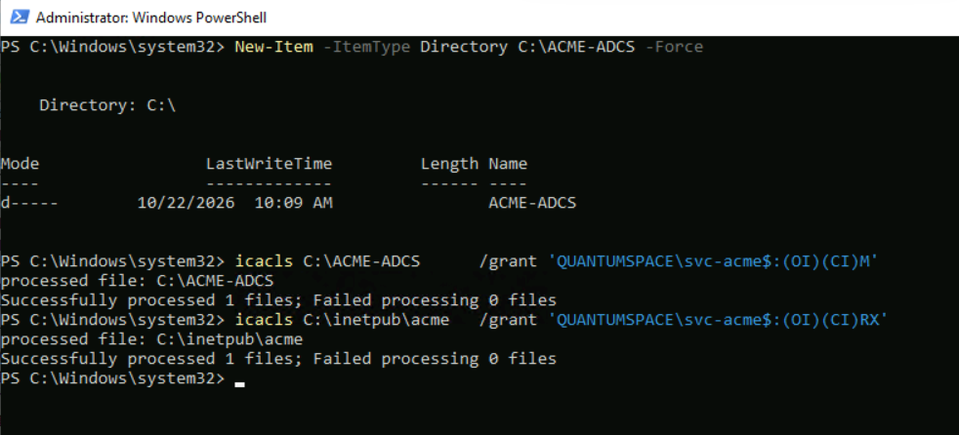
Figure 5. Folder permissions for the gMSA
The app writes accounts, orders and challenges to C:\ACME-ADCS (Modify) but only reads its own program folder (Read and execute). Keeping data outside the web folder is safer.

11. Create the app pool and site
- App pool ACME-ADCS: No Managed Code; identity = custom account QUANTUMSPACE\svc-acme$ (leave the password blank).
- Site ACME-ADCS: path C:\inetpub\acme, that pool, HTTPS binding on 443 with host qs-ra-acme.quantumspace.com and the certificate from step 8.
- Stop the Default Web Site if it holds port 443.
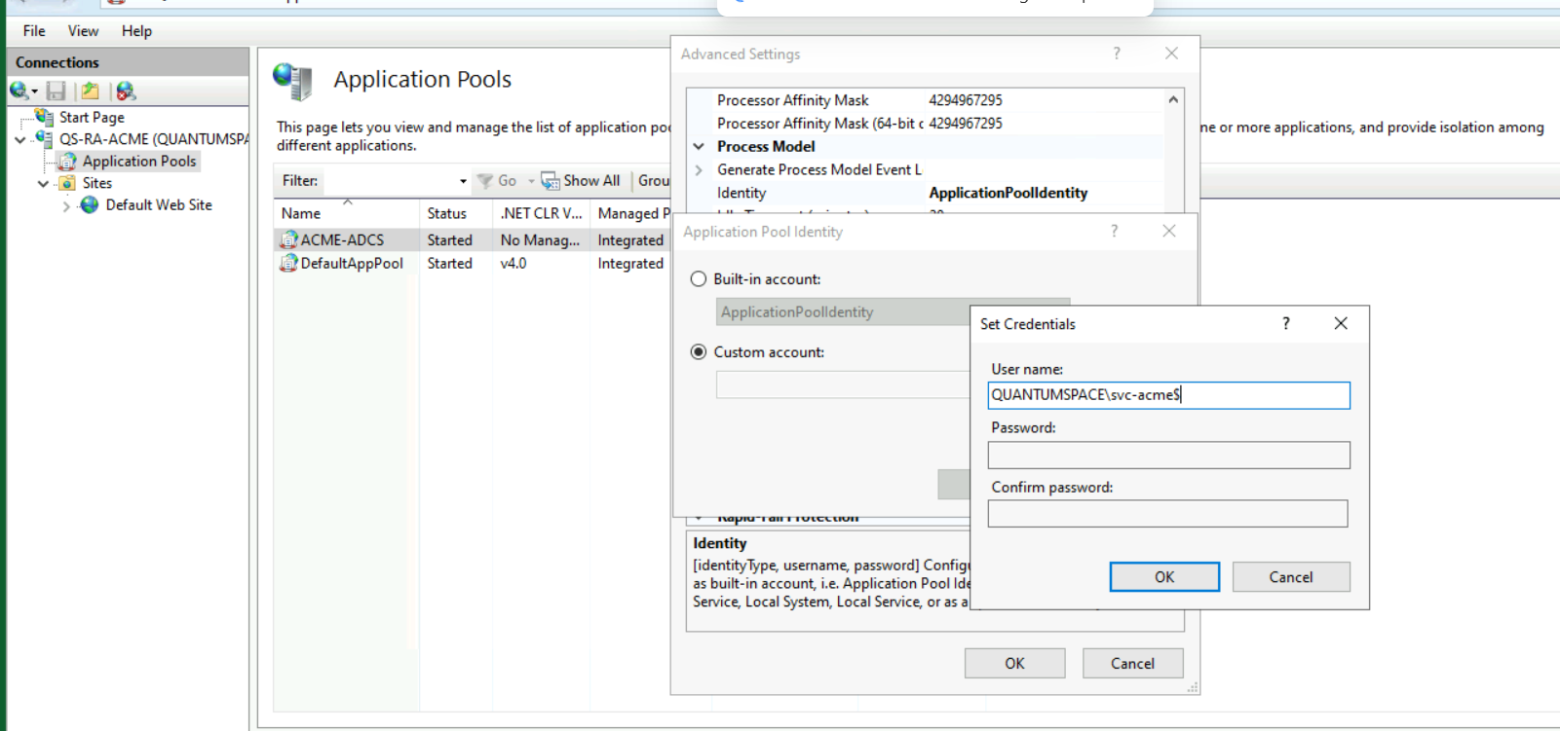
Figure 6. IIS application pool settings
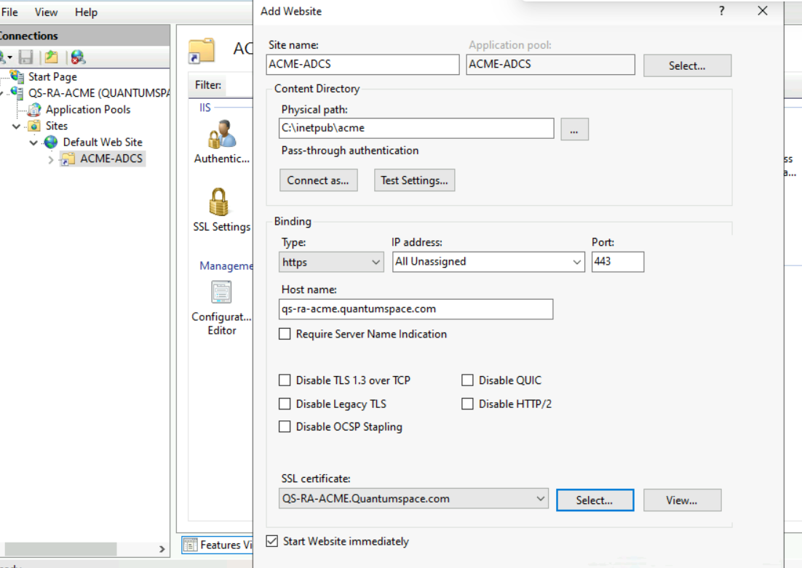
Figure 7. IIS site bindings
Why these settings:
- No Managed Code: ASP.NET Core brings its own runtime.
- The pool identity decides who talks to the CA, so it must be the gMSA.
- A host-name binding makes IIS answer for the name clients use.
Verify:
Get-IISAppPool ACME-ADCS | Select Name, State
Get-Website ACME-ADCS | Select Name, State, PhysicalPath
(Get-ItemProperty IIS:\AppPools\ACME-ADCS).processModel | Select identityType, userName
Get-WebBinding -Name ACME-ADCS
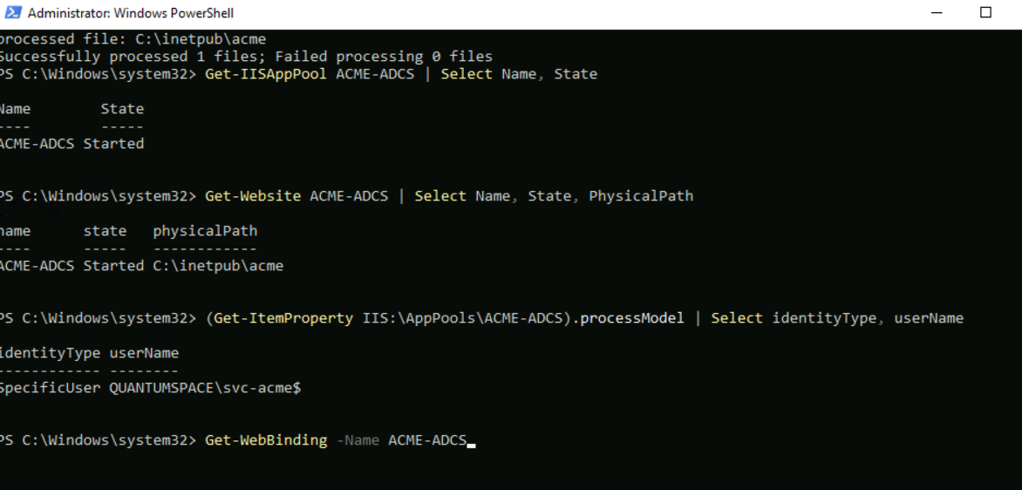
Figure 8. Verification output for pool, site and binding

Phase 4: Configure ACME-ADCS

12. Create appsettings.Production.json
v3.0 reads this file, not appsettings-custom.json.
@'
{
"AcmeFileStore": { "BasePath": "C:\\ACME-ADCS\\" },
"AcmeServer": { "SupportsRevocation": false },
"Profiles": {
"Default-Profile": {
"SupportedIdentifiers": [ "dns" ],
"ADCSOptions": {
"CAServer": "QS-SUB-CA1.Quantumspace.com\\Quantumspace Issuing CA1",
"TemplateName": "ACME-Auto-QS"
}
}
}
}
'@ | Set-Content C:\inetpub\acme\appsettings.Production.json -Encoding UTF8

13. Test the app outside IIS first
cd C:\inetpub\acme
dotnet .\ACMEServer.ADCS.dll
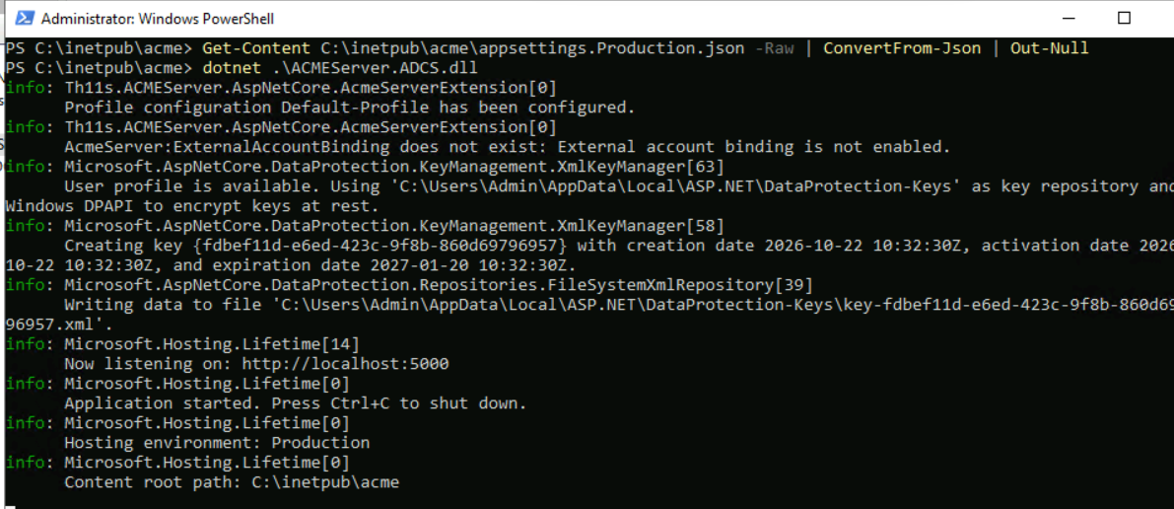
Figure 9. ACME app started from the console

14. Start IIS and check the directory
Restart-WebAppPool ACME-ADCS
Browse to https://qs-ra-acme.quantumspace.com/. You should see JSON containing newNonce, newAccount, newOrder and your profile.
Figure 10. ACME directory JSON in the browser
Checkpoint: this single page proves that IIS, the Hosting Bundle, the gMSA pool, the config and TLS all work.

Phase 5: Test client and issuance
Note: The client does not need to be domain-joined. It only talks ACME over HTTPS and answers a challenge over HTTP; it never authenticates to AD or the CA. Only the ACME server needs a domain identity (the gMSA), because it performs the CA enrollment. The template is set to Supply in the request, so no AD information is taken from the client either.
What the client does need
- Trust your root CA. Import the root certificate into the client's trusted root store, otherwise it rejects the ACME server's HTTPS certificate. (On Linux, point certbot at the PEM with REQUESTS_CA_BUNDLE.)
- Resolve the ACME server's name. Use your internal DNS server, or add a hosts entry for qs-ra-acme.quantumspace.com.
- Be resolvable from the ACME server. For http-01, the ACME server connects to the name in the certificate request, so QS-TEST-SRV.quantumspace.com (or whatever name you request) must resolve to the client's IP from the ACME server. A non-domain machine won't register itself in DNS, so create the A record manually.
- Be reachable on port 80 from the ACME server, with a web server listening there and any firewall or NSG rules in place.

15. Prepare the client's web server for validation
Install-WindowsFeature Web-Server
New-NetFirewallRule -DisplayName "HTTP 80 inbound (ACME)" -Direction Inbound -Protocol TCP -LocalPort 80 -Action Allow
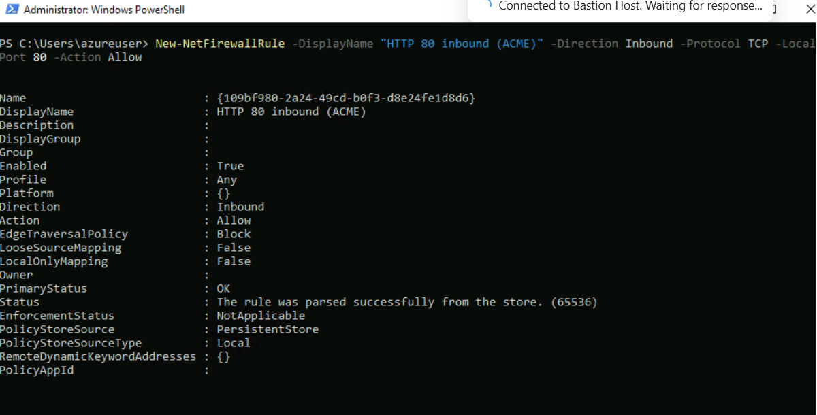
Figure 11. Client web server and firewall rule
Also allow inbound TCP 80 in any Azure NSG from the ACME server's IP, and add an extensionless-file mapping:
$dir='C:\inetpub\wwwroot\.well-known\acme-challenge'
New-Item -ItemType Directory $dir -Force
@'
<?xml version="1.0" encoding="UTF-8"?>
<configuration><system.webServer><staticContent>
<mimeMap fileExtension="." mimeType="text/plain" />
</staticContent></system.webServer></configuration>
'@ | Set-Content "$dir\web.config" -Encoding UTF8
With http-01, the ACME server connects back to the client on port 80 and reads a token file. The client therefore needs a web server on port 80, firewall and NSG rules that allow it, and IIS configured to serve a file with no extension (otherwise it returns 404).

16. Request a certificate from a non-domain machine
Using Posh-ACME on the client:
Install-Module Posh-ACME -Scope CurrentUser
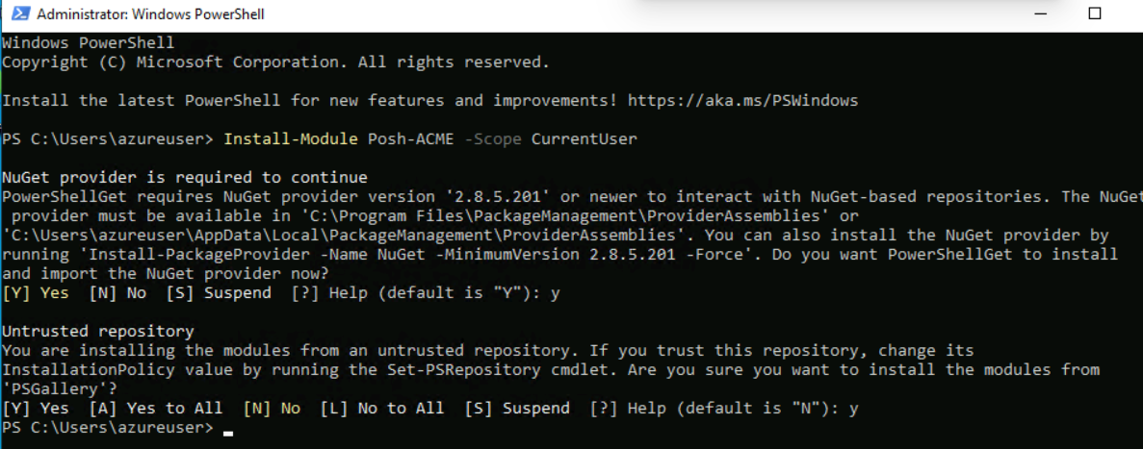
Figure 12. Posh-ACME installation
Confirm the client can resolve the ACME server:
Resolve-DnsName qs-ra-acme.quantumspace.com
Get-DnsClientServerAddress -InterfaceAlias Ethernet* -AddressFamily IPv4
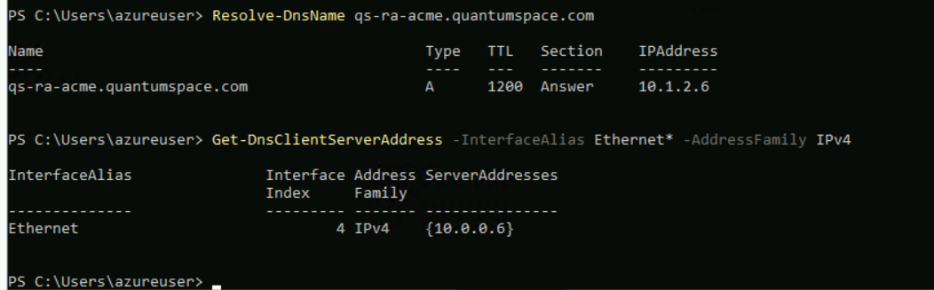
Figure 13. DNS resolution from the client
Point Posh-ACME at the directory. If this works, the directory loads and you are ready to request the certificate. A certificate or TLS error means the root CA is not trusted (requirement 1).
Set-PAServer -DirectoryUrl https://qs-ra-acme.quantumspace.com/
Because the client is not domain-joined, create its DNS A record on the DC and check that the ACME server can resolve it:
Add-DnsServerResourceRecordA -ZoneName quantumspace.com -Name QS-TEST-SRV -IPv4Address <client-ip>
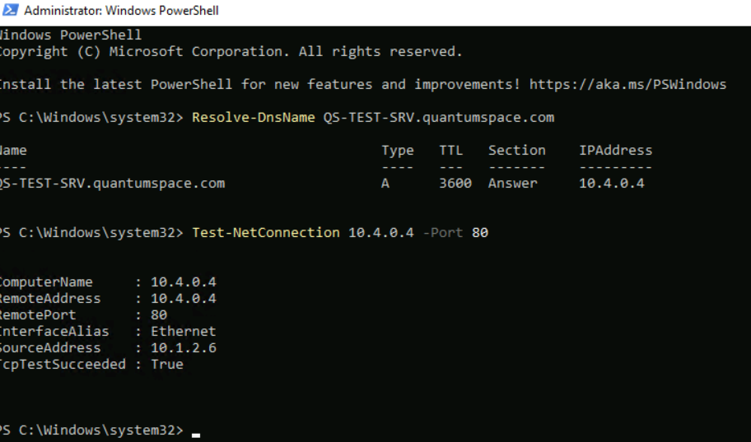
Figure 14. DNS A record for the test machine
Request the certificate:
New-PACertificate QS-TEST-SRV.quantumspace.com -AcceptTOS -Plugin WebSelfHost -CertKeyLength 3072 -Force
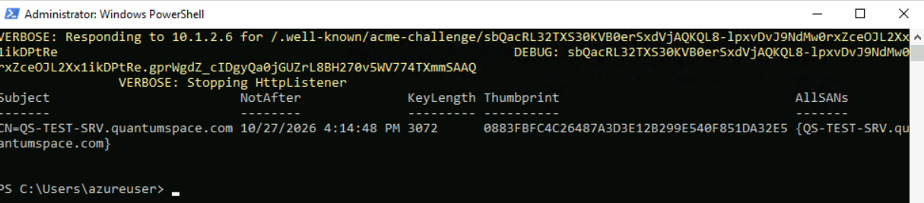
Figure 15. Certificate request output
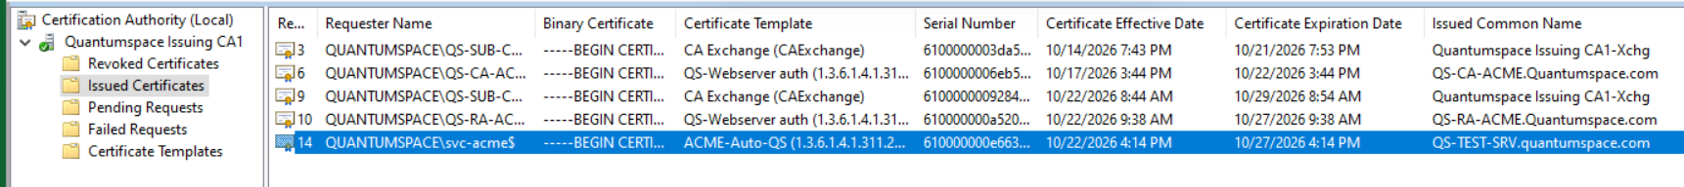
Figure 16. Certificate request result
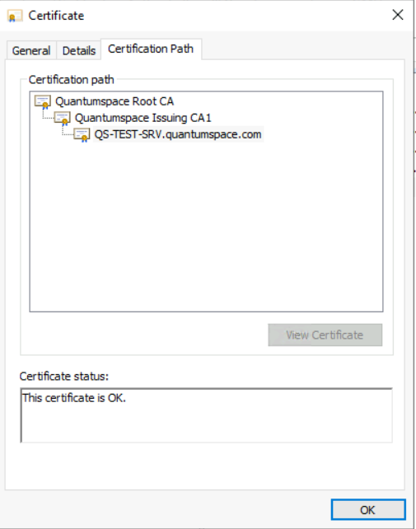
Figure 17. Issued certificate

Troubleshooting

Error 1: ERR_CERT_AUTHORITY_INVALID in the browser
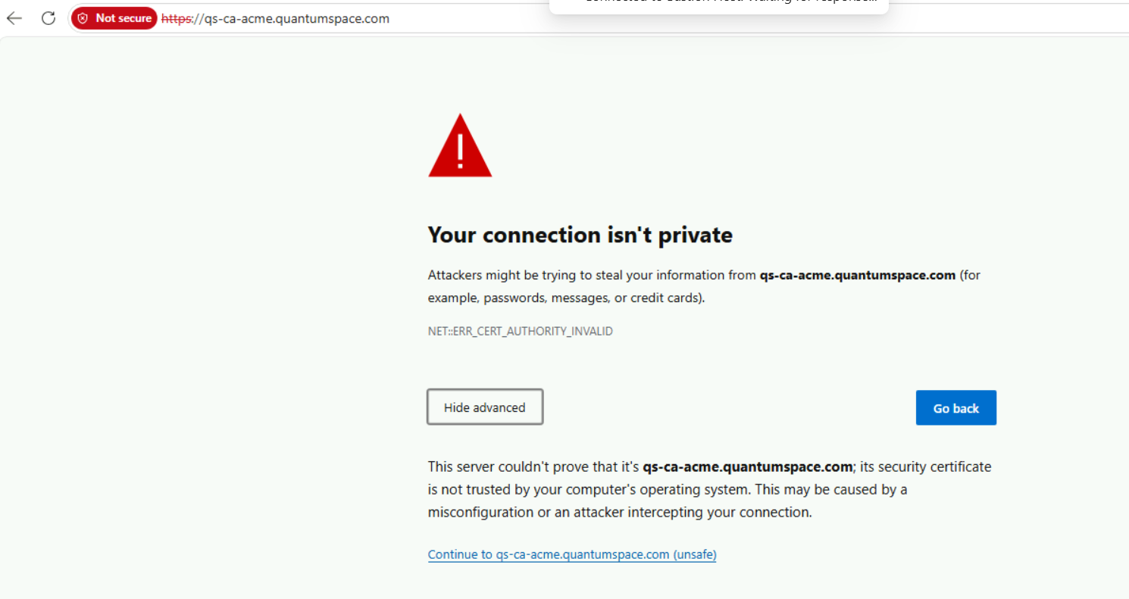
Figure 18. Browser certificate error
The browser reached the ACME server and completed the TLS handshake. This error means the client doesn't trust the CA that issued the server's HTTPS certificate. A non-domain machine doesn't receive the root CA from Group Policy, so install it manually.

Error 2: Challenge validation returns 404 (IIS on the test machine)
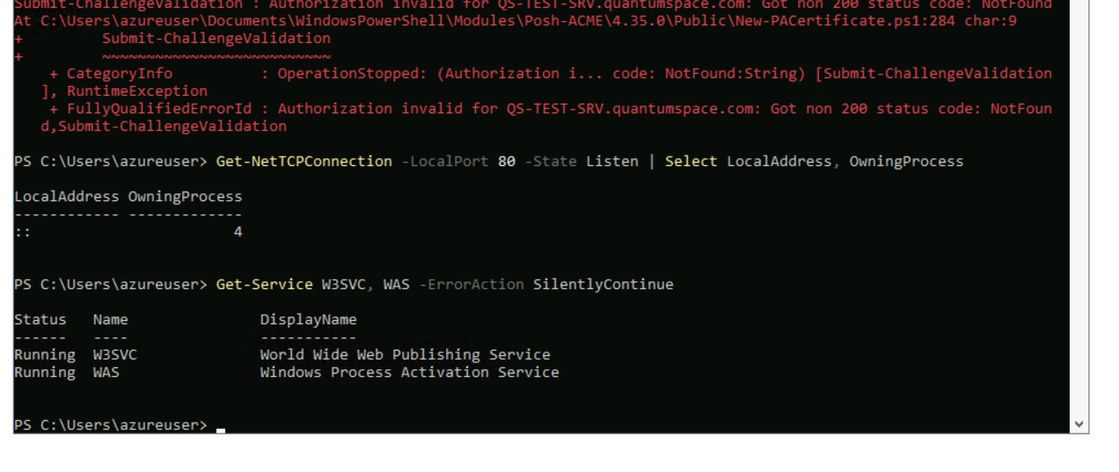
Figure 19. IIS service state on the test machine
IIS is running on the test machine (W3SVC and WAS are Running, and PID 4 is HTTP.sys, which IIS uses). When the ACME server requests the challenge file, IIS answers with its own 404, because Posh-ACME's temporary listener can't take port 80 while IIS holds it.
Fix: stop IIS temporarily, request the certificate, then start it again.
iisreset /stop
# run New-PACertificate (step 16)
iisreset /start

