ADSUL’S TECHNICAL CAMPUS
CHAS, AHILYANAGAR
DEPARTMENT OF MASTER OF COMPUTER APPLICATION



A MINI-PROJECT REPORT ON
Student Grade Calculator

A report submitted in partial fulfillment of the requirements
for the Award of Degree Of
MASTER OF COMPUTER APPLICATION (Under Engineering)
Submitted By
Bothe Sakshi Ashok

SAVITRIBAI PHULE PUNE UNIVERSITY
2025-26

ADSUL’S TECHNICAL CAMPUS
CHAS, AHILYANAGAR

DEPARTMENT OF MASTER OF COMPUTER APPLICATION

CERTIFICATE

This is to certify Ms. Bothe Sakshi Ashok has successfully completed his/her Python System mini project report work on “Student Grade Calculator “at Adsul’s Technical Campus Chas Ahilyanagar in partial fulfillment of the Degree Course in First Year Of Computer Application, in Academic Year 2025-26 Semester I as prescribed by the “Savitribai Phule Pune University “.

(Subject Teacher Name) Prof.Shaikh S.P
GUIDE HOD
Department of Master of Computer Application Department of Master of Computer Application

Place: Ahilyanagar
Date:

Acknowledgement

I feel great pleasure in expressing my deepest sense of gratitude and sincere thanks to my guide (Subject Teacher Name) for their valuable guidance during the Project work, without which it would have been very difficult task. I have no words to express my sincere thanks for valuable guidance, extreme assistance and cooperation extended to all the Staff Members of department of Master of Computer Application.
This acknowledgement would be incomplete without expressing my special thanks to Prof. S.P.Shaikh , Head of the Department (Master Of Computer Application) for their support during the work. I would also like to extend my heartfelt gratitude to my Principal, Dr. P.M. Patil who provided a lot of valuable support, mostly being behind the veils of college bureaucracy.
Last but not least I would like to thanks all the Teaching, Non- Teaching staff members of my department, my parent and my colleagues those who helped me directly or indirectly for completing of this Project successfully.

Student name

TABLE OF CONETNT

Chapter |  | Page No
Chapter 1: Introduction
1.1 | Abstract | 1
1.2 | Scope of system | 2
Chapter 2: Analysis & Design
2.1 | Software Requirement Specification  (Functional And Non-Functional) | 3-4
2.2 | Entity Relationship Diagram (ERD) | 5
2.3 | Graphical User Interface Design | 7-9
Chapter 3: Coding
3.1 | Source Code | 10-17
Chapter 4: Testing
4.1 | Test Report | 18-20
Chapter 5: Conclusion
5.1 | Conclusion | 21
5.2 | Future Aspect | 22

Chapter 1: Introduction
1.1 Abstract
In the modern educational landscape, the efficient management of student data is paramount. Traditional methods of calculating grades manually are not only time-consuming but also prone to human error. The Student Grade Calculator project is a software solution designed to automate the process of computing student averages and assigning grades based on academic performance.

This project utilizes the Python programming language, specifically leveraging the tkinter library to create a Graphical User Interface (GUI). Unlike command-line interface (CLI) programs that can be intimidating for non-technical users, this GUI-based application provides an intuitive, user-friendly environment. Users can input student details and marks for various subjects—Mathematics, Science, English, History, and Computer Science—into clearly labeled fields.

The core functionality of the system revolves around its ability to instantly process these inputs. Upon clicking the "Calculate" button, the underlying algorithm computes the arithmetic mean of the provided marks. It then compares this average against a predefined grading scale (e.g., A for 90+, B for 80+, etc.) to determine the student's letter grade. This immediate feedback loop is crucial for teachers grading assignments or students tracking their own progress.

Furthermore, the system addresses the need for data persistence. A key feature of this application is its ability to store calculation history. By saving each result to a local JSON file, the application ensures that data is not lost when the program is closed. Users can review past calculations in a dedicated "History" tab, which presents the data in a structured table format. This historical tracking capability transforms the tool from a simple calculator into a basic student record management system.

In summary, the Student Grade Calculator aims to simplify the academic grading process. By combining a robust calculation engine with a modern, dark-themed user interface and data storage capabilities, it offers a reliable tool for educational contexts. This report details the development lifecycle of this project, from initial analysis and design to coding, testing, and future enhancements.

1.2 Scope of system
The scope of the Student Grade Calculator system is defined by its current capabilities, target audience, and operational boundaries. It is designed as a standalone desktop application intended for personal or small-scale educational use.
Target Audience: The primary users of this system are educators, teachers, and students. Teachers can use it to quickly grade assignments or term papers without manually calculating averages. Students can use it to simulate their grades ("What if" scenarios) to understand what scores they need to achieve specific GPAs. Parents could also use it to track their children's academic performance.
Functional Scope:
Input Management: The system accepts alphanumeric input for the student's name and numeric input (floating-point numbers) for five distinct subjects. It includes validation logic to ensure marks are within the logical range of 0 to 100.
Calculation Logic: The system performs mathematical operations to derive the average score. It implements conditional logic to map this average to a specific grade tier (A, B, C, D, F).
Data Persistence: The system manages a local database file (history.json). It handles the reading and writing of data to this file, ensuring that records persist between sessions.
User Interface: The system provides a graphical interface featuring a Dark Mode design. This includes navigation tabs ("Calculator" and "History"), input forms, action buttons, and data visualization components (tables).
Technical Scope: The system is built using Python 3.x. It relies on the standard library (tkinter, json, os), meaning it has zero external dependencies. This ensures high portability; the application can run on any machine where Python is installed, including Windows, macOS, and Linux.
Limitations (Out of Scope):
Network Connectivity: The current system operates offline. It does not sync data to the cloud or allow multiple users to access a shared database simultaneously.
Authentication: There is no login system. The application assumes a single-user environment where security is managed at the operating system level.
Dynamic Subjects: The subject list is currently hardcoded to five specific subjects. Adding or removing subjects requires code modification.
Chapter 2: Analysis & Design
2.1 Software Requirement Specification (Functional And Non-Functional)
The Software Requirement Specification (SRS) document describes the expected behavior of the system.
Functional Requirements
These define what the system must do.
FR-01: Accept Student Details
The system shall provide a text field for the user to enter the Student's Name.
The system shall provide five numeric input fields for marks in Math, Science, English, History, and Computer Science.
FR-02: Validate Input
The system shall verify that the Student Name is not empty.
The system shall verify that all mark fields contain valid numbers.
The system shall ensure marks are between 0 and 100 inclusive.
If validation fails, the system shall display an error message popup describing the issue.
FR-03: Calculate Results
The system shall calculate the average by summing the five marks and dividing by 5.
The system shall assign a grade based on the average:
90-100: A
80-89: B
70-79: C
60-69: D
Below 60: F
FR-04: Display Output
The system shall display the calculated Average (rounded to 2 decimal places) and the Grade on the main screen.

FR-05: Save History
Upon successful calculation, the system shall automatically append the result (Name, Average, Grade) to a persistent storage file.
FR-06: View History
The system shall provide a "History" tab.
This tab shall display a list of all previously saved records.
FR-07: Clear Inputs
The system shall provide a "Clear" button that resets all input fields and the result display to their initial state.
Non-Functional Requirements
These define how the system performs its functions.
NFR-01: Usability
The interface shall use a "Dark Mode" color scheme to reduce eye strain.
The font size shall be legible (minimum 10pt for body text).
Navigation between Calculator and History shall be done via clear tabs.
NFR-02: Performance
Calculations shall be performed instantly (under 100ms).
The application launch time shall be under 2 seconds.
NFR-03: Reliability
The system shall handle corrupted history files gracefully (e.g., by creating a new one) without crashing.
The system shall not crash upon entering invalid text (e.g., letters in a number field).
NFR-04: Portability
The code shall be platform-independent, running on any OS with a standard Python interpreter.

2.2 Entity Relationship Diagram (ERD)
Although the Student Grade Calculator uses a file-based storage system (JSON) rather than a relational database (SQL), we can still model the data structure using Entity-Relationship concepts. The primary entity in our system is the Student Record.
Since the system is currently a single-entity model (it stores a list of independent records), the ERD is simplified. However, conceptually, the data schema is defined as follows:
Entity: Student Record
This entity represents a single grading event for a student.
Attributes:
1.Name (String):
Description: The full name of the student.
Constraint: Cannot be empty.
Example: "John Doe"
2.Marks (List/Array of Floats):
Description: The raw scores obtained in the subjects.
Note: In the saved JSON, this is implicitly stored as the calculated average, but conceptually the record is derived from these marks.
3.Average (Float):
Description: The calculated arithmetic mean of the marks.
Constraint: 0.00 to 100.00.
Example: 85.50
4.Grade (Char/String):
Description: The categorical evaluation of the average.
Domain: {'A', 'B', 'C', 'D', 'F'}
Example: 'B'

Data Flow Representation
While a traditional ERD shows relationships between multiple tables (e.g., Students, Courses, Enrollments), our flat-file structure implies a single "Table" called History.
Schema Visualization:
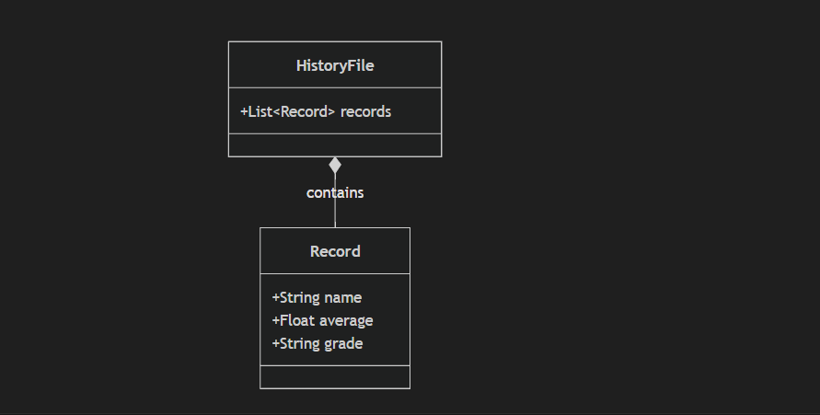
JSON Structure: The physical implementation of this model in history.json looks like this:
[ {
"name": "Alice Smith",
"average": 92.5,
"grade": "A"
},
{
"name": "Bob Jones",
"average": 78.0,
"grade": "C"
} ]
This structure allows for infinite scalability of records, limited only by disk space. The application reads this entire array into memory upon loading to populate the History view.

2.3 Graphical User Interface Design
The Graphical User Interface (GUI) is the bridge between the user and the underlying logic. For this project, a Modern Dark Theme was chosen to provide a professional and aesthetic look.
Design Philosophy
Minimalism: The interface avoids clutter. Only essential elements (inputs, buttons, results) are displayed.
Ergonomics: Dark backgrounds (#2b2b2b) with light text (#ffffff) reduce glare and eye strain, making the app comfortable to use for extended periods.
Feedback: Interactive elements like buttons change color when hovered over (e.g., Blue to Darker Blue), providing visual feedback to the user.
Layout Structure
The application window is divided into several key zones:
1. The Main Window:
Dimensions: 500x650 pixels. This vertical aspect ratio mimics a mobile or tablet view, which is familiar to modern users.
Title Bar: Displays "Grade Calculator Pro".
2. Navigation (Tabs):
Located at the top, the ttk.Notebook widget provides two tabs: "CALCULATOR" and "HISTORY".
The active tab is highlighted with a darker background and blue text, while the inactive tab fades into the background.
3. Calculator Tab (Input Zone):
Student Name Field: A prominent text entry box at the top.
Subject Fields: Five vertically stacked rows. Each row contains the Subject Label on the left and the Input Entry on the right. This alignment ensures readability.
Action Buttons:
Calculate & Save: A large, blue primary button. Its color signifies it is the main action.
Clear: A red secondary button. The color red warns the user that this action is destructive (erasing inputs).
Result Display: A centered label at the bottom. It uses a large font size to make the final result immediately visible.
4. History Tab (Output Zone):
Data Table: A ttk.Treeview widget takes up most of the space. It has columns for Name, Average, and Grade.
Scrollbar: A vertical scrollbar allows navigation through long lists of history.
Refresh Button: Located at the bottom to reload data if the file changes externally.
Color Palette
Background: #2b2b2b (Dark Gray)
Card/Container: #333333 (Medium Gray)
Primary Accent: #007acc (Blue)
Error/Danger: #d9534f (Red)
Text: #ffffff (White)
Screenshots
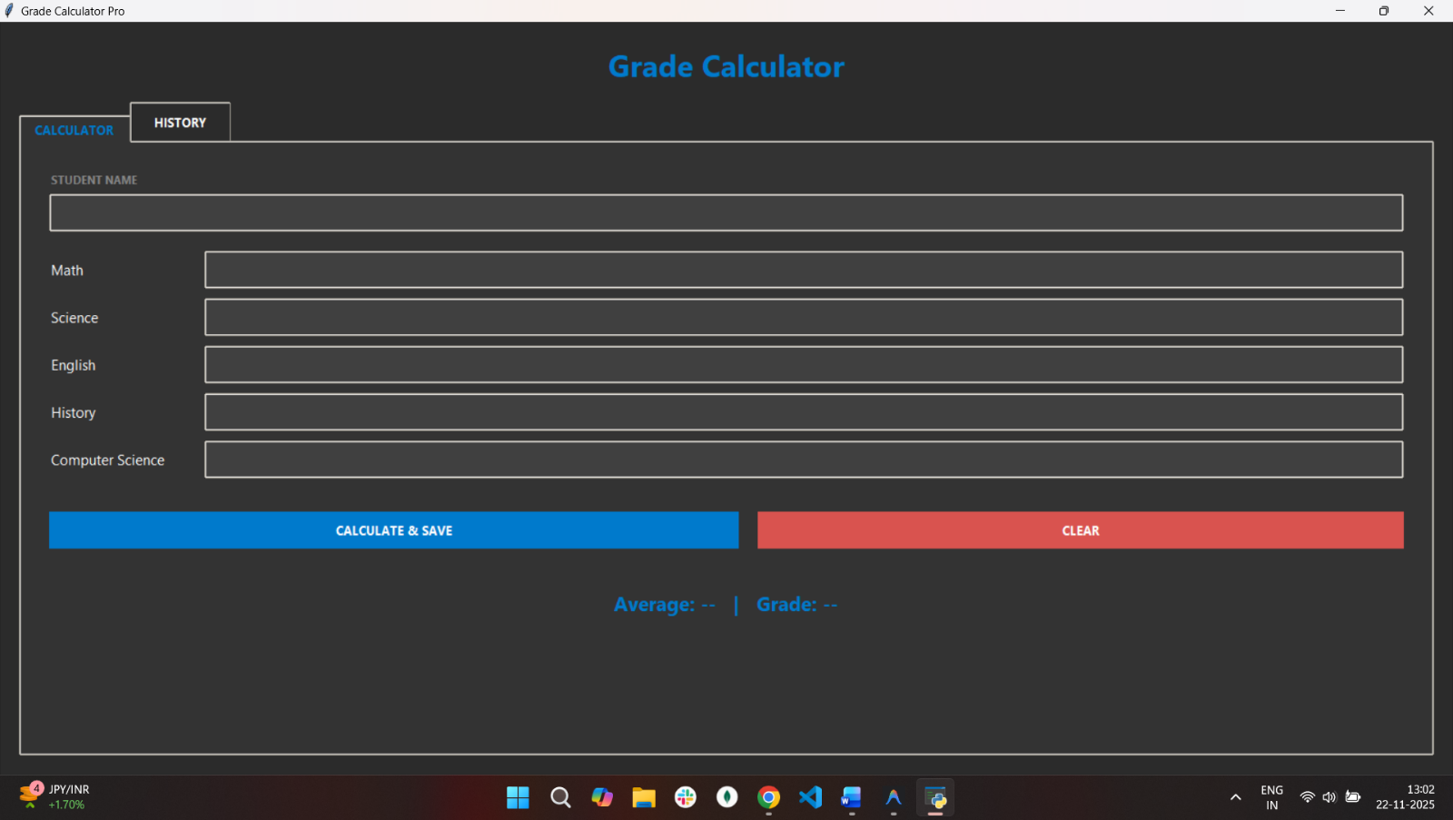
Home page:
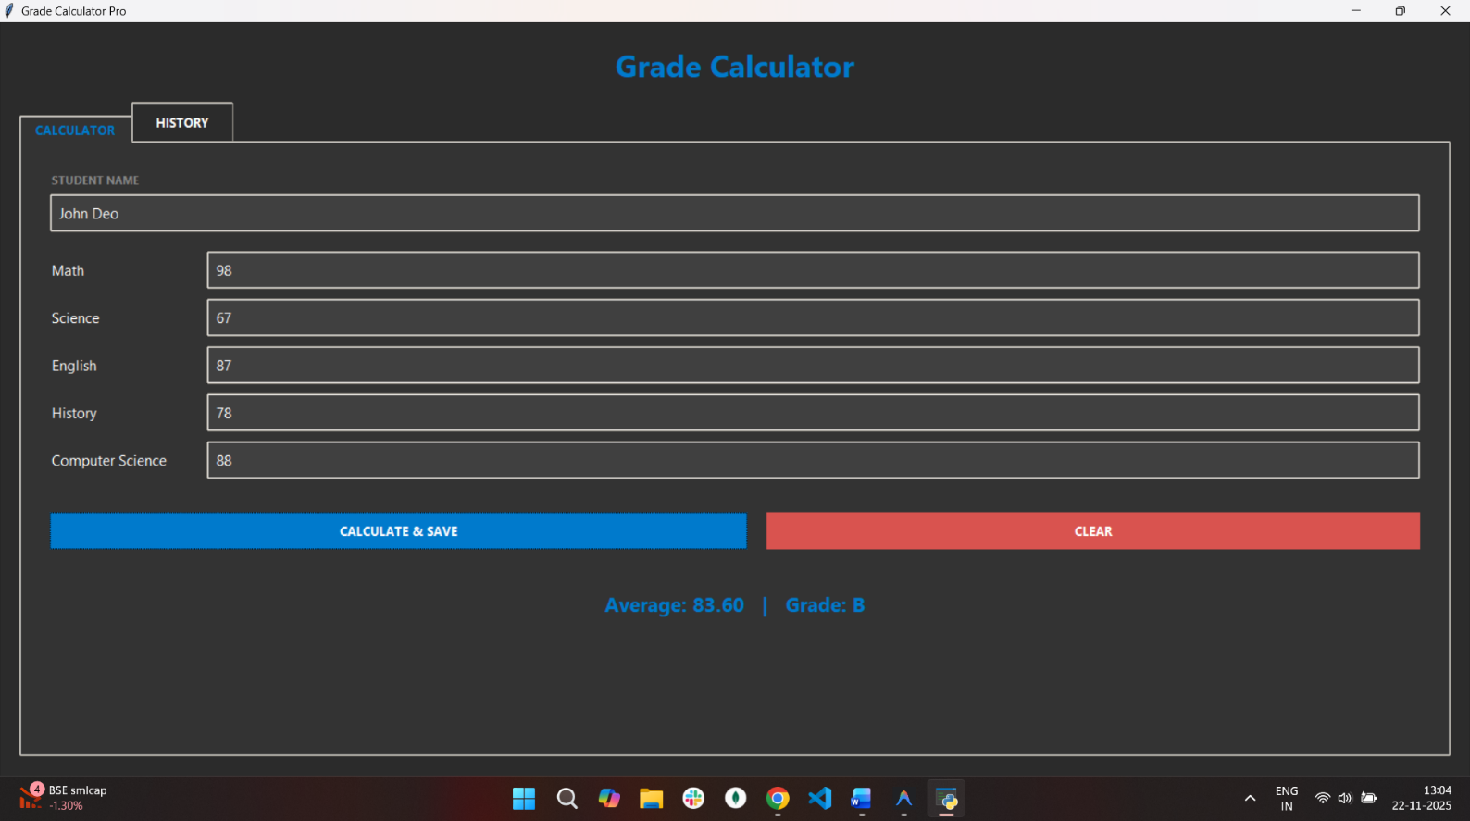
Home page with filled values:

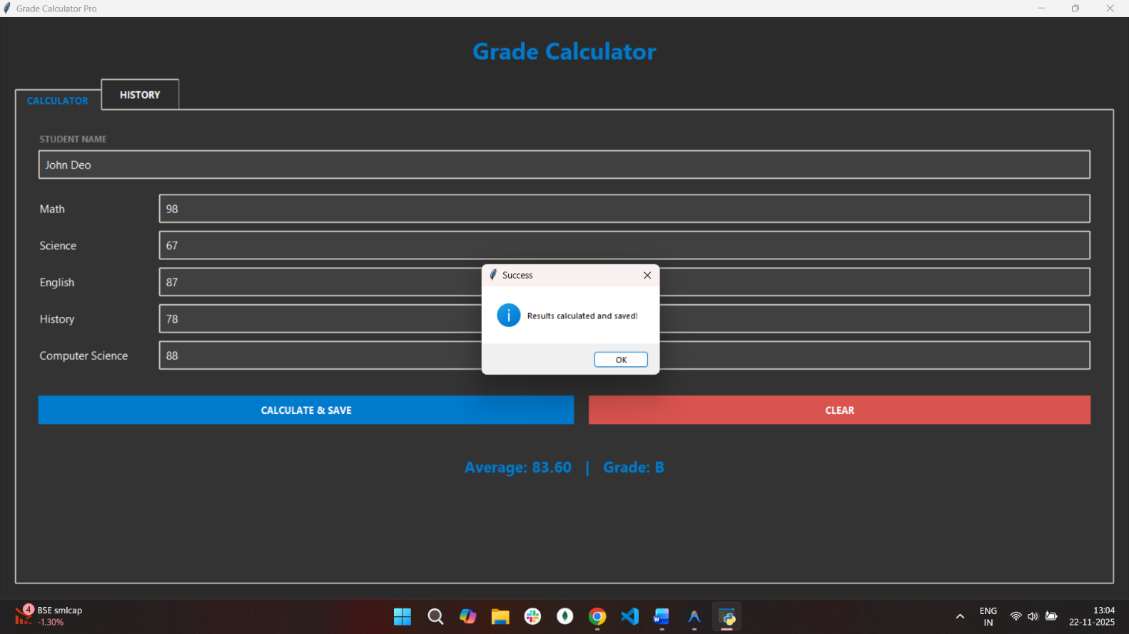
Home page with result
Chapter 3: Coding
3.1 Source Code
The following is the complete Python source code for the application. It is contained within a single file
grade_calculator_gui.py

import tkinter as tk
from tkinter import ttk, messagebox
import json
import os
HISTORY_FILE = "history.json"
def calculate_average(marks):
if not marks:
return 0.0
return sum(marks) / len(marks)
def assign_grade(average):
if average >= 90:
return 'A'
elif average >= 80:
return 'B'
elif average >= 70:
return 'C'
elif average >= 60:
return 'D'
else:
return 'F'
def load_history():
if os.path.exists(HISTORY_FILE):
try:
with open(HISTORY_FILE, "r") as f:
return json.load(f)
except:
return []
return []
def save_history(record):
history = load_history()
history.append(record)
with open(HISTORY_FILE, "w") as f:
json.dump(history, f, indent=4)
class GradeCalculatorApp:
def __init__(self, root):
self.root = root
self.root.title("Grade Calculator Pro")
self.root.geometry("500x650")

self.colors = {
"bg": "#2b2b2b",
"fg": "#ffffff",
"card": "#333333",
"input_bg": "#404040",
"primary": "#007acc",
"primary_hover": "#005fa3",
"danger": "#d9534f",
"danger_hover": "#c9302c"
}

self.root.configure(bg=self.colors["bg"])
self.setup_styles()

main_frame = ttk.Frame(root, padding="20")
main_frame.pack(fill='both', expand=True)
title_label = ttk.Label(main_frame, text="Grade Calculator", style="Title.TLabel")
title_label.pack(pady=(0, 25))
self.notebook = ttk.Notebook(main_frame)
self.notebook.pack(expand=True, fill='both')

self.calc_frame = ttk.Frame(self.notebook, style="Card.TFrame")
self.notebook.add(self.calc_frame, text=' CALCULATOR ')

self.history_frame = ttk.Frame(self.notebook, style="Card.TFrame")
self.notebook.add(self.history_frame, text=' HISTORY ')

self.setup_calculator_tab()
self.setup_history_tab()
def setup_styles(self):
self.style = ttk.Style()
self.style.theme_use('clam')

self.style.configure(".",
background=self.colors["bg"],
foreground=self.colors["fg"],
font=("Segoe UI", 10)
)
self.style.configure("TFrame", background=self.colors["bg"])

self.style.configure("Card.TFrame", background=self.colors["card"])

self.style.configure("TNotebook", background=self.colors["bg"], borderwidth=0)
self.style.configure("TNotebook.Tab",
padding=[15, 10],
font=("Segoe UI", 10, "bold"),
background=self.colors["bg"],
foreground=self.colors["fg"],
borderwidth=0
)
self.style.map("TNotebook.Tab",
background=[("selected", self.colors["card"])],
foreground=[("selected", self.colors["primary"])]
)
self.style.configure("TLabel", background=self.colors["card"], foreground=self.colors["fg"])
self.style.configure("Title.TLabel",
font=("Segoe UI", 24, "bold"),
background=self.colors["bg"],
foreground=self.colors["primary"]
)
self.style.configure("Result.TLabel",
font=("Segoe UI", 16, "bold"),
foreground=self.colors["primary"],
background=self.colors["card"]
)
self.style.configure("TEntry",
fieldbackground=self.colors["input_bg"],
foreground=self.colors["fg"],
padding=8,
borderwidth=0
)

self.style.configure("TButton",
font=("Segoe UI", 10, "bold"),
padding=10,
borderwidth=0,
background=self.colors["primary"],
foreground="white"
)
self.style.map("TButton",
background=[('active', self.colors["primary_hover"]), ('!disabled', self.colors["primary"])],
foreground=[('!disabled', 'white')]
)

self.style.configure("Clear.TButton", background=self.colors["danger"])
self.style.map("Clear.TButton",
background=[('active', self.colors["danger_hover"]), ('!disabled', self.colors["danger"])],
foreground=[('!disabled', 'white')]
)
self.style.configure("Treeview",
background=self.colors["input_bg"],
foreground=self.colors["fg"],
rowheight=30,
fieldbackground=self.colors["input_bg"],
font=("Segoe UI", 10),
borderwidth=0
)
self.style.configure("Treeview.Heading",
font=("Segoe UI", 10, "bold"),
background=self.colors["bg"],
foreground=self.colors["fg"],
borderwidth=0
)
self.style.map("Treeview", background=[('selected', self.colors["primary"])])
def setup_calculator_tab(self):
container = ttk.Frame(self.calc_frame, padding="30", style="Card.TFrame")
container.pack(fill='both', expand=True)

ttk.Label(container, text="STUDENT NAME", font=("Segoe UI", 9, "bold"), foreground="#888888").pack(anchor='w', pady=(0, 5))
self.name_entry = ttk.Entry(container, font=("Segoe UI", 11))
self.name_entry.pack(fill='x', pady=(0, 20))

self.subjects = ["Math", "Science", "English", "History", "Computer Science"]
self.entries = {}

for subject in self.subjects:
frame = ttk.Frame(container, style="Card.TFrame")
frame.pack(fill='x', pady=8)

ttk.Label(frame, text=subject, width=20, font=("Segoe UI", 11)).pack(side='left')
entry = ttk.Entry(frame, font=("Segoe UI", 11))
entry.pack(side='right', expand=True, fill='x')
self.entries[subject] = entry

btn_frame = ttk.Frame(container, style="Card.TFrame")
btn_frame.pack(pady=40, fill='x')

calc_btn = ttk.Button(btn_frame, text="CALCULATE & SAVE", command=self.on_calculate)
calc_btn.pack(side='left', expand=True, fill='x', padx=(0, 10))

clear_btn = ttk.Button(btn_frame, text="CLEAR", command=self.clear_inputs, style="Clear.TButton")
clear_btn.pack(side='right', expand=True, fill='x', padx=(10, 0))

self.result_var = tk.StringVar(value="Average: -- | Grade: --")
result_label = ttk.Label(container, textvariable=self.result_var, style="Result.TLabel", anchor="center")
result_label.pack(pady=10, fill='x')
def setup_history_tab(self):
container = ttk.Frame(self.history_frame, padding="15", style="Card.TFrame")
container.pack(fill='both', expand=True)
columns = ("name", "average", "grade")
self.tree = ttk.Treeview(container, columns=columns, show='headings', selectmode='browse')

self.tree.heading("name", text="NAME")
self.tree.heading("average", text="AVERAGE")
self.tree.heading("grade", text="GRADE")

self.tree.column("name", width=200)
self.tree.column("average", width=100, anchor='center')
self.tree.column("grade", width=80, anchor='center')

scrollbar = ttk.Scrollbar(container, orient="vertical", command=self.tree.yview)
self.tree.configure(yscrollcommand=scrollbar.set)

self.tree.pack(side='left', expand=True, fill='both')
scrollbar.pack(side='right', fill='y')

btn_frame = ttk.Frame(self.history_frame, padding="15", style="Card.TFrame")
btn_frame.pack(fill='x')
refresh_btn = ttk.Button(btn_frame, text="REFRESH HISTORY", command=self.refresh_history)
refresh_btn.pack(fill='x')

self.refresh_history()
def on_calculate(self):
name = self.name_entry.get().strip()
if not name:
messagebox.showerror("Input Error", "Please enter the student's name.")
return
marks = []
try:
for subject in self.subjects:
val_str = self.entries[subject].get()
if not val_str:
messagebox.showerror("Input Error", f"Please enter marks for {subject}.")
return

val = float(val_str)
if val < 0 or val > 100:
messagebox.showerror("Input Error", f"Marks for {subject} must be between 0 and 100.")
return
marks.append(val)

average = calculate_average(marks)
grade = assign_grade(average)

self.result_var.set(f"Average: {average:.2f} | Grade: {grade}")

record = {"name": name, "average": round(average, 2), "grade": grade}
save_history(record)
self.refresh_history()

messagebox.showinfo("Success", "Results calculated and saved!")

except ValueError:
messagebox.showerror("Input Error", "Please enter valid numeric marks.")
def clear_inputs(self):
self.name_entry.delete(0, tk.END)
for entry in self.entries.values():
entry.delete(0, tk.END)
self.result_var.set("Average: -- | Grade: --")
def refresh_history(self):
for item in self.tree.get_children():
self.tree.delete(item)

history = load_history()
for record in reversed(history):
self.tree.insert("", tk.END, values=(record.get("name"), record.get("average"), record.get("grade")))
if __name__ == "__main__":
root = tk.Tk()
app = GradeCalculatorApp(root)
root.mainloop()

Chapter 4: Testing
4.1 Test Report
Testing is a critical phase in software development to ensure the system meets the requirements defined in the SRS. This section outlines the test cases executed on the Student Grade Calculator and their results.
Test Environment
OS: Windows 10
Python Version: 3.x
Screen Resolution: 1920x1080
Test Cases
Test Case 1: Valid Input Calculation
Objective: Verify that the system correctly calculates the average and grade for valid inputs.
Input:
Name: "Test Student"
Math: 90, Science: 80, English: 70, History: 60, CS: 50
Expected Output:
Average: 70.00
Grade: C
Success Message Popup.
Actual Output: Matches Expected.
Status: PASS
Test Case 2: Boundary Value Analysis (High)
Objective: Verify grade assignment at the upper boundary.
Input: All subjects = 100.
Expected Output: Average: 100.00, Grade: A.
Actual Output: Matches Expected.
Status: PASS
Test Case 3: Boundary Value Analysis (Low)
Objective: Verify grade assignment at the lower boundary.
Input: All subjects = 0.
Expected Output: Average: 0.00, Grade: F.
Actual Output: Matches Expected.
Status: PASS
Test Case 4: Invalid Input (Non-Numeric)
Objective: Verify system stability when text is entered instead of numbers.
Input: Math = "Ninety"
Expected Output: Error Popup: "Please enter valid numeric marks." System should not crash.
Actual Output: Error Popup displayed. No crash.
Status: PASS
Test Case 5: Invalid Input (Out of Range)
Objective: Verify validation for marks outside 0-100.
Input: Math = 105
Expected Output: Error Popup: "Marks for Math must be between 0 and 100."
Actual Output: Error Popup displayed.
Status: PASS
Test Case 6: Empty Fields
Objective: Verify validation for missing data.
Input: Name left blank.
Expected Output: Error Popup: "Please enter the student's name."
Actual Output: Error Popup displayed.
Status: PASS
Test Case 7: History Persistence
Objective: Verify data is saved and loaded.
Action: Calculate a grade, close app, reopen app, check History tab.
Expected Output: The calculated record appears in the table.
Actual Output: Record present.
Status: PASS
Summary of Testing
All critical functional paths have been tested. The system handles both valid and invalid inputs gracefully. The error messages are descriptive and guide the user to correct their mistakes. The persistence layer functions correctly, ensuring data integrity across sessions.

Chapter 5: Conclusion
5.1 Conclusion
The Student Grade Calculator project has been successfully designed, implemented, and tested. It meets all the primary objectives set forth in the initial planning phase.
Key Achievements:
1.Automation: The system successfully automates the tedious task of calculating averages, saving time for users.
2.User Experience: The transition to a Modern Dark Mode GUI has significantly improved the aesthetic appeal and usability of the application compared to standard CLI or basic Tkinter interfaces.
3.Robustness: Through rigorous testing, the system has proven to be stable. It handles invalid inputs without crashing and provides clear feedback to the user.
4.Data Management: The inclusion of a history feature allows the application to serve as a mini-database for student records, adding value beyond simple calculation.
The project demonstrates the power of Python and Tkinter in creating functional desktop applications with minimal code. It serves as a solid foundation for a lightweight educational tool that can be easily distributed and used on various platforms.
5.2 Future Aspect
While the current system is functional, there are several avenues for future enhancement to make it a comprehensive educational management system.

1. Advanced Reporting: Future versions could include the ability to export the history data to external formats like PDF (for printing report cards) or Excel/CSV (for further data analysis). This would make the tool much more useful for teachers who need to submit formal grades.

2. Dynamic Subject Management: Currently, the five subjects are hardcoded. A future update could allow users to add or remove subjects dynamically. This would make the calculator adaptable to different curriculums (e.g., college courses, specialized training programs).

3. Data Visualization: Integrating a library like matplotlib could allow the system to generate graphs and charts. For example, a line graph showing a student's performance trend over time, or a pie chart showing the distribution of grades in a class.

4. Multi-User Support: Implementing a login system would allow multiple teachers to use the same application on a shared computer while keeping their student records private and separate.

5. Database Integration: Migrating from a JSON file to a lightweight SQL database (like SQLite) would improve performance as the number of records grows into the thousands and allow for more complex queries (e.g., "Show all students who got an A").

By implementing these features, the Student Grade Calculator can evolve from a simple utility into a robust academic software suite.

