Unit 3
Fundamental of Neural networks and artificial neural networks
Q1
Explain fundamental of neural networks in big data
Explain architecture of artificial neural networks.
Write note on Artificial Intelligence explaining its need and applications.
How does forward propagation and back propagation work in ANN?

Neural networks, inspired by the human brain, are essential for analyzing big data. They consist of interconnected nodes, or artificial neurons, that process information and learn patterns from data. These networks can be trained to perform tasks like pattern recognition, prediction, and decision-making, making them powerful tools for big data analytics.
Here's a more detailed explanation of the fundamental aspects:
1. Structure and Architecture:
- Neurons (Nodes):
The basic units of a neural network, receiving inputs, processing them, and generating outputs.
- Layers:
Neural networks are organized into layers: an input layer to receive data, hidden layers for processing, and an output layer for the final result.
- Connections:
Neurons within and between layers are interconnected, with each connection having a weight representing its strength.
- Types:
Different architectures exist, such as feedforward neural networks (FNNs) for sequential processing and convolutional neural networks (CNNs) for visual data.
2. How They Learn:
- Training:
Neural networks learn from data through a process called training, where they adjust their weights and biases to minimize errors.
- Forward Propagation:
Input data flows through the network, with each node computing its output based on its inputs, weights, biases, and an activation function.
- Backpropagation:
After the forward pass, the error is calculated, and the weights and biases are updated to reduce the error by propagating it backward through the network.
- Optimization:
Algorithms like gradient descent are used to optimize the weights and biases, enabling the network to learn and improve its performance.
3. Applications in Big Data:
- Pattern Recognition:
Neural networks can identify patterns in large datasets, like image or speech recognition.
- Prediction:
They can be used to predict future outcomes or trends based on historical data.
- Classification:
Neural networks can categorize data into different classes based on learned features.
- Data Mining:
They can be used to extract valuable insights and patterns from large datasets.
- Recommendation Systems:
Neural networks can be used to build recommendation systems that suggest relevant items based on user preferences.
4. Advantages of using Neural Networks for Big Data:
- Handling Complex Data:
Neural networks can handle complex and high-dimensional data, making them suitable for big data analysis.
- Adaptive Learning:
They can learn from data and adapt to new information, making them flexible and robust.
- Automated Feature Extraction:
Neural networks can automatically extract relevant features from data, reducing the need for manual feature engineering.
- High Accuracy:
With sufficient training data, neural networks can achieve high accuracy in various tasks.
In essence, neural networks provide a powerful and versatile framework for analyzing big data, enabling the discovery of hidden patterns, making accurate predictions, and automating complex tasks.
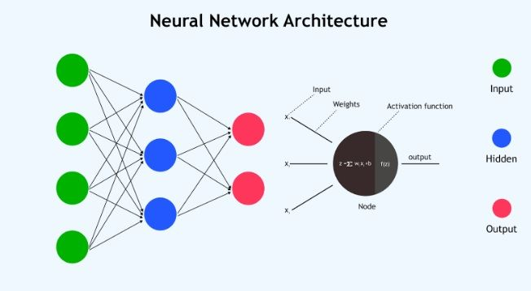
1. What are Neural Networks?
A Neural Network is a computational model inspired by the human brain. It consists of layers of interconnected nodes (neurons) that can learn to recognize patterns from data.
- Input Layer: Receives the raw data.
- Hidden Layers: Perform computations and extract features.
- Output Layer: Produces the prediction/classification.
These networks learn from data using an algorithm called backpropagation along with optimization techniques like gradient descent.

📊 2. Role of Neural Networks in Big Data
In Big Data, the challenge lies in:
- Volume (huge data size),
- Variety (structured, semi-structured, unstructured),
- Velocity (high speed of data generation).
Neural networks are powerful tools for handling big data because:
✅ They are:
- Scalable: Can be expanded with more layers and neurons.
- Flexible: Can model both linear and complex nonlinear relationships.
- Adaptive: Improve with more data (which Big Data offers).

🧠 3. Types of Neural Networks Common in Big Data
Type | Use Case
Feedforward Neural Network (FNN) | Basic classification & regression
Convolutional Neural Network (CNN) | Image data (e.g., MRI scans in medical imaging)
Recurrent Neural Network (RNN) | Sequential data (e.g., time series, language data)
Deep Neural Networks (DNN) | Very large and deep models for complex patterns
Autoencoders | Dimensionality reduction and anomaly detection
GANs (Generative Adversarial Networks) | Generating synthetic data

🛠️ 4. How Neural Networks Process Big Data
- Data Collection – from sensors, logs, social media, etc.
- Preprocessing – cleaning, normalization, handling missing values.
- Feature Extraction – converting raw data to meaningful inputs.
- Model Training – feeding data to the neural network to learn patterns.
- Prediction / Classification – using the trained model on new data.

🧪 5. Challenges in Big Data for Neural Networks
- Computational Cost: Training deep networks requires high-end GPUs or TPUs.
- Overfitting: More data ≠ better results unless properly regularized.
- Noise and Outliers: Big data often contains irrelevant or misleading info.
- Data Labeling: Supervised neural networks need lots of labeled data.

💡 Example Use Cases
Domain | Application
Healthcare | Tumor detection from MRI scans (CNNs)
Finance | Stock market prediction (RNNs)
Retail | Customer purchase prediction
Social Media | Sentiment analysis from posts
IoT | Sensor data analysis and fault detection

📈 Summary
Aspect | Neural Networks in Big Data
Goal | Learn patterns from vast, varied data
Strength | Scalability, pattern recognition, high accuracy
Needs | Good data preprocessing, computational resources
Output | Classification, prediction, generation, compression

The architecture of an artificial neural network (ANN) refers to the arrangement of its components, specifically the layers of interconnected nodes (neurons), which determine how the network processes information. A typical ANN architecture includes an input layer, one or more hidden layers, and an output layer.
Here's a more detailed breakdown:
- Input Layer:
This layer receives the raw data or features as input. Each neuron in this layer represents a feature from the dataset.
- Hidden Layers:
These layers perform computations on the input data, learning complex patterns and extracting features. An ANN can have multiple hidden layers, making it a deep neural network (DNN).
- Output Layer:
This layer produces the final prediction or output of the network. For example, in a classification task, the output might represent the probability of each class.
Key Concepts:
- Neurons (Nodes):
The fundamental building blocks of a neural network, each receiving input, performing calculations, and passing the result to the next layer.
- Layers:
Groups of neurons that are connected and work together to process information.
- Weights and Biases:
Parameters associated with each connection between neurons that are adjusted during training to learn the relationships in the data.
- Activation Function:
A function applied to the output of a neuron to introduce non-linearity and enable the network to learn complex patterns.
Types of Architectures:
- Feedforward Neural Network:
A basic type where information flows in one direction, from the input layer to the output layer.
- Recurrent Neural Network (RNN):
A type designed to process sequential data, where information can be passed between layers and also back to previous layers.
- Convolutional Neural Network (CNN):
A type commonly used for image and video processing, using convolutional filters to extract features.
- Deep Neural Network (DNN):
A network with multiple hidden layers, enabling it to learn complex patterns and make more accurate predictions.
………………………….
What is the Architecture of an Artificial Neural Network?
The architecture of an ANN refers to how neurons (nodes) and layers are organized and connected. It mimics the way the human brain processes information, allowing a machine to learn from data.

🧩 Components of ANN Architecture
1. Input Layer
- Receives raw data (e.g., pixel values of an image or features of a dataset).
- One node per input feature.
- No computation, only passes the data forward.
Example: If your dataset has 5 features, the input layer has 5 neurons.

2. Hidden Layer(s)
- One or more layers between input and output.
- Each neuron applies a weighted sum followed by an activation function.
Each hidden layer transforms input into something more meaningful for the next layer.
Key components:
- Weights: How important is each input?
- Bias: Adjusts the output independently of the input.
- Activation Functions: Non-linear functions like ReLU, Sigmoid, or Tanh that help the network learn complex patterns.
🧠 Deep Neural Network (DNN): ANN with multiple hidden layers.

3. Output Layer
- Produces the final result (prediction).
- Number of neurons depends on the task:
  - Binary Classification: 1 neuron with sigmoid.
  - Multi-Class Classification: One neuron per class with softmax.
  - Regression: 1 neuron with no activation or linear activation.

🔁 Data Flow (Forward Propagation)
- Inputs are multiplied by weights and added to bias.
- Activation function is applied.
- Output is passed to the next layer.
- Final output is compared to actual value using a loss function.

🔄 Learning Process (Backpropagation)
- ANN adjusts weights and biases using a loss function and optimization algorithm like Gradient Descent.
- This is done by backpropagating the error from output to input.

🎯 Architecture Types
Architecture | Description | Example Use
Single-layer Perceptron | One input and one output layer | Simple binary classification
Multi-layer Perceptron (MLP) | One input, one output, and one/more hidden layers | Complex classification, regression
Convolutional Neural Network (CNN) | Adds convolutional and pooling layers | Image data
Recurrent Neural Network (RNN) | Includes memory of previous inputs (feedback loop) | Time series, language modeling

🧠 Diagram of a Simple ANN Architecture
less
CopyEdit
Input Layer Hidden Layer Output Layer
[x1] [x2] [x3] → [H1] [H2] [H3] [H4] → [y]
\ | / | | | | |
\ | / V V V V V
Weights & Biases → Activation → Output Prediction

🧪 Example
Imagine a neural network predicting if a patient has a tumor based on 4 medical features:
- Input Layer: 4 neurons (features like age, scan size, density, etc.)
- Hidden Layer: 5 neurons with ReLU
- Output Layer: 1 neuron with Sigmoid (1 = Tumor, 0 = No Tumor)

✅ Summary Table
Component | Role
Input Layer | Takes raw data
Hidden Layer(s) | Learns features and patterns
Output Layer | Produces prediction
Weights & Biases | Adjust based on learning
Activation Function | Adds non-linearity
Loss Function | Measures error
Optimizer | Minimizes the loss
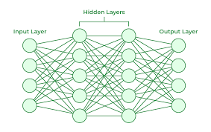
Write note on Artificial Intelligence explaining its need and applications.
Artificial intelligence (AI) is the field of science and engineering concerned with making computers do things that would require human intelligence if done by people. Its need stems from the ability of AI to automate tasks, analyze complex data, and make predictions, leading to significant improvements across various industries. Applications of AI include self-driving cars, virtual assistants, and disease diagnosis, among many others.
Need for Artificial Intelligence:
- Automation:
AI can automate repetitive tasks, freeing up human resources for more strategic work.
- Data Analysis:
AI can process and analyze vast amounts of data to identify patterns and trends, enabling better decision-making.
- Prediction:
AI can predict future outcomes based on historical data, allowing businesses and individuals to make informed decisions.
- Improved Efficiency:
AI can optimize processes and workflows, leading to increased efficiency and productivity.
Applications of Artificial Intelligence:
- Healthcare:
AI can assist in diagnosing diseases, developing new drugs, and providing personalized treatment plans.
- Transportation:
AI powers self-driving cars and optimizes traffic flow, leading to safer and more efficient transportation systems.
- Finance:
AI can detect fraud, manage portfolios, and predict market trends.
- E-commerce:
AI can personalize shopping experiences, make product recommendations, and optimize advertising campaigns.
- Manufacturing:
AI can automate production processes, improve quality control, and optimize supply chains.
- Education:
AI can personalize learning experiences, provide automated grading, and offer individualized tutoring.
- Agriculture:
AI can optimize crop yields, manage irrigation systems, and improve food production.
- Cybersecurity:
AI can detect and prevent cyber threats, enhance security measures, and protect sensitive data.
- Virtual Assistants:
AI powers virtual assistants like Siri and Alexa, enabling users to interact with technology through voice commands.
- Chatbots:
AI-powered chatbots can provide customer support, answer questions, and automate interactions.
- Robotics:
AI is used in robotics for various applications, including manufacturing, exploration, and healthcare.
Note on Artificial Intelligence (AI)
📌 Definition
Artificial Intelligence (AI) is a branch of computer science that aims to create systems or machines that can simulate human intelligence. These systems are capable of learning, reasoning, problem-solving, understanding language, and making decisions.

💡 Need for Artificial Intelligence
- Handling Complex Tasks: AI can analyze vast amounts of data faster and more accurately than humans, making it ideal for tasks involving large datasets (e.g., in medical diagnostics, financial analysis).
- Automation of Repetitive Jobs: It reduces human effort and increases productivity by automating routine and time-consuming tasks.
- 24/7 Availability: Unlike humans, AI-powered machines can operate continuously without fatigue.
- Data-Driven Decisions: AI can uncover patterns and insights in big data that help in better decision-making.
- Improved Customer Experience: AI is used in chatbots, virtual assistants, and recommendation systems to enhance user engagement and satisfaction.

🌍 Applications of Artificial Intelligence
Domain | Applications
Healthcare | Disease diagnosis, medical imaging (e.g., tumor detection), drug discovery, robotic surgeries
Finance | Fraud detection, credit scoring, algorithmic trading, risk analysis
Retail & E-commerce | Product recommendations, customer service (chatbots), inventory management
Transportation | Self-driving cars, route optimization, traffic prediction
Education | Personalized learning, grading automation, virtual teaching assistants
Agriculture | Crop monitoring, pest detection, smart irrigation using AI-based sensors
Security | Face recognition, surveillance, cybersecurity threat detection
Manufacturing | Predictive maintenance, quality control, robotic automation
Entertainment | Movie/music recommendations, video game AI, content generation
…………………
In Artificial Neural Networks (ANNs), forward propagation involves input data moving through the network to generate an output, while backpropagation is used to adjust the network's weights and biases based on the error between the predicted and actual outputs. Forward propagation is the computation phase, and backpropagation is the training phase.
Here's a more detailed explanation:
1. Forward Propagation:
- Input: Input data is fed into the network, starting from the input layer.
- Weighted Sum: At each node, the weighted sum of the inputs is calculated, along with the addition of a bias.
- Activation Function: The weighted sum is passed through an activation function, which introduces non-linearity into the model.
- Output: The output of each node is then passed to the next layer, until the final output layer is reached.
- Prediction: The output of the final layer is the network's prediction.
2. Backpropagation:
- Error Calculation:
The network's prediction is compared to the actual output, and the error is calculated using a loss function.
- Gradient Calculation:
Backpropagation calculates the gradients of the loss function with respect to each weight and bias in the network.
- Weight Adjustment:
The weights and biases are then updated using an optimization algorithm (e.g., gradient descent) to minimize the error.
- Iterative Process:
This process is repeated iteratively, with each forward and backward pass refining the network's parameters and improving its accuracy.
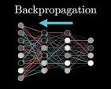
In essence: Forward propagation calculates the output, and backpropagation adjusts the network's parameters to minimize the error and improve the accuracy of future predictions.
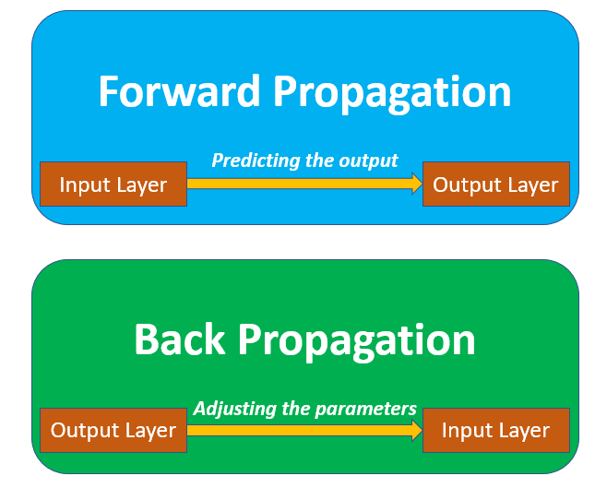

perceptron and linear models
Q2
What is perceptron? Explain Types of Perceptron.
A perceptron is a basic computational model inspired by the biological neuron, serving as the fundamental building block of artificial neural networks. It's a linear classifier that performs binary classification, meaning it classifies data into one of two categories (e.g., 0 or 1). There are two main types of perceptrons: single-layer perceptrons and multi-layer perceptrons.
Single-layer Perceptron:
- This is the simplest type of perceptron, consisting of a single layer of input nodes connected to a single output node.
- It can only learn linearly separable patterns, meaning it can separate data into two classes with a straight line or plane.
- Examples include basic binary classification problems like identifying whether an image is a cat or a dog.
Multi-layer Perceptron (MLP):
- This type of perceptron has one or more hidden layers between the input and output layers.
- It can learn more complex, non-linear decision boundaries, allowing it to handle more intricate classification tasks.
- Examples include image recognition, where the hidden layers learn to extract features from the image, and then the output layer classifies it.
Key Features of Perceptrons:
- Linear Classifier:
Perceptrons are linear classifiers, meaning they use a linear combination of inputs to make predictions.
- Binary Output:
The output of a perceptron is binary (0 or 1), indicating which category the input data belongs to.
- Weighted Inputs:
Each input to a perceptron is assigned a weight, reflecting its importance in the classification process.
- Bias:
A bias term (threshold) is also added to the weighted sum, allowing the perceptron to adjust its decision boundary.
- Activation Function:
An activation function (like the Heaviside step function) is applied to the weighted sum of inputs to produce the final binary output.
Perceptrons are a foundational concept in machine learning and artificial intelligence, paving the way for more complex neural network architectures.
…………………..
What is a Perceptron?
A Perceptron is the simplest type of artificial neural network model, introduced by Frank Rosenblatt in 1958. It is used for binary classification problems and mimics the working of a biological neuron.
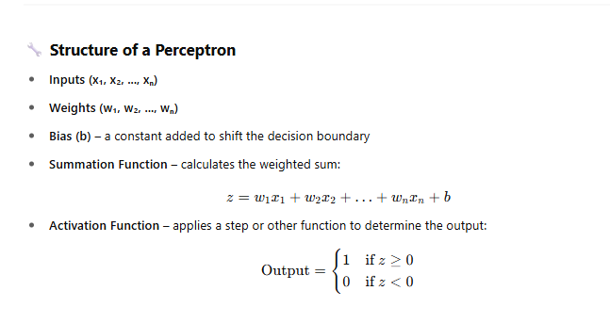
Working of a Perceptron
- Takes multiple input values.
- Multiplies them with corresponding weights.
- Adds the bias.
- Applies an activation function (like step or sigmoid).
- Produces a single binary output (1 or 0).

📚 Types of Perceptron
🔹 1. Single Layer Perceptron
- Contains only one layer: input connected directly to output.
- Suitable for linearly separable data (data that can be separated with a straight line).
- Limitation: Cannot solve non-linear problems (e.g., XOR problem).
Example:
Classifying emails as spam or not spam based on word frequency.

🔹 2. Multi-Layer Perceptron (MLP)
- Contains one or more hidden layers between input and output layers.
- Can learn non-linear functions using activation functions like ReLU, Sigmoid, etc.
- Trained using Backpropagation and Gradient Descent.
- Forms the foundation of Deep Learning.
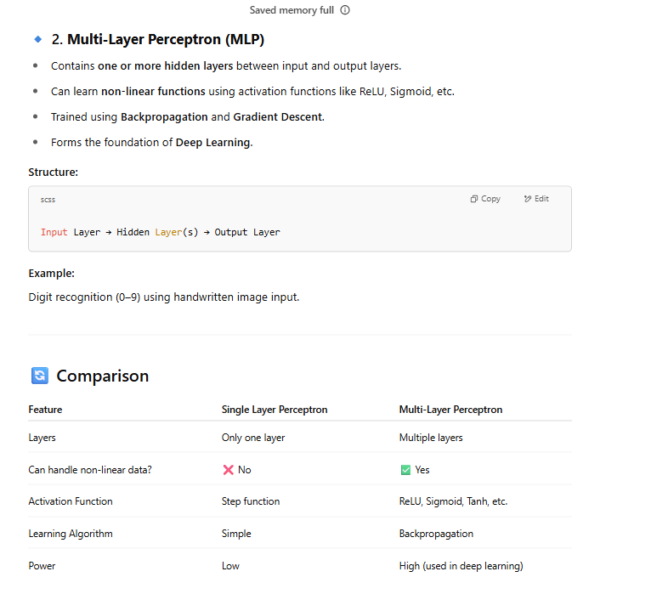
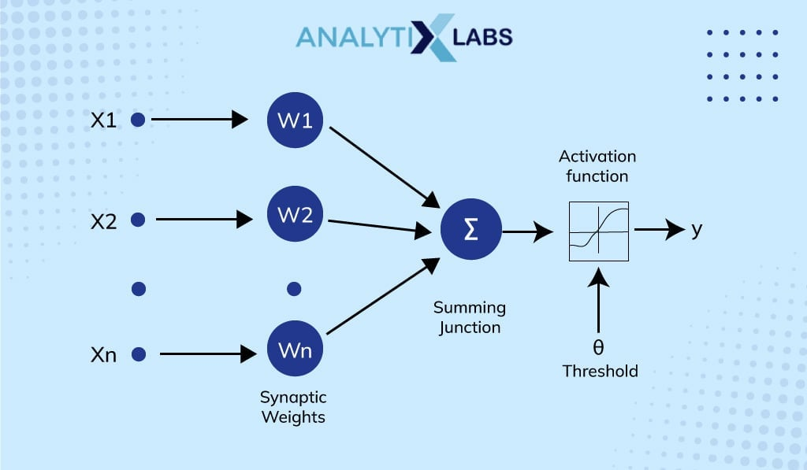
Difference between linear and nonlinear neural networks
Linear and nonlinear neural networks differ primarily in how they transform input data to produce output. Linear neural networks use only linear functions, while nonlinear networks employ non-linear activation functions. This difference impacts their ability to model complex relationships in data.
Linear Neural Networks:
- Linear activation functions: These functions produce outputs that are directly proportional to the input.
- Limited representation: Linear networks can only learn and represent linear relationships in the data.
- Simple models: They are simpler to train and understand compared to nonlinear networks.
Nonlinear Neural Networks:
- Non-linear activation functions:
These functions introduce non-linearities, such as sigmoid or ReLU, into the network's calculations.
- Enhanced complexity:
Nonlinear activation functions allow the network to capture complex patterns and relationships in the data that linear networks cannot.
- More versatile:
They can model a wider range of data patterns and are often preferred for complex tasks like image recognition or natural language processing.
In essence, linear neural networks are like simple linear regressions, while nonlinear neural networks are like regression models with more complex relationships.
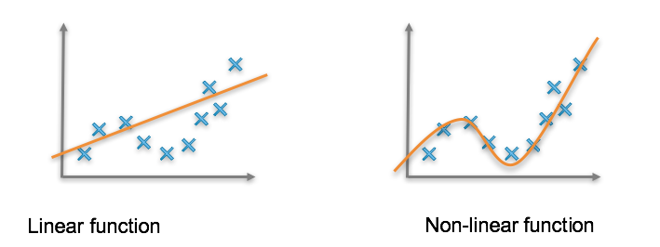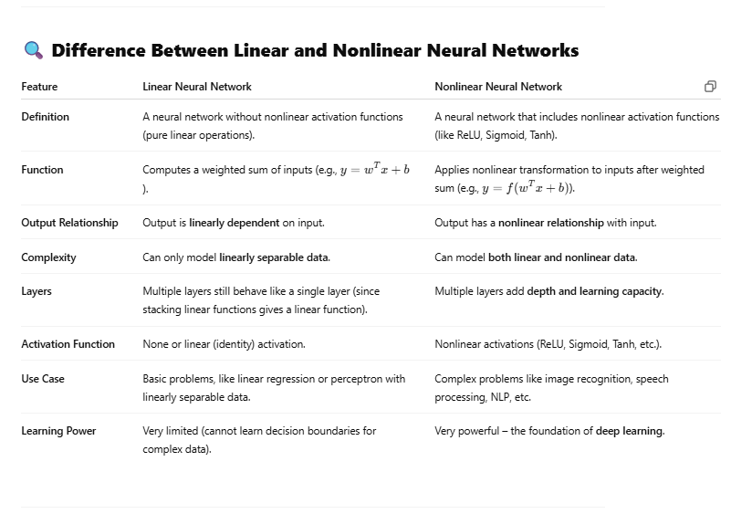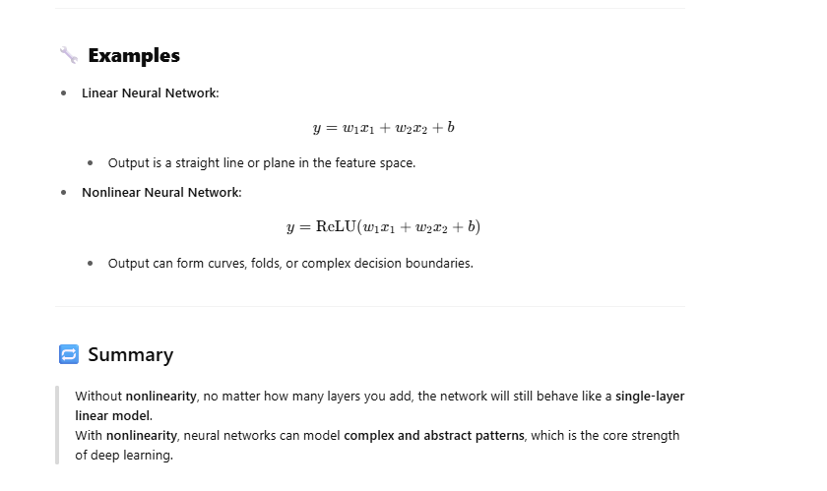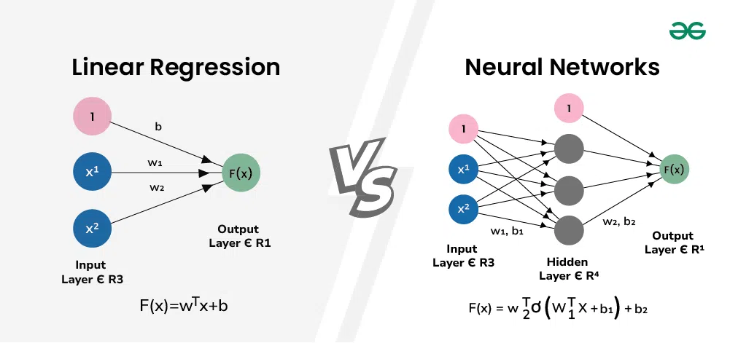
linear models
Linear models, in a statistical context, describe relationships between variables where the relationship is assumed to be linear. This means the model is based on the idea that changes in one variable directly correspond to changes in another, in a proportional manner. They are commonly used for prediction and understanding relationships in data.
Key Characteristics of Linear Models:
- Linearity:
The core principle is that the relationship between variables is linear, meaning a straight line or a plane can represent the relationship.
- Predictor and Response Variables:
Linear models typically involve a predictor variable (independent variable) and a response variable (dependent variable). The model aims to predict the response variable based on the predictor variable(s).
- General Equation:
A common representation of a linear model is y = β₀ + ∑βᵢxᵢ + ε, where y is the response variable, xᵢ are the predictor variables, β₀ is the intercept, βᵢ are the coefficients, and ε represents the error term.
- Applications:
Linear models find applications in various fields like regression analysis, time series analysis, and understanding complex systems.
- Types of Linear Models:
  - Simple Linear Regression: Models with only one predictor variable.
  - Multiple Linear Regression: Models with multiple predictor variables.
  - Generalized Linear Models (GLMs): Extensions of linear models that allow for different types of response variables and error structures.
Examples of Linear Models:
- Simple Linear Regression: Predicting house prices based on square footage.
- Multiple Linear Regression: Predicting stock prices based on multiple factors like market trends, interest rates, and company performance.
- Time Series Analysis: Predicting future values of a time series based on past values.
In essence, linear models provide a powerful and versatile tool for understanding and predicting relationships between variables, particularly when the underlying relationship is assumed to be linear.
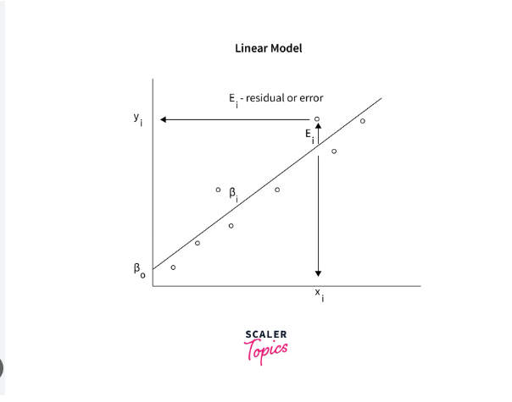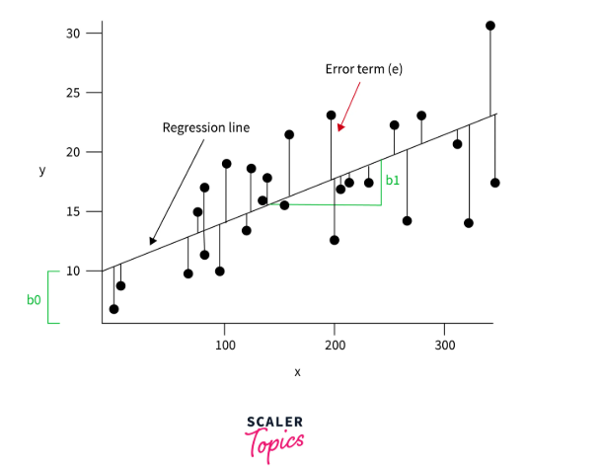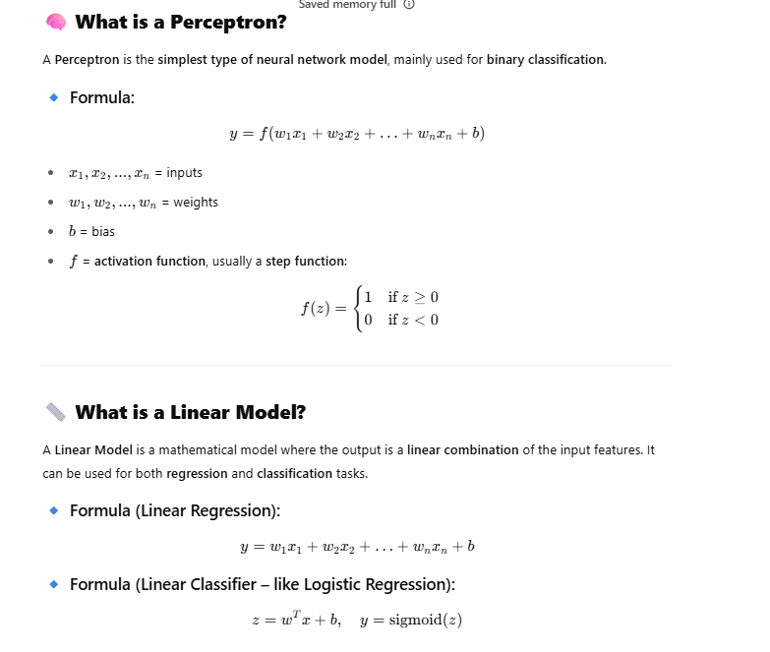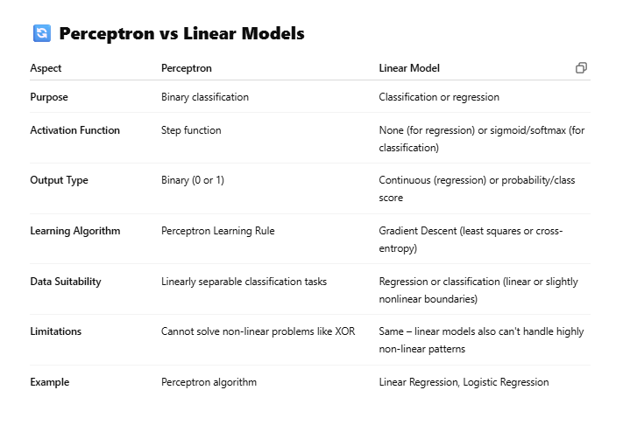
nonlinearities model

A "nonlinearities model" refers to any model where the relationship between variables is not a straight line. Unlike linear models, nonlinear models can capture complex relationships and interactions that linear models cannot. These models are common in various fields like statistics, computer science, and machine learning, where they are used to model phenomena with non-proportional relationships between variables.
Key Characteristics of Nonlinear Models:
- Non-linear relationships:
The dependent variable does not change proportionally with the independent variable.
- Complex patterns:
Nonlinear models can capture intricate patterns and interactions that are not easily represented by straight lines.
- Variety of forms:
Nonlinear models can take many forms, including polynomial, exponential, logarithmic, and logistic models.
Examples of Nonlinear Models:
- Logistic regression:
Used for binary or categorical outcomes, modeling the relationship between independent variables and the probability of an event.
- Neural networks:
Inspired by biological neurons, they can learn complex patterns in data.
- Polynomial regression:
Models relationships where the independent variable raised to a power influences the dependent variable.
- Exponential regression:
Models relationships where the independent variable's influence is amplified over time.
Applications of Nonlinear Models:
- Statistics and data science: Modeling complex relationships in datasets.
- Computer science: Modeling systems where the superposition principle doesn't hold.
- Machine learning: Building predictive models that capture non-linear relationships in data.
- Finance: Modeling risk and return in investment portfolios.
- Physics and biology: Modeling complex systems and interactions.
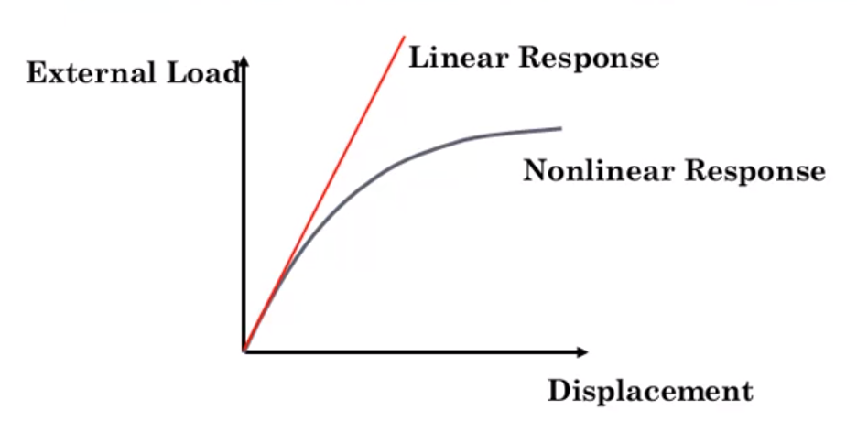
Q3 feed forward neural networks
What is feed forward neural netwok explain with example
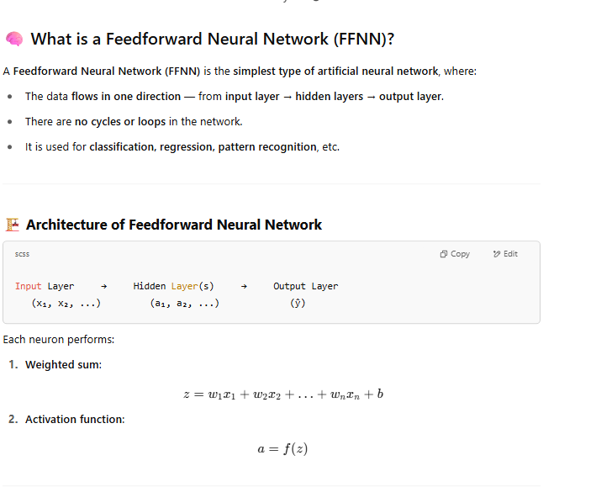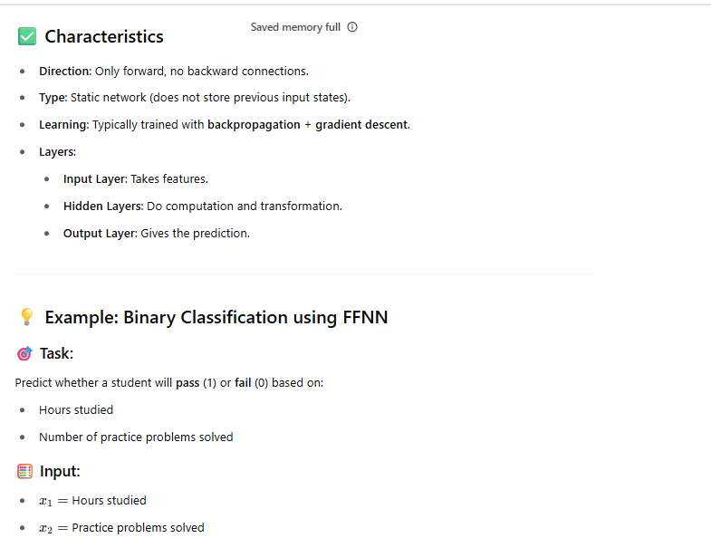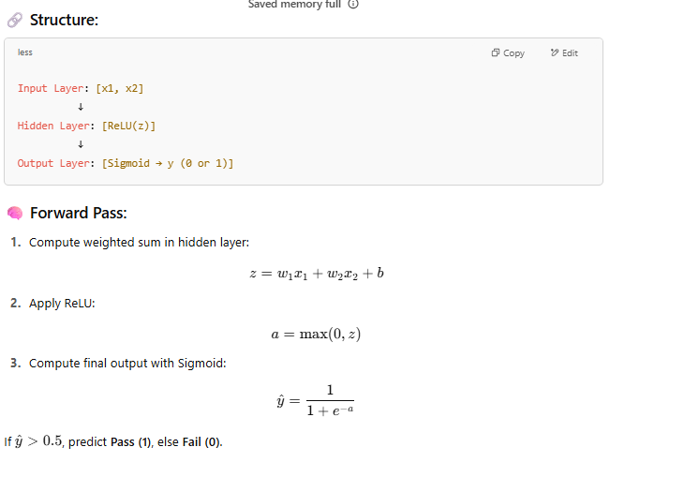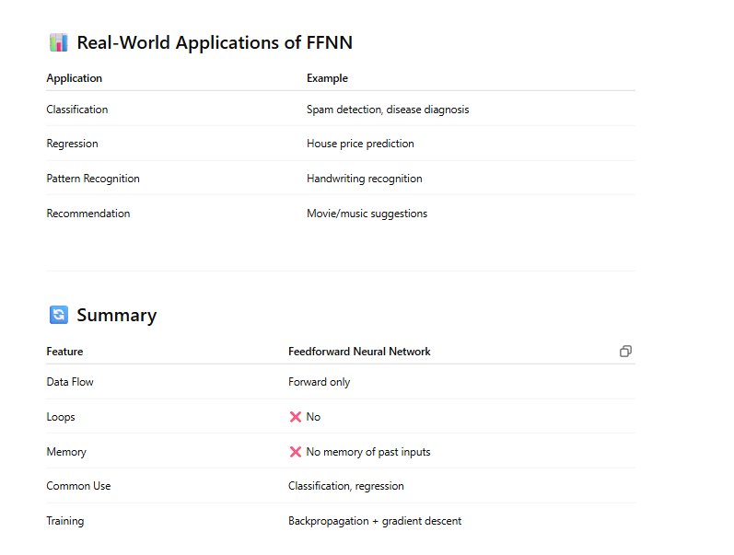
,,,,,,,,,,,,,,,,,,,
A feedforward neural network (FNN) is a type of artificial neural network where information flows in one direction, from the input layer through hidden layers to the output layer, without any loops or cycles. It's often used for pattern recognition and classification tasks, like image and speech recognition.
Here's a breakdown:
- Input Layer:
This is the first layer of the network, where data is fed into the network.
- Hidden Layers:
These layers perform computations on the data, transforming and extracting features. There can be one or more hidden layers.
- Output Layer:
This is the final layer that produces the network's output, such as a classification or prediction.
- Forward Propagation:
The process of data flowing from the input layer through the hidden layers to the output layer is called forward propagation.
- No Feedback:
Unlike recurrent neural networks, FNNs do not have feedback loops, meaning the output from one layer does not feed back into a previous layer.
Example: Simple Classification
Imagine an FNN tasked with classifying whether a given image is a cat or a dog.
- Input: The input would be the pixel data of the image.
- Hidden Layers: These layers would learn to recognize patterns like edges, shapes, and colors in the image.
- Output Layer: The output layer would provide a probability score for the image being a cat or a dog. If the probability for "cat" is higher, the network would classify the image as a cat.
Key Concepts:
- Neurons: The basic computational units in the network.
- Weights: Parameters that determine the strength of connections between neurons.
- Bias: A value added to the output of each neuron.
- Activation Function: A mathematical function that determines the output of a neuron.
In essence, an FNN learns by adjusting its weights and biases to minimize the difference between its predicted output and the actual output for a given input.
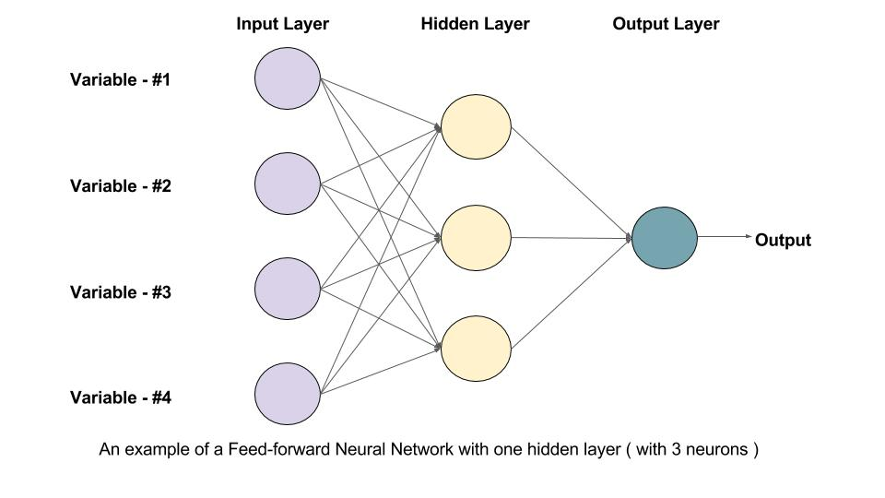
Gradient descent and backpropagation
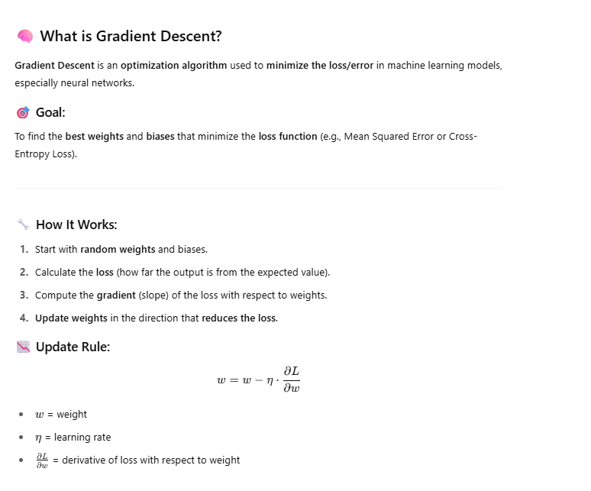
………………
Gradient descent is a popular optimization algorithm used in machine learning to minimize a cost function and find the optimal parameters for a model. It's an iterative process that adjusts the model's parameters by moving in the direction opposite to the gradient of the cost function. This process continues until the cost function reaches a minimum, indicating that the model's parameters have been optimized.
Key Concepts:
- Cost Function:
A mathematical function that measures the error between the model's predictions and the actual values.
- Gradient:
The rate of change of the cost function with respect to the model's parameters.
- Learning Rate:
A parameter that controls the size of the step taken in the direction of the negative gradient.
- Iteration:
A single pass through the training data, during which the model's parameters are updated.
- Local Minimum:
A point where the cost function is lower than its surrounding points, but may not be the absolute minimum.
How it works:
- Initialization: Start with random initial values for the model's parameters.
- Calculate the Cost Function: Measure the error between the model's predictions and the actual values.
- Compute the Gradient: Calculate how much the cost function changes with respect to each parameter.
- Update Parameters: Adjust the parameters in the direction opposite to the gradient, using the learning rate to control the step size.
- Repeat: Continue steps 2-4 until the cost function stops decreasing significantly.
Variants:
- Batch Gradient Descent: Updates parameters after processing the entire training dataset.
- Stochastic Gradient Descent (SGD): Updates parameters after processing a single data point or a small batch.
- Mini-batch Gradient Descent: Updates parameters after processing a small batch of the training data.
Applications:
- Linear Regression: Finding the best-fit line for a set of data points.
- Logistic Regression: Predicting the probability of a binary outcome.
- Neural Networks: Training deep learning models.
Benefits:
- Widely Used: Gradient descent is a fundamental algorithm in machine learning.
- General Purpose: It can be used with various models and loss functions.
- Iterative: It provides a systematic approach to finding the optimal parameters.
Limitations:
- Local Minima: Gradient descent may get stuck in local minima, particularly in non-convex landscapes.
- Slow Convergence: It can be slow to converge, especially with high-dimensional data.

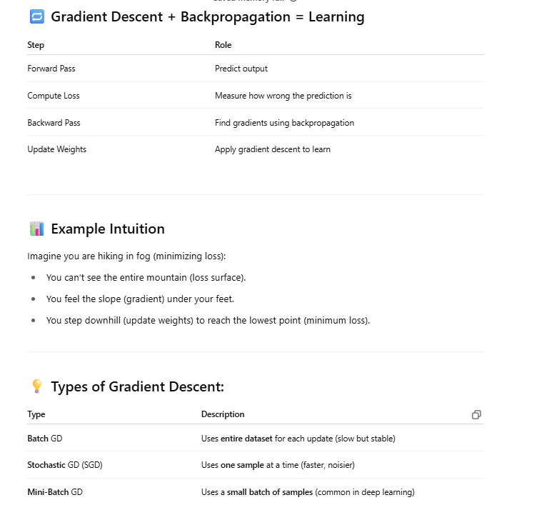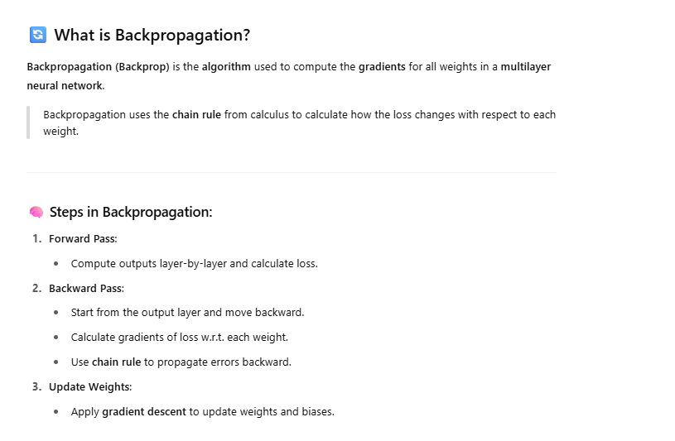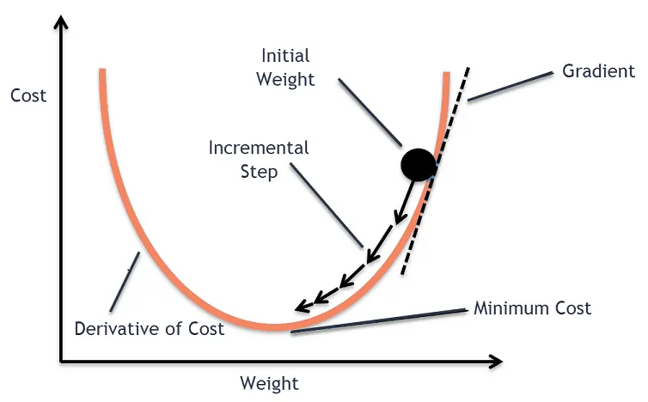
Backpropagation is a fundamental algorithm in machine learning used to train artificial neural networks. It involves a backward pass through the network, calculating the error and adjusting the network's weights to minimize that error, according to an IBM article. Essentially, it's a method for efficiently computing gradients, which are crucial for adjusting the network's parameters during the learning process.
Here's a more detailed explanation:
- Forward Pass:
Input data is fed into the network, and the network makes a prediction.
- Error Calculation:
The predicted output is compared to the actual output, and an error (or loss) is calculated.
- Backward Pass:
The error is propagated back through the network, starting from the output layer and working backward to the input layer.
- Weight Adjustment:
At each layer, the weights and biases are adjusted based on the error and the gradient of the loss function.
- Iteration:
This process is repeated iteratively until the network's performance converges to an acceptable level.

Backpropagation is a cornerstone of deep learning, enabling the training of complex neural networks for various applications like image recognition, natural language processing, and more.
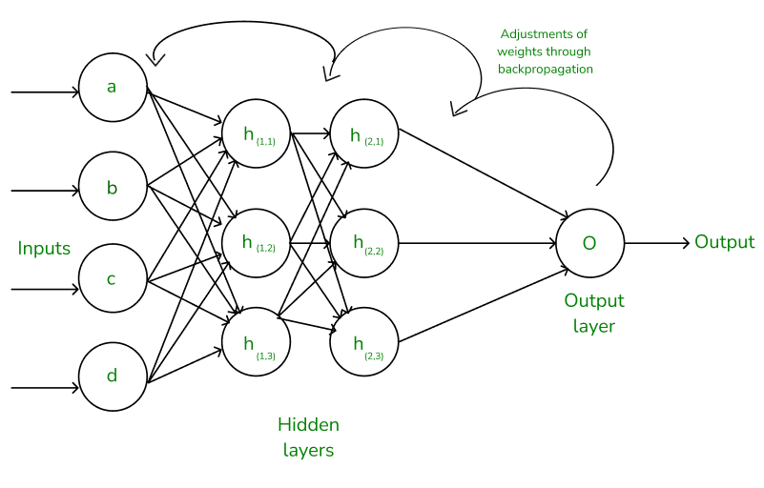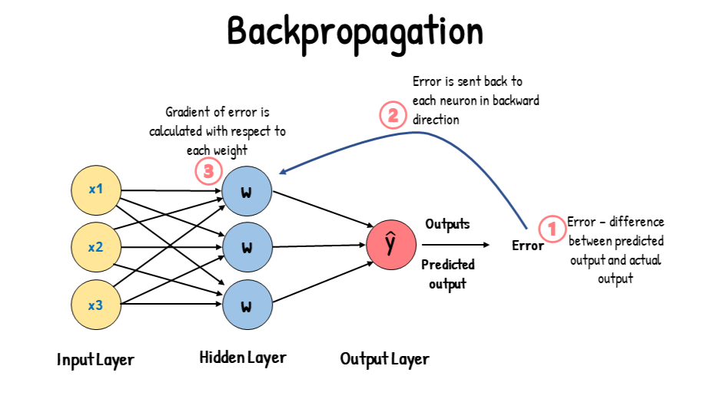
Overfitting
Overfitting occurs when a machine learning model becomes too tailored to the training data, including its noise and irrelevant details, leading to poor performance on new, unseen data. The model essentially memorizes the training set rather than learning generalizable patterns.
Key characteristics of overfitting:
- Excellent training performance, poor test performance:
The model performs very well on the data it was trained on, but struggles to make accurate predictions on new data.
- Captures noise and anomalies:
Instead of identifying general patterns, the model learns specific details and fluctuations in the training data.
- Model complexity:
Overfitting is often associated with overly complex models that have too many parameters.
- Fails to generalize:
The model's ability to apply learned patterns to new, unseen data is significantly reduced.
Causes of overfitting:
- Insufficient training data:
A small training dataset can lead the model to overgeneralize based on limited observations.
- Noisy training data:
Errors or inconsistencies in the training data can be misinterpreted by the model as patterns.
- Complex models:
Using a model that is too complex for the task at hand can lead it to memorize the training data rather than learn the underlying relationships.
- High variance:
A model with high variance is more susceptible to overfitting because it can easily adapt to minor fluctuations in the training data.
Prevention and mitigation:
- Data augmentation:
Increasing the size and diversity of the training dataset can help the model learn more generalizable patterns.
- Regularization techniques:
Methods like L1 and L2 regularization can help prevent the model from becoming too complex by penalizing large coefficients.
- Cross-validation:
Using techniques like k-fold cross-validation to evaluate the model's performance on different subsets of the data can help detect overfitting.
- Early stopping:
Monitoring the model's performance on a validation set during training and stopping the training process when the performance on the validation set starts to decrease can help prevent overfitting.
- Feature selection:
Removing irrelevant features from the training data can help simplify the model and reduce the risk of overfitting.
- Ensemble methods:
Using multiple models and combining their predictions can help improve the model's generalization ability and reduce overfitting.
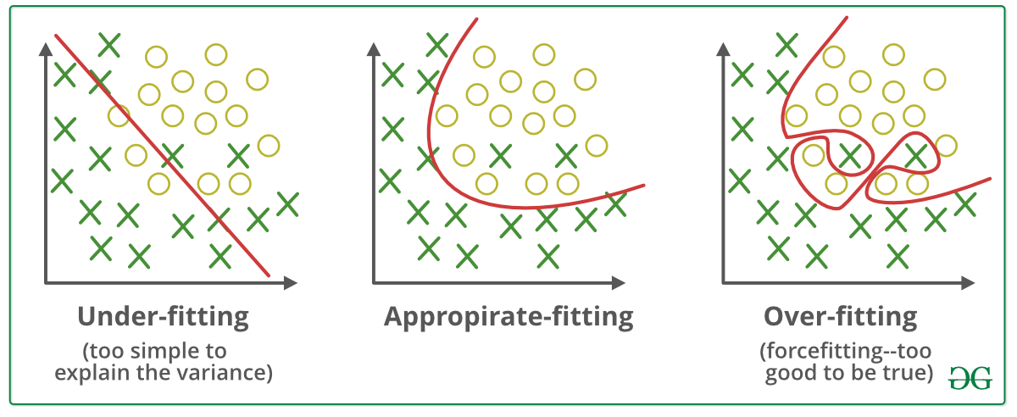
What is Overfitting?
Overfitting happens when a model learns too much from the training data — including noise and irrelevant patterns — and performs poorly on new (unseen) data.
📌 In simple terms:
High training accuracy but low test accuracy.

🔍 Example:
Suppose you're training a model to predict if a person has diabetes based on features like age, weight, glucose level, etc.
- If the model is overfitting:
  - It might learn the exact values from the training data (like memorization).
  - But when given new data, it fails to generalize (makes wrong predictions).

📉 Symptoms of Overfitting
Observation | Meaning
✅ Training loss ↓ very low | Model is fitting training data very well
❌ Validation/Test loss ↑ | Model is not generalizing to new data
❌ High variance | Predictions vary a lot on new data
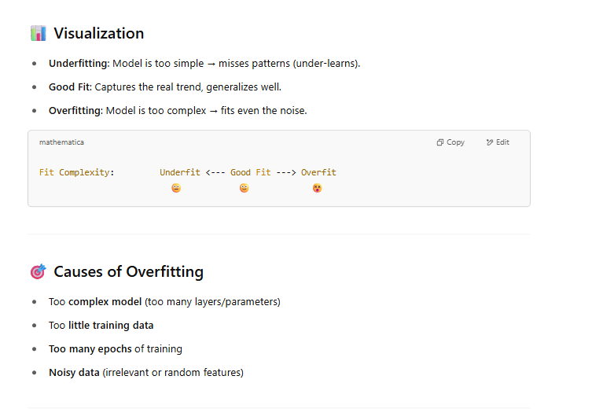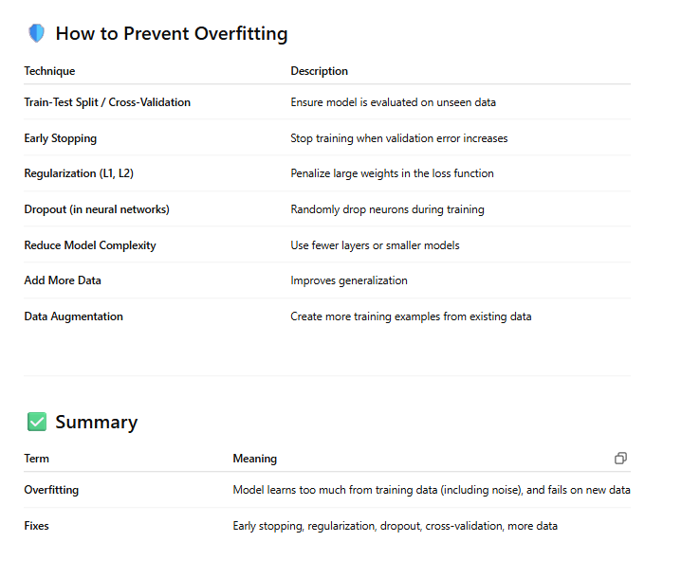
Recurrent neural networks
Explain recurrent neural networks with example.
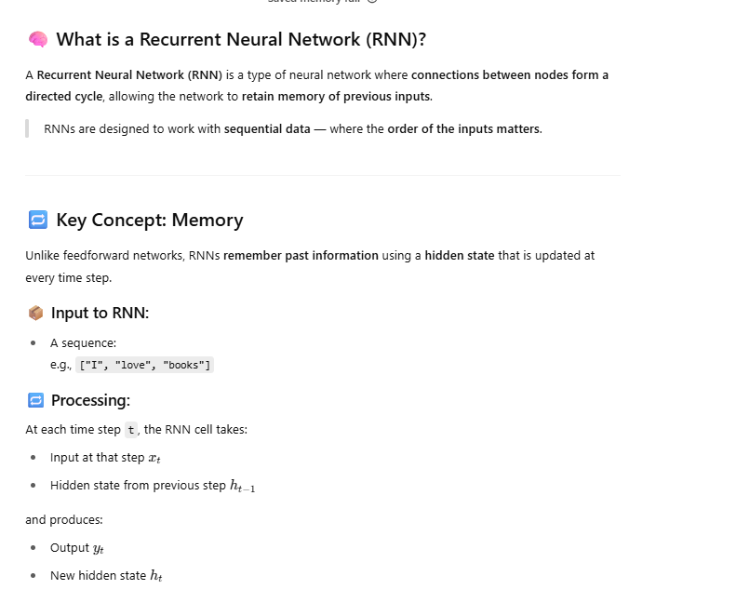 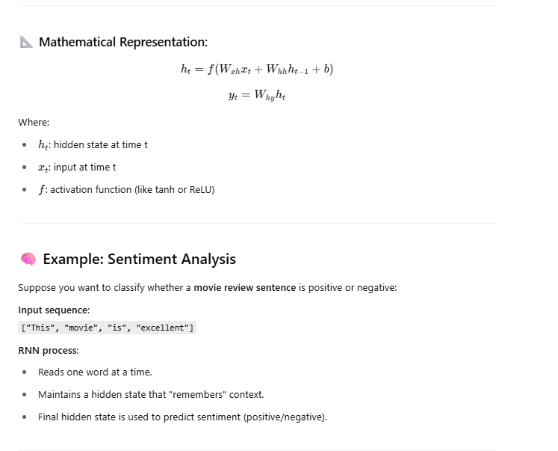 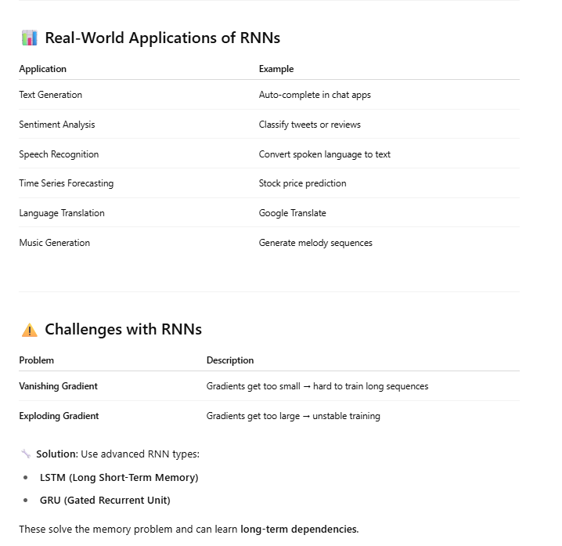 Summary
Feature | Recurrent Neural Network (RNN)
Input | Sequence (time, text, etc.)
Remembers | Previous inputs using hidden state
Use Case | Text, speech, time series
Variants | LSTM, GRU (better performance on long sequences)
…………………………
Recurrent Neural Networks (RNNs) are a type of neural network designed to process sequential data, like text or time series. They have a "memory" that remembers past inputs to influence current outputs. A simple example is predicting the next word in a sentence, where an RNN considers the preceding words to make its prediction.
Explanation:
- Sequential Data:
RNNs excel at tasks involving sequences, where the order of inputs matters. Examples include language translation, speech recognition, and time series forecasting.
- Memory:
RNNs have a "hidden state" that acts as memory. This state is updated at each step of the sequence, capturing information from previous inputs.
- Example:
Imagine predicting the next word in the sentence "The cat sat on the mat." An RNN would use the preceding words ("The cat sat on the") to determine the most likely next word ("the"). The hidden state remembers the context, so the RNN can make an informed decision.
- Applications:
RNNs are used in various applications, including:
  - Natural Language Processing: Language modeling, machine translation, and sentiment analysis.
  - Speech Recognition: Converting spoken words into text.
  - Time Series Forecasting: Predicting stock prices, weather patterns, or other time-dependent data.
- Variants:
There are various RNN architectures, such as LSTMs and GRUs, which address the vanishing gradient problem that can occur in standard RNNs.
