Data Science) (Honors
Unit 4
Hadoop Ecosystem
Q1
Explain Hadoop Ecosystem in detail.
The Hadoop ecosystem is a collection of open-source software tools and frameworks built on the core components of Apache Hadoop, enabling the storage, processing, and analysis of large datasets. It's designed for distributed storage and processing, leveraging clusters of computers to handle massive amounts of data. Key components include HDFS (Hadoop Distributed File System), YARN (Yet Another Resource Negotiator), and MapReduce, along with various other tools.
Here's a breakdown of the Hadoop ecosystem:
Core Components:
- Hadoop Distributed File System (HDFS):
A distributed file system that stores data across multiple nodes in a cluster, ensuring high fault tolerance and high-throughput access. It breaks large files into smaller blocks and distributes them across the cluster, enabling parallel processing.
- Yet Another Resource Negotiator (YARN):
A resource management framework that manages cluster resources and schedules applications for processing. YARN allows multiple processing engines to work in parallel, optimizing resource allocation.
- MapReduce:
A programming model and processing engine for parallel computation of large datasets. It divides the processing into two phases: Map and Reduce, where tasks are distributed across the cluster for parallel execution.
Other Key Components and Tools:
- Apache Spark:
A fast and general-purpose distributed computing engine often used in conjunction with Hadoop for data processing and analytics.
- Apache Hive:
A data warehouse and query language designed for Hadoop, providing SQL-like functionality for analyzing large datasets.
- Apache Pig:
A language and processing framework for analyzing large datasets in Hadoop, using the "Pig Latin" language.
- Apache HBase:
A distributed, column-oriented database built on top of Hadoop, enabling real-time access to large datasets.
- Apache Kafka:
A distributed streaming platform used for building real-time data pipelines.
- Apache Cassandra:
A distributed database that can be used with Hadoop for storing and accessing data.
- Apache Oozie:
A workflow engine for scheduling and managing Hadoop jobs.
- Apache Sqoop:
A tool for transferring data between Hadoop and other databases.
- Apache Flume:
A distributed streaming service for collecting and transporting large amounts of data into Hadoop.
- Apache Solr:
An open-source search platform that can be used with Hadoop for building search applications.
- Apache Lucene:
A Java library for indexing and searching documents, often used in conjunction with Solr and Hadoop.
- Apache Zookeeper:
A distributed coordination service that provides services like configuration management, synchronization, and group management for Hadoop clusters.
- Apache Ambari:
A web-based management tool for Hadoop clusters, providing monitoring, deployment, and configuration capabilities.
- Apache Mahout:
A machine learning library designed for Hadoop, providing algorithms for tasks like clustering, recommendation, and classification.
- Apache Drill:
An interactive data analysis tool that can be used with Hadoop.
- Apache MLlib:
A machine learning library within Apache Spark that provides algorithms for data analysis and predictive modeling.
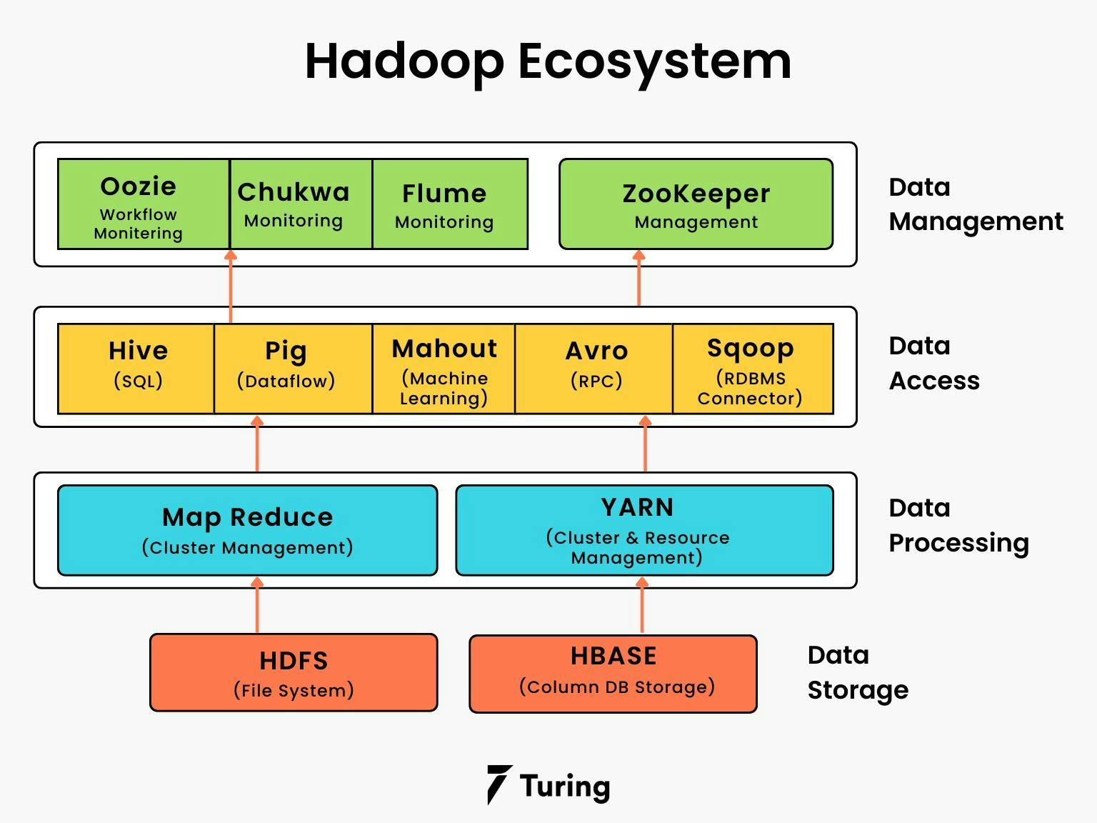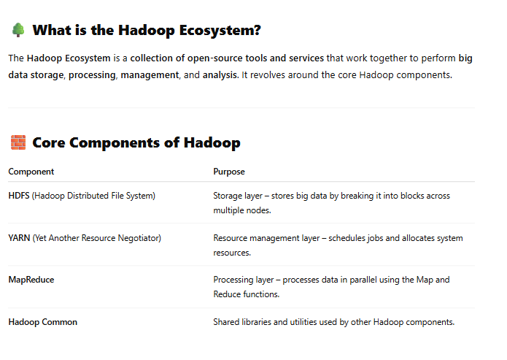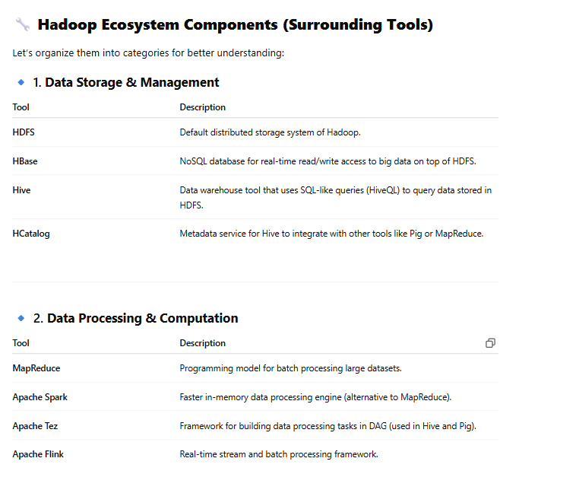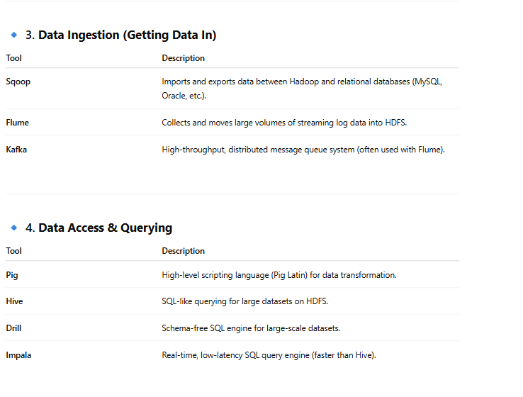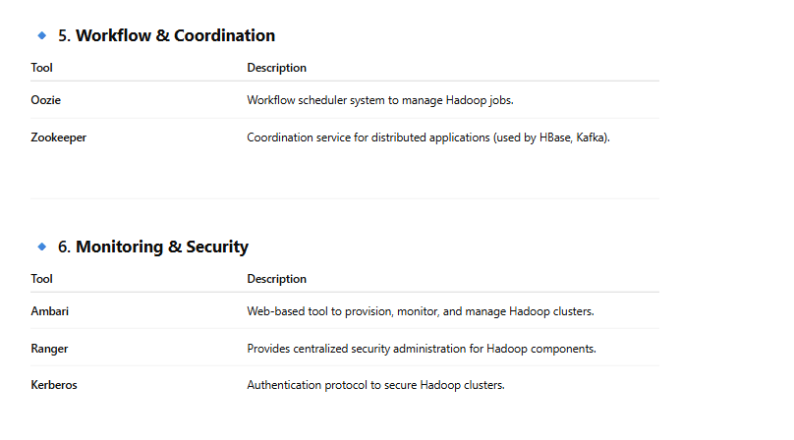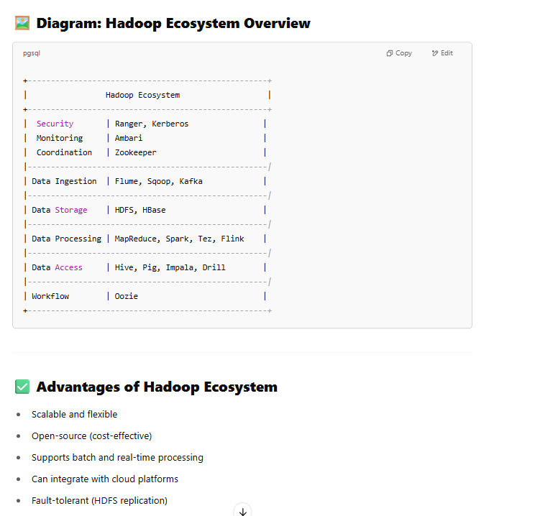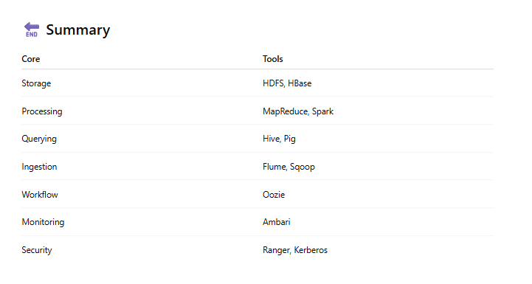

HDFS
Q2
Hadoop Distributed File System (HDFS) is a distributed, fault-tolerant file system designed to store and process large datasets. It's a core component of the Apache Hadoop ecosystem and enables the storage and management of big data across a cluster of machines. HDFS provides high-performance access to data and is designed to run on commodity hardware.
Here's a more detailed explanation:
Key Features:
- Distributed:
HDFS breaks large files into blocks and distributes them across multiple nodes in the cluster.
- Fault-tolerant:
Data is replicated across multiple nodes to ensure data availability even if some nodes fail.
- Scalable:
HDFS can be scaled to handle very large datasets and a large number of nodes in the cluster.
- High-performance:
HDFS provides efficient access to data through a distributed, parallel architecture.
- Designed for big data:
HDFS is optimized for storing and processing big datasets that are typically gigabytes to terabytes in size.
Architecture:
- NameNode: The NameNode is the master node that manages the file system namespace and metadata.
- DataNode: DataNodes are worker nodes that store the actual data blocks.
- Client: The client is the application that interacts with HDFS to perform file operations.
Use Cases:
- Storing and processing large datasets:
HDFS is used to store and process large datasets for various applications like data warehousing, analytics, and machine learning.
- Supporting big data analytics:
HDFS is a key component of many Hadoop systems, providing a foundation for big data analytics.
- Data storage for Hadoop applications:
HDFS is the primary data storage system for applications within the Hadoop ecosystem.
In essence, HDFS provides a reliable and scalable way to manage and access large datasets, making it a crucial component of the Hadoop ecosystem for big data applications.
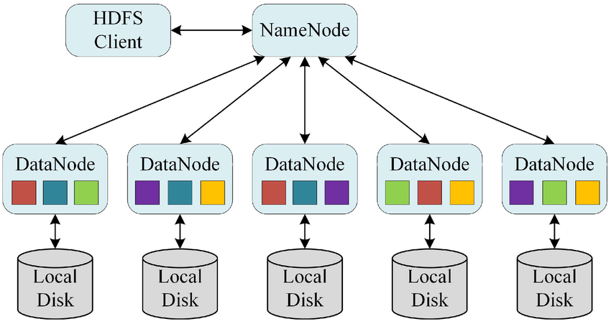 What is HDFS?
HDFS (Hadoop Distributed File System) is the primary storage system used by Hadoop for storing large volumes of data across multiple computers (nodes) in a distributed and fault-tolerant manner.

🔍 Key Idea:
HDFS splits large files into blocks, and stores them across multiple machines, ensuring high availability and reliability, even if some machines fail.

⚙️ Architecture of HDFS
HDFS follows a master-slave architecture:
🧠 1. NameNode (Master)
- Stores metadata (file names, block locations, permissions).
- Manages the file system namespace.
- Knows where the actual data blocks are stored.
💾 2. DataNodes (Slaves)
- Store the actual data blocks.
- Send heartbeat and block reports to NameNode.
🗃️ 3. Secondary NameNode
- It’s not a backup NameNode.
- It helps in periodically merging the metadata from NameNode to prevent overload.

📦 How HDFS Stores Files
- A file is split into fixed-size blocks (default: 128 MB or 64 MB).
- Each block is replicated (default: 3 copies).
- Blocks are stored on different DataNodes for fault tolerance.

🎯 Features of HDFS
Feature | Description
Fault Tolerant | Automatically recovers data if a node fails (via replication).
High Throughput | Optimized for large datasets and batch processing.
Scalability | Easily add more nodes to increase storage.
Write Once, Read Many | Files are written once and read many times — simplifies consistency.
Data Locality | Computation is moved to where the data is stored, improving performance.

💡 Real-Life Analogy
Imagine a library:
- The NameNode is the catalog that knows where each book (block) is kept.
- The DataNodes are the shelves holding the books (data).
- If one shelf is damaged, another copy is available on a different shelf (replication).
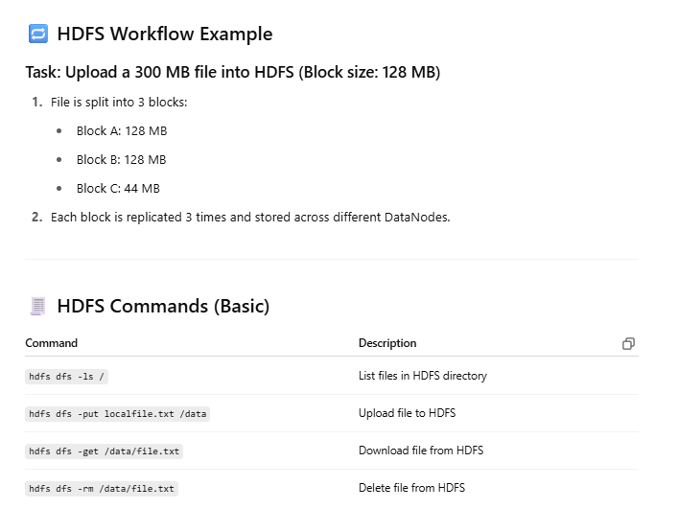 Summary
Feature | Details
Full Form | Hadoop Distributed File System
Structure | Master-Slave (NameNode & DataNodes)
Data Handling | Splits files into blocks, replicates, and distributes
Fault Tolerance | High – via replication
Suitable For | Big Data storage (TBs to PBs)

Explain HDFS and Map Reduce.
Hadoop Distributed File System (HDFS) and MapReduce are fundamental components of the Apache Hadoop framework, working together to enable efficient processing of large datasets. HDFS provides a distributed storage layer, while MapReduce is a programming model that facilitates parallel processing of data stored in HDFS.
HDFS (Hadoop Distributed File System):
- Storage:
HDFS stores data in large, fixed-size blocks (typically 64MB or 128MB) and distributes these blocks across a cluster of machines, providing fault tolerance and scalability.
- Scalability:
HDFS can handle massive datasets by distributing data across multiple nodes, enabling it to scale to petabytes of data.
- Fault Tolerance:
Data blocks are replicated multiple times across different nodes to ensure data availability in case of failures.
- File System:
HDFS serves as a distributed file system, providing an interface for storing and accessing data across the cluster.
MapReduce:
- Programming Model:
MapReduce is a programming model that provides a framework for processing data stored in HDFS in a distributed and parallel manner.
- Two Phases:
MapReduce tasks are typically divided into two phases:
  - Map: The map phase involves processing each input record and producing intermediate key-value pairs.
  - Reduce: The reduce phase aggregates the intermediate key-value pairs from the map phase and produces the final output.
- Parallel Processing:
MapReduce utilizes parallel processing by distributing the map and reduce tasks across multiple nodes in the cluster, enabling efficient processing of large datasets.
- Data Locality:
MapReduce leverages data locality, meaning that tasks are assigned to nodes that store the relevant data, reducing network overhead.
Relationship between HDFS and MapReduce:
- Interdependence:
HDFS and MapReduce are highly dependent, with HDFS providing the storage layer for MapReduce to process data.
- Data Flow:
MapReduce jobs read data from HDFS, process it in the map and reduce phases, and write the output back to HDFS.
- HDFS as Input/Output:
HDFS is commonly used as the input and output for MapReduce jobs, although technologies like Sqoop can allow MapReduce to access data from relational systems.
- Simplified Distributed Programming:
MapReduce simplifies distributed programming by providing a framework that handles the complexities of parallel processing and data distribution.
In essence, HDFS provides the infrastructure for storing and managing large datasets, while MapReduce provides the framework for processing that data in a distributed and parallel manner. Together, they enable efficient processing of big data within the Hadoop ecosystem.
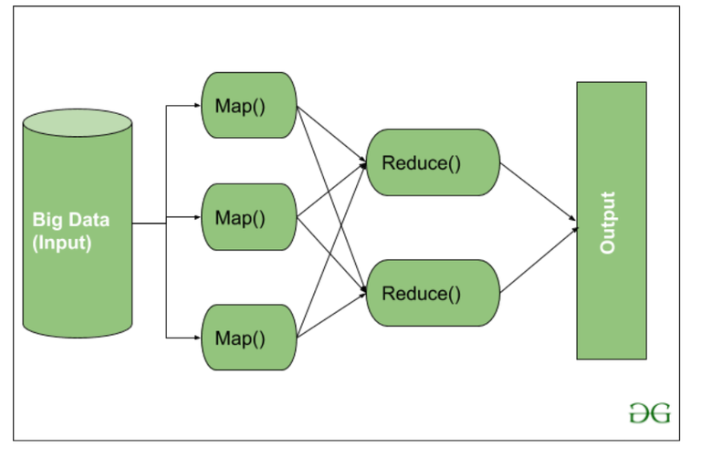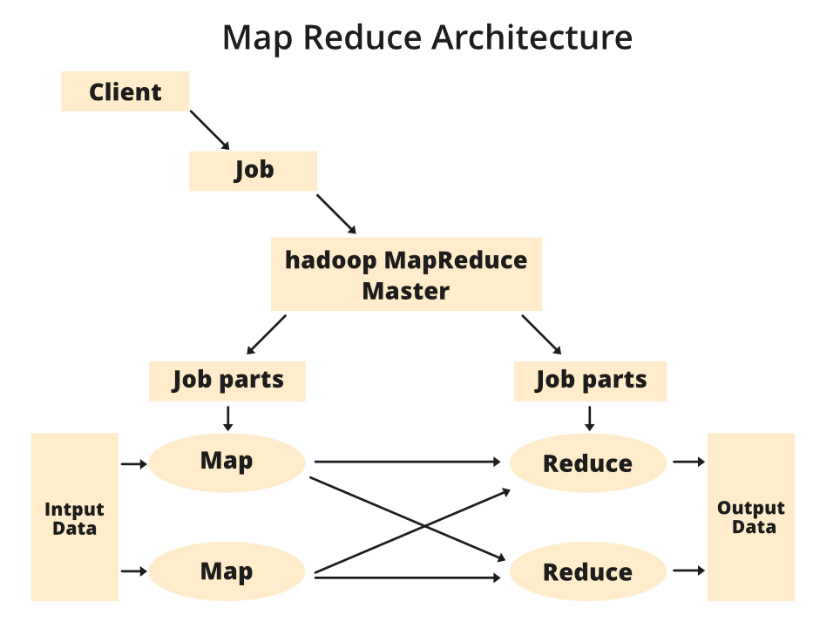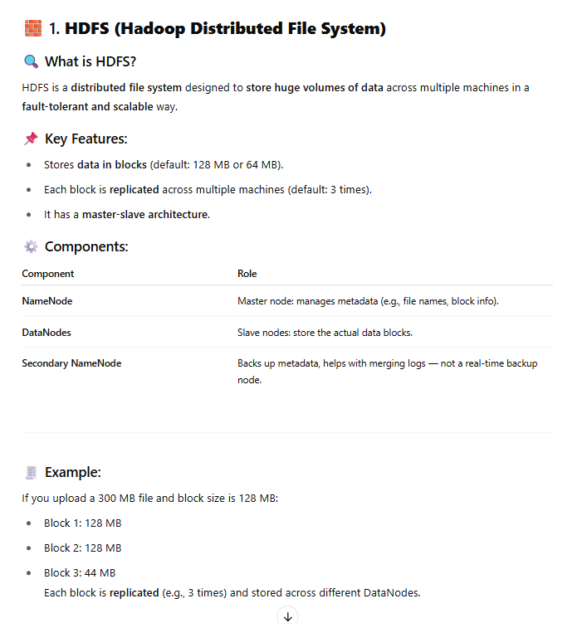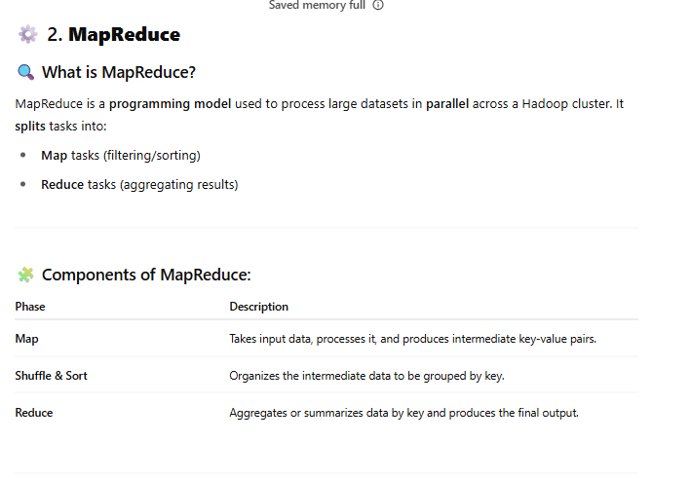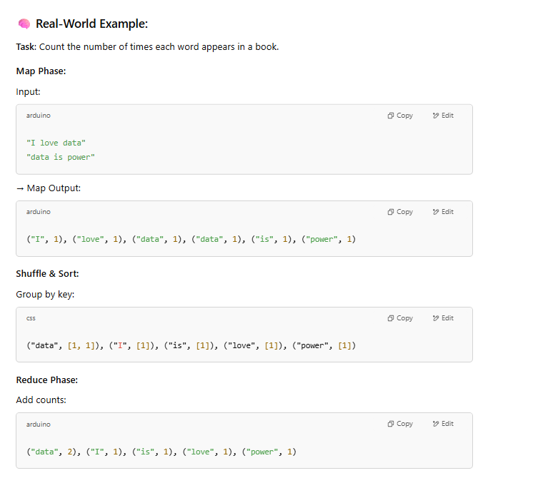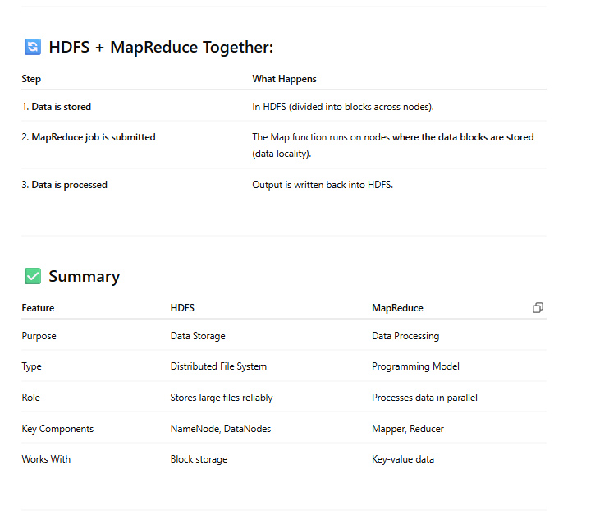
Python And Hadoop streaming
Q3
What is Hadoop Streaming? How Streaming is works in Hadoop
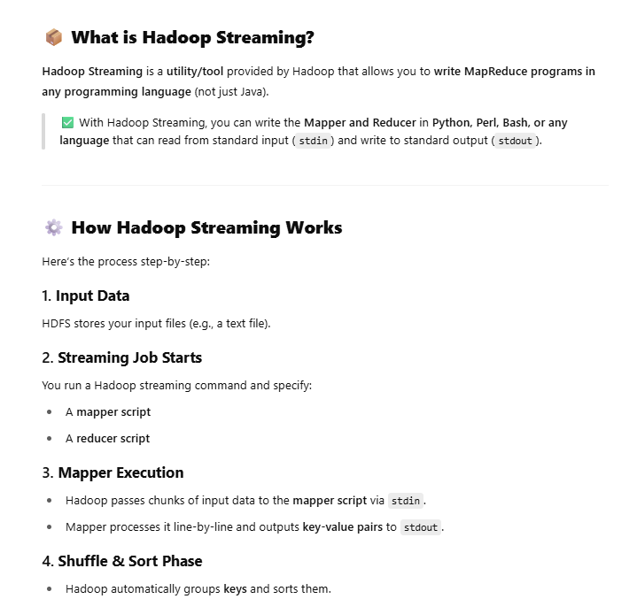 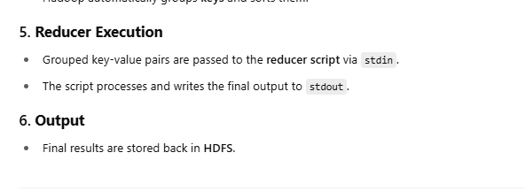 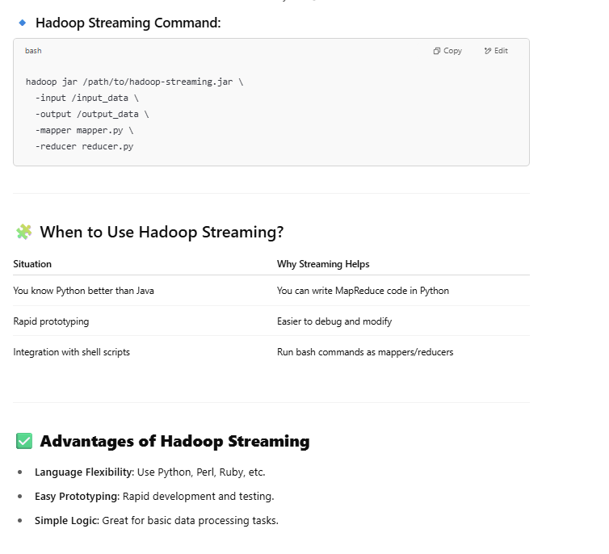 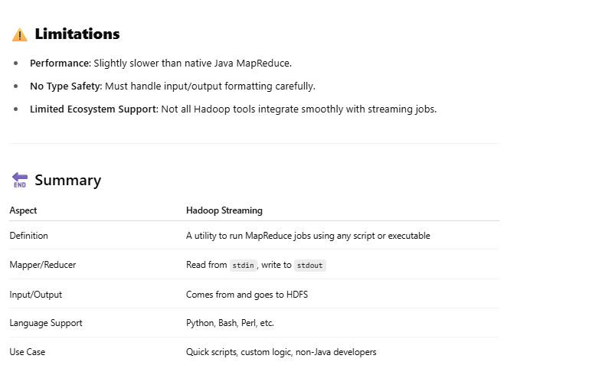……………….
What is Hadoop Streaming? Hadoop Streaming is a utility that allows users to create and run MapReduce jobs with any script or executable as the mapper and/or the reducer. Can Hadoop Streaming work with languages other than Java? Yes, Hadoop Streaming can work with other languages.
How does Hadoop Streaming Work? Input is read from standard input and the output is emitted to standard output by Mapper and the Reducer. The utility creates a Map/Reduce job, submits the job to an appropriate cluster, and monitors the progress of the job until completion.
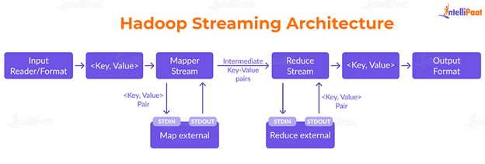
, Spark- basics
Q4
What is Spark? Explain the key features of Spark
Spark is a fast, general-purpose distributed computing framework that can handle interactive queries, machine learning, and real-time workloads. It's built on a concept called Resilient Distributed Datasets (RDDs), allowing for in-memory processing, which is significantly faster than traditional batch processing frameworks like Hadoop MapReduce.
………………….
What is Apache Spark?
Apache Spark is an open-source, distributed computing system designed for fast big data processing. Unlike Hadoop MapReduce, Spark performs in-memory computation, making it much faster for iterative tasks.
🔥 Developed at UC Berkeley’s AMPLab, and now maintained by the Apache Software Foundation.

🧠 Why Use Spark?
- It processes large datasets quickly.
- Supports multiple programming languages.
- Provides real-time stream processing as well as batch processing.

🧰 Key Features of Apache Spark
🔑 Feature | 📖 Description
1. Speed | Spark runs programs up to 100x faster than Hadoop MapReduce using in-memory computing.
2. In-Memory Computation | Stores intermediate data in memory (RAM), reducing time spent in disk I/O.
3. Easy to Use | Supports APIs in Python, Java, Scala, and R. Comes with built-in libraries.
4. Unified Engine | Supports batch processing, stream processing, machine learning, and graph processing in one framework.
5. Fault Tolerant | Uses a data structure called RDD (Resilient Distributed Dataset), which can recover lost data automatically.
6. Lazy Evaluation | Spark waits to execute until it’s needed, allowing for optimization of tasks.
7. Real-Time Processing | With Spark Streaming, you can process real-time data (unlike Hadoop MapReduce, which only does batch).
8. Integration with Hadoop | Can run on HDFS, YARN, and work with Hive, HBase, etc.
9. Advanced Analytics | Comes with libraries like:
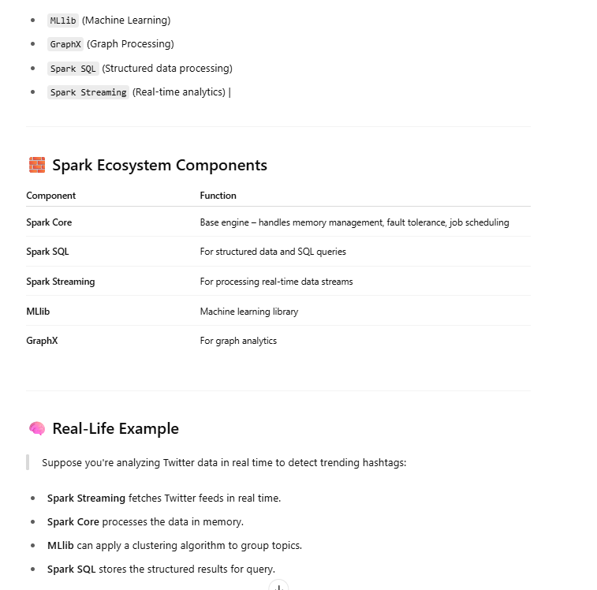Summary
Topic | Details
Name | Apache Spark
Type | Big Data Processing Framework
Speed | Fast (in-memory computation)
Languages | Scala, Python, Java, R
Supports | Batch, Real-Time, Machine Learning, Graph
Integrates with | Hadoop, Hive, HBase, Cassandra, etc.
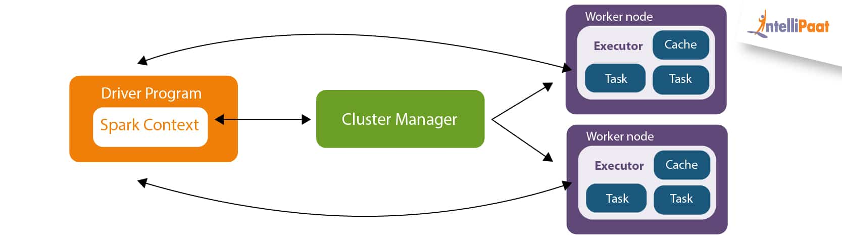
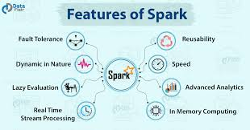
Q6
Explain the pyspark in big data analytics using hadoop.
ySpark is the Python API for Apache Spark, a powerful open-source, distributed computing framework designed for big data analytics. PySpark leverages Spark's in-memory processing capabilities, making it significantly faster than traditional MapReduce-based systems like Hadoop for many workloads.
Key Features and Concepts:
- Integration with Hadoop:
PySpark seamlessly integrates with Hadoop's ecosystem. It can read and write data from the Hadoop Distributed File System (HDFS), process data stored in Hadoop data warehouses like Hive, and utilize Hadoop's resource management system, YARN.
- Resilient Distributed Datasets (RDDs):
PySpark operates on RDDs, which are fault-tolerant, distributed collections of data that can be processed in parallel across a cluster.
- In-Memory Processing:
Spark's in-memory processing capabilities enable it to perform computations much faster than disk-based systems. This is particularly beneficial for iterative algorithms and interactive data analysis.
- Distributed Computing:
PySpark distributes data and computations across multiple nodes in a cluster, allowing it to scale to handle large datasets that cannot be processed on a single machine.
- Multi-Language Support:
While PySpark is the Python API, Spark itself supports multiple languages, including Java, Scala, and R, providing flexibility for developers.
- Data Source Variety:
PySpark can process data from various sources, including HDFS, AWS S3, databases, and streaming platforms like Kafka.
- Real-Time Data Processing:
PySpark's streaming capabilities allow it to process data streams in real time, making it suitable for applications like fraud detection, real-time analytics, and sensor data processing.
- Machine Learning:
PySpark includes the MLlib library for distributed machine learning, enabling users to train and deploy machine learning models on large datasets.
- SQL Support:
PySpark SQL provides a SQL interface for querying and processing structured data, making it easy to leverage existing SQL knowledge and infrastructure.
How PySpark Works with Hadoop:
- Data Storage:
Hadoop's HDFS provides a distributed file system for storing large datasets across multiple machines.
- Resource Management:
YARN manages cluster resources, allocating them to Spark applications.
- Data Processing:
PySpark reads data from HDFS, processes it in parallel across the cluster, and writes the results back to HDFS or other storage systems.
- Integration with Hadoop Ecosystem:
PySpark can interact with other Hadoop components like Hive for data warehousing and Kafka for streaming.
Benefits of Using PySpark:
- Speed:
In-memory processing makes PySpark much faster than MapReduce for iterative algorithms and interactive queries.
- Scalability:
Distributed computing enables PySpark to handle large datasets by scaling horizontally.
- Ease of Use:
Python's simplicity and PySpark's high-level APIs make it easier to develop big data applications.
- Flexibility:
PySpark's support for various data sources, processing types, and machine learning capabilities makes it a versatile tool for big data analytics.
- Real-Time Processing:
PySpark's streaming capabilities enable real-time data analysis.
