Data Science(Honors)
Unit 5
Data warehousing and mining
Q1
Write a short note on: Data Warehousing.
Data warehousing is a method of organizing and compiling data from multiple sources into a single, centralized database for analysis and reporting. It acts as a central repository for historical and current data, facilitating business intelligence (BI) and data analytics.
Here's a more detailed explanation:
Key Features and Purpose:
- Centralized Repository:
Data warehouses consolidate data from various operational systems, databases, and other sources.
- Historical Data:
They store historical data, allowing for trend analysis and understanding business performance over time.
- Data Analytics and BI:
Data warehouses are designed for analysis and reporting, enabling users to gain insights into business operations and make informed decisions.
- Data Transformation:
Data often requires transformation (cleaning, standardization, aggregation) before being loaded into the data warehouse.
- Online Analytical Processing (OLAP):
Data warehouses often utilize OLAP techniques for efficient multidimensional analysis.
Benefits of Data Warehousing:
- Improved Data Quality:
Centralization and standardization of data lead to more accurate and reliable results.
- Faster Analysis:
By consolidating data, analysis can be performed more quickly and efficiently.
- Better Decision Making:
Insights derived from data analysis enable more informed and strategic decisions.
- Increased Efficiency:
Streamlined data processing and reporting processes can lead to increased efficiency.
- Data Security:
Data warehouses can be designed with robust security features to protect sensitive information.
Types of Data Warehouses:
- Enterprise Data Warehouse (EDW): A large-scale data warehouse that supports the entire organization.
- Data Mart: A smaller, more focused data warehouse designed for a specific department or business function.
- Cloud Data Warehouse: A data warehouse hosted in the cloud, offering scalability and cost-effectiveness.
In essence, data warehousing is a crucial tool for businesses looking to leverage their data for strategic decision-making and business intelligence initiatives.
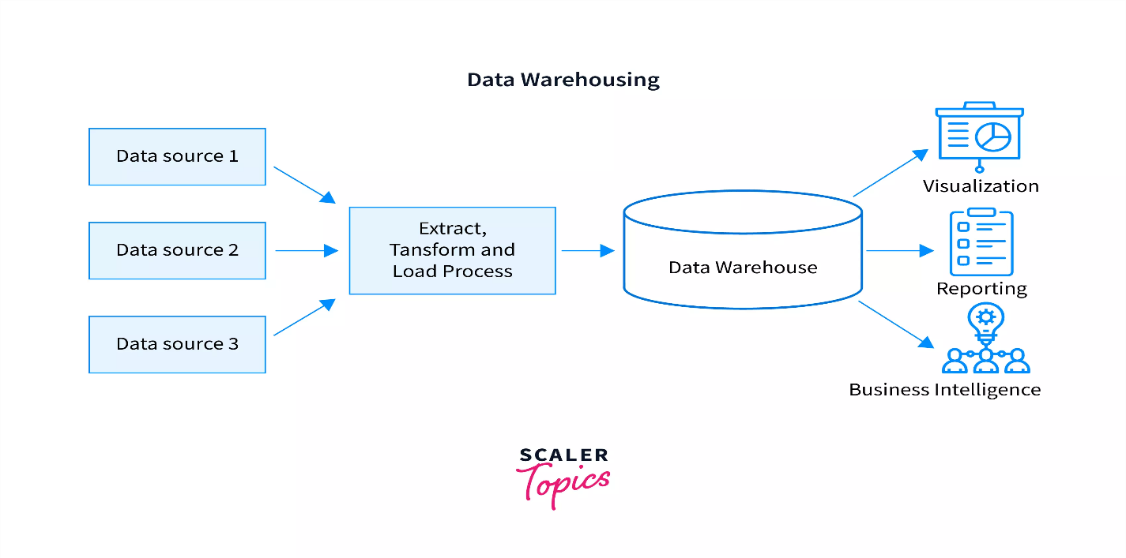
Data Warehousing
🔍 Definition:
A Data Warehouse is a centralized repository that stores large volumes of structured data from multiple sources. It is designed to support business intelligence (BI), reporting, and data analysis.

🧰 Key Features:
- Subject-Oriented: Organized around key subjects like sales, customers, or finance.
- Integrated: Combines data from different sources into a consistent format.
- Time-Variant: Maintains historical data for trend analysis.
- Non-Volatile: Once data is entered, it is not frequently updated or deleted.

🧱 Architecture Components:
- Data Source – Databases, files, ERP systems.
- ETL (Extract, Transform, Load) – Processes that move data into the warehouse.
- Data Warehouse Database – The main storage area.
- Metadata – Data about the data (e.g., source, update time).
- Data Marts – Smaller subsets for specific departments or teams.
- BI Tools – Used for reporting and visualization.

📊 Applications:
- Business performance reporting
- Sales forecasting and trend analysis
- Market research and customer behavior analysis
- Financial and compliance reporting

✅ Benefits:
- Faster query performance
- Better decision-making
- Data consistency and quality
- Historical data analysis
Q2
What are the different key characteristics of a Data Warehouse?
A Data Warehouse is distinguished by four key characteristics: subject-oriented, integrated, time-variant, and non-volatile. These characteristics help to distinguish data warehouses from other databases and ensure the integrity of data for analytical purposes.
Subject-Oriented:
- Data is organized around specific business subjects, such as customers, products, or sales, rather than the operational activities of the organization.
- This allows for a more holistic view of business data, rather than focusing on specific transactions.
Integrated:
- Data from multiple sources (e.g., ERP, CRM) is combined and standardized into a single, unified view.
- This ensures consistency and avoids data duplication or conflicting information.
Time-Variant:
- Data warehouses store historical data, allowing for trend analysis and the examination of data over time.
- This historical perspective is crucial for understanding past performance and forecasting future trends.
Non-Volatile:
- Data in a data warehouse is not typically deleted or updated, allowing for a permanent record of historical data.
- This ensures that historical data is readily available for analysis, even as new data is loaded.
These four characteristics, along with other modern additions like scalability and accessibility, are essential for a data warehouse to be a powerful tool for business intelligence and analytics.
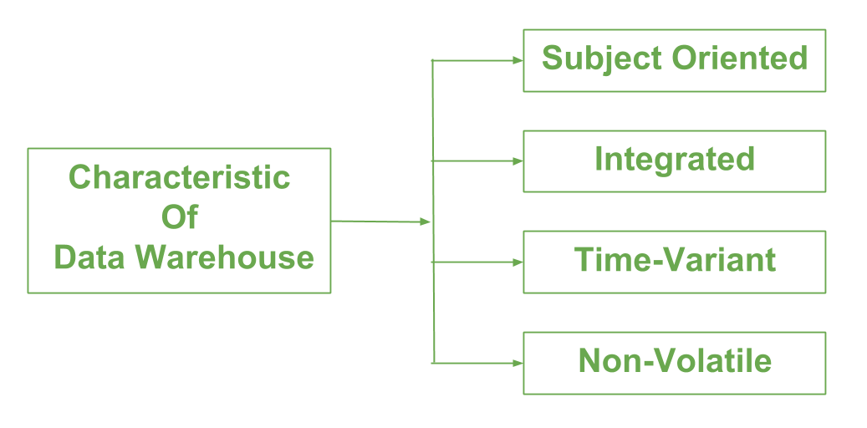 Key Characteristics of a Data Warehouse
- Subject-Oriented
  - Data is organized around major subjects like customers, products, sales, etc., rather than focusing on specific applications or processes.
  - Helps in analyzing data related to particular areas of business.
- Integrated
  - Data from multiple, heterogeneous sources is combined into a consistent format.
  - Resolves inconsistencies in naming conventions, data types, and formats.
- Time-Variant
  - Stores historical data to enable trend analysis over different time periods.
  - Data is tagged with time stamps (e.g., daily, monthly) to track changes over time.
- Non-Volatile
  - Once data is entered, it is stable and does not change frequently.
  - Supports read-only operations for querying and analysis rather than frequent transactional updates.
- Data Consistency and Quality
  - Ensures accuracy, completeness, and reliability of data by cleansing and validating during the ETL process.
- Accessible and Query-Optimized
  - Designed for fast retrieval of large volumes of data.
  - Supports complex queries and reporting efficiently.
- Supports Decision Making
  - Provides summarized and detailed data to support strategic, tactical, and operational decision-making.

Data mining
Q3
Data mining is the process of sorting through large data sets to identify patterns and relationships that can help solve business problems through data analysis. Data mining techniques and tools help enterprises to predict future trends and make more informed business decisions.13 Feb 2024
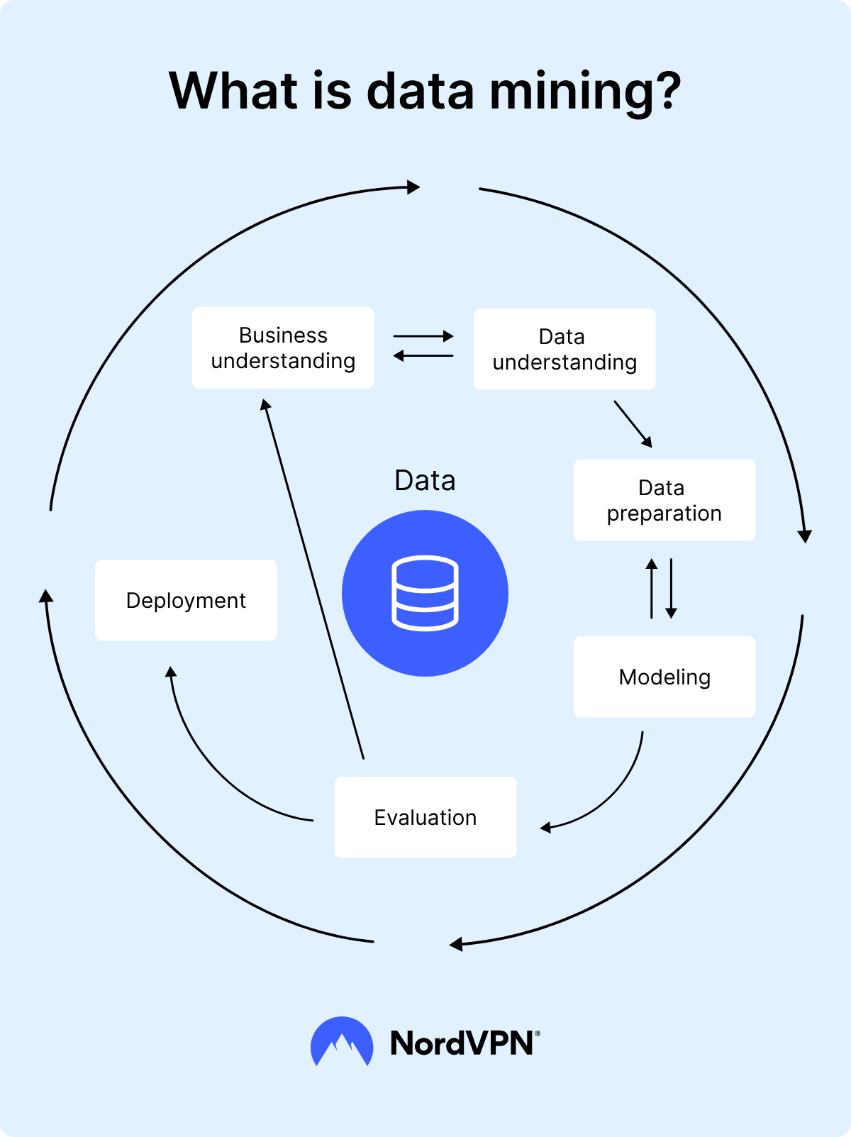
Data Mining
What is Data Mining?
Data Mining is the process of discovering hidden patterns, trends, and useful information from large sets of data using techniques from statistics, machine learning, and database systems.

Key Points:
- It extracts meaningful insights from raw data.
- Helps in predicting future trends and making informed decisions.
- Often called Knowledge Discovery in Databases (KDD).

Common Techniques in Data Mining:
- Q
- Clustering: Grouping similar data points together without predefined labels.
- Association Rule Mining: Finding relationships between variables (e.g., market basket analysis).
- Regression: Predicting continuous values based on data trends.
- Anomaly Detection: Identifying unusual data points or outliers.

Applications of Data Mining:
- Fraud detection in banking
- Customer segmentation in marketing
- Medical diagnosis
- Recommendation systems (like Netflix, Amazon)

, Data analysis using Hive
Q4
What are the different Features of Hive in Big Data.
Apache Hive is a data warehousing system built on top of Hadoop that allows users to query and analyze large datasets stored in the HDFS using SQL-like queries. It provides a familiar interface for querying data stored in a distributed system, abstracting the complexity of MapReduce. Hive is widely used for data warehousing, ETL processes, and ad-hoc data analysis, particularly in organizations that have adopted the Hadoop ecosystem.
Here's a more detailed explanation:
What is Hive?
- Data Warehouse:
Hive is a data warehouse system that provides a SQL-like interface for querying data stored in HDFS.
- Hadoop Integration:
It's built on top of Hadoop and can leverage its distributed storage (HDFS) and processing capabilities.
- HiveQL:
It uses a query language called HiveQL, which is similar to SQL, allowing users to query and analyze large datasets.
- MapReduce Abstraction:
Hive converts HiveQL queries into MapReduce jobs, allowing users to interact with Hadoop without needing to write complex MapReduce programs.
Key Features and Benefits:
- Ease of Use:
Hive provides a user-friendly SQL-like interface for querying data, making it accessible to both programmers and non-programmers.
- Scalability:
Built on Hadoop, Hive can handle massive datasets and scale horizontally to accommodate growing data volumes.
- ETL and Data Warehousing:
Hive is well-suited for ETL (Extract, Transform, Load) tasks and data warehousing, providing a structured approach to data preparation and analysis.
- Ad-hoc Querying:
Hive enables users to perform ad-hoc queries and analysis of large datasets, providing insights into data patterns and trends.
- Integration with Hadoop Ecosystem:
Hive integrates seamlessly with other tools and systems in the Hadoop ecosystem, such as HDFS and other data processing frameworks.
How it Works:
- Data Storage: Data is stored in HDFS, a distributed file system that is part of Hadoop.
- HiveQL Queries: Users write HiveQL queries to interact with the data stored in HDFS.
- Query Execution: Hive converts the HiveQL queries into MapReduce jobs, which are then executed on Hadoop.
- Results: The results of the queries are then returned to the user.
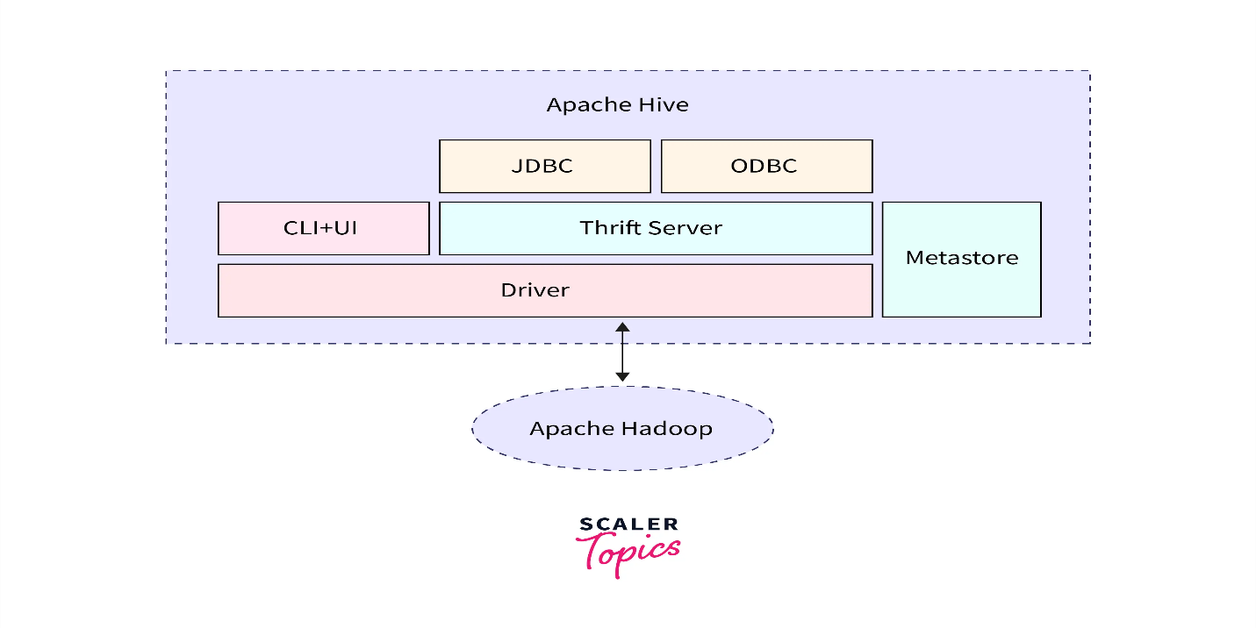
eatures of Hive in Big Data
- SQL-Like Query Language (HiveQL)
  - Hive provides an SQL-like language called HiveQL which makes it easier for users familiar with SQL to query large datasets stored in Hadoop.
- Data Warehousing on Hadoop
  - Hive acts like a data warehouse infrastructure built on top of Hadoop, enabling data summarization, querying, and analysis.
- Schema on Read
  - Unlike traditional databases, Hive applies schema at the time of reading data (not writing), making it flexible for semi-structured and unstructured data.
- Supports Large Datasets
  - Can process petabytes of data stored in HDFS or compatible file systems.
- Extensible and Customizable
  - Supports User Defined Functions (UDFs), allowing users to write custom functions for complex transformations.
- Partitioning and Bucketing
  - Improves query performance by organizing data into partitions and buckets for faster data retrieval.
- Supports Different File Formats
  - Compatible with multiple file formats such as Text, ORC, Parquet, Avro, and more.
- Integration with Hadoop Ecosystem
  - Works seamlessly with other Hadoop components like HDFS, MapReduce, YARN, HBase, and Spark.
- Batch Processing
  - Optimized for batch processing jobs over large datasets.
- Metadata Storage
  - Uses a Metastore (usually backed by a relational database) to store metadata about tables, partitions, columns, etc.
Q5
What is Hive Big Data and its Benefits?
What is Hive in Big Data?
Apache Hive is a data warehouse infrastructure built on top of Hadoop. It provides an easy-to-use SQL-like query language called HiveQL that allows users to query and analyze large datasets stored in Hadoop’s HDFS (Hadoop Distributed File System) without writing complex MapReduce programs.
- Hive translates SQL-like queries into MapReduce, Tez, or Spark jobs behind the scenes.
- It is designed for batch processing and analysis of large datasets.

🌟 Benefits of Hive
Benefit | Explanation
1. Easy to Use | Uses familiar SQL-like HiveQL, so users don’t need to know Java or MapReduce.
2. Handles Large Data | Designed to efficiently query huge volumes of data stored in HDFS.
3. Extensible | Supports User Defined Functions (UDFs) to extend functionality.
4. Integration | Works seamlessly with other Hadoop components like HDFS, YARN, Spark, and HBase.
5. Schema Flexibility | Supports schema on read, making it flexible to work with semi-structured or unstructured data.
6. Data Partitioning | Allows partitioning tables to improve query speed and performance.
7. Cost-Effective | Leverages Hadoop's distributed storage and processing, which is scalable and economical.
8. Metadata Management | Stores metadata in a Metastore, simplifying data management and query optimization.

Data ingestion
Data ingestion is the process of collecting, importing, and preparing data from various sources into a central location or repository for analysis, processing, reporting, and other applications. It's a crucial step in any data analytics workflow, ensuring data is accessible and usable for further processing.
Key Aspects of Data Ingestion:
- Data Collection:
Involves gathering data from diverse sources like databases, social media platforms, IoT devices, and more.
- Data Transformation:
May include cleaning, formatting, and other transformations to ensure data accuracy and consistency.
- Data Loading:
Involves moving the transformed data into a target system, such as a data warehouse, database, or data lake.
- Data Validation:
Ensures the quality of the data by checking for errors, inconsistencies, and missing values.
Purpose and Benefits:
- Centralization: Consolidates data from various sources into a single repository, making it easier to manage and access.
- Data Integration: Integrates data from diverse sources, creating a unified view for analysis.
- Real-time Processing: Enables real-time data streaming for immediate insights and reactions.
- Data Transformation: Prepares data for analysis by cleaning, formatting, and other transformations.
- Improved Decision-Making: Provides data-driven insights for better decision-making and strategy development.
- Scalability: Handles large volumes of data and can scale to meet growing demands.
Common Tools and Techniques:
- ETL (Extract, Transform, Load):
A process for extracting data from source systems, transforming it, and loading it into a target system.
- Data Pipelines:
Automated workflows that facilitate data movement and transformation.
- Streaming Technologies:
Enable real-time data ingestion and processing, such as Apache Kafka and Apache NiFi.
- Cloud-based Solutions:
Provide scalable and flexible data ingestion capabilities, such as AWS Glue and Google Cloud Dataflow.
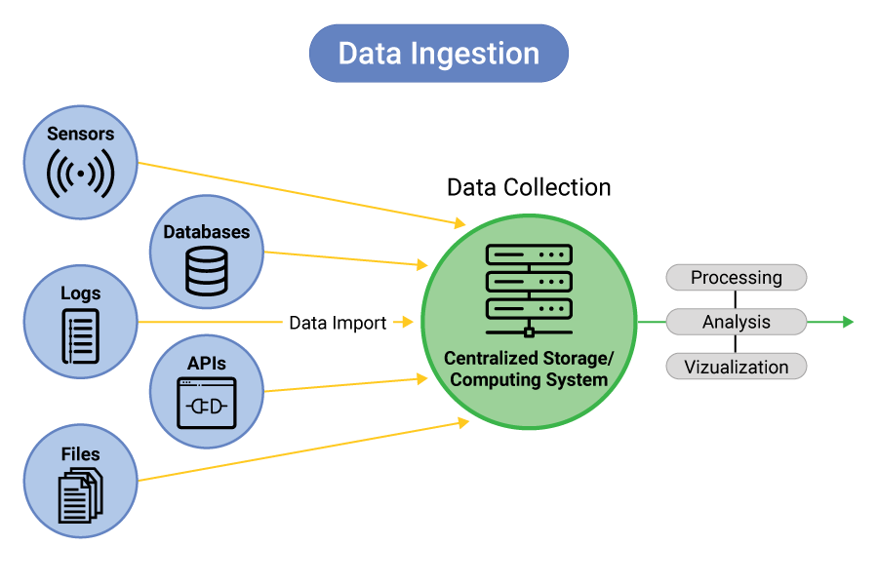 What is Data Ingestion?
Data Ingestion is the process of collecting, importing, and transferring data from various sources into a storage system where it can be accessed and analyzed, such as a data warehouse, data lake, or big data platform.

🔑 Key Points:
- It’s the first step in any data pipeline.
- Can handle batch (large chunks of data at intervals) or streaming (continuous real-time data) ingestion.
- Sources can be databases, logs, IoT devices, social media, APIs, files, etc.

🧰 Types of Data Ingestion:
Type | Description
Batch Ingestion | Data is collected and ingested in chunks at scheduled intervals (e.g., nightly loads).
Streaming Ingestion | Data is ingested continuously in real time (e.g., sensor data, clickstreams).

📈 Why is Data Ingestion Important?
- Ensures data availability for analytics and decision making.
- Enables integration of data from multiple and diverse sources.
- Supports scalable and reliable data processing pipelines.

Scalable machine learning using Spark.
Q6
Explain Scalable Machine Learing on Big Data using Spark

Scalable Machine Learning using Spark
🔥 What is Apache Spark?
Apache Spark is an open-source distributed computing system that supports fast and scalable data processing. It has a built-in library called MLlib specifically for machine learning tasks.

🧠 What is MLlib?
MLlib (Machine Learning Library) is Spark’s scalable machine learning library.
It provides distributed implementations of common ML algorithms, optimized to run across clusters.

✅ Why Use Spark for Machine Learning?
Feature | Benefit
Distributed Processing | Can train models on very large datasets across multiple nodes.
In-Memory Computation | Faster than Hadoop MapReduce; avoids writing to disk between steps.
Language Support | Works with Python (PySpark), Scala, Java, R.
Scalability | Suitable for datasets from gigabytes to petabytes.
Integration | Easily integrates with Hadoop, HDFS, Kafka, HBase, etc.
Pipelines | Supports ML pipelines for building complete workflows (data processing → modeling → evaluation).

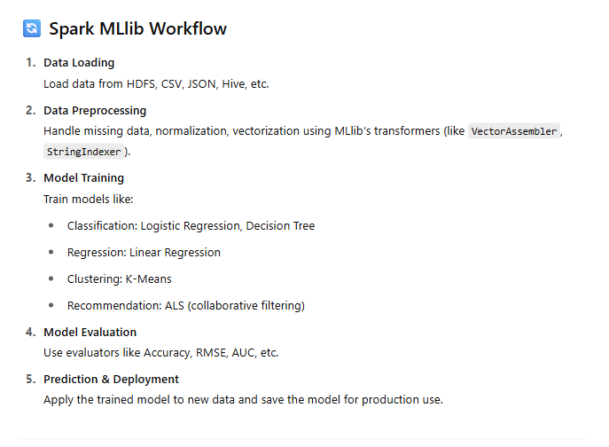 Summary
Component | Role
Spark | Framework for distributed processing
MLlib | Library for scalable machine learning
Use Case | Classification, regression, clustering, recommendation
Advantage | Scalability + Speed + Integration with Big Data
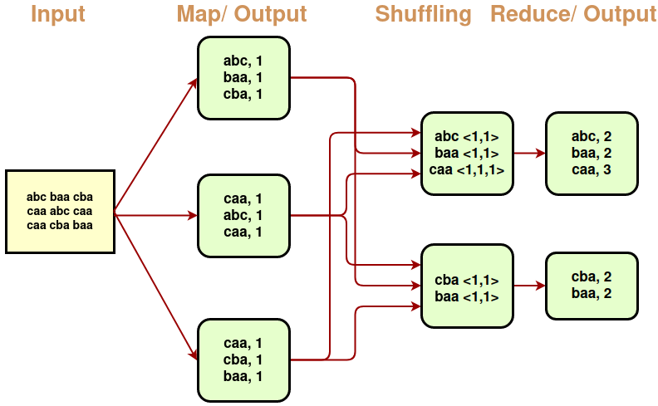
Apache Spark is a powerful, open-source, distributed computing framework that can be used to build scalable machine learning pipelines. It offers libraries like Spark MLlib and Spark.ml, which provide a wide range of algorithms and tools for handling large datasets and creating efficient models.
Key aspects of scalable machine learning with Spark:
- Distributed Computing:
Spark is designed to run on clusters of computers, enabling parallel processing of large datasets and algorithms.
- Spark MLlib:
This library provides a collection of machine learning algorithms, including classification, regression, clustering, and collaborative filtering.
- Spark.ml:
A higher-level API built on top of DataFrames, making it easier to create and manage machine learning pipelines.
- Scalable Data Handling:
Spark can handle various data sources, including HDFS, S3, and other Hadoop-compatible sources, allowing for large-scale data processing.
- End-to-End Pipelines:
Spark's pipelines allow you to chain together transformations, estimators, and evaluators to create complete machine learning workflows.
- MLflow Integration:
MLflow can be used with Spark to track, version, and deploy machine learning models, enhancing the reproducibility and reliability of your models.
- Hyperparameter Tuning:
Spark supports distributed hyperparameter tuning, allowing you to optimize your models without being limited by the resources of a single machine.
- Pandas on Spark:
Spark provides a pandas API that allows you to leverage pandas-like data manipulations on Spark DataFrames, bridging the gap between your existing pandas code and Spark's distributed processing.
- Community Support:
Spark has a large and active community, providing extensive documentation, tutorials, and community support.
Benefits of using Spark for scalable machine learning:
- Scalability: Handles large datasets and computationally intensive tasks that would be impossible or impractical on a single machine.
- Efficiency: Parallel processing and distributed computing lead to faster training and inference times.
- Flexibility: Supports a wide range of machine learning algorithms and data sources.
- Reproducibility: MLflow and other tools help ensure that your models are reproducible and can be deployed reliably.
- Community and Ecosystem: Benefits from a vibrant community and ecosystem of tools and libraries.

