Data Science) (Honors)
unit 6
Natural language processing steps: Text pre-processing, feature extraction, applying NLP techniques
Q1
Natural language processing (NLP) involves several steps, starting with text pre-processing, followed by feature extraction, and then applying various NLP techniques for analysis and tasks like sentiment analysis or machine translation. Text pre-processing involves cleaning and transforming raw text data to prepare it for analysis, while feature extraction converts pre-processed text into a format suitable for machine learning models. NLP techniques are then used to perform specific tasks on the processed data.
1. Text Pre-processing:
- Goal: To clean and transform raw text data into a format suitable for analysis.
- Steps:
  - Lowercasing: Converting all text to lowercase to ensure consistency.
  - Tokenization: Breaking down text into smaller units like words or sentences.
  - Punctuation Removal: Removing punctuation marks.
  - Stop Word Removal: Removing common words that don't add much meaning (e.g., "the", "a").
  - Stemming/Lemmatization: Reducing words to their root form.
  - Other: Removing HTML tags, numbers, and special characters.
2. Feature Extraction:
- Goal:
To represent the pre-processed text in a way that machine learning models can understand.
- Techniques:
  - Bag-of-Words: Creating a vector representation of the text based on the frequency of words.
  - TF-IDF (Term Frequency-Inverse Document Frequency): Assigning weights to words based on their frequency in the document and the corpus.
  - Word Embeddings: Creating vector representations of words that capture their semantic meaning.
  - N-grams: Representing text as sequences of n words.
3. Applying NLP Techniques:
- Goal: To perform specific tasks on the processed and feature-extracted data.
- Examples:
  - Sentiment Analysis: Determining the sentiment expressed in a text (e.g., positive, negative, neutral).
  - Named Entity Recognition (NER): Identifying and classifying entities in text (e.g., people, organizations, locations).
  - Text Summarization: Creating a shorter version of a text while preserving its key information.
  - Machine Translation: Translating text from one language to another.
  - Chatbots and Virtual Assistants: Enabling systems to engage in conversations with users.
Example:
Consider the sentence "The quick brown fox jumps over the lazy dog."
- 1. Pre-processing:
  - Tokenization: ["The", "quick", "brown", "fox", "jumps", "over", "the", "lazy", "dog"]
  - Lowercasing: ["the", "quick", "brown", "fox", "jumps", "over", "the", "lazy", "dog"]
  - Stop Word Removal: ["quick", "brown", "fox", "jumps", "over", "lazy", "dog"]
- 2. Feature Extraction:
  - Bag-of-Words: Create a vocabulary of unique words and count their frequency in the sentence.
  - TF-IDF: Calculate the TF-IDF score for each word in the sentence.
- 3. NLP Techniques:
  - Sentiment Analysis: Using the TF-IDF scores and a trained model, determine if the sentence expresses positive or negative sentiment.
  - Named Entity Recognition: Identify that "fox" is an animal and "lazy dog" is a noun phrase.
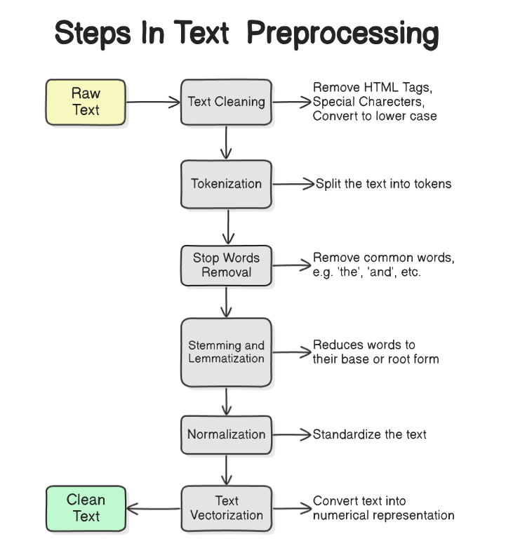
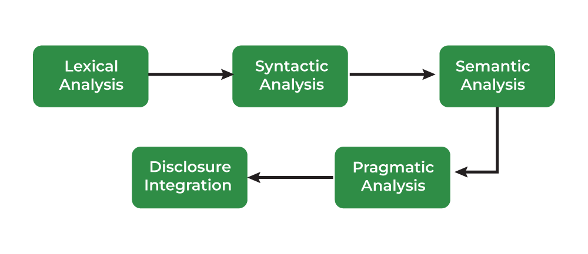
Text Preprocessing → ✨ Feature Extraction → 🤖 Applying NLP Techniques

💬 Step 1: Text Preprocessing
Text preprocessing is the cleaning and preparing of raw text before analysis. It ensures consistency and removes noise.
🔧 Common Preprocessing Steps:
Step | Description
Tokenization | Breaking text into words, phrases, or sentences.
Lowercasing | Converting all text to lowercase to maintain consistency.
Stopword Removal | Removing common words like the, is, and, in that don't carry meaning.
Stemming | Reducing words to their root form (e.g., playing → play).
Lemmatization | Similar to stemming, but returns real root words (e.g., better → good).
Removing Punctuation and Numbers | Removes symbols and digits if not needed.
Text Normalization | Fixing spelling errors, expanding abbreviations, etc.

📊 Step 2: Feature Extraction
Once cleaned, the text must be converted into numerical format for ML models.
🔍 Techniques:
Method | Description
Bag of Words (BoW) | Counts word occurrences (frequency-based).
TF-IDF (Term Frequency-Inverse Document Frequency) | Weights words by how important they are in a document.
Word Embeddings | Represents words in vector space with semantic meaning (e.g., Word2Vec, GloVe).
N-grams | Extracts sequences of n words (e.g., bigrams, trigrams) to capture context.
POS Tagging | Identifies part of speech (noun, verb, etc.) for each word.

🤖 Step 3: Applying NLP Techniques
Once features are ready, apply NLP techniques for tasks like:
Task | Description
Text Classification | Spam detection, sentiment analysis, topic labeling
Named Entity Recognition (NER) | Identifying names, dates, locations
Sentiment Analysis | Classify text as positive, negative, or neutral
Machine Translation | Translating text from one language to another
Text Summarization | Generating a short summary of a document
Question Answering / Chatbots | Building conversational systems

🔁 Example Workflow:
Input Text → Clean (Preprocess) → Convert to Features → Apply ML Model → NLP Output
Example:
"I love this movie!" → remove stopwords → vectorize → classify sentiment → ✅ Positive

Q2
Explain the challenges of natural language processing.
Challenges of Natural Language Processing (NLP)
Natural Language Processing deals with human language, which is inherently ambiguous, complex, and context-driven. That makes NLP a challenging task for machines.

🔑 Key Challenges in NLP:
Challenge | Description
1. Ambiguity | Same word/sentence can have multiple meanings depending on context.  👉 Example: “I saw the man with the telescope.” (Who has the telescope?)
2. Context Understanding | Machines struggle to understand deep contextual or cultural meaning.  👉 Example: Sarcasm, idioms, or jokes.
3. Polysemy & Synonymy | - Polysemy: Words with multiple meanings (e.g., “bank” – river bank or financial?)  - Synonymy: Different words with similar meanings (e.g., start, begin)
4. Language Variability | Many ways to express the same idea; informal grammar, slang, dialects.  👉 "I’m gonna go" vs. "I am going to leave."
5. Named Entity Recognition (NER) Issues | Identifying names, places, or dates can be tricky, especially if they are uncommon or overlap with common words.  👉 Example: “Amazon” – river or company?
6. Data Sparsity | Not all words or phrases occur frequently, especially in smaller datasets. This causes problems in understanding rare or domain-specific terms.
7. Multilingual Support | Handling multiple languages, translation, and cross-lingual understanding is complex.
8. Dependency Parsing | Understanding grammatical structure and relationships between words is not always straightforward.
9. Real-time Processing | Running NLP algorithms efficiently in real-time applications (like chatbots or voice assistants) is challenging.
10. Bias and Fairness | Pre-trained models may inherit biases from training data, leading to unethical or unfair outputs.

🚧 Example Case: Sentiment Analysis
- Input: “I didn’t hate the movie.”
- Challenge: Double negative – does the user like or dislike the movie?

🧠 Conclusion:
NLP is advancing rapidly with models like BERT, GPT, and transformers, but the inherent complexity of human language still presents many challenges.
Handling context, emotion, sarcasm, and diversity of expression remains an ongoing area of research.

Let me know if you’d like a diagram showing NLP challenges, or a real-world case study showing one of these problems!
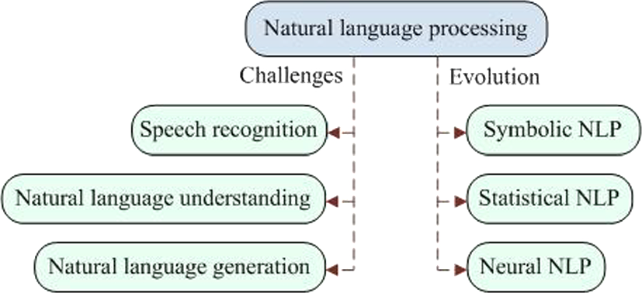
Q3
Explain in details feature extraction of NLP
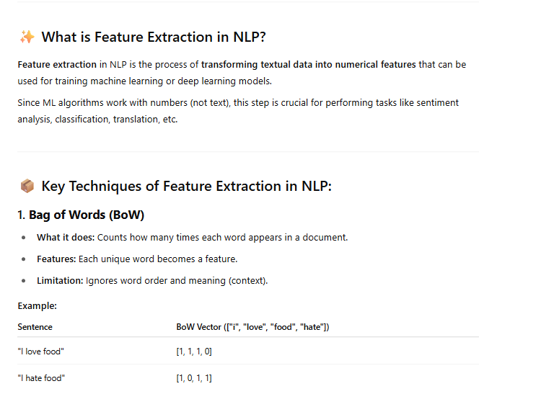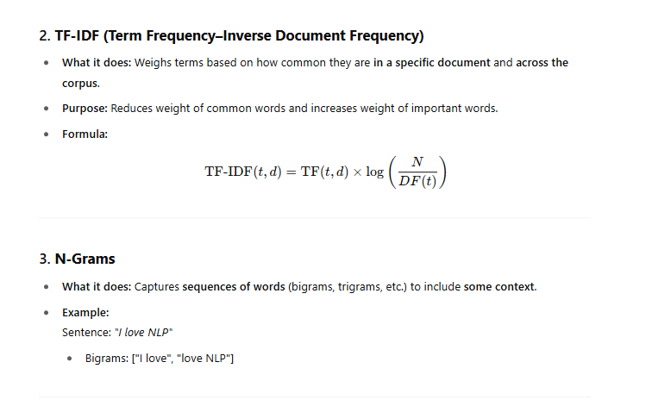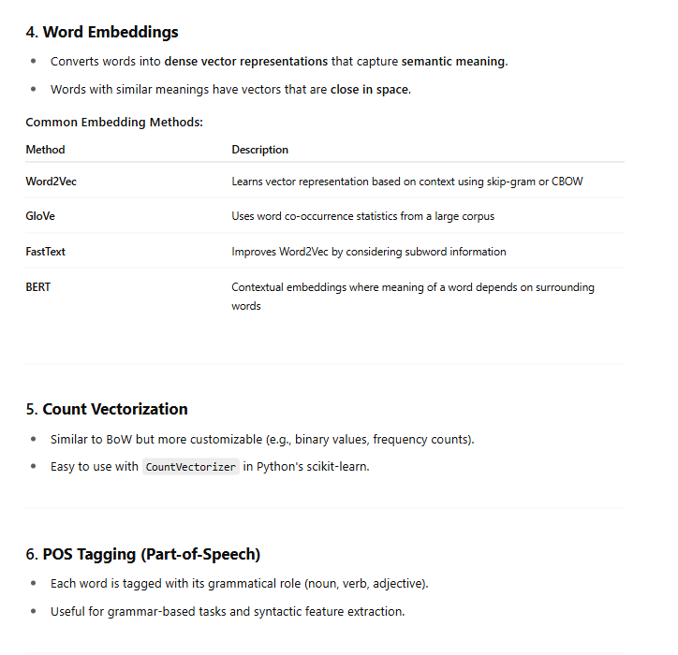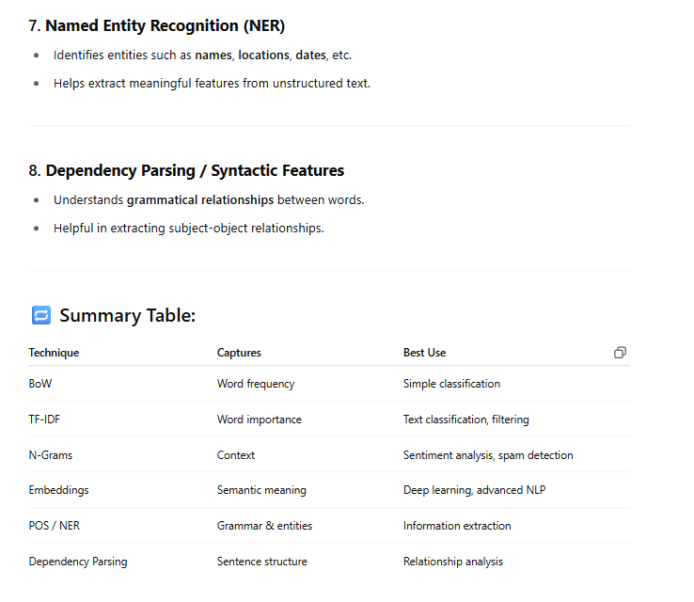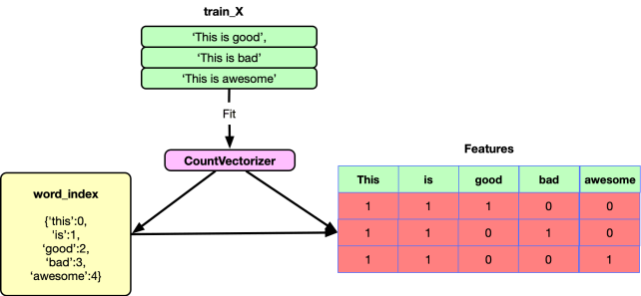

Q4
List and explain the applications of NLP
Natural Language Processing (NLP) has diverse applications across various fields. Some key areas include: text classification, sentiment analysis, machine translation, chatbot development, and text summarization. Additionally, NLP is used in applications like named entity recognition, predictive text modeling, and bias/fake news detection.
Here's a more detailed look at some NLP applications:
- Text Classification:
NLP can be used to categorize text data into different classes or categories, such as spam detection, news article classification, or customer support ticket categorization.
- Sentiment Analysis:
NLP algorithms can analyze the sentiment (positive, negative, or neutral) expressed in text data, such as customer reviews, social media posts, or news articles.
- Machine Translation:
NLP powers translation tools that automatically translate text from one language to another, facilitating global communication.
- Chatbots:
NLP enables the development of chatbots that can engage in natural language conversations with users, providing customer support or other interactive services.
- Text Summarization:
NLP can automatically create concise summaries of long text documents, making it easier to extract key information.
- Named Entity Recognition:
NLP can identify and classify named entities (persons, organizations, locations, etc.) in text data.
- Predictive Text Modeling:
NLP models can predict the next word or phrase in a sequence of text, as used in predictive text in mobile phones.
- Bias and Fake News Detection:
NLP can be used to identify and mitigate bias or fake news content in text data.
- Recommender Systems:
NLP can be used to create recommender systems that suggest products, articles, or other content based on user preferences.
- Speech Recognition:
NLP is a core component of speech recognition technology, converting spoken language into text.
- Natural Language Generation:
NLP can generate human-readable text from structured data or code, as seen in automated reports or summaries.
- Automated Essay Scoring:
NLP can be used to automatically evaluate and grade essays, providing objective feedback and reducing workload for educators.
- Market Intelligence:
NLP can be used to analyze large amounts of text data, such as social media posts or news articles, to identify market trends and customer opinions.
- Spelling and Grammar Checkers:
NLP is used in spell and grammar checkers to identify and correct errors in written text.
- Digital Phone Calls:
NLP can be used to direct calls to service representatives or chatbots, improving customer service efficiency.
- Email Filters:
NLP can identify spam emails by recognizing patterns and keywords.
- Smart Assistants:
NLP enables voice-activated assistants like Siri and Alexa to understand and respond to user commands.
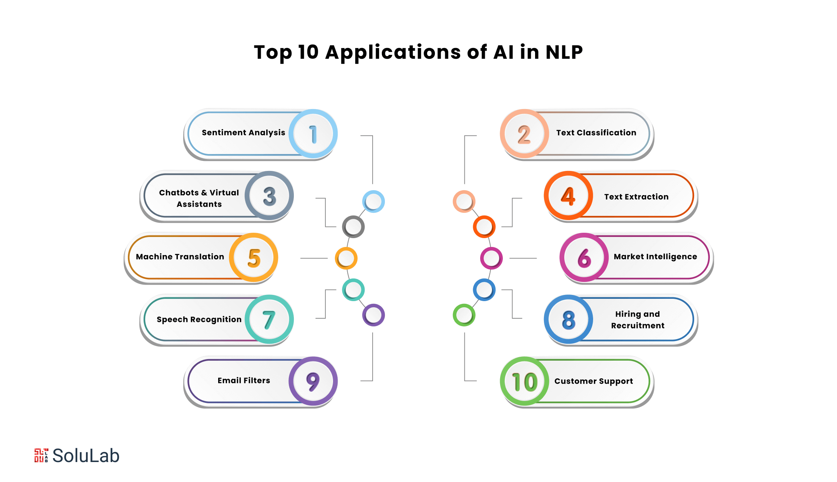
Applications of Natural Language Processing (NLP)
NLP bridges the gap between human language and machine understanding. It is used across many industries to extract value from text, speech, and language-based data.

🔠 1. Text Classification
Description: Automatically categorizing text into predefined labels.
- 📌 Examples:
  - Spam detection in emails
  - News topic classification
  - Hate speech or toxic comment detection on social media

💬 2. Sentiment Analysis
Description: Identifying the emotional tone of text (positive, negative, neutral).
- 📌 Examples:
  - Customer review analysis
  - Social media opinion monitoring
  - Feedback sentiment detection

🧾 3. Machine Translation
Description: Translating text or speech from one language to another.
- 📌 Examples:
  - Google Translate
  - Real-time subtitles in multilingual meetings
  - Language learning apps

🧠 4. Chatbots and Virtual Assistants
Description: NLP enables bots to understand and respond to human queries.
- 📌 Examples:
  - Siri, Alexa, Google Assistant
  - Customer service bots
  - FAQ automation

🏷️ 5. Named Entity Recognition (NER)
Description: Identifying names of people, places, dates, organizations, etc.
- 📌 Examples:
  - Resume parsing
  - Information extraction from contracts or articles
  - Financial news analysis

📊 6. Text Summarization
Description: Creating a shorter version of a long text that preserves key ideas.
- 📌 Examples:
  - News summarization
  - Scientific paper abstracts
  - Legal document summarization

🔍 7. Information Retrieval
Description: Finding relevant documents or passages based on user queries.
- 📌 Examples:
  - Search engines (Google, Bing)
  - Academic paper search
  - Legal case lookup

🧮 8. Speech Recognition
Description: Converting spoken language into text.
- 📌 Examples:
  - Voice typing
  - Automated subtitles
  - Virtual assistant voice commands

🗣️ 9. Speech Generation (Text-to-Speech)
Description: Generating human-like speech from text.
- 📌 Examples:
  - Reading assistants for visually impaired
  - Audiobook narrators
  - Interactive voice response (IVR) systems

🕵️ 10. Plagiarism Detection & Grammar Correction
Description: Analyzing writing to detect copied content or grammatical errors.
- 📌 Examples:
  - Grammarly, QuillBot
  - Turnitin (plagiarism checker)
  - Writing assistant tools

🧾 11. Document Classification & Tagging
Description: Automatically organizing and tagging documents for easier retrieval.
- 📌 Examples:
  - Legal document analysis
  - Medical records organization
  - Email and folder categorization

🛍️ 12. E-commerce & Recommendation Systems
Description: Analyzing product reviews and user queries to improve recommendations.
- 📌 Examples:
  - Product search optimization
  - Personalized suggestions
  - Customer support automation

🧠 Summary Table:
Application | Real-world Example
Text Classification | Spam filter
Sentiment Analysis | Social media monitoring
Translation | Google Translate
Chatbots | Customer service bots
NER | Resume screening
Summarization | News digest
Speech Recognition | Voice typing
Grammar Check | Grammarly

NLP application: Sentiment Analysis.
Q 5
Explain NLP application: Sentiment Analysis.
What is Sentiment Analysis?
Sentiment Analysis (also known as opinion mining) is the process of identifying and extracting the emotional tone behind a series of words used in text.
👉 It helps determine whether the text expresses:
- Positive
- Negative, or
- Neutral sentiment.

📌 Why is Sentiment Analysis Important?
- Understand public opinion or customer satisfaction
- Monitor brand reputation
- Make data-driven decisions
- Automate feedback analysis at scale

🔧 How Does Sentiment Analysis Work?
✅ Step-by-Step Process:
- Text Preprocessing
  - Clean the text: remove stopwords, punctuation, emojis, etc.
  - Tokenization, lemmatization/stemming
- Feature Extraction
  - Convert text into numerical features using:
    - Bag of Words (BoW)
    - TF-IDF
    - Word Embeddings (Word2Vec, BERT)
- Sentiment Classification
  - Apply machine learning or deep learning models to classify the sentiment.
    - Supervised models: Logistic Regression, SVM, Naive Bayes
    - Deep learning: LSTM, GRU, Transformers
- Output Sentiment
  - Labels like: Positive, Negative, Neutral
  - Sometimes includes a sentiment score from -1 to +1

🛒 Real-World Applications of Sentiment Analysis:
Domain | Use Case
💼 Business | Analyze customer reviews or feedback to improve products
📱 Social Media | Track public sentiment on trending topics or events
🎥 Entertainment | Understand audience reaction to movies, shows, etc.
🏛️ Politics | Gauge public opinion on political campaigns or speeches
🏥 Healthcare | Analyze patient feedback or mental health discussions

🌟 Example:
Input Review:
"I absolutely love the new camera features. Great job, team!"
Steps:
- Preprocessed and vectorized
- Classified using ML model
- Output: Positive Sentiment (with 95% confidence)

📉 Challenges in Sentiment Analysis:
Challenge | Description
Sarcasm | "Wow, this update really made my life harder." (Sounds positive, but it's not!)
Mixed Sentiment | "The battery is great, but the camera is poor."
Context Understanding | Understanding emotional cues from context or slang

🧠 Conclusion:
Sentiment analysis is a powerful NLP tool for understanding emotions in text data. It helps businesses and researchers analyze human opinions quickly and at scale using machine learning and deep learning techniques.
…………………………
Sentiment analysis is a subfield of Natural Language Processing (NLP) that focuses on identifying and analyzing the emotional tone or sentiment expressed in a given text. It aims to determine whether the text conveys a positive, negative, or neutral attitude. This analysis can be performed on various levels, including documents, sentences, or even individual aspects of a product or service.
Here's a more detailed explanation:
- What it does:
Sentiment analysis helps understand the public opinion or attitude towards a specific topic, product, or service.
- How it works:
NLP techniques, like machine learning algorithms, are used to analyze the text and identify sentiment-related words and phrases.
- Why it's important:
It's valuable for various applications, including customer feedback analysis, social media monitoring, market research, and product analytics. For example, businesses can use it to understand customer satisfaction, improve product quality, and manage brand reputation.
- Levels of Analysis:
Sentiment analysis can be performed at different levels:
  - Document level: Classifying the entire document as positive, negative, or neutral.
  - Sentence level: Analyzing the sentiment of each sentence within a document.
  - Feature level: Identifying the sentiment of specific aspects or features mentioned in the text (e.g., "the battery life was too short" would identify the negative sentiment towards battery life, not the product as a whole).
- Applications:
  - Customer Reviews: Analyzing reviews to understand customer satisfaction and identify areas for improvement.
  - Social Media Monitoring: Tracking social media posts to gauge public opinion and identify potential crises.
  - Market Research: Understanding public sentiment towards products, events, or campaigns.
  - Product Analytics: Using reviews to identify product strengths and weaknesses.
- Benefits:
  - Accurate Customer Analytics: Provides a more precise understanding of customer opinions.
  - Improved Customer Experience: Helps businesses address customer concerns and improve their products or services.
  - Reputation Management: Allows businesses to monitor and manage their online reputation.
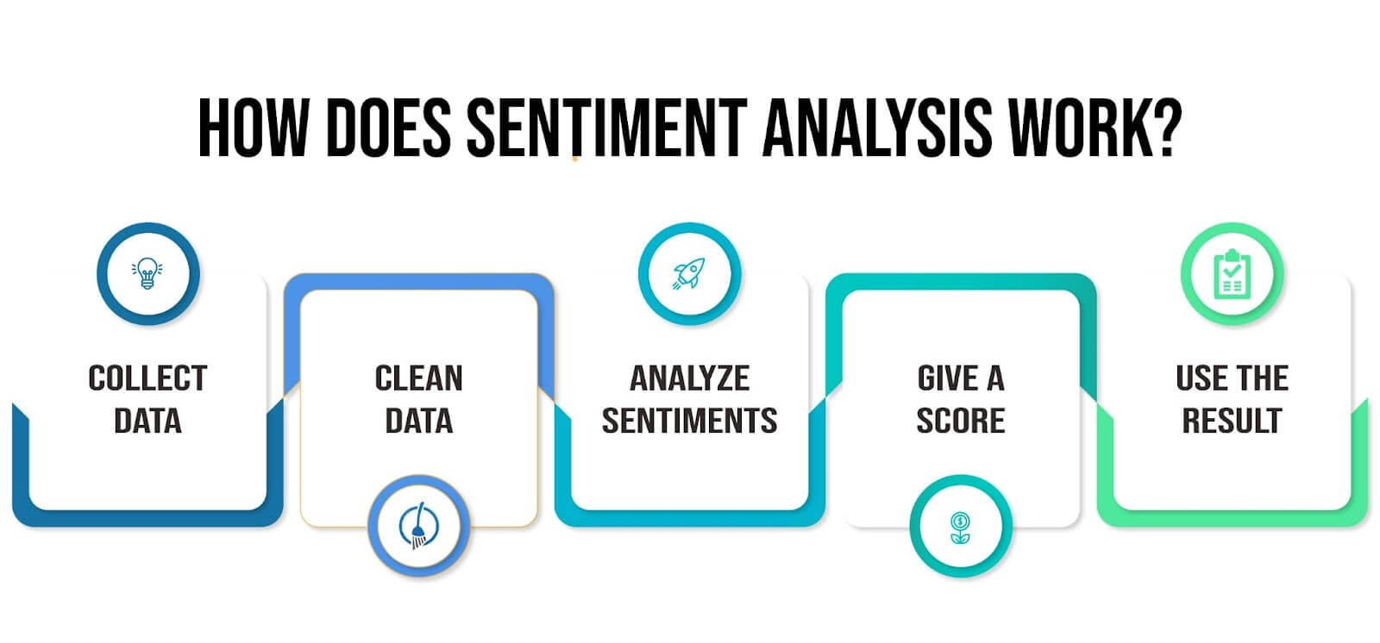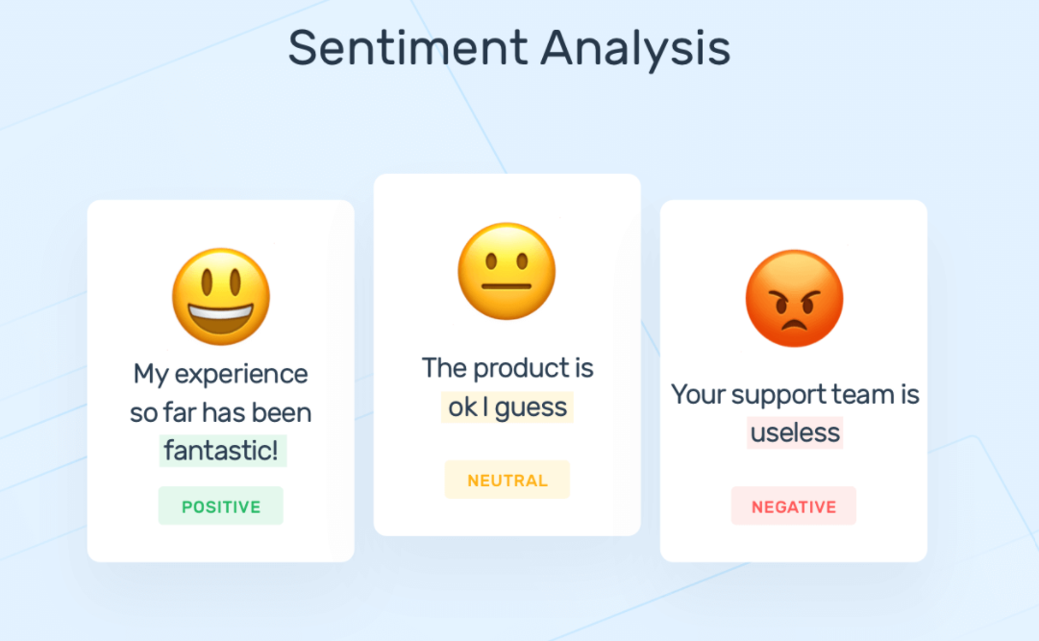
Q6
Explain object detection application in Computer Vision.
Object detection is a core computer vision application that identifies and localizes objects within images or videos. It uses algorithms, often deep learning-based, to detect objects and draw bounding boxes around them, indicating their location and category. This technology is widely used in various applications, from self-driving cars to medical imaging and visual inspection.
How it works:
- Input:
An image or video stream is fed into the object detection system.
- Feature Extraction:
The system analyzes the visual data, extracting relevant features such as shapes, edges, and colors.
- Object Localization:
The system uses algorithms to pinpoint the location of objects within the image, typically by drawing a bounding box around each object.
- Object Classification:
The system identifies and classifies each object, assigning a category label such as "car", "person", or "dog".
Real-world applications:
- Autonomous Vehicles:
Object detection is crucial for self-driving cars to identify and track other vehicles, pedestrians, and obstacles.
- Medical Imaging:
It can assist doctors in analyzing medical images to detect tumors, fractures, and other abnormalities.
- Retail:
Object detection can be used to track customer movement, identify high-traffic areas, and monitor inventory.
- Security and Surveillance:
It helps in identifying intruders, monitoring traffic flow, and detecting suspicious activities.
- Industrial Inspection:
Object detection can automate the inspection of products, identifying defects and ensuring quality control.
Key concepts:
- Bounding Box: A rectangular area drawn around an object to indicate its location in the image.
- Classification: The process of assigning a category label to an object.
- Deep Learning: Object detection often uses deep learning algorithms like Convolutional Neural Networks (CNNs) to extract features and make predictions.
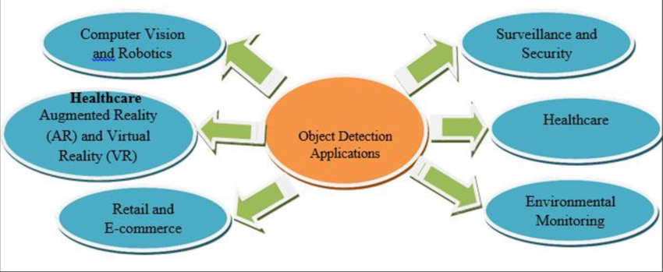
What is Object Detection?
Object Detection is a computer vision technique that identifies and locates multiple objects in an image or video.
It not only detects what the objects are (classification) but also where they are (bounding box).
Components of Object Detection:
- Classification: What object is in the image? (e.g., cat, car, person)
- Localization: Where is the object in the image? (bounding box coordinates)
- Instance Count: How many objects are present?

🔍 How Does Object Detection Work?
- Input: Image or video frame
- Feature Extraction: CNNs (like ResNet, VGG) extract patterns like edges, colors, shapes
- Detection Model: Predicts:
  - Object class (label)
  - Bounding box coordinates
  - Confidence score
- Output: Image with labeled boxes and class names

🛠️ Popular Object Detection Algorithms:
Algorithm | Description
R-CNN / Fast R-CNN / Faster R-CNN | Region-based CNNs, accurate but slower
YOLO (You Only Look Once) | Real-time detection, fast and efficient
SSD (Single Shot Detector) | Fast and good for mobile applications
RetinaNet | Balances accuracy and speed

🎯 Applications of Object Detection:
Domain | Use Case
🚗 Autonomous Vehicles | Detect pedestrians, other vehicles, traffic signs
🛒 Retail | Automated checkout systems, customer movement tracking
🔐 Security & Surveillance | Intruder detection, anomaly recognition
🏥 Healthcare | Detect tumors or abnormalities in medical imaging
📦 Manufacturing | Quality control, defect detection on products
📸 Photo Tagging | Automatically identify people, pets, objects in photos

📷 Example:
Given an image of a street, the object detection model may output:
- "Person" at coordinates (x1, y1, x2, y2)
- "Car" at another set of coordinates
- "Traffic Light" with bounding box

⚠️ Challenges in Object Detection:
Challenge | Description
Occlusion | One object partially blocks another
Lighting | Poor lighting can affect accuracy
Scale Variation | Same object may appear small or large in different images
Real-time Processing | Speed and accuracy tradeoff in live video

🔁 Summary:
Task | Involves
Classification | What is in the image
Localization | Where the object is (bounding box)
Detection | Doing both at once for multiple objects

Q7
Computer Vision: General steps image pre-processing, feature extraction, applying machine learning algorithms. Applications: object detection

Computer Vision: General Steps
Computer Vision enables machines to understand and interpret visual data from the world, such as images or videos.
🔄 1. Image Pre-processing
Improves image quality and makes feature extraction easier.
✅ Common techniques:
- Resizing – Standardizes image size
- Grayscale conversion – Removes color for simplicity
- Noise removal – Using filters (e.g., Gaussian, Median)
- Histogram Equalization – Improves contrast
- Edge Detection – Finds object boundaries (e.g., Canny)

🧲 2. Feature Extraction
Extracts meaningful data from the image (e.g., shape, color, texture) to identify patterns.
✅ Common methods:
- SIFT / SURF / ORB – Detect and describe key points
- HOG (Histogram of Oriented Gradients) – Captures edge directions
- Color Histograms – Represent color distribution
- CNN Features – Deep learning-based features from convolutional layers

🧠 3. Applying Machine Learning Algorithms
Trained on extracted features to recognize, classify, or detect patterns.
✅ Examples:
- Traditional ML: SVM, KNN, Random Forest
- Deep Learning: Convolutional Neural Networks (CNNs), YOLO, Faster R-CNN

🎯 Application: Object Detection
Object Detection identifies and localizes multiple objects in an image or video using bounding boxes and labels.
✅ How it works:
- Input image → Pre-processing → Feature extraction
- Model predicts object class + location
- Outputs bounding boxes with labels (e.g., “person”, “car”)
🛠 Common models:
- YOLO (You Only Look Once) – Fast and accurate real-time detection
- Faster R-CNN – High accuracy
- SSD (Single Shot Detector) – Balance of speed and precision

📌 Uses of Object Detection
Domain | Application
Security | Intruder detection, surveillance
Healthcare | Tumor localization in MRI scans
Retail | Smart checkout, shelf monitoring
Autonomous Vehicles | Pedestrian & traffic detection
Manufacturing | Defect detection in products

📝 Summary:
Step | Description
Image Pre-processing | Cleans and enhances image
Feature Extraction | Converts image to usable data
ML Algorithm | Learns patterns to classify or detect
Application | Object detection with bounding boxes
……………………………
Computer vision is a field of artificial intelligence (AI) that enables computers to "see" and interpret images and videos, much like humans do. It involves using algorithms and machine learning to process visual data, identify objects, detect patterns, and extract meaningful insights.
Here's a more detailed breakdown:
Key Concepts:
- Image and Video Processing: Computer vision involves techniques for manipulating and analyzing visual data, such as images and videos, to extract features and patterns.
- Machine Learning and Deep Learning: These AI techniques are used to train computer vision systems to recognize objects, faces, and other features in images and videos.
- Object Detection: Identifying and locating specific objects within an image or video.
- Image Classification: Categorizing images or video frames into different classes or categories.
- Face Recognition: Identifying and recognizing faces in images and videos.
- Scene Understanding: Interpreting the overall context and meaning of an image or video scene.
How it works:
- 1. Data Input:
Computer vision systems take visual data as input, which can be from cameras, sensors, or video files.
- 2. Feature Extraction:
Algorithms are used to extract relevant features from the input data, such as edges, shapes, and colors.
- 3. Pattern Recognition:
Machine learning algorithms are used to identify patterns and relationships between these features.
- 4. Decision Making:
Based on the extracted features and recognized patterns, the system can make decisions about the visual data, such as identifying objects or classifying scenes.
Applications:
- Self-Driving Cars: Used for navigation, obstacle detection, and lane keeping.
- Facial Recognition: In security systems, law enforcement, and social media.
- Medical Imaging: Analyzing medical images for disease detection and diagnosis.
- Industrial Automation: Inspecting products, detecting defects, and monitoring equipment.
- Security and Surveillance: Monitoring areas, identifying intruders, and detecting suspicious activity.
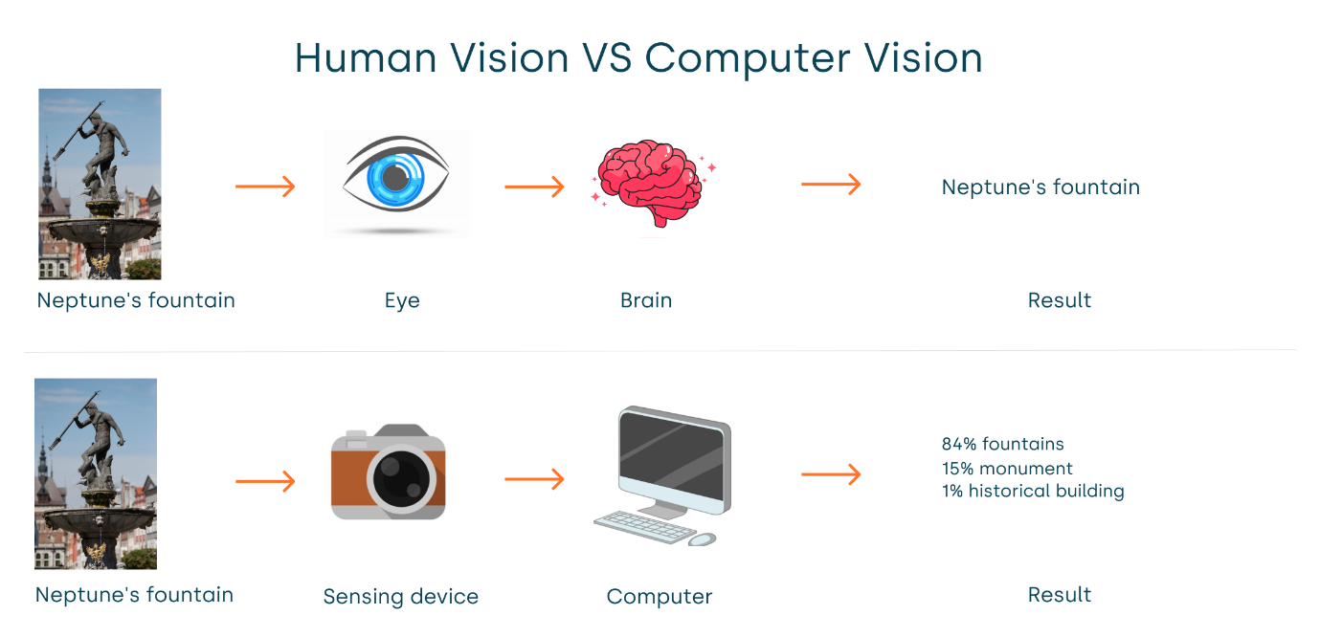
Q8
Explain computer vision applications : object detection.
What is Object Detection in Computer Vision?
Object Detection is a computer vision task that involves:
- Identifying objects in an image (classification), and
- Locating them using bounding boxes (localization).
Unlike simple image classification, object detection works on multiple objects in an image and tells what and where each object is.

🧠 How Object Detection Works
It generally involves three stages:
1. Image Pre-processing
- Resize, normalize, and denoise the image.
- Convert to grayscale or apply filters if needed.
2. Feature Extraction
- Use feature descriptors (like HOG, SIFT) or CNNs (in deep learning).
- These extract key patterns (edges, textures, colors).
3. Detection and Localization
- Apply machine learning or deep learning models to:
  - Predict class labels (e.g., cat, person, car)
  - Draw bounding boxes around detected objects

🛠️ Popular Object Detection Algorithms
Algorithm | Description
YOLO (You Only Look Once) | Real-time, fast and efficient
SSD (Single Shot Detector) | Lightweight and mobile-friendly
Faster R-CNN | Very accurate, but slower
RetinaNet | Balances speed and accuracy

📷 Example Output
A street image → Model detects:
- 🚶 Person at (x1, y1, x2, y2)
- 🚗 Car at (x1, y1, x2, y2)
- 🚦 Traffic light at (x1, y1, x2, y2)
Each object has:
- Label: e.g., "Car"
- Confidence score: e.g., 95%
- Bounding box coordinates

🔍 Real-World Applications
Domain | Use Case
🚗 Autonomous Vehicles | Detect pedestrians, cars, signs
🏥 Healthcare | Identify tumors or abnormalities in scans
🏬 Retail | Detect products on shelves for inventory
🔐 Security | Surveillance, intruder detection
🏭 Manufacturing | Quality control, defect detection
📱 AR/VR | Detect environment features in real time

⚠️ Challenges in Object Detection
Challenge | Description
Occlusion | Objects partially hidden
Lighting Conditions | Poor lighting affects accuracy
Scale Variability | Objects appear in different sizes
Real-time Processing | High speed required for live video

✅ Summary:
Feature | Object Detection
What it does | Detects and localizes multiple objects
Uses | Real-world AI applications like self-driving cars, CCTV, medicine
Tools | YOLO, SSD, Faster R-CNN, OpenCV, TensorFlow, PyTorch
…………….
Object detection, a core computer vision application, identifies and locates objects within images or videos. It uses algorithms to classify objects and draw bounding boxes around them, indicating their precise location. This technology has widespread applications in various industries, from security and surveillance to autonomous vehicles and medical imaging.

Here's a more detailed explanation:
Core Concepts:
- Localization:
Object detection pinpointing the precise location of objects within an image using bounding boxes or pixel-level masks.
- Classification:
Object detection determines the type or category of objects, like "car," "person," or "dog".
Key Technologies:
- Convolutional Neural Networks (CNNs):
These are the backbone of many object detection algorithms, allowing them to learn complex visual patterns.
- Machine Learning and Deep Learning:
Object detection leverages these techniques to train models that can accurately identify and locate objects.
Applications:
- Security and Surveillance: Detecting objects like people or vehicles to enhance security measures.
- Autonomous Vehicles: Identifying obstacles, traffic signals, and other vehicles for safe navigation.
- Medical Imaging: Detecting tumors or other anomalies in medical scans.
- Retail: Tracking customer movement, identifying high-traffic zones, and optimizing store layouts.
- Manufacturing: Detecting defects in products or monitoring worker safety.
- Robotics: Enabling robots to interact with and manipulate objects in their environment.
- Agriculture: Monitoring crops, detecting pests, and optimizing irrigation.
- Image Annotation: Automating the process of labeling images for training computer vision models.
Benefits:
- Automation:
Object detection can automate tasks that would otherwise require human intervention.
- Increased Efficiency:
By automating processes and providing insights, object detection can improve efficiency and productivity.
- Improved Accuracy:
Object detection models can identify objects with a high degree of accuracy, reducing errors and improving decision-making.
- Real-time Processing:
Many object detection algorithms can process video streams in real-time, allowing for immediate insights and responses.
In essence, object detection empowers computers to "see" and understand the world, enabling a wide range of applications across various industries.
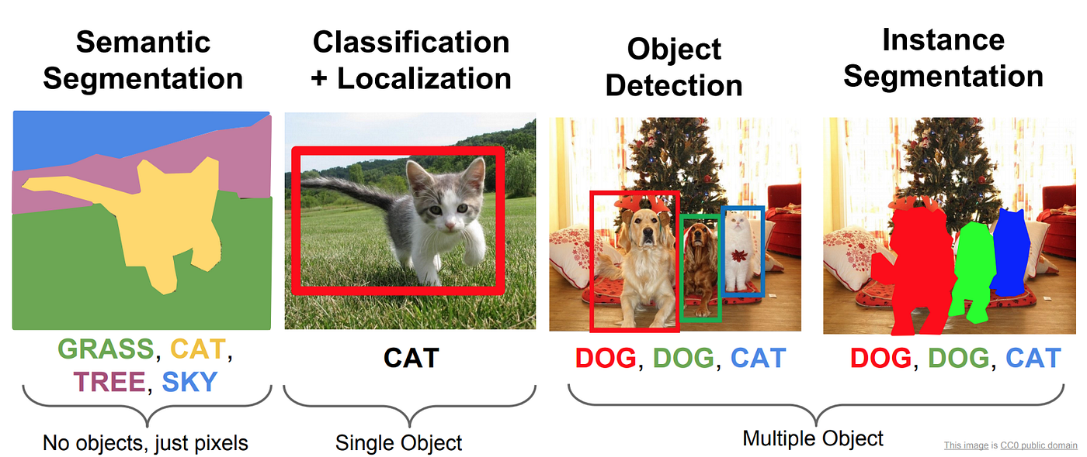
Q9
What are some of the machine learning algorithms that can be used for computer vision.
Machine Learning Algorithms for Computer Vision
1. Support Vector Machines (SVM)
- Used for image classification and object recognition.
- Works well on small to medium-sized feature sets.
- Often combined with feature extractors like HOG or SIFT.
2. K-Nearest Neighbors (KNN)
- Simple algorithm for classification based on feature similarity.
- Used in basic image recognition tasks.
- Computationally expensive for large datasets.
3. Decision Trees and Random Forests
- Used for image classification by learning decision rules.
- Random Forest combines many trees for better accuracy and robustness.
4. Naive Bayes
- Probabilistic classifier sometimes used for simple image classification.
- Less common for complex vision tasks.

🚀 Deep Learning Algorithms (Most Popular in Modern Computer Vision)
5. Convolutional Neural Networks (CNNs)
- Designed to process images by detecting spatial hierarchies.
- Key for tasks like image classification, object detection, segmentation.
- Famous architectures: LeNet, AlexNet, VGG, ResNet, Inception.
6. Recurrent Neural Networks (RNNs)
- Used for sequence data; less common in pure vision.
- Applied in video analysis, image captioning (combined with CNNs).
7. Generative Adversarial Networks (GANs)
- Used for generating realistic images, image enhancement, style transfer.
8. You Only Look Once (YOLO)
- Real-time object detection algorithm.
- Combines classification and localization in a single neural network.
9. Single Shot MultiBox Detector (SSD)
- Fast object detection, suitable for real-time applications on mobile.
10. Faster R-CNN
- Accurate two-stage detector for object detection tasks.

🧩 Summary Table
Algorithm Type | Use Case | Notes
SVM | Image classification | Works well with engineered features
KNN | Simple image recognition | Slow on big data
Decision Trees/Random Forest | Classification | Interpretable, ensemble improves accuracy
Naive Bayes | Basic classification | Rare in vision
CNNs | Classification, detection, segmentation | Most powerful for vision tasks
RNNs | Video analysis, captions | For sequential data
GANs | Image generation, enhancement | Creative applications
YOLO, SSD, Faster R-CNN | Object detection | Real-time and high accuracy models
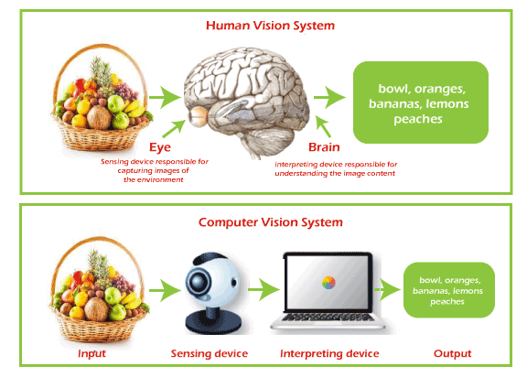
Q9
Which of the techniques that can be used to compute the distance between two word vectors in NLP?
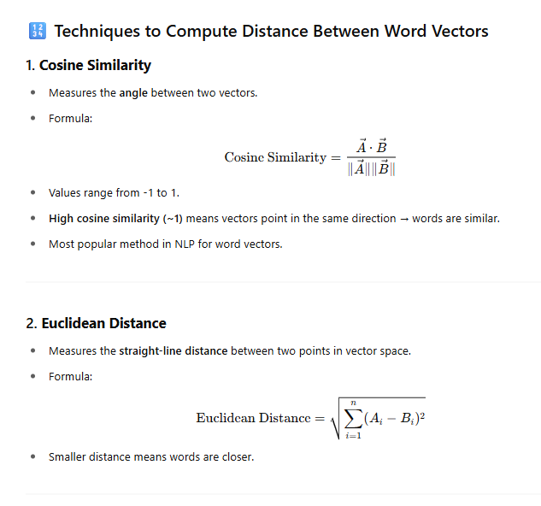 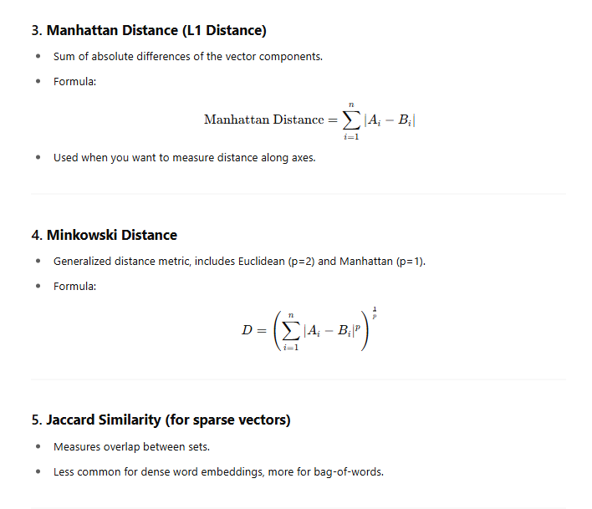 Summary:
Distance Metric | Measures | Use Case
Cosine Similarity | Angle between vectors | Most common, semantic similarity
Euclidean Distance | Straight-line distance | Geometric distance
Manhattan Distance | Sum of absolute differences | When movement along axes matters
Minkowski Distance | General form of distance | Flexible, generalizes others
Jaccard Similarity | Set overlap | Sparse vectors or sets
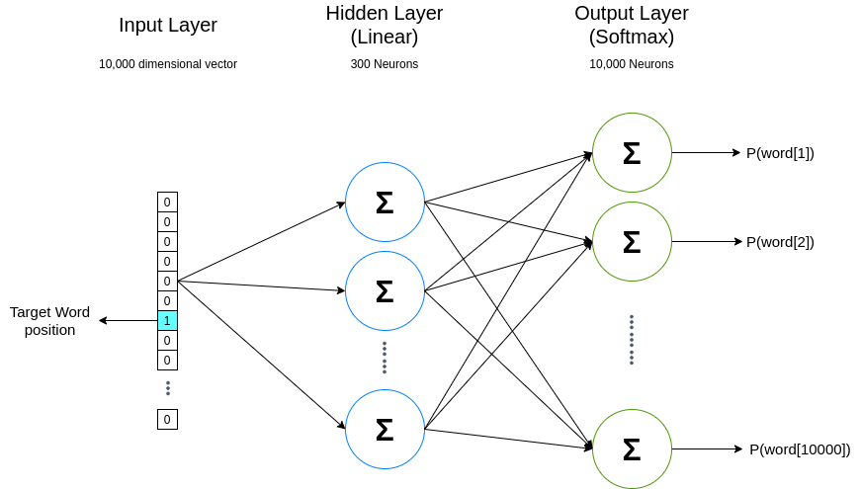
Q10
List some of the best NLP tools and explain one of then?
Best NLP Tools
Tool Name | Description
NLTK | Natural Language Toolkit — for text processing and linguistic analysis
spaCy | Industrial-strength NLP library, fast and efficient
Stanford NLP | Suite of NLP tools with coreference, parsing, sentiment analysis
GPT (OpenAI) | Powerful language models for generation, understanding, translation
BERT | Transformer-based model for understanding context in text
TextBlob | Simple API for common NLP tasks, built on NLTK and Pattern
Gensim | Topic modeling and document similarity analysis
CoreNLP | Java-based NLP toolkit from Stanford with many features
AllenNLP | Deep learning NLP research library based on PyTorch
OpenNLP | Apache’s machine learning toolkit for NLP tasks

📌 Explanation: spaCy
What is spaCy?
- spaCy is a modern, open-source NLP library designed for production use.
- It’s written in Python and Cython, making it very fast and efficient.
- Supports multiple languages and offers easy integration with deep learning frameworks like TensorFlow and PyTorch.
Key Features:
- Tokenization: Splits text into words, punctuation, etc.
- Part-of-Speech (POS) tagging: Labels each word with its grammatical role.
- Named Entity Recognition (NER): Detects entities like names, dates, locations.
- Dependency Parsing: Analyzes grammatical structure of sentences.
- Lemmatization: Converts words to their base form.
- Text Classification: Categorizes text into labels (e.g., sentiment).
- Pre-trained models: Ready-to-use models for various languages.
Why use spaCy?
- Very fast compared to other Python NLP libraries.
- Easy to train custom models.
- Clean and consistent API.
- Good for both research and real-world applications like chatbots, content analysis, information extraction.
