HONOR SEM 8TH
(these notes is according PYP of SPPU )
Unit I | Introduction to Artificial Intelligence
Need of AI
Need for AI (Artificial Intelligence)
Artificial Intelligence (AI) has become essential in today's world due to its ability to automate tasks, analyze large data, enhance decision-making, and improve efficiency across various domains. Here are some key reasons why AI is needed:
1. Automation and Efficiency
- AI helps in automating repetitive and mundane tasks, reducing human effort and increasing efficiency.
- Examples: Chatbots for customer support, Robotic Process Automation (RPA) in industries, AI-powered email filtering.
2. Data Processing and Analysis
- AI can process and analyze huge amounts of data faster than humans.
- Used in Big Data analytics, fraud detection, and market trend predictions.
3. Improved Decision-Making
- AI-driven algorithms help in making accurate and data-driven decisions with minimal human intervention.
- Used in financial forecasting, medical diagnosis, and business strategy planning.
4. Personalization
- AI enhances user experience by providing personalized recommendations based on user behavior.
- Examples: Netflix recommending movies, Amazon suggesting products, Spotify curating playlists.
5. Healthcare Advancements
- AI is transforming healthcare by early disease detection, medical imaging, and robotic surgeries.
- Examples: AI-powered MRI scans for brain tumor detection, AI chatbots for health monitoring.
6. Enhancing Cybersecurity
- AI helps in identifying and preventing cyber threats by analyzing unusual patterns.
- Used in firewall security, spam detection, and real-time fraud prevention.
7. Smart Assistants and IoT Integration
- AI powers virtual assistants like Siri, Alexa, and Google Assistant to automate tasks.
- IoT devices use AI for smart homes, smart cities, and connected vehicles.
8. Revolutionizing Industries
- Manufacturing: AI-powered robots improve production efficiency.
- Education: AI-driven tutoring and smart learning systems.
- Agriculture: AI in precision farming and crop monitoring.
9. Solving Complex Problems
- AI helps in scientific research, space exploration, climate prediction, and drug discovery.
- Example: AI models predicting natural disasters.
10. Enhancing Creativity
- AI is used in content creation, music composition, and artwork generation.
- Example: AI-generated blogs, AI-powered video editing tools.
Conclusion
AI is no longer just an emerging technology but a necessity in today’s fast-paced world. From healthcare to finance, education to entertainment, and security to space research, AI is shaping the future by making systems smarter, faster, and more efficient.
……………
AI is needed because it helps us solve complex problems, drives innovation across various fields, and enables the processing of vast amounts of data to reveal insights that would be difficult for humans to uncover alone.
Here's a more detailed look at why AI is important:
- Problem Solving:
AI can tackle complex challenges in areas like healthcare, finance, and science by analyzing large datasets and identifying patterns that humans might miss.
- Innovation:
AI is a catalyst for innovation, leading to new products, services, and processes across various industries.
- Efficiency:
AI can automate tasks, optimize processes, and improve efficiency, freeing up human resources for more strategic work.
- Personalized Experiences:
AI can personalize learning, recommendations, and customer experiences by understanding individual needs and preferences.
- Data Analysis:
AI excels at processing and analyzing massive amounts of data, extracting valuable insights and making predictions.
- Improved Decision-Making:
AI can provide data-driven insights that support better decision-making in various fields.
- Examples of AI in Action:
  - Healthcare: AI can assist in diagnosing diseases, developing new treatments, and improving patient care.
  - Finance: AI can be used for fraud detection, risk assessment, and algorithmic trading.
  - Transportation: AI powers self-driving cars, optimizes traffic flow, and improves logistics.
  - Manufacturing: AI can automate production processes, improve quality control, and optimize supply chains.
  - Education: AI can personalize learning experiences, provide automated feedback, and improve student engagement.
- Skills for AI:
  - Programming: A strong foundation in programming languages is crucial for AI professionals.
  - Machine Learning: Understanding machine learning concepts and algorithms is essential.
  - Data Processing: Skills in data warehousing, database modeling, and data processing are valuable.
  - Problem Solving: AI professionals need strong problem-solving skills to tackle complex challenges.
APPLICATION:
Need for AI (Artificial Intelligence)
Artificial Intelligence (AI) has become essential in today's world due to its ability to automate tasks, analyze large data, enhance decision-making, and improve efficiency across various domains. Here are some key reasons why AI is needed:
1. Automation and Efficiency
- AI helps in automating repetitive and mundane tasks, reducing human effort and increasing efficiency.
- Examples: Chatbots for customer support, Robotic Process Automation (RPA) in industries, AI-powered email filtering.
2. Data Processing and Analysis
- AI can process and analyze huge amounts of data faster than humans.
- Used in Big Data analytics, fraud detection, and market trend predictions.
3. Improved Decision-Making
- AI-driven algorithms help in making accurate and data-driven decisions with minimal human intervention.
- Used in financial forecasting, medical diagnosis, and business strategy planning.
4. Personalization
- AI enhances user experience by providing personalized recommendations based on user behavior.
- Examples: Netflix recommending movies, Amazon suggesting products, Spotify curating playlists.
5. Healthcare Advancements
- AI is transforming healthcare by early disease detection, medical imaging, and robotic surgeries.
- Examples: AI-powered MRI scans for brain tumor detection, AI chatbots for health monitoring.
6. Enhancing Cybersecurity
- AI helps in identifying and preventing cyber threats by analyzing unusual patterns.
- Used in firewall security, spam detection, and real-time fraud prevention.
7. Smart Assistants and IoT Integration
- AI powers virtual assistants like Siri, Alexa, and Google Assistant to automate tasks.
- IoT devices use AI for smart homes, smart cities, and connected vehicles.
8. Revolutionizing Industries
- Manufacturing: AI-powered robots improve production efficiency.
- Education: AI-driven tutoring and smart learning systems.
- Agriculture: AI in precision farming and crop monitoring.
9. Solving Complex Problems
- AI helps in scientific research, space exploration, climate prediction, and drug discovery.
- Example: AI models predicting natural disasters.
10. Enhancing Creativity
- AI is used in content creation, music composition, and artwork generation.
- Example: AI-generated blogs, AI-powered video editing tools.
Conclusion
AI is no longer just an emerging technology but a necessity in today’s fast-paced world. From healthcare to finance, education to entertainment, and security to space research, AI is shaping the future by making systems smarter, faster, and more efficient.
Would you like AI applications in a specific domain like Data Science, Healthcare, or Web Development? 😊
4o
You said:
Applications of AI,
ChatGPT said:
Applications of Artificial Intelligence (AI)
AI is transforming various industries by enhancing automation, improving efficiency, and enabling data-driven decision-making. Here are some of its key applications:

1. Healthcare
- Medical Diagnosis: AI-powered tools like IBM Watson analyze medical records and assist in diagnosing diseases.
- Medical Imaging: AI enhances MRI, CT scans, and X-rays for early disease detection (e.g., brain tumor detection).
- Drug Discovery: AI speeds up drug research by predicting molecular interactions.
- Personalized Medicine: AI suggests treatments based on patient data and genetics.
- Health Monitoring: AI-powered wearables (like Fitbit, Apple Watch) track heart rate, sleep, and physical activity.

2. Finance and Banking
- Fraud Detection: AI detects unusual transaction patterns to prevent fraud.
- Algorithmic Trading: AI-driven stock market trading predicts profitable opportunities.
- Credit Scoring: AI evaluates loan applications by analyzing financial history.
- Chatbots for Customer Support: AI-powered virtual assistants handle banking queries.

3. Education
- Personalized Learning: AI-based platforms like Coursera, Udemy, and Duolingo adjust content as per the learner’s progress.
- Automated Grading: AI assists in evaluating assignments and tests.
- AI Tutors: Chatbots provide real-time explanations and help students.
- Smart Content Creation: AI generates study materials, summaries, and interactive textbooks.

4. Transportation
- Self-Driving Cars: AI is used in autonomous vehicles (e.g., Tesla’s Autopilot).
- Traffic Management: AI optimizes traffic signals and reduces congestion.
- Predictive Maintenance: AI predicts vehicle breakdowns and maintenance needs.

5. Retail and E-commerce
- Recommendation Systems: AI suggests products based on user behavior (Amazon, Flipkart, Netflix).
- Chatbots: AI-based customer support agents assist shoppers.
- Inventory Management: AI predicts demand and manages stock efficiently.

6. Cybersecurity
- Threat Detection: AI detects cyber threats and prevents hacking.
- Spam and Phishing Detection: AI filters out malicious emails.
- Behavior Analysis: AI identifies unusual activity to prevent unauthorized access.

7. Entertainment and Media
- Content Recommendations: AI suggests movies (Netflix), music (Spotify), and news (Google News).
- AI-Generated Content: AI creates music, videos, and articles (e.g., OpenAI’s DALL·E for image generation).
- Deepfake Technology: AI creates realistic fake videos for entertainment and research.

8. Manufacturing and Industry 4.0
- Predictive Maintenance: AI predicts machine failures before they happen.
- Robotic Process Automation (RPA): AI-driven robots automate repetitive tasks.
- Quality Control: AI identifies defects in manufacturing processes.

9. Agriculture
- Crop Monitoring: AI-powered drones monitor crop health.
- Smart Irrigation: AI optimizes water usage based on weather and soil conditions.
- Pest Control: AI detects and prevents pest infestations.

10. Space Exploration
- AI-Powered Rovers: NASA’s Perseverance rover uses AI to navigate Mars.
- Satellite Image Analysis: AI helps in weather prediction and space research.
- Autonomous Spacecraft: AI assists in autonomous decision-making for deep space missions.

11. Smart Assistants and IoT
- Virtual Assistants: AI powers Alexa, Google Assistant, and Siri.
- Smart Homes: AI integrates with IoT devices for automation (smart lighting, security systems).
- Smart Cities: AI helps in traffic management, waste management, and energy optimization.

12. Law and Legal Services
- Contract Review: AI scans legal documents to find important clauses.
- Case Prediction: AI predicts case outcomes based on past judgments.
- Legal Chatbots: AI helps in legal consultations.

Q 2.
Logic programming-solving problems using logic programming
Logic Programming: Solving Problems Using Logic Programming
Logic programming is a declarative programming paradigm where problems are solved using facts, rules, and logical inference rather than step-by-step instructions. The most widely used logic programming language is Prolog (Programming in Logic).

1. Understanding Logic Programming
- Logic programming is based on formal logic, specifically predicate logic (first-order logic).
- Instead of specifying how to solve a problem, we define what the problem is using facts and rules.
- The system infers solutions automatically using a reasoning mechanism.
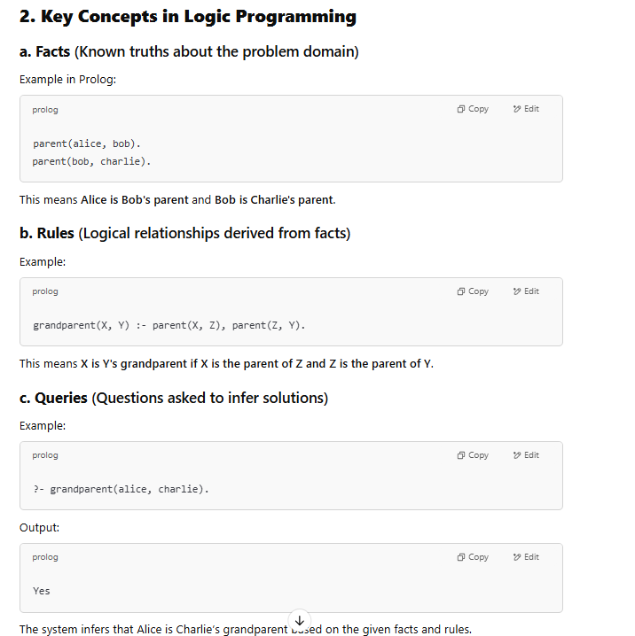 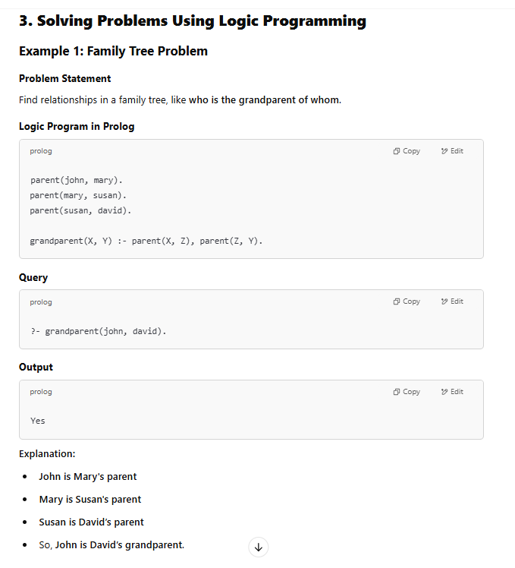 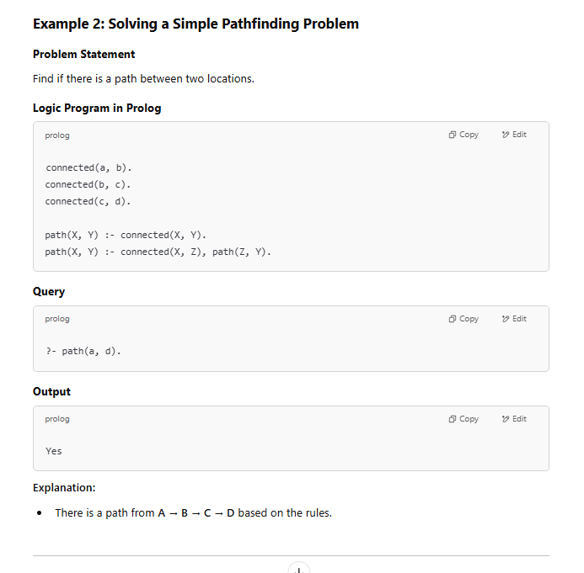 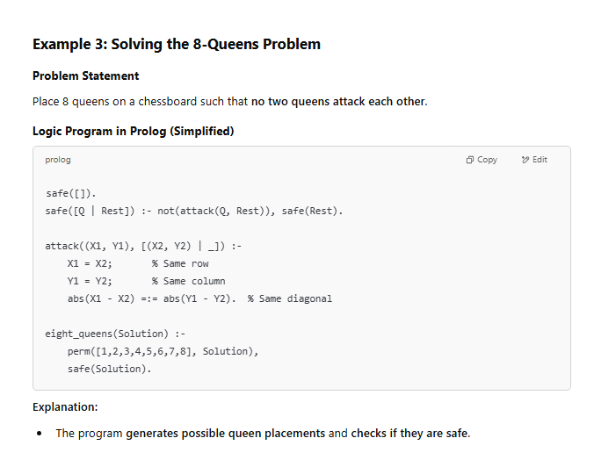 4. Applications of Logic Programming
- Artificial Intelligence (AI): Expert systems, chatbots, and automated reasoning.
- Natural Language Processing (NLP): Semantic understanding and language translation.
- Database Querying: Deductive databases use logic programming for data retrieval.
- Automated Planning & Scheduling: AI agents use logic to plan tasks.
- Constraint Solving: Used in Sudoku, scheduling problems, and optimization tasks.

5. Advantages of Logic Programming
✔ Declarative Nature: No need to specify how to compute results—only define relationships.
✔ High-Level Abstraction: Easier to model complex systems with rules and constraints.
✔ Automatic Inference: The system derives solutions using logical reasoning.
✔ Good for AI & Knowledge Representation: Ideal for AI applications, rule-based systems, and automated reasoning.
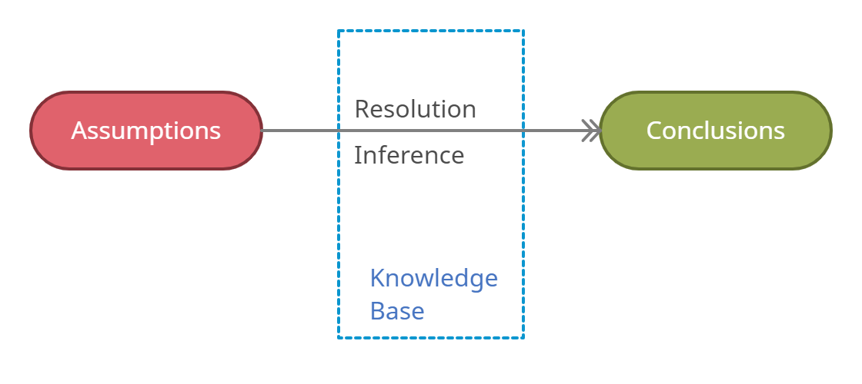
Q 3.
Heuristic search techniques-
Heuristic Search Techniques in AI
1. What is Heuristic Search?
A heuristic search is a problem-solving technique used in Artificial Intelligence (AI) to find solutions more efficiently than brute-force methods. It employs heuristic functions, which estimate the cost or distance to the goal, guiding the search in a promising direction.

2. Why Use Heuristic Search?
✔ Faster than brute-force approaches (e.g., BFS, DFS).
✔ Reduces search space by prioritizing promising paths.
✔ Applicable to complex AI problems (e.g., pathfinding, game playing, decision making).

3. Types of Heuristic Search Techniques
(A) Uninformed vs. Informed Search
- Uninformed Search: No knowledge about the goal (e.g., BFS, DFS).
- Informed Search (Heuristic Search): Uses problem-specific knowledge to guide the search (e.g., A*, Greedy Search).

(B) Types of Heuristic Search Techniques
1. Best-First Search (BFS)
- Expands the most promising node first based on a heuristic function f(n).
- Uses a priority queue (sorted by heuristic value).
🔹 Example: Pathfinding in Google Maps.
✅ Pros: Efficient for finding an optimal path.
❌ Cons: May get stuck in loops without proper handling.

2. Greedy Best-First Search
- Selects the next node with the lowest heuristic value (h(n)).
- It does not consider the actual cost from the start node.
🔹 Example: Maze solving using Manhattan Distance.
✅ Pros: Faster than exhaustive search.
❌ Cons: Not always optimal (may choose a misleading path).

3. A Algorithm (A-Star)*
- Uses f(n) = g(n) + h(n), where:
  - g(n): Cost from start node to current node.
  - h(n): Estimated cost from current node to the goal.
- Guarantees the shortest path if h(n) is admissible (does not overestimate the cost).
🔹 Example: GPS Navigation (Google Maps).
✅ Pros: Finds the optimal path efficiently.
❌ Cons: High memory usage due to maintaining multiple paths.

4. Hill Climbing Algorithm
- Moves in the direction of increasing value (higher heuristic score).
- Only considers immediate neighbors, ignoring previous states.
🔹 Example: AI in chess to evaluate best moves.
✅ Pros: Efficient for local optimization.
❌ Cons: Can get stuck in local maxima or plateaus (solution: Simulated Annealing).

5. Simulated Annealing
- Variation of hill climbing that allows occasional bad moves to escape local maxima.
- Inspired by metal cooling (annealing) in physics.
🔹 Example: Used in job scheduling and game AI.
✅ Pros: Avoids local maxima.
❌ Cons: May take time to converge to the best solution.

6. Genetic Algorithms (GA)
- Inspired by natural selection and evolutionary principles.
- Uses mutation, crossover, and selection to evolve solutions over generations.
🔹 Example: Feature selection in Machine Learning, AI game bots.
✅ Pros: Works well in complex search spaces.
❌ Cons: Requires fine-tuning of parameters.

7. Beam Search
- Expands only k best nodes at each level (instead of all).
- Used in Natural Language Processing (NLP).
🔹 Example: Google Translate, AI chatbots.
✅ Pros: Efficient for large search spaces.
❌ Cons: Can miss the best solution if k is too small.

4. Applications of Heuristic Search
💡 AI & Game Playing: Chess, Sudoku solving.
💡 Robotics: Path planning for autonomous robots.
💡 Natural Language Processing (NLP): Sentence prediction.
💡 Data Science & Machine Learning: Hyperparameter tuning.
💡 Optimization Problems: Scheduling, resource allocation.

5. Conclusion
Heuristic search techniques help solve complex AI problems efficiently by guiding the search intelligently. The choice of technique depends on the problem constraints and performance requirements.
………….
Understanding Heuristic Search
Heuristics operates on the search space of a problem to find the best or closest-to-optimal solution via the use of systematic algorithms. In contrast to a brute-force approach, which checks all possible solutions exhaustively, a heuristic search method uses heuristic information to define a route that seems more plausible than the rest. Heuristics, in this case, refer to a set of criteria or rules of thumb that offer an estimate of a firm's profitability. Utilizing heuristic guiding, the algorithms determine the balance between exploration and exploitation, and thus they can successfully tackle demanding issues. Therefore, they enable an efficient solution finding process.
Significance of Heuristic Search in AI
The primary benefit of using heuristic search techniques in AI is their ability to handle large search spaces. Heuristics help to prioritize which paths are most likely to lead to a solution, significantly reducing the number of paths that must be explored. This not only speeds up the search process but also makes it feasible to solve problems that are otherwise too complex to handle with exact algorithms.
Components of Heuristic Search
Heuristic search algorithms typically comprise several essential components:
- State Space: This implies that the totality of all possible states or settings, which is considered to be the solution for the given problem.
- Initial State: The instance in the search tree of the highest level with no null values, serving as the initial state of the problem at hand.
- Goal Test: The exploration phase ensures whether the present state is a terminal or consenting state in which the problem is solved.
- Successor Function: This create a situation where individual states supplant the current state which represent the possible moves or solutions in the problem space.
- Heuristic Function: The function of a heuristic is to estimate the value or distance from a given state to the target state. It helps to focus the process on regions or states that has prospect of achieving the goal.
Types of Heuristic Search Techniques
Over the history of heuristic search algorithms, there have been a lot of techniques created to improve them further and attend different problem domains. Some prominent techniques include:
1. A Search Algorithm*
A* Search Algorithm is perhaps the most well-known heuristic search algorithm. It uses a best-first search and finds the least-cost path from a given initial node to a target node. It has a heuristic function, often denoted as f(n)=g(n)+h(n)f(n)=g(n)+h(n), where g(n) is the cost from the start node to n, and h(n) is a heuristic that estimates the cost of the cheapest path from n to the goal. A* is widely used in pathfinding and graph traversal.
2. Greedy Best-First Search
Greedy best-first search expands the node that is closest to the goal, as estimated by a heuristic function. Unlike A*, which takes into account the cost of the path from the start node to the current node, the greedy best-first search only prioritizes the estimated cost from the current node to the goal. This makes it faster but less optimal than A*.
3. Hill Climbing
Hill climbing is a heuristic search used for mathematical optimization problems. It is a variant of the gradient ascent method. Starting from a random point, the algorithm takes steps in the direction of increasing elevation or value to find the peak of the mountain or the optimal solution to the problem. However, it may settle for a local maximum and not reach the global maximum.
4. Simulated Annealing
Inspired by the process of annealing in metallurgy, simulated annealing is a probabilistic technique for approximating the global optimum of a given function. It allows the algorithm to jump out of any local optimums in search of the global optimum by probabilistically deciding whether to accept or reject a higher-cost solution during the early phases of the search.
5. Beam Search
Beam search is a heuristic search algorithm that explores a graph by expanding the most promising nodes in a limited set or "beam". The beam width, which limits the number of nodes stored in memory, plays a crucial role in the performance and accuracy of the search.
Applications of Heuristic Search
Heuristic search techniques find application in a wide range of problem-solving scenarios, including:
- Pathfinding: Discovery, of the shortest distance that can be found from the start point to the destination at the point of coordinates or graph.
- Optimization: Solving the problem of the optimal distribution of resources, planning or posting to achieve maximum results.
- Game Playing: The agency of AI with some board games, e.g., chess or Go, is on giving guidance and making strategy-based decisions to the agents.
- Robotics: Scheduling robots` location and movement to guide carefully expeditions and perform given tasks with high efficiency.
- Natural Language Processing: Language processing tasks involving search algorithms, such as parsing or semantic analysis, should be outlined. That means.
Advantages of Heuristic Search Techniques
Heuristic search techniques offer several advantages:
- Efficiency: As they are capable of aggressively digesting large areas for the more promising lines, they can allot more time and resources to investigate the area.
- Optimality: If the methods that an algorithm uses are admissible, A* guarantees of an optimal result.
- Versatility: Heuristic search methods encompass a spectrum of problems that are applied to various domains of problems.
Limitations of Heuristic Search Techniques
- Heuristic Quality: The power of heuristic search strongly depends on the quality of function the heuristic horizon. If the heuristics are constructed thoughtlessly, then their level of performance may be low or inefficient.
- Space Complexity: The main requirement for some heuristic search algorithms could be a huge memory size in comparison with the others, especially in cases where the search space considerably increases.
- Domain-Specificity: It is often the case that devising efficient heuristics depends on the specifics of the domain, a challenging obstruction to development of generic approaches.
Conclusion
Heuristic search methodologies open into the AI toolbox, which enables the refined exploration and traversal of perplexing issue areas equipped with a precise analytic precision that is unquenchable in the midst of challenging circumstances. Using heuristic-based approach, these algorithms can achieve an equilibrium between exploring the solution space and exploiting what is already known and get near-optimal solution to at least some domains. With the development of AI even further towards perfection, new strides in progress with heuristic search algorithms will undoubtedly lead to the exploration of more effective methods for problems resolving and decision making.
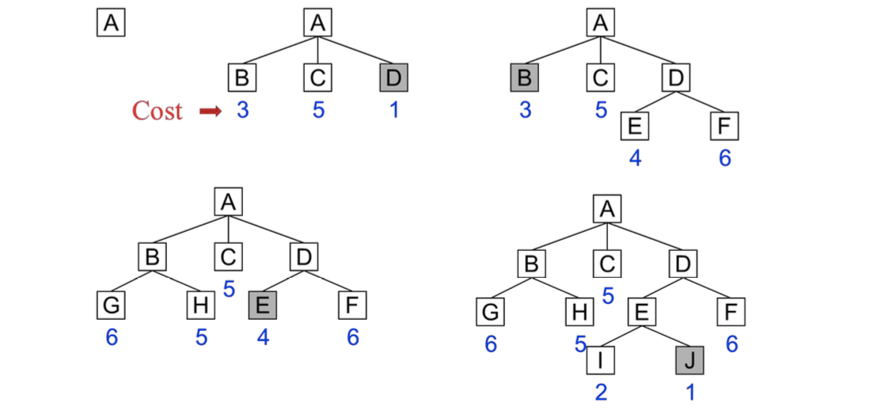
Q 4.
constraint satisfaction problems
Constraint Satisfaction Problems (CSP) play a crucial role in artificial intelligence (AI) as they help solve various problems that require decision-making under certain constraints. CSPs represent a class of problems where the goal is to find a solution that satisfies a set of constraints. These problems are commonly encountered in fields like scheduling, planning, resource allocation, and configuration.
In this article, we will dive deep into the concept of CSP, its components, methods to solve CSPs, and real-world applications, illustrating how CSPs can be used effectively in AI systems.
Table of Content
- What is a Constraint Satisfaction Problem (CSP)?
- Components of Constraint Satisfaction Problems
- Representation of Constraint Satisfaction Problems (CSP)
- CSP Algorithms: Solving Constraint Satisfaction Problems Efficiently
- Solving Sudoku with Constraint Satisfaction Problem (CSP) Algorithms
- Benefits of CSP in AI Systems
- Challenges in Solving CSPs
- Conclusion
What is a Constraint Satisfaction Problem (CSP)?
A Constraint Satisfaction Problem is a mathematical problem where the solution must meet a number of constraints. In a CSP, the objective is to assign values to variables such that all the constraints are satisfied. CSPs are used extensively in artificial intelligence for decision-making problems where resources must be managed or arranged within strict guidelines.
Common applications of CSPs include:
- Scheduling: Assigning resources like employees or equipment while respecting time and availability constraints.
- Planning: Organizing tasks with specific deadlines or sequences.
- Resource Allocation: Distributing resources efficiently without overuse.
Components of Constraint Satisfaction Problems
CSPs are composed of three key elements:
- Variables: The things that need to be determined are variables. Variables in a CSP are the objects that must have values assigned to them in order to satisfy a particular set of constraints. Boolean, integer, and categorical variables are just a few examples of the various types of variables, for instance, could stand in for the many puzzle cells that need to be filled with numbers in a sudoku puzzle.
- Domains: The range of potential values that a variable can have is represented by domains. Depending on the issue, a domain may be finite or limitless. For instance, in Sudoku, the set of numbers from 1 to 9 can serve as the domain of a variable representing a problem cell.
- Constraints: The guidelines that control how variables relate to one another are known as constraints. Constraints in a CSP define the ranges of possible values for variables. Unary constraints, binary constraints, and higher-order constraints are only a few examples of the various sorts of constraints. For instance, in a sudoku problem, the restrictions might be that each row, column, and 3×3 box can only have one instance of each number from 1 to 9.
Types of Constraint Satisfaction Problems
CSPs can be classified into different types based on their constraints and problem characteristics:
- Binary CSPs: In these problems, each constraint involves only two variables. For example, in a scheduling problem, the constraint could specify that task A must be completed before task B.
- Non-Binary CSPs: These problems have constraints that involve more than two variables. For instance, in a seating arrangement problem, a constraint could state that three people cannot sit next to each other.
- Hard and Soft Constraints: Hard constraints must be strictly satisfied, while soft constraints can be violated, but at a certain cost. This distinction is often used in real-world applications where not all constraints are equally important.
Representation of Constraint Satisfaction Problems (CSP)
In Constraint Satisfaction Problems (CSP), the solution process involves the interaction of variables, domains, and constraints. Below is a structured representation of how CSP is formulated:
- Finite Set of Variables (V1,V2,…,Vn)(V1​,V2​,…,Vn​):
The problem consists of a set of variables, each of which needs to be assigned a value that satisfies the given constraints.
- Non-Empty Domain for Each Variable (D1,D2,…,Dn)(D1​,D2​,…,Dn​):
Each variable has a domain—a set of possible values that it can take. For example, in a Sudoku puzzle, the domain could be the numbers 1 to 9 for each cell.
- Finite Set of Constraints (C1,C2,…,Cm)(C1​,C2​,…,Cm​):
Constraints restrict the possible values that variables can take. Each constraint defines a rule or relationship between variables.
- Constraint Representation:
Each constraint CiCi​ is represented as a pair <scope, relation>, where:
  - Scope: The set of variables involved in the constraint.
  - Relation: A list of valid combinations of variable values that satisfy the constraint.
- Example:
Let’s say you have two variables V1V1​ and V2V2​. A possible constraint could be V1≠V2V1​=V2​, which means the values assigned to these variables must not be equal.
  - Detailed Explanation:
    - Scope: The variables V1V1​ and V2V2​.
    - Relation: A list of valid value combinations where V1V1​ is not equal to V2V2​.
Some relations might include explicit combinations, while others may rely on abstract relations that are tested for validity dynamically.
CSP Algorithms: Solving Constraint Satisfaction Problems Efficiently
Constraint Satisfaction Problems (CSPs) rely on various algorithms to explore and optimize the search space, ensuring that solutions meet the specified constraints. Here’s a breakdown of the most commonly used CSP algorithms:
1. Backtracking Algorithm
The backtracking algorithm is a depth-first search method used to systematically explore possible solutions in CSPs. It operates by assigning values to variables and backtracks if any assignment violates a constraint.
How it works:
- The algorithm selects a variable and assigns it a value.
- It recursively assigns values to subsequent variables.
- If a conflict arises (i.e., a variable cannot be assigned a valid value), the algorithm backtracks to the previous variable and tries a different value.
- The process continues until either a valid solution is found or all possibilities have been exhausted.
This method is widely used due to its simplicity but can be inefficient for large problems with many variables.

2. Forward-Checking Algorithm
The forward-checking algorithm is an enhancement of the backtracking algorithm that aims to reduce the search space by applying local consistency checks.
How it works:
- For each unassigned variable, the algorithm keeps track of remaining valid values.
- Once a variable is assigned a value, local constraints are applied to neighboring variables, eliminating inconsistent values from their domains.
- If a neighbor has no valid values left after forward-checking, the algorithm backtracks.
This method is more efficient than pure backtracking because it prevents some conflicts before they happen, reducing unnecessary computations.
3. Constraint Propagation Algorithms
Constraint propagation algorithms further reduce the search space by enforcing local consistency across all variables.
How it works:
- Constraints are propagated between related variables.
- Inconsistent values are eliminated from variable domains by leveraging information gained from other variables.
- These algorithms refine the search space by making inferences, removing values that would lead to conflicts.
Constraint propagation is commonly used in conjunction with other CSP algorithms, such as backtracking, to increase efficiency by narrowing down the solution space early in the search process.
…………
Constraint Satisfaction Problems (CSP) in AI
1. What is a Constraint Satisfaction Problem (CSP)?
A Constraint Satisfaction Problem (CSP) is a mathematical problem defined by a set of variables, each with a specific domain of possible values, and a set of constraints that specify the allowed combinations of values. The goal is to assign values to the variables while satisfying all constraints.
🔹 Example: Solving a Sudoku puzzle, where each cell must contain a number from 1 to 9 without repeating in any row, column, or 3×3 sub-grid.

2. Components of a CSP
1️⃣ Variables (X): The set of elements to be assigned values.
2️⃣ Domains (D): Possible values for each variable.
3️⃣ Constraints (C): Restrictions on value assignments.
Example: Map Coloring Problem
- Variables (X): {A, B, C, D} (regions on a map)
- Domains (D): {Red, Blue, Green} (colors)
- Constraints (C): Adjacent regions cannot have the same color.

3. Types of CSPs
1️⃣ Binary CSPs
- Constraints involve two variables at a time.
- Example: Graph coloring, where each node (variable) has a color, and adjacent nodes must be different.
2️⃣ Unary CSPs
- Constraints involve only one variable.
- Example: A variable must be an even number.
3️⃣ Higher-Order CSPs
- Constraints involve three or more variables.
- Example: Sudoku, where a set of 9 variables (row, column, box) must contain unique numbers.

4. Solving CSPs: Techniques
(A) Backtracking Algorithm
- A depth-first search (DFS) that assigns values to variables and backtracks when a constraint is violated.
- Example: Solving Sudoku using backtracking.
🔹 Advantage: Simple and complete.
❌ Disadvantage: Can be slow for large problems.
(B) Forward Checking
- Improves backtracking by eliminating inconsistent values from domains before making a decision.
🔹 Example: While solving Sudoku, remove invalid numbers early.
(C) Constraint Propagation (AC-3 Algorithm)
- Uses Arc Consistency (AC-3) to remove values that violate constraints.
🔹 Example: If a variable is assigned "Red," remove "Red" from its neighbors' domains.
(D) Local Search (Min-Conflicts Heuristic)
- Starts with a random assignment and iteratively modifies values to minimize conflicts.
🔹 Example: Solving N-Queens by swapping queens to reduce conflicts.

5. Applications of CSPs
💡 AI & Robotics: Path planning in autonomous vehicles.
💡 Sudoku & Puzzles: Constraint-based problem-solving.
💡 Scheduling & Timetabling: University exam scheduling.
💡 Natural Language Processing (NLP): Syntax checking in grammar.
💡 Resource Allocation: Assigning tasks to workers.
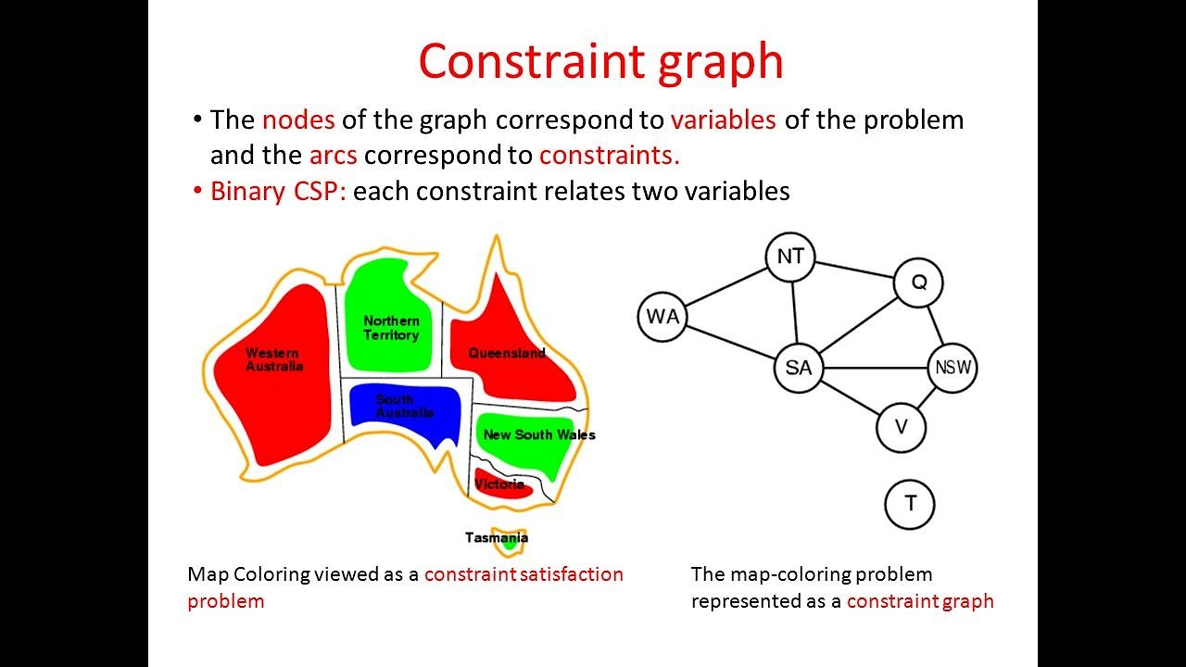
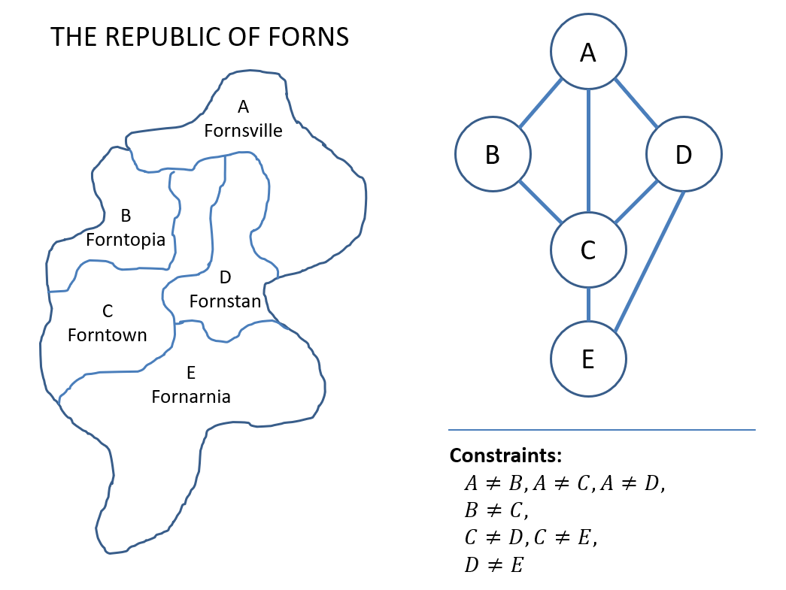
Q 5.
, local search techniques
Local Search Algorithm in Artificial Intelligence
Last Updated : 22 Aug, 2024
Local search algorithms are essential tools in artificial intelligence and optimization, employed to find high-quality solutions in large and complex problem spaces. Key algorithms include Hill-Climbing Search, Simulated Annealing, Local Beam Search, Genetic Algorithms, and Tabu Search.
Each of these methods offers unique strategies and advantages for solving optimization problems.
Table of Content
- 1. Hill-Climbing Search Algorithm
- 2. Simulated Annealing
- 3. Local Beam Search
- 4. Genetic Algorithms
- 5. Tabu Search
1. Hill-Climbing Search Algorithm
Hill-Climbing is a straightforward local search algorithm that iteratively moves towards better solutions. It is often used for optimization problems where the goal is to find the peak of a landscape, represented by an objective function.
- Process:
  - Start: Begin with an initial solution.
  - Evaluate: Assess the neighboring solutions.
  - Move: Transition to the neighbor with the highest objective function value if it improves the current solution.
  - Repeat: Continue this process until no better neighboring solution exists.
- Types:
  - Simple Hill-Climbing: Chooses the first neighbor that improves the solution.
  - Steepest-Ascent Hill-Climbing: Evaluates all neighbors and selects the best one.
  - Stochastic Hill-Climbing: Randomly selects neighbors to explore.
- Pros:
  - Easy to implement.
  - Works well in small or smooth search spaces.
- Cons:
  - May get stuck in local optima.
  - Limited exploration of the search space.
2. Simulated Annealing
Simulated Annealing is inspired by the annealing process in metallurgy, where materials are heated and then gradually cooled to remove defects. It allows for occasional moves to worse solutions to escape local optima, with the probability of such moves decreasing over time.
- Process:
  - Start: Begin with an initial solution and an initial temperature.
  - Move: Transition to a neighboring solution with a certain probability.
  - Cooling Schedule: Gradually reduce the temperature according to a predefined schedule.
  - Probability Function: Accept worse solutions with a probability that decreases as the temperature decreases.
- Pros:
  - Can escape local optima due to probabilistic acceptance of worse solutions.
  - Flexible in exploring the solution space.
- Cons:
  - Requires careful tuning of parameters like temperature and cooling schedule.
  - Computationally expensive due to repeated evaluations.
3. Local Beam Search
Local Beam Search is a variant of local search that maintains multiple states (or beams) at each level of the search. It explores multiple paths simultaneously, aiming to increase the likelihood of finding a good solution.
- Process:
  - Start: Begin with a set of initial solutions (beams).
  - Generate: Expand all current solutions to their neighbors.
  - Select: Choose a subset of the best neighbors to form the new beams.
  - Repeat: Continue expanding and selecting until a solution meets the criteria or a stopping condition is reached.
- Pros:
  - More likely to find a good solution than single-state local search.
  - Reduces the risk of getting stuck in local optima.
- Cons:
  - Requires managing multiple states and their neighbors.
  - Computationally intensive as the number of beams increases.
4. Genetic Algorithms
Genetic Algorithms (GAs) are inspired by the process of natural selection and evolution. They work with a population of solutions and evolve them over time using genetic operators like selection, crossover, and mutation.
- Process:
  - Initialize: Start with a population of random solutions.
  - Evaluate: Assess the fitness of each solution.
  - Select: Choose the best solutions for reproduction based on their fitness.
  - Crossover: Combine pairs of solutions to produce new offspring.
  - Mutate: Apply random changes to offspring to maintain diversity.
  - Replace: Form a new population by selecting which solutions to keep.
- Pros:
  - Can explore a broad solution space and find high-quality solutions.
  - Suitable for complex problems with large search spaces.
- Cons:
  - Computationally expensive due to the need for evaluating many solutions.
  - Requires tuning of various parameters like population size and mutation rate.
5. Tabu Search
Tabu Search enhances local search by using a memory structure called the tabu list to avoid revisiting previously explored solutions. This helps to prevent cycling back to local optima and encourages exploration of new areas.
- Process:
  - Start: Begin with an initial solution and initialize the tabu list.
  - Move: Transition to a neighboring solution while considering the tabu list.
  - Update: Add the current solution to the tabu list and potentially remove older entries.
  - Aspiration Criteria: Allow moves that lead to better solutions even if they are in the tabu list.
- Pros:
  - Reduces the chance of getting stuck in local optima.
  - Effective in exploring large and complex search spaces.
- Cons:
  - Requires careful management of the tabu list and aspiration criteria.
  - Computational complexity can be high.
Local search algorithms are powerful tools for solving optimization problems, each with its strengths and weaknesses. Hill-Climbing is simple and easy to understand but can be limited in its exploration. Simulated Annealing introduces randomness to escape local optima, while Local Beam Search leverages multiple paths to find better solutions. Genetic Algorithms offer a broad exploration strategy through evolution, and Tabu Search uses memory to enhance exploration and avoid cycles. Understanding these algorithms helps in selecting the right approach for a given problem and optimizing the solution effectively.
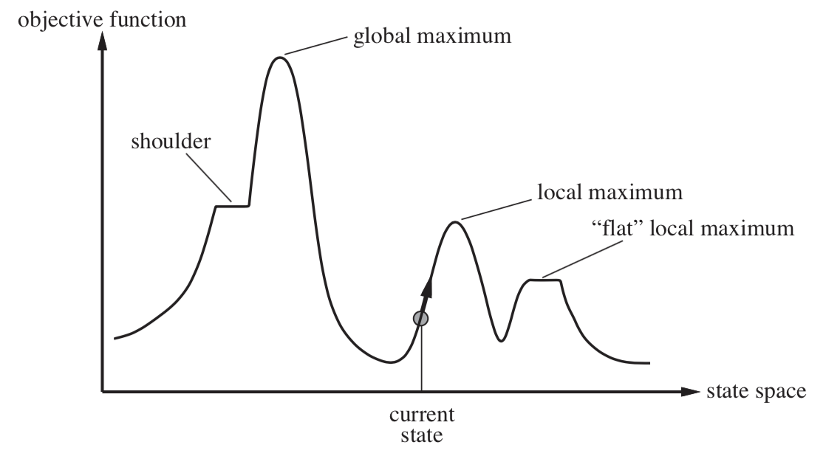
Q 6
greedy search
A greedy search algorithm makes locally optimal choices at each step, hoping to find a globally optimal solution, focusing on immediate benefits rather than exploring all possibilities.
Here's a more detailed explanation:
- Locally Optimal Choices:
At each stage, a greedy algorithm selects the option that appears best at that moment, without considering the potential consequences of that choice on the overall solution.
- Not Always Optimal:
While greedy algorithms can be efficient and easy to implement, they don't always guarantee the best possible solution.
- Examples:
  - Dijkstra's Algorithm: Finds the shortest path in a graph by iteratively selecting the closest unvisited node.
Dijkstra's algorithm is a step-by-step procedure that finds the shortest path between a starting node and all other nodes in a graph. It's a greedy search technique that's often used for finding distances, but can also be used for costs and processing times.
How it works
- Set initial distances for all vertices
- Choose the unvisited vertex with the shortest distance from the start to be the current vertex
- Consider all of the current node's unvisited neighbors
- Remove the current node from the unvisited set
- Repeat from step 3 until every visited node contains its shortest distance from the starting node
Use cases
- Finding the shortest path between your current location and a destination on a Google map
- Designing a shortest-path tree
- Figuring out the minimum costs in finance
- Figuring out the shortest processing times in manufacturing
Limitations
Dijkstra's algorithm can handle graphs with cycles, but negative weights will cause incorrect results. It's also only appropriate when all weights are favorable.
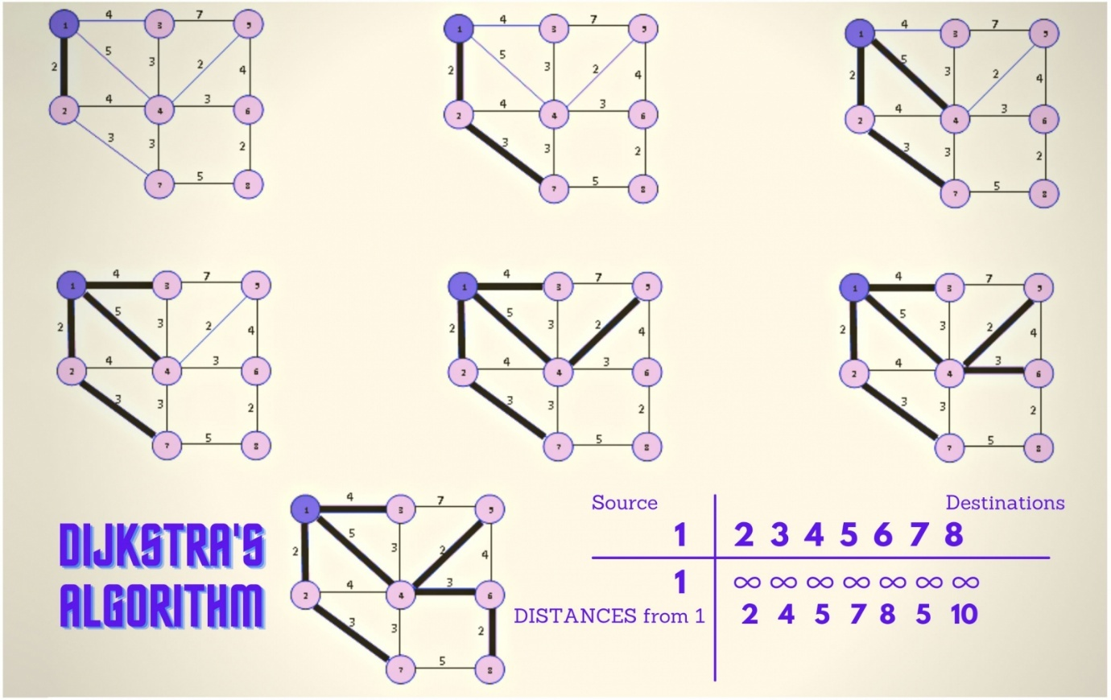
  - Fractional Knapsack Problem: Selects items with the highest value-to-weight ratio to maximize the value within a weight limit.
The fractional knapsack problem is a classic optimization problem where you aim to maximize the total value of items placed in a knapsack (container) with a limited capacity, allowing you to take fractions of items.
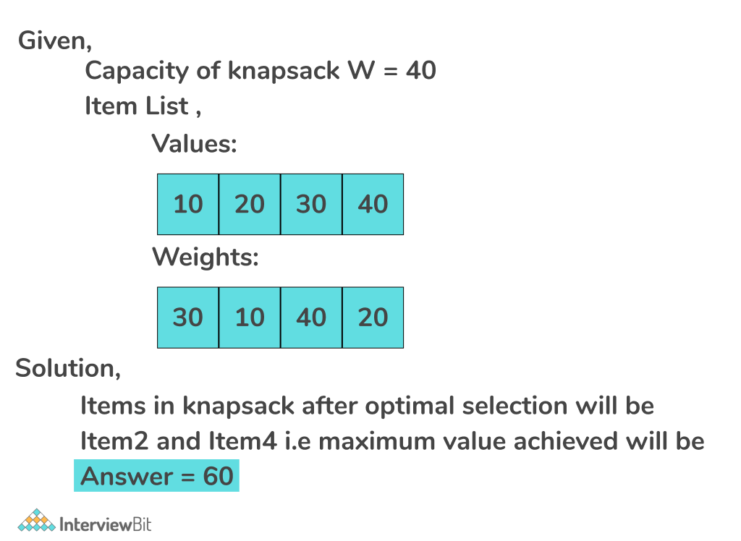
…
Greedy Search in AI
1. What is Greedy Search?
Greedy Search is an uninformed search algorithm that makes decisions based on the best immediate (local) choice at each step, without considering the overall solution. It selects the path with the lowest cost (or highest benefit) at each step, hoping to reach the goal quickly.
🔹 Key Idea: Always choose the most promising option at each step.
🔹 It does NOT guarantee the optimal solution but is fast and efficient.

2. How Greedy Search Works?
1️⃣ Start with an initial state.
2️⃣ Expand the node with the lowest heuristic value.
3️⃣ Repeat until the goal is reached.
🚀 Example: Finding the shortest path in a city using distance as a heuristic.

3. Properties of Greedy Search
✅ Completeness: No (May get stuck in loops if not handled properly).
✅ Optimality: No (May find suboptimal solutions).
✅ Time Complexity: O(b^d) (where b is the branching factor, d is depth).
✅ Space Complexity: O(b^d) (stores all nodes in memory).
5. Advantages and Disadvantages of Greedy Search
✅ Advantages
✔️ Fast execution (compared to exhaustive searches like BFS, DFS).
✔️ Memory efficient (stores only necessary nodes).
✔️ Simple and easy to implement.
❌ Disadvantages
❌ May not find the optimal path (gets stuck in local optima).
❌ Can enter infinite loops (if cycles are not handled).
❌ Heuristic choice is crucial (poor heuristic → bad results).

6. Applications of Greedy Search
💡 Pathfinding Algorithms: GPS Navigation, Google Maps.
💡 Graph Problems: Shortest path (Dijkstra's Algorithm).
💡 AI & Game Development: Chess AI, Pac-Man.
💡 Machine Learning: Feature selection in AI models.
💡 Network Routing: Finding the shortest network path.
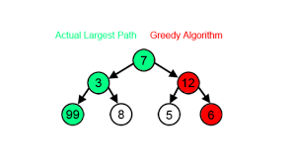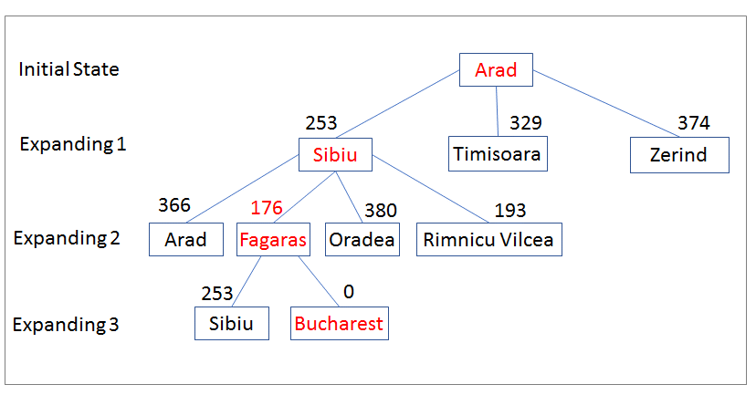

Unit II | Big Data Learning | (07 Hours)
Q 1.
Introduction to Big Data
What is Big Data?
Big Data refers to large, complex datasets that cannot be processed efficiently using traditional data processing methods. These datasets grow rapidly and require advanced tools and techniques for storage, analysis, and visualization.
🔹 Example: Social media posts, sensor data from IoT devices, financial transactions, medical records, etc.
Big data refers to extremely large and complex datasets, often characterized by volume, velocity, variety, and veracity, that are difficult to manage and analyze using traditional data processing tools. It encompasses structured, semi-structured, and unstructured data, and its analysis can reveal valuable insights for various applications.

2. Characteristics of Big Data (5 Vs)
✅ 1. Volume
- The size of data is massive (terabytes to petabytes).
- Example: Facebook generates 4 petabytes of data daily.
✅ 2. Velocity
- Data is generated and processed in real-time or near real-time.
- Example: Stock market transactions, online streaming data.
✅ 3. Variety
- Data comes in different formats:
  - Structured (databases, tables)
  - Unstructured (emails, videos, social media posts)
  - Semi-structured (JSON, XML)
✅ 4. Veracity
- Ensuring data accuracy and reliability despite inconsistencies.
- Example: Fake news detection in social media data.
✅ 5. Value
- Extracting meaningful insights to make business decisions.
- Example: E-commerce companies analyzing customer behavior.

3. Sources of Big Data
📊 Social Media: Twitter, Facebook, Instagram posts.
📡 IoT Devices: Smart home devices, sensors.
📈 Business Transactions: Bank records, e-commerce purchases.
🏥 Healthcare: Patient records, medical imaging data.
🌍 Government & Public Sector: Census data, satellite imagery.

4. Technologies for Big Data Processing
(A) Storage & Processing Frameworks
- Hadoop: Open-source framework for storing and processing large datasets.
- Spark: Faster alternative to Hadoop, used for real-time data processing.
- NoSQL Databases: MongoDB, Cassandra, HBase for handling unstructured data.
(B) Cloud Platforms
- AWS, Google Cloud, Azure: Offer scalable storage and processing power.
(C) Big Data Analytics Tools
- Apache Kafka: Real-time data streaming.
- Apache Flink: Batch & real-time data processing.
- Elasticsearch: Fast text search and analytics.

5. Applications of Big Data
💡 Healthcare: Predict disease outbreaks, personalized medicine.
💡 E-commerce: Recommendation systems (Amazon, Flipkart).
💡 Finance: Fraud detection, stock market predictions.
💡 Social Media Analytics: Sentiment analysis, trend prediction.
💡 Cybersecurity: Identifying and preventing cyber attacks.

6. Challenges in Big Data
❌ Data Storage: Managing petabytes of data efficiently.
❌ Processing Speed: Handling real-time data streams.
❌ Security & Privacy: Protecting sensitive user data.
❌ Data Quality: Handling missing, inconsistent, or duplicate data.
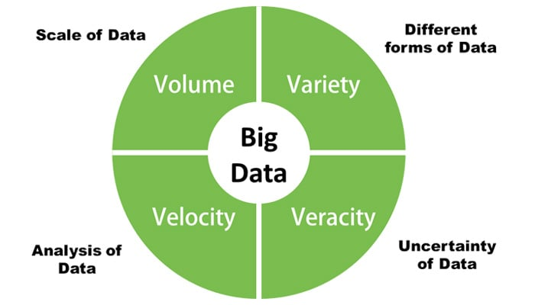
Q 2
Characteristics of big data
Big Data is defined by five key characteristics, often called the 5 Vs: Volume, Velocity, Variety, Veracity, and Value. These properties distinguish Big Data from traditional data and require specialized tools for processing.

1. Volume (Size of Data)
🔹 Refers to the huge amount of data generated every second.
🔹 Data size is measured in terabytes, petabytes, and even exabytes.
🔹 Example:
- Facebook generates 4 petabytes of data per day.
- YouTube users upload 500 hours of video every minute.
📌 Why is this important?
Traditional storage and processing tools (e.g., relational databases) cannot handle such large datasets, so distributed storage (e.g., Hadoop HDFS, cloud storage) is used.

2. Velocity (Speed of Data Generation & Processing)
🔹 Refers to the speed at which data is generated, processed, and analyzed.
🔹 Some applications require real-time processing to provide insights instantly.
🔹 Example:
- Stock market trading: Milliseconds matter when making decisions.
- Online transactions: Fraud detection needs real-time analysis.
- IoT devices: Sensors generate continuous data streams.
📌 Why is this important?
Traditional batch processing is too slow. Big Data tools like Apache Kafka, Apache Spark, and Flink help process data in real-time.

3. Variety (Different Types of Data)
🔹 Data comes in various formats, unlike traditional structured databases.
🔹 Three main types of data:
- Structured Data: Databases, Excel sheets.
- Semi-structured Data: JSON, XML, emails.
- Unstructured Data: Images, videos, social media posts, sensor data.
🔹 Example:
- Twitter generates structured (user info), semi-structured (tweets), and unstructured (images, videos) data.
- Medical records include patient data (structured), X-rays (unstructured), and reports (semi-structured).
📌 Why is this important?
Big Data tools (e.g., NoSQL databases like MongoDB, Elasticsearch) handle diverse data formats.

4. Veracity (Data Quality & Accuracy)
🔹 Refers to the trustworthiness and reliability of data.
🔹 Inconsistencies, missing values, or incorrect data can affect decision-making.
🔹 Example:
- Fake news on social media affects sentiment analysis.
- Sensor data errors in smart cities can lead to incorrect predictions.
📌 Why is this important?
Big Data tools (e.g., Data Cleaning, AI-based anomaly detection) help improve data quality.

5. Value (Usefulness of Data)
🔹 The most crucial aspect: How valuable is the data for decision-making?
🔹 Extracting meaningful insights from large datasets is the goal.
🔹 Example:
- Amazon & Netflix: Personalized recommendations based on user behavior.
- Healthcare: Predicting disease outbreaks from patient data.
- E-commerce: Fraud detection in online payments.
📌 Why is this important?
Data alone is useless unless it is analyzed and turned into actionable insights using Big Data Analytics, AI, and Machine Learning.

Conclusion
The 5 Vs of Big Data (Volume, Velocity, Variety, Veracity, and Value) define the challenges and opportunities in handling large datasets. To process Big Data effectively, organizations use tools like Hadoop, Spark, Kafka, and AI-based analytics.
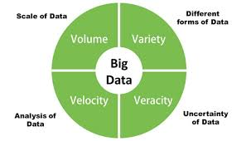
Q 3
types of data,
Types of Data in Big Data
Big Data consists of different types of data based on its structure, source, and nature. It is categorized into three main types: Structured, Semi-structured, and Unstructured Data.

1. Structured Data
🔹 Data that is organized, stored in a fixed format, and easily searchable in databases.
🔹 Uses tables, rows, and columns (similar to Excel sheets or relational databases).
🔹 Stored in: SQL databases like MySQL, PostgreSQL, Oracle.
📌 Examples:
- Customer information in a bank (Name, Account No., Balance).
- Sales data in an e-commerce website.
- Student records in a university database.
✅ Easy to store, manage, and retrieve using SQL-based systems.

2. Semi-structured Data
🔹 Data that does not follow a strict format but has some structure.
🔹 It is partially organized and often stored in text-based formats.
🔹 Stored in: NoSQL databases (MongoDB, Elasticsearch).
📌 Examples:
- JSON and XML files (used in web APIs).
- Emails (structured metadata + unstructured email body).
- Sensor logs from IoT devices.
✅ Flexible format, useful for applications that require both structure and flexibility.

3. Unstructured Data
🔹 Data that has no predefined format and is difficult to organize.
🔹 Requires advanced AI and Big Data analytics tools to process.
🔹 Stored in: Data lakes, cloud storage (AWS S3, Google Cloud Storage).
📌 Examples:
- Social media posts (text, images, videos).
- Medical images (MRI scans, X-rays).
- Videos, audio recordings, and PDFs.
✅ 80% of Big Data is unstructured! AI & ML are used to extract insights.
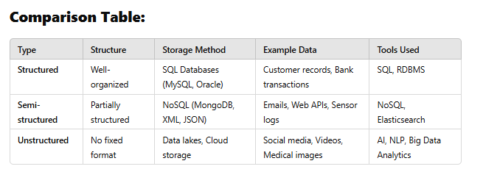
Learn more
Listen
Data can be broadly classified as qualitative (or categorical) and quantitative (or numerical), with further subdivisions within each category: qualitative data includes nominal and ordinal, while quantitative data includes discrete and continuous.
Here's a more detailed breakdown:
1. Qualitative (Categorical) Data:
- Nominal Data:
This type of data represents categories or names without any inherent order or ranking. Examples include colors (red, blue, green), types of fruits (apple, banana, orange), or gender (male, female).
- Ordinal Data:
This data type represents categories that can be ranked or ordered, but the difference between categories may not be equal. Examples include customer satisfaction ratings (very dissatisfied, dissatisfied, neutral, satisfied, very satisfied), or educational levels (high school, bachelor's, master's, PhD).
2. Quantitative (Numerical) Data:
- Discrete Data:
This data type represents values that can be counted and are typically whole numbers or integers. Examples include the number of students in a class, the number of cars passing a certain point, or the number of items sold.
- Continuous Data:
This data type represents values that can take on any value within a specific range and are often measured. Examples include height, weight, temperature, or time.
Other Data Types (Beyond the Main Categories):
- Boolean: A data type that represents truth values, either true or false.
- Integer: A data type that represents whole numbers (positive, negative, or zero).
- Float: A data type that represents numbers with decimal points.
- Array: A data structure that can store a collection of elements of the same data type.
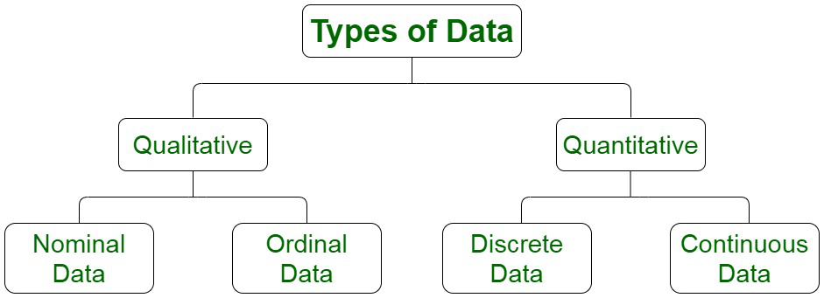
Q 4
Supervised and unsupervised machine learning.
Supervised vs. Unsupervised Machine Learning
Machine Learning (ML) is divided into two major types:
✅ Supervised Learning (Labeled data)
✅ Unsupervised Learning (Unlabeled data)
Both methods help machines learn from data, but they differ in their approach, purpose, and applications.

1. Supervised Learning (Labeled Data)
🔹 In supervised learning, the model is trained on labeled data (input-output pairs).
🔹 The goal is to learn a mapping function f(x) → y, where x = input and y = output.
🔹 The model is trained using correct answers (ground truth) and makes predictions on new data.
📌 Examples:
- Spam Detection: Classify emails as Spam or Not Spam (Input: email content, Output: spam label).
- Disease Prediction: Predict if a patient has diabetes based on medical records.
- Stock Price Prediction: Forecast stock prices based on historical data.
📌 Types of Supervised Learning:
1️⃣ Classification (Discrete output) → "Yes or No", "Cat or Dog"
- Algorithms: Logistic Regression, Decision Trees, SVM, Neural Networks
2️⃣ Regression (Continuous output) → Predict numbers (e.g., house price)
- Algorithms: Linear Regression, Random Forest Regression, Neural Networks
✅ Best for: Problems where historical labeled data is available.

2. Unsupervised Learning (Unlabeled Data)
🔹 In unsupervised learning, the model is trained on unlabeled data (no predefined categories).
🔹 The goal is to find hidden patterns, clusters, or relationships in the data.
🔹 There are no correct answers given during training.
📌 Examples:
- Customer Segmentation: Grouping customers based on purchasing behavior.
- Anomaly Detection: Detect fraud in credit card transactions.
- Topic Modeling: Identifying topics in a collection of news articles.
📌 Types of Unsupervised Learning:
1️⃣ Clustering → Grouping similar data points together
- Algorithms: K-Means, DBSCAN, Hierarchical Clustering
2️⃣ Dimensionality Reduction → Reduce complexity while keeping important information
- Algorithms: PCA (Principal Component Analysis), t-SNE, Autoencoders
✅ Best for: When labeled data is unavailable, and we want to explore hidden patterns.
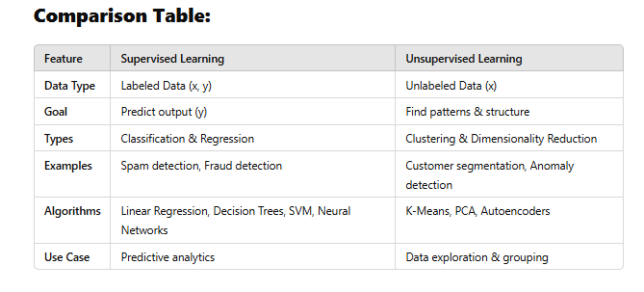
………….
What is Supervised learning?
Supervised learning as the name indicates has the presence of a supervisor as a teacher. Supervised learning is when we teach or train the machine using data that is well-labelled. Which means some data is already tagged with the correct answer. After that, the machine is provided with a new set of examples (data) so that the supervised learning algorithm analyses the training data (set of training examples) and produces a correct outcome from labeled data.
Supervised learning is a type of machine learning where the algorithm learns from labeled data meaning the data comes with correct answers or classifications.
For example, a labeled dataset of images of Elephant, Camel and Cow would have each image tagged with either “Elephant“, “Camel” or “Cow.”
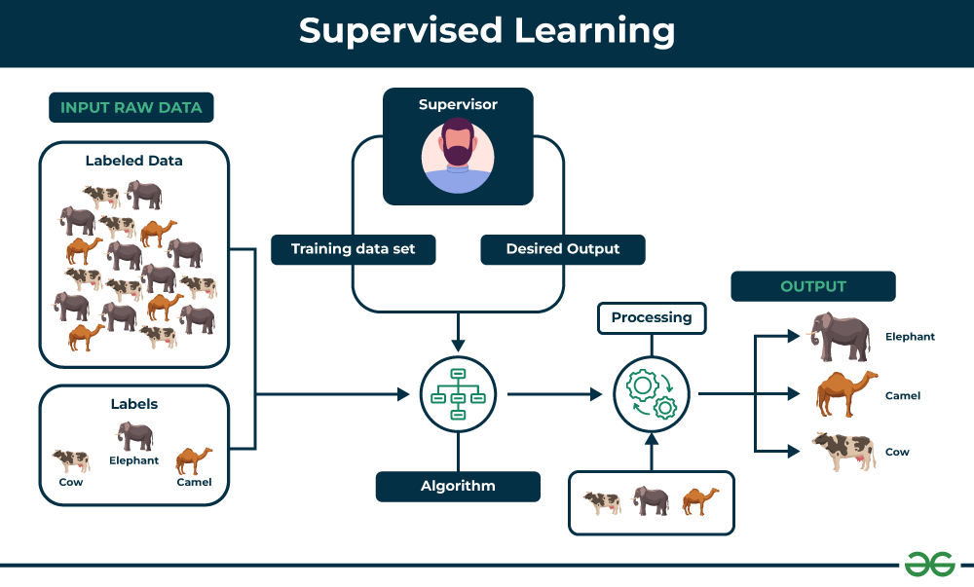 Example to Understand
Let’s say you have a fruit basket that you want to identify. The machine would first analyze the image to extract features such as its shape, color, and texture. Then, it would compare these features to the features of the fruits it has already learned about. If the new image’s features are most similar to those of an apple, the machine would predict that the fruit is an apple.
For instance, suppose you are given a basket filled with different kinds of fruits. Now the first step is to train the machine with all the different fruits one by one like this:
- If the shape of the object is rounded and has a depression at the top, is red in color, then it will be labeled as –Apple.
- If the shape of the object is a long curving cylinder having Green-Yellow color, then it will be labeled as –Banana.
Now suppose after training the data, you have given a new separate fruit say Banana from the basket and asked to identify it.

Since the machine has already learned the things from previous data and this time has to use it wisely. It will first classify the fruit with its shape and color and would confirm the fruit name as BANANA and put it in the Banana category. Thus the machine learns the things from training data(basket containing fruits) and then applies the knowledge to test data(new fruit).
Types of Supervised Learning
Supervised learning is classified into two categories of algorithms:
- Regression: A regression problem is when the output variable is a real value, such as “dollars” or “weight”.
- Classification: A classification problem is when the output variable is a category, such as “Yes” or “No” , “disease” or “no disease”.
1. Regression
Regression is a type of supervised learning that is used to predict continuous values, such as house prices, stock prices, or customer churn. Regression algorithms learn a function that maps from the input features to the output value.
Some common regression algorithms include:
- Linear Regression
- Polynomial Regression
- Lasso Regression
- Ridge Regression
2. Classification
Classification is a type of supervised learning that is used to predict categorical values, such as whether a customer will churn or not, whether an email is spam or not, or whether a medical image shows a tumor or not. Classification algorithms learn a function that maps from the input features to a probability distribution over the output classes.
Some of the most common classification algorithms include:
- Logistic Regression
- Support Vector Machines
- Decision Trees
- Random Forests
- Naive Baye
Applications of Supervised learning
Supervised learning can be used to solve a wide variety of problems, including:
- Spam filtering: Supervised learning algorithms can be trained to identify and classify spam emails based on their content, helping users avoid unwanted messages.
- Image classification: Supervised learning can automatically classify images into different categories, such as animals, objects, or scenes, facilitating tasks like image search, content moderation, and image-based product recommendations.
- Medical diagnosis: Supervised learning can assist in medical diagnosis by analyzing patient data, such as medical images, test results, and patient history, to identify patterns that suggest specific diseases or conditions.
- Fraud detection: Supervised learning models can analyze financial transactions and identify patterns that indicate fraudulent activity, helping financial institutions prevent fraud and protect their customers.
- Natural language processing (NLP): Supervised learning plays a crucial role in NLP tasks, including sentiment analysis, machine translation, and text summarization, enabling machines to understand and process human language effectively.
Advantages of Supervised learning
- By using labeled examples, supervised learning builds models that draw on prior experiences to produce reliable outputs for new, unseen data.
- It Improves Over Time. With more data and training, these models can refine their accuracy, leading to better performance and more reliable predictions.
- Supervised learning is practical for a range of applications, from detecting spam emails to predicting house prices, thanks to its ability to handle diverse computational challenges.
- It can be used to categorize data into predefined labels (classification) or to predict continuous outcomes (regression), providing flexibility for various tasks.
Disadvantages of Supervised learning
- Supervised learning requires a well-labeled dataset, where each input is paired with a corresponding output. Creating such datasets can be time-consuming, expensive, and prone to human error, which may limit its applicability in scenarios where labeled data is scarce or difficult to obtain.
- While supervised learning performs well on many tasks, it often struggles with highly complex or unstructured problems. For instance, it may have difficulty handling nuanced patterns, multiple dependencies, or tasks that involve abstract reasoning, as these typically go beyond the model’s trained scope.
- Training supervised models on large datasets can demand substantial computational power and time. This need for high-performance hardware and long training durations can make supervised learning less practical for organizations with limited resources or urgent timelines.
What is Unsupervised learning?
Unsupervised learning is a type of machine learning that works with data that has no labels or categories. The main goal is to find patterns and relationships in the data without any guidance.
In this approach, the machine analyzes unorganized information and groups it based on similarities, patterns, or differences. Unlike supervised learning, there is no teacher or training involved. The machine must uncover hidden structures in the data on its own.
For example, unsupervised learning can analyze animal data and group the animals by their traits and behavior. These groups could correspond to different species, making it possible to organize the animals without pre-existing labels.
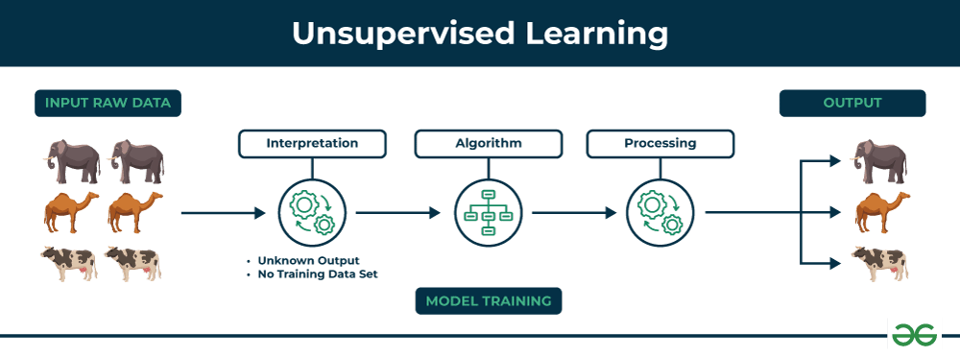
Example to understand
Imagine you have a machine learning model trained on a large dataset of unlabeled images, containing both dogs and cats. The model has never seen an image of a dog or cat before, and it has no pre-existing labels or categories for these animals. Your task is to use unsupervised learning to identify the dogs and cats in a new, unseen image.
suppose it is given an image having both dogs and cats which it has never seen.
Thus the machine has no idea about the features of dogs and cats so we can’t categorize it as ‘dogs and cats ‘. But it can categorize them according to their similarities, patterns, and differences, i.e., we can easily categorize the above picture into two parts. The first may contain all pics having dogs in them and the second part may contain all pics having cats in them. Here you didn’t learn anything before, which means no training data or examples.
It allows the model to work on its own to discover patterns and information that was previously undetected. It mainly deals with unlabeled data.
Types of Unsupervised Learning
Unsupervised learning is classified into two categories of algorithms:
- Clustering: A clustering problem is where you want to discover the inherent groupings in the data, such as grouping customers by purchasing behavior.
- Association: An association rule learning problem is where you want to discover rules that describe large portions of your data, such as people that buy X also tend to buy Y
Clustering
Clustering is a type of unsupervised learning that is used to group similar data points together. Clustering algorithms work by iteratively moving data points closer to their cluster centers and further away from data points in other clusters. Some of the most important hierarchical clustering algorithms include:
- K-means clustering
- Hierarchical clustering
- Principal Component Analysis (PCA)
- Singular Value Decomposition (SVD)
- Independent Component Analysis
- Gaussian Mixture Models (GMMs)
- Density-Based Spatial Clustering of Applications with Noise (DBSCAN)
Association rule learning
Association rule learning is a type of unsupervised learning that is used to identify patterns in a data. Association rule learning algorithms work by finding relationships between different items in a dataset.
Some common association rule learning algorithms include:
- Apriori Algorithm
- Eclat Algorithm
- FP-Growth Algorithm
Application of Unsupervised learning
Non-supervised learning can be used to solve a wide variety of problems, including:
- Anomaly detection: Unsupervised learning can identify unusual patterns or deviations from normal behavior in data, enabling the detection of fraud, intrusion, or system failures.
- Scientific discovery: Unsupervised learning can uncover hidden relationships and patterns in scientific data, leading to new hypotheses and insights in various scientific fields.
- Recommendation systems: Unsupervised learning can identify patterns and similarities in user behavior and preferences to recommend products, movies, or music that align with their interests.
- Customer segmentation: Unsupervised learning can identify groups of customers with similar characteristics, allowing businesses to target marketing campaigns and improve customer service more effectively.
Advantages of Unsupervised learning
- 1. Unsupervised learning doesn’t require data to be labeled, making it easier and faster to start working with large datasets.
- 2. This approach can handle large amounts of data and reduce it into simpler forms without losing essential patterns, making it more manageable and efficient.
- 3. It can uncover patterns and relationships in the data that were previously unknown, offering valuable insights you may not have found otherwise.
- 4. By analyzing unlabeled data, unsupervised learning can reveal meaningful trends and groupings that help you understand your data more deeply.
Disadvantages of Unsupervised learning
- 1. Since there are no labeled answers to compare with, it can be challenging to gauge how accurate or effective the model is.
- 2. The lack of clear guidance can result in less precise results, particularly for complex tasks.
- 3. After unsupervised learning groups the data, the user often needs to review and label these groupings, which can be time-consuming.
- 4. Unsupervised learning is easily influenced by missing values, outliers, or noisy data, which can affect the quality of the results.
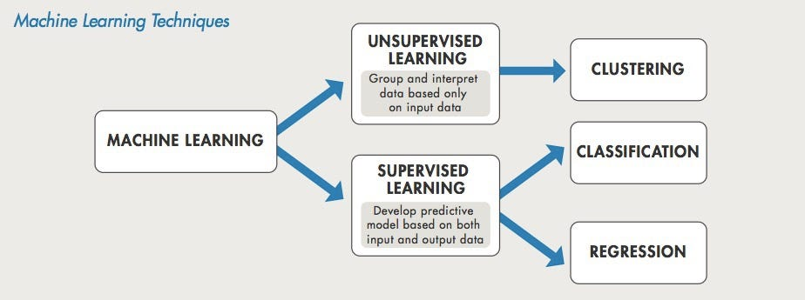
Q 5.
Overview of regression analysis
Regression analysis is a statistical method used to model the relationship between a dependent variable and one or more independent variables, allowing for prediction and understanding of the relationship between them.
Here's a more detailed overview:
- Purpose:
Regression analysis aims to:
  - Predict: Estimate the value of a dependent variable based on the values of independent variables.
  - Understand Relationships: Determine the strength and direction of the relationship between variables.
  - Identify Influential Factors: Pinpoint which independent variables significantly impact the dependent variable.
- Types of Regression:
  - Simple Linear Regression: Models the relationship between one dependent and one independent variable.
  - Multiple Linear Regression: Models the relationship between one dependent variable and multiple independent variables.
  - Non-linear Regression: Models relationships that are not linear.
- Key Concepts:
  - Dependent Variable (Response Variable): The variable you are trying to predict or understand.
  - Independent Variable (Predictor Variable): The variable(s) used to predict or explain the dependent variable.
  - Regression Line/Equation: A line or equation that best represents the relationship between the variables.
  - Coefficients: Numbers that represent the strength and direction of the relationship between the independent and dependent variables.
  - R-squared (R²): A measure of how well the regression model fits the data, indicating the proportion of variance in the dependent variable explained by the independent variables.
  - Error/Residuals: The difference between the observed values and the predicted values.
- Applications:
  - Predicting Sales: Forecasting future sales based on marketing spend, advertising campaigns, etc.
  - Analyzing Investment Returns: Understanding factors that influence investment returns.
  - Assessing the Impact of Treatments: Evaluating the effectiveness of a new drug or therapy.
  - Understanding Social Phenomena: Analyzing the relationship between socioeconomic factors and health outcomes.
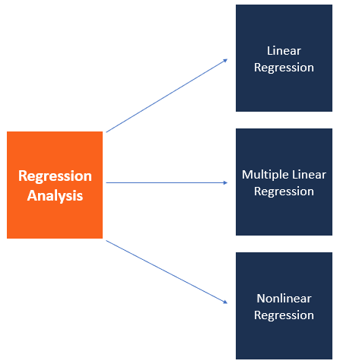
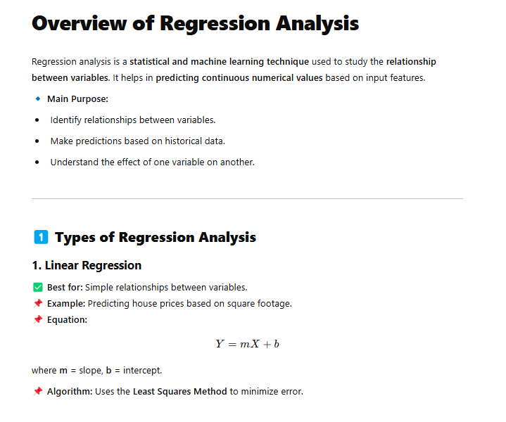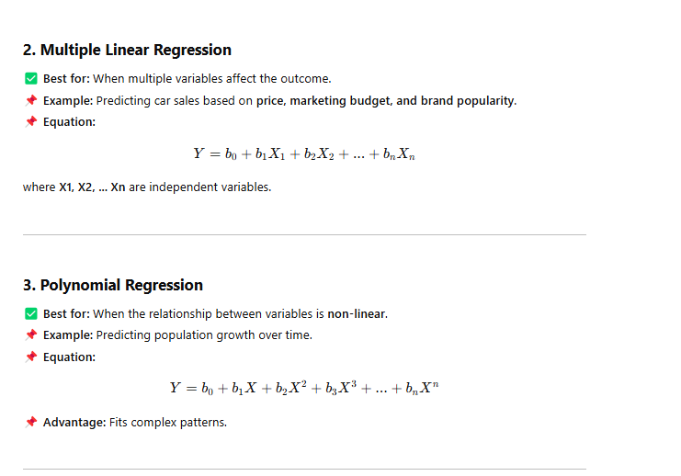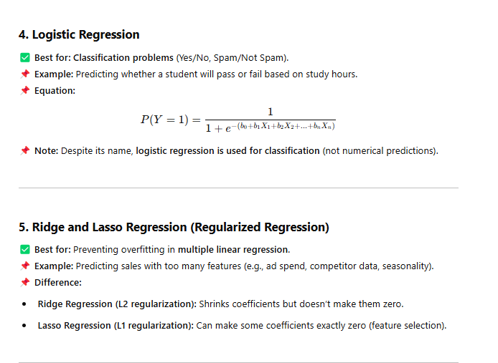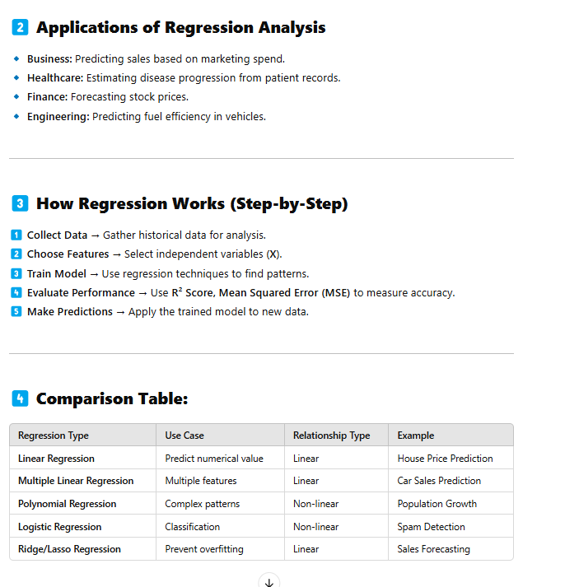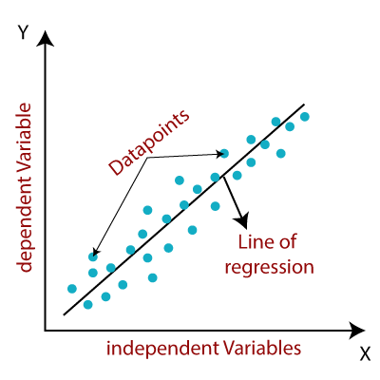
Q 6
Clustering
Clustering is an unsupervised machine learning technique designed to group unlabeled examples based on their similarity to each other. (If the examples are labeled, this kind of grouping is called classification.)
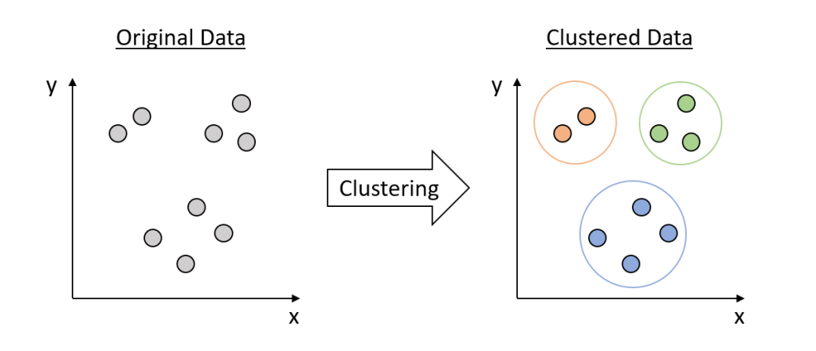
Clustering in Machine Learning
Clustering is an unsupervised machine learning technique used to group similar data points together based on patterns. Unlike classification, clustering doesn’t have labeled data. Instead, it finds natural structures in data.

1️⃣ What is Clustering?
🔹 Definition: Clustering is the process of grouping similar objects based on certain characteristics.
🔹 Purpose: Identify patterns, reduce data complexity, and find relationships within data.
🔹 No Labels: Unlike supervised learning, clustering doesn’t use predefined labels.
📌 Example:
- Grouping customers based on purchasing behavior (Customer Segmentation).
- Identifying anomalies in credit card transactions (Fraud Detection).

2️⃣ Types of Clustering Algorithms
1. K-Means Clustering
✅ Best for: Well-defined clusters, quick execution.
📌 How it Works:
1️⃣ Select K (number of clusters).
2️⃣ Choose K random centroids (initial cluster centers).
3️⃣ Assign each data point to the nearest centroid.
4️⃣ Update centroids by taking the mean of points in each cluster.
5️⃣ Repeat until centroids stop changing.
📌 Example: Segmenting customers in an e-commerce store.
🔹 Limitation: You must predefine K (number of clusters).

2. Hierarchical Clustering
✅ Best for: When you don’t know the number of clusters beforehand.
📌 How it Works:
1️⃣ Starts with each data point as its own cluster.
2️⃣ Iteratively merge the closest clusters.
3️⃣ Continue until all points belong to a single cluster.
4️⃣ Represented as a dendrogram (tree diagram).
📌 Example: Organizing genes in DNA sequencing.
🔹 Limitation: Computationally expensive for large datasets.

3. DBSCAN (Density-Based Clustering)
✅ Best for: Detecting clusters of different shapes and sizes, handling noise.
📌 How it Works:
1️⃣ Finds dense regions in data.
2️⃣ Expands clusters from these dense points.
3️⃣ Identifies outliers as noise (unclustered points).
📌 Example: Identifying fraudulent transactions in banking data.
🔹 Limitation: Not ideal for clusters of varying densities.

4. Gaussian Mixture Model (GMM)
✅ Best for: When clusters overlap and are not well-separated.
📌 How it Works:
- Assumes data is generated from multiple Gaussian distributions.
- Uses probability to assign points to clusters.
📌 Example: Image segmentation in medical imaging.
🔹 Limitation: More complex than K-Means, slower convergence.

3️⃣ Applications of Clustering
📌 Customer Segmentation → Grouping customers based on shopping habits.
📌 Anomaly Detection → Detecting fraudulent transactions.
📌 Image Segmentation → Separating objects in an image.
📌 Document Clustering → Grouping similar news articles.
📌 Biological Data Analysis → Classifying genes based on characteristics.
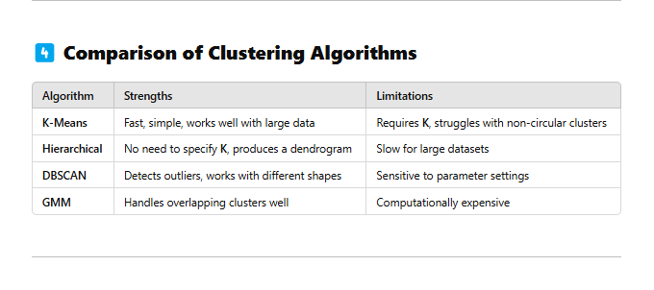
Q 7
data dimensionality
Data dimensionality refers to the number of features or attributes in a dataset. It's a key factor in data engineering, machine learning, and statistics.
Why is dimensionality important?
- High-dimensional data: Datasets with many features can be difficult to process, store, and move.
- Machine learning: High-dimensional data can decrease the accuracy of predictive models.
- Statistics: High-dimensional data can make it difficult to meet the assumptions needed for statistical testing.
How to address high-dimensional data?
- Dimensionality reduction: Techniques like feature selection, feature extraction, and t-SNE can reduce the number of features in the data.
- Feature engineering: Techniques can help make data more manageable and easier to process.
Examples of high-dimensional data
- Healthcare data, which can include blood pressure, weight, and cholesterol
- Microarrays, which can contain tens of thousands of genes for each sample
- Netflix data, which contains data on millions of users and movies
- Social science observational studies, where the number of data points exceeds the number of predictor variables
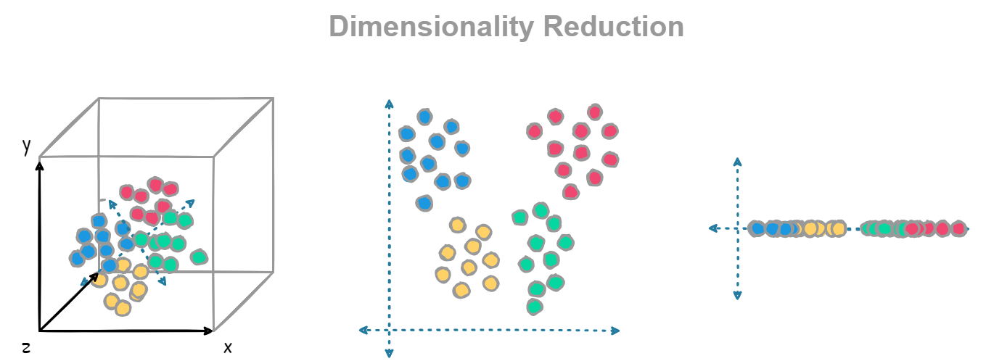
Q 8
clustering methods
Clustering Methods in Machine Learning
Clustering is an unsupervised machine learning technique used to group similar data points together. It helps uncover hidden patterns in data without requiring labeled examples.

1️⃣ Types of Clustering Methods
1. Partition-Based Clustering
✅ Divides data into K groups, where each point belongs to exactly one cluster.
📌 Algorithm:
- K-Means Clustering
  - Selects K random centroids.
  - Assigns each data point to the nearest centroid.
  - Updates centroids until convergence.
🔹 Example: Customer segmentation in e-commerce.
🔹 Limitation: Needs to predefine K (number of clusters).

2. Hierarchical Clustering
✅ Builds a tree-like hierarchy of clusters using a dendrogram.
📌 Algorithms:
- Agglomerative Hierarchical Clustering (Bottom-Up)
  - Starts with each point as its own cluster.
  - Merges closest clusters iteratively.
- Divisive Hierarchical Clustering (Top-Down)
  - Starts with all data points in one cluster.
  - Splits into smaller clusters recursively.
🔹 Example: DNA sequencing and gene classification.
🔹 Limitation: Computationally expensive for large datasets.

3. Density-Based Clustering
✅ Finds clusters of arbitrary shape by detecting dense regions.
📌 Algorithm:
- DBSCAN (Density-Based Spatial Clustering of Applications with Noise)
  - Groups points that are close together.
  - Points that don’t belong to any cluster are considered outliers.
🔹 Example: Fraud detection in banking.
🔹 Limitation: Struggles with varying densities.

4. Grid-Based Clustering
✅ Divides the data space into a grid and forms clusters based on density.
📌 Algorithm:
- STING (Statistical Information Grid Approach)
  - Divides data into rectangular grids.
  - Merges or splits grids based on density.
🔹 Example: Image segmentation.
🔹 Limitation: Grid size affects results.

5. Model-Based Clustering
✅ Assumes that data is generated from a mixture of probabilistic models.
📌 Algorithm:
- Gaussian Mixture Model (GMM)
  - Uses multiple Gaussian distributions to model data.
  - Assigns probabilities to each data point belonging to a cluster.
🔹 Example: Speech recognition.
🔹 Limitation: More complex and computationally expensive.
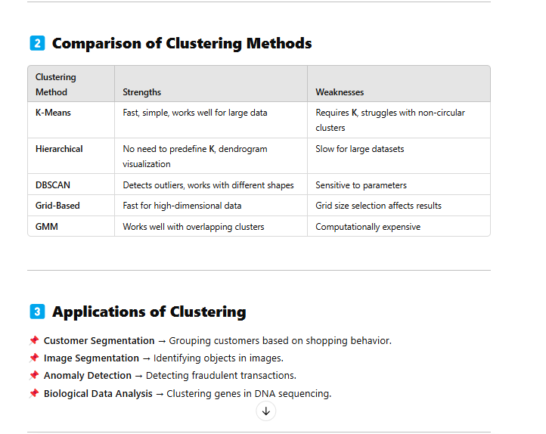
……………………….
What is Clustering?
The task of grouping data points based on their similarity with each other is called Clustering or Cluster Analysis. This method is defined under the branch of unsupervised learning, which aims at gaining insights from unlabelled data points.
Think of it as you have a dataset of customers shopping habits. Clustering can help you group customers with similar purchasing behaviors, which can then be used for targeted marketing, product recommendations, or customer segmentation
Uses of Clustering
Now before we begin with types of clustering algorithms, we will go through the use cases of Clustering algorithms. Clustering algorithms are majorly used for:
- Market Segmentation: Businesses use clustering to group their customers and use targeted advertisements to attract more audience.
- Market Basket Analysis: Shop owners analyze their sales and figure out which items are majorly bought together by the customers. For example, In USA, according to a study diapers and beers were usually bought together by fathers.
- Social Network Analysis: Social media sites use your data to understand your browsing behavior and provide you with targeted friend recommendations or content recommendations.
- Medical Imaging: Doctors use Clustering to find out diseased areas in diagnostic images like X-rays.
- Anomaly Detection: To find outliers in a stream of real-time dataset or forecasting fraudulent transactions we can use clustering to identify them.
- Simplify working with large datasets: Each cluster is given a cluster ID after clustering is complete. Now, you may reduce a feature set’s whole feature set into its cluster ID. Clustering is effective when it can represent a complicated case with a straightforward cluster ID. Using the same principle, clustering data can make complex datasets simpler.
Q 9
Introduction to Spark programming model and MLib library
Introduction to Spark Programming Model and MLlib Library
1️⃣ What is Apache Spark?
Apache Spark is an open-source, distributed computing framework used for big data processing and machine learning. It is known for its speed, scalability, and ease of use compared to traditional frameworks like Hadoop.
🔥 Key Features of Apache Spark:
✔ In-Memory Computing → Faster than Hadoop’s disk-based processing.
✔ Supports Multiple Languages → Python (PySpark), Java, Scala, and R.
✔ Distributed Computing → Handles large-scale data efficiently.
✔ Rich Libraries → Includes SQL, MLlib (Machine Learning), GraphX (Graph Processing), and Streaming (Real-time data analysis).

2️⃣ Spark Programming Model
Apache Spark follows the Resilient Distributed Dataset (RDD) model.
✨ Core Spark Concepts
✅ RDD (Resilient Distributed Dataset) → The fundamental data structure in Spark.
- Immutable, distributed, and can be processed in parallel.
- Created from files (CSV, JSON, Parquet) or other RDD transformations.
✅ DataFrame → A higher-level abstraction built on RDDs.
- Similar to a SQL table with named columns.
- More optimized for queries and transformations.
✅ DAG (Directed Acyclic Graph) → Represents the execution plan of Spark jobs.
- Optimizes tasks before execution.
✅ Transformations & Actions:
- Transformations (Lazy Evaluation) → map(), filter(), groupBy().
- Actions (Trigger Execution) → collect(), count(), saveAsTextFile().
- 3️⃣ What is MLlib?
- MLlib (Machine Learning Library) is Spark’s built-in machine learning library that provides scalable algorithms for classification, regression, clustering, and more.
- ✨ Features of MLlib:
- ✔ Scalable → Works with distributed datasets.
✔ Supports Multiple Algorithms → Regression, Classification, Clustering.
✔ Works with RDDs and DataFrames → More optimized than traditional ML frameworks.

4️⃣ Key Machine Learning Algorithms in MLlib
- 📌 1. Classification & Regression
- ✅ Logistic Regression
✅ Decision Trees & Random Forest
✅ Gradient Boosted Trees
✅ Linear Regression

2. Clustering (Unsupervised Learning)
- ✅ K-Means
✅ Gaussian Mixture Model (GMM)

Why Use Spark & MLlib?
- ✅ Handles Big Data efficiently.
✅ Supports real-time & batch processing.
✅ Works with Hadoop, Kafka, and cloud platforms.
✅ MLlib is optimized for l 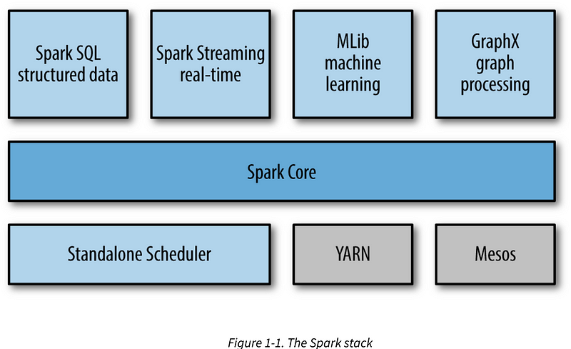 arge-scale machine learning.
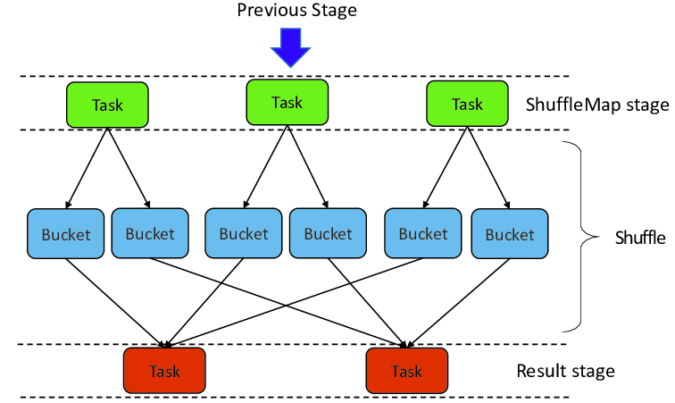
Q 10
Content based recommendation systems
Content-Based Recommendation Systems
A Content-Based Recommendation System (CBRS) suggests items to users by analyzing item characteristics and matching them with user preferences. It focuses on the similarity between items rather than user behavior.

1️⃣ How Does a Content-Based Recommendation System Work?
CBRS relies on item features (e.g., genre, keywords, description) and a user’s past interactions.
🔹 Example: If a user watches science fiction movies, the system recommends other sci-fi movies based on their features.
Steps in Content-Based Filtering:
1️⃣ Feature Extraction → Represent items as vectors of features (e.g., TF-IDF for text).
2️⃣ Profile Building → Create a user profile based on past preferences.
3️⃣ Similarity Calculation → Compute similarity between user profile and items (e.g., Cosine Similarity).
4️⃣ Recommendation Generation → Rank items based on similarity scores.
2️⃣ Techniques Used in Content-Based Filtering
📌 1. Term Frequency-Inverse Document Frequency (TF-IDF)
- Used for text-based features (e.g., movie descriptions, book summaries).
- TF-IDF gives high weight to important words while ignoring common words.
🔹 Example: Finding similar books based on description.
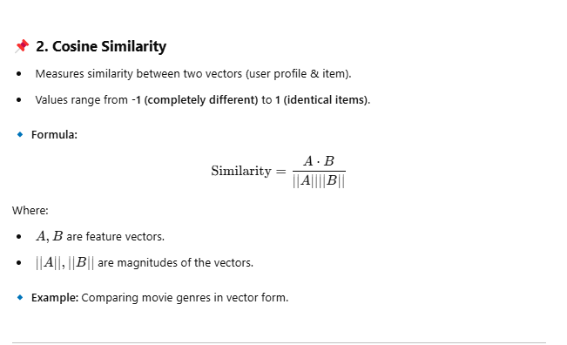 4️⃣ Advantages & Disadvantages of Content-Based Filtering
✅ Advantages:
✔ Works well for new users (cold-start problem for items is less severe).
✔ Does not require user interactions (works on individual preferences).
✔ Can be interpreted easily (explains why an item is recommended).
❌ Disadvantages:
❌ Cold-start problem for new items (requires item descriptions).
❌ Cannot suggest diverse recommendations (only similar items).
❌ Struggles with user preferences shifting over time.

5️⃣ Applications of Content-Based Filtering
📌 Movie Recommendation → Suggesting similar movies based on genre and description.
📌 E-commerce → Recommending products based on user preferences.
📌 News Articles → Suggesting similar articles based on text content.
📌 Online Courses → Suggesting courses based on learning history.

6️⃣ Hybrid Recommendation Systems
To overcome CBRS limitations, a hybrid approach combines Content-Based Filtering & Collaborative Filtering.
📌 Example:
- Netflix → Uses content-based filtering for personalized movie suggestions and collaborative filtering to recommend trending shows.
- Amazon → Uses a hybrid approach to recommend books based on similar content & customer behavior.

🔹 Conclusion
✔ Content-Based Recommendation Systems are effective for personalized recommendations.
✔ They rely on item features and user preferences to make suggestions.
✔ To improve recommendations, hybrid methods are used in real-world applications.
…………………….
Content-based recommendation systems are a popular and widely used approach to provide personalized recommendations to users. These systems are based on the idea that a user's preferences can be predicted based on their previous interactions with items, such as their viewing and purchasing history
