Breast Cancer Insights: Analytical Report

Prepared by: Sakshi Kamble
Tools Used: Excel, Tableau
Project Type: Healthcare Data Analytics
Total Patients Analyzed: 334

Introduction:-
Breast cancer is one of the most commonly diagnosed cancers worldwide and remains a major public health concern. Understanding how patient demographics, tumor characteristics, and treatment choices influence disease progression and outcomes is critical for improving clinical decision-making. This project applies data analytics and statistical techniques to explore patterns and relationships within a breast cancer patient dataset.

Problem Statement:-
Breast cancer treatment and patient outcomes are influenced by a combination of demographic factors, tumor characteristics, biological markers, and treatment decisions. However, understanding how these variables interact is challenging without structured analysis.
The goal of this project is to analyze breast cancer patient data to identify key relationships between age, tumor stage, biological markers, surgery type, and follow-up outcomes. By applying exploratory analysis, statistical testing, and interactive visualization, the project aims to answer the following questions:
1. How does age vary across different tumor stages?
2. Are tumor stages associated with demographic and biological factors such as gender, HER2 status, and protein expression?
3. Do treatment choices (surgery type) influence follow-up duration?
4. Which clinical factors show statistically significant associations, and which do not?
The insights derived from this analysis are intended to support data-driven clinical understanding and demonstrate how analytics can be applied to healthcare datasets.

Data Description:-
This dataset contains clinical and demographic information of breast cancer patients who underwent surgical treatment for tumor removal. The data spans a short time frame and is suitable for exploratory analysis and hypothesis testing in a healthcare context. After data cleaning, the dataset consists of 334 patient records, with each row representing a unique patient.
The original dataset downloaded from Kaggle, contained 16 columns and more than 400 records. After removing incomplete and invalid entries, 18 columns 334 valid patient records were retained for analysis. Each record corresponds to an individual breast cancer patient.
- Patient_ID – Unique identifier for each patient
- Age – Age of the patient at diagnosis (in years)
- Gender – Male or Female
- Protein1, Protein2, Protein3, Protein4 – Protein expression levels (units not specified)
- Tumour_Stage – Stage of cancer (I, II, III)
- Histology – Type of breast cancer (Infiltrating Ductal Carcinoma, Infiltrating Lobular Carcinoma, Mucinous Carcinoma)
- ER Status – Estrogen receptor status (Positive/Negative) (Only Positive in the dataset)
- PR Status – Progesterone receptor status (Positive/Negative) (Only Positive in the dataset)
- HER2 Status – Human Epidermal Growth Factor Receptor 2 status (Positive/Negative)
- Surgery_Type – Type of surgical procedure performed
- Date_of_Surgery – Date on which the surgery was performed
- Date_of_Last_Visit – Date of last recorded hospital visit (may be null)
- Patient_Status – Alive, Dead, or Unknown

Data Cleaning and Preprocessing:-
Data preparation was performed using Excel Power Query to ensure consistency and accuracy.
Cleaning Steps Performed:
- Standardized Gender values to remove inconsistencies
- Removed blank rows with no patient information
- Reduced dataset to 334 valid patient records
- Retained null values in Date of Last Visit for patients who did not return after surgery
- Replaced null values in Patient Status with “Unknown”
- Calculated Follow-up Days using:
- Date of Last Visit – Date of Surgery
- Created Age Groups for categorical analysis:
- 29–39
- 40–49
- 50–59
- 60–69
- 70+

Exploratory Data Analysis (EDA):-
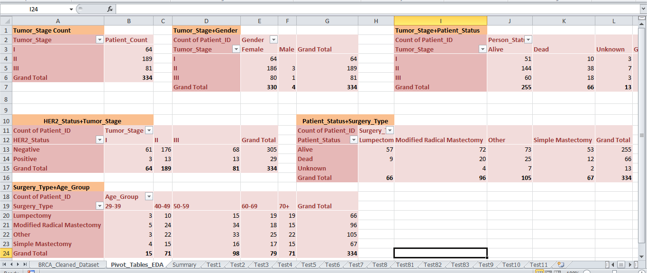
Fig1. EDA: Excel Pivot Tables
EDA was conducted using Excel Pivot Tables to understand patient distribution and clinical patterns.
Key Observations:
- Tumor Stage Distribution:
- Stage I: 64 patients
- Stage II: 189 patients
- Stage III: 81 patients
- Initial exploration revealed:
- High prevalence of female patients
- Majority of patients clustered in Tumor Stage II
- Noticeable variation in surgery types and outcomes
EDA helped identify meaningful variables for statistical testing and dashboard analysis.

Statistical Analysis and Hypothesis Testing:-
Hypothesis testing was conducted in Excel, supported by VBA macros to dynamically populate a Hypothesis summary results table.
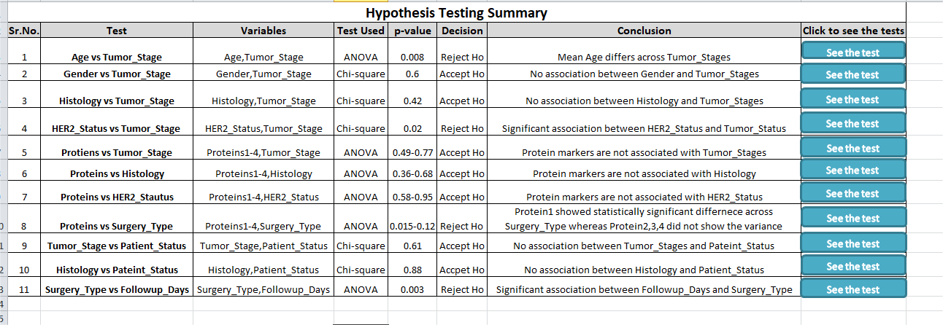
Fig2. Hypothesis Testing Summary
ANOVA was used for numerical vs categorical variables, and Chi-square tests were used for categorical variable comparisons.
- Age VS Tumor Stage (ANOVA):
Age is significantly associated with tumor stage, indicating that tumor progression varies across age groups.
- Gender VS Tumor Stage (Chi-square):
No significant association was found, meaning tumor stage distribution is independent of gender and is not limited to any specific gender.
- Histology VS Tumor Stage (Chi-square):
No significant association observed; cancer type does not determine tumor stage at diagnosis in this dataset.
- HER2 Status VS Tumor Stage (Chi-square):
A significant association exists, suggesting HER2 status is linked to tumor progression.
- Protein Expression VS Surgery Type (ANOVA):
Protein1 shows a significant association with surgery type, while Protein2, Protein3, and Protein4 do not.
- Surgery Type VS Follow-up Days (ANOVA):
Follow-up duration varies significantly by surgery type, reflecting differences in post-surgical care requirements.
- Tumor Stage VS Patient Status (Chi-square):
No significant association found; patient outcome cannot be inferred solely from tumor stage.
- Histology VS Patient Status (Chi-square):
No significant association observed between cancer type and patient status.

Dashboard Insights:-
- Total Patients: 334
- Average Age: 58.89 years
- Gender Distribution: 98.80% Female, 1.20% Male i.e.~1 in 8 women diagnosed with breast cancer while ~1 in 1000 men diagnosed
- Patient Status: 76.35% Alive, 19.76% Dead, 3.89% Unknown
- Most Common Cancer Type: Infiltrating Ductal Carcinoma
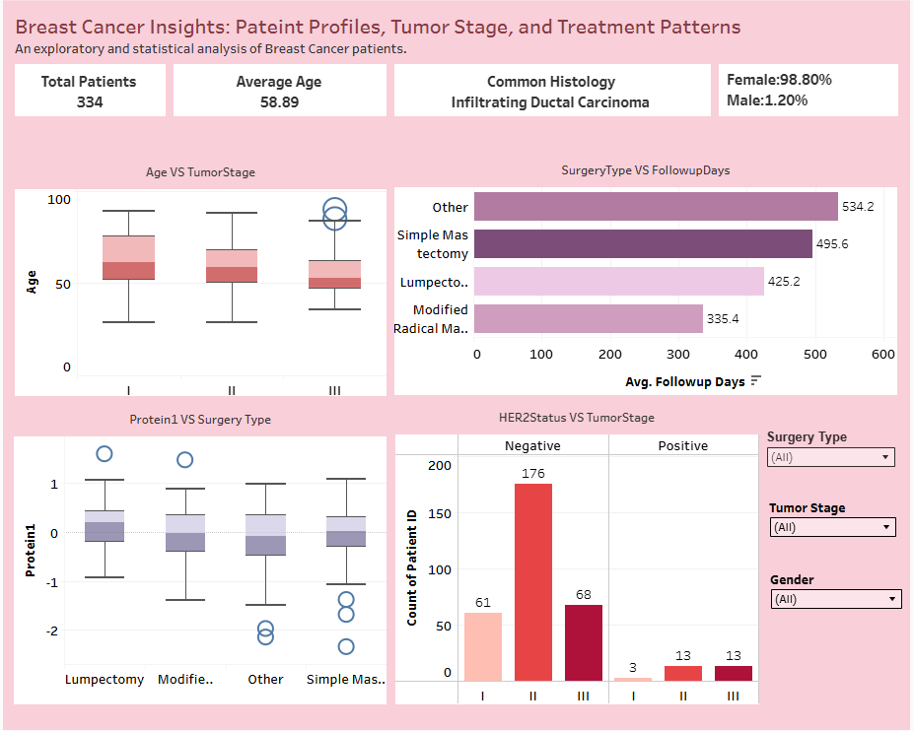
Fig3. Breast Cancer Insights Dashboard
- Age VS Tumor Stage:
Median age decreases with tumor severity — Stage I: 61.5 yrs, Stage II: 59 yrs, Stage III: 53 yrs, indicating earlier onset in advanced stages.
- Protein1 VS Surgery Type:
Median Protein1 is highest for Lumpectomy (0.199) and lowest for Other surgeries (-0.080), confirming Protein1’s association with surgical choice.
- Surgery Type VS Follow-up Days:
Other surgery types show the longest average follow-up duration, followed by Simple Mastectomy, Lumpectomy, and Modified Radical Mastectomy.
- HER2 Status VS Tumor Stage:
HER2-negative Stage II patients form the largest group (176 patients), while HER2-positive cases remain low across all stages (≤13 patients per stage).
- Cancer Histology:
Infiltrating Ductal Carcinoma dominates all tumor stages, while Mucinous Carcinoma is rare and limited to early stages.
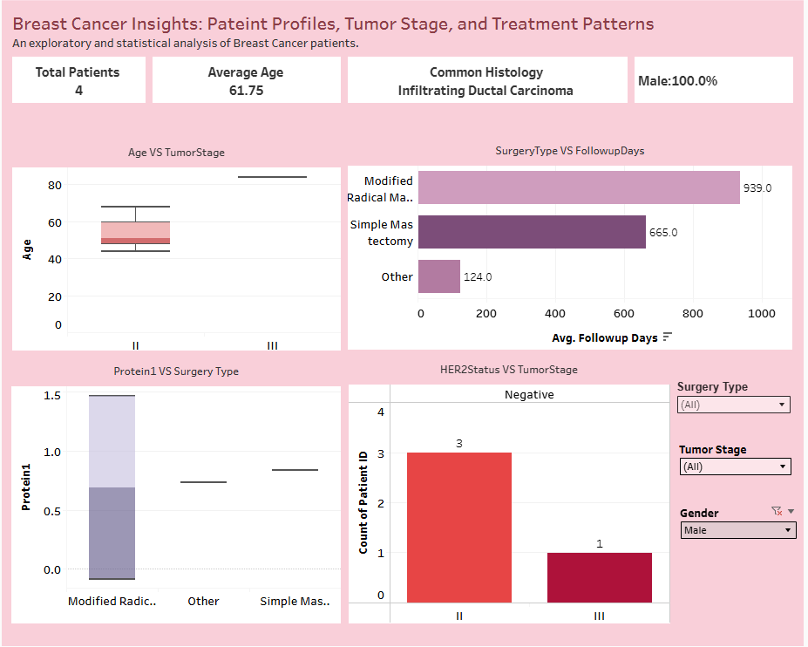
Fig4. Breast Cancer Insights Dashboard (Gender: Male)

Key Interpretations:-
- Tumor severity varies across age groups, with advanced stages appearing at lower median ages.
- Biological markers (HER2 status and Protein1 expression) show stronger relationships with tumor characteristics and treatment patterns than demographic variables.
- Gender does not independently influence tumor stage distribution, reinforcing that breast cancer severity is not gender-dependent within this dataset.
- Surgical approach is linked to post-operative follow-up duration, indicating differing care pathways.
- Rare histological subtypes are limited to early tumor stages and represent a small proportion of cases.

Conclusion:-
This project demonstrates an end-to-end data analytics workflow, combining data cleaning, exploratory analysis, statistical testing, and interactive visualization. The findings reveal meaningful relationships between demographics, tumor stage, biological markers, treatment types, and follow-up outcomes, while also highlighting variables with no statistical association.

