# Tesla Stock Price Analysis (2010–2024) Report

Tool Used: Microsoft Excel 2010

Project Type: Data Analytics Dashboard

## 1. Business Problem

The objective of this project is to analyze the stock performance of Tesla Inc. from 2010 to 2024 using Microsoft Excel. The goal is to understand the stock trends, price fluctuations, moving averages and trading volumes over the different quarters and years, and to identify key insights that can help investors understand Tesla’s historical performance.

## 2. Dataset Description

The dataset was downloaded from Kaggle and includes daily stock data from June 2010 to 2024.

Columns in the dataset:

* Date – Trading date
* Open – Stock price at the opening of the market
* High – Highest price of the stock during the day
* Low – Lowest price of the stock during the day
* Close – Price at which the stock closed
* Adjusted Close – Adjusted price after stock splits or dividends
* Volume – Number of shares traded on that day
* Day, Month, Year, Quarter – extracted from Date
* Daily Return = (Current Close - Previous Close) / Previous Close
* Cumulative Return = (Current Close / First Close) - 1
* 7-Day Moving Average (MA)
* 30-Day Moving Average (MA)

## 3. Data Cleaning and Preparation

1. Checked for missing or blank values (none found).
2. Converted numeric columns to Number format (2 decimals).
3. Extracted day, month, year, and quarter from the Date column.
4. Created calculated fields for Daily Return, Cumulative Return, 7-Day MA, and 30-Day MA.

## 4. KPIs (Key Performance Indicators)

* Average Close Price
* Maximum High Price
* Minimum Low Price
* Total Volume Traded
* Total Cumulative Return

## 5. Visualizations Created

* Quarterly Average of Close Price – to observe seasonal trends.
* Quarterly Max of High vs. Min of Low – to identify volatility.
* Quarterly Average of Volume – to understand trading activity.
* Monthly Average of Daily_Return – to analyze monthly performance.
* Monthly Average of Close vs 7-Day MA vs 30-Day MA – to compare stock trends over time.

Slicers Used: Year, Quarter, Day for interactive filtering.

Dashboard:-

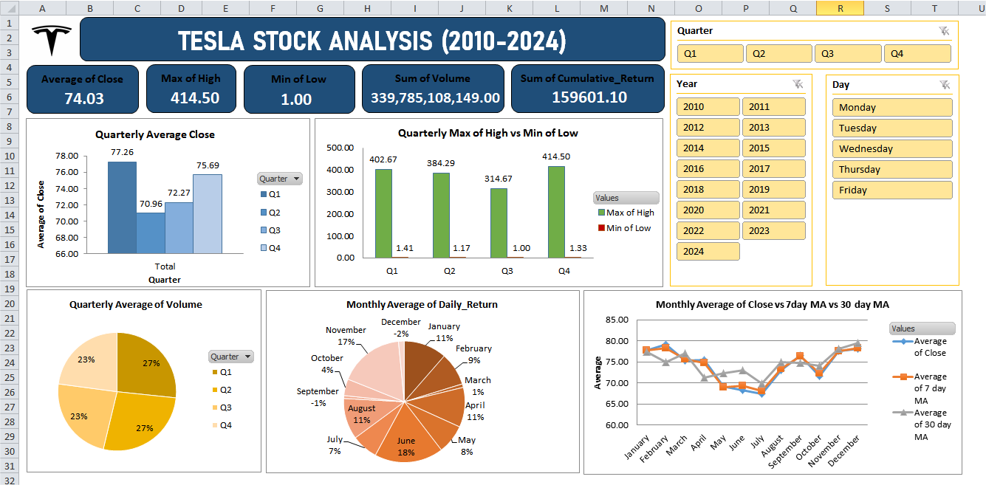

## 6. Key Insights & Observations

* In 2010 (Q4), Tesla’s average close price was around 1.78, and cumulative return was

–2.98%.

* By 2014, cumulative return increased to 2103.75%, with prices reaching highs of 19.43.
* In 2016, the 7-day moving average decreased slightly in February, showing minor short-term decline.
* During 2020, Tesla’s cumulative return peaked at 15,102.64%, with a significant rise in average close price (170.65 in Q4).
* From 2020–2024, Tesla’s prices fluctuated, but overall trends remained positive, reflecting company growth and investor interest.
* Trading volume increased from 3B in 2010 to 34B in 2023, showing increased market participation. In 2020 the volume became 57B.

## 7. Tools & Techniques Used

* Microsoft Excel 2010 – for data cleaning, pivot tables, and visualization.
* Pivot Tables, Pivot Charts, and Slicers for data summarization.
* Formulas: AVERAGE(), YEAR(), MONTH(), ROUNDUP(), etc.
* Data Cleaning and Visualization techniques applied on large stock data.

## Conclusion

The analysis highlights Tesla’s strong stock growth trajectory over the years, especially after 2019, with particularly sharp increases around 2020–2022. Volume and cumulative returns show rising investor confidence and higher trading activity. Short-term fluctuations were visible in daily returns, but moving averages confirmed a steady upward trend over time. The use of moving averages helps in understanding trend stability and price momentum.  
Overall, Tesla has shown remarkable growth from a small-cap company to a global market leader.

## 9. Future Scope

* Integrate this Excel analysis into Power BI for an interactive dashboard.
* Include SQL analysis to calculate advanced metrics (e.g., top growth months, highest volume days).