Project Progress Report
Skill Extraction from Job Descriptions

1. Project Overview
This report summarizes the work completed on the job-posting skill-extraction project. The objective is to take raw job-posting data and process it so that relevant technical skills can be identified and extracted from job descriptions.
The project has progressed through dataset inspection, exploratory data analysis, text cleaning, skill taxonomy creation, skill extraction, NLP preprocessing, rule-based improvement, TF-IDF analysis, and N-Gram analysis. Each stage is described below along with its corresponding output.

2. Dataset Inspection
The project began with the original job-posting dataset. The dataset was inspected and analyzed to understand its structure before any modifications were made.

Activities Performed
- Inspected the overall dataset structure.
- Checked the total number of records.
- Checked for missing values.
- Checked for duplicate job entries.
- Checked the text/description length of job postings.
- Identified the columns relevant to the skill-extraction objective.
- Removed unnecessary fields (e.g., views, salary-listed time) that were not required for the project.
Output: A separate working dataset was created while the original dataset was kept unchanged.
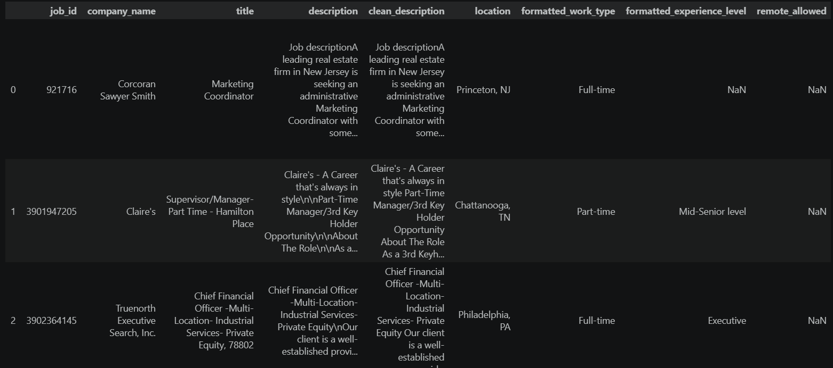

3. Exploratory Data Analysis (EDA)
Exploratory Data Analysis was performed on raw_jobs.csv to better understand the dataset before cleaning. This stage was analysis-only; the working dataset was not permanently modified as a result.

Aspects Analyzed
- Total number of jobs.
- Unique job titles.
- Most common job roles.
- Jobs by location.
- Description length (minimum, maximum, and average).
- Missing values.
- Duplicate records.

Visualizations Created
- Top job titles.
- Jobs by location.
- Description-length distribution.
- Missing values chart.
- Top companies.
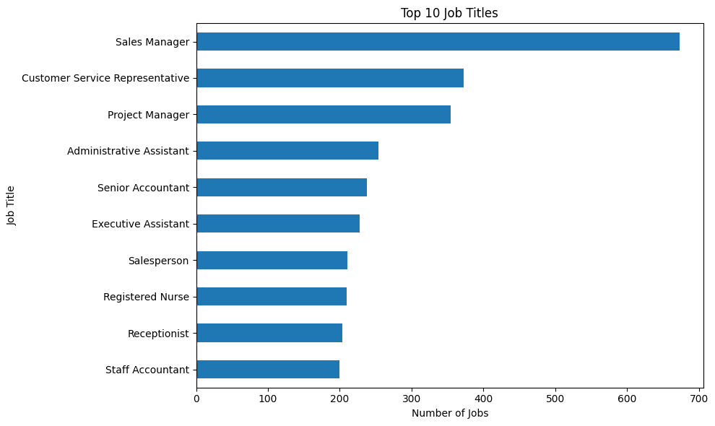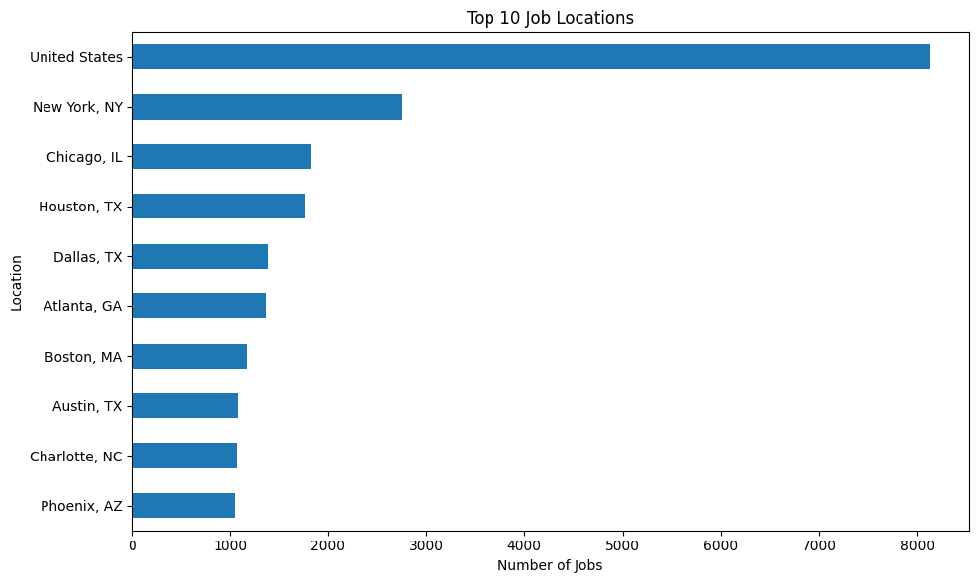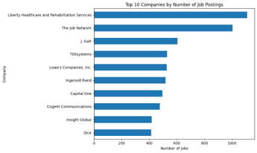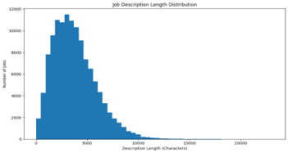

4. Data Cleaning
After completing EDA, the job-description text was cleaned to prepare it for the NLP and skill-extraction stages. The description column was used to create a new clean_description column.

Cleaning Steps Applied
- Removed HTML tags.
- Removed URLs.
- Removed email addresses.
- Removed phone-number-like text.
- Removed special characters and unnecessary symbols.
- Removed extra spaces.
- Removed repeated consecutive words.
Output: clean_jobs.csv was created as the cleaned working dataset.
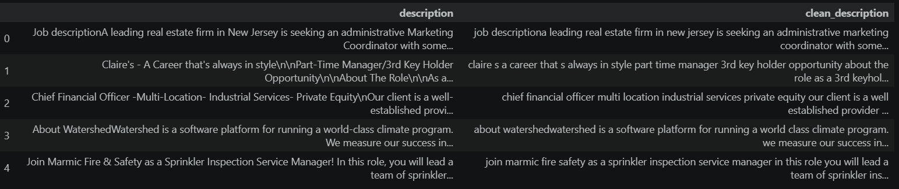

5. Skill Taxonomy and Skill Extraction
A master skill taxonomy was created first, followed by applying it to the cleaned job descriptions to extract skills.

5.1 Skill Taxonomy
The taxonomy contains the columns skill, category, and aliases. The taxonomy covers skills across areas such as Programming, Database, Data Analytics, Machine Learning, Data Science, Cloud, Big Data, DevOps, Marketing, Finance, and Productivity.
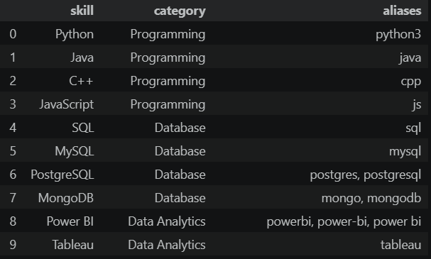
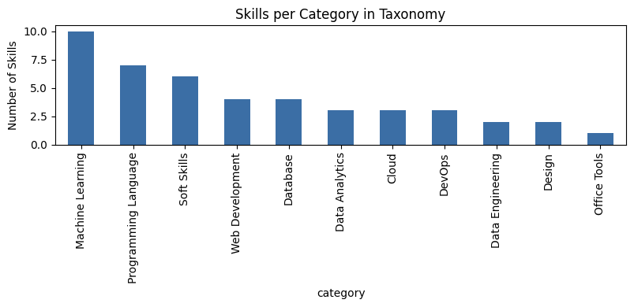

5.2 Taxonomy Creation Approach
- Extracted candidate skill-like phrases from clean_description text across the dataset and counted their frequency.
- Filtered out generic or junk phrases such as “various”, “using”, and “basic”.
- Built a CANONICAL_MAP to merge spelling and naming variants into one canonical skill.
- Assigned each canonical skill a category and, where relevant, known aliases.
- Matched the canonical taxonomy back against each job description to produce per-job skill lists.
Tools: Python, pandas, Counter.
Outputs: skill_taxonomy.csv and jobs_with_skills.csv.
Key learning: Reading a CSV with pd.read_csv() can silently convert empty string fields to NaN. This was handled using keep_default_na=False and na_values=[] so aliases were not lost during reload.
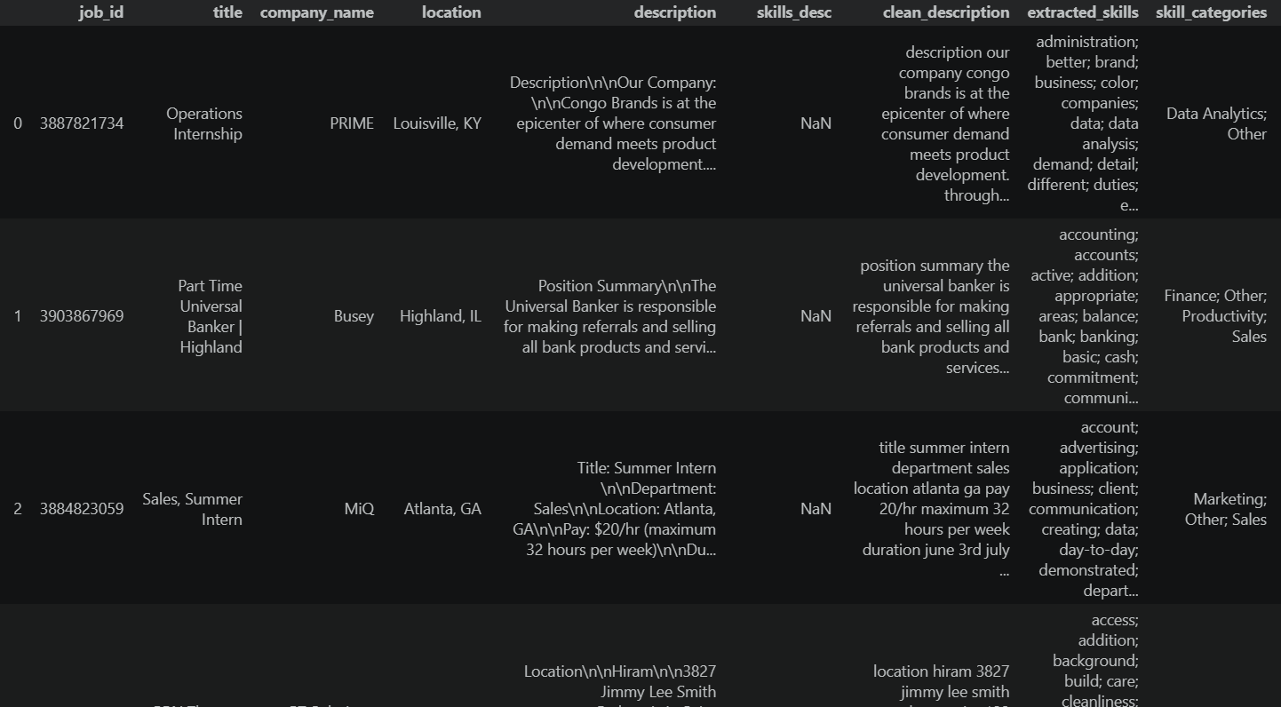

6. NLP Text Preprocessing
Standard NLP preprocessing techniques were applied to job-description text.
- Tokenization — split text into individual word tokens.
- Lowercasing — normalize case.
- Stopword removal — remove common function words such as the, and, and is.
- Lemmatization — reduce words to their dictionary base form.
- Stemming comparison — compare Porter stemming with lemmatization and observe the trade-off.
- Sentence segmentation — split descriptions into individual sentences.
The complete pipeline was demonstrated on a real job posting and then applied across all 2,500 postings.
Tools: NLTK (word_tokenize, sent_tokenize, stopwords, WordNetLemmatizer, PorterStemmer).
Output: lemmatized_tokens column added to the working dataset.
Key learning: Preprocessed lemmatized tokens were not fed directly into skill extraction because tokenization can separate multi-word phrases such as “power bi”. The preprocessing and phrase-based extraction stages are complementary.
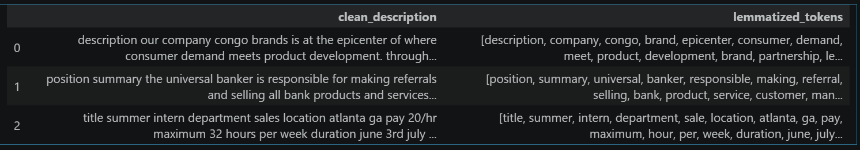

7. Rule-Based (Dictionary) Skill Extractor
A simple dictionary-based skill extractor was developed to check whether known skill strings appear in each job description.
Approach: A fixed list of approximately 24 target skills was checked against lowercased descriptions.
Tools: Python string matching.
Output: skills_day7 column containing matched skills per job.
Key learning: Naive substring matching can create false positives because it has no concept of word boundaries. For example, “digital marketing” can incorrectly match git, and “sparkling water” can incorrectly match spark. It also has difficulty unifying variants such as Python, Python3, Python 3, and Python programming.
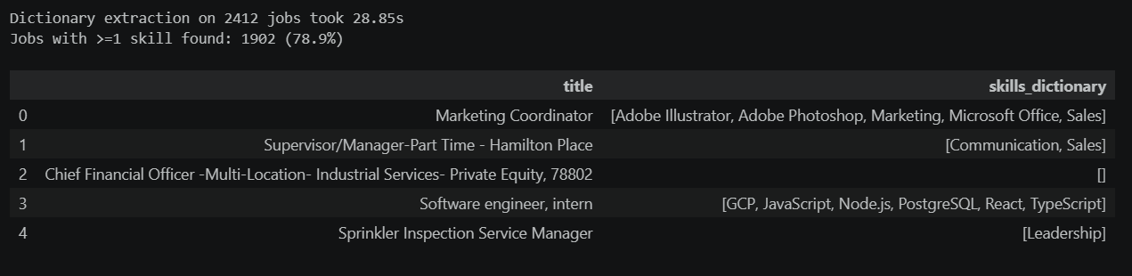

8. Improved Extraction with Regex + Phrase Matching
The dictionary extractor was improved to reduce false positives and handle skill variants and multi-word phrases.
- Word-boundary regex (\bskill\b) to eliminate false positives such as git matching inside digital.
- Variant-aware patterns to map Python, Python3, Python 3, and Python programming to the canonical skill Python.
- Multi-word phrase patterns for terms such as machine learning, deep learning, natural language processing, and data science.
- spaCy PhraseMatcher used as a token-level cross-check against regex results.
The regex and PhraseMatcher approaches showed 98.8% exact agreement across all postings, with the remaining differences attributed to minor tokenization edge cases.
Tools: Python re module and spaCy PhraseMatcher.
Output: skills_day8, later saved as skills_advanced in the final dataset.
Final deliverable: jobs_with_skills_advanced.csv containing the original job data plus the final skills_advanced and skills_advanced_count fields. The original jobs_with_skills.csv was left unmodified.
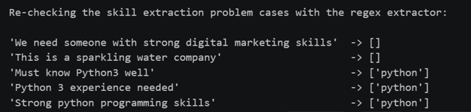
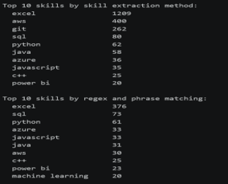

9. TF-IDF Analysis
TF-IDF was introduced as a statistical NLP technique to identify important and distinctive terms in job descriptions. Unlike a fixed dictionary, TF-IDF does not assume in advance which words are skills.

Objective
Identify important terms in the cleaned job descriptions and compare the automatically surfaced TF-IDF keywords with previously extracted dictionary-based skills.

Approach
- Loaded jobs_with_skills_advanced.csv.
- Used only the clean_description text for TF-IDF analysis.
- Applied TfidfVectorizer with max_features=1000 and English stopword removal.
- Calculated mean TF-IDF scores across the corpus to rank important terms.
- Examined the highest-scoring terms for the overall corpus and for an individual job posting.
- Compared the TF-IDF vocabulary with the known dictionary skill list.
Example configuration: TfidfVectorizer(max_features=1000, stop_words='english').

Results and Interpretation
TF-IDF successfully identifies terms that are statistically distinctive, but the highest-scoring terms are not necessarily technical skills. In the full dataset, common job-posting vocabulary such as experience, team, customer, skills, and management can receive high scores. Therefore, plain unigram TF-IDF does not reliably identify useful technical skills automatically.
Key learning: TF-IDF is useful for discovering important vocabulary, but statistical importance alone does not guarantee that a term is a technical skill. Combining TF-IDF with domain knowledge or a skill-extraction method provides more reliable results.
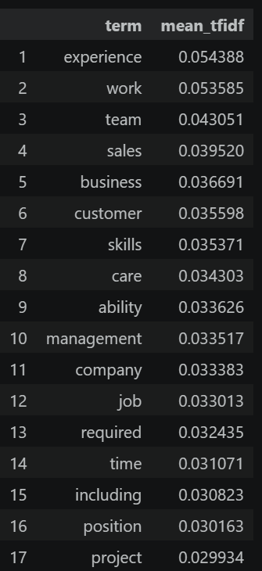
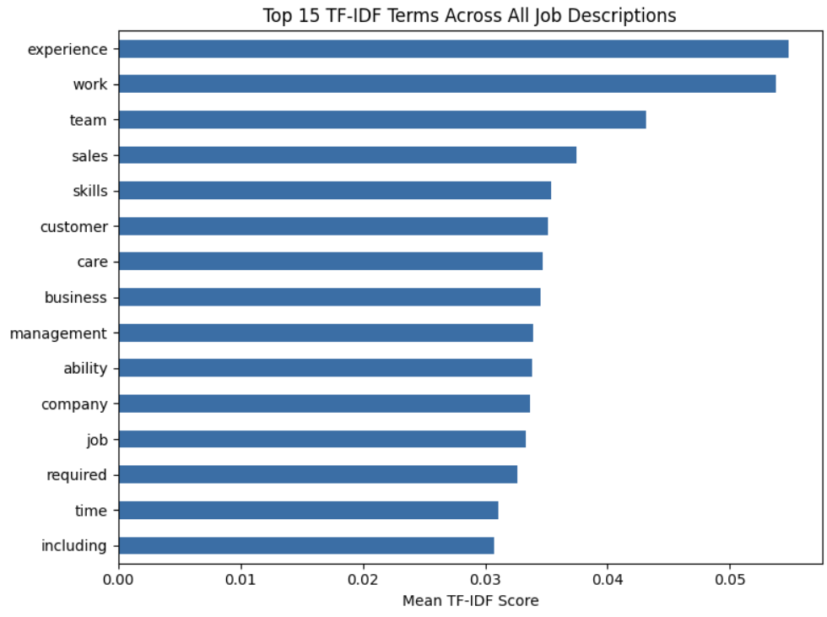

10. N-Gram Analysis
Many real-world skills contain multiple words, such as machine learning, deep learning, power bi, data science, natural language processing, computer vision, and cloud computing. N-Gram analysis was therefore used to identify unigrams, bigrams, and trigrams.

Objective
Discover important one-word, two-word, and three-word terms and determine whether multi-word skills can be surfaced more effectively than with single-word analysis.

Approach
- Used TfidfVectorizer with ngram_range=(1, 3), max_features=2000, and English stopword removal.
- Generated unigrams, bigrams, and trigrams from clean_description.
- Ranked phrases using mean TF-IDF scores.
- Examined the highest-scoring bigrams and trigrams across the full corpus.
- Repeated the analysis on the technical-skill subset to reduce dilution from non-technical job postings.
- Checked whether target multi-word skills appeared in the resulting vocabulary.
Example configuration: TfidfVectorizer(ngram_range=(1,3), stop_words='english').

Results and Interpretation
Across the complete dataset, many high-scoring multi-word phrases were generic or related to employment and legal language, such as equal opportunity employer, customer service, and years experience. This occurs because the dataset contains many non-technical postings.
When the analysis was restricted to technical-skill postings, useful multi-word terms such as data analysis, data science, machine learning, and power bi became visible. Less frequent phrases such as natural language processing, deep learning, computer vision, and cloud computing may still be missed when a vocabulary-size cutoff is applied.
Key learning: N-Gram analysis is more suitable than unigram-only analysis for discovering multi-word skills, but the corpus and filtering strategy strongly affect the results.
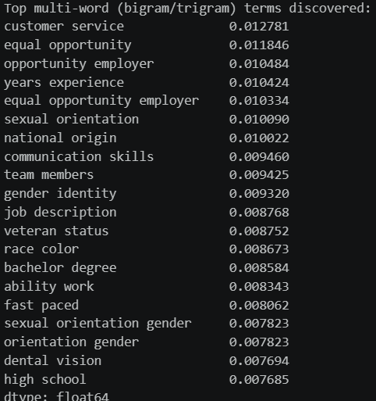
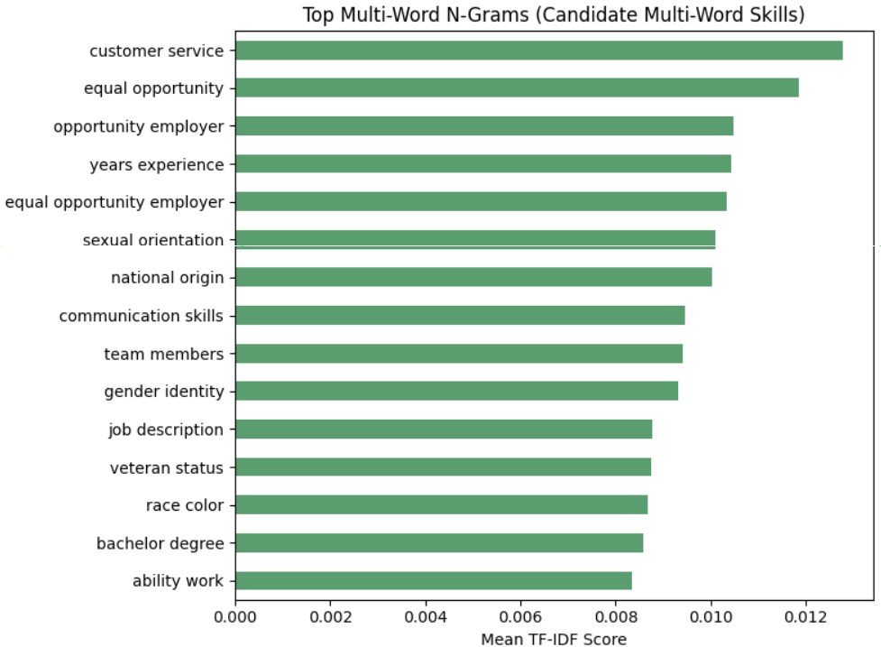
11. Named Entity Recognition (NER)
Named Entity Recognition was introduced as an NLP-based approach for identifying meaningful entities in job descriptions. The approach is useful because job descriptions contain technology names, tools, platforms, organizations, and other entity-like expressions that can be difficult to capture using simple word matching.
Objective
Identify entity mentions in clean job-description text and examine whether general NER can contribute to skill extraction.
Approach
• Used clean_description as the source text for entity processing.
• Examined the transition from traditional NLP and statistical methods toward entity-level extraction.
• Considered technology and skill mentions as candidate entities that can be further classified.
• Kept general NER output separate from the canonical skill taxonomy so that entity recognition did not automatically treat every recognized entity as a skill.
Tools: Python, spaCy / transformer-based NER workflows.
Key learning: General NER models are not specifically trained for job skills, so recognized entities must be filtered or mapped to the project's skill taxonomy before being treated as skills.
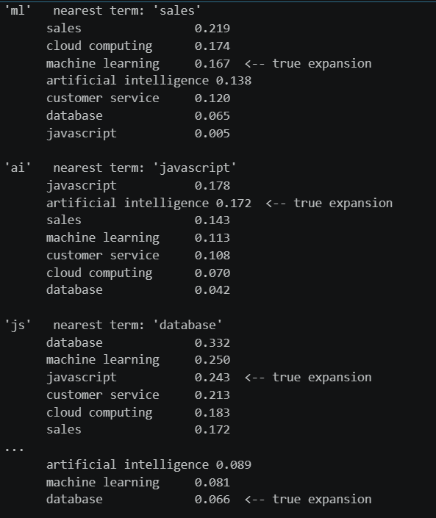

12. Entity and Skill Extraction Preparation
The existing cleaned descriptions and extracted-skill outputs were prepared for more advanced learning-based extraction. This stage connects the rule-based/statistical work with supervised machine-learning and transformer approaches.
Objective
Prepare a consistent text-and-label representation so different extraction approaches can be compared on the same job-description data.
Approach
• Continued using clean_description as the primary text source.
• Reused the existing extracted skill information as a starting point for constructing skill-labelled examples.
• Represented examples using text, entity/skill, and label information.
• Kept the skill representation aligned with the canonical taxonomy and its aliases wherever possible.
• Prepared the workflow so that traditional extraction, statistical methods, NER, supervised ML, and transformer methods can be evaluated as stages of the same project rather than as unrelated experiments.
Output: A structured labelled representation suitable for supervised skill classification and entity-extraction experiments.
Key learning: Consistent labels and a common text source are essential for a fair comparison between extraction approaches.
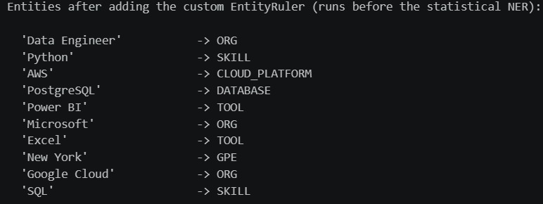

13. Machine Learning Skill Classifier
A supervised machine-learning approach was developed to move beyond direct dictionary matching. The objective was to learn patterns from labelled job-description examples and classify skill-related text.
Objective
Create a supervised ML model for skill classification using TF-IDF features.
Approach
• Created labelled examples containing Text, Entity, and Label.
• Used clean_description as the text source.
• Applied text preprocessing before feature extraction.
• Converted text into numerical features using TF-IDF.
• Used Logistic Regression as the supervised classifier.
• Followed the pipeline: Text → Preprocessing → TF-IDF → ML Model → Skill Category.
• Evaluated the classifier on a held-out test set using classification metrics.
• Saved the trained pipeline as skill_classifier.pkl.
Possible supervised alternatives considered include Logistic Regression, Random Forest, and SVM; TF-IDF with Logistic Regression was selected for the implemented pipeline.
Key learning: TF-IDF provides useful numerical representations for a supervised model, while the classifier can learn patterns that simple exact matching cannot.
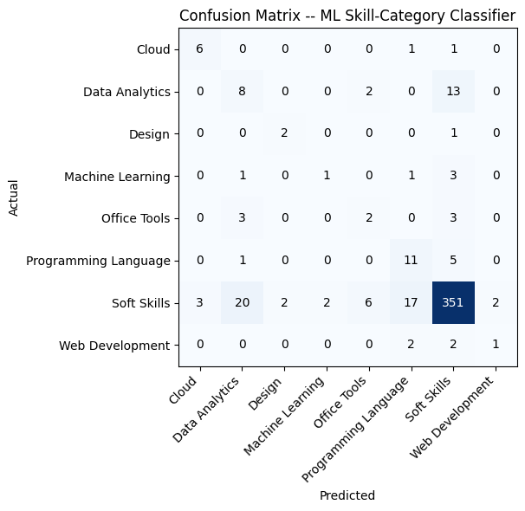

14. Transformer-Based Skill and Entity Extraction
A transformer-based approach was introduced as the advanced NLP component of the project. Transformer models use contextual representations to understand words and phrases according to their surrounding text.
Models and concepts considered
• BERT
• DistilBERT
• RoBERTa
• BERT-NER
Conceptual progression
Traditional NLP → TF-IDF → Word Embeddings → NER → Transformers
Approach
• Used clean_description as the input text.
• Used a pretrained transformer NER model as a practical baseline.
• Applied token-level entity recognition and aggregated related tokens into entities.
• Examined recognized entities for their usefulness in identifying skills.
• Kept the pretrained baseline distinct from a custom fine-tuned skill model.
Example objective: For a sentence containing Python, SQL and AWS, identify the relevant entity spans and classify them as skills.
Output: jobs_with_transformer_entities.csv.
Key learning: A general pretrained NER model provides a useful baseline, but a custom skill-specific transformer requires appropriately labelled token-level training data and fine-tuning.
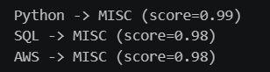
15. Model Evaluation and Comparison
All available extraction approaches were brought together for systematic comparison. The objective was to determine which approach performs best for job-skill extraction when evaluated using the same reference data.
Methods Compared
• Dictionary Matching
• Regex
• TF-IDF
• NER
• ML Model
• Transformer
Evaluation Metrics
Precision = TP / (TP + FP)
Recall = TP / (TP + FN)
F1 Score = 2 × Precision × Recall / (Precision + Recall)
Accuracy and a confusion matrix were also included where the evaluation setup was appropriate.
Approach
• Used the same clean_description-based workflow and existing extraction outputs.
• Converted predictions into comparable skill/entity sets where possible.
• Calculated precision, recall, F1 and exact record-level accuracy for compatible extraction outputs.
• Generated a comparison table and saved the results as model_comparison.csv.
• Placed greater emphasis on precision, recall and F1 for entity/skill extraction because raw accuracy can be misleading when the number of non-skill tokens is large.
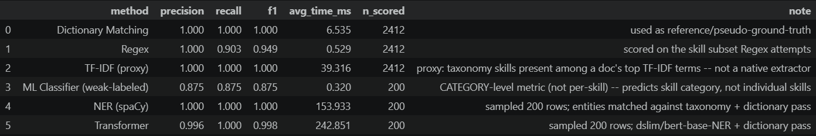
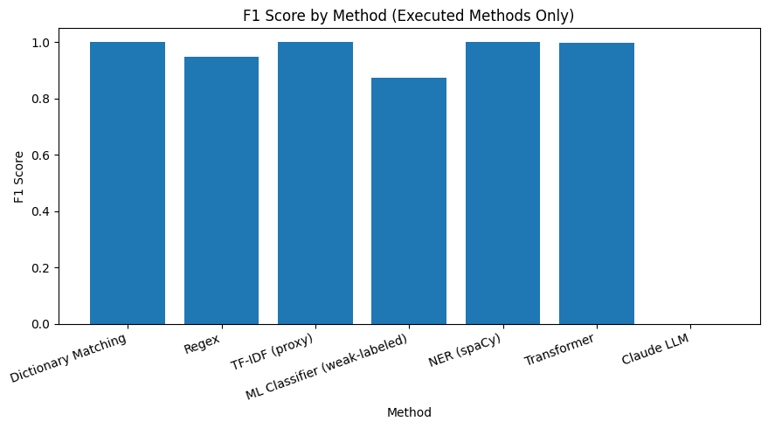
16. Error Analysis
Error analysis was performed to understand where skill extraction systems fail and why. This is important for improving the extraction pipeline rather than relying only on a single performance score.
Error Categories
• False Positive — a skill is extracted even though it is not actually present as a required skill.
• False Negative — an actual skill is present but the system fails to extract it.
• Wrong Entity — the system extracts an incorrect entity or assigns the wrong entity span.
• Partial Entity — only part of the intended skill phrase is extracted.
• Duplicate Skill — the same skill is extracted more than once.
• Unknown Skill — a genuine skill is not represented in the current taxonomy or model vocabulary.
• Synonym Problem — equivalent skill names are treated as different terms.
• Spelling Problem — spelling or formatting variation prevents correct matching.
Examples
• “Experience with cloud technologies” does not identify a specific cloud platform, so a system should not automatically invent AWS, Azure, or GCP.
• “Experience with Python programming” should normally be normalized to the canonical skill Python rather than storing the longer phrase as a separate skill.
Approach
• Compared actual/reference skills with predicted skills.
• Recorded the original text, actual skills, predicted skills, and error category.
• Summarized errors by category and method.
• Prepared an Excel workbook containing Error Details, Category Summary, and Method Summary.
Output: Error_Analysis_Report.xlsx.
Key learning: Error analysis reveals specific weaknesses such as incomplete taxonomy coverage, synonym handling, partial phrase extraction, and false positives that aggregate metrics alone cannot explain.
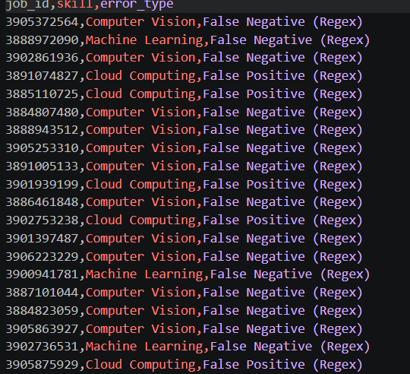

17.Skill Normalization
Skill normalization was performed to standardize different representations, spellings, and formats of the same skill into a single canonical skill name. Job descriptions may contain variations such as Python, Python3, Python 3, and Python programming, which should all be treated as Python. Similarly, variations such as PowerBI, Power BI, and Power-BI should be standardized as Power BI. A normalization engine was developed using a sequence of steps: raw skill identification, lowercase conversion, removal of special characters, alias matching, and mapping to the canonical skill. The existing canonical skill mapping and aliases were used to ensure consistency with the project's skill taxonomy. This process helps prevent duplicate skill entries, improves the accuracy of skill frequency analysis, and ensures that equivalent skills are counted together during subsequent analytics. The normalized skill information was saved as normalized_skills.csv for use in the business analytics stage.
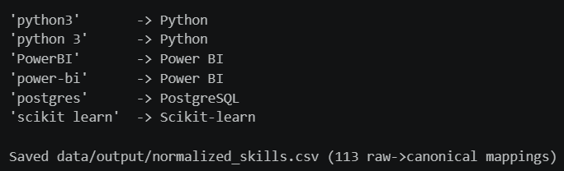

18. Business Dashboard
The extracted and normalized skill information was converted into business analytics through an interactive dashboard using Power BI. The dashboard provides a summarized view of job and skill demand through key performance indicators including Total Jobs, Unique Skills, Top Skill, Top Job Role, Most Required Technology, and Top Skill Category. Visualizations were created to show the Top 20 Skills, helping identify the technologies most frequently required in job postings, and Skill Demand by Job Role, which shows the skills associated with different roles such as Data Analyst, Data Scientist, and Data Engineer. A Skill Category Distribution visualization was also included to analyze categories such as Programming, Database, Cloud, Analytics, Machine Learning, and Soft Skills. Where date information is available, skill trends can be analyzed across months or years to understand changes in demand over time. The dashboard converts the results obtained from the NLP and skill-extraction pipeline into an easy-to-understand analytical format and provides useful insights into skill requirements in job postings. The final dashboard was saved as Job_Skill_Analytics.pbix.

19. Summary
The project developed a complete workflow for extracting and analyzing skills from job descriptions, beginning with dataset inspection and exploratory data analysis. The original job-posting dataset was examined for structure, records, missing values, duplicates, job titles, locations, companies, and description lengths, after which a separate working dataset was prepared while keeping the original data unchanged. The job descriptions were cleaned by removing HTML tags, URLs, email addresses, phone-number-like text, unnecessary special characters, extra spaces, and repeated consecutive words. A master skill taxonomy containing skills, categories, and aliases was then created and applied to the cleaned descriptions to produce per-job skill lists.
The NLP pipeline included tokenization, lowercasing, stopword removal, lemmatization, stemming comparison, and sentence segmentation. Skill extraction was progressively improved from dictionary matching to regex and phrase matching, reducing false positives and supporting skill variants and multi-word phrases. TF-IDF and N-Gram analysis were used to identify statistically important terms and multi-word expressions, while NER, supervised machine learning with TF-IDF and Logistic Regression, and transformer-based approaches were introduced as more advanced extraction methods. The different methods were brought together for evaluation using precision, recall, F1 score, accuracy where appropriate, and confusion matrices, followed by detailed error analysis covering false positives, false negatives, wrong or partial entities, duplicate skills, unknown skills, synonym problems, and spelling problems.
Finally, skill normalization was used to convert different representations of the same skill into canonical names, improving consistency and preventing duplicate counting. The normalized results were then converted into business analytics through a Power BI dashboard containing KPIs and visualizations for total jobs, unique skills, top skills, job roles, required technologies, skill categories, skill demand by role, and skill trends where date information is available. Overall, the project progresses from raw job-posting data through cleaning, taxonomy creation, NLP preprocessing, multiple skill extraction approaches, evaluation and error analysis, normalization, and dashboard-based analytics, providing a structured end-to-end approach for understanding skill requirements from job descriptions.

