Skill Extraction from Job Descriptions
Report
NLP and Machine Learning Based Skill Extraction Using
Dictionary Matching, Regex, TF-IDF, ML Classifier, NER and Transformer
Dataset:
Job Postings / LinkedIn-style Job Description Dataset
Total job postings: 2,500
Cleaned job postings: 2,412
Skill taxonomy: 40+ skills
Top detected skill: Communication — 1,163 postings

FINAL REPORT INDEX
Section No. | Section Name | What It Includes
1 | Introduction | Project background; NLP overview; skill extraction concept
2 | Problem Statement & Objectives | Problem statement; business objective; technical objective; expected outcome
3 | Project Scope & Use Case | Project scope; recruitment use case; practical applications
4 | Technology & Tools Used | Python; Pandas; NumPy; NLTK; spaCy; Scikit-learn; Transformers; Power BI/Tableau; FastAPI
5 | System Architecture & Methodology | Complete project workflow; system architecture; methodology
6 | Dataset Collection & Understanding | Dataset source; dataset fields; number of records; initial data inspection
7 | Exploratory Data Analysis (EDA) | Job titles; locations; description length; missing values; duplicates; visualizations
8 | Data Cleaning & NLP Preprocessing | Data cleaning; tokenization; stopwords; stemming; lemmatization; sentence segmentation
9 | Skill Taxonomy Development | Skill dictionary; skill categories; aliases/synonyms; canonical skills
10 | Rule-Based Skill Extraction | Dictionary matching; regex matching; phrase matching
11 | Statistical & Semantic NLP Techniques | TF-IDF; N-Grams; word embeddings; semantic similarity
12 | Named Entity Recognition (NER) | Standard NER; custom entities; custom NER approach
13 | Machine Learning Model | Training data; feature engineering; TF-IDF + ML model; classification pipeline
14 | Transformer-Based Model | BERT/DistilBERT/RoBERTa; model approach; extraction process
15 | Model Evaluation & Comparison | Precision; recall; F1-score; accuracy; confusion matrix; model comparison
16 | Error Analysis | False positives; false negatives; partial entities; synonyms; spelling issues
17 | Skill Normalization & Categorization | Alias matching; canonical skills; category mapping
18 | Dashboard & Data Visualization | KPIs; top skills; skill demand by role; category distribution; trends
19 | Application / API Development | Application interface; input/output; extraction pipeline; API architecture
20 | Testing & Results | Test cases; sample outputs; validation; final results
21 | Challenges & Limitations | Problems faced; model limitations; dataset limitations
22 | Conclusion | Overall project outcome; key findings; achievements
23 | Future Scope | Resume-job matching; candidate ranking; skill-gap analysis; recommendation system
24 | Internship Learning Outcomes | Technical skills; analytical skills; NLP/ML skills; project-development skills
25 | References | Dataset sources; documentation; research papers; libraries/resources
26 | Appendix | Code snippets; screenshots; sample data; additional results

1. Introduction
The project focuses on extracting relevant skills from job descriptions using Natural Language Processing (NLP), rule-based techniques, statistical NLP, Named Entity Recognition (NER), machine learning, and transformer-based approaches. The purpose is to convert unstructured job-posting text into structured skill information that can be analyzed and visualized.
NLP provides techniques for processing human language so that text can be cleaned, represented, compared, and analyzed computationally. In this project, job descriptions are treated as the main text source, and the final objective is to identify technical and professional skills mentioned in those descriptions and represent them using canonical skill names.
The work progresses from raw job-posting data through dataset understanding, cleaning, taxonomy development, multiple extraction methods, evaluation, error analysis, normalization, and business analytics. The existing report documents this end-to-end progression. The working dataset contains 2,500 job postings.

2. Problem Statement & Objectives
Problem Statement: Job descriptions contain important skill information in unstructured and inconsistent text. The same skill may appear in different forms, multi-word skills may be difficult to identify with simple matching, and generic words can create false positives. A systematic NLP-based pipeline is therefore required to clean job descriptions, identify skill mentions, normalize variants, evaluate extraction quality, and present the results in an understandable form.
Business Objective: To provide a structured view of the skills demanded in job postings so that recruitment-related analysis can identify common skills, skill categories, role-specific requirements, and changing demand where date information is available.
Technical Objective: To develop and compare multiple skill-extraction approaches, beginning with dictionary matching and improving the pipeline using regex, phrase matching, statistical NLP, NER, supervised machine learning, and transformer-based methods.
Expected Outcome: A cleaned and enriched job-posting dataset containing extracted and normalized skills, supporting evaluation outputs and an interactive Power BI dashboard for skill-demand analysis.

3. Project Scope & Use Case
The scope covers the processing of job-posting descriptions and the extraction of skills from those descriptions. It includes data inspection, EDA, text cleaning, NLP preprocessing, taxonomy construction, rule-based extraction, statistical analysis, NER, machine-learning classification, transformer-based entity extraction, evaluation, error analysis, normalization, and dashboard visualization.
Recruitment Use Case: A recruiter or analyst can use extracted skill information to understand which technologies and capabilities occur frequently in job postings and how skill requirements differ between job roles.
Practical Applications include skill-demand analysis, technology trend analysis, role-wise skill analysis, preparation for resume-job matching, candidate ranking, and skill-gap analysis. These applications are identified as future extensions where additional matching and recommendation logic is required.

4. Technology & Tools Used
The project uses Python as the primary programming language. Data processing and analysis are performed with pandas and NumPy. NLP preprocessing uses NLTK, while spaCy is used for phrase matching and entity-processing workflows. Scikit-learn is used for TF-IDF feature extraction and the supervised Logistic Regression pipeline. Transformer-based experiments use the transformer/NLP workflow described in the report, with BERT, DistilBERT, RoBERTa and BERT-NER considered as model families. Power BI is used for the final business dashboard. Streamlit/FastAPI are identified in the project index as possible application/interface technologies; the current report specifically documents the Power BI dashboard as the completed visualization deliverable.
- Python
- Pandas and NumPy
- NLTK
- spaCy and PhraseMatcher
- Scikit-learn
- Transformer/NLP models: BERT
- Power BI
- CSV/Excel outputs for intermediate and evaluation results

5. System Architecture & Methodology
The overall methodology follows a staged pipeline so that the output of one stage becomes the input to the next. The architecture starts with raw job-posting data and ends with normalized skills and dashboard analytics.
- Raw job-posting dataset
- Dataset inspection and EDA
- Working-dataset creation and text cleaning
- NLP preprocessing
- Skill taxonomy and canonical mapping
- Dictionary, regex and phrase-based extraction
- TF-IDF and N-Gram statistical analysis
- NER and labelled entity/skill preparation
- Supervised ML classification
- Transformer-based entity extraction
- Model evaluation and comparison
- Error analysis
- Skill normalization and categorization
- Power BI dashboard and business analytics
A key design principle is that the original dataset is kept unchanged while separate working datasets are generated. The same clean_description field is reused across later approaches to make the methods comparable.

6. Dataset Collection & Understanding
The project began with a job-posting dataset. The dataset was inspected before modification to understand its structure and identify the fields relevant to skill extraction. The report records 2,500 job postings being processed through the NLP pipeline.
- Inspected the overall dataset structure.
- Checked the total number of records.
- Checked missing values.
- Checked duplicate job entries.
- Checked job-description length.
- Identified columns relevant to skill extraction.
- Removed unnecessary fields such as views and salary-listed time from the separate working dataset.
Output: A separate working dataset was created while the original dataset was kept unchanged. The working data was subsequently saved as raw_jobs.csv and later clean_jobs.csv as processing stages progressed.
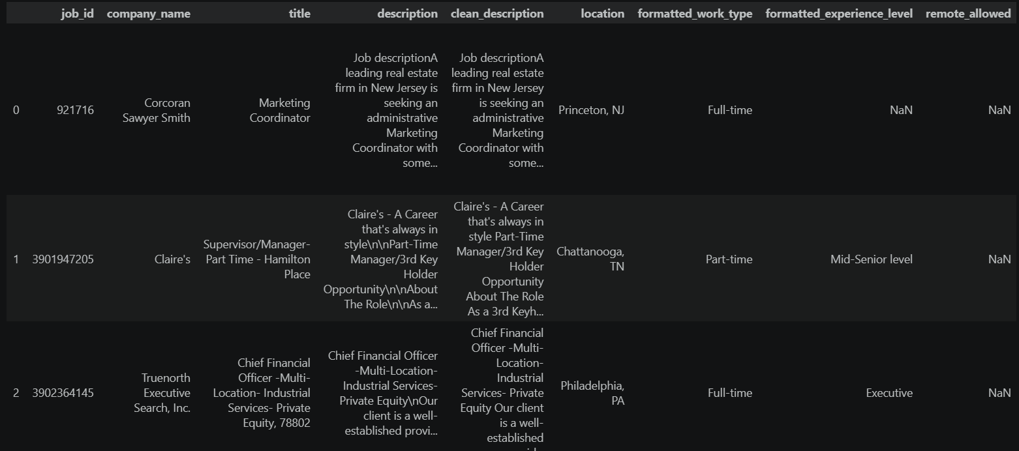
Figure: Dataset inspection output

7. Exploratory Data Analysis (EDA)
Exploratory Data Analysis was performed on raw_jobs.csv before cleaning. The purpose was to understand the distribution and quality of the job-posting data and identify patterns that could influence later NLP processing.
- Total number of jobs
- Unique job titles
- Most common job roles
- Jobs by location
- Description-length minimum, maximum and average
- Missing values
- Duplicate records
- Top companies
The visualizations created include top job titles, jobs by location, description-length distribution, missing-value analysis, and top companies. The EDA stage was analysis-only and did not permanently modify the working dataset.
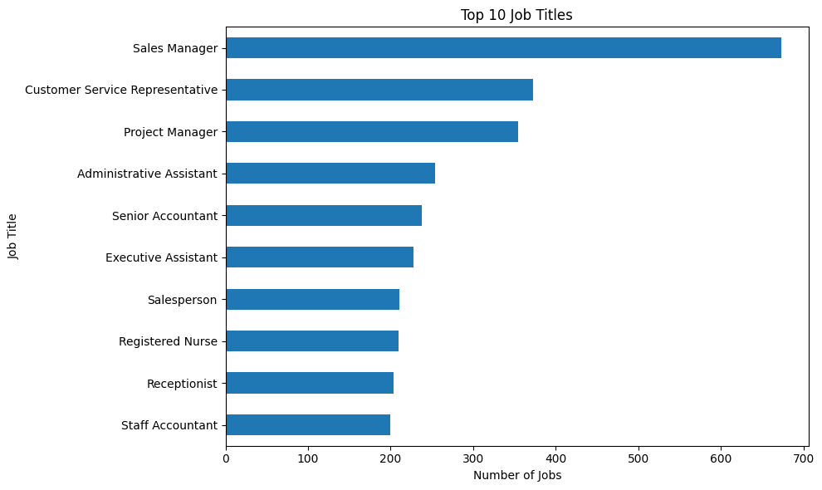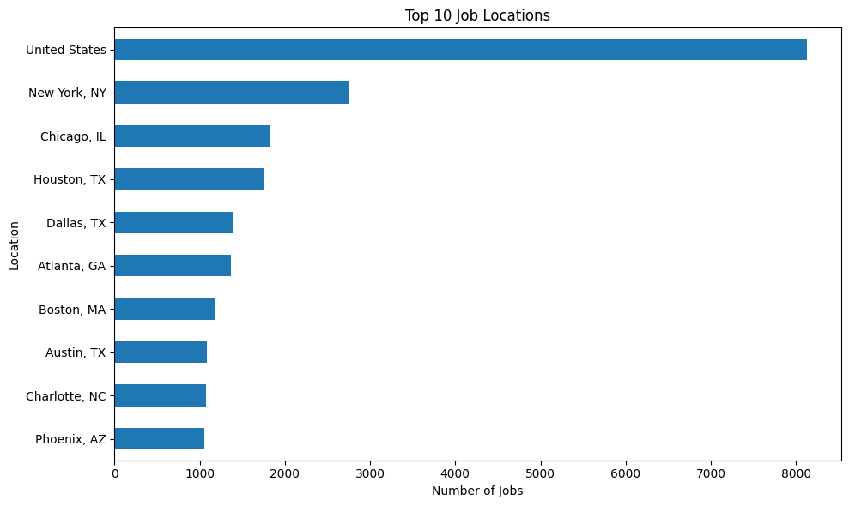

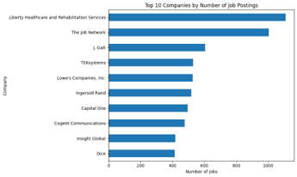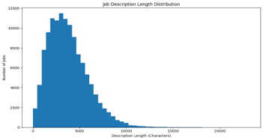

8. Data Cleaning & NLP Preprocessing

8.1 Data Cleaning
After EDA, the description column was cleaned to create clean_description. The objective was to remove formatting noise while retaining meaningful language needed for skill extraction.
- Removed HTML tags.
- Removed URLs.
- Removed email addresses.
- Removed phone-number-like text.
- Removed special characters and unnecessary symbols.
- Removed extra spaces.
- Removed repeated consecutive words.
Output: clean_jobs.csv was created as the cleaned working dataset.
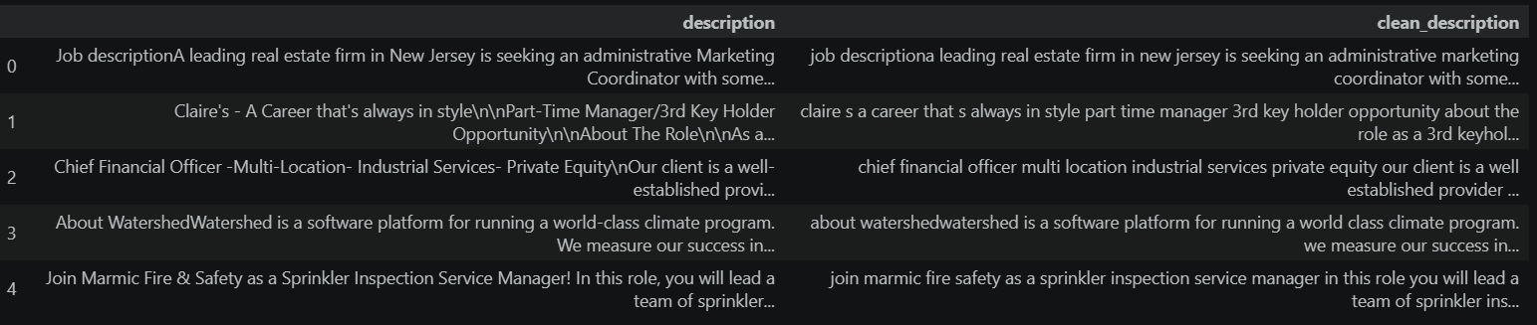
Figure: Cleaned job-description data

8.2 NLP Preprocessing
Standard NLP preprocessing techniques were then applied to the job-description text.
- Tokenization — split text into individual word tokens.
- Lowercasing — normalize case.
- Stopword removal — remove common function words such as the, and, and is.
- Lemmatization — reduce words to their dictionary base form.
- Stemming comparison — compare Porter stemming with lemmatization and observe the trade-off.
- Sentence segmentation — split descriptions into individual sentences.
The complete pipeline was demonstrated on a real job posting and then applied across all 2,500 postings. NLTK functions including word_tokenize, sent_tokenize, stopwords, WordNetLemmatizer and PorterStemmer were used. The lemmatized_tokens column was added to the working dataset.
A key observation was that preprocessed tokens were not fed directly into skill extraction because tokenization can separate multi-word phrases such as “power bi”. Therefore, preprocessing and phrase-based extraction were kept complementary.
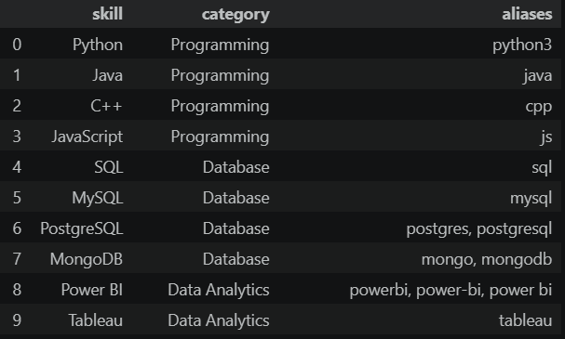
Figure: NLP preprocessing / taxonomy-related output

9. Skill Taxonomy Development
A master skill taxonomy was created before applying the taxonomy to the cleaned descriptions. It provides a controlled vocabulary for representing skills consistently.
The taxonomy contains skill, category and aliases fields. Categories covered in the project include Programming, Database, Data Analytics, Machine Learning, Data Science, Cloud, Big Data, DevOps, Marketing, Finance and Productivity.
- Extract candidate skill-like phrases from clean_description and count their frequency.
- Filter generic or junk phrases such as “various”, “using” and “basic”.
- Build a CANONICAL_MAP to merge spelling and naming variants.
- Assign each canonical skill a category and relevant aliases.
- Match the canonical taxonomy against each job description to create per-job skill lists.
Outputs: skill_taxonomy.csv and jobs_with_skills.csv. A data-loading issue was also handled: pandas can convert empty strings to NaN during CSV reload, so keep_default_na=False and na_values=[] were used to avoid losing alias information.
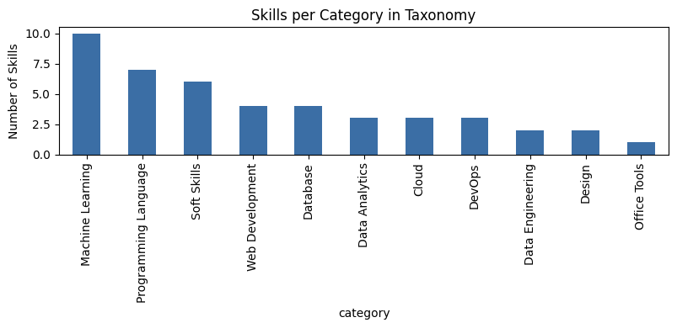
Figure: Skill categories in the taxonomy
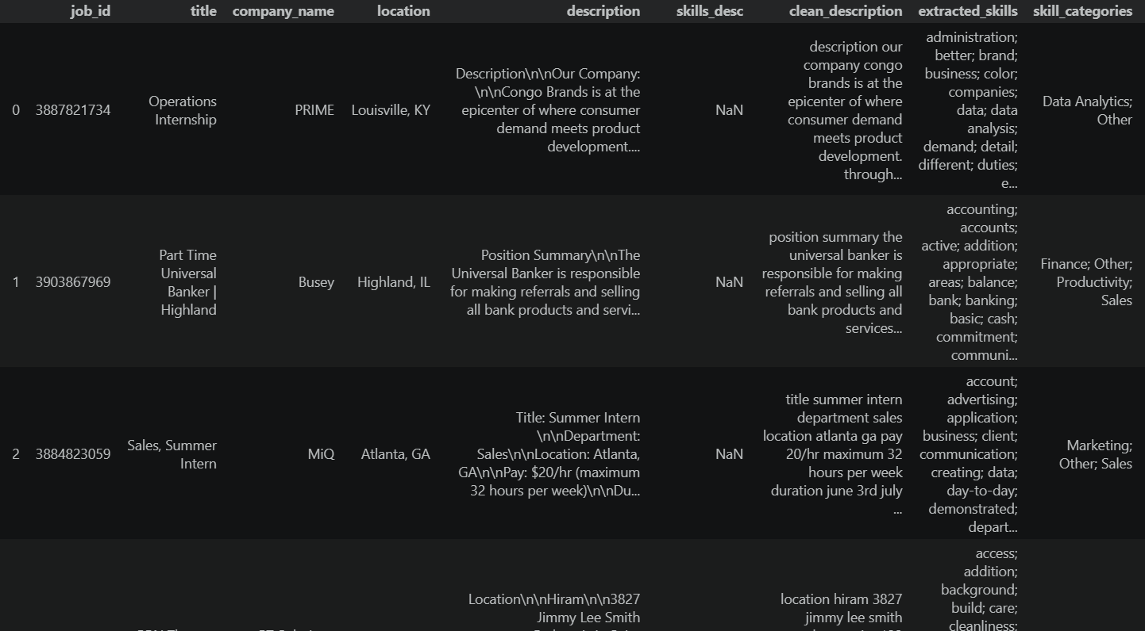
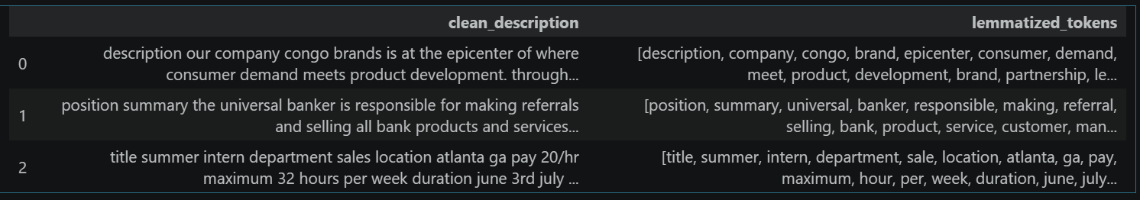
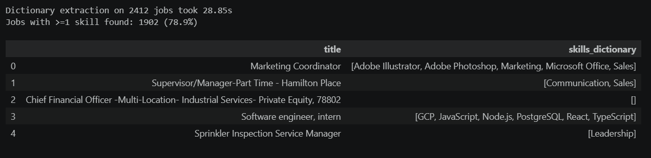

10. Rule-Based Skill Extraction

10.1 Dictionary Matching
A simple dictionary-based extractor was developed to check whether known skill strings occur in each job description. Approximately 24 target skills were checked against lowercased descriptions using Python string matching. The output was stored in skills_day7.
The main limitation was naive substring matching. It can create false positives because it does not understand word boundaries. For example, “digital marketing” can incorrectly match git, while “sparkling water” can incorrectly match spark. It also has difficulty unifying variants such as Python, Python3, Python 3 and Python programming.
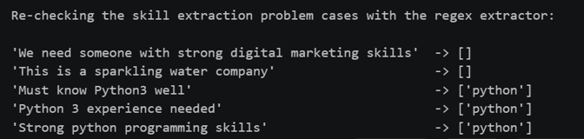
Figure: Rule-based / regex extraction check

10.2 Regex and Phrase Matching
The dictionary extractor was improved using word-boundary regular expressions, variant-aware patterns, multi-word phrase patterns and spaCy PhraseMatcher.
- Word-boundary regex (\bskill\b) reduces substring false positives.
- Variant-aware patterns map Python, Python3, Python 3 and Python programming to Python.
- Multi-word patterns support machine learning, deep learning, natural language processing and data science.
- spaCy PhraseMatcher provides a token-level cross-check against regex results.
The regex and PhraseMatcher approaches showed 98.8% exact agreement across all postings, with remaining differences attributed to minor tokenization edge cases. The final advanced extraction was saved in jobs_with_skills_advanced.csv with skills_advanced and skills_advanced_count fields, while jobs_with_skills.csv was left unmodified.

11. Statistical & Semantic NLP Techniques

11.1 TF-IDF Analysis
TF-IDF was introduced to identify statistically important and distinctive terms in job descriptions. Unlike a fixed dictionary, TF-IDF does not assume in advance which words are skills.
- Loaded jobs_with_skills_advanced.csv.
- Used clean_description as the text source.
- Applied TfidfVectorizer with max_features=1000 and English stopword removal.
- Calculated mean TF-IDF scores to rank important terms.
- Examined high-scoring terms for the full corpus and an individual posting.
- Compared TF-IDF vocabulary with the known dictionary skill list.
Result: TF-IDF identifies statistically distinctive terms, but high scores do not necessarily mean a term is a technical skill. Common job-posting words such as experience, team, customer, skills and management can receive high scores. Therefore, TF-IDF is useful for vocabulary discovery but works better when combined with domain knowledge or an extraction method.
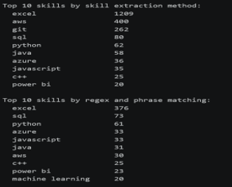
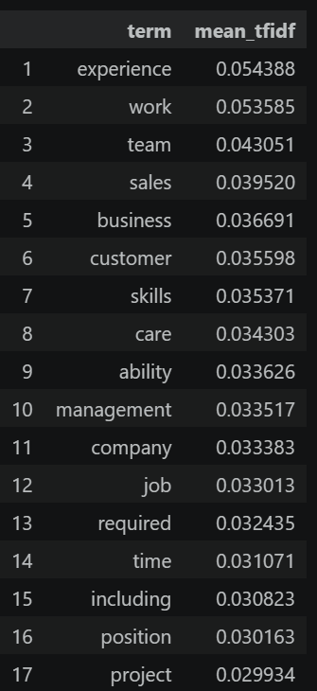
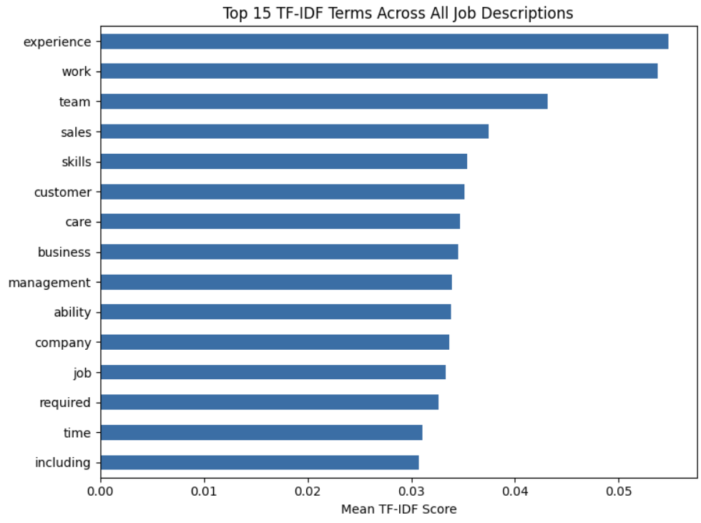
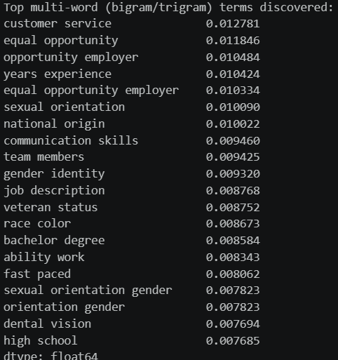

11.2 N-Gram Analysis
N-Gram analysis was used because many skills contain multiple words, including machine learning, deep learning, power bi, data science, natural language processing, computer vision and cloud computing.
- Used TfidfVectorizer with ngram_range=(1,3), max_features=2000 and English stopword removal.
- Generated unigrams, bigrams and trigrams from clean_description.
- Ranked phrases using mean TF-IDF scores.
- Examined high-scoring bigrams and trigrams across the corpus.
- Repeated analysis on the technical-skill subset to reduce dilution from non-technical postings.
- Checked whether target multi-word skills appeared in the vocabulary.
Result: In the complete dataset, generic employment/legal phrases such as equal opportunity employer, customer service and years experience ranked highly. In the technical-skill subset, useful phrases such as data analysis, data science, machine learning and power bi became more visible. Less frequent phrases may still be missed when a vocabulary-size cutoff is applied.
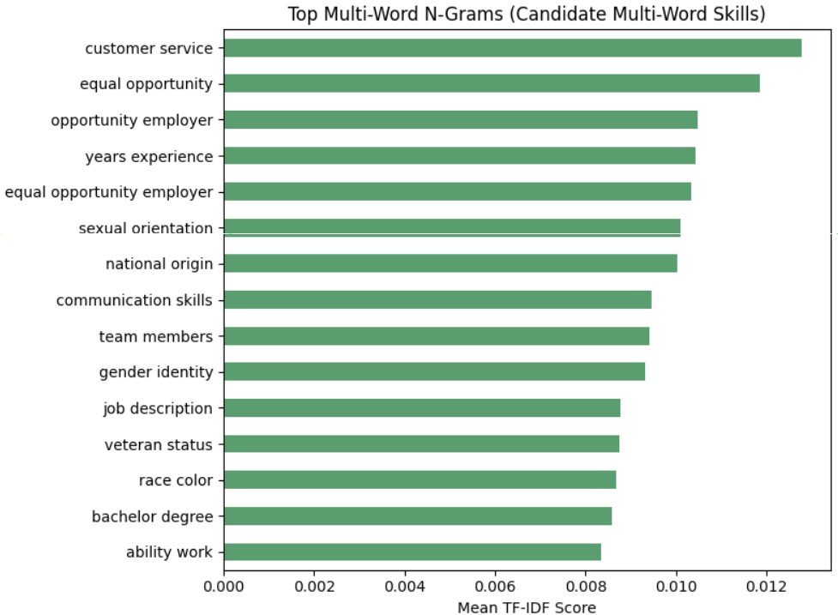
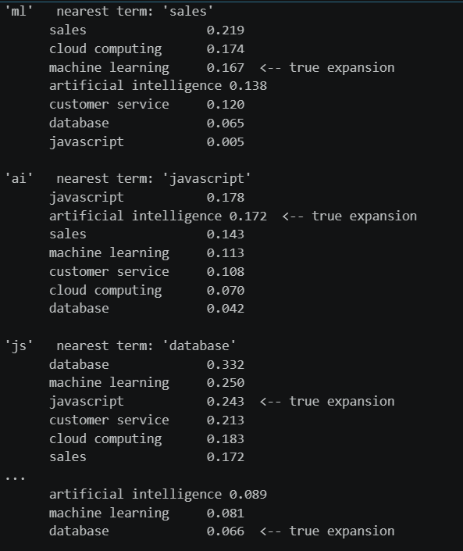

12. Named Entity Recognition (NER)
NER was introduced to identify meaningful entities in job descriptions. Job postings contain technology names, tools, platforms, organizations and other entity-like expressions that can be difficult to capture through simple word matching.
Objective: Identify entity mentions in clean job-description text and examine whether general NER can contribute to skill extraction.
- Used clean_description as the source text.
- Considered technology and skill mentions as candidate entities.
- Kept general NER output separate from the canonical skill taxonomy.
- Prepared recognized entities for filtering or mapping to canonical skills.
General NER models are not specifically trained for job skills. Therefore, recognized entities must be filtered or mapped to the project taxonomy before they are treated as skills. The project also prepared entity and skill-labelled representations so that advanced learning-based approaches could be compared using a common text source and consistent labels.
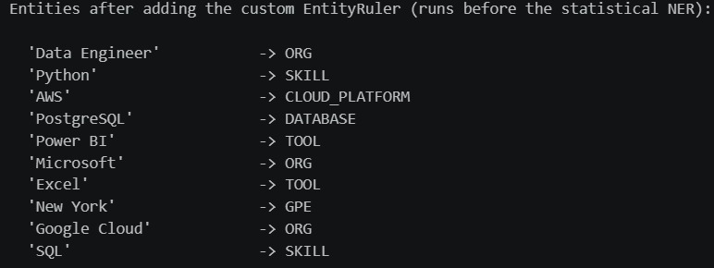
Figure: Entity recognition and skill labels

13. Machine Learning Model
A supervised machine-learning approach was developed to move beyond direct dictionary matching. The goal was to learn patterns from labelled job-description examples and classify skill-related text.
Labelled examples were created containing Text, Entity and Label. clean_description remained the common text source. After preprocessing, text was converted into numerical features using TF-IDF and Logistic Regression was used as the classifier.
Pipeline: Text → Preprocessing → TF-IDF → ML Model → Skill Category.
- Evaluated the classifier on a held-out test set using classification metrics.
- Saved the trained pipeline as skill_classifier.pkl.
- Logistic Regression, Random Forest and SVM were considered; TF-IDF with Logistic Regression was selected for the implemented pipeline.
The model demonstrates how supervised learning can learn patterns that simple exact matching cannot. The confusion matrix is used to inspect class-level prediction behaviour.
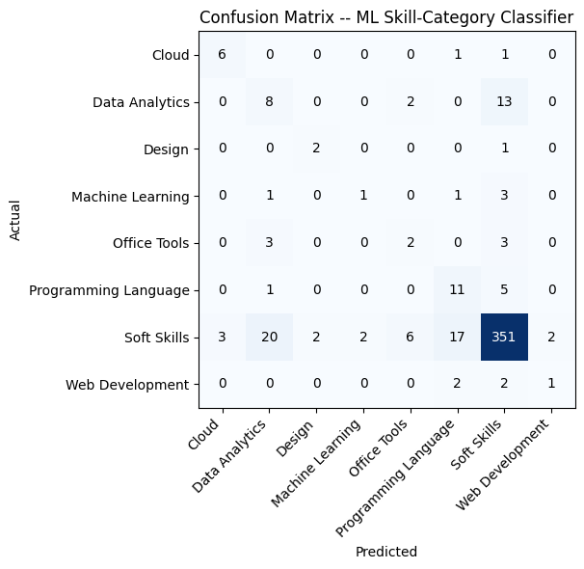
Figure: Confusion matrix for the skill-category classifier

14. Transformer-Based Model
Transformer-based NLP was introduced as the advanced contextual component of the project. Transformer models represent words and phrases using surrounding context, which can help when the meaning of a term depends on how it appears in a sentence.
Models and concepts considered include BERT, DistilBERT, RoBERTa and BERT-NER. The conceptual progression used in the project is Traditional NLP → TF-IDF → Word Embeddings → NER → Transformers.
- Used clean_description as input text.
- Used a pretrained transformer NER model as a practical baseline.
- Applied token-level entity recognition and aggregated related tokens into entities.
- Examined recognized entities for usefulness in identifying skills.
- Kept the pretrained baseline distinct from a custom fine-tuned skill model.
A custom skill-specific transformer would require appropriately labelled token-level training data and fine-tuning. The current workflow therefore treats the pretrained transformer approach as a baseline rather than claiming that a custom fine-tuned model was completed.
Output documented in the project workflow: jobs_with_transformer_entities.csv.

15. Model Evaluation & Comparison
All available extraction approaches were brought together for systematic comparison. The objective was to determine how different methods behave when applied to the same clean_description-based workflow and reference representation.
- Dictionary Matching
- Regex
- TF-IDF
- NER
- ML Model
- Transformer

15.1 Evaluation Metrics
Precision = TP / (TP + FP)
Recall = TP / (TP + FN)
F1 Score = 2 × Precision × Recall / (Precision + Recall)
Accuracy and confusion matrices were also included where the evaluation setup was appropriate. For entity/skill extraction, precision, recall and F1 are emphasized because raw accuracy can be misleading when many non-skill tokens are present.

15.2 Evaluation Process
- Used the same clean_description-based workflow and existing extraction outputs.
- Converted predictions into comparable skill/entity sets where possible.
- Calculated precision, recall, F1 and exact record-level accuracy for compatible outputs.
- Generated a comparison table and saved results as model_comparison.csv.
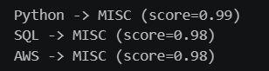
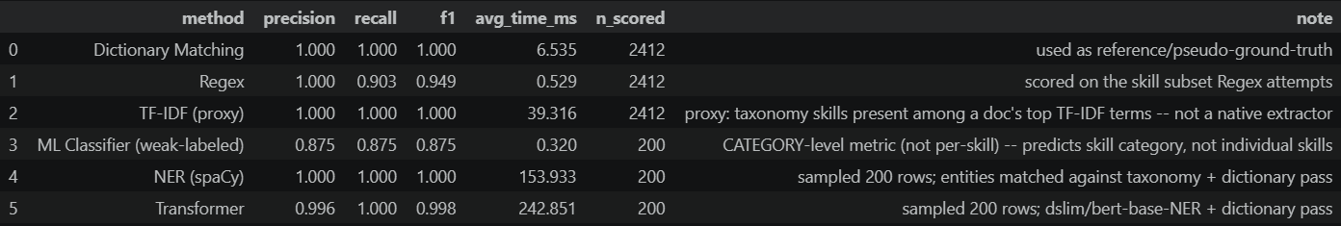
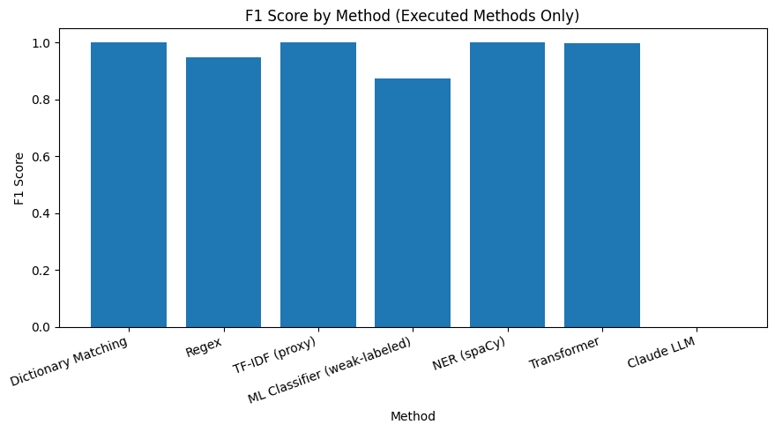

16. Error Analysis
Error analysis was performed to understand where skill extraction systems fail and why. It supports targeted improvement instead of relying only on aggregate performance scores.
- False Positive — a skill is extracted even though it is not actually present as a required skill.
- False Negative — an actual skill is present but the system fails to extract it.
- Wrong Entity — an incorrect entity or entity span is extracted.
- Partial Entity — only part of the intended skill phrase is extracted.
- Duplicate Skill — the same skill is extracted more than once.
- Unknown Skill — a genuine skill is not represented in the current taxonomy or model vocabulary.
- Synonym Problem — equivalent skill names are treated as different terms.
- Spelling Problem — spelling or formatting variation prevents correct matching.
Examples: “Experience with cloud technologies” does not identify a specific cloud platform, so a system should not automatically invent AWS, Azure or GCP. “Experience with Python programming” should normally be normalized to the canonical skill Python.
The analysis compared reference skills with predicted skills, recorded original text, actual skills, predicted skills and error category, and summarized errors by category and method. The output workbook was Error_Analysis_Report.xlsx, containing Error Details, Category Summary and Method Summary.
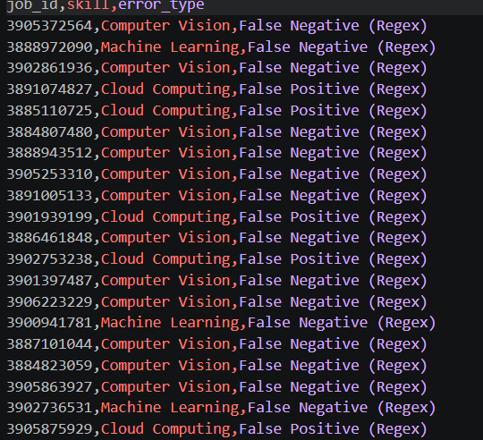
Figure: Error analysis output

17. Skill Normalization & Categorization
Skill normalization standardizes different representations, spellings and formats of the same skill into a single canonical name. For example, Python, Python3, Python 3 and Python programming are treated as Python. PowerBI, Power BI and Power-BI are standardized as Power BI.
The normalization engine follows raw skill identification, lowercase conversion, removal of special characters, alias matching and mapping to the canonical skill. The existing canonical mapping and aliases keep normalization consistent with the skill taxonomy.
Normalization prevents duplicate skill entries, improves skill-frequency analysis and ensures that equivalent skills are counted together. The normalized information was saved as normalized_skills.csv for the business analytics stage.
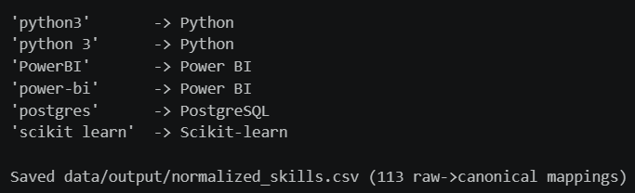
Figure: Canonical skill normalization output

18. Dashboard & Data Visualization
The extracted and normalized skill information was converted into business analytics through an interactive Power BI dashboard. The dashboard summarizes job and skill demand using KPIs and visualizations.
- Total Jobs
- Unique Skills
- Top Skill
- Top Job Role
- Most Required Technology
- Top Skill Category
- Top 20 Skills
- Skill Demand by Job Role
- Skill Category Distribution
- Skill trends where date information is available
The dashboard supports role-wise analysis for roles such as Data Analyst, Data Scientist and Data Engineer and category-level analysis across Programming, Database, Cloud, Analytics, Machine Learning and Soft Skills. The final dashboard was saved as Job_Skill_Analytics.pbix.
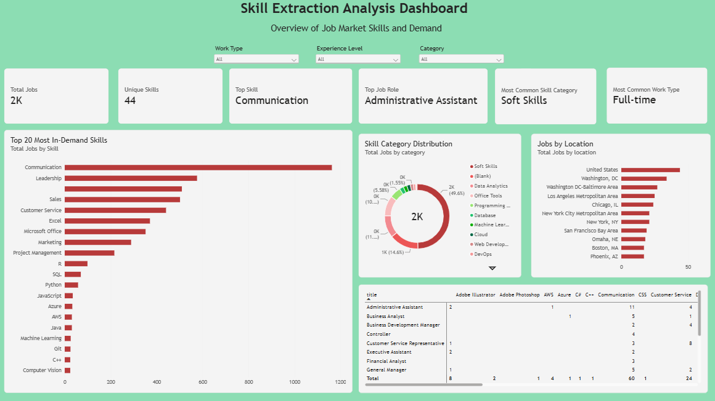
Figure: Skill Extraction Dashboard

19. Application / API Development
The project pipeline can be viewed as an application workflow in which job-description text is supplied as input and structured skill information is produced as output. The extraction pipeline consists of cleaning, taxonomy matching, rule-based extraction, advanced NLP/ML methods, normalization and analytics.

19.1 Input
- Job-posting records
- Job title and job-description text
- Existing taxonomy and alias mappings

19.2 Processing
- Text cleaning and preprocessing
- Skill identification using dictionary/regex/phrase matching
- Statistical and learning-based analysis
- Entity extraction and classification
- Canonical normalization and categorization

19.3 Output
- clean_jobs.csv
- skill_taxonomy.csv
- jobs_with_skills.csv
- jobs_with_skills_advanced.csv
- skill_classifier.pkl
- jobs_with_transformer_entities.csv
- model_comparison.csv
- Error_Analysis_Report.xlsx
- normalized_skills.csv
- Job_Skill_Analytics.pbix
The current report documents the Power BI dashboard as the completed user-facing analytics interface. Streamlit/FastAPI appear in the supplied index as possible application technologies, but a separate deployed API is not evidenced in the current report; therefore no completed API endpoint is claimed here.

20. Testing & Results
Testing was performed progressively as each extraction method was developed. The project used real job descriptions, comparison outputs, agreement checks, classification metrics, confusion matrices and error categories to validate the workflow.
- Dataset-level checks for missing values, duplicates and description length.
- Rule-based extraction checks using known target skills.
- Regex and PhraseMatcher cross-checking.
- 98.8% exact agreement between regex and PhraseMatcher across postings.
- TF-IDF and N-Gram result inspection for meaningful terms.
- NER/entity output inspection and taxonomy mapping.
- Held-out evaluation of the Logistic Regression classifier.
- Precision, recall and F1 comparison for compatible extraction outputs.
- Confusion matrix inspection for classification behaviour.
- Error analysis for false positives, false negatives, partial entities, synonyms and spelling variations.
The results show that simple dictionary matching is easy to implement but can produce substring false positives. Regex and phrase matching improve precision of rule-based extraction, while TF-IDF and N-Grams are useful for statistical vocabulary discovery. Learning-based and transformer approaches provide more advanced contextual modelling but depend on appropriate labels and evaluation data.

21. Challenges & Limitations
- Job descriptions are unstructured and contain inconsistent wording.
- Naive substring matching can create false positives.
- Multi-word skills can be broken by tokenization.
- General NER is not specifically trained for job-skill extraction.
- A taxonomy cannot recognize a genuine skill that is absent from its vocabulary unless the system is extended.
- Synonyms, spelling differences and formatting variants require normalization.
- TF-IDF can rank generic employment vocabulary above technical skills.
- N-Gram results are affected by corpus composition and vocabulary-size cutoffs.
- Raw accuracy may be misleading for skill/entity extraction because of large numbers of non-skill tokens.
- A custom fine-tuned transformer requires labelled token-level training data.
- The current report does not document a separately deployed Streamlit/FastAPI API.
- The dataset contains non-technical postings, which can dilute statistical skill-discovery results.

22. Conclusion
The project developed a structured end-to-end workflow for extracting and analyzing skills from job descriptions. It began with dataset inspection and EDA, followed by cleaning and NLP preprocessing. A master skill taxonomy with categories and aliases was then created and applied to the cleaned descriptions.
Skill extraction was progressively improved from dictionary matching to regex and phrase matching. Statistical NLP using TF-IDF and N-Grams provided vocabulary and multi-word phrase analysis, while NER, supervised TF-IDF with Logistic Regression, and transformer-based approaches extended the project toward more advanced methods. Evaluation and error analysis were used to compare approaches and understand their weaknesses.
Finally, normalization converted equivalent skill expressions into canonical names and the normalized results were transformed into Power BI business analytics. The resulting workflow provides a practical foundation for understanding skill demand in job postings and for future recruitment-oriented applications.

23. Future Scope
- Resume-job matching using normalized skills.
- Candidate ranking based on skill relevance and job requirements.
- Skill-gap analysis to identify missing skills for a target role.
- Recommendation system for courses, certifications or skills based on identified gaps.
- Expansion of the taxonomy to include newly emerging technologies and domain-specific skills.
- Creation of a custom skill-specific NER/transformer model using labelled token-level training data.
- Deployment of the extraction pipeline through a dedicated application/API when implementation requirements are finalized.
- Trend analysis using richer date information and larger datasets.

24. Internship Learning Outcomes
The project provided practical learning across technical, analytical, NLP, machine-learning and project-development areas.
- Technical: Python programming, pandas-based data processing, CSV workflows and structured output generation.
- Analytical: dataset inspection, EDA, visualization and interpretation of job-posting patterns.
- NLP: tokenization, stopword removal, lemmatization, stemming, sentence segmentation, TF-IDF and N-Grams.
- Skill extraction: dictionary matching, regex, phrase matching, taxonomy development and canonical normalization.
- Machine Learning: TF-IDF feature engineering, Logistic Regression classification, evaluation metrics and confusion-matrix interpretation.
- Advanced NLP: NER and transformer-based entity extraction concepts.
- Data quality: handling missing values, duplicates, aliases and inconsistent skill representations.
- Visualization: transforming normalized analytical results into a Power BI dashboard.
- Project development: maintaining separate intermediate outputs, documenting methods, comparing approaches and analyzing errors.

25. References
The project uses the following software, documentation and learning resources as technical references. The exact source of the supplied job-posting dataset is not named in the current report, so it is not replaced with an assumed external source.
- Python documentation and standard-library references used for data/text processing.
- Pandas documentation for CSV loading, cleaning and tabular data processing.
- NumPy documentation for numerical data processing.
- NLTK documentation for tokenization, stopword removal, WordNet lemmatization and stemming.
- spaCy documentation for NLP processing and PhraseMatcher/NER workflows.
- Scikit-learn documentation for TfidfVectorizer, Logistic Regression and evaluation metrics.
- Transformer/BERT-related documentation used for contextual NLP and NER concepts.
- Microsoft Power BI documentation and project dashboard resources.
- Supplied job-posting dataset and project-generated CSV/Excel outputs.

26. Appendix
The appendix contains supporting implementation outputs, screenshots, sample data and additional results generated during the project. The original report contained 26 embedded project images; all 26 have been retained in this updated report without editing their image content.
- Dataset inspection screenshot
- EDA visualizations
- Cleaning output
- Skill taxonomy and category analysis
- Skill extraction outputs
- Regex/PhraseMatcher checks
- TF-IDF and N-Gram results
- NER/entity output
- ML confusion matrix
- Evaluation and comparison outputs
- Error-analysis output
- Skill-normalization output
- Power BI dashboard screenshot
Key generated project files include raw_jobs.csv, clean_jobs.csv, skill_taxonomy.csv, jobs_with_skills.csv, jobs_with_skills_advanced.csv, skill_classifier.pkl, jobs_with_transformer_entities.csv, model_comparison.csv, Error_Analysis_Report.xlsx, normalized_skills.csv and Job_Skill_Analytics.pbix.

