Proposed solution:-

Most of the above dataset can be solved by the following solution

Feedback on course quality can be taken by conducting online quizzes. If students are answering a question incorrectly, AI can zero in on the specific information or concepts that students are missing, so educators can deliver targeted improvements in materials or methods. Some students may be shy about taking risks or receiving critical feedback in the classroom but with AI , students can feel comfortable to make the mistakes necessary for learning and receive the feedback they need for improvement. While solving these quizzes, AI based tool can be designed as such to monitor student activities. This monitoring access can be given to parents and teachers. Grades can be awarded for the same adding to the student’s points table which can make studying fun and increase their interests with a view of adding on to their points table .Students who have interest in a particular field can be matched to professionals in that field based on the results obtained, so as to increase student interaction and knowledge.

Tech stack used for data preprocessing, cleaning and visualization:-

We used python programming language by incorporating libraries such as pandas and seaborn.

Data insights:-

The given dataset gives an overview of what all issues the students face regarding education, financial situation, not getting regular meals, not getting basic services, etc being the reasons.

Procedure followed for data cleaning:-

We browsed through the given dataset and followed data cleaning wherever required in the following ways.

* [Dropping Columns in a DataFrame](https://realpython.com/python-data-cleaning-numpy-pandas/#dropping-columns-in-a-dataframe)
* [Changing the Index of a DataFrame](https://realpython.com/python-data-cleaning-numpy-pandas/#changing-the-index-of-a-dataframe)
* [Tidying up Fields in the Data](https://realpython.com/python-data-cleaning-numpy-pandas/#tidying-up-fields-in-the-data)
* [Combining str Methods with NumPy to Clean Columns](https://realpython.com/python-data-cleaning-numpy-pandas/#combining-str-methods-with-numpy-to-clean-columns)
* [Cleaning the Entire Dataset Using the applymap Function](https://realpython.com/python-data-cleaning-numpy-pandas/#cleaning-the-entire-dataset-using-the-applymap-function)
* [Renaming Columns and Skipping Rows](https://realpython.com/python-data-cleaning-numpy-pandas/#renaming-columns-and-skipping-rows)
* [Python Data Cleaning: Recap and Resources](https://realpython.com/python-data-cleaning-numpy-pandas/#python-data-cleaning-recap-and-resources)

Data visualization snippets:-

Following are few of the data visualization outputs

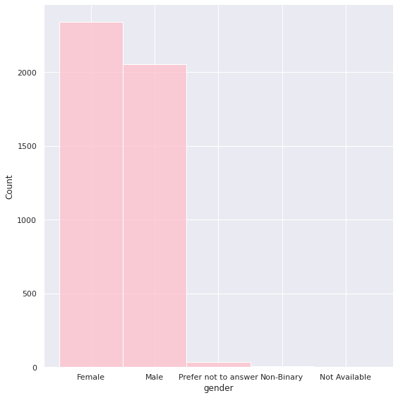

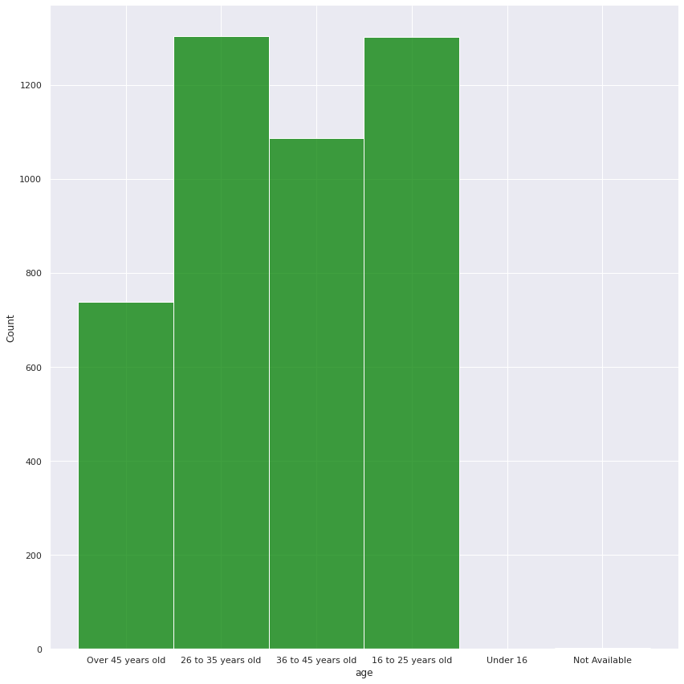

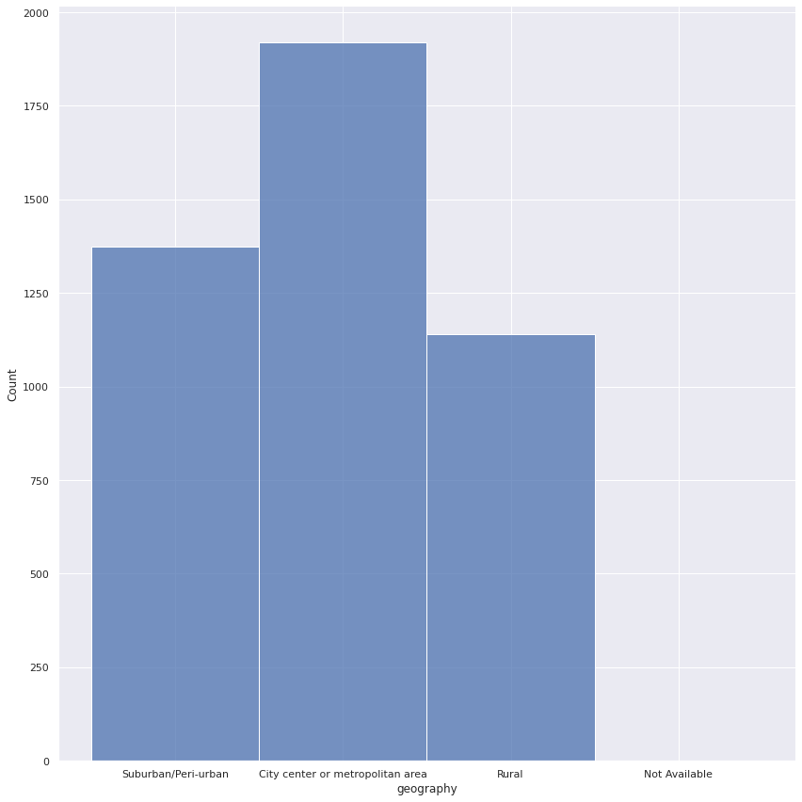

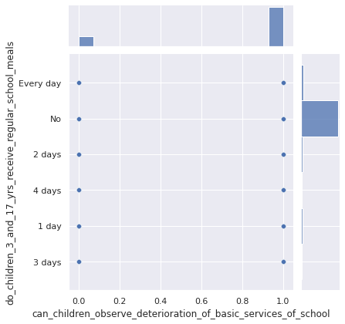

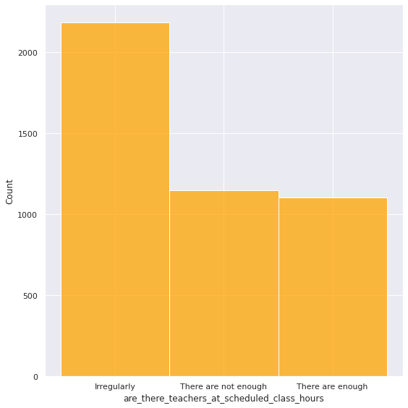

Github link:-

https://github.com/SakshiManjrekar/1_BinaryBrains_1

Google colab link:-

https://colab.research.google.com/drive/18mf5paJo9VAtLzjSeGM_Tpp_5SjVMG4D?usp=sharing