Cloud Security – Unit 4 Assignment
Launch a Windows Server VM on AWS EC2 and Connect Using RDP

Name | Sakshi More
PRN | 2124UCSF1022
Institution | Sanjivani University
Date | 20 October 2026
Cloud platform | Amazon Web Services (AWS) – EC2

1. Objective
To launch a Windows Server virtual machine on AWS EC2, restrict Remote Desktop (RDP, port 3389) access to only my own public IP address, connect to the server over RDP, and apply basic security hardening: a separate user account with a strong password, Windows Firewall enabled, and a simple file created on the server.

2. Environment Summary
AWS Region | Europe (Stockholm) – eu-north-1
Instance name | Windows-Cloud-Security-Lab
Instance ID | i-0ef57076802588e53
AMI | Microsoft Windows Server 2025 Base (ami-0acea970af6753c4f), free tier eligible
Instance type | t3.micro (2 vCPU, 1 GiB RAM)
Storage | 1 x 30 GiB EBS volume
Key pair | windows-lab-key (RSA, .pem) – used to decrypt the Administrator password
Security group | Windows-RDP-SG (sg-09ee6180809e4ca7d)
Inbound rule | RDP – TCP – 3389 – source 106.210.235.94/32 (My IP only)
Public DNS | ec2-56-228-26-217.eu-north-1.compute.amazonaws.com
Username | Administrator
Password | Not disclosed in this report (retrieved from the console using the .pem key)

3. Step-by-Step Procedure

Step 1 – Launch a Windows Server VM on AWS EC2
1. Sign in to the AWS Management Console, select the Europe (Stockholm) region and open the EC2 service. Click Launch instance.
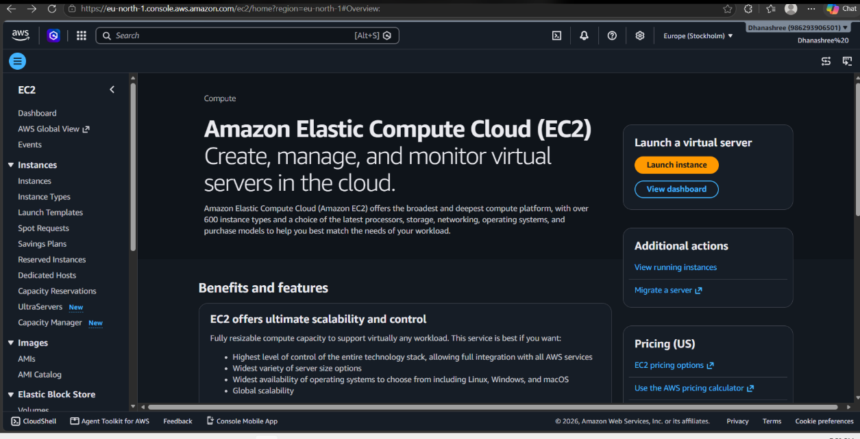
Figure 1: EC2 console home page – Launch instance
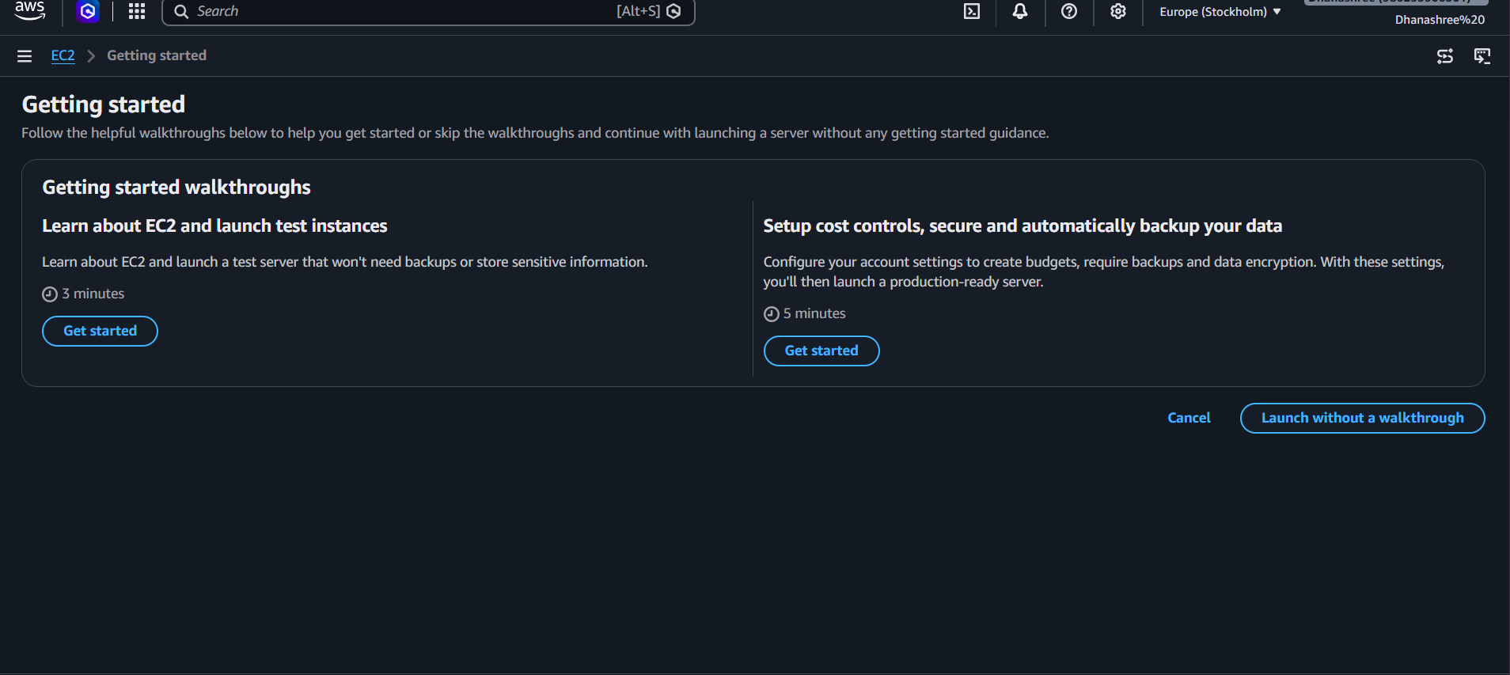
Figure 2: Getting started page – Launch without a walkthrough
2. Enter the instance name Windows-Cloud-Security-Lab. Under Application and OS Images choose the Windows tab (Amazon Linux is the default).
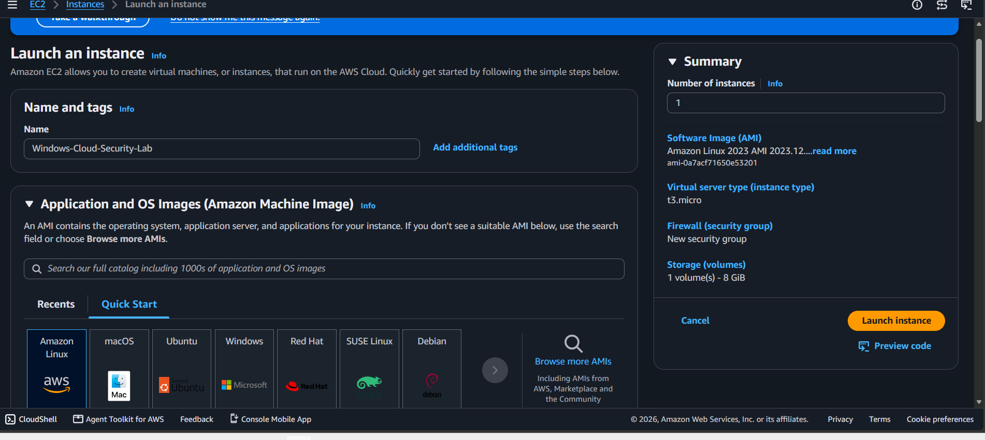
Figure 3: Name and tags, and the OS image selection
3. Select Microsoft Windows Server 2025 Base (Free tier eligible, 64-bit x86).
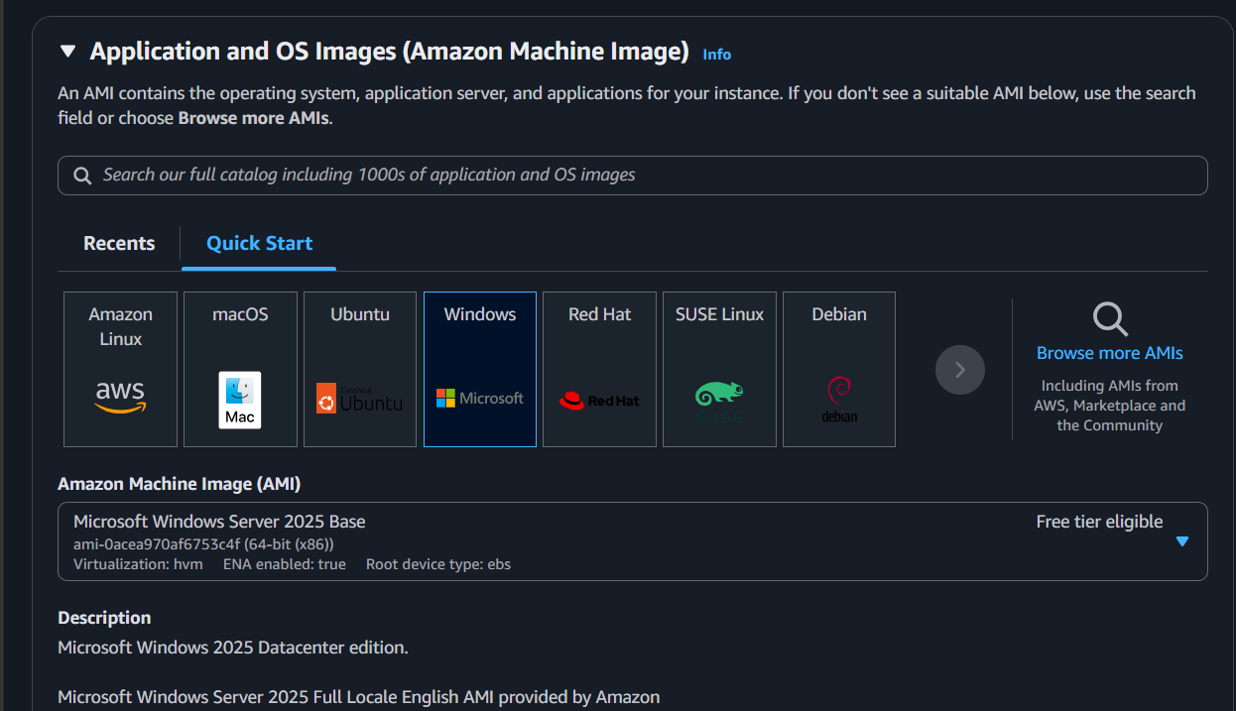
Figure 4: Windows Server 2025 Base AMI selected
4. Choose instance type t3.micro, then create a key pair named windows-lab-key (RSA, .pem format). The private key is stored safely on my computer and is needed to decrypt the Administrator password.
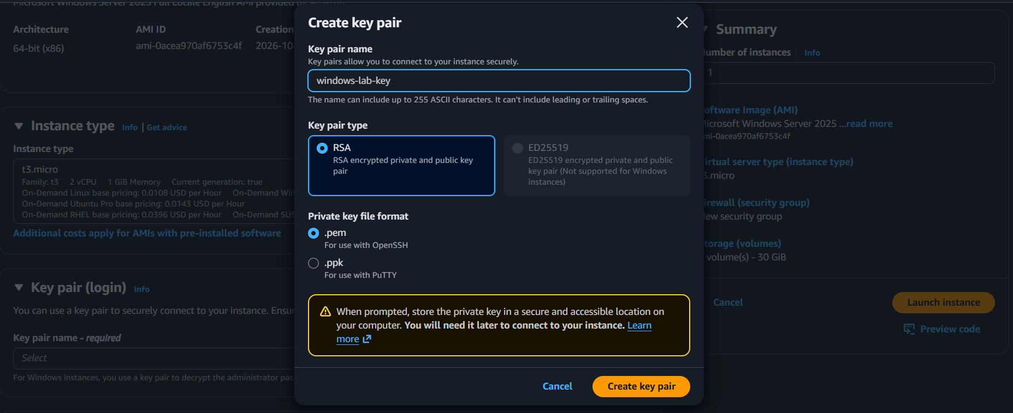
Figure 5: Creating the RSA key pair
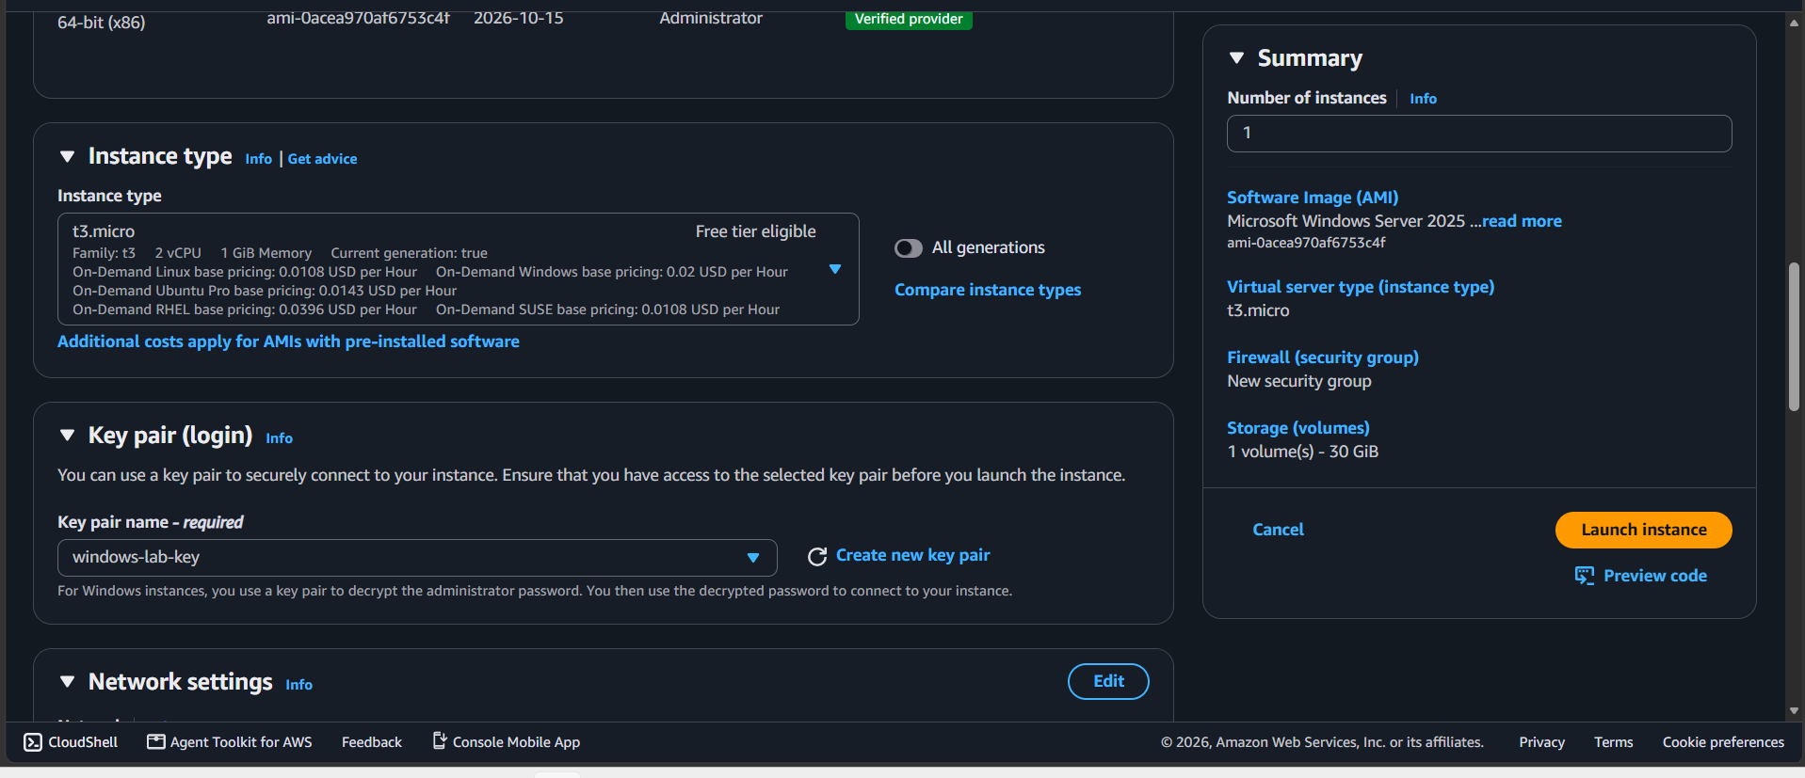
Figure 6: Instance type t3.micro and key pair windows-lab-key selected

Step 2 – Configure the Security Group (RDP from my IP only)
5. Under Network settings, keep the default VPC with Auto-assign public IP enabled, and choose Create security group named Windows-RDP-SG.
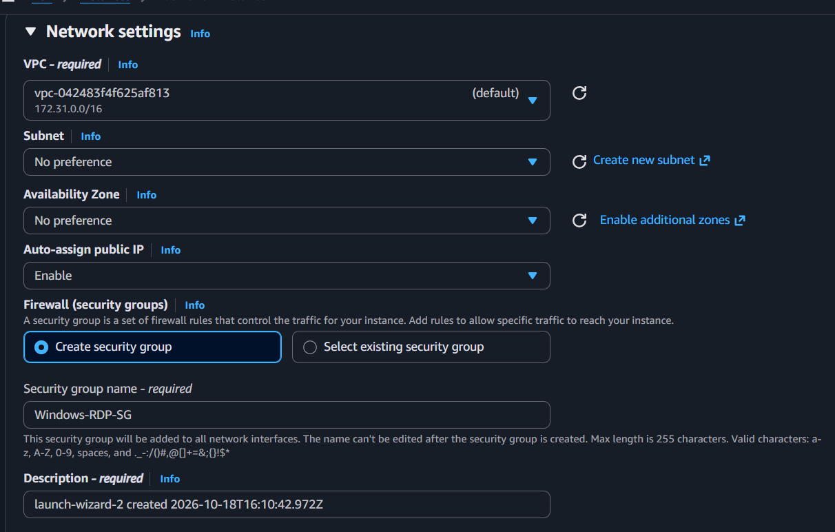
Figure 7: Network settings and new security group Windows-RDP-SG
6. In Inbound Security Group Rules, set Type = RDP (TCP 3389) and Source type = My IP. AWS fills in my public address as 106.210.235.94/32, so only this single address can reach the RDP port. The default 0.0.0.0/0 (anywhere) was NOT used.
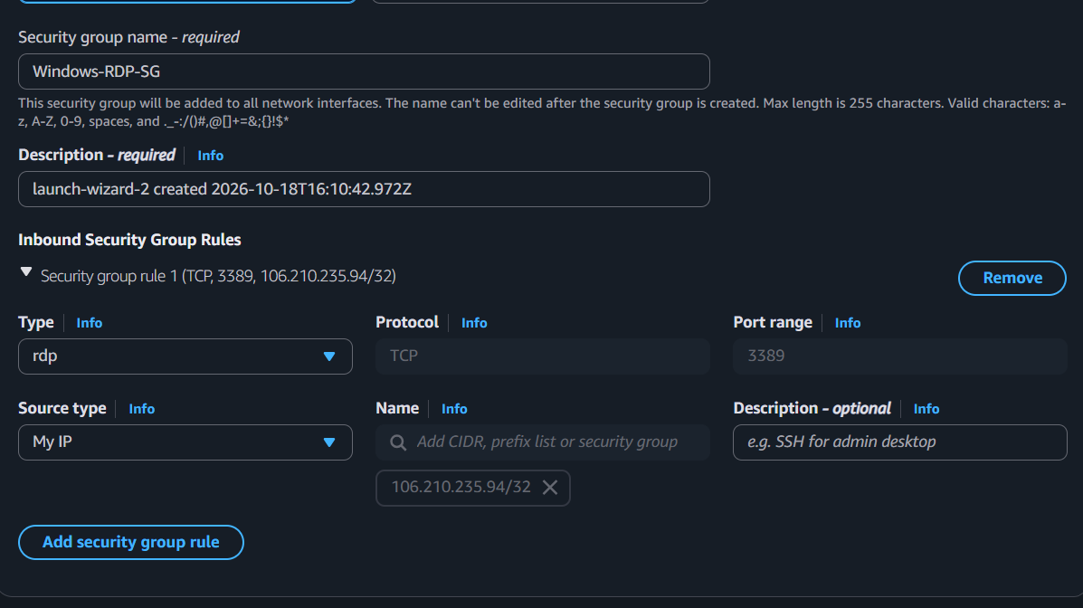
Figure 8: Inbound rule – RDP, TCP 3389, source My IP (106.210.235.94/32)
7. Review the summary and click Launch instance.
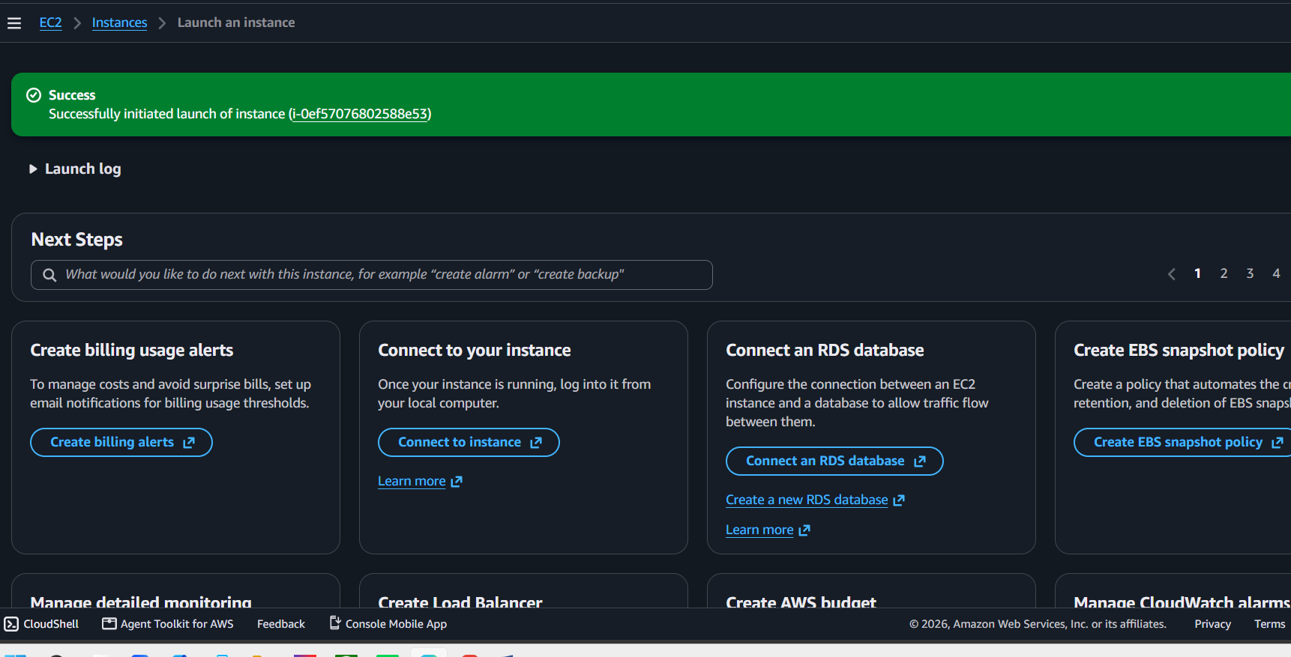
Figure 9: Instance launched successfully (i-0ef57076802588e53)
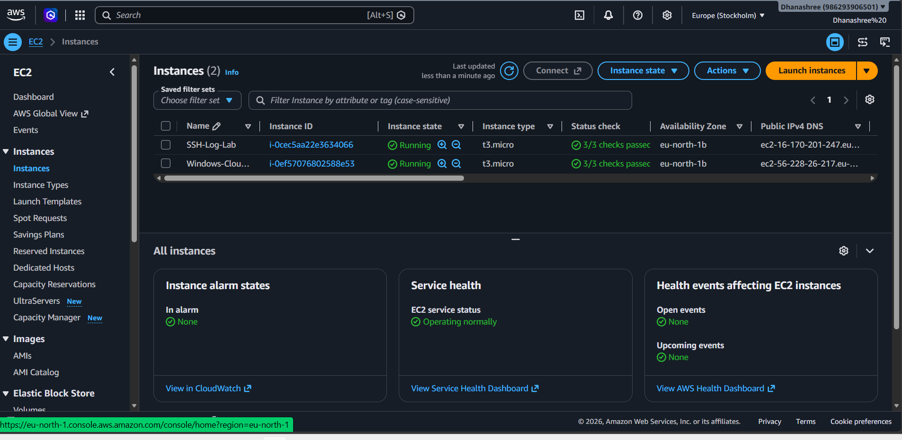
Figure 10: Instances list – Windows-Cloud-Security-Lab running, status checks 3/3 passed

Step 3 – Connect to the Windows VM using RDP
8. Select the instance, click Connect and open the RDP client tab. It shows the Public DNS and username Administrator. Download the RDP shortcut file, then click Get Windows password, upload the windows-lab-key.pem file and decrypt the password.
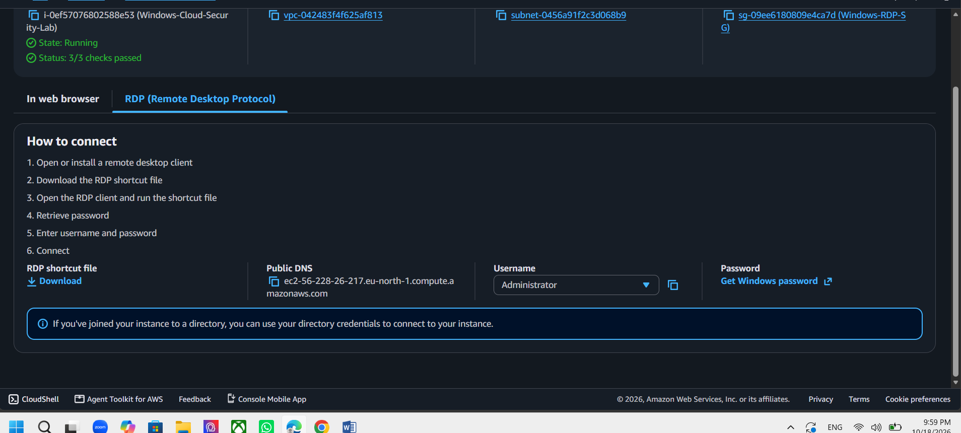
Figure 11: Connect to instance – RDP client details (Public DNS, Administrator)
9. Open the downloaded .rdp file in Remote Desktop Connection, enter the Administrator password and accept the certificate prompt. The Windows Server desktop opens.

Step 4 – Explore the desktop and check system information
Open Server Manager, Start menu and Settings to explore the desktop. Then open PowerShell (Run as administrator) and run:
systeminfo
hostname
Get-ComputerInfo | Select-Object OsName, OsVersion, CsName

These show the OS name/version (Windows Server 2025 Datacenter), host name, memory, processor and network details of the EC2 instance.

Step 5 – Create a new user account with a strong password
Create a standard user with a strong password (at least 12 characters, mixing upper-case, lower-case, digits and symbols). The password is typed at the secure prompt so it is not stored in history or shown on screen.
$pw = Read-Host -AsSecureString "Enter strong password"
New-LocalUser -Name "labuser" -Password $pw -FullName "Lab User" -Description "Standard user for cloud security lab"
Add-LocalGroupMember -Group "Remote Desktop Users" -Member "labuser"
Get-LocalUser

Equivalent classic command: net user labuser * /add (prompts for the password twice).

Step 6 – Enable Windows Firewall and verify its status
Set-NetFirewallProfile -Profile Domain,Private,Public -Enabled True
Get-NetFirewallProfile | Select-Object Name, Enabled
netsh advfirewall show allprofiles state

Expected result: Domain, Private and Public profiles all show Enabled = True / State ON.

Step 7 – Create a text file on the server
New-Item -Path "$env:USERPROFILE\Desktop\cloud_lab.txt" -ItemType File
Set-Content -Path "$env:USERPROFILE\Desktop\cloud_lab.txt" -Value "Cloud Security Unit 4 - Dhanashree Madhavai - PRN 2124UCSF1090"
Get-Content "$env:USERPROFILE\Desktop\cloud_lab.txt"

4. Security Configurations Applied
- RDP (TCP 3389) allowed only from a single trusted address (106.210.235.94/32) – never 0.0.0.0/0, so the server is not exposed to internet-wide brute-force scans.
- Key-pair based password retrieval: the Administrator password is encrypted with the public key and can only be decrypted with the private .pem file kept by me.
- Separate non-default user account created with a strong password, so daily work need not use the built-in Administrator account.
- Windows Defender Firewall enabled on the Domain, Private and Public profiles and verified.
- Least privilege: no other inbound ports (HTTP, SSH, SMB etc.) were opened in the security group.
- Passwords are not included in this report or in screenshots.

5. Clean-up (to avoid AWS charges)
After capturing all screenshots, the instance was stopped/terminated from the EC2 console (Instance state → Terminate instance), and the security group and unused key pair can be deleted. Note: Windows instances are billed per hour while running.

6. Conclusion
In this assignment I launched a Windows Server 2025 virtual machine on AWS EC2, restricted RDP access to my own IP address through a security group, retrieved the Administrator password with the key pair and connected using Remote Desktop. I then explored the server, created a separate user with a strong password, confirmed Windows Firewall was enabled and created a file on the server. The exercise showed that cloud security is a shared responsibility: AWS secures the infrastructure, while the user must correctly configure network access, credentials and the operating system firewall. The most important lesson is never to expose RDP to the entire internet and to shut down unused instances to avoid cost and risk.

