Shree Siddheshwar Devasthan, Solapur

SHREE SIDDHESHWAR WOMEN’S COLLEGE OF ENGINEERING, SOLAPUR

(Affiliated to DBATU, Lonere)



A
MINI-PROJECT REPORT ON
“Vital Blood Tracking Platform”
Submitted by
Roll_no Name PRN
243 Akshata kore 24069381925521
247 Sakshi Mulage 24069381925526

Department of Computer Science & Engineering
(Artificial Intelligence & Data Science)

UNDER THE GUIDANCE OF
Prof. P. S. Yadav.

(Academic Year: 2025-2026)
Shree Siddheshwar Devasthan, Solapur
SHREE SIDDHESHWAR WOMEN’S COLLEGE OF ENGINEERING, SOLAPUR

Department of Computer Science Engineering

(Artificial Intelligence & Data Science)

CERTIFICATE
Certified that the mini-project work entitled “Vital Blood Tracking Platform” is a bonafide work carried out by
Roll_no Name PRN
243 Akshata kore 24069381925521
247 Sakshi Mulage 24069381925526
he report has been approved as it satisfies the academic requirements in respect of mini- project work prescribed for the course.

………………………… …………………………

Guide Mini-project Co-ordinator

…………………………… …………………………..
- External Examiner
Head of the Department

ACKNOWLEDGEMENT
It gives me great pleasure and satisfaction in presenting this mini project on “ Vital Blood Tracking System ”.
I would like to express my deep sense of gratitude towards Prof. P. S. Yadav to encouraging us towards a new innovative idea.
I have further more to thank CSE(Artificial Intelligence & Data Science) Department HOD and for continuous guidance. I also want to thank Prof. A. A. Phatak for all his assistance and guidance for preparing report. Prof.-- and Prof. -- to encourage me to go ahead
I would like to thank all those, who have directly or indirectly helped me for the completion of the work during this mini project.

T.Y. (Div: B) B.Tech . CSE (AI & DS)
Name PRN
Akshata kore 24069381925521
Sakshi Mulage 24069381925526

Contents
- INTRODUCTION 6
1.1 Introduction ……………………………………………………………………6
1.2 Motivation ……………………………………………………………………. 7
1.3 Objective ……………………………………………………………………... 7
1.4 Overview of Project ………………………………………………………….. 7
1.5 Activity Diagram……………………………………………………………….8
1.6 Sequences Diagram…………………………………………………………….8
- PROBLEM STATEMENT 9
2.1 Problem Statement …………………………………………………………… 9
2.2 Solution ………………………………………………………………………. 9
2.3 Key Challenges ……………………………………………………………… 9
2.4 Goals ………………………………………………………………………….11
2.5 Use Case Diagram……………………………………………………………..11
- SPECIFICATION 6
  - Software Specification………………………………………………………....12
  - Hardware Specification ……………………………………………………… 14
  - Technology Considerations …………………………………………………. 16
  - Software Requirements ………………………………………………………17
  - Hardware Requirements ……………………………………………………...17
- WOEKFLOW OF PROJECT 18
- DFD Levels
  - DFD Level 0…………………………………………………………………..21
  - DFD Level 1…………………………………………………………………..21
  - DFD Level 2(Donor)………………………………………………………….22
  - DFD Level 2(Receiver)……………………………………………………….22
  - DFD Level 2(Search)…………………………………………………………23
  - DFD Level 2(Admin)…………………………………………………………23
- IMPLEMENTATION OF PROJECT 24
6.1 Implementation of Project …………………………………………………. ..24
6.2 Screen shots of Project ………………………………………………………. 27
- CONCLUSION 31

List of Figures

6.2 Screenshots of the Project

6.2.1 Fig 1: Home Page 27

6.2.2 Fig 2: Donor Form Page 27

6.2.3 Fig 3: Receiver Form Page 28

6.2.4 Fig 4: Search Form Page 28

6.2.5 Fig 5: Admin Login Page 29

6.2.6 Fig 4: Search Blood Group Page 29

6.2.7 Fig 4: Search Donor Blood Group Page 30

6.2.8 Fig 4: Search Receiver Blood Group Page 30

ABSTRACT

The Vital Blood Tracking System is a smart, technology-driven solution designed to enhance the efficiency, accuracy, and reliability of blood management in hospitals, blood banks, and emergency healthcare services. The primary goal of the system is to ensure real-time tracking, monitoring, and availability of blood units in order to minimize shortages, reduce wastage, and support timely patient care.

This system enables digital recording of donor details, blood collection, testing, storage, and distribution using an integrated database. Each blood unit is assigned a unique ID (barcode/RFID) to monitor its complete lifecycle—from donation to transfusion. Real-time stock updates allow healthcare staff to check availability of different blood groups instantly and avoid manual errors.

The system also incorporates features like expiry alerts, low-stock notifications, donor eligibility reminders, and emergency request processing. Hospitals can quickly raise urgent requests, track request progress, and allocate blood units with accuracy. The system enhances transparency and reduces delays during critical situations such as accidents, surgeries, and medical complications.

By digitalizing the entire workflow, the Vital Blood Tracking System improves operational efficiency, ensures safe transfusion practices, and supports accurate decision-making. Ultimately, the project aims to provide a reliable and user-friendly platform that ensures timely availability of life-saving blood units, thereby improving healthcare outcomes and saving lives.

Chapter 1 INTRODUCTION

1.1 Introduction

Blood is one of the most essential components of the human body and plays a crucial role in saving lives during medical emergencies, surgeries, accidents, and various health complications. Hospitals and blood banks must maintain accurate information about the availability, storage, and movement of blood units. However, traditional manual methods of recording and tracking blood often lead to issues such as errors, mismatch of blood groups, delays, limited visibility of stock levels, and wastage due to expiry.
To overcome these challenges, the Vital Blood Tracking System is designed as an advanced digital solution that ensures efficient management of blood units from donation to transfusion. The system provides a centralized database where information about donors, blood collection, testing results, storage conditions, and distribution activities can be recorded and retrieved quickly. Each blood unit can be tracked using a unique identification number such as a barcode or RFID tag, allowing real-time monitoring of its status and location.
The system helps hospitals, blood banks, and emergency services access up-to-date information on blood availability, making it easier to manage urgent requests and reduce critical shortages.
Overall, the Vital Blood Tracking System aims to create a reliable, transparent, and user-friendly platform that enhances the quality of healthcare services. By ensuring timely access to the right blood type, the system contributes significantly to saving lives and improving patient care
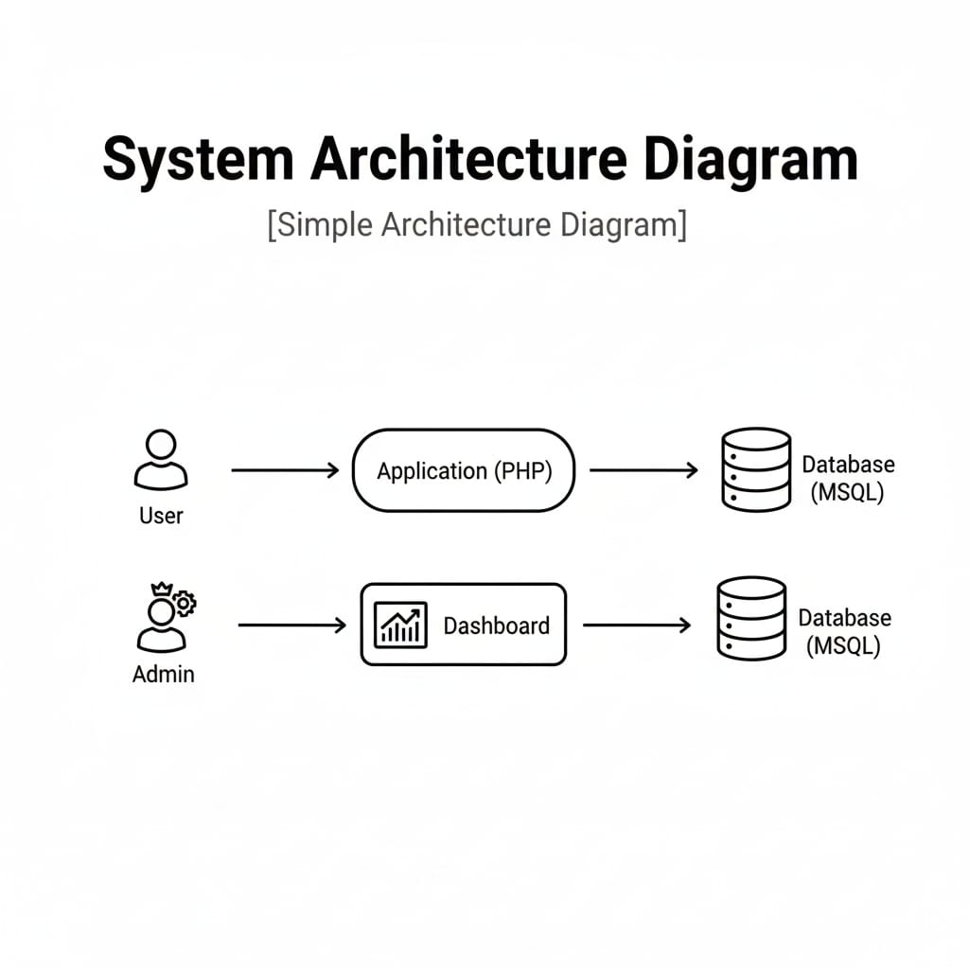

Dig. System Architecture Diagram

1.2 Motivation

Blood is a vital resource that can save lives in critical situations such as accidents, surgeries, childbirth complications, and medical emergencies. However, many hospitals and blood banks struggle with inefficient manual record-keeping, mismanagement of blood inventory, and delays in locating the required blood group. These issues often lead to avoidable loss of life, which highlights the urgent need for a more reliable and streamlined system.
The motivation behind developing the Vital Blood Tracking System arises from the need to create a safer, faster, and more transparent method of managing blood units. Existing manual processes make it difficult to track expiry dates, donor history, and real-time stock levels, which can cause shortages or wastage. A digital tracking system ensures accuracy, reduces human errors, and improves availability of blood during emergencies.

1.3 Objective
The main objective of the Vital Blood Tracking System is to create an efficient and reliable digital platform for managing blood units throughout their entire lifecycle—from donation to transfusion. The system aims to maintain a centralized database that securely stores donor information, blood group details, testing results, and inventory records. Another key objective is to enable real-time monitoring of blood availability so hospitals and blood banks can quickly access accurate stock levels during critical situations. By implementing automated processes and unique identification methods such as barcodes or RFID tags, the system seeks to reduce manual errors and ensure safe tracking of every blood unit. It also strives to provide timely alerts regarding expiry dates, low stock, and donor eligibility, thus improving decision-making and minimizing wastage. Overall, the project focuses on enhancing operational efficiency, streamlining emergency request handling, and improving patient safety by ensuring that the right blood type is delivered to the right patient at the right time.

1.4 Overview of Project
The Vital Blood Tracking System is a comprehensive digital solution designed to simplify and enhance the management of blood units in hospitals and blood banks. The project focuses on creating a centralized platform where all blood-related information such as donor details, blood group, collection date, testing status, storage location, and receiver can be stored, updated, and accessed
Overall, the project aims to improve the safety, reliability, and speed of blood management by replacing manual processes with an automated tracking system. By integrating all key functions into one user-friendly interface, the Vital Blood Tracking System supports better decision-making, enhances operational efficiency, and contributes to saving lives in critical situations.
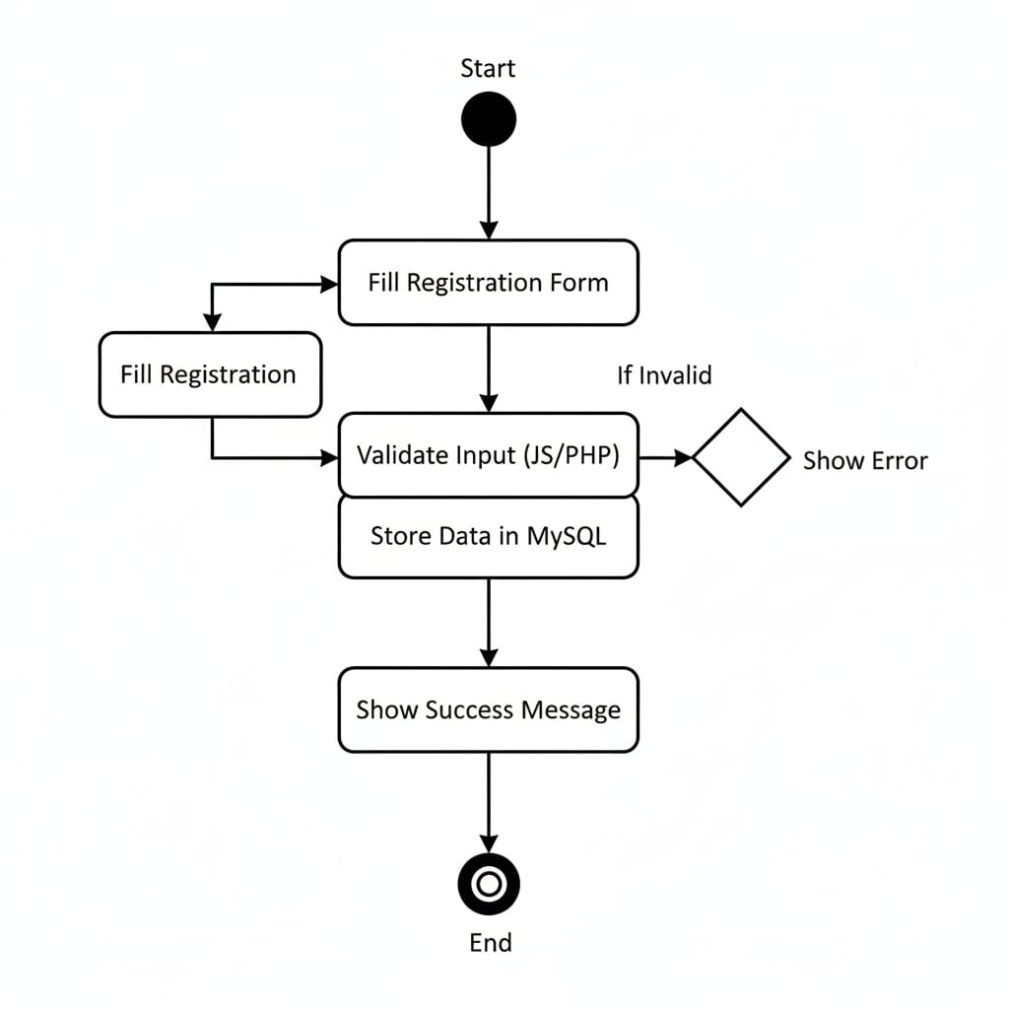
1.5 Activity Digram
Dig. Activity Diagram

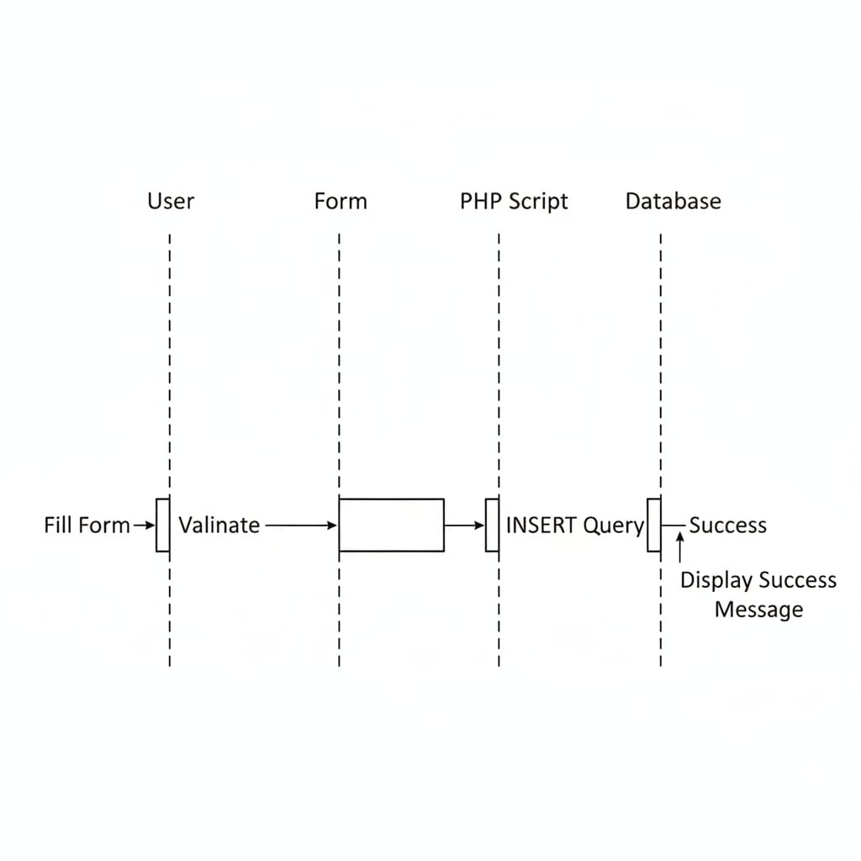
1.6 Sequences Diagram

Dig. Sequences Diagram
Chapter 2 PROBLEM STATEMENT

2.1 Problem Statement

Blood banks and hospitals often face significant challenges in managing blood units due to traditional manual processes. These manual methods make it difficult to accurately record donor information, track collected blood, monitor stock levels, and identify the location or status of specific blood units. As a result, issues such as delayed response during emergencies, mismatch of blood groups, expired or wasted units, and lack of real-time availability information frequently occur. The absence of an automated tracking system also increases the chances of human errors and makes it harder to maintain transparency and safety in blood transfusion procedures. Therefore, there is a need for a reliable, centralized, and automated system that can efficiently track blood units, manage inventory, and ensure timely availability of the right blood type to the right patient.

2.2 Solution

The Vital Blood Tracking System offers an automated and centralized way to manage blood units efficiently. By assigning each blood unit a unique barcode or RFID tag, the system enables accurate tracking from donation to transfusion. It provides real-time stock updates, automated alerts for expiry and low inventory, and quick emergency request handling. This digital solution reduces manual errors, saves time, minimizes wastage, and ensures that the required blood is available when needed, improving overall patient safety.

2.3 Key Challenges

- Manual Errors: Traditional recording methods often lead to mistakes in donor details, blood grouping, and stock updates.
- Lack of Real-Time Information: Hospitals struggle to know the exact availability of blood units at any moment.
- Difficulty in Tracking Blood Units: Without unique identification, it becomes hard to trace a blood unit’s status, location, and expiry.
- Wastage Due to Expiry: Poor monitoring of storage dates leads to expired blood units being discarded.
- Slow Emergency Response: Delay in identifying the required blood group during critical situations affects patient care.
- Poor Donor Management: No proper reminders for donor eligibility or follow-ups reduce donation frequency.
- Low Transparency: Manual systems lack visibility, making it difficult to audit or verify blood movement.
- Data Mismanagement: Storing and maintaining records in paper format risks loss, damage, or duplication.

Evaluation Metrics

- Accuracy: Ensures correct tracking of donor details, blood units, and stock levels with minimal errors.
- Efficiency: Reduces time required for data entry, searching, and updating blood records.
- Usability: Provides a simple, user-friendly interface easily understood by all.
- Reliability: Offers stable performance with consistent uptime and error-free operations.
- Security: Protects blood and donor data using authentication, access control, and safe storage methods.
- Real-Time Tracking: Instantly updates blood availability and unit status for quick decision-making.
- Scalability: Handles increased data and users without affecting performance.
- Error Reduction: Significantly decreases human errors compared to manual record-keeping.
- Cost-Effectiveness: Lowers operational costs by reducing paperwork, delays, and wastage.
- User Satisfaction: Achieves positive feedback from staff due to its simplicity and reliability.

Dataset

You can use available datasets, such as:
- Donor Dataset
- Receiver Dataset
- Search Dataset
- Admin Dataset

2.4 Goal of Vital Blood Tracking Platform

The primary goal of the Vital Blood Tracking Platform is to create a safe, efficient, and fully automated system that ensures accurate tracking and availability of blood units from donation to transfusion. The platform aims to centralize all blood-related data, reduce manual errors, provide real-time visibility of blood inventory, and support hospitals and blood banks in delivering timely and reliable healthcare services. By improving transparency, reducing wastage, and enabling quick emergency response, the goal is to ensure that the right blood reaches the right patient at the right time, ultimately saving lives and enhancing the overall quality of medical care.

2.5 Use Case Diagram

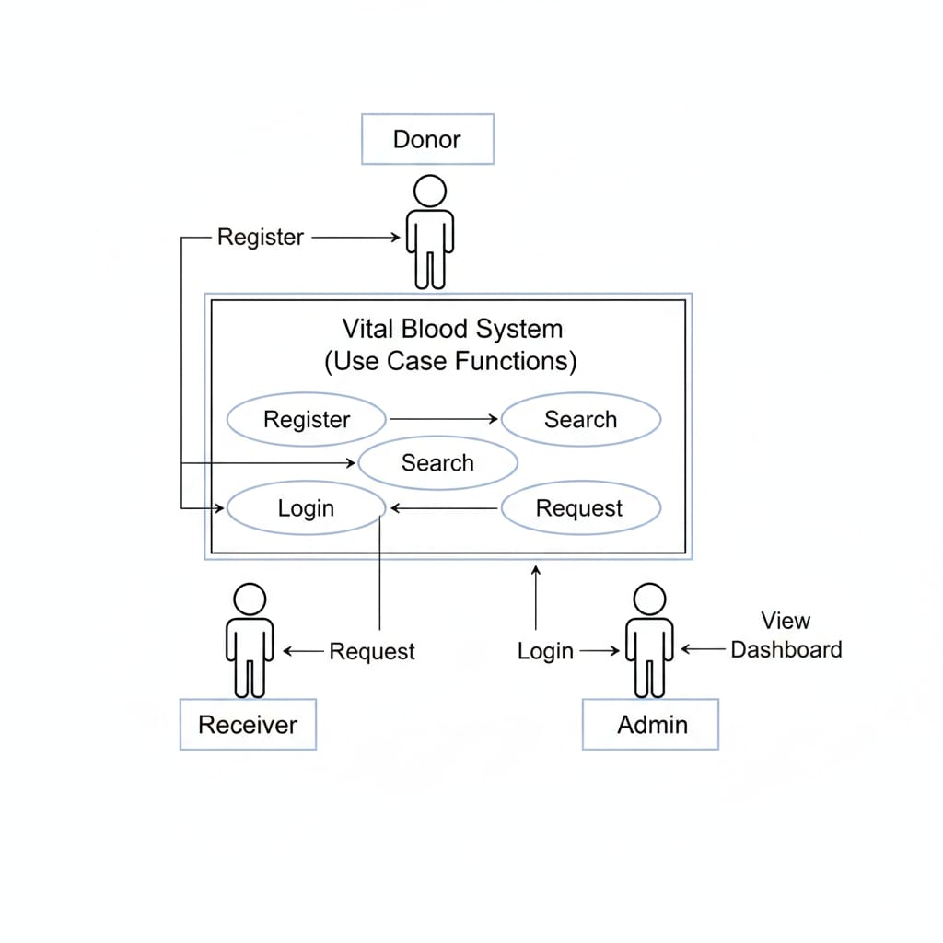

Dig.Use Case Diagram

Chapter 3 FUNCTIONAL SPECIFICATION

3.1 Software Requirements Specification
Software Requirements Specification (SRS) for a Vital Blood Tracking Platform

1. Introduction

- Purpose:
The purpose of the Vital Blood Tracking System is to provide a fast, accurate, and automated way to manage and track blood units, ensuring real-time availability and reducing errors during blood collection, storage, and transfusion.
- Scope:
The scope of the Vital Blood Tracking System includes managing donor details, tracking blood units using unique IDs, receiver details, monitoring inventory in real time, generating alerts for expiry and low stock, and supporting hospitals in handling emergency blood requests efficiently.
- Audience:
The system is intended for hospitals, blood banks, medical staff, and emergency healthcare teams who manage or use blood units.

2. Overall Description

- System Overview:
To provide a fast, accurate, and automated platform for tracking blood units from donation to transfusion, ensuring real-time availability and reducing errors.
- System Goals:
The system records donor details, assigns unique IDs to blood units, tracks inventory, sends alerts for expiry or low stock, and helps hospitals handle emergency blood requests efficiently.
- Assumptions:
Users have basic computer knowledge, internet access is available, and all blood units are properly labeled and tested before entry into the system.
- Constraints:
Limited technical skills of staff, dependency on internet/database connectivity, and compliance with medical data privacy and safety standards.
3. Functional Requirements
a. Donor Module
- The system must allow donors to register with basic details (name, age, blood group, contact).
- The system must store donor information in the database.
- The system must update donor availability status after each donation.
b. Receiver Module
- The system must allow receivers (patients/hospitals) to request blood by entering required blood group and units.
- The system must record receiver/request details in the database.
- The system must check blood availability before approving a request.
c. Search Module
- The system must allow users to search for available blood groups.
- The system must display real-time availability of each blood group.
- The system must show donor or stock information related to the searched blood group.
d. Admin Module
- The admin must be able to add, edit, or delete donor and receiver records.
- The admin must manage blood stock (update available units).
- The admin must view all donor lists, receiver requests, and search logs.
- The admin must approve or reject blood requests from receivers.

4. Non-Functional Requirements
a. Performance
- The system should load donor, receiver, and search results within 2–3 seconds.
b. Usability
- The interface should be simple and easy for admins, donors, and receivers to use.
- Users should need minimal training to operate the system.
c. Security
- Only authorized admins should be able to add, update, or delete data.
- Sensitive donor and receiver information must be protected through secure login and data encryption.
d. Availability
- The system should be accessible 24/7, especially for emergency search requests.
3.2: Hardware Requirements Specification

The Vital Blood Tracking System requires basic yet reliable hardware to ensure smooth functioning and efficient performance.

1.Development Environment

1. Server-Side Hardware
- Processor: Intel i5 or higher
- RAM: Minimum 8 GB
- Storage: 500 GB HDD or 256 GB SSD
- Network: Stable internet/LAN connection
- Backup Device: External HDD or Cloud storage

2. Client-Side Hardware (For Admin, Donor, Receiver, Staff)
- Processor: Intel i3 or higher
- RAM: Minimum 4 GB
- Storage: 250 GB HDD or SSD
- Display: 14-inch or larger monitor
- Input Devices: Keyboard, Mouse
- Scanner (Optional): Barcode or QR scanner for tracking blood units

2.Testing Environment
- Operating System: Windows 10 / Windows 11
- Database: MySQL / SQL Server
- Server Environment: XAMPP / WAMP / Apache Server
- Programming Language: PHP ,HTML,CSS.
- Browser for Testing: Chrome / Firefox / Edge
- Testing Tools Used: Postman (for API testing), phpMyAdmin (for database testing)
- Hardware: Minimum 4GB RAM
- User Roles Tested: Admin, Donor, Receiver
- Scenarios Tested: Login, registration, search blood, update records, admin operations

3.Production Environment

The production setup must support real-time detection, user interaction, and high reliability.

- Inference & Web Server (Fake News Detection Engine)

  - Processor :-
A multi-core processor (like Intel i5/i7 or AMD Ryzen) is required to handle web requests and system operations smoothly without delays.
  - Storage :-
Fast SSD storage is needed to store system files, logs, and temporary data so that the server loads pages and processes requests quickly.
  - RAM :-
At least 8GB RAM is required to allow smooth multitasking, manage active sessions, and ensure stable performance under multiple user loads.
  - Network :-
A high-speed and stable internet connection with low latency is essential to ensure fast data access, real-time updates, and uninterrupted communication between client and server.

b. Database Server
- Processor
A multi-core processor (minimum quad-core) is required to handle multiple database queries quickly and ensure smooth performance during data retrieval and updates.
- Storage
High-capacity and fast storage (SSD preferred) is needed to store donor records, receiver details, blood unit data, and logs without delay or data loss.
- RAM
At least 8–16 GB RAM is necessary to support efficient query processing, maintain caching, and ensure the database runs smoothly under multiple user requests.

5.User Devices

The fake news detection system should be accessible from a wide range of user devices:
- Supported Platforms:
  - Web browsers (Chrome, Firefox, Edge)
  - Android/iOS apps (if applicable)
- Minimum Device Requirements:
  - RAM: 2 GB
  - CPU: Dual-core
  - Internet: Minimum 1 Mbps for smooth access to the web interface

3.3 Technology Considerations
- Programming Language (PHP):
PHP is used for server-side development because it is easy to learn, widely supported, and works well for database-driven web applications like a blood tracking system.
- Database (MySQL):
MySQL is chosen due to its reliability, speed, and seamless integration with PHP for storing donor, receiver, and blood unit data.
- Frontend Technologies (HTML, CSS, JavaScript):
These technologies are used to build a clean and user-friendly interface for donors, receivers, and admin users.
- Server Environment (XAMPP Server):
PHP needs a server environment to run. Tools like XAMPP or a live Apache server help host the system and connect it with the database.
- Security Measures:
Proper validation, user authentication, input sanitization, and secure database queries are required to protect sensitive medical data.
- Scalability:
The system should be able to handle growing data like more donors, receivers, and blood records without slowing down.
- Compatibility:
The system must run smoothly on all common browsers (Chrome, Firefox, Edge) and support desktop and mobile devices.

3.4 Software Requirements

Frontend Software Requirements
- HTML– for creating the structure of the web pages.
- CSS – for styling and designing the user interface.
- JavaScript – for form validation, dynamic actions, and user interaction.
- Browser (Chrome / Firefox / Edge) – to run and test the application.
Backend:
- PHP (v7.x or v8.x) – main backend scripting language for server-side logic.
- MySQL – for storing donor, receiver, admin, and blood unit data.
- Apache Server (XAMPP) – to run PHP and handle HTTP requests.
- phpMyAdmin – for managing the MySQL database easily.

  - Hardware Requirements
- Processor: Dual Core 2.0 GHz or higher
- RAM: 4 GB minimum
- Hard Disk: 20 GB free space

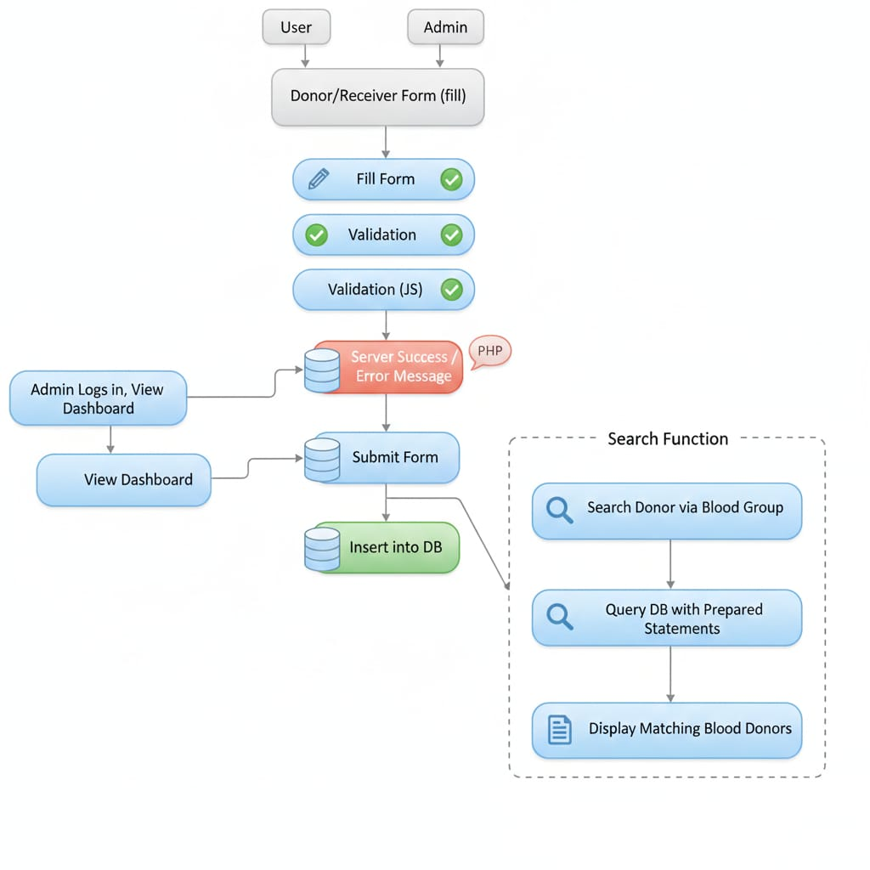
Chapter 4 WORKFLOW OF PROJECT

Dig. Workflow OF Project

1.User / Admin
- The system has two types of people using it:
  - User (donor or receiver)
  - Admin (manages system)

2. Donor/Receiver Form (Fill)
- Both user and admin can open the form where donor/receiver information is entered.

3. Fill Form
- The person enters all required details like name, blood group, contact info etc.

4. Validation
- After filling, the system checks whether all required fields are entered properly.
- This step ensures no important information is missing.

5. Validation (JS)
- JavaScript validation runs in the browser.
- It checks mistakes instantly before the form is sent to the server.

6. Server Success / Error Message (PHP)
- After submission, PHP checks the data on the server.
- Two possibilities:
  - ✔ Success message if everything is fine
  - ✖ Error message if something is wrong

7. Admin Logs In & Views Dashboard
- The admin signs into the system.
- Admin can see all information on the dashboard (summary screen).

8. View Dashboard
- Admin sees options like:
  - Add donor
  - View all donors
  - Search donors
  - Pending requests
  - Total entries, etc.

9. Submit Form
- When admin or user submits a form, the details are sent to the database.

10. Insert into Database
- The validated data is saved safely into the database.

Search Function (Right-Side Section)

11. Search Donor via Blood Group
- Admin/user can search donors by selecting a blood group.

12. Query Database with Prepared Statements
- The system connects to the database using secure prepared statements.
- This avoids SQL injection and ensures safe data search.

13. Display Matching Blood Donors
- Finally, the system shows a list of donors that match the selected blood group.

Chapter 5 DFD Level Diagrams

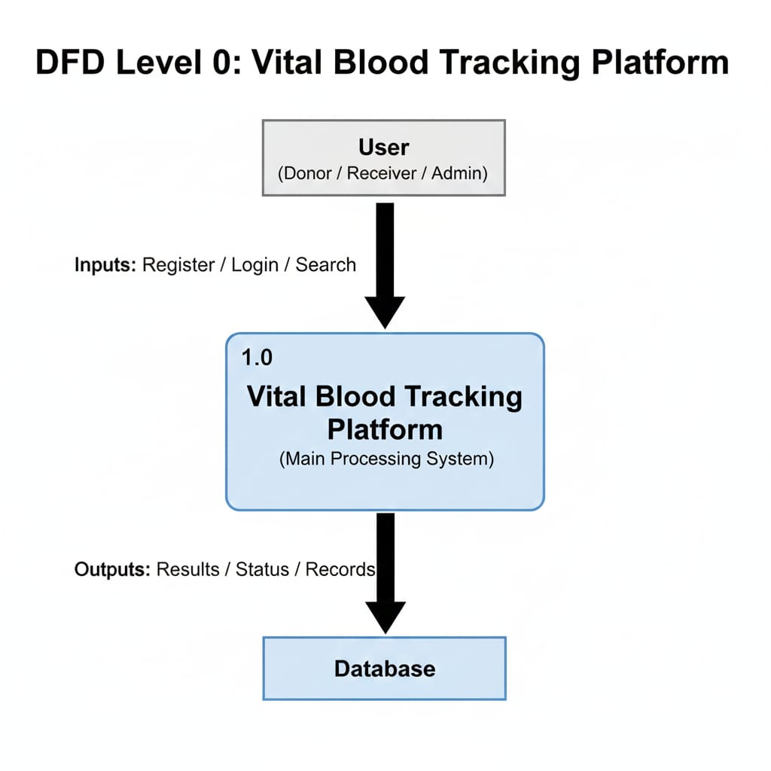
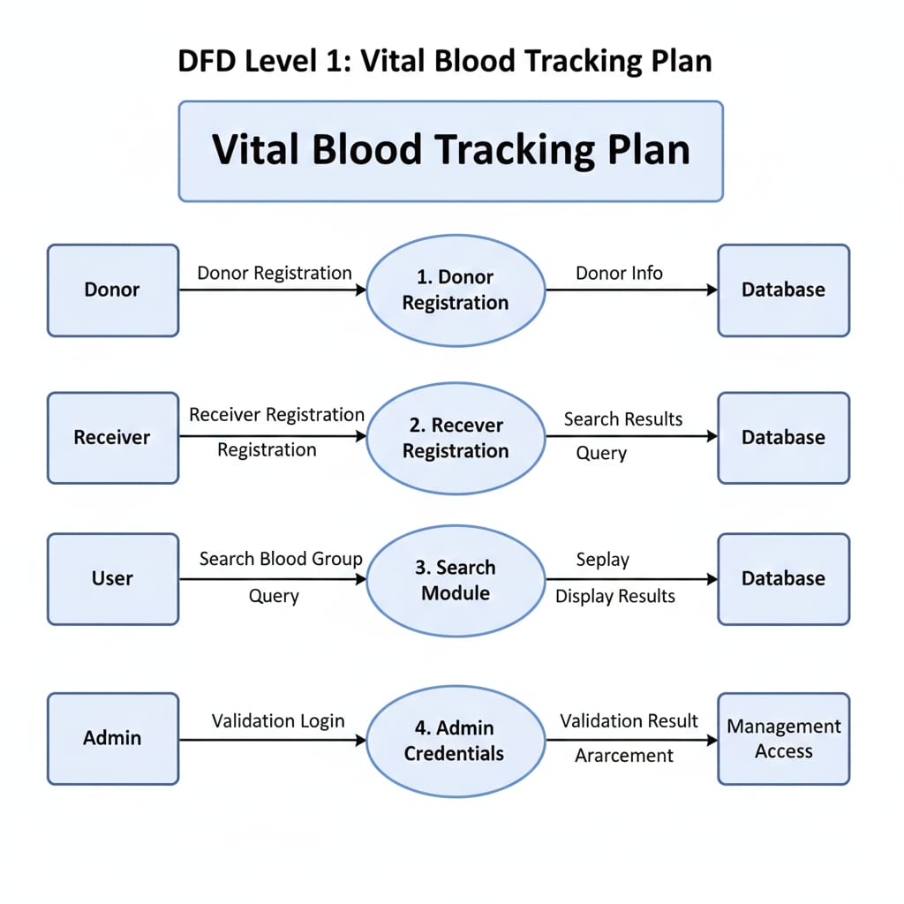
5.1 DFD Level 0

Dig. DFD Level 0

5.2 DFD Level 1

Dig. DFD Level 1

5.3 DFD Level 2(Donor)
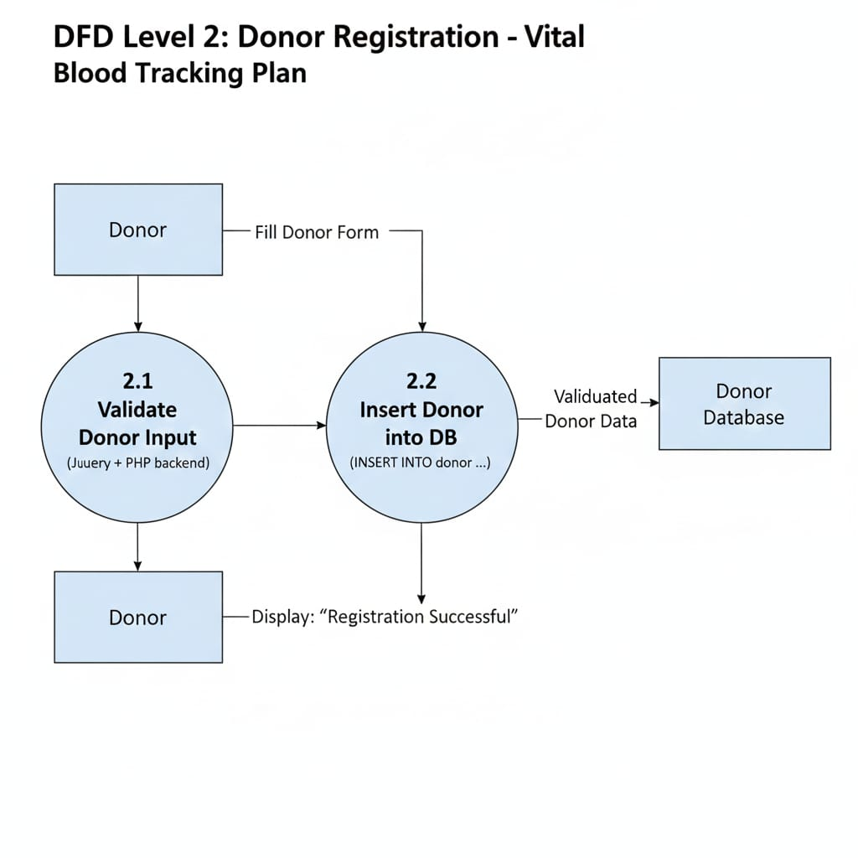

Dig. DFD Level 2(Donor)

5.4 DFD Level 2(Receiver)

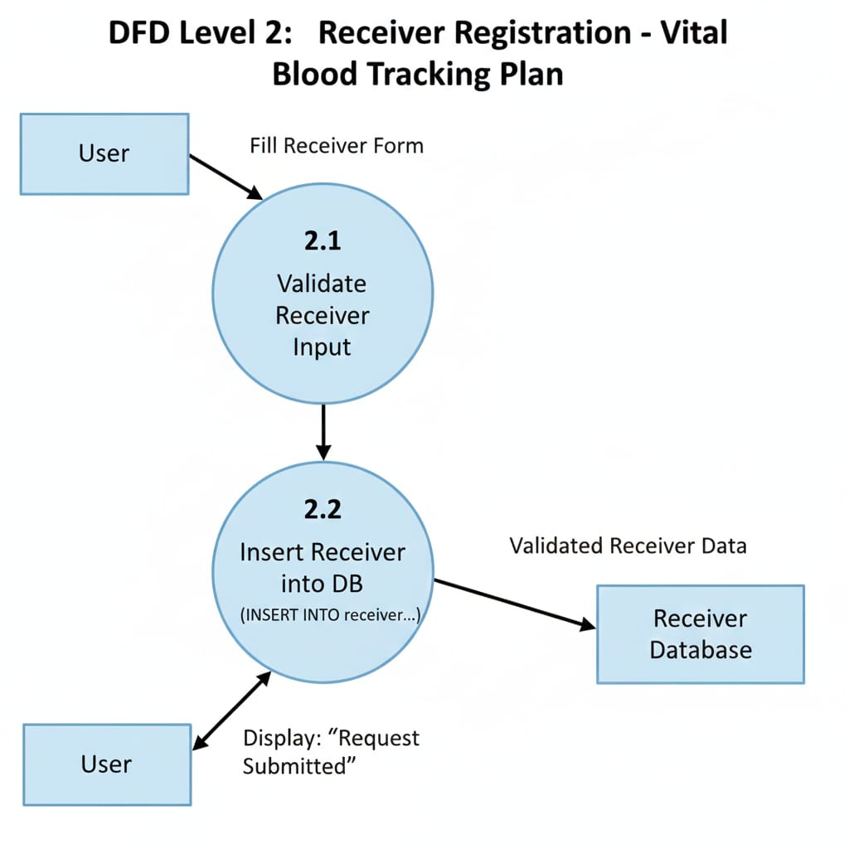

Dig. DFD Level 2(Receiver)

5.5 DFD Level 2(Search)
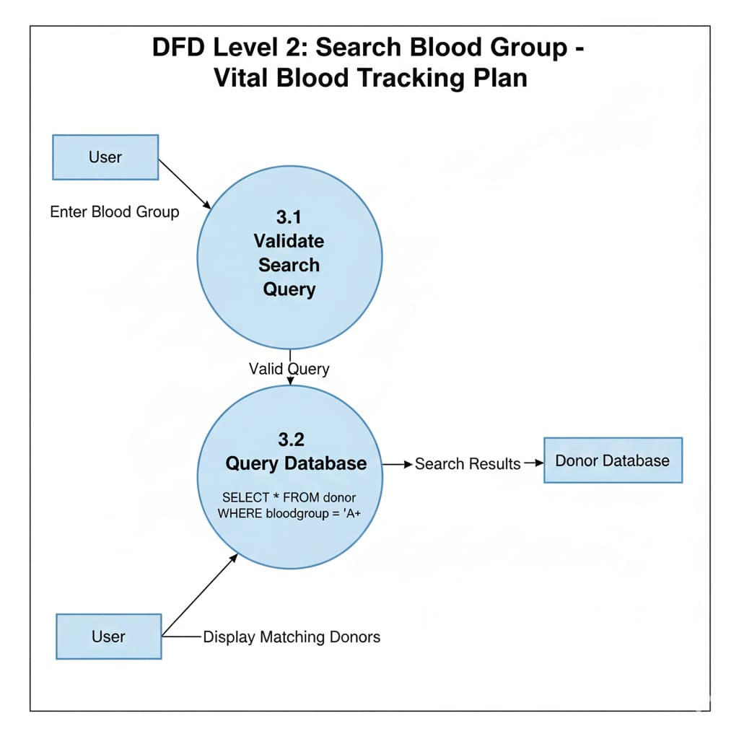

Dig. DFD Level 2(Search)

5.6 DFD Level 2(Admin)
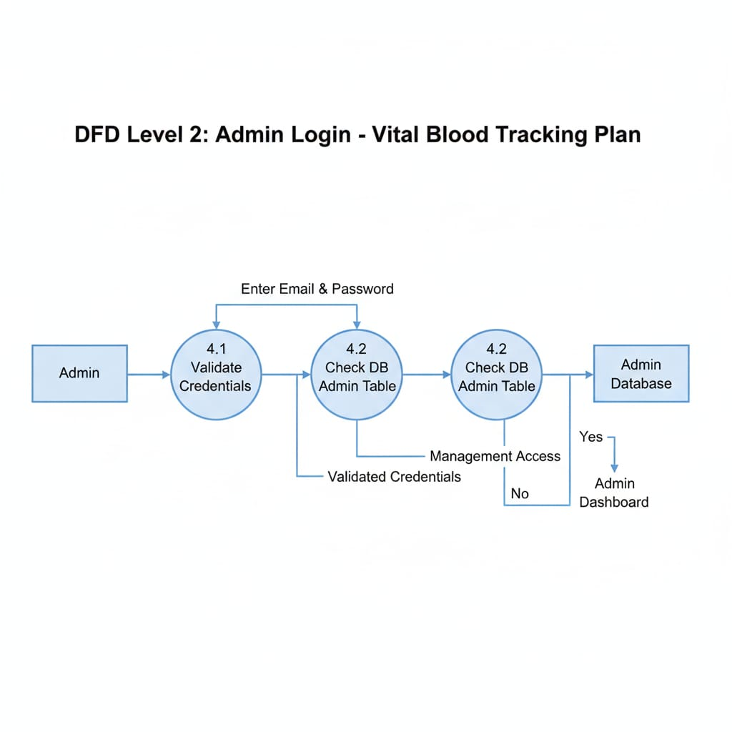

Dig. DFD Level 2(Admin)

Chapter 6 IMPLEMENTATION OF PROJECT

6.1 Implementation of Project
The implementation of a vital blood tracking platform involves collecting labeled datasets, preprocessing data and building a user-friendly interface. Below is a step-by-step implementation guide:
1 1. User and Admin Interaction
- The system has two main users: general users (donors/receivers) and admins.
- Users mainly fill out donation or request forms.
- Admins manage submitted data and monitor the system from the dashboard.
2. Donor/Receiver Form Filling
- The first step is when the user fills out the Donor/Receiver Form.
- This form collects essential details like name, age, blood group, phone number, address, etc.
- The form acts as an entry point for adding new donors or receivers to the database.
3. Form Validation (Server + JavaScript)
There are two levels of validation:
a) Client-Side (JavaScript) Validation
- As soon as the user fills the form, JavaScript checks:
  - required fields
  - correct phone number format
  - correct email format
  - valid age
- This prevents wrong inputs before sending the data to the server.
b) Server-Side (PHP) Validation
- After form submission, the server again verifies all information.
- It ensures no invalid or harmful data goes into the database.
4. Server Response Message
- Once validation is done:
  - If everything is correct → Success Message is shown.
  - If something is wrong → Error Message is displayed.
- This tells the user whether the submission was successful or not.

5. Admin Login and Dashboard
- The admin logs into the system using a secure login page.
- After login, the admin is redirected to the Dashboard.
- The dashboard displays:
  - total donors
  - pending requests
  - recent submissions
  - search tools
6. Form Submission (Backend Processing)
- After validation, the form data is processed by PHP.
- It prepares the data using prepared statements to avoid SQL injection.
- Then the form is ready to be stored in the database.
7. Insertion into Database
- The final validated data is inserted into the system database.
- This creates a new record of a donor or receiver.
- This stored data becomes available for admin view and searching.
8. Search Function Module
The system also includes a search feature for finding donors.
a) Search Donor by Blood Group
- Admin or user selects a blood group.
- Example: “A+”, “O–”, etc.
b) Query Database with Prepared Statements
- The system sends a secure SQL query to the database.
- Prepared statements keep the database safe from hacking (SQL injection).
c) Display Matching Donors
- If matching donors are found:
  - Their names, contacts, and locations are shown.
- If no match is found:
  - A “No Donor Found” message is displayed.

6.2 Screen shots of Project

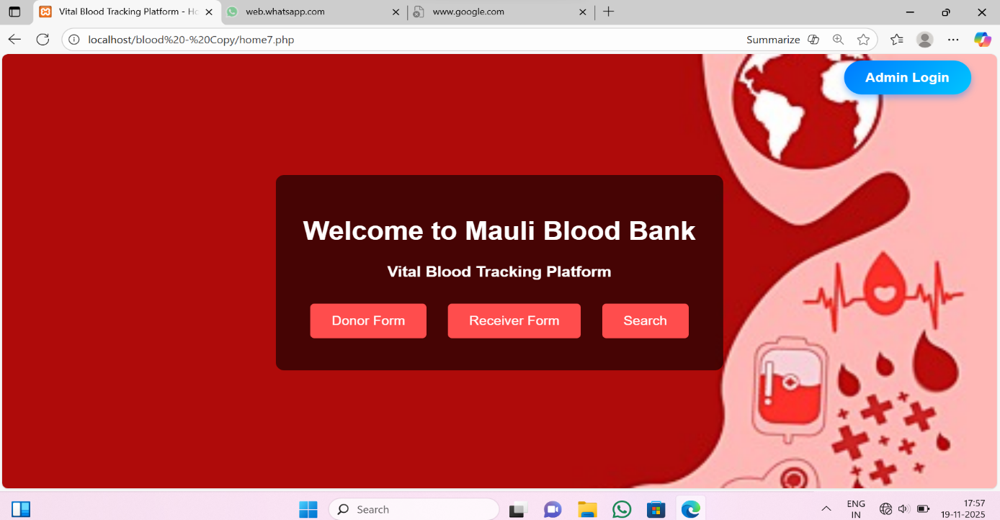

Fig: 1 Home Page

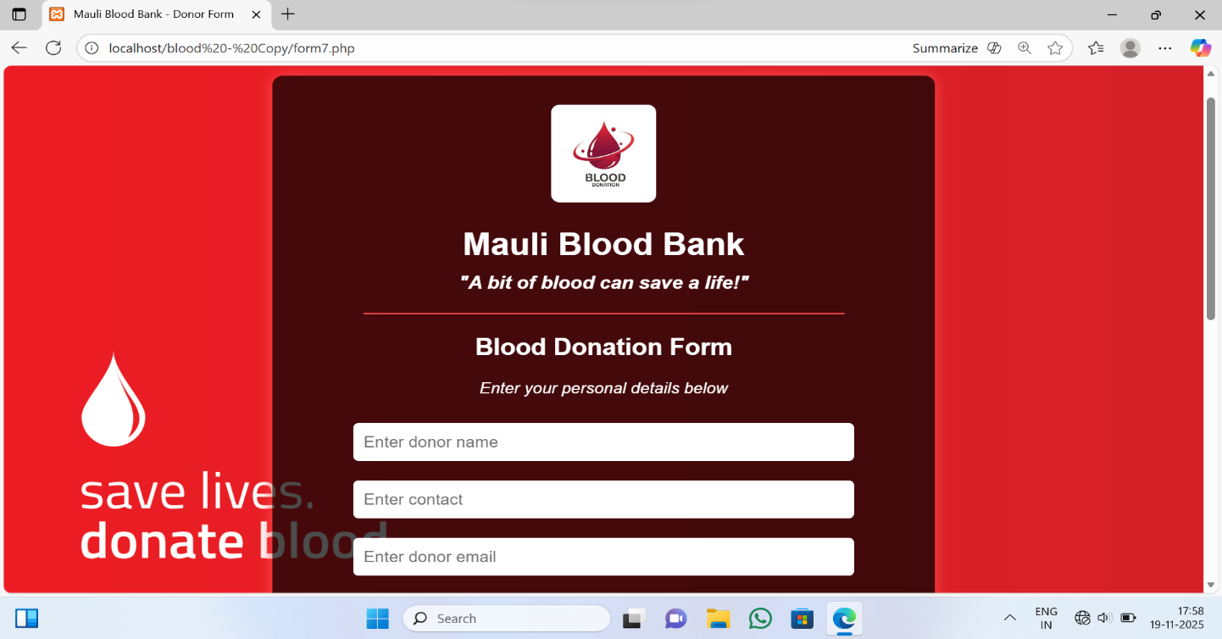

Fig: 2 Donor Form page

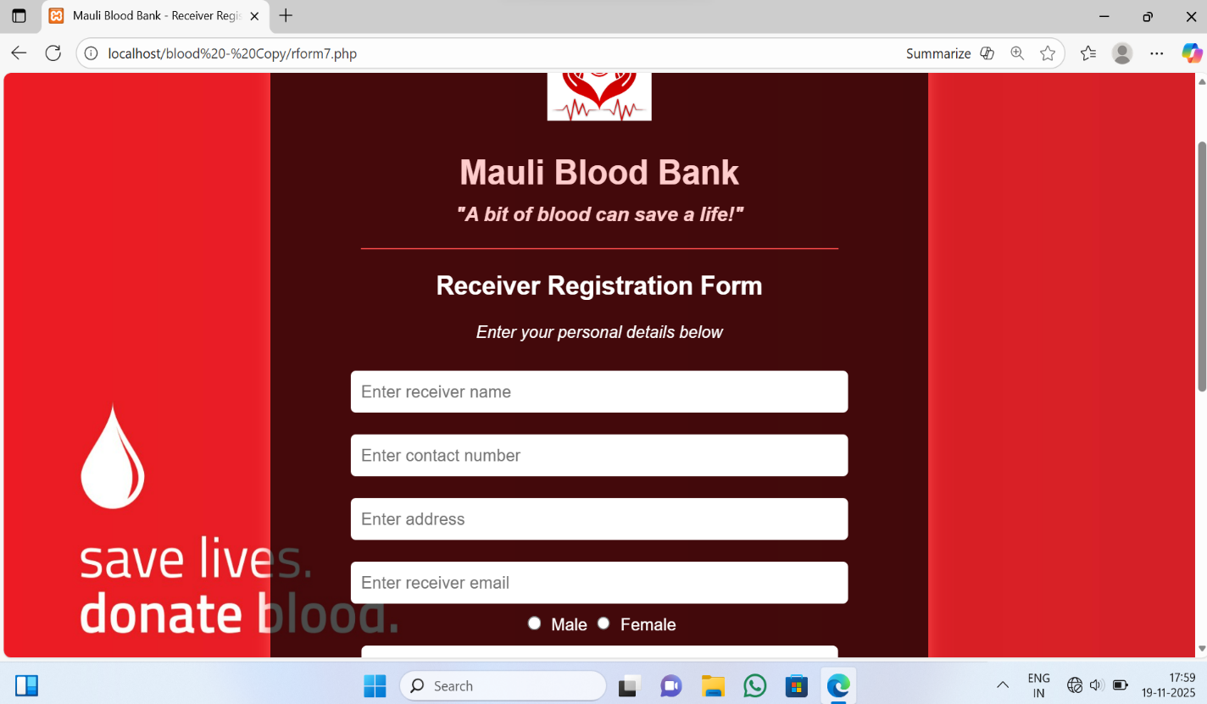
Fig: 3 Receiver Form Page

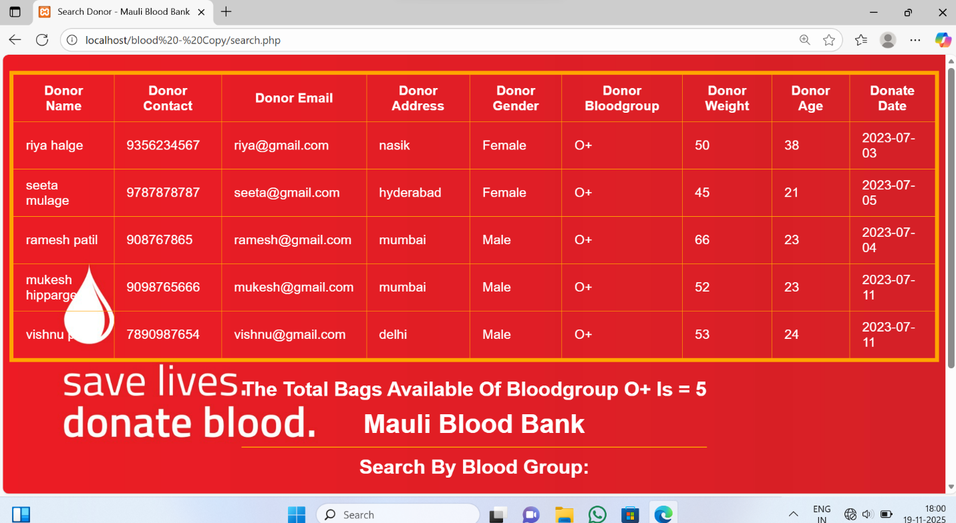

Fig: 4 Search Blood Page

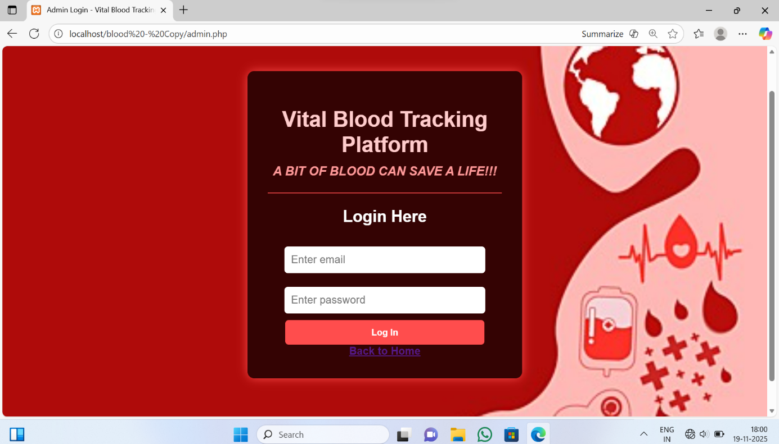

Fig.5 Admin Login Page

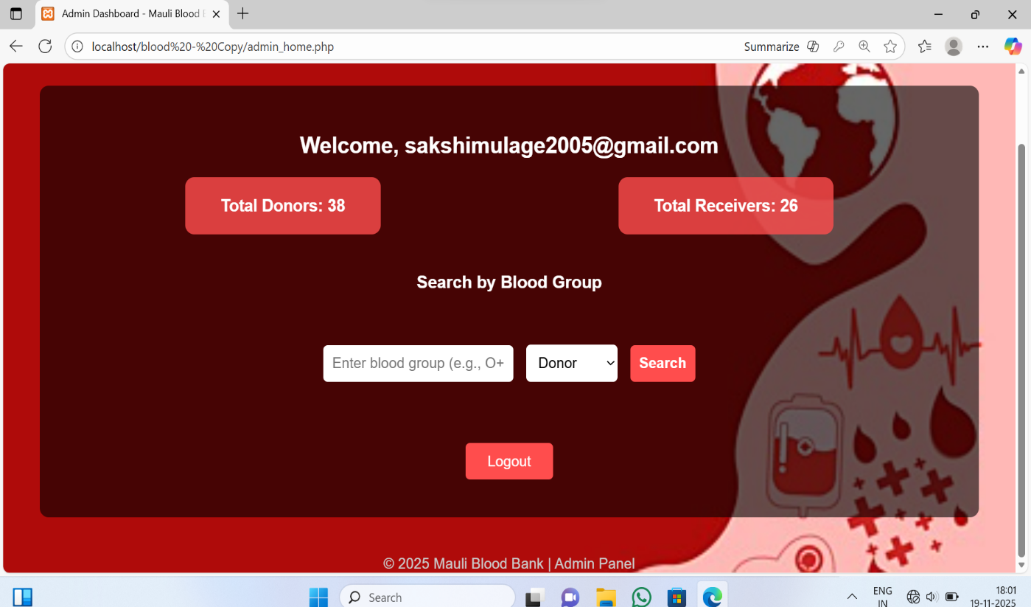

Fig. 6 Search Blood Group
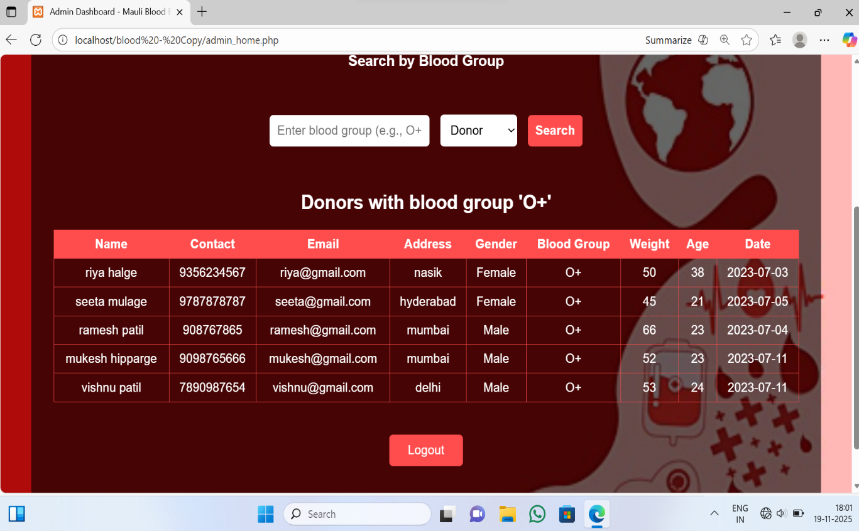

Fig.7 Search Donors Blood Group

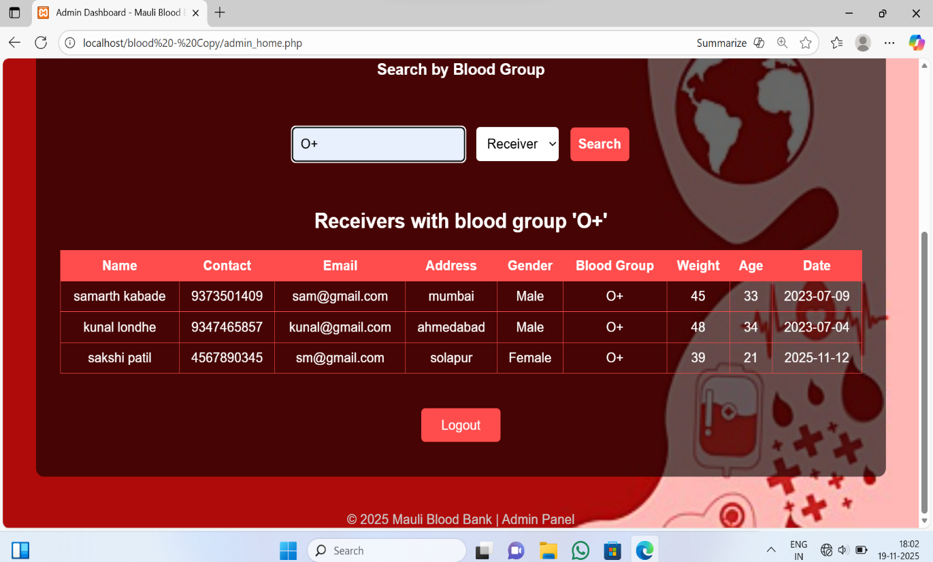

Fig.8 Search Receivers Blood Group

Chapter 6 CONCLUSION

CONCLUSION

The Vital Blood Tracking System provides an efficient, reliable, and technology-driven solution to manage the critical process of blood collection, storage, and distribution. By replacing traditional manual methods with an automated digital platform, the system ensures greater accuracy, transparency, and safety in handling blood units. Real-time tracking, automated alerts, and centralized data management help reduce human errors, minimize wastage, and ensure timely availability of required blood groups during emergencies.
This system not only simplifies the workflow for hospitals and blood banks but also enhances decision-making, improves donor management, and ensures safe transfusion practices. It contributes significantly to improving healthcare services by enabling fast access to updated information, ensuring quality control, and supporting emergency medical responses.
In conclusion, the Vital Blood Tracking System stands as an effective, scalable, and life-saving solution that supports both healthcare providers and patients by ensuring that the right blood reaches the right person at the right time.

