**Shell Foundation – Final Case Study Document**

1. **Azure Devops User Stories and Test Cases**

Link to the website-

<https://opensource-demo.orangehrmlive.com/web/index.php/auth/login>

1. **Azure Devops VM creation**

1. **Test Case Report**

Attached with an Excel file named TestCasesHRM.xlsx, there are 5 user stories with 5 test cases each

UserStory1

UserStory2



UserStory3

1. **Defect Report**

Defects which could be discovered are elucidated in the file named DefectReport.xlsx



Defects are as follows-

* Even after changing the password, the user is not able to login with the new password. The old password is not changed.

* User not able to file Tax exemptions as it is disabled

* When clicking on the My info tab in the navbar, at the title of the page PIM is displayed instead of My info, thus the interface has a bug

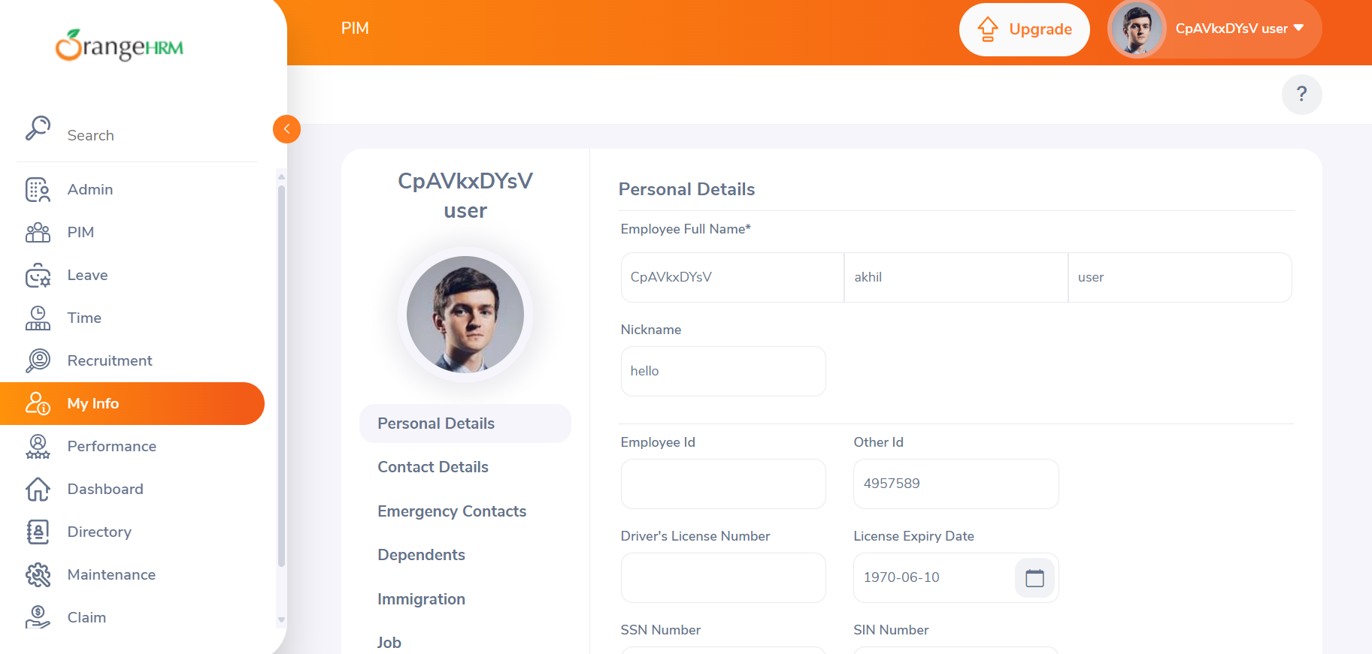

* Even when password is admin123, on entering Admin123 the user is able to login, thus case sensitivity for the password attribute has a bug

1. **Azure Devops Screenshots**

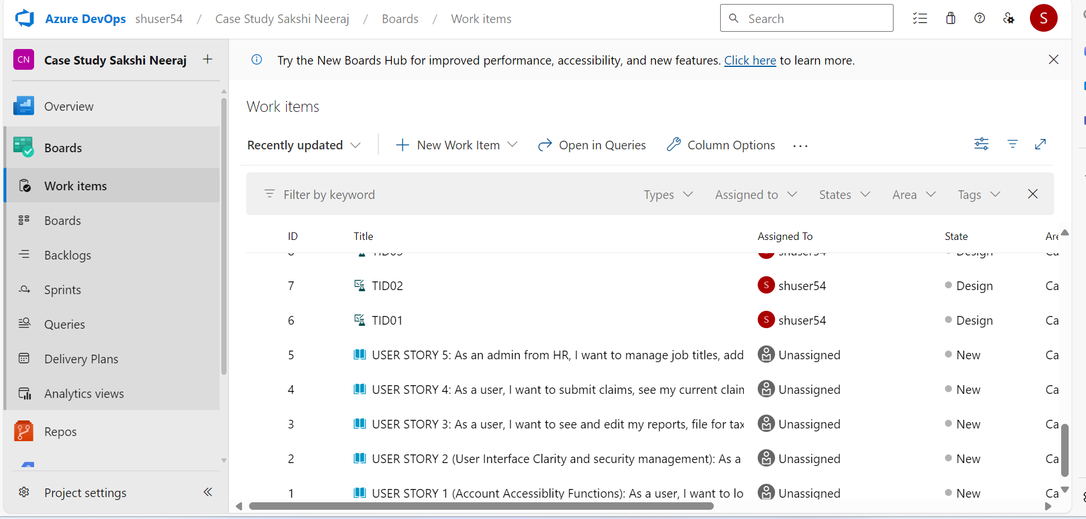

Epic name is HR management website. This epic contains 5 user stories and each user story contains 5 test cases.

Example structure of 1 user story with its test cases are-

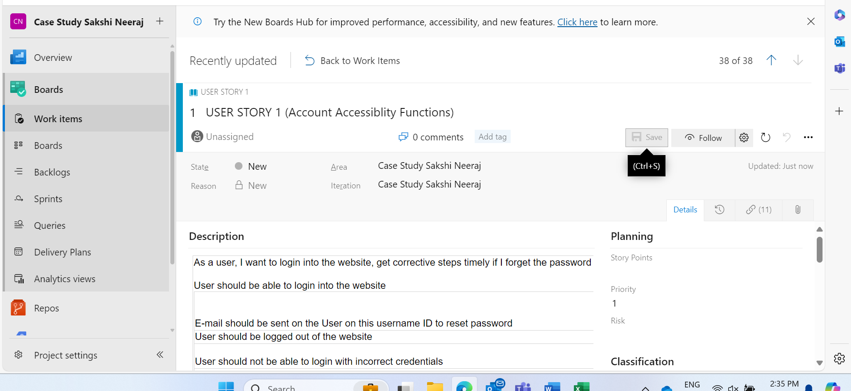

1. **Github Actions workflow**

* Making a repository named ‘Journey-PPT_Sakshi-Neeraj’
* Making a file named test_bmi_calculator.py which calculates the BMI of a person taking input of weight and height as the input. It takes an excel file with testcases.xlsx name to test the working of this program



* YAML file describing the workflow which automates the build of the python code

* Screenshots for successful build of the workflow

This screenshot shows that that testcases are run automatically. 2 of the test cases are passed but 1 has failed. This workflow automatically builds the program and runs the test cases.