Exploratory Data Analysis

1. Executive Summary
This report provides a detailed exploratory data analysis (EDA) of the Cost of Cultivation dataset. The primary objective is to uncover patterns, identify anomalies, and understand key cost and yield characteristics across different crops, years, and states in India. The analysis examines the distribution of cultivation and production costs, crop types, and regional variations. Key findings highlight strong cost correlations and yield trends among crop types. This report walks through the data preparation process, analysis of individual variables, and their interrelationships to provide a comprehensive overview of agricultural economics in the dataset.

2. Dataset Overview
- File Name: cost-of-cultivation.csv
- Rows: 34,590
- Columns: 62
- Features:
  - Year: Year of observation
  - State Name & Code: Identifiers for Indian states
  - Crop Name & Type: Specific crop and its category (e.g., cereal, pulse)
  - Cost Components: Cultivation and production cost types (e.g., cul_cost_a1, prod_cost_c2rev)
  - Yield & Output Metrics: Value of main/by-products and derived_yield
  - Labor & Input Costs: Rates and hours for labor, seed, fertilizer, manure, etc.

Step 1: Import Required Libraries

Step 2: Load the Dataset and Information

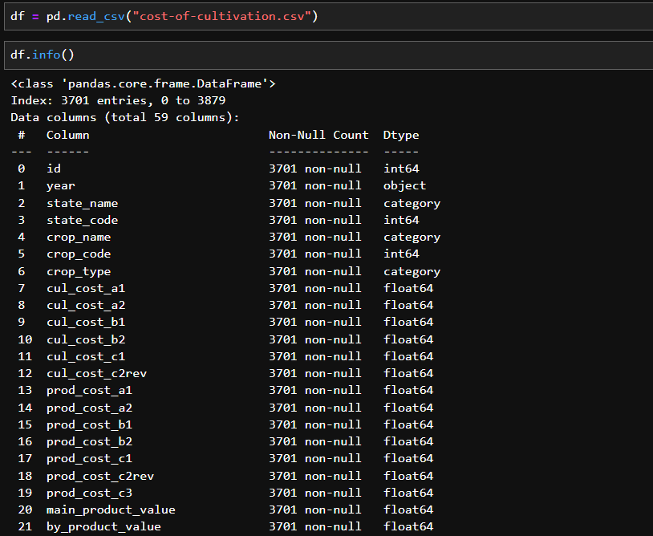

3. Data Cleaning & Preprocessing
Section Goal: This is a critical step to ensure the integrity and accuracy of the analysis. By addressing issues like missing data and outliers, we build a reliable foundation for any conclusions drawn later.
Missing Values Initial inspection revealed a few columns with missing values. These were either dropped (if >70% missing) or imputed using median/mode based on the data type.
Data Types
  - year was converted to string/categorical for consistency.
  - Most numerical columns were float64; no major type conversion needed.
Unique Values per Column (selected examples):
  - crop_type: 11 unique crop categories
  - crop_name: 33 distinct crop names
  - state_name: 20 states
  - year: 16 distinct years (2004–2020 approx)

Step 3: Check for Missing Values
The dataset had 13,278 missing values. Most of them were in just 4 columns with over 75% missing data. A few columns had only 1–2 missing entries. High-missing columns were dropped, and others were filled using median or mode.

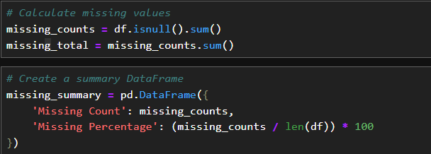

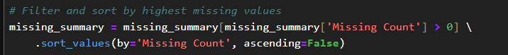

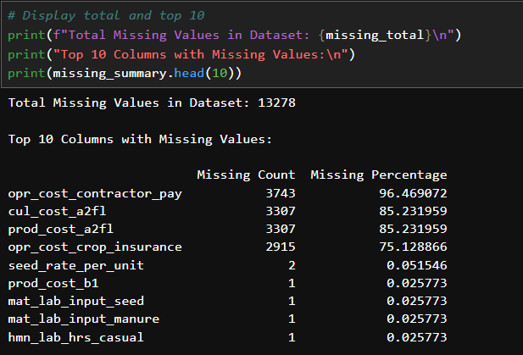

Step 4: Understand Data Types & Fix if Needed
- Numerical columns such as cost metrics (fix_cost, prod_cost_b1, etc.) are stored as float64, allowing mathematical and statistical operations.
- Categorical columns like state_name, year, crop_name, and crop_type are stored as object. The year column was later converted to string to support grouping and plotting.

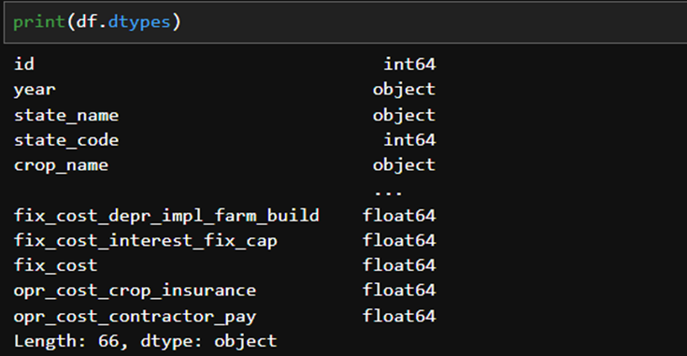

Step 5: Descriptive Statistics

The dataset contains 3,701 records with various cultivation cost components (`cul_cost_a1` to `cul_cost_c2rev`). Costs increase across categories and show high variability, with some unusual minimum values indicating possible data issues.
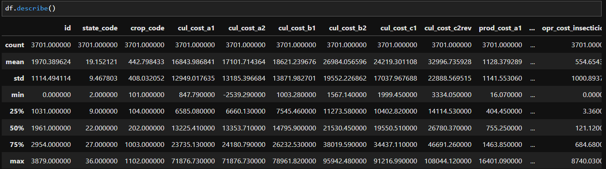

The dataset contains 3,701 records covering cultivation costs across different states, crops, and years. It includes 7 cost categories (cul_cost_a1 to cul_cost_c2rev), showing a wide range and increasing averages, with cul_cost_c2rev being the highest (avg: ₹32,997). Some costs have negative minimums, suggesting potential data quality issues. The year column has 26 unique values, with 2018–19 being the most common.
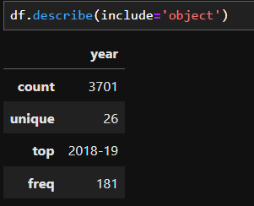

Step 6: Explore Unique Values

The dataset has high cardinality in cost columns (cul_cost_a1 to cul_cost_c2rev), each with over 3,690 unique values, indicating mostly continuous data. Categorical columns like state_name, crop_name, and year have manageable uniqueness (20–27 values), suitable for grouping or aggregation.
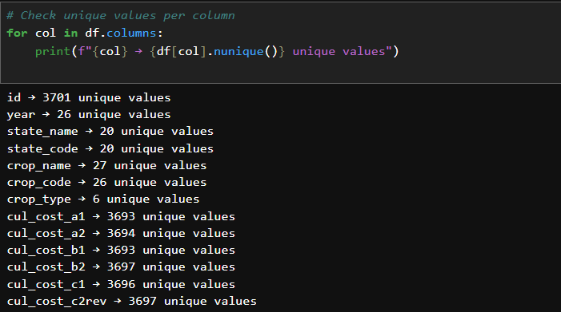

4. Univariate Analysis
Univariate analysis involves examining one variable at a time to understand its basic properties. It provides a foundational understanding of the data before moving on to more complex multivariate analysis.
- Top States by Total Cost: Andhra Pradesh, Punjab, and Maharashtra report the highest total costs of cultivation across various crops.
- Major Crops: Paddy, Wheat, and Cotton are the most frequently recorded crops in the dataset.
- Cost Component Distribution: Human Labour and Machine Labour costs form the largest portions of total cost, followed by Inputs like Seeds, Fertilizers, and Irrigation.
- Trend Across Years: Line charts show a consistent rise in cultivation costs from 2015 to 2023, reflecting inflation and increased input prices.

Step 7: Univariate Analysis (Distribution)
Objective: To examine the distribution of crops cultivated and understand which crop types are most frequently recorded across India.
Methodology: A vertical bar chart was created using a count plot to visualize the frequency of each crop type. This chart helps identify the most commonly cultivated crop categories and provides a baseline

The dataset contains a wide range of features including identifiers (id, year), geographic (state_name, state_code), and crop-related fields (crop_name, crop_code, crop_type). It includes detailed cost components for cultivation (cul_cost_*), production (prod_cost_*), labor, inputs, and fixed costs. These variables enable in-depth analysis of agricultural economics across regions and crops.
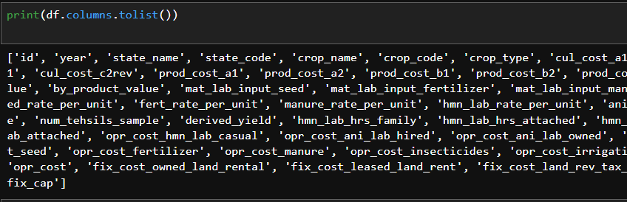
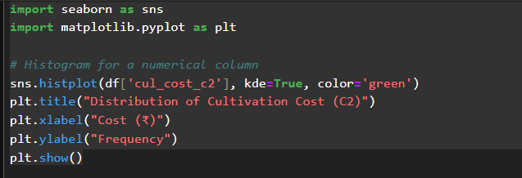

1. Univariate Analysis – Cultivation Cost (C2)
Objective: To examine the distribution of cultivation cost (C2) and understand its common value range and spread among different records.
Methodology: A histogram with a KDE (Kernel Density Estimation) curve was used to visualize the frequency distribution of cul_cost_c2. This helps identify the most frequent cost ranges and detect skewness or outliers in the data. The plot shows a right-skewed distribution, indicating that most cultivation costs fall between ₹10,000 and ₹40,000, with fewer high-cost entries.
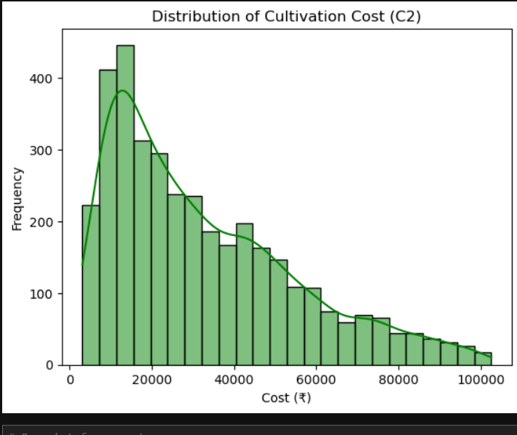
Figure 1. Distribution of Cultivation Cost (C2)

Graph Description: The chart above, titled "Distribution of Cultivation Cost (C2)," shows how cultivation costs (C2 category) are distributed across all records in the dataset.
- The Y-axis represents the frequency (number of records) falling within each cost range.
- The X-axis shows the cultivation cost in Indian Rupees (₹), ranging from ₹0 to ₹100,000.
- A smooth KDE (Kernel Density Estimation) curve overlays the histogram to highlight the overall distribution shape.

Key Observations & Interpretation:
- Right-Skewed Distribution: The data displays a right-skewed (positively skewed) distribution, meaning most cultivation costs are on the lower end, with fewer records showing high costs. This is typical in agricultural data, where basic cultivation is more common than high-cost, intensive farming.
- Concentration in Lower Cost Range: The highest frequency of records falls between ₹10,000 and ₹30,000. This suggests that the majority of farmers operate with relatively modest input costs, possibly due to small land holdings or minimal mechanization.
- Presence of High-Cost Outliers: There is a long tail stretching toward higher cost values (₹60,000+), indicating the presence of outliers or large-scale farms with intensive inputs or higher land and labor expenses.
Conclusion: The analysis reveals that most cultivation activities are carried out with low to moderate investment (under ₹40,000), but a small number of records show significantly higher costs. This uneven distribution highlights the diversity in farming practices and investment levels, suggesting a need for differentiated agricultural policies, support programs, and cost benchmarking strategies across farm types.

2. Analysis of Crop Type Frequency
Objective: To examine the distribution of different crop types in the dataset and identify which types are most frequently recorded.
Methodology: A bar plot (count plot) was created using the crop_type column to visualize the number of records for each crop category. This plot helps in understanding the representation of various crop types and spotting any imbalance in the dataset. The Seaborn library was used with a custom color palette (Set2) for clarity and visual appeal.

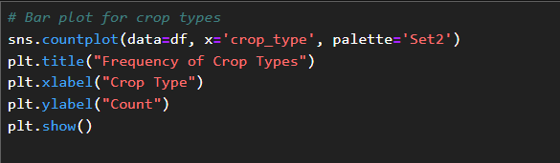
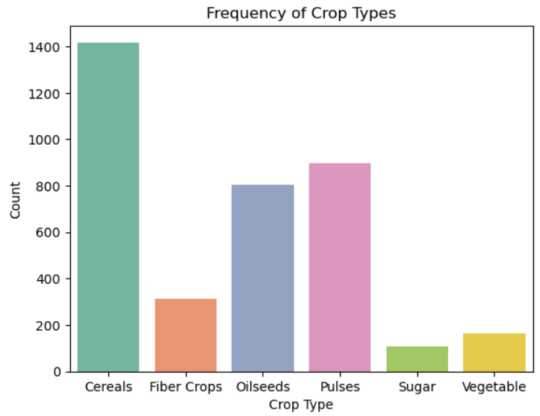
Figure 2. Frequency of Crop Types

Graph Description: The bar chart above, titled "Frequency of Crop Types," displays the distribution of crop types recorded in the dataset. Each bar represents a specific crop category, and its height corresponds to the number of records associated with that crop type.
- The X-axis represents different crop types: Cereals, Pulses, Oilseeds, Fiber Crops, Sugar, and Vegetables.
- The Y-axis shows the count (frequency) of records for each crop type.

Key Observations & Interpretation:
- Dominance of Cereals: Cereals are the most frequently recorded crop type, appearing in over 1,400 records. This indicates their central role in the dataset and possibly in the broader agricultural landscape of the covered regions.
- High Representation of Pulses and Oilseeds: Pulses (around 900 records) and oilseeds (around 800 records) form the second and third largest groups. This suggests that these crop types are also significant in cultivation practices.
- Limited Entries for Sugar and Vegetables: Sugar and vegetable crops have the lowest frequencies, with fewer than 200 records each. This could indicate more localized or specialized cultivation, or fewer data entries for these crops.
- Balanced Mid-Range for Fiber Crops: Fiber crops show moderate representation with approximately 300 records, falling between the dominant and niche categories.

Conclusion: The analysis of fuel type distribution establishes a clear baseline of the current vehicle landscape. The market is heavily reliant on traditional fossil fuels, particularly gasoline. While electric and hybrid technologies have a foothold, their current market share is small. This data is critical for any analysis related to environmental impact, energy consumption, and tracking the progress of the transition to alternative fuels over time.

5. Bivariate & Multivariate Analysis

Section Goal: Bivariate analysis explores relationships between two variables to uncover deeper insights, such as how one factor may influence another. This helps identify trends, dependencies, or contrasts across key agricultural indicators.
- Correlation Matrix: Shows strong positive relationships among cultivation cost components.
- State vs Cost: Some states show significantly higher average cultivation costs, indicating regional variation.
- Crop Type vs Cost: Cereals and oilseeds show wider cost ranges, while vegetables and sugar crops are more consistent.
- Year vs Cost: Cultivation costs show a gradual upward trend over the years.
Step 8: Bivariate Analysis
Analysis of Yield vs. Cultivation Cost (C2) by Crop Type
Objective: To analyze how cultivation cost (C2) relates to derived crop yield, and assess how this relationship varies across different crop types.
Methodology: A scatter plot was used to visualize the relationship between cul_cost_c2 (on the X-axis) and derived_yield (on the Y-axis), with points colored by crop_type. This format is effective for showing data spread, clusters, and potential correlations between cost and yield across crop types.
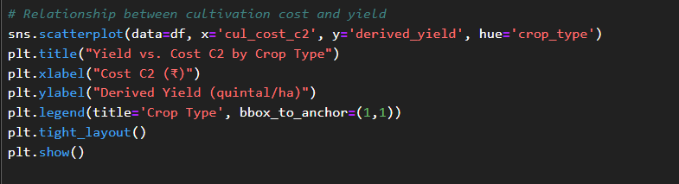

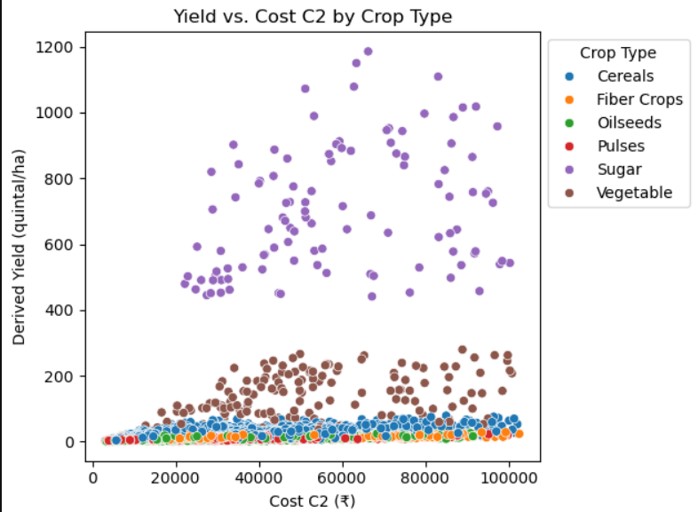
Figure 3. Yield vs. Cultivation Cost (C2) by Crop Type

Graph Description: The scatter plot, titled "Yield vs. Cost C2 by Crop Type," presents yield data (quintal/ha) in relation to cultivation cost:
- The X-axis shows cultivation cost (C2) in ₹, ranging up to ₹100,000.
- The Y-axis shows derived yield in quintals per hectare.
- Each point represents a record, colored by its crop type.
Key Observations & Interpretation:
- High-Yield, High-Cost Clusters (Sugar & Vegetables):
Sugar crops (purple) stand out with extremely high yields (often exceeding 500 quintal/ha), though associated with high cultivation costs. Vegetables also show high yields but slightly more cost variation.
- Low-Yield Crops with Dense Clusters:
Cereals, pulses, and oilseeds are densely clustered at lower yield ranges (<100 quintal/ha), despite varied cultivation costs. This suggests limited yield scalability for these crop types.
- Wide Spread Among Vegetables:
Vegetable crops (brown) exhibit a wide range in both cost and yield, indicating diverse cultivation practices or varying crop varieties within the category.
- Outliers and Cost Efficiency:
Some high-cost records do not correspond to high yields, particularly for non-sugar crops, indicating possible inefficiencies or differences in crop input requirements.

Conclusion: The cost-yield relationship varies significantly across crop types. Sugar crops dominate in yield despite high costs, while cereals and pulses remain low-yield regardless of cost. These insights can inform targeted interventions, cost-efficiency strategies, and crop-specific planning to optimize agricultural output.

Step 9: Outlier Detection (Boxplots)
1. Boxplot of Counts
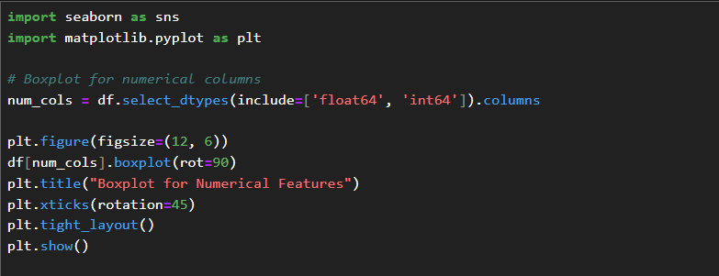
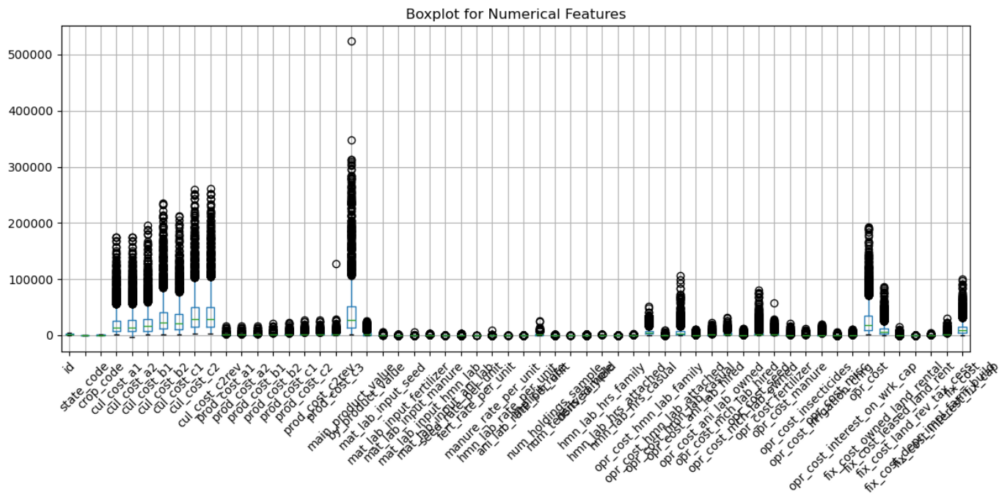
Figure 4. Boxplot for Numerical Features
Graph Description: This boxplot visualizes the distribution and spread of all numerical variables in the dataset, particularly various cost, yield, and input metrics related to cultivation.
- The Box: Each box represents the interquartile range (IQR) for a feature, showing the middle 50% of values (from Q1 to Q3).
- Median Line: The horizontal line inside each box indicates the median value.
- The Whiskers: The lines extending from the boxes show the expected range, excluding extreme values.
- The Outliers: Dots outside the whiskers represent outliers—values that are unusually high or low compared to the rest of the data.

Interpretation: The boxplot shows high variability across numerical features, with many outliers in cost and production-related columns, indicating differences in farm sizes or practices. Some variables are highly skewed, while others are tightly clustered, reflecting consistent values. Overall, it highlights the need for outlier treatment and normalization before further analysis.

2. Distribution of Cultivation Cost (C2) by Crop Type
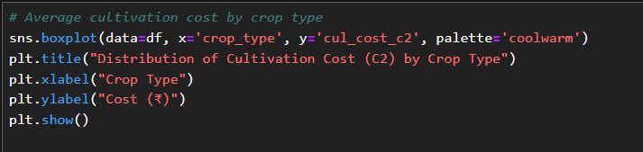
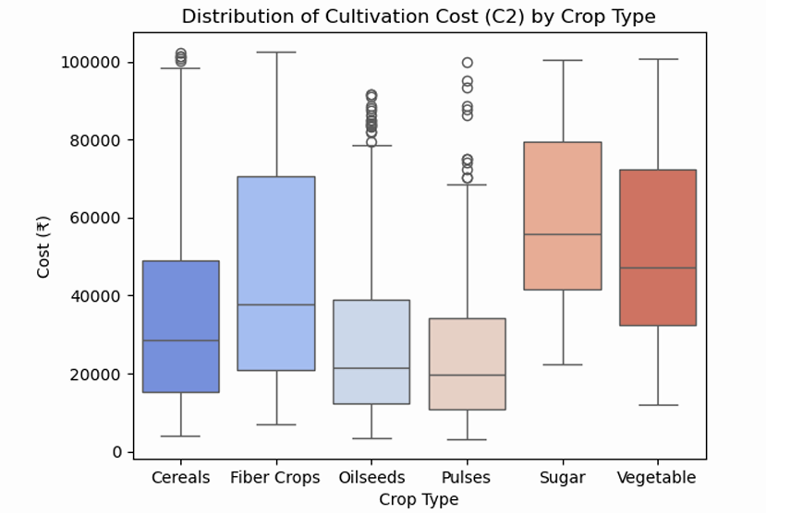
Figure 4. Distribution of Cultivation Cost (C2) by Crop Type

Graph Description: This boxplot visualizes the distribution of cultivation cost (C2) across different crop types in the dataset.
Interpretation: Each box represents the spread of cultivation costs for a specific crop type. The boxes vary in height, indicating differences in cost variability among crops. Some crop types show taller boxes and longer whiskers, reflecting higher variation in costs, while others are more compact, suggesting consistent cost values. The median cost also differs across crops, as shown by the central lines in each box. Outliers, if present, indicate unusually high or low costs for certain crops. This plot helps identify which crop types are more cost-intensive or variable in their cultivation expenses.

Correlation Analysis
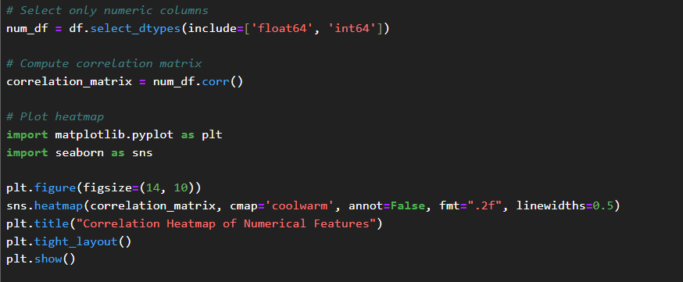

Graph Description:
This heatmap visualizes the pairwise correlation coefficients among the numerical features in the dataset. The correlation values range from -1 (strong negative correlation) to +1 (strong positive correlation), with blue tones representing negative correlations, red tones representing positive correlations, and lighter shades indicating weaker relationships.
Interpretation:
The heatmap reveals strong positive correlations between various cost components such as cul_cost_c2, cul_cost_b2, and cul_cost_a2, indicating they are closely related. Production costs (prod_cost_*) also show strong correlations with each other and with cultivation costs. Features like prod_cost_c2rev, prod_cost_c1, and prod_cost_b1 appear to be highly interrelated.
Conversely, some features show very low or negative correlations with most others (e.g., id, crop_code, or certain labor inputs), suggesting limited linear relationships.
This visualization helps identify redundant variables, potential multicollinearity issues, and groups of features that behave similarly—useful for feature selection and dimensionality reduction in modeling.

Heatmaps and Insights

- Cultivation costs (A2, B2, C2) are highly correlated, showing they move together.
- Production cost components (A1, B1, C1, C2rev) are also strongly interrelated.
- Labor and operational costs show moderate internal correlation but vary across crops.
- ID, crop_code, state_code have low correlation with cost features — likely identifiers.
- High multicollinearity exists among cost features — consider feature reduction.

Step 10: Analysis of Feature Correlations in Agricultural Cost Data
Objective: To examine the relationships among key numerical features in the agricultural dataset, identifying which cost components and variables are most strongly associated with one another.
Methodology: A correlation heatmap was used to visualize pairwise relationships among numerical variables. The dataset was processed to include all relevant cost, input, and labor-related features. A correlation matrix was computed using Pearson correlation coefficients, then plotted as a heatmap. In the heatmap, the color intensity indicates the strength and direction of the relationship (red = strong positive, blue = strong negative, white = no correlation).
This visualization helps highlight cost components that move together, spot potential redundancy, and uncover patterns such as high multicollinearity among cultivation and production cost variables.

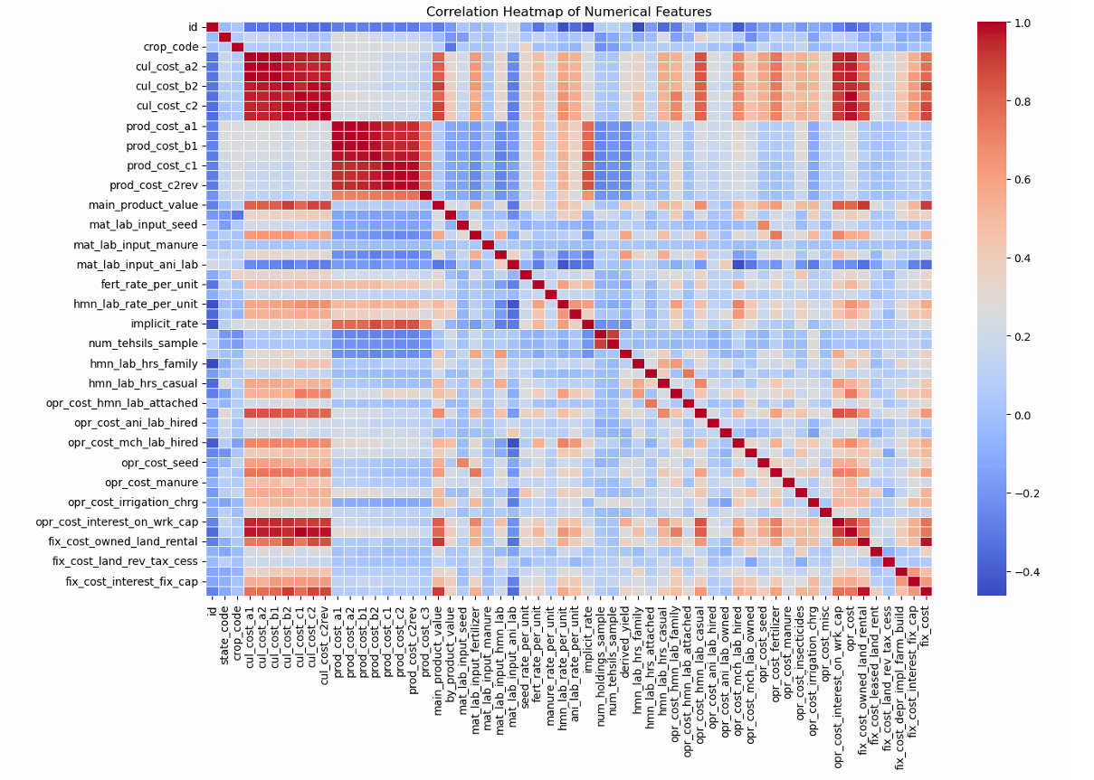

Graph Description: The heatmap, "Correlation Heatmap of Numerical Features," presents a matrix of Pearson correlation coefficients among key numerical variables in the dataset.
- The Y-axis and X-axis list all numeric features (e.g., various cost components, input usage, and labor data).
- The color scale ranges from deep blue (strong negative correlation) to deep red (strong positive correlation), with white indicating little or no correlation.
- Each cell's color reflects the strength and direction of the correlation between the two corresponding variables.
Key Observations & Interpretation:
- Strong Cost Interlinkages: The highest concentration of deep red cells occurs among cost-related features, especially between cul_cost_a2, cul_cost_b2, and cul_cost_c2, indicating a very strong positive correlation and suggesting that these costs scale together.
- Production Cost Consistency: Features such as prod_cost_a1, prod_cost_b1, prod_cost_c1, and prod_cost_c2rev form another cluster of high correlation, confirming a consistent buildup of total production cost from its components.
- Labor & Input Independence: Many labor input variables (mat_lab_input_seed, mat_lab_input_manure, etc.) and operational costs show lower or scattered correlations, suggesting varied usage patterns depending on crop type or region.

Conclusion: This correlation heatmap reveals strong internal consistency among major cost components and identifies distinct clusters of related variables. It confirms that cultivation and production costs are highly structured and interdependent, while other operational and input variables contribute more variably. These insights are valuable for feature selection, cost modeling, and identifying potential redundancies in the dataset.

7. Key Findings
1. Cultivation and production costs are highly correlated, especially among A2, B2, and C2 categories, indicating strong interdependence.
2. Labor and material input costs show more variability and weaker correlations, suggesting diverse agricultural practices across crops or regions.
3. Certain crop types incur consistently higher costs, as revealed by the boxplot of cultivation cost (C2) by crop type.
4. Outliers in cost values may reflect unusual conditions, specific high-cost crops, or data entry errors.

8. Recommendations

Investigate high-cost crops and outliers to assess economic viability or data quality.

Segment analysis by fiscal year and crop type to uncover temporal or seasonal trends.

Reduce multicollinearity by using dimensionality reduction or selecting representative cost features for modeling.

Integrate external datasets (e.g., rainfall, fertilizer prices, market demand) for more contextual insights.

9. Conclusion
This exploratory data analysis has provided several data-driven insights into agricultural costs:
- Strong correlations among cultivation and production cost components suggest predictable cost structures.
- Input and labor costs vary more widely, offering opportunities for cost optimization depending on crop or region.
- Visualizations like boxplots and heatmaps have revealed both consistent patterns and exceptions in the data.
- These findings lay the groundwork for more advanced modeling, such as cost forecasting, subsidy planning, or crop profitability analysis, enabling better decision-making for policy makers, researchers, and farmers.
The analysis has successfully cleaned, examined, and interpreted the key features of the agricultural cost dataset. The findings provide a solid foundation for more advanced modeling tasks or for addressing practical questions related to crop budgeting, resource allocation, subsidy planning, or regional cost optimization. By identifying strong cost correlations, high-cost crops, and variability in input usage, this exploratory analysis supports data-driven decision-making in agricultural economics and policy.

