Key Performance Indicators (KPI) for Pizza Sales Analysis Project

1.SELECT SUM(total_price) AS Total_Revenue FROM pizza_sales;

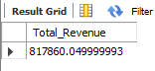

2. SELECT SUM(total_price)/COUNT(DISTINCT order_id) AS Avg_order FROM pizza_sales;

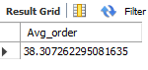

3. SELECT SUM(quantity) as Pizza_sold FROM pizza_sales;

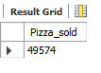

4. SELECT COUNT(DISTINCT order_id) AS Total_order FROM pizza_sales;



5. SELECT CAST(CAST(SUM(quantity) AS DECIMAL(10,2)) /

CAST(COUNT(DISTINCT order_id) AS DECIMAL(10,2)) AS DECIMAL(10,2)) AS Avg_pizza_sold

FROM pizza_sales;

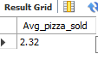

6. SELECT DAYNAME(order_date) AS Days, COUNT(DISTINCT order_id) AS Total_orders

FROM pizza_sales

GROUP BY DAYNAME(order_date);

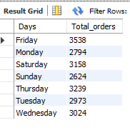

7. SELECT MONTHNAME(order_date) AS Month_name, COUNT(DISTINCT order_id) AS Total_orders

FROM pizza_sales

GROUP BY MONTHNAME(order_date)

ORDER BY Total_orders DESC;

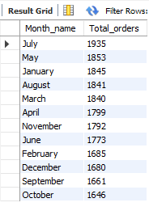

8. SELECT pizza_category,SUM(total_price) AS Total_sales, SUM(total_price) * 100/

(SELECT SUM(total_price) FROM pizza_sales) AS Percentage_T

FROM pizza_sales

GROUP BY pizza_category;

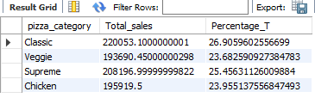

9. SELECT pizza_size, CAST(SUM(total_price) AS DECIMAL(10,2)) AS Total_sales, CAST(SUM(total_price) * 100/

(SELECT SUM(total_price) FROM pizza_sales) AS DECIMAL(10,2)) AS Percentage_T

FROM pizza_sales

GROUP BY pizza_size

ORDER BY Percentage_T DESC;

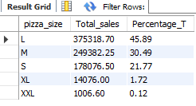

10. SELECT pizza_category, SUM(quantity) AS Total_Quantity_sold

FROM pizza_sales

GROUP BY pizza_category

ORDER BY SUM(quantity) DESC;

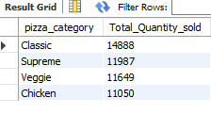

11. SELECT pizza_name, SUM(total_price) AS Total_revenue

FROM pizza_sales

GROUP BY pizza_name

ORDER BY Total_revenue DESC -- (desc/asc)

LIMIT 5;

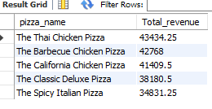

11(2). SELECT pizza_name, SUM(quantity) AS Total_quantity

FROM pizza_sales

GROUP BY pizza_name

ORDER BY Total_quantity DESC -- (desc/asc)

LIMIT 5;

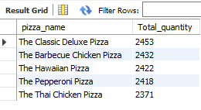

11(3). SELECT pizza_name, COUNT(DISTINCT order_id) AS Total_orders

FROM pizza_sales

GROUP BY pizza_name

ORDER BY Total_orders DESC -- (desc/asc)

LIMIT 5;

