Operating System

Report
Assignment Simulation Based

Programming Problem 11 Operating
System By Galvin 9th Edition

11. Design a scheduler that uses a preemptive priority scheduling algorithm based on dynamically changing priority. Larger number for priority indicates higher priority.
Assume that the follwing processes with arrival time and service time wants to execute(for reference):

ProcessID ArrivalTime ServiceTime
P1 0 4
P2 1 1
P3 2 2
P4 3 1

When the process starts execution(i.e. CPU assigned),priority for that process changes at the rate of m=1.When the process waits for CPU in the ready queue(but not yet starts execution), its priority changes at rate n=2. All the processes are initially assigned priority value of 0 when they enter ready queue for the first time.The time slice for each process is q=1. When two processes want to join ready queue simulataneously, the process which has not executed recently is given priority. Calculate the average waiting time for each process. The program must be generic i.e. number of processes,their burst time and arrival time must be entered by user.

Student Name: Sakshi Priya
Student ID: 11609970
Section No: K1655
Roll No.: A20
Email Address: sakshi.priya@outlook.com
GitHub Link:https://github.com/SakshiPrRoy/OS-Assignment

Priority Scheduling
Priority scheduling is a non-preemptive algorithm and one of the most common scheduling algorithm. Each process is assigned first arrival time(less arrival time process first) if two processes have same arrival time, then compare to priorities(higher priority first). Also, if two processes have same priority then compare to process number(less process number first). This process is repeated while all process get executed.

Implementation--

1. First input the processes with their arrival time, burst time and priority.
2. Sort the processes, according to arrival time if two process arrival time is same then sort according process priority if two process priority are same then sort according to process number.
3. Now simply apply FCFS algorithm.

Compile and Run:

Use following command to command to compile program -
gcc os.c -o os
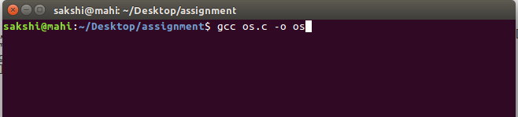

Use following command to compile program-
./os
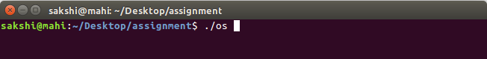

Test Cases:
General ShortCuts used:
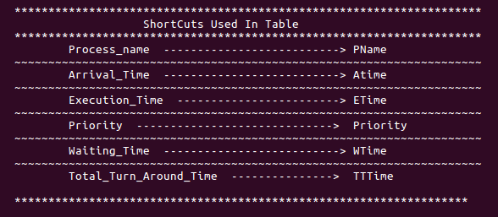

Case 1: When arrival time is zero but priority is different.

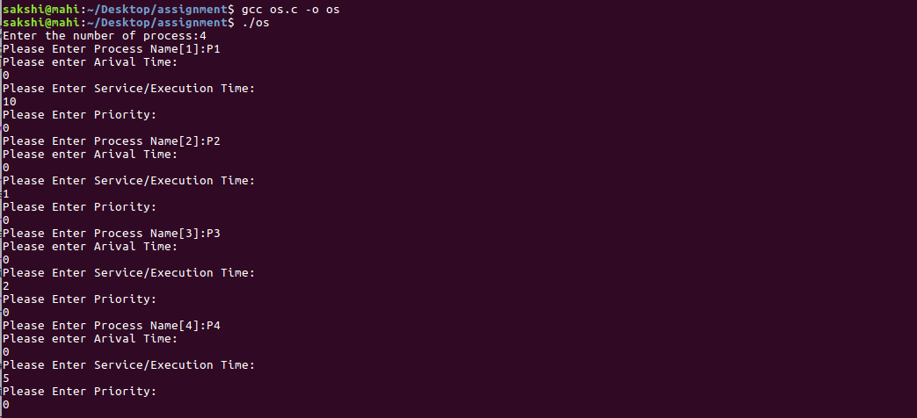
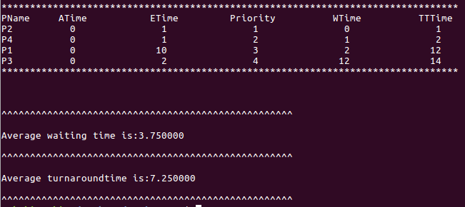

Case 2: When arrival time is different and priority is also different.
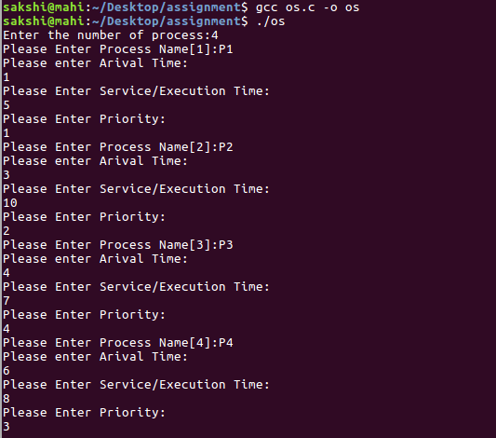
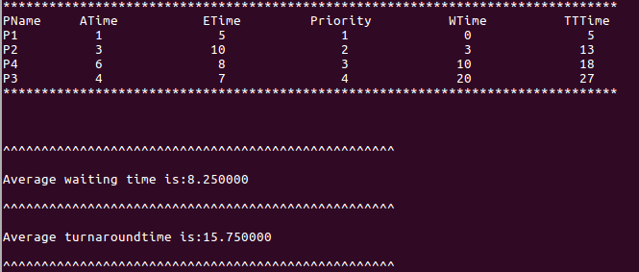

Case 3: When arrival and priority both are zero.
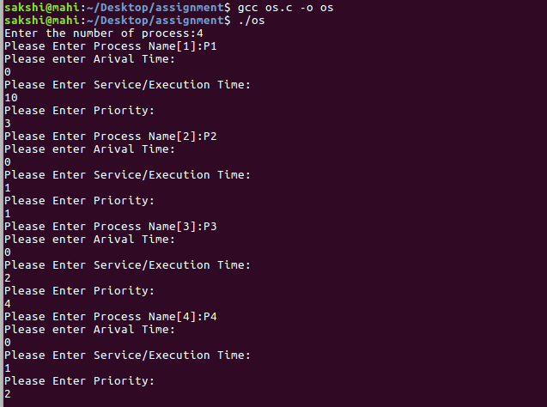
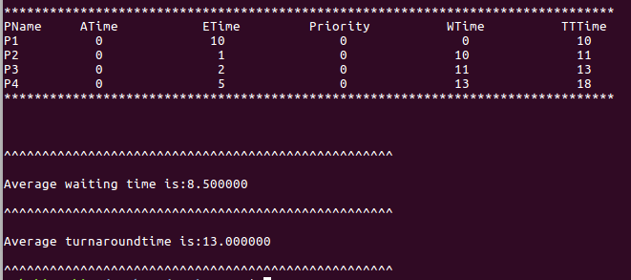

GitHub Link : https://github.com/SakshiPrRoy/OS-Assignment

