Executive Summary
The objective of this project was to perform an Exploratory Data Analysis (EDA) on Geldium's customer credit dataset to evaluate data quality, identify potential delinquency risk factors, and prepare the dataset for future predictive modeling. The analysis covered 500 customer records across 19 variables representing demographic, financial, credit, and repayment information. Data quality was generally good, with missing values limited to three financial variables and no duplicate records detected. While no single variable demonstrated a strong linear relationship with delinquency, several financial and behavioral attributes were identified as potential contributors to repayment risk. The findings provide a strong foundation for feature engineering and predictive credit risk modeling.

Project Background
Geldium aims to strengthen its delinquency prediction process by improving the quality of customer data before predictive modeling. As part of this objective, exploratory data analysis was performed to understand the structure of the dataset, identify missing values, detect anomalies, and uncover variables that may influence delinquent account behavior. The insights generated from this analysis will support future machine learning models and enable more informed credit risk decisions.

Dataset Overview
Attribute | Value
Total Records | 500
Total Features | 19
Numerical Features | 14
Categorical Features | 5
Missing Columns | 3
Duplicate Rows | 0
Target Variable | Delinquent_Account

Data Quality Assessment
Issue | Observation | Action
Missing Income | 7.8% | Median Imputation
Missing Loan Balance | 5.8% | Median Imputation
Missing Credit Score | 0.4% | Median Imputation
Duplicate Records | None | No Action
Invalid Values | None | No Action

Exploratory Data Analysis
Target Distribution
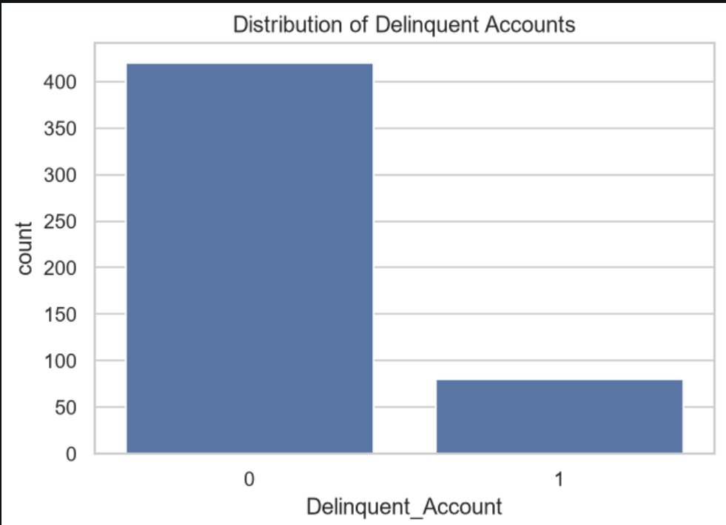
Credit Score Distribution
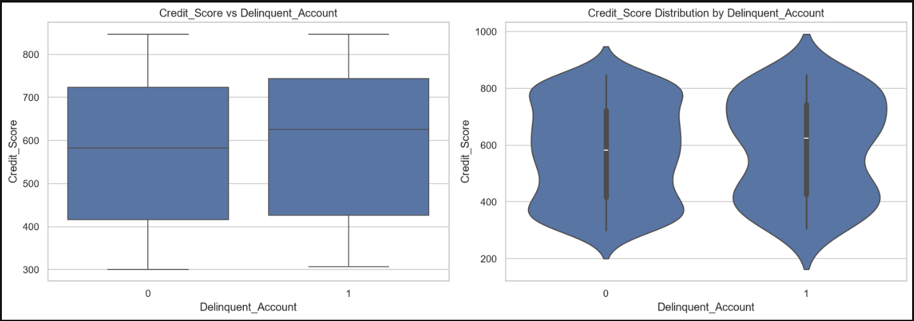

Credit Utilization Distribution
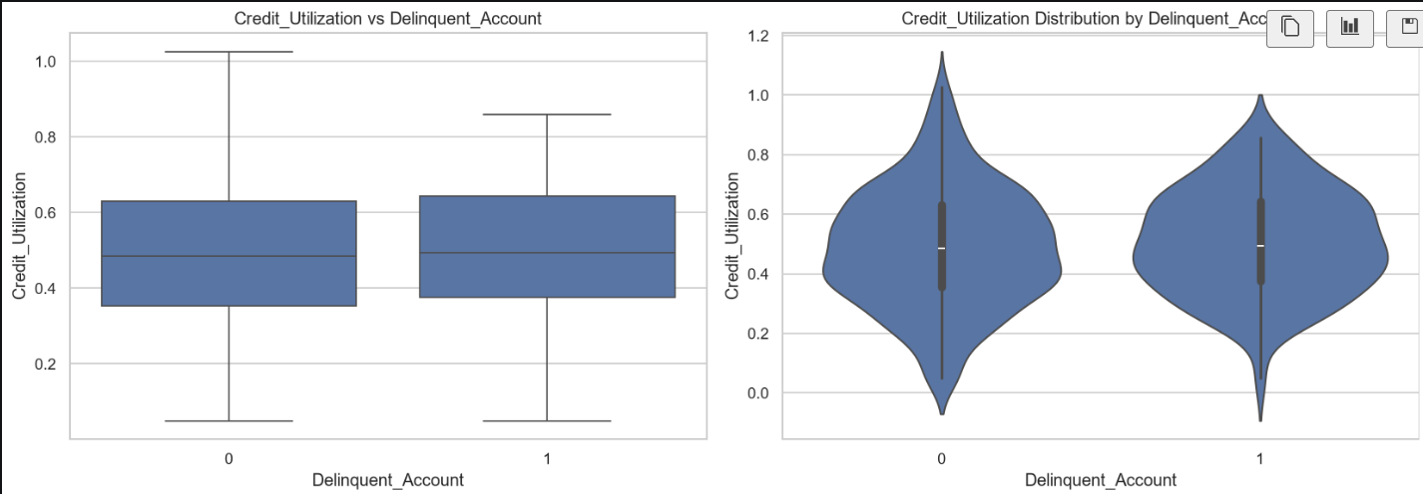

Correlation Heatmap
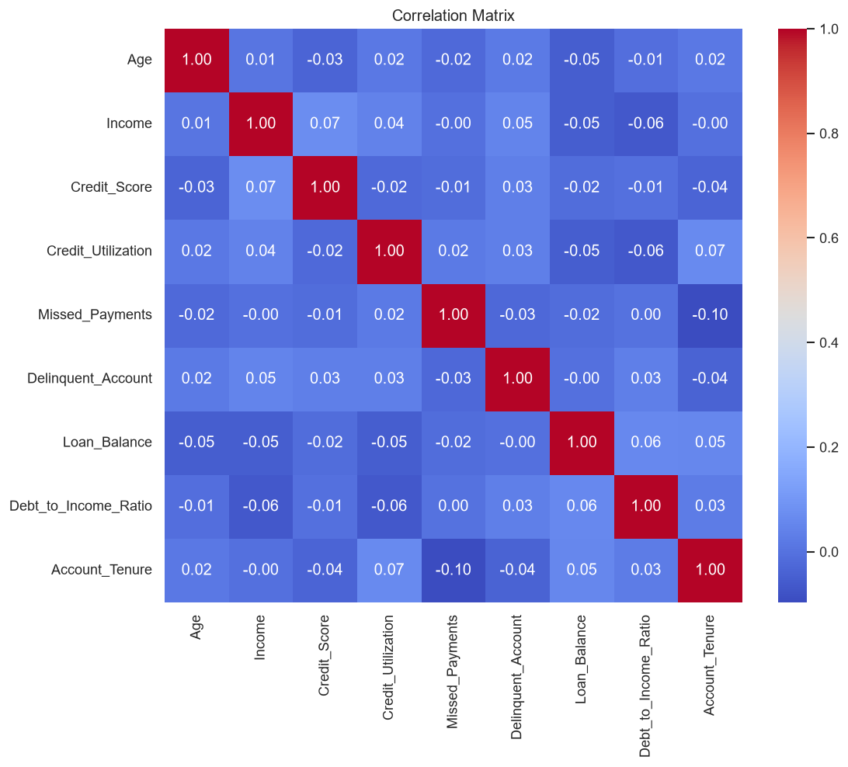
Employment Status vs Delinquency
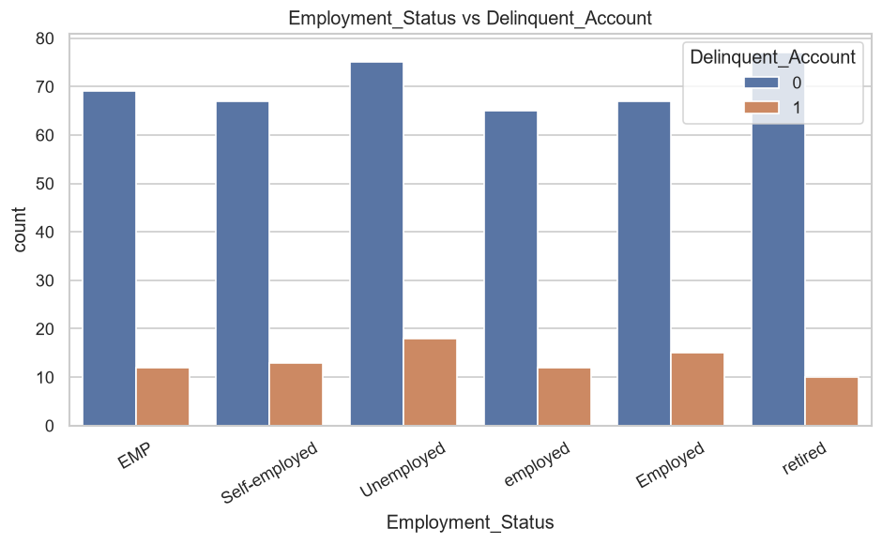

Risk Indicators

Risk Indicator | Observation | Potential Impact
Missed Payments | Customers with more missed payments may exhibit repayment challenges | High
Credit Utilization | Higher utilization may indicate financial stress | High
Debt-to-Income Ratio | Higher ratios reduce repayment capacity | Medium
Credit Score | Lower scores indicate weaker creditworthiness | Medium
Employment Status | Unemployment may increase repayment risk | Medium
Monthly Payment Behaviour | Consistent late payments could improve prediction | High

Recommendations

Recommendation 1
Impute missing financial variables using the median to preserve data distribution while minimizing bias.

Recommendation 2
Retain customers with credit utilization exceeding 100%, as these records may represent meaningful financial stress rather than data errors.

Recommendation 3
Engineer additional behavioral variables using the six months of payment history to improve model performance.

Recommendation 4
Address moderate class imbalance during predictive modeling using class weighting or resampling techniques.

Recommendation 5
Evaluate non-linear machine learning algorithms because linear relationships between predictors and delinquency are relatively weak.

Conclusion
The exploratory data analysis confirmed that the dataset is suitable for predictive modeling following limited preprocessing. Missing values are minimal, duplicate records are absent, and most variables fall within expected business ranges. Although individual variables exhibit weak linear relationships with delinquency, multiple financial and behavioral features demonstrate potential value when considered collectively. The analysis provides a reliable foundation for feature engineering and predictive credit risk modeling.

