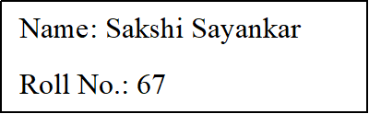

**CalculatorServlet:**

/*

* To change this license header, choose License Headers in Project Properties.

* To change this template file, choose Tools | Templates

* and open the template in the editor.

*/

import com.myservice.MyCalculatorWebService_Service;

import java.io.IOException;

import java.io.PrintWriter;

import javax.servlet.ServletException;

import javax.servlet.http.HttpServlet;

import javax.servlet.http.HttpServletRequest;

import javax.servlet.http.HttpServletResponse;

import javax.xml.ws.WebServiceRef;

/**

*

* @author ASUS

*/

public class CalculatorServlet extends HttpServlet {

@WebServiceRef(wsdlLocation = "WEB-INF/wsdl/localhost_8080/Assignment7/MyCalculatorWebService.wsdl")

private MyCalculatorWebService_Service service;

/**

* Processes requests for both HTTP <code>GET</code> and <code>POST</code>

* methods.

*

* @param request servlet request

* @param response servlet response

* @throws ServletException if a servlet-specific error occurs

* @throws IOException if an I/O error occurs

*/

protected void processRequest(HttpServletRequest request, HttpServletResponse response)

throws ServletException, IOException {

response.setContentType("text/html;charset=UTF-8");

try (PrintWriter out = response.getWriter()) {

double num1,num2;

num1 =Double.parseDouble(request.getParameter("number1"));

num2 =Double.parseDouble(request.getParameter("number2"));

out.println("<!DOCTYPE html>");

out.println("<html>");

out.println("<head>");

out.println("<title>CalculatorServlet Output</title>");

out.println("</head>");

out.println("<body>");

out.println("<h1> Addition is : " +addition(num1,num2)+ "</h1>");

out.println("<h1> Substraction is : " +substraction(num1,num2)+ "</h1>");

out.println("<h1> Multiplication is : " +multiplication(num1,num2)+ "</h1>");

out.println("<h1> Division is : " +division(num1,num2)+ "</h1>");

out.println("</body>");

out.println("</html>");

}

}

// <editor-fold defaultstate="collapsed" desc="HttpServlet methods. Click on the + sign on the left to edit the code.">

/**

* Handles the HTTP <code>GET</code> method.

*

* @param request servlet request

* @param response servlet response

* @throws ServletException if a servlet-specific error occurs

* @throws IOException if an I/O error occurs

*/

@Override

protected void doGet(HttpServletRequest request, HttpServletResponse response)

throws ServletException, IOException {

processRequest(request, response);

}

/**

* Handles the HTTP <code>POST</code> method.

*

* @param request servlet request

* @param response servlet response

* @throws ServletException if a servlet-specific error occurs

* @throws IOException if an I/O error occurs

*/

@Override

protected void doPost(HttpServletRequest request, HttpServletResponse response)

throws ServletException, IOException {

processRequest(request, response);

}

/**

* Returns a short description of the servlet.

*

* @return a String containing servlet description

*/

@Override

public String getServletInfo() {

return "Short description";

}// </editor-fold>

private double addition(double num1, double num2) {

// Note that the injected javax.xml.ws.Service reference as well as port objects are not thread safe.

// If the calling of port operations may lead to race condition some synchronization is required.

com.myservice.MyCalculatorWebService port = service.getMyCalculatorWebServicePort();

return port.addition(num1, num2);

}

private double substraction(double num1, double num2) {

// Note that the injected javax.xml.ws.Service reference as well as port objects are not thread safe.

// If the calling of port operations may lead to race condition some synchronization is required.

com.myservice.MyCalculatorWebService port = service.getMyCalculatorWebServicePort();

return port.substraction(num1, num2);

}

private double multiplication(double num1, double num2) {

// Note that the injected javax.xml.ws.Service reference as well as port objects are not thread safe.

// If the calling of port operations may lead to race condition some synchronization is required.

com.myservice.MyCalculatorWebService port = service.getMyCalculatorWebServicePort();

return port.multiplication(num1, num2);

}

private double division(double num1, double num2) {

// Note that the injected javax.xml.ws.Service reference as well as port objects are not thread safe.

// If the calling of port operations may lead to race condition some synchronization is required.

com.myservice.MyCalculatorWebService port = service.getMyCalculatorWebServicePort();

return port.division(num1, num2);

}

}

**index.html:**

Top of Form

<!DOCTYPE html>

<!--

To change this license header, choose License Headers in Project Properties.

To change this template file, choose Tools | Templates

and open the template in the editor.

-->

<html>

<head>

<title>Calculator Web Service Client</title>

<meta charset="UTF-8">

<meta name="viewport" content="width=device-width, initial-scale=1.0">

</head>

<body>

<form action="CalculatorServlet">

Enter Number-1:<input type="text" name="number1" value=""/><br>

Enter Number-2:<input type="text" name="number2" value=""/><br>

<input type="submit" value="Submit" />

</form>

</body>

</html>

**MyCalculatorWebService.java:**

/*

* To change this license header, choose License Headers in Project Properties.

* To change this template file, choose Tools | Templates

* and open the template in the editor.

*/

package com.myservice;

import javax.jws.WebService;

import javax.jws.WebMethod;

import javax.jws.WebParam;

/**

*

* @author ASUS

*/

@WebService(serviceName = "MyCalculatorWebService")

public class MyCalculatorWebService {

/**

* Web service operation

*/

@WebMethod(operationName = "addition")

public double addition(@WebParam(name = "num1") double num1, @WebParam(name = "num2") double num2) {

//TODO write your implementation code here:

return num1+num2;

}

/**

* Web service operation

*/

@WebMethod(operationName = "substraction")

public double substraction(@WebParam(name = "num1") double num1, @WebParam(name = "num2") double num2) {

//TODO write your implementation code here:

return num1-num2;

}

/**

* Web service operation

*/

@WebMethod(operationName = "multiplication")

public double multiplication(@WebParam(name = "num1") double num1, @WebParam(name = "num2") double num2) {

//TODO write your implementation code here:

return num1*num2;

}

/**

* Web service operation

*/

@WebMethod(operationName = "division")

public double division(@WebParam(name = "num1") double num1, @WebParam(name = "num2") double num2) {

//TODO write your implementation code here:

return num1/num2;

}

/**

* Web service operation

*/

}

/*

**ConcatServlet.java:**

/*

* To change this license header, choose License Headers in Project Properties.

* To change this template file, choose Tools | Templates

* and open the template in the editor.

*/

import com.myservice1.MyConcatWebService_Service;

import java.io.IOException;

import java.io.PrintWriter;

import javax.servlet.ServletException;

import javax.servlet.http.HttpServlet;

import javax.servlet.http.HttpServletRequest;

import javax.servlet.http.HttpServletResponse;

import javax.xml.ws.WebServiceRef;

/**

*

* @author ASUS

*/

public class ConcatServlet extends HttpServlet {

@WebServiceRef(wsdlLocation = "WEB-INF/wsdl/localhost_8080/Concatenate/MyConcatWebService.wsdl")

private MyConcatWebService_Service service;

/**

* Processes requests for both HTTP <code>GET</code> and <code>POST</code>

* methods.

*

* @param request servlet request

* @param response servlet response

* @throws ServletException if a servlet-specific error occurs

* @throws IOException if an I/O error occurs

*/

protected void processRequest(HttpServletRequest request, HttpServletResponse response)

throws ServletException, IOException {

response.setContentType("text/html;charset=UTF-8");

try (PrintWriter out = response.getWriter()) {

String string1,string2;

string1 = String.parseString(request.getParameter("string1"));

string1 = String.parseString(request.getParameter("string1"));

/* TODO output your page here. You may use following sample code. */

out.println("<!DOCTYPE html>");

out.println("<html>");

out.println("<head>");

out.println("<title>Servlet ConcatServlet</title>");

out.println("</head>");

out.println("<body>");

out.println("<h1>Concatenation is " + concatenation(string1,string2) + "</h1>");

out.println("</body>");

out.println("</html>");

}

}

// <editor-fold defaultstate="collapsed" desc="HttpServlet methods. Click on the + sign on the left to edit the code.">

/**

* Handles the HTTP <code>GET</code> method.

*

* @param request servlet request

* @param response servlet response

* @throws ServletException if a servlet-specific error occurs

* @throws IOException if an I/O error occurs

*/

@Override

protected void doGet(HttpServletRequest request, HttpServletResponse response)

throws ServletException, IOException {

processRequest(request, response);

}

/**

* Handles the HTTP <code>POST</code> method.

*

* @param request servlet request

* @param response servlet response

* @throws ServletException if a servlet-specific error occurs

* @throws IOException if an I/O error occurs

*/

@Override

protected void doPost(HttpServletRequest request, HttpServletResponse response)

throws ServletException, IOException {

processRequest(request, response);

}

/**

* Returns a short description of the servlet.

*

* @return a String containing servlet description

*/

@Override

public String getServletInfo() {

return "Short description";

}// </editor-fold>

private String concatenation(java.lang.String string1, java.lang.String string2) {

// Note that the injected javax.xml.ws.Service reference as well as port objects are not thread safe.

// If the calling of port operations may lead to race condition some synchronization is required.

com.myservice1.MyConcatWebService port = service.getMyConcatWebServicePort();

return port.concatenation(string1, string2);

}

}

**index.html:**

<!DOCTYPE html>

<!--

To change this license header, choose License Headers in Project Properties.

To change this template file, choose Tools | Templates

and open the template in the editor.

-->

<html>

<head>

<title>TODO supply a title</title>

<meta charset="UTF-8">

<meta name="viewport" content="width=device-width, initial-scale=1.0">

</head>

<body>

<div>TODO write content</div>

</body>

</html>

**MyConcatWebService.java:**

/*

* To change this license header, choose License Headers in Project Properties.

* To change this template file, choose Tools | Templates

* and open the template in the editor.

*/

package com.myservice1;

import javax.jws.WebService;

import javax.jws.WebMethod;

import javax.jws.WebParam;

/**

*

* @author ASUS

*/

@WebService(serviceName = "MyConcatWebService")

public class MyConcatWebService {

/**

* Web service operation

*/

@WebMethod(operationName = "concatenation")

public String concatenation(@WebParam(name = "string1") String string1, @WebParam(name = "string2") String string2) {

//TODO write your implementation code here:

return string1 + string2;

}

}

Bottom of Form

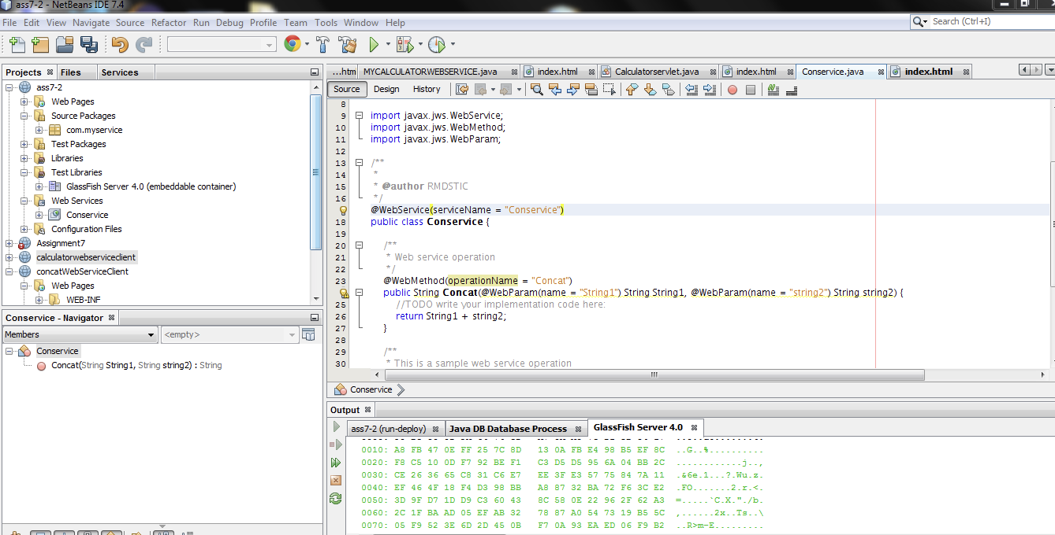

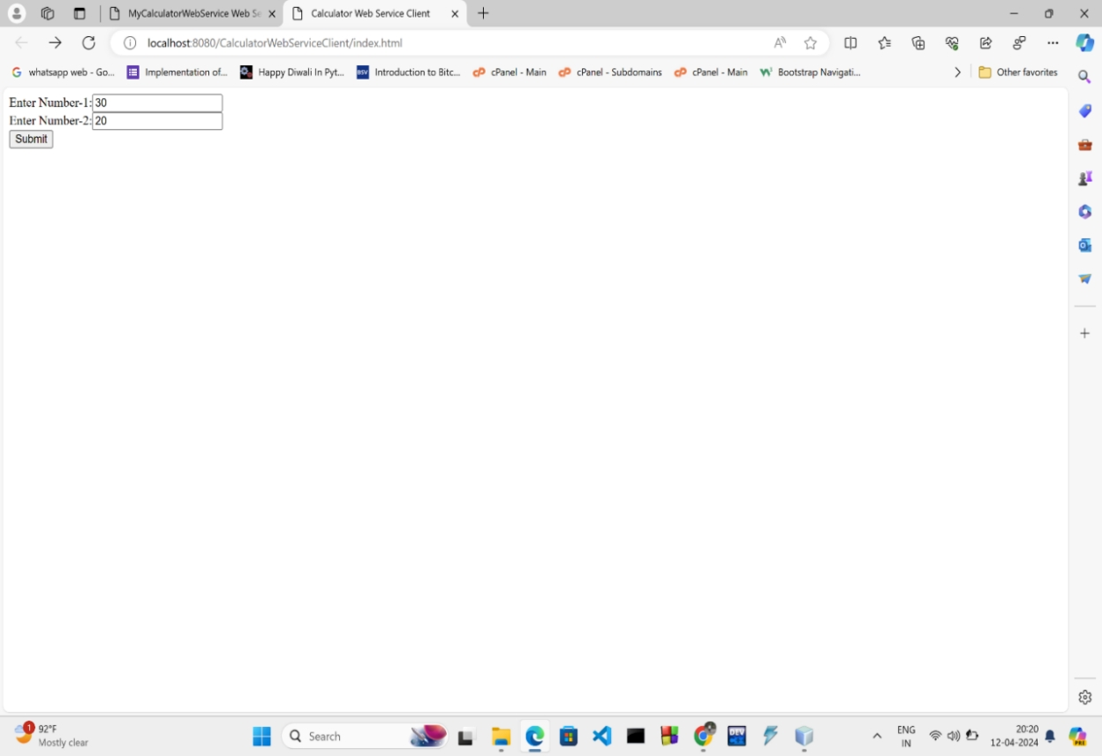Bottom of Form

