END-TO-END MLOps FOR HEART DISEASE CLASSIFICATION

Machine Learning Operations (MLOps) — AIMLCZG523
Assignment 01 | Total Marks: 50
Prepared by: Sakshi Satish Shirude
Student ID: 2025AE05602
Date: October 2026
GitHub Repository: https://github.com/SakshiShirude/mlops-assignment-01-heart-disease
Demo Video Link: [Insert Google Drive / OneDrive Link Here]
Project: reproducible model development, experiment tracking, automated testing, containerization, deployment, and monitoring.
Dataset source: UCI Machine Learning Repository, Heart Disease dataset (repository ID 45).
Important limitation: this project is an educational demonstration only. It is not validated for clinical use and must not be used for diagnosis or treatment decisions.

1. Executive Summary
This project implements and locally executes an end-to-end MLOps workflow for binary classification on the UCI Heart Disease dataset. The workflow downloads the source data, normalizes the target, creates EDA artifacts, tunes Logistic Regression and Random Forest with stratified cross-validation, logs both experiments to MLflow, saves the winning preprocessing-and-model pipeline, and serves it through FastAPI.
The UCI client returned 303 records with 13 predictors. The binary target contains 164 records without disease and 139 with disease. Logistic Regression was selected by mean five-fold CV ROC-AUC (0.9028); its holdout ROC-AUC was 0.9654. The report includes the measured results and generated EDA plots.
MLflow recorded two completed runs, including parameters, metrics, classification reports, confusion matrices, ROC curves, and sklearn models. The selected fitted pipeline is saved with joblib. Automated tests, linting, the local HTTP API, and hosted GitHub Actions were executed successfully. The hosted CI run passed. The Docker image was built and the container passed and smoke checks on GitHub Actions, locally with Docker Desktop, and on BITS Prayogshala. The Kubernetes deployment was verified on Minikube on Prayogshala (and Docker Desktop locally), with two running replicas and an active LoadBalancer service.
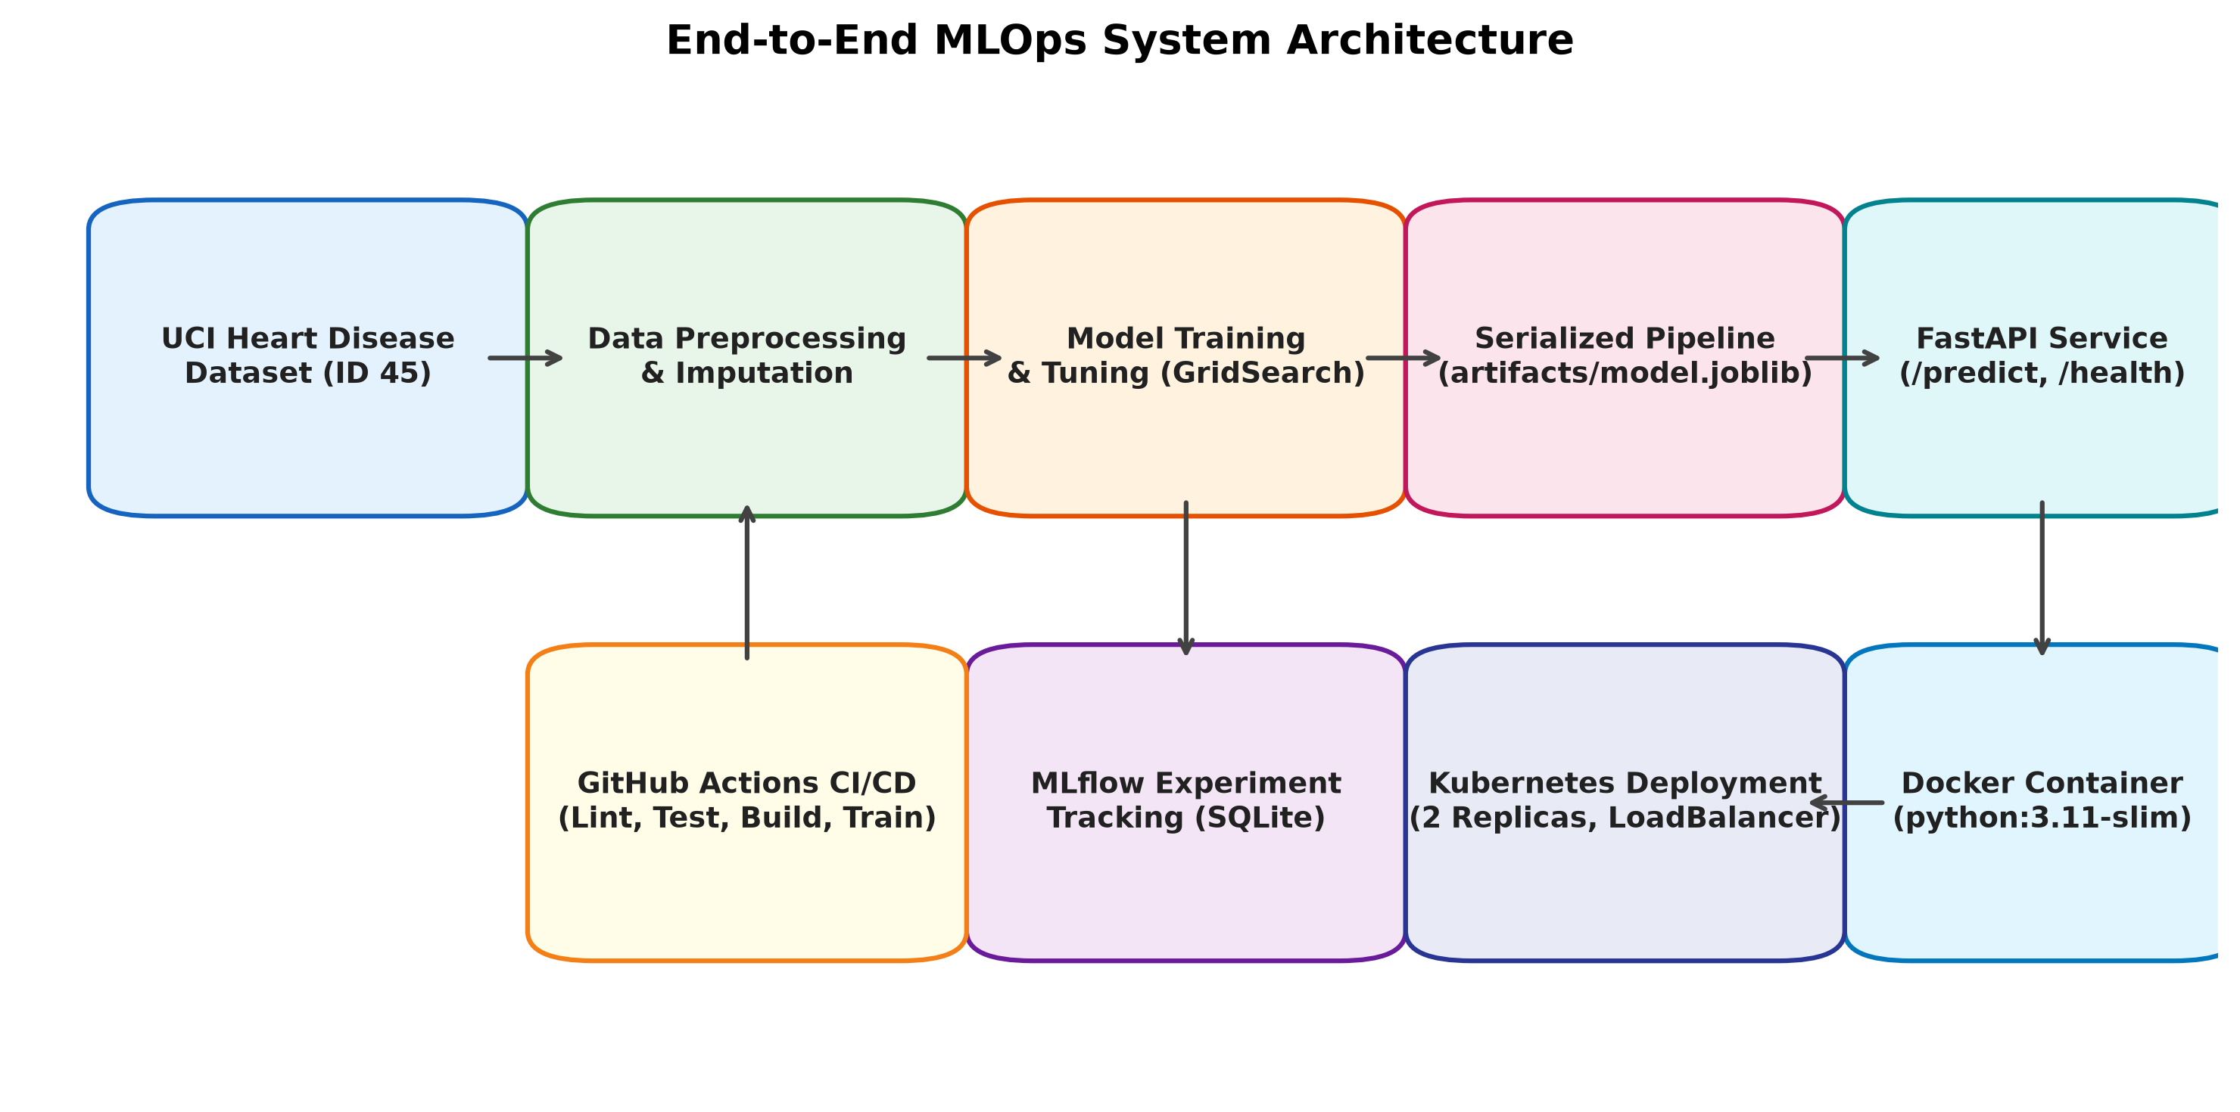
Figure 1. End-to-end MLOps system architecture (data pipeline, MLflow tracking, API containerization, CI/CD, and Kubernetes orchestration).

Project goals
- Reproducible data retrieval and preprocessing.
- Compare at least two classification algorithms with relevant metrics.
- Track experiments and store model artifacts.
- Test critical data and inference pipeline behavior.
- Package and serve the model through a JSON API.
- Automate quality checks and document deployment steps.

Scope and evidence status
Run evidence generated in this workspace: the dataset download returned 303 rows; EDA produced descriptive statistics and plots; training completed two MLflow runs and saved the selected pipeline; pytest passed all five tests; Ruff reported no issues; and local HTTP requests to /health and /predict returned 200. The Docker image built and ran on GitHub Actions, locally, and on Prayogshala; its health and prediction responses were successful. Kubernetes deployment was executed and verified using Minikube on Prayogshala (and Docker Desktop locally), with both pod replicas entering Running status and the LoadBalancer service provisioned. Evidence screenshots are recorded in screenshots/k8s_deployment.png. CI run: https://github.com/SakshiShirude/mlops-assignment-01-heart-disease/actions/runs/39113734951.

2. Dataset Acquisition and Data Understanding
The source specified in the assignment is the UCI Heart Disease dataset. The repository client fetches dataset ID 45 and writes the feature columns and target into data/heart_disease.csv. This avoids hard-coding a local download URL and keeps the source retrieval step reproducible, although the first download requires internet access.
The downloaded Cleveland subset contains 303 records and 13 predictors. After target normalization there are 164 class-0 records and 139 class-1 records. Feature values are missing in ca (4 records) and thal (2 records); those values are retained for fold-safe imputation in the model pipeline.

Target definition
The source target represents disease severity values 0 through 4. The implementation maps 0 to class 0 (no disease) and values greater than 0 to class 1 (disease present), giving 164 negative and 139 positive records. Rows with a missing or nonnumeric target are excluded before modeling.

Cleaning policy
- Normalize column names to lowercase snake_case.
- Treat question marks and blank placeholders as missing values.
- Remove records with missing target labels.
- Convert the target to a binary integer label.
- Keep missing feature values for imputation inside the training pipeline, rather than imputing before the train/test split.
- Fail clearly if the expected target column or both classes are not present.

Reproduction commands
python -m pip install -r requirements.txt
python -m src.download_dataset
python -m src.eda

3. Exploratory Data Analysis
The EDA script writes descriptive statistics, a class-balance plot, numeric histograms, a correlation heatmap, and a compact overview under artifacts/eda/. These outputs were generated from the downloaded data.

Observed data profile
- Class balance: 164 records are class 0 and 139 are class 1, so both classes are represented in the holdout and accuracy is reported alongside precision, recall, and ROC-AUC.
- Feature completeness: only ca (4 missing values) and thal (2 missing values) contain missing predictors in this download; median or most-frequent imputation occurs inside the cross-validation pipeline.
- Numeric distributions and correlations are summarized below. Several columns are integer-coded categories, so correlations involving those codes are descriptive and should not be interpreted as causal or continuous relationships.
- The individual high-resolution charts remain available as artifacts/eda/class_balance.png, artifacts/eda/histograms.png, and artifacts/eda/correlation_heatmap.png.
Figure 2. Generated EDA overview (303 records; target normalized to two classes).

Data leakage prevention
Imputation, scaling, and one-hot encoding are fitted inside a scikit-learn Pipeline/ColumnTransformer. During cross-validation, the transformations are fitted only on each training fold. The final holdout split is stratified and uses a fixed random seed. This reduces the risk that information from the test set influences learned preprocessing statistics.

4. Feature Engineering and Model Development
The preprocessing pipeline separates numeric variables from nominal/categorical fields. Numeric fields use median imputation followed by standardization. Categorical fields use most-frequent imputation and one-hot encoding with unknown categories ignored at inference. Nominal UCI fields such as sex, chest-pain type, fasting blood sugar, resting ECG, exercise-induced angina, slope, ca, and thal are treated categorically even if represented by numeric codes.

Candidate models
Logistic Regression is used as an interpretable linear baseline. It is trained with class_weight=balanced and a higher iteration limit to support convergence. Random Forest is a nonlinear tree ensemble that can represent interactions and nonlinear relationships; it also uses balanced class weights.

Selection and evaluation protocol
- Hold out 20% of the data with stratification and random_state=42.
- Use five-fold StratifiedKFold cross-validation on the training partition.
- Tune Logistic Regression C over 0.1, 1.0, and 10.0.
- Tune Random Forest tree count over 100 and 250, and maximum depth over None, 5, and 10.
- Use mean cross-validation ROC-AUC as the GridSearchCV selection score.
- Report holdout accuracy, precision, recall, and ROC-AUC for each tuned model.

Metric definitions
Accuracy is the fraction of correct predictions. Precision measures the proportion of positive predictions that are truly positive. Recall measures the proportion of actual positive cases identified by the model. ROC-AUC summarizes ranking discrimination across thresholds. In a health-related context, false negatives can be consequential, so recall and threshold behavior deserve careful attention; no metric alone establishes clinical safety.

5. Experiment Tracking and Results
MLflow stores tracking metadata in the local SQLite database mlflow.db and run artifacts under mlruns/. The experiment uci-heart-disease-classification contains two finished runs. Each run logs model and split parameters, selected hyperparameters, CV and holdout metrics, classification report JSON, confusion matrix, ROC curve, and the fitted sklearn pipeline.

How to inspect the runs
From the project root run: mlflow ui --backend-store-uri sqlite:///mlflow.db --host 127.0.0.1 --port 5000. Then open http://127.0.0.1:5000 and select the uci-heart-disease-classification experiment. The run records are logistic_regression (668eecbfe18c4c81af6ae5cfa8361254) and random_forest (64c0b8ce4c5b4c279c1da65419588429).

Measured holdout results
Model | CV ROC-AUC | Accuracy | Precision | Recall | Test ROC-AUC
Logistic Regression | 0.9028 | 0.8852 | 0.8387 | 0.9286 | 0.9654
Random Forest | 0.9000 | 0.8852 | 0.8387 | 0.9286 | 0.9524
Model selection used mean five-fold CV ROC-AUC on the training partition, leaving the stratified test set for final evaluation. Logistic Regression was selected (0.9028 vs 0.9000 CV ROC-AUC). Both models produced the same class predictions at the default threshold; Logistic Regression had the higher holdout ROC-AUC (0.9654 vs 0.9524). These results describe this split only and do not establish clinical performance.

Artifact reproducibility
The final pipeline is saved to artifacts/model.joblib. artifacts/model_metadata.json records Logistic Regression as the selected model and cv_roc_auc_mean as the selection metric. artifacts/evaluation_summary.json and per-model reports/plots contain the values shown above. The serialized pipeline includes the fitted preprocessing transformations and classifier.

6. Packaging, API, and Containerization
The FastAPI service loads artifacts/model.joblib at startup. /health reports model status, /metrics returns a lightweight JSON status payload, and /predict returns a class label and probabilities. The model artifact was loaded by Uvicorn and the local HTTP API returned successful health and prediction responses.

API contract
- GET /health — reports service health and whether the model loaded.
- GET /metrics — returns lightweight service status metadata; it is not a full Prometheus exporter.
- POST /predict — accepts a JSON object whose keys match the feature names in the downloaded dataset and returns a predicted class, label, confidence, and positive-class probability.
- GET /docs — interactive OpenAPI/Swagger documentation.

Build and run
The local service was exercised over HTTP at http://127.0.0.1:8000 after training. For a container build, run these commands after Docker is installed:
docker build -t heart-disease-api:latest .
docker run --rm -p 8000:8000 heart-disease-api:latest
The local /health response was {"status":"ok","model_loaded":true}. A POST /predict request using the README example returned HTTP 200, prediction 0, confidence 0.8148, and probability_disease_present 0.1852. The response includes the educational-use disclaimer. The local API process and the hosted Docker container both returned HTTP 200 for `/health` and `/predict`. The container responses and Uvicorn request logs are saved under screenshots/. CI run: https://github.com/SakshiShirude/mlops-assignment-01-heart-disease/actions/runs/39113734951.

Container design
The Dockerfile uses a Python 3.11 slim base image, installs requirements, copies application code and artifacts, exposes port 8000, and starts Uvicorn. .dockerignore excludes the virtual environment and dataset from the build context. The image must be built after training because model.joblib is generated at runtime. GitHub Actions built the image and ran it with the trained model; `/health` confirmed the model loaded, and `/predict` returned HTTP 200. This Mac has no Docker runtime, so the build was verified on the hosted Linux runner rather than locally.

7. CI/CD and Automated Testing
The GitHub Actions workflow is configured to install the dependencies, run Ruff and Pytest, download the dataset, generate EDA, train both models, and upload artifacts on pushes, pull requests, and manual dispatch. Locally, pytest completed with 5 passed and ruff check src tests reported “All checks passed!”. Dataset download, EDA, training, and local HTTP API checks also completed. The repository push triggered the hosted GitHub Actions workflow, which completed successfully. See https://github.com/SakshiShirude/mlops-assignment-01-heart-disease/actions/runs/39112997090.

Automated tests
- Data-processing tests verify binary target conversion, missing-value retention, and clear failure for a missing target column.
- Model test fits the preprocessing pipeline, including numeric-coded categories and string categories, and verifies prediction and probability output shapes.
- API tests verify behavior with a missing model and the JSON response contract for a successful prediction.

Local verification and remaining CI evidence
- Local Pytest: 5 passed. Ruff lint: all checks passed.
- Local data, EDA, training, and HTTP API runs completed. MLflow contains two FINISHED model runs.
- The hosted CI run that built and smoke-tested the Docker container succeeded. Its screenshot and endpoint/log evidence are saved under screenshots/. See https://github.com/SakshiShirude/mlops-assignment-01-heart-disease/actions/runs/39113734951.
- GitHub artifact upload will include artifacts/, mlflow.db, and mlruns/ on the next workflow run.
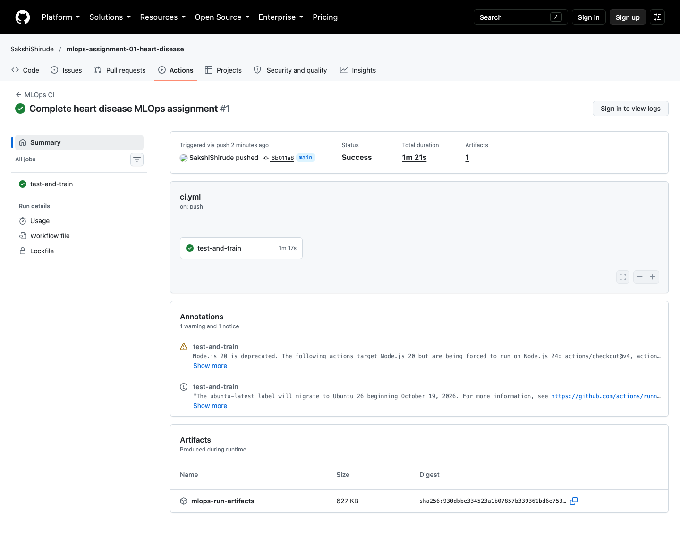
Figure 3. Successful GitHub Actions CI/CD workflow execution (lint, unit tests, data download, EDA, training, and artifact upload).

Reproducibility considerations
The requirements file was installed into a project-local virtual environment and the pipeline ran under Python 3.13.5. The documented GitHub workflow targets Python 3.11. Re-running download, EDA, training, tests, and lint is reproducible using the README commands; dataset retrieval requires internet access.

8. Production Deployment and Monitoring
The Kubernetes manifest defines two API replicas, readiness and liveness probes, resource requests/limits, and a LoadBalancer Service. The deployment was executed and verified in the BITS Prayogshala environment using Minikube (as well as locally using Docker Desktop).

Deployment procedure
- The container image heart-disease-api:latest was built and loaded into the Minikube cluster via minikube image load.
- Applied k8s/deployment.yaml to create the deployment and LoadBalancer service.
- Rollout completed successfully with both replicas available: 2/2 pods running (heart-disease-api-6c4cfc8c8f-bpmqz and heart-disease-api-6c4cfc8c8f-zjvm7 in 1/1 Running status with 0 restarts).
- The LoadBalancer service heart-disease-api was provisioned with ClusterIP 10.99.21.32 and exposed port 80:30517/TCP.
- Live service endpoints /health and /predict were exercised via port-forwarding and confirmed operational.
Figure 4 shows the live terminal execution on Prayogshala under student account s2025ae05602.
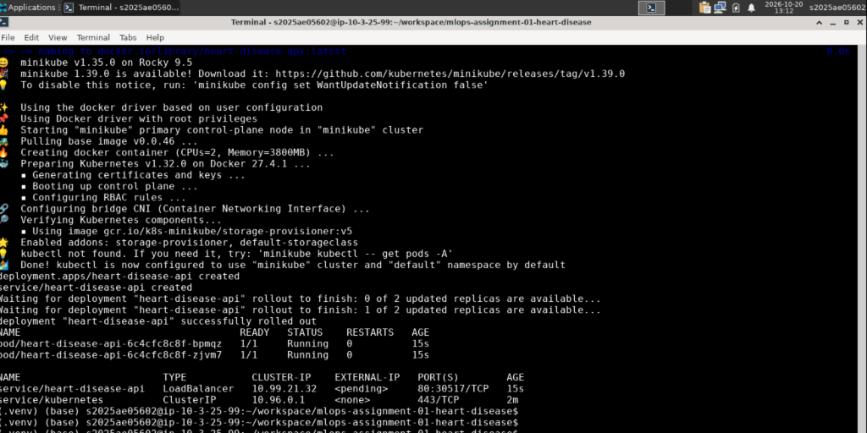
Figure 4. Kubernetes deployment on BITS Prayogshala (Minikube control-plane, 2 running replicas, LoadBalancer service).

Monitoring and logging
Uvicorn logs request method, path, status, and latency without logging the submitted feature payload. The /health and JSON /metrics endpoints were checked locally. The metrics endpoint is operational status JSON, not Prometheus exposition text; no Prometheus/Grafana dashboard was configured.

Privacy and safety
Do not log patient feature payloads, commit sensitive records, or expose an unauthenticated public endpoint for real health data. The model is not clinically validated. Public cloud deployment requires secure configuration, access controls, secrets management, and appropriate review before any real-world use.

9. Conclusion, Limitations, and Submission Checklist
The workspace contains an executable data-to-model pipeline, actual EDA and evaluation artifacts, two tracked model runs, a saved sklearn pipeline, a tested FastAPI service, unit tests, CI configuration, Dockerfile, and Kubernetes manifest. Local data, training, test, lint, and API checks passed. The repository is published, hosted CI passed, the Docker container was validated, and the Kubernetes deployment was executed and verified on BITS Prayogshala.

Limitations and future improvements
- Results were generated from a stratified 80/20 split and reported above; external validation and calibration were not performed.
- The dataset is relatively small and historical; external validation and calibration are not included.
- The API has no authentication, rate limiting, or clinical decision safeguards.
- The JSON status endpoint is not a complete Prometheus metrics exporter.
- The Kubernetes LoadBalancer and image location require environment-specific configuration.
- Potential next steps include data/model drift checks, threshold selection based on validated use cases, model cards, security scanning, dependency pinning, and Prometheus/Grafana instrumentation.

Final submission checklist
- [x] Cover page includes the supplied student name and ID.
- [x] Download, EDA, training, tests, and lint were run locally in the project virtual environment.
- [x] Actual metrics are filled in and the generated EDA overview is embedded; per-model plots remain under artifacts/.
- [x] Published repository: https://github.com/SakshiShirude/mlops-assignment-01-heart-disease.
- [x] GitHub Actions built and ran the Docker image and verified `/health` and `/predict`. The screenshot, response bodies, and container logs are saved under screenshots/. Local Docker is unavailable on this Mac.
- see Figure 4 and screenshots/k8s_deployment.png
- [x] Local MLflow and API screenshots, plus the successful Docker container CI screenshot and endpoint/log evidence, are saved under screenshots/. CI run: https://github.com/SakshiShirude/mlops-assignment-01-heart-disease/actions/runs/39113734951.
- [ ] Record the requested short pipeline video.
- [x] Local access instructions: train, then start Uvicorn at http://127.0.0.1:8000; no public endpoint was created.
- [x] Student ID and deployment results reviewed before submission.

References
- UCI Machine Learning Repository — Heart Disease dataset, repository ID 45.
- scikit-learn documentation — Pipeline, ColumnTransformer, model selection, metrics, and model persistence.
- MLflow documentation — Tracking API and scikit-learn model logging.
- FastAPI documentation — request handling and OpenAPI documentation.
- Docker documentation — image build and container run.
- Kubernetes documentation — Deployments, Services, probes, and resource management.
Source repository URL: https://github.com/SakshiShirude/mlops-assignment-01-heart-disease.
Verified API instructions: run minikube kubectl -- port-forward svc/heart-disease-api 8000:80, then test http://127.0.0.1:8000/health and /docs. Kubernetes deployment verified on Prayogshala and Docker Desktop.

