**INFO5100 AED Project**

**Project Name: Helping Hands Club**

Group Members:

Sakshi Pekale  
 NUD ID: 002743873

Sakshi Sasalate  
 NU ID: 002742867

Sayali Hulle  
 NU ID: 002754075

Description:

Helping Hands is an NGO (Non-Profit Organization) which provides any kind of medical assistance to people who need their help.

Using this application, the help seeker is able to Create their profile, view and update their information and they can enter into the application, whatever service they require this Helping Hands Club to provide for them. They can then also enter their vital signs which can be later seen by the doctor who can review request and then prescribe them with the required medications. That in turn can be seen by the patient as well. The doctor can too create, update and view their profile on the application.

As this is an NGO, volunteers can themselves register with the Helping Hands to offer help and join this organization. Their login credentials are autogenerated. The volunteers can also view and update their profile. On the work area, they can see the requests that help seeks have put. The volunteers are able to pick up the requests that they think can be fulfilled by them. They can also view the feedbacks that the help seeker gave them post completion of the task.

The enterprise admin can log into the application using their credentials. All enterprise admins can create employee/person into their own enterprise and can also create their user IDs and passwords.

Enterprises: 1. Travel Agent  
 2. NGO   
 3. Finance  
 4. Hospital  
 5. Region Head

The organizations can log in through their credentials and manage all forms of transactions taking place within the organization. The Supervisor can view Create and View profiles as well as see all the roles and what they all are up to. Similarly, the Manager can graphically view all the statistics of events taking place in the organization. The donor can make donations to the Helping Hands club. The region head too can view statistical information.

Organizations: 1. Transport  
 2. Supervisor  
 3. Manager  
 4. Donor  
 5. Region Head  
 6. Volunteer  
 7. Help seeker   
 8. Doctor

The system admin can perform all the CRUD operations on all the roles and admin.

Roles: 1. System admin  
 2. Help Seeker  
 3. Volunteer  
 4. Admin  
 5. Doctor  
 6. Donor  
 7. Driver  
 8. Manager  
 9. Region Head  
 10. Supervisor

**Class Diagram:**

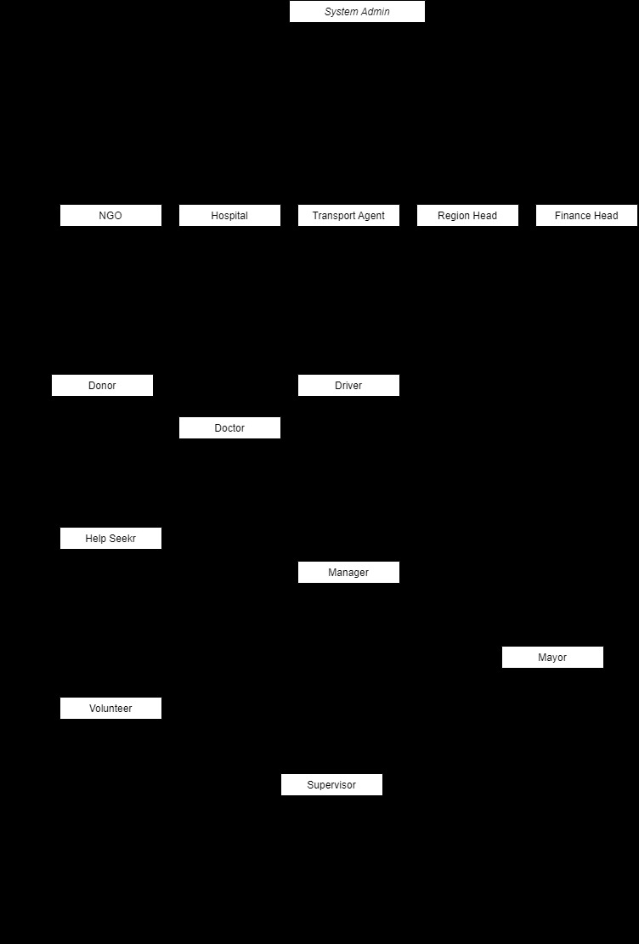

**OBJECT DIAGRAM:**

