CREATE TABLE PERSON(DRIVER_ID VARCHAR2(10),NAME VARCHAR2(20),ADDRESS VARCHAR2(15),PRIMARY KEY(DRIVER_ID));

CREATE TABLE CAR(REGNO VARCHAR2(10),MODEL VARCHAR2(10),YEAR NUMBER(4),PRIMARY KEY(REGNO));

CREATE TABLE ACCIDENT(REPORT_NO NUMBER(5),ADATE DATE,LOCATION VARCHAR2(15),PRIMARY KEY(REPORT_NO));

CREATE TABLE OWNS(DRIVER_ID VARCHAR2(10),REGNO VARCHAR2(10),PRIMARY KEY(DRIVER_ID,REGNO),FOREIGN KEY(DRIVER_ID)REFERENCES PERSON(DRIVER_ID),FOREIGN KEY(REGNO)REFERENCES CAR(REGNO));

CREATE TABLE PARTICIPATED(DRIVER_ID VARCHAR2(10),REGNO VARCHAR2(10),REPORT_NO NUMBER(5),DAMAGE_AMT NUMBER(7,2),PRIMARY KEY(DRIVER_ID,REGNO,REPORT_NO),FOREIGN KEY(DRIVER_ID,REGNO)REFERENCES OWNS(DRIVER_ID,REGNO)ON DELETE CASCADE,FOREIGN KEY(REPORT_NO)REFERENCES ACCIDENT(REPORT_NO)ON DELETE CASCADE);

INSERT INTO PERSON VALUES('&DRIVER_ID','&NAME','&ADDRESS');

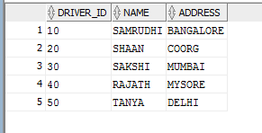

INSERT INTO CAR VALUES('&REGNO','&MODEL','&YEAR');

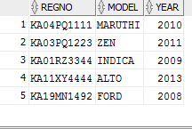

INSERT INTO ACCIDENT VALUES('&REPORT_NO','&ADATE','&LOCATION');

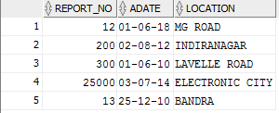

INSERT INTO OWNS VALUES('&DRIVER_ID','&REGNO');

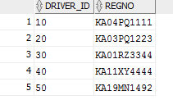

INSERT INTO PARTICIPATED VALUES('&DRIVER_ID','&REG_NO','&REPORT_NO','&DAMAGE_AMT');

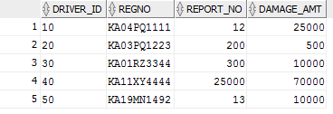

SELECT * FROM PERSON;

SELECT * FROM CAR;

SELECT * FROM ACCIDENT;

SELECT * FROM OWNS;

SELECT * FROM PARTICIPATED;

UPDATE PARTICIPATED

SET DAMAGE_AMT=25000

WHERE REPORT_NO =12 AND REGNO='KA04PQ1111';

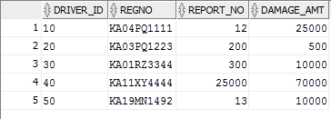

SELECT COUNT(*) FROM ACCIDENT

WHERE ADATE LIKE '01 JUN 10';



SELECT COUNT(A.REPORT_NO)

FROM ACCIDENT A, PARTICIPATED P, CAR C

WHERE A.REPORT_NO=P.REPORT_NO AND P.REGNO=C.REGNO AND C.MODEL='MARUTHI'; 