CONSTRUCTAI FLOW
UI/UX Web Application Workflow & Figma Plan
Web pages, page contents, end-to-end workflow and Figma implementation plan

1. Objective
Design ConstructAI Flow as a connected web application in which construction information moves from technical inputs through quantity, resources, procurement, contracts, planning, execution, commercial processing and handover. The UI should mirror the project's layered architecture and minimize repeated manual data entry.

2. Architecture Reference
Figure 1. Supplied ConstructAI Flow architecture
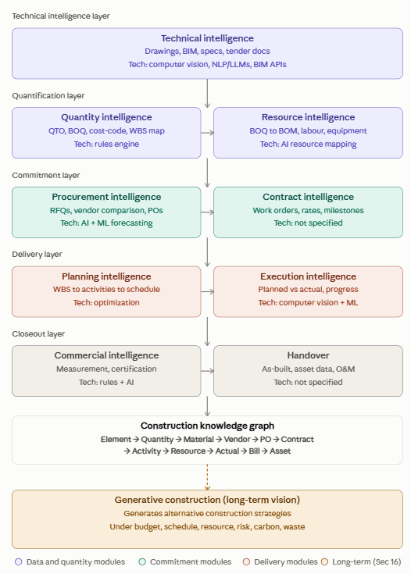

3. Complete Web Application Flow
LOGIN → DASHBOARD → PROJECT SELECTION → TECHNICAL INTELLIGENCE → QUANTITY / QTO → BOQ → BOM & RESOURCES → PROCUREMENT / RFQ → VENDOR COMPARISON → PO → CONTRACTS → PLANNING → EXECUTION → COMMERCIALS → HANDOVER → ANALYTICS / KNOWLEDGE GRAPH → GENERATIVE CONSTRUCTION

4. Page-by-Page UI Plan

1 — Login
What will be on the page: Email/username; Password; Login; Role-based access.
Workflow: User signs in; the system identifies the user's role and opens the appropriate dashboard.

2 — Dashboard
What will be on the page: Project KPIs; Cost vs budget; Planned vs actual progress; Procurement status; AI insights; Recent activities.
Workflow: Acts as the project control center by aggregating information and highlighting risks and actions.

3 — Project Selection
What will be on the page: Project cards; Location/type; Progress; Open Project.
Workflow: User selects a project; all following pages operate on that project's data.

4 — Technical Intelligence
What will be on the page: Upload drawing; Upload BIM; Upload specifications/tender documents; Document library; AI extraction status; Detected elements.
Workflow: Technical files are processed using AI/computer vision/NLP/BIM extraction. Structured construction information is sent to QTO.

5 — Quantity Intelligence / QTO
What will be on the page: AI QTO; Import BOQ; BOQ table; Classification; Quantity/unit/location; Review and approve.
Workflow: Extracted technical information is converted into quantities and a structured BOQ. User reviews and approves it.

6 — BOQ Details
What will be on the page: Description; Quantity/unit; Location; Cost code; WBS; Source document; AI confidence; Edit/approve.
Workflow: Shows item-level traceability and the source of the generated quantity.

7 — BOM & Resources
What will be on the page: Material/BOM; Labour; Equipment; Required quantities; Resource mapping.
Workflow: Approved BOQ automatically generates material, labour and equipment requirements.

8 — Procurement / RFQ
What will be on the page: Material requirements; Required dates; Create RFQ; RFQ status; Send to vendors.
Workflow: Approved material requirements are converted into procurement requests and RFQs.

9 — Vendor Comparison
What will be on the page: Price; Delivery; Rating/performance; Total cost; AI recommendation; Select vendor.
Workflow: Vendor responses are compared and the system can recommend an option based on project criteria.

10 — Purchase Order
What will be on the page: Vendor; Items/quantities; Delivery dates; Total amount; Generate PO; Approval status.
Workflow: Selected vendor and procurement data are converted into a PO.

11 — Contract Intelligence
What will be on the page: Contract value; Contractor; Work orders; Rates; Milestones; Payment terms; Progress.
Workflow: Procurement commitments are connected to contract and milestone tracking.

12 — Planning Intelligence
What will be on the page: WBS tree; Activities; Resources; Dates; Gantt chart; Schedule status.
Workflow: Quantities and resources are mapped to WBS and activities to create a quantity-linked schedule.

13 — Execution Intelligence
What will be on the page: Planned progress; Actual progress; Schedule variance; Site images; AI progress detection; Delay alerts.
Workflow: Site images/actual data are analyzed for progress. Planned vs actual values are compared and ML can identify delay risk.

14 — Commercial Intelligence
What will be on the page: Executed quantity; Measurement; Certification; RA bill; Payment information; Review/certify.
Workflow: Verified execution quantities flow into measurement, certification and billing.

15 — Handover
What will be on the page: As-built drawings; Asset register; Warranties; O&M documents; Certifications; Generate package.
Workflow: Closeout information is organized into a digital handover package.

16 — Analytics & AI Insights
What will be on the page: Project health; Cost/schedule/procurement indicators; Predictions; Risk alerts; AI recommendations; Trends.
Workflow: Aggregates project lifecycle information for decision support.

17 — Construction Knowledge Graph
What will be on the page: Entity relationships; Element/quantity/material/vendor links; PO/contract/activity/resource links; Actual/bill/asset links.
Workflow: Visualizes how information generated across modules remains connected.

18 — Generative Construction
What will be on the page: Budget; Completion target; Resources; Risk; Carbon/waste targets; Generate strategies; Compare strategies.
Workflow: Advanced layer that generates and compares executable construction strategies under project constraints.

5. End-to-End Data Workflow
- Login and select a project.
- Upload drawings, BIM models and specifications.
- AI extracts construction elements and technical attributes.
- QTO converts extracted information into quantities and a BOQ.
- BOQ items are classified and mapped to cost codes/WBS where required.
- After review and approval, BOQ is converted into materials, labour and equipment requirements.
- Material requirements create RFQs and vendor comparison workflows.
- Selected vendor information becomes a purchase order and commitment.
- Contract information is tracked through work orders, rates and milestones.
- Quantities and resources become WBS-linked activities and schedules.
- Execution data and site images are used to monitor actual progress.
- Planned vs actual data supports progress and delay-risk insights.
- Verified executed quantities move into measurement, certification and billing.
- Final information is organized into as-built, asset, warranty and O&M handover records.
- Connected lifecycle data supports analytics, the knowledge graph and future generative construction.

6. Figma File Structure
ConstructAI Flow — UI/UX
01 — Design System
02 — Login
03 — Dashboard
04 — Projects
05 — Technical Intelligence
06 — Quantity / QTO
07 — BOQ
08 — BOM & Resources
09 — Procurement
10 — Vendor Comparison
11 — Contracts
12 — Planning
13 — Execution
14 — Commercials
15 — Handover
16 — Analytics
17 — Knowledge Graph
18 — Generative Construction
19 — Prototype Flow

7. Figma Design Process
- Research & Requirements: Identify user roles, tasks, information needs and pain points.
- Information Architecture: Define navigation, page hierarchy, module relationships and project-level data flow.
- Low-Fidelity Wireframes: Create simple layouts before applying final visual styling.
- Design System: Define colors, typography, buttons, cards, tables, charts, forms, navigation and status components.
- High-Fidelity Screens: Apply the design system consistently to every web page.
- Interactive Prototype: Connect screens in Figma so the full construction workflow can be demonstrated.
- User Testing: Test tasks such as drawing upload → QTO → BOQ → BOM → RFQ → vendor selection.
- Developer Handoff: Use Figma Dev Mode for components, measurements, assets and implementation reference.

8. Recommended MVP Pages
For the first working prototype, prioritize the pages that demonstrate the core BIM/QS → BOQ → BOM → Procurement workflow, then connect planning and execution.
- Login
- Dashboard
- Project Selection
- Technical Intelligence
- QTO / BOQ
- BOM & Resources
- Procurement / RFQ
- Vendor Comparison
- Planning
- Execution Dashboard

9. Prototype Demonstration Scenario
- Login as QS/Estimator.
- Open a construction project.
- Upload a drawing or BIM file.
- Run AI extraction and inspect detected elements.
- Run AI QTO and review the generated BOQ.
- Approve the BOQ.
- Generate BOM, labour and equipment requirements.
- Create an RFQ for required materials.
- Compare vendors and view the AI recommendation.
- Select a vendor and generate the PO.
- Open Planning and view quantities mapped to activities.
- Open Execution and compare planned vs actual progress.
- View AI delay-risk insight.
- Open Commercials to see executed quantities and billing.
- Open Handover to view final project records.

10. Final UI Goal
ONE PROJECT → ONE CONNECTED DATA FLOW → LESS REPEATED ENTRY → AI-ASSISTED DECISIONS → ACTIONABLE CONSTRUCTION INTELLIGENCE

