CONSTRUCTAI FLOW
Project Implementation Plan
AI-Driven Construction Information and Execution Automation Platform

1. Project Overview
ConstructAI Flow is planned as a connected construction intelligence platform in which technical information is progressively converted into quantities, resources, commitments, delivery information and closeout data. The implementation follows the layered architecture shown in the supplied project architecture diagram.

2. Proposed Project Architecture
Figure 1. ConstructAI Flow architecture supplied for the project
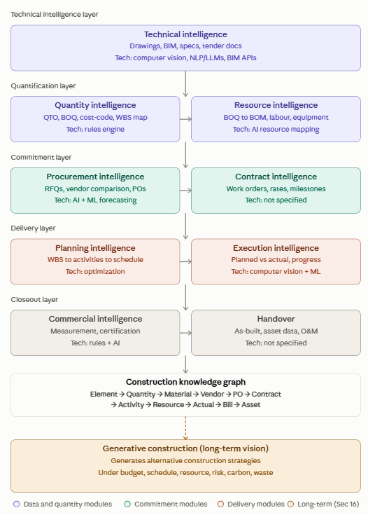

3. Implementation Approach
- Layered implementation: Build the platform from the technical intelligence layer downward, so each layer consumes structured information from the previous layer.
- Single connected data flow: Maintain continuity from Element → Quantity → Material → Vendor → PO → Contract → Activity → Resource → Actual → Bill → Asset.
- AI + deterministic rules: Use AI where interpretation, prediction or matching is required, while keeping calculations, mappings and approval-sensitive operations rule-based where appropriate.
- Human approval: Keep human review in important quantity, procurement, contract and commercial decisions.
- Incremental delivery: Implement the core pipeline first and add advanced planning, execution, closeout and generative capabilities progressively.

4. Layer-by-Layer Implementation Plan
# | Layer | Primary Input | Implementation Objective | Technology Focus
1 | Technical Intelligence | Drawings, BIM, specifications and tender documents | Extract structured technical information; identify construction elements, specifications and relevant attributes. | Computer vision, NLP/LLM, BIM APIs
2 | Quantity Intelligence | Technical information | Generate QTO/BOQ, classify items, map cost codes and WBS information. | Rules engine + AI-assisted classification
3 | Resource Intelligence | BOQ | Convert BOQ requirements into material/BOM, labour and equipment requirements. | Resource mapping + rules/AI
4 | Procurement Intelligence | Material requirements | Generate RFQs, compare vendors, support purchase orders and resource/demand forecasting. | AI/ML forecasting + comparison logic
5 | Contract Intelligence | Procurement/commitment information | Manage work orders, rates, milestones and contract-related quantities. | Structured workflow + rules
6 | Planning Intelligence | BOQ, WBS and resources | Map work quantities to activities and build/optimize schedules. | Optimization algorithms
7 | Execution Intelligence | Planned quantities and schedule | Compare planned vs actual quantities, monitor progress, consumption and productivity, and identify delay risk. | Computer vision + ML
8 | Commercial Intelligence | Executed quantities | Support measurement, certification, RA billing and payment-related workflows. | Rules + AI-assisted reconciliation
9 | Handover | Project closeout information | Organize as-built quantities, asset data, warranties and O&M information. | Structured asset/handover data
10 | Construction Knowledge Graph | Data from all layers | Connect construction entities and relationships into a reusable project knowledge structure. | Graph data model / knowledge graph
11 | Generative Construction | Connected project data | Generate and compare executable construction strategies against budget, schedule, resources, risk, carbon and waste constraints. | Optimization + AI

5. End-to-End Implementation Workflow
- Collect technical inputs: drawings, BIM models, specifications and tender documents.
- Extract and normalize construction elements and technical attributes.
- Perform quantity takeoff and generate a structured BOQ.
- Classify BOQ items and map them to cost codes/WBS where applicable.
- Transform BOQ requirements into materials, labour and equipment resources.
- Generate procurement requirements and support RFQ/vendor comparison workflows.
- Create commitment information such as purchase orders, work orders, rates and milestones.
- Convert quantities and resources into activities and schedules.
- Capture execution information and compare planned versus actual progress.
- Convert verified executed quantities into commercial measurement and billing information.
- Prepare handover information including as-built and asset/O&M data.
- Persist connected relationships in the construction knowledge graph.
- Use the accumulated data foundation for advanced optimization and generative construction.

6. Recommended MVP Scope
Initial implementation should focus on the most demonstrable connected pipeline: Technical Input → QTO/BOQ → BOM/Resources → Procurement.
MVP deliverables:
- Technical drawing/BIM/document input module
- Structured quantity extraction and BOQ generation
- BOQ item classification and mapping
- BOM/material requirement generation
- Labour and equipment resource mapping
- Basic RFQ and vendor comparison workflow
- A unified project data model connecting the generated records
- Simple dashboard/API to demonstrate the complete flow

7. Development Phases
Phase | Focus | Main Activities | Expected Output
Phase 1 | Foundation | Project setup, data model, input formats, database/API structure | Working project skeleton
Phase 2 | Technical + Quantity Intelligence | Document/BIM extraction, QTO, BOQ generation and classification | Structured BOQ
Phase 3 | Resource Intelligence | BOM, labour and equipment mapping | Resource requirements
Phase 4 | Procurement Intelligence | RFQ, vendor comparison, PO workflow and forecasting prototype | Procurement-ready output
Phase 5 | Planning Intelligence | WBS/activity mapping and schedule prototype | Quantity-linked plan
Phase 6 | Execution Intelligence | Progress capture, planned-vs-actual and CV/ML prototype | Progress monitoring
Phase 7 | Commercial + Handover | Measurement, certification, billing and handover data | Closeout workflow
Phase 8 | Knowledge Graph + Generative Vision | Cross-layer relationships and strategy optimization | Advanced platform prototype

8. Suggested Team Work Division
Team | Modules | Responsibilities
Team A | Technical Intelligence | Drawing/BIM/document extraction and preprocessing
Team B | Quantity Intelligence | QTO, BOQ, classification and WBS/cost-code mapping
Team C | Resource Intelligence | BOM, labour and equipment mapping
Team D | Procurement Intelligence | RFQ, vendor comparison, PO and forecasting
Team E | Planning + Execution | Scheduling, progress monitoring and ML/CV
Team F | Platform + Integration | Backend, frontend, database, APIs and system integration

9. Suggested Software Structure
ConstructAI_MLCV/
├── docs/
│ ├── architecture/
│ └── project_report/
├── data/
│ ├── raw/
│ ├── processed/
│ └── sample/
├── notebooks/
├── src/
│ ├── technical_intelligence/
│ ├── quantity_intelligence/
│ ├── resource_intelligence/
│ ├── procurement_intelligence/
│ ├── contract_intelligence/
│ ├── planning_intelligence/
│ ├── execution_intelligence/
│ ├── commercial_intelligence/
│ ├── handover/
│ └── knowledge_graph/
├── models/
├── tests/
├── app/
│ ├── backend/
│ └── frontend/
├── config/
├── requirements.txt
└── README.md

10. Validation and Key KPIs
- QTO preparation time
- BOQ preparation time
- Quantity error percentage
- Procurement lead time
- Material wastage
- Purchase price variance
- Schedule variance
- Billing cycle time
- Manual data-entry hours
- Cost savings per project
- Procurement savings per project

11. Key Risks and Mitigation
Risk | Mitigation
Incorrect AI-generated quantities | Combine AI with BIM/deterministic rules and require human approval for critical quantities.
Low user trust | Keep humans in approval loops for contractual quantities and financial commitments.
Integration complexity | Design APIs/connectors so BIM, ERP and planning systems can be integrated progressively.
Excessive scope | Prioritize the MVP pipeline before expanding to the complete lifecycle.

12. Final Implementation Roadmap
The project should be implemented as a progressively connected pipeline rather than as isolated AI modules. The first demonstrable release should convert technical construction information into quantities, resources and procurement requirements. Once this foundation is stable, planning, execution, commercial closeout and handover modules can be connected. The final stage is the construction knowledge graph and generative construction layer, where the accumulated project information can support alternative executable strategies.
Element → Quantity → Material → Vendor → PO → Contract → Activity → Resource → Actual → Bill → Asset

