AI-Powered Skill Gap Analyzer
Developed by: Sakshi Dande

1. Abstract
In today’s competitive job market, both applicants and recruiters struggle with accurately mapping the skills required for a job and the skills candidates already possess. Manual comparison of resumes with job descriptions is not only time-consuming but prone to subjectivity and human error. The AI-Powered Skill Gap Analyzer addresses this challenge by providing an automated intelligence-based comparison model that identifies gaps between resume skills and job description requirements.
The system applies Natural Language Processing (NLP) and Semantic Similarity through SBERT (Sentence-BERT) to extract, process, and categorize skills into three groups: Matched, Weak Match, and Missing Skills. It visually represents results using pie and bar charts, enabling better understanding of skill alignment. Additionally, the system exports the report in CSV/XLSX formats for documentation and further analysis. The project aims to empower job seekers, HR recruitment teams, and academic placement departments with accurate and fast skill analysis.

2. Introduction
Skill assessment has become one of the essential processes in hiring and candidate evaluation. With the increasing number of applicants for each job role, recruiters commonly face difficulty in manually reviewing resumes. Even candidates preparing for interviews often struggle to identify which skills they lack and how strongly they match the role they are applying for.
Traditional manual review methods take time and effort, and often subjective human judgment introduces bias. There is also no clear, structured way for candidates to measure where they stand. To overcome these challenges, automated AI-based tools are essential.
This project introduces a smart system that:
- Automatically extracts skills from resumes and job descriptions,
- Identifies semantic meaning behind skills using AI embeddings,
- Computes similarity between extracted elements,
- Classifies the result into actionable insights,
- Provides visual representation and downloadable reports.
The purpose is to support smarter decision-making and improve hiring outcomes.

3. Problem Statement
The primary challenge in recruitment is identifying relevant candidates quickly and accurately. Every job description contains a list of essential and desirable skills. While resumes may contain detailed experience, recognizing whether the applicant meets the expected criteria requires manual evaluation.
Problems commonly faced are:
- Large volume of resumes makes manual comparison time-consuming.
- Skills may appear differently in text, leading to misinterpretation (e.g., “ML” vs “Machine Learning”).
- Difficult to calculate similarity levels accurately.
- No structured visibility of missing or weak areas.
- Students lack clarity about which skills to improve for specific job roles.
Therefore, a system is required that automatically compares resume skills with job description skills and produces meaningful insights that are easy to understand and use.

4. Objectives
The major objectives of the AI-Powered Skill Gap Analyzer include:
- Automating resume and job description text extraction.
- Extracting relevant technical and soft skills using NLP methods.
- Generating sentence embeddings for semantic skill comparison.
- Measuring similarity using cosine similarity.
- Categorizing skills into Matched, Weak Match, and Missing.
- Visualizing results using charts and detailed tables.
- Providing downloadable structured reports for review.
- Supporting students and professionals to improve job readiness.

5. Scope of the Project
The system can be widely used in multiple domains, especially:
- Universities and training institutes for placement preparation
- Corporate HR departments during hiring
- Resume-building platforms
- Job seekers applying for multiple roles
- Online learning systems recommending upskilling roadmaps
In-Scope Features
- Uploading resume and job description in PDF, DOCX, or TXT format
- NLP-based skill extraction
- Similarity-based skill matching
- Visual analytics and detailed insights
Future Scope
- Adding job role-based learning suggestions
- Multi-resume batch analysis for HR teams
- AI Chatbot guidance for improving candidate profile
- Voice-based resume description summarization
- Deployment to cloud environments like AWS / Render

6. System Workflow (Methodology)
The workflow of the project is divided into step-by-step modules:
Step | Description
Upload Resume & JD | Users upload files in supported formats
Text Extraction | Extract text using PDFMiner, python-docx or basic reader
Preprocessing | Convert to lowercase, remove special characters, noise cleaning
Skill Extraction | Identify skills using keyword list or spaCy noun-chunk extraction
Embedding Generation | Convert skills into vector embeddings using SBERT
Similarity Calculation | Use cosine similarity to measure how close skills are
Result Classification | Matched, Weak Match, Missing Skills
Visualization | Pie chart, bar graph
Report Export | CSV / XLSX report generation

7. System Architecture

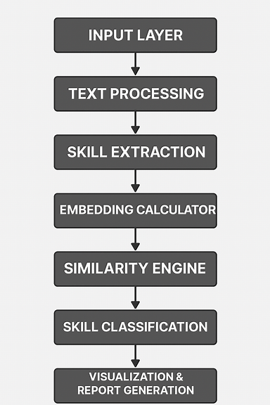

8. Technologies Used
Component | Technology
Programming Language | Python
IDE | VS Code / PyCharm
Frontend | Streamlit
NLP Tools | spaCy
Embedding Model | SBERT (all-MiniLM-L6-v2)
Machine Learning | Sklearn cosine similarity
Visualization | Matplotlib, Plotly
Data Storage / Processing | pandas, numpy
File Reading | pdfminer.six, python-docx
Deployment Tools | GitHub
Report Generation | openpyxl
Version Control | Git

9. Implementation (Milestone-Wise)
Milestone 1: Data Ingestion & Parsing
- Implemented file upload system
- Supported PDF, DOCX, TXT formats
- Extracted text using specialized parsers
- Implemented text preprocessing and normalization
Milestone 2: Skill Extraction
- Loaded skill list from database
- Applied keyword-based extraction
- Applied spaCy candidate phrase extraction when skill list is absent
Milestone 3: Similarity Computation
- Converted extracted skills into vectors using SBERT embeddings
- Calculated similarity matrix using cosine similarity
- Classified results using threshold values
Milestone 4: Visualization & Export
- Created pie chart to visualize percentage distribution
- Built bar chart representing similarity score per skill
- Exported results to CSV & Excel using pandas

10. Results & Discussion
The output modules clearly show candidate strengths and weaknesses. The model displays:
- Overall Skill Match Percentage
- Skill-wise comparison table with similarity scores
- Pie chart for skill gap breakdown
- Job description coverage summary
This gives HR and candidates a clear roadmap for improvement and selection.

11. Conclusion
The AI-Powered Skill Gap Analyzer successfully bridges the gap between candidate skills and job requirements. It offers a fast, accurate, automated and unbiased approach to evaluating employability. The project demonstrates the power of AI in recruitment and provides measurable insights that help improve hiring quality and educational training outcomes.

12. Future Enhancements
- Integration of OCR for scanned images and photo-based resumes
- Personalized career recommendations and course suggestions
- Multi-user collaboration features for HR
- Integration with LinkedIn API or Naukri.com parser
- Cloud hosting with database storage support

13. References
- https://www.sbert.net/
- https://spacy.io/
- https://streamlit.io/
- https://scikit-learn.org/
- YouTube tutorials and official model documentation

