Open Source Graphics & Animation Tools

MID-SEM EVALUATION
MARCH 2020

Submitted to
Dr. Durgansh Sharma
Professor, Cybernetics SCS, UPES

Submitted By
Name: Sakshi Bansal
Roll No: 51
SAP ID: 500067315
B. Tech CSE (OSSOS)
Department of Cybernetics
COMPUTER SCIENCE & ENGINEERING

School of Computer Science
University of Petroleum and Energy Studies,
Dehradun – 248007: Uttarakhand
Table of Contents
Phase- 2: 3
Project on Blender 3
Topic: Dairy milk Chocolate Animation 3
Procedure: 3

Phase- 2:

Project on Blender

Topic: Dairy Milk Chocolate Animation

Procedure:
Step1: Open new file and then delete the cube already placed by pressing the X key.

Step2: Start by adding a plane and scale it along X and Y axis so as to get desired chocolate base.

Step3: Press the Tab key and go to edit mode . Extrude the base by selecting the vertices .

Step4: Now add Loop cut using Ctrl + R , and then add a new plane as the base.

Step5: Using Shift + A add the text and write ‘chocolate’ in edit mode . Extrude the text by .1 and bevel its depth by .02.

Step6: Now add a remesh modifier to the text . Set the octree value to 9 , so as to get more refined mesh.

Step7: Check the shading smooth icon and uncheck the disconnected path icon.

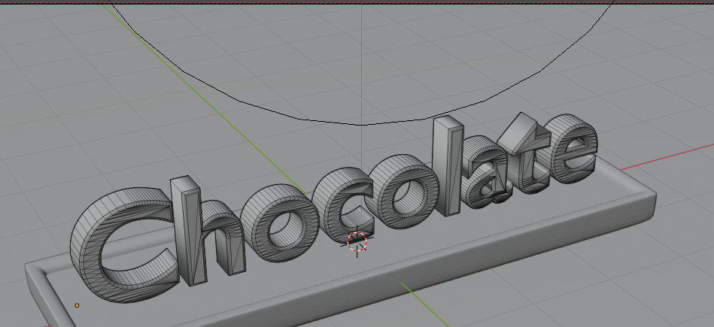
Step8: You will see a refined mesh.
Step 9 : Now add a beizer curve modifier to the text . Scale it
Step 10 : Set the starting frame to 1 and ending frame to 140.
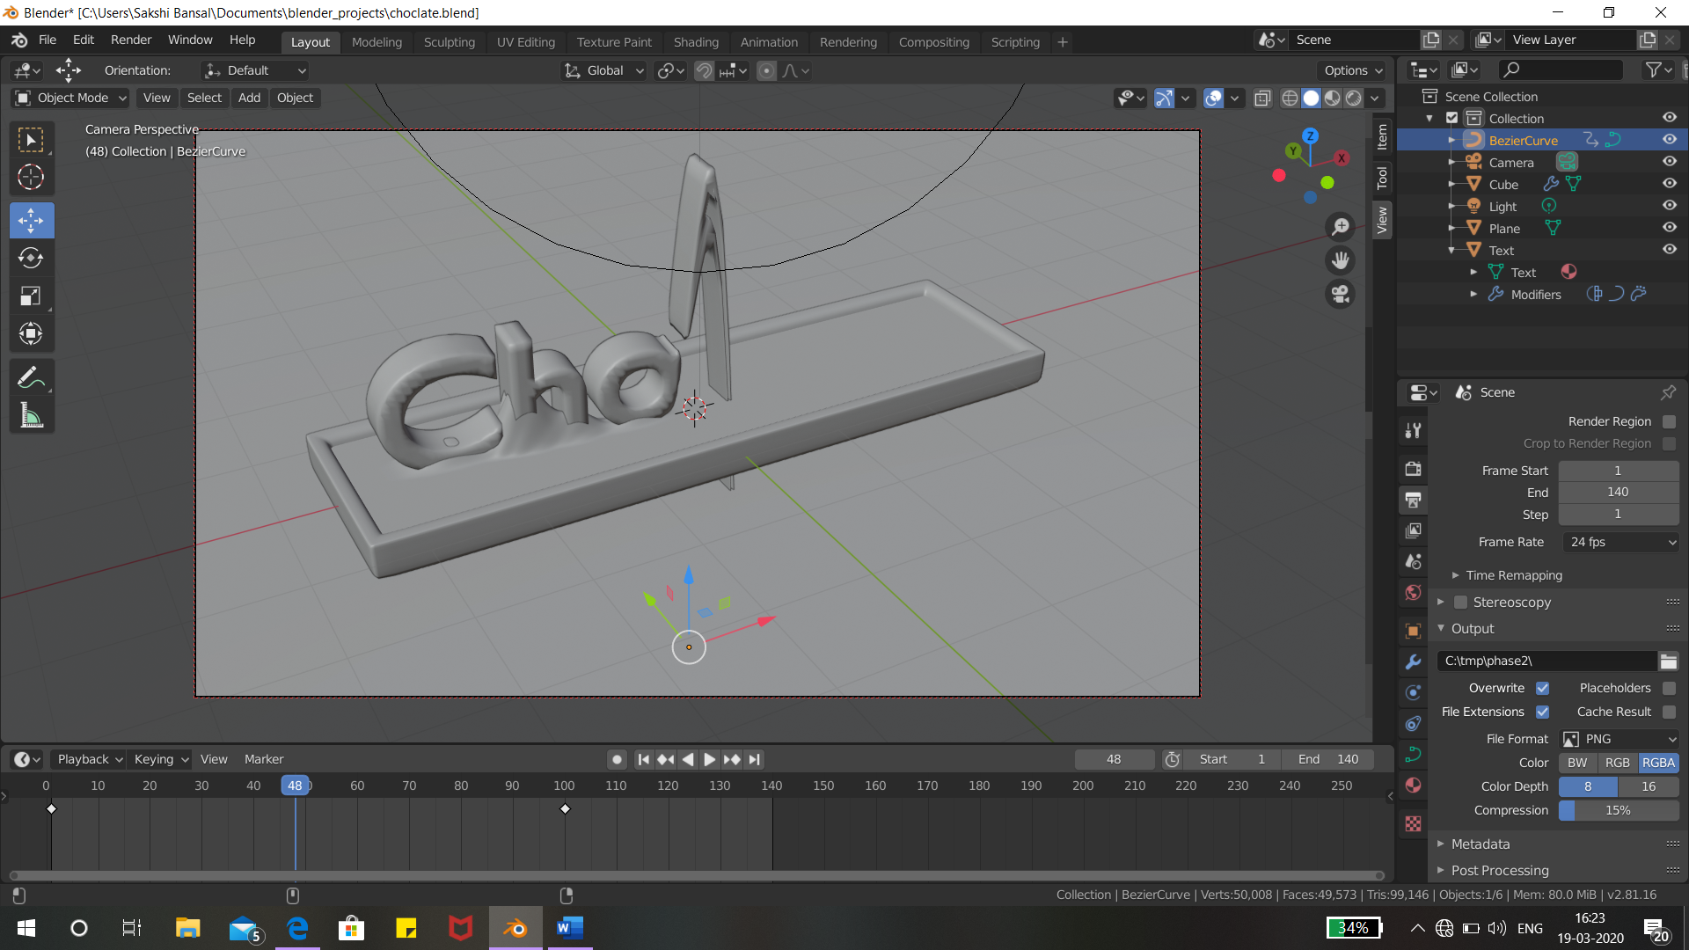
Step10: Play the animation to see the effect

Step11: Now from the material properties add mix shader to the chocolate bar
Step12: Set Shader 1 : Diffuse and Shader 2: Glossy

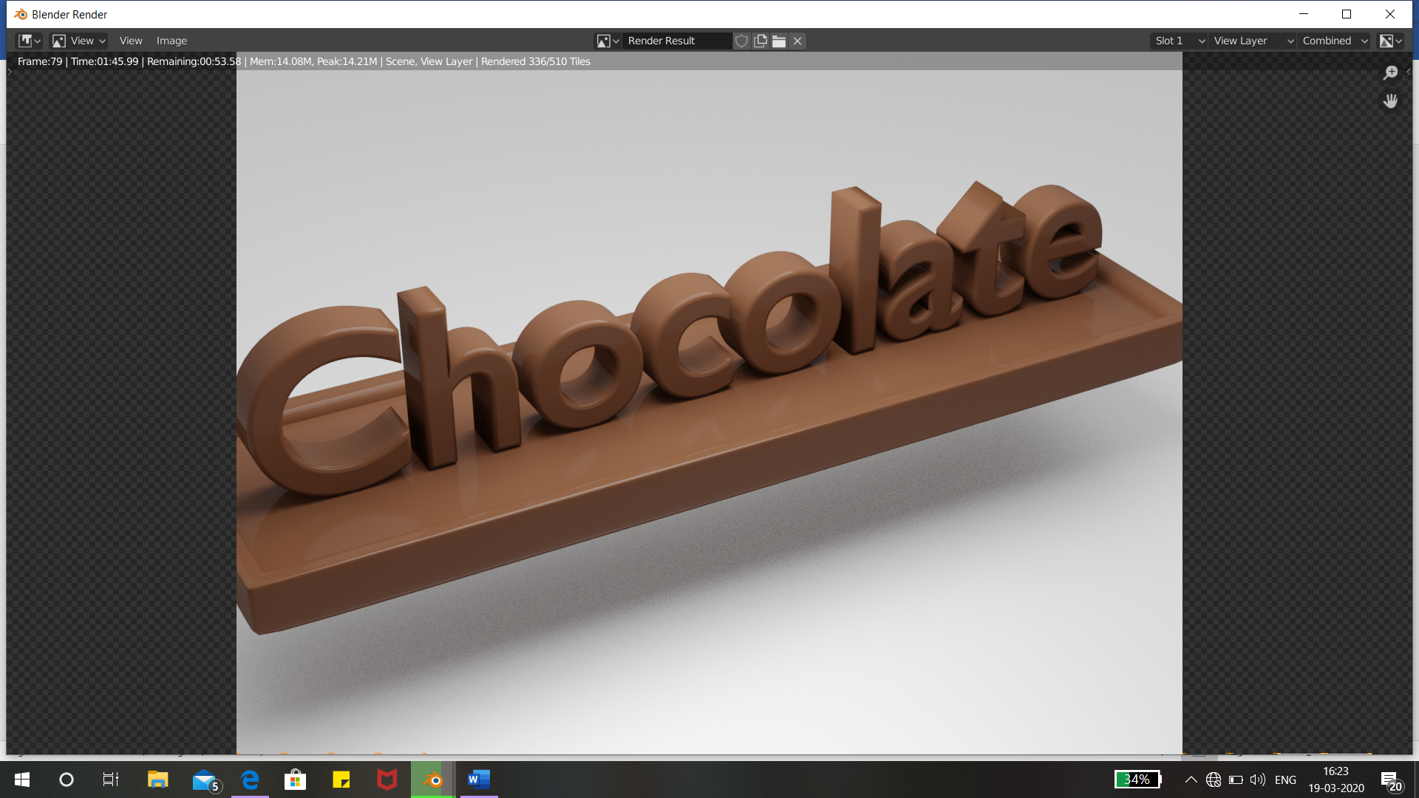
Step13: Add the same material to the text.

Step14: Set the camera position

Step15: Set the point light and power to 1 W.

Step16: From the Output properties tab set the output path and the format

Step 17: Click on render animation

