**OUTPUT**

OUTPUT OF FACTORIAL PROGRAM :

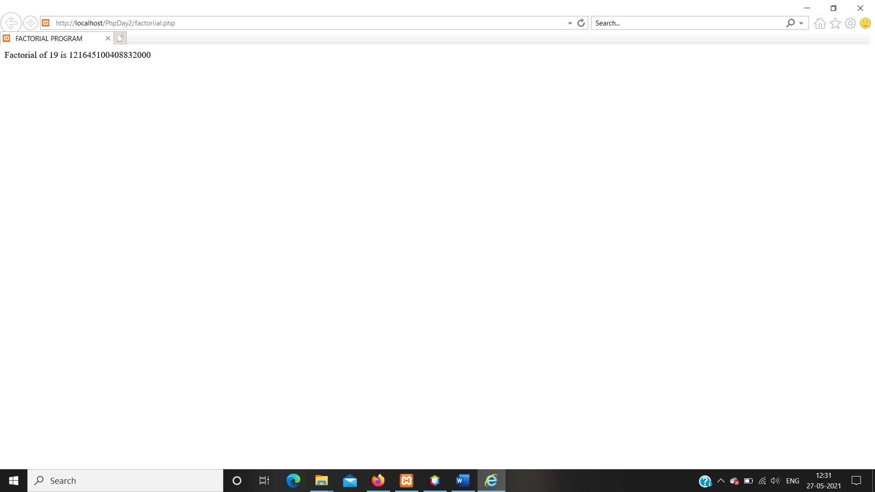

OUTPUT OF MARKSHEET PROGRAM :

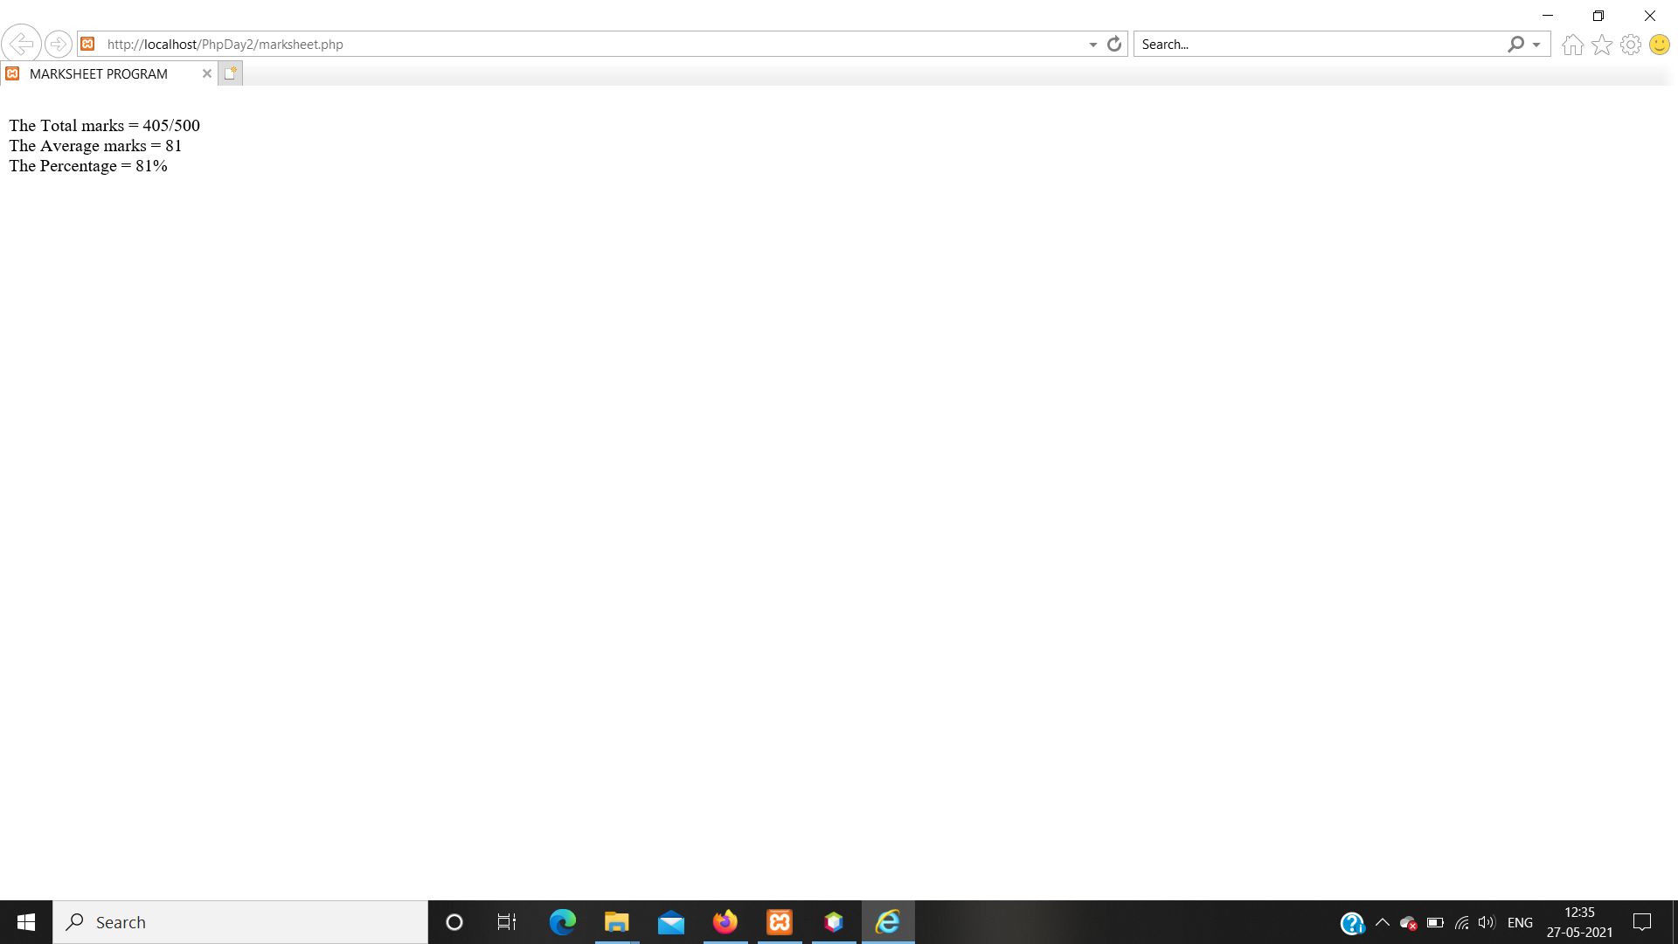

OUTPUT OF PALINDROME PROGRAM :

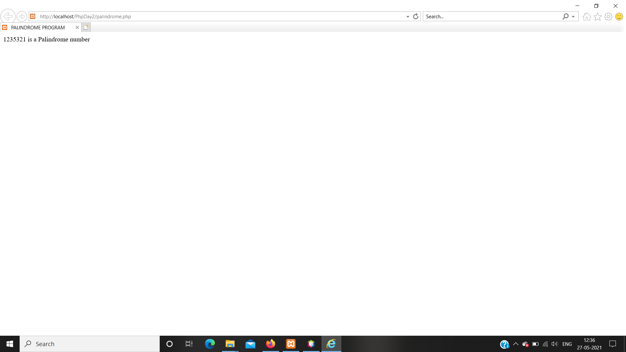

OUTPUT OF LEAPYEAR PROGRAM :

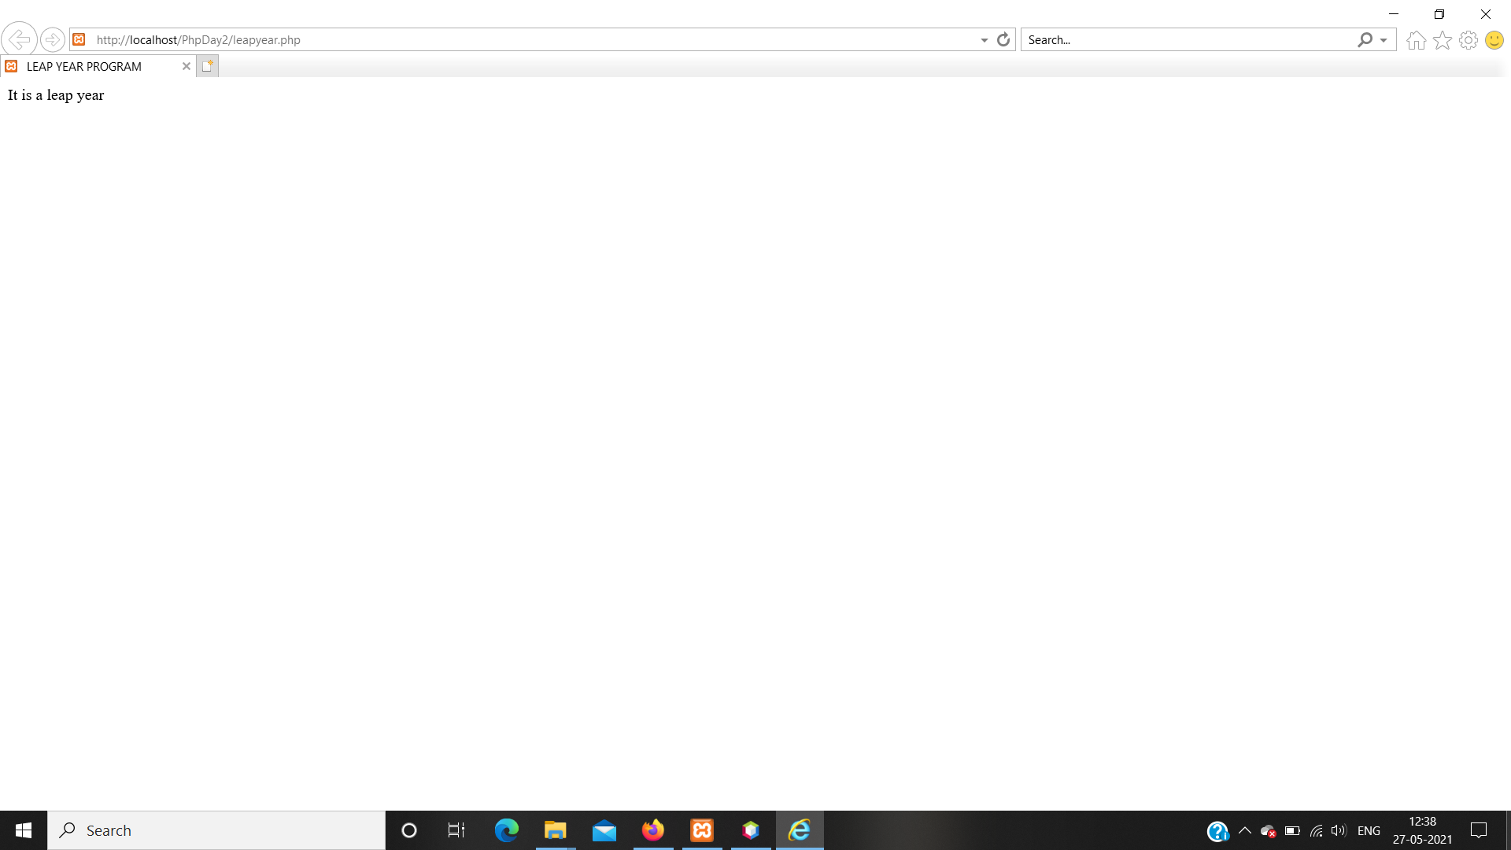

OUTPUT OF ARMSTRONG PROGRAM :

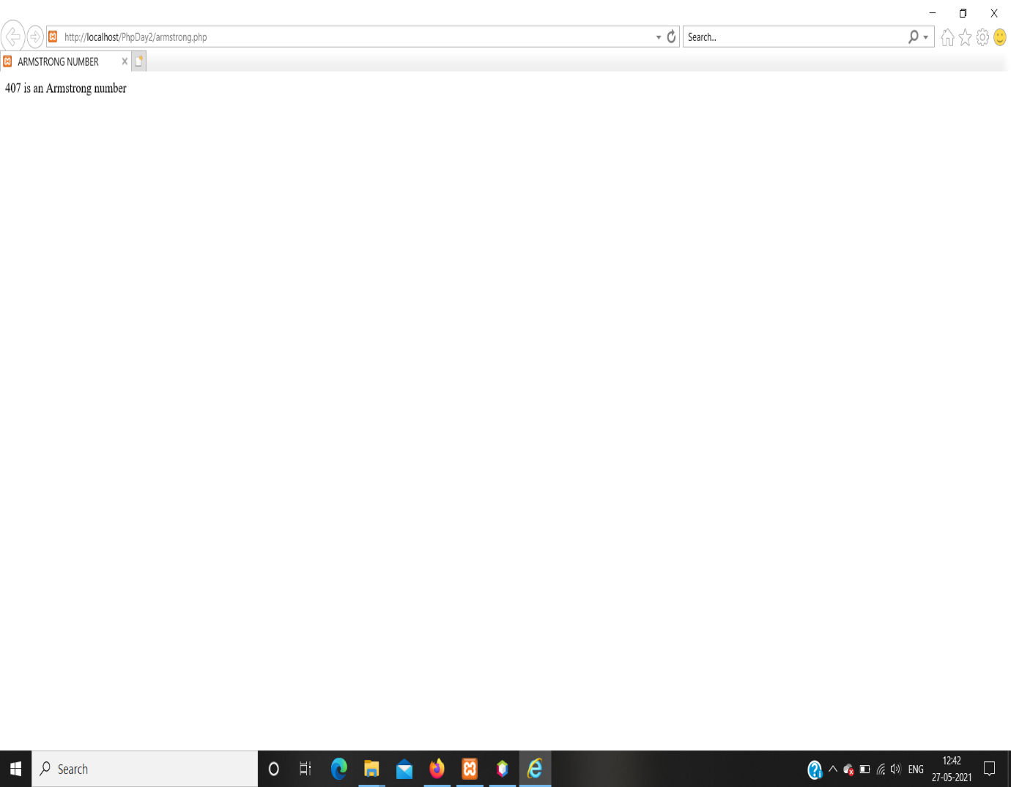

OUTPUT OF SWITCHCASE PROGRAM :

