Review Of Puzzle Alarm
Sakshi deore^{[1]}, Pratiksha bhamare^{[2]}, Mehak Gill^{[3]}, Darpana Pawar^{[4]}
Department of Computer Engineering, Guru Gobind Singh Polytechnic, Nashik, Maharashtra, India
deoresakshi473@gmail.com, pbhmare440@gmail.com, mehakkaurgill48@gmail.com darpanapawar007@gmail.com,

ABSTRACT

The puzzle alarm concept goes beyond the traditional blare of alarm clock, incorporating various puzzles and challenges that users must solve to silence the alarm.This is approach not only ensures timely wake-up but also engages the brain from the moment the an alarm sounds, promoting mental alertness and a positive start to the day. In this era of technology innovation, the puzzle alarm app offers a unique blend of a functionality and entertainment. Users can the customize the wake-up experience by selecting from variety of puzzles,including math problem, memory games, pattern recognition challenges. The app not only aims to disrupt the monotonous act of waking up and introduces an element of ,rewarding users for waking with achievements and incentives.
KEYWORDS:

Puzzle ,Technology , Innovative, Mental alertness , etc.

INTRODUCTION
In today's fast-paced world, the struggle to wake up on time is a common challenge faced by many individuals.As students juggle academic responsibilities, extracurricular activities, and social engagements, ensuring timely waking becomes paramount for success.This project encompasses various aspects, including hardware development, software programming, user interface design, and user experience testing.
To address this issue, our project focuses on designing and implementing a Puzzle Alarm System
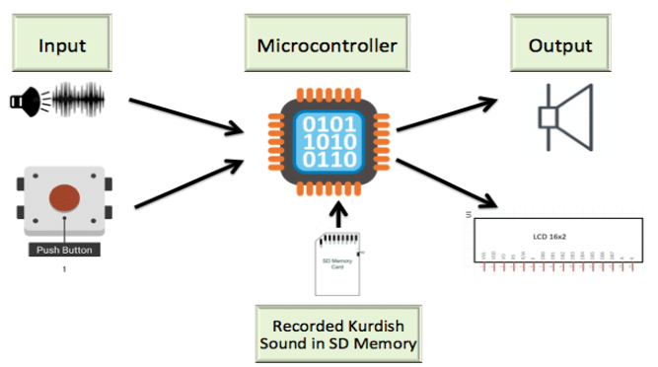

  - Block Diagram

Existing System:

Traditional alarm clock applications for Android devices typically offer basic functionality, allowing users to set alarms at specific times with options to choose alarm tones and set snooze durations.

However, these conventional alarm systems often fail to effectively address issue of users repeatedly snoozing or turning off alarm without fully waking up, leading to oversleeping and tardiness.

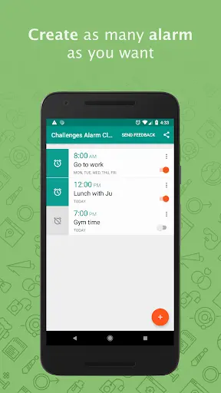
  - Existing System Diagram

Literature Survey:

Smart alarm clocl for effective health:

The reason of this venture is to ponder and create an alert clock to offer assistance wake up at the set time. Without having to rest the caution and not be so languid that you have to go back to rest once more to offer assistance decrease the chance of sleep related infection by utilizing different sensors,the Internet Of Thing (IOT) innovation is utilized for well being advantage

Wake uo task manager:

The most recent portable caution apps provide wake-up task to expel the alarm, and numerous clients readily acknowledge such an bother in return for effectively waking up on time. Be that as it may, there have been no thinks about that examine how the wake-up task are utilized and their impacts from a human–computer interaction viewpoint. This consider points to develop our understanding of how clients lock in and utilize the task-based caution app by looking at the characteristics of different wake-up task and extricating utilization components of difficult task which include physical or cognitive task loads over a certain level.

Advantages:
- A puzzle alarm clock requires solving a puzzle or completing a task to turn off the alarm.
- Regular use of the puzzle alarm clock can improve your problem solving skills and mental flexibility.
- Puzzle alarm clocks often come with different types of puzzles or tasks to solve, such as math problems, memory games, or physical challenges.
- By requiring you to engage in an activity to turn off the alarm, a puzzle alarm clock can discourage the habit of hitting the snooze button repeatedly

Disadvantages:
- For heavy sleepers or individuals with irregular sleep patterns, standard alarm tones may not be sufficient to rouse them from deep sleep, resulting in missed alarms and late starts to the day.
- If you are not a morning person or struggle with problem-solving,a puzzle alarm clock may cause frustration and stress
- Depending on the complexity of the puzzle or task, a puzzle alarm clock may take longer to turn off compared to a regular alarm clock

Output:

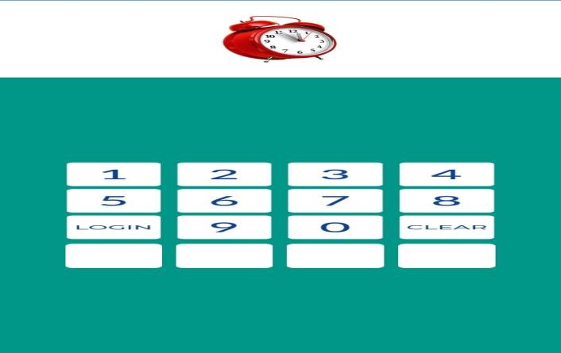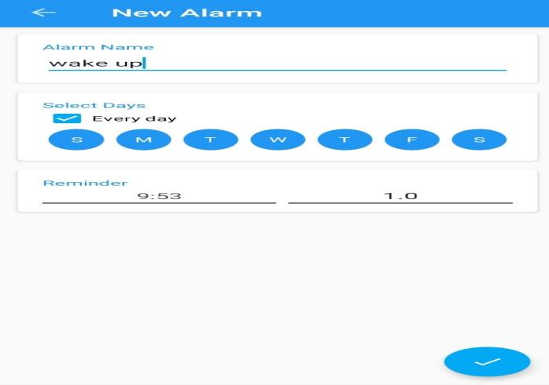

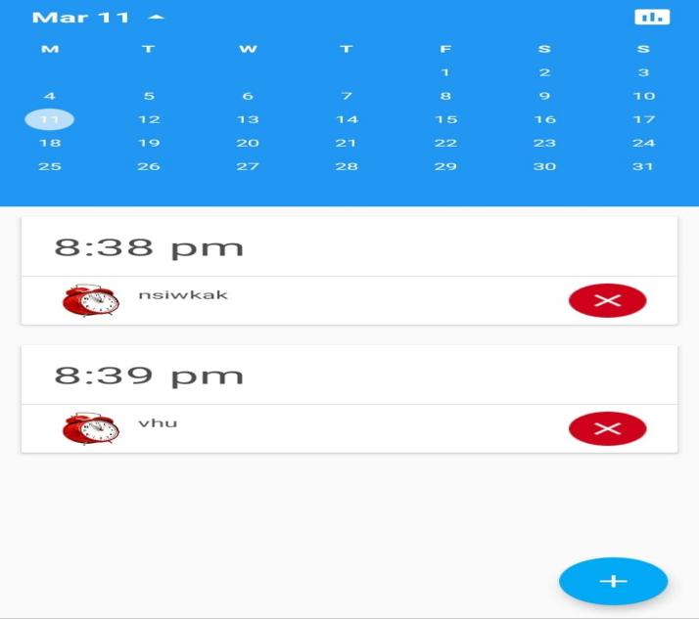
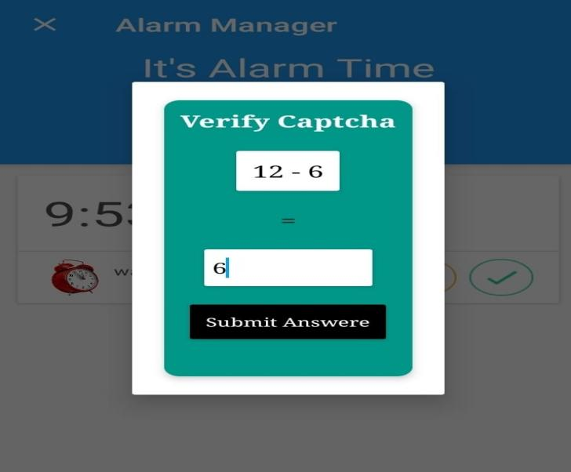

Conclusion:
In conclusion, the Puzzle Alarm System represents a novel and innovative approach to waking up effectively by integrating interactive puzzles and challenges into traditional alarm functionality. Through this project, we have explored the technical feasibility, economic viability, and operational potential of developing such a system. The feasibility study indicates that the Puzzle Alarm System is technically feasible, with the necessary resources and expertise available for development. While further analysis is required to assess economic and operational feasibility accurately, the project holds promise for providing users with a unique and engaging wake-up experience.
Future Scope:
1 Improved Puzzle Algorithms : Continuous improvement of puzzle solving algorithms to provide more varied and challenging puzzles such as logic puzzles and games to keep users interested and motivated to play.
2 Integrating Machine Learning: Implementing machine learning algorithms to personalize the waking experience.

3 Game elements : Includes game elements such as reward systems, achievement badges and scoreboards to encourage users to wake up.
.

References:
  - A.Jahrami et al., "Sleep disturbances during the COVID-19 pandemic:A systematic review, meta-analysis, and meta-regression," Sleep Medicine Reviews, vol. 62, p. 101591, 2022.
  - B.Ploderer, S. Rodgers, and Z. Liang, "What’s keeping teens up at night? Reflecting on sleep and technology habits with teens," Personal and Ubiquitous Computing, vol. 27, pp. 249-270, 2023.
  - Z.Liang et al., "Sleep Explorer: a visualization tool to make sense of correlations between personal sleep data and contextual factors,"Personal Ubiquitous Comput., vol. 20, no. 6, pp. 985-1000, 2016.
  - O.J. Wang et al., "Mobile crowd sourcing based context-aware smart alarm sound for smart living," Pervasive and Mobile Computing, vol.55, pp. 32-44, 2019.

