

G. H .RAISONI COLLEGE OF ENGINEERING AND MANAGEMENT, WAGHOLI ,PUNE
ANEMPOWERED AUTONOMOUS INSTITUTE ,AFFILIATED TO SAVITRIBAI PHULE PUNE UNIVERSITY , PUNE
TAE 1
23UDSPCL3508/23UDSPCP3508 :
Database Management Systems

PROJECT NAME:
Waste Segregation & Municipal Collection Tracking System

Submitted BY:
Full Name: Sakshi Subhash Shinde
Roll Number: P47
PRN: 24ACDS1101015
Section: P

Under the Guidance of:
Mr. Chinmay Mukim
1 . Database System Title :
Waste Segregation & Municipal Collection Tracking System

2. Problem Statement & System Requirements:
Municipal corporations are responsible for collecting garbage from thousands of households on a daily basis. However, traditional register-based tracking systems make it difficult to maintain proper records of waste segregation compliance, truck-wise collection history, and zone-wise accountability. Data recorded manually in registers is often redundant and unstructured, with household, zone, and vehicle details repeated across every entry, making audits and analysis difficult. This project proposes a relational database system to organize municipal solid waste collection data in a structured, normalized manner that supports accurate reporting and monitoring.

System Requirements:
• Maintain records of households grouped under specific collection zones.
• Link every collection event to the truck that performed it and the date it occurred.
• Track waste type-wise (wet / dry / hazardous) segregation compliance for each collection.
• Identify non-compliant households so municipal authorities can follow up.
• Support zone-wise and truck-wise reporting for operational monitoring.

Operational Transactions:
• Registering a new household under a collection zone.
• Recording a daily collection entry (truck, household, waste type, weight, segregation status).
• Generating zone-wise and truck-wise collection reports.
• Tracking and flagging non-compliant households over time.

3. Literature & System Reference
1. IEEE Xplore — "IoT-Enabled Smart Waste Management Systems for Smart Cities: A Systematic Review" — supports modeling Truck separately, linked to Collection.
2. IJERT — "A Review of Smart Waste Management Systems using IOT and Embedded Technologies" — supports Weight_kg and Segregation_Status as Collection attributes.
3.PMC/NCBI — "Smart waste management and classification system using advanced IoT and AI technologies" — justifies Segregation_Status on every record.
4 Neso Academy (YouTube) — ER Diagram Fundamentals — supports Section 4 ER design.
🔗 https://www.classcentral.com/course/youtube-entity-relationship-er-diagram-412873
5. YouTube — Database Normalization: 1NF, 2NF & 3NF — supports Section 5 normalization steps.
🔗 https://www.youtube.com/watch?v=suKHq3ZLPmU
6.Database Reference:
https://drive.google.com/file/d/1MmwtcEGfEhREegU0U2GPfHcwpBtA18bd/view?usp=sharing

4. Conceptual Schema Design (ER Diagram)

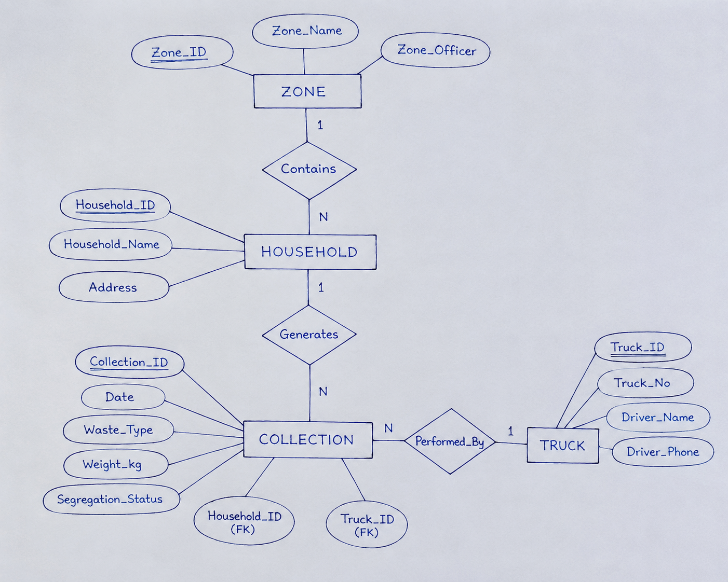
Entities, Keys & Cardinalities:
• Zone (PK: Zone_ID) — represents a municipal collection zone/ward.
• Household (PK: Household_ID, FK: Zone_ID) — a household located within a zone.
• Truck (PK: Truck_ID) — a collection vehicle with its assigned driver.
• Collection (PK: Collection_ID, FK: Household_ID, FK: Truck_ID) — an individual collection
event capturing date, waste type, weight, and segregation status.
• Zone Household: One-to-Many (1:N) — one zone contains many households.
• Household Collection: One-to-Many (1:N) — one household generates many collection
records over time.
• Truck Collection: One-to-Many (1:N) — one truck performs many collections

5. Relational Schema & Normalisation Plan:
5.1 Raw Unnormalized Data (Sample Municipal Register) :
RowDataset:
:https://drive.google.com/file/d/1MmwtcEGfEhREegU0U2GPfHcwpBtA18bd/view?usp=sharing

This structure repeats household, zone, and truck/driver details on every row, mixes multiple waste-type records under the same Collection_ID, and even shows real-world data quality issues such as a missing Zone_Officer value (row 4) and inconsistent status labelling ("Non-Compliant" vs "Non compliant") — exactly the kind of dirty, unnormalized data this proposal is designed to clean up.
5.2 Functional Dependencies (Identified from Raw Data):
Before normalising, the functional dependencies (FDs) present in the raw data are identified. These FDs drive every decomposition step that follows:
• Collection_ID Date, Household_ID
• Collection_ID, Waste_Type Weight_kg, Segregation_Status
• Household_ID Household_Name, Address, Zone_ID
• Zone_ID Zone_Name, Zone_Officer
• Truck_ID Truck_No, Driver_Name, Driver_Phone

5.3 First Normal Form (1NF):
Rule: Every column should contain only one value (atomic value), and there should be no repeating data in the same row. Each table must also have a primary key. In the raw data, one Collection_ID contained multiple waste types (Wet, Dry, Hazardous) in a single record, creating repeating data. To solve this, each waste type is stored in a separate row, and the combination of Collection_ID and Waste_Type is used as the primary key. Now, each row stores only one waste type with its weight and segregation status, satisfying First Normal Form (1NF).

5.4 Second Normal Form (2NF):
Rule: A table must already be in 1NF, and every non-key column should depend on the entire primary key, not just part of it. In this table, the primary key is (Collection_ID, Waste_Type). However, details like Household_Name, Address, Zone_Name, Zone_Officer, Truck_No, Driver_Name, and Driver_Phone depend only on Collection_ID, not on Waste_Type. This is called a partial dependency, which breaks the rules of 2NF. To fix this, these details are moved into separate Household, Zone, and Truck tables. These tables are connected to the Collection table using foreign keys. Now, every non-key attribute depends only on the primary key of its own table, so the database satisfies Second Normal Form (2NF).
5.5 Third Normal Form (3NF):
Rule: A table must already be in 2NF, and no non-key attribute should depend on another non-key attribute. In the Household table, the Zone_Officer depends on Zone_ID, not directly on Household_ID. This is called a transitive dependency, which violates 3NF. To solve this, Zone_Officer is stored only in the Zone table, and the Household table refers to it using Zone_ID. Similarly, Driver_Name and Driver_Phone are stored in the Truck table because they depend directly on Truck_ID. After these changes, every non-key attribute depends only on the primary key, so the database satisfies Third Normal Form (3NF).
5.6 Boyce-Codd Normal Form (BCNF) Check:
Rule: In BCNF (Boyce-Codd Normal Form), every attribute should depend only on a super key (a primary key or candidate key). In this database, Zone_ID is the key for the Zone table, Household_ID is the key for the Household table, and Truck_ID is the key for the Truck table. In the Collection table, Collection_ID identifies the collection details, and (Collection_ID, Waste_Type) identifies the Weight_kg and Segregation_Status. Since all attributes depend only on their keys and not on any non-key attribute, all the tables satisfy BCNF.
5.7 Integrity Constraints Enforced:
Entity Integrity: Every table has a unique Primary Key (Zone_ID, Household_ID, Truck_ID, Collection_ID). The Primary Key cannot be NULL, so each record is unique and can be identified easily.
Referential Integrity: Every Foreign Key must match an existing Primary Key in another table. For example:
- Household.Zone_ID must exist in the Zone table.
- Collection.Household_ID must exist in the Household table.
- Collection.Truck_ID must exist in the Truck table.

This ensures that the database does not contain invalid or missing references.

Domain Integrity :The database allows only valid values:
- Waste_Type can only be Wet, Dry, or Hazardous.
- Segregation_Status can only be Compliant or Non-Compliant.
- Weight_kg must be greater than 0.
These rules help prevent incorrect or invalid data from being stored in the database.
5.8 Final Normalized Relational Schema (BCNF-Compliant :
Zone:

